Supplementary Information
Tackling water theft: an empirical framework for compliance-inducing penalties under uncertainty
Giammauro Soriano ^{1,2}, Noureddine Bouzidi ^{1, 3}, Manuel Bea Martínez ⁴, C. Dionisio Pérez-Blanco ^{1,5}

Supplementary Note 1 | Enforcement-probability scenarios
The main analysis samples prosecution and conviction probabilities over their full admissible range (0.01–1.00), imposing no prior on enforcement performance. Two alternative scenarios replace that agnostic support with enforcement probabilities reported for Doñana by Loch et al.⁴, each varied ±50% around its central value.
The first uses Total Probability I of their Supplementary Table 4 (prosecution 0.70, conviction 0.60), giving sampling ranges of 0.35–1.00 and 0.30–0.90. The second uses the caseload recorded in their Supplementary Box 1—135 of 2,000 theft cases prosecuted and 50 of 135 convicted—giving 0.034–0.101 and 0.185–0.556. Detection probability is held at 0.80–1.00 in both. Each scenario was evaluated over the same Saltelli design, the same 13 municipalities and the same three PMP calibrations. The implied joint enforcement probability spans 0.084–0.900 under Total Probability I and 0.005–0.056 under the observed caseload, against 0.00008–1.000 in the main analysis.
Under Total Probability I the median compliance-inducing penalty is 1.43 EUR/m³ (IQR 0.39–3.81; P10–P90 0.03–7.80), roughly half the main estimate of 3.01 EUR/m³. Under the observed Doñana caseload it is 23.08 EUR/m³ (IQR 6.18–62.25; P10–P90 0.52–129.02), close to eight times the main estimate. The ordering across calibrations is unchanged in both scenarios—Standard 1.09 and 17.49 EUR/m³, Average 1.18 and 18.92, Paris 2.04 and 33.14—so the calibration choice shifts the penalty by a factor of about two while the enforcement scenario shifts it by a factor of sixteen. The share of simulated cases deterred by the upper observed penalty of 1.35 EUR/m³ is 48.6% under Total Probability I and 14.0% under the observed caseload, against 34.9% in the main analysis; at the lower observed penalty of 0.29 EUR/m³ the corresponding shares are 21.8%, 8.1% and 16.9%. The substantive conclusion is insensitive to the choice: even under the most favourable enforcement assumptions tested, more than half of simulated cases are not deterred by the highest penalty observed in Doñana, and under the enforcement rates the region has actually recorded that share rises to 86%.
The second scenario is the only one anchored in Doñana's own prosecutorial record rather than in modelled values, and it admits an independent check. Its central rates—6.75% of cases prosecuted and 37.04% of prosecutions convicted—imply a combined prosecution-and-conviction probability of 2.50%, which falls inside the 2.2–4.4% range obtained from the district attorney's office for the same period. Under it the median compliance-inducing penalty is 23.08 EUR/m³—17 times the highest penalty observed in Doñana and 80 times the lowest—and 86.0% of simulated cases would remain undeterred by the upper observed penalty. Municipal medians range from 8.22 EUR/m³ in Aznalcázar to 70.57 EUR/m³ in Niebla. Across the 13 eligible municipalities, baseline illegal water use totals 14.45 million m³, with Sanlúcar de Barrameda alone accounting for 3.21 million m³ (22.2%). On this reading the headline estimate of 3.01 EUR/m³ is conservative with respect to the enforcement performance the region has actually recorded.
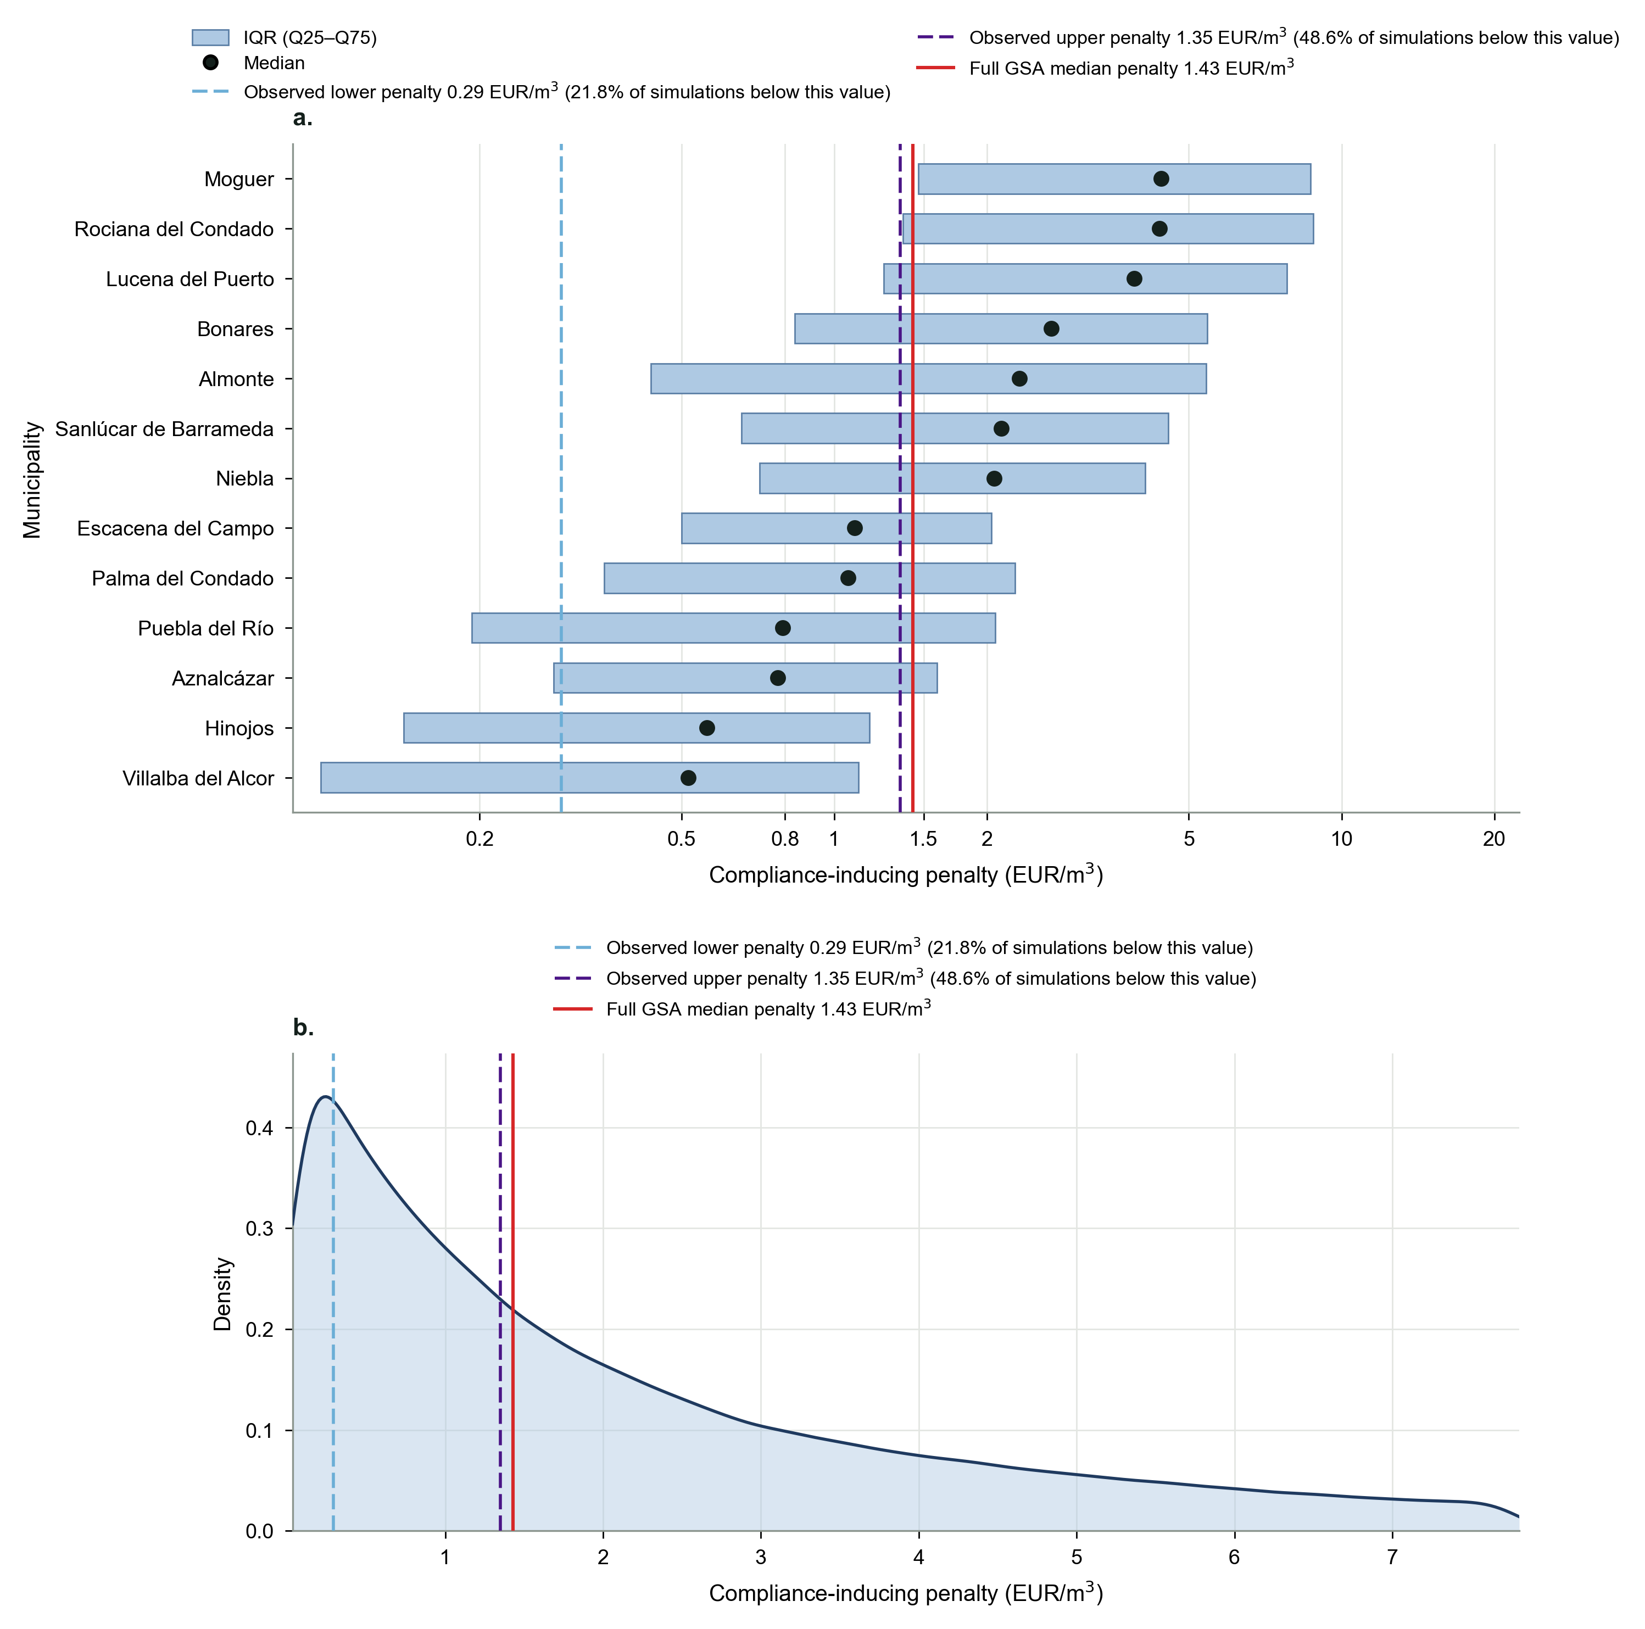
Supplementary Figure 1 | Compliance-inducing penalties across municipalities under Total Probability I enforcement. a, Municipal distributions of modelled compliance-inducing penalties, shown as interquartile ranges (Q25–Q75) with median values on a logarithmic axis. The dashed light-blue line marks the lower observed penalty (0.29 EUR/m³), the dashed dark-purple line marks the higher observed penalty (1.35 EUR/m³), and the red line marks the full GSA median penalty (1.43 EUR/m³). b, Kernel-density estimate of the compliance-inducing penalty distribution within the P10–P90 range (0.03–7.80 EUR/m³). The median penalty is 1.43 EUR/m³ (IQR 0.39–3.81), the mean 2.95 EUR/m³, with Q80 and Q90 reaching 4.71 and 7.80 EUR/m³. Prosecution and conviction probabilities are sampled over 0.35–1.00 and 0.30–0.90 respectively, and detection over 0.80–1.00. The observed penalty range would address 21.8–48.6% of simulated cases.
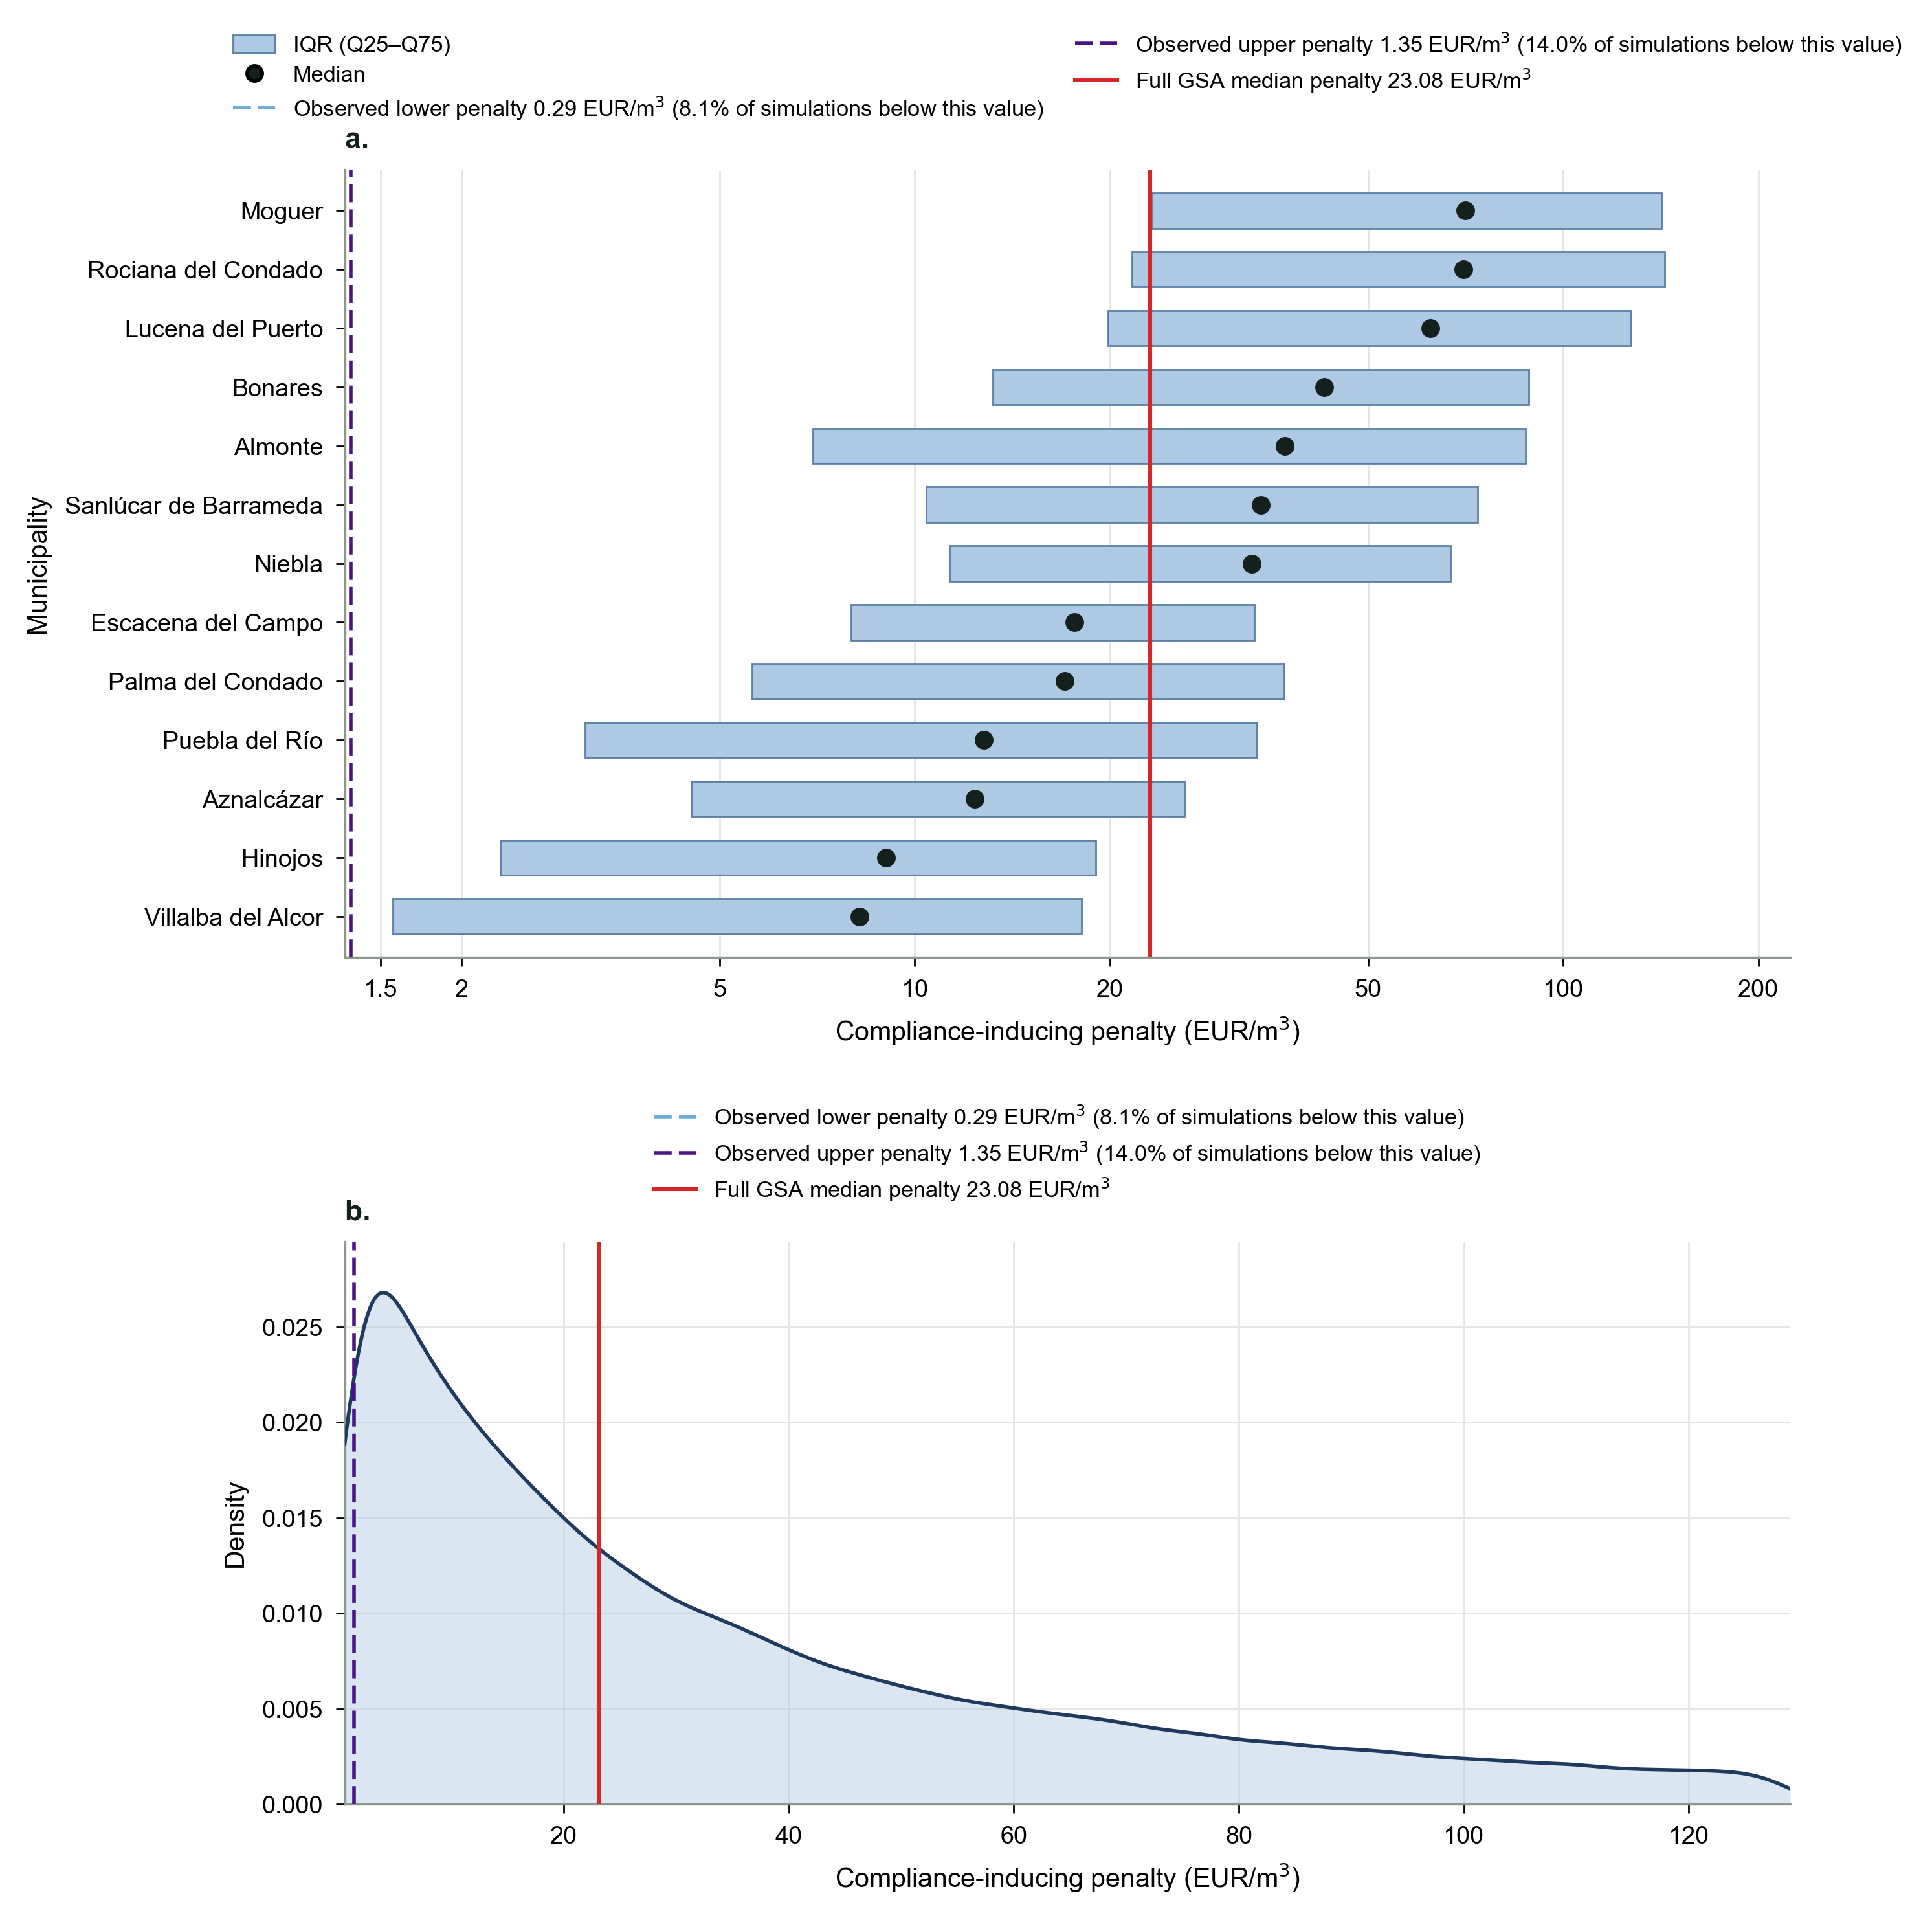
Supplementary Figure 2 | Compliance-inducing penalties across municipalities under the observed Doñana caseload in Loch et al⁴. a, Municipal distributions of modelled compliance-inducing penalties, shown as interquartile ranges (Q25–Q75) with median values on a logarithmic axis. The dashed light-blue line marks the lower observed penalty (0.29 EUR/m³), the dashed dark-purple line marks the higher observed penalty (1.35 EUR/m³), and the red line marks the full GSA median penalty (23.08 EUR/m³). b, Kernel-density estimate of the compliance-inducing penalty distribution within the P10–P90 range (0.52–129.02 EUR/m³). The median penalty is 23.08 EUR/m³ (IQR 6.18–62.25), the mean 49.01 EUR/m³, with Q80 and Q90 reaching 76.91 and 129.02 EUR/m³. Prosecution and conviction probabilities are sampled over 0.034–0.101 and 0.185–0.556 respectively, and detection over 0.80–1.00. The observed penalty range would address 8.1–14.0% of simulated cases.

Supplementary Note 2 | Microeconomic validation of empirical sensitivity results: first-order conditions, dual values, and comparative statics of compliance-inducing penalties
Here, we provide the microeconomic theoretical validation for the empirical sensitivity rankings and parameter interactions identified by the Random Forest emulator and the TreeSHAP GSA. While analytical comparative statics operate under local, ceteris paribus conditions and cannot evaluate high-dimensional global variance propagation or extreme tail distributions ($Q_{80}$, $Q_{90}$), they reveal the fundamental structural mechanisms of the optimization problem. Specifically, they explain why the empirical SHAP decomposition attributes dominant importance to the institutional probabilities of enforcement.
Structural model formulation
Each municipality $m$ $m∈\left\{1, … ,M\right\}$ is modeled as an economic agent choosing agricultural land allocation $x_{mc}$ (hectares) across available crops $c∈C_{m}$ to maximize regional gross margin under land and water constraints. Following the PMP specification of the manuscript, the behavioral optimization problem is:
$$\max_{x_{mc}≥0} Π_{m}=\sum_{c∈C_{m}}{\left(p_{mc}y_{mc}+s_{mc}+i_{mc}-α_{mc}-\frac{1}{2}β_{mc}x_{mc}\right)x_{mc}}$$
subject to:
$$\sum_{c∈C_{m}}{x_{mc}}≤{Land}_{m} \left[λ_{m}^{L}\right]$$
$$\sum_{c∈C_{m}}{w_{mc}x_{mc}}≤W_{m} \left[λ_{m}^{W}\right]$$
where:
$p_{mc}$ is the producer price for crop $c$ in municipality $m$ (EUR/kg). Under parametric uncertainty, it is scaled by the regional price multiplier $d_{p}∈\left(0.50,1.50\right)$. $y_{mc}$ is the crop yield (kg/ha), scaled by the yield multiplier $d_{y}∈\left(0.50,1.50\right)$. $s_{mc}$ and $i_{mc}$ are subsidies and agricultural insurance indemnities per hectare, respectively. $k_{mc}$ is the accounting variable production cost per hectare, scaled under uncertainty by the cost multiplier $d_{c}∈\left(0.50,1.50\right)$. $α_{mc}$ and $β_{mc}$ are the calibrated linear and quadratic PMP cost parameters ($β_{mc}>0$), capturing increasing marginal costs of production due to unobserved heterogeneity, land quality gradients, and managerial constraints. $w_{mc}$ is the crop-specific irrigation water requirement ($m^{3}$/ha). ${Land}_{m}$ is total available arable land in municipality $m$. $W_{m}$ is total irrigation water available to municipality $m$. In the baseline regime with non-compliance, water availability equals legal water plus illegal water: $W_{m}^{0}=λW_{m,0}^{L}+W_{m}^{I}$. In the counterfactual compliance regime, illegal abstractions are eliminated: $W_{m}^{s}=λW_{m,0}^{L}$, where $λ∈\left(0,1\right)$ scales legal water availability. $λ_{m}^{L}$ and $λ_{m}^{W}$ are the Lagrange multipliers associated with the regional land and water constraints, respectively.
Lagrangian and First-Order Conditions
Let the linear net revenue per hectare be defined as:
$$R_{mc}=d_{p}p_{mc}⋅d_{y}y_{mc}+s_{mc}+i_{mc}-α_{mc}$$
The Lagrangian function for municipality $m$ is:
$$L_{m}\left(x_{mc}, λ_{m}^{L}, λ_{m}^{W}\right)=\sum_{c∈C_{m}}{\left(R_{mc}x_{mc}-\frac{1}{2}β_{mc}{x_{mc}}^{2}\right)}+λ_{m}^{L}\left({Land}_{m}-\sum_{c∈C_{m}}{x_{mc}}\right)+λ_{m}^{W}\left(W_{m}-\sum_{c∈C_{m}}{w_{mc}x_{mc}}\right)$$
For any actively irrigated crop cultivated on an interior solution ($x_{mc}^{*}>0$), the Karush-Kuhn-Tucker (KKT) first-order stationary condition is:
$$\frac{∂L_{m}}{∂x_{mc}}=R_{mc}-β_{mc}x_{mc}^{*}-λ_{m}^{L}-λ_{m}^{W}w_{mc}=0$$
Solving explicitly for the optimal land allocation $x_{mc}^{*}$ yields:
$$x_{mc}^{*}=\frac{R_{mc}-λ_{m}^{L}-λ_{m}^{W}w_{mc}}{β_{mc}}=\frac{d_{p}p_{mc}d_{y}y_{mc}+s_{mc}+i_{mc}-α_{mc}-λ_{m}^{L}-λ_{m}^{W}w_{mc}}{β_{mc}}$$
The associated complementary slackness conditions are:
$$λ_{m}^{L}≥0, {Land}_{m}-\sum_{c∈C_{m}}{x_{mc}^{*}}≥0, λ_{m}^{L}\left({Land}_{m}-\sum_{c∈C_{m}}{x_{mc}^{*}}\right)=0$$
$$λ_{m}^{W}≥0, W_{m}-\sum_{c∈C_{m}}{w_{mc}x_{mc}^{*}}≥0, λ_{m}^{W}\left(W_{m}-\sum_{c∈C_{m}}{w_{mc}x_{mc}^{*}}\right)=0$$
Foregone profit and compliance-inducing penalty formulation
The private return from water theft per cubic meter ($ΔΠ_{m}$) represents the average foregone gross margin when removing the illegal water volume $W_{m}^{I}$:
$$ΔΠ_{m}=\frac{Π_{m}\left(W_{m}^{0}\right)-Π_{m}\left(W_{m}^{s}\right)}{W_{m}^{I}}=\frac{Π_{m}\left(λW_{m,0}^{L}+W_{m}^{I}\right)-Π_{m}\left(λW_{m,0}^{L}\right)}{W_{m}^{I}}$$
This discrete difference is the integral of the water shadow price evaluated over the non-compliant allocation domain:
$$ΔΠ_{m}=\frac{1}{W_{m}^{I}}\int_{λW_{m,0}^{L}}^{λW_{m,0}^{L}+W_{m}^{I}}{λ_{m}^{W*}\left(W\right) dW}$$
Under the Beckerian deterrence framework, an irrigator desists from illegal abstraction if the expected monetary penalty weakly exceeds the private return from theft:
$$E⋅P_{m3}^{*}≥ΔΠ_{m} ⟹ P_{m3}^{*}=\frac{ΔΠ_{m}}{E}=\frac{ΔΠ_{m}}{p_{d}⋅p_{p}⋅p_{c}}$$
Substituting the integral representation of foregone profit into the deterrence condition:
$$P_{m3}^{*}\left(z\right)=\frac{1}{p_{d}⋅p_{p}⋅p_{c}⋅W_{m}^{I}}\int_{λW_{m,0}^{L}}^{λW_{m,0}^{L}+W_{m}^{I}}{\left[\sum_{c∈C_{m}}{\frac{w_{mc}\left(R_{mc}-λ_{m}^{L}\right)}{β_{mc}}}-W\sum_{c∈C_{m}}{\frac{{w_{mc}}^{2}}{β_{mc}}}\right] dW}$$
Cross-Partial Derivatives and Parameter Interactions
The SHAP beeswarm and scatter plots reveal strong bivariate interactions between market parameters and institutional enforcement. Evaluating the cross-partial derivative of $P_{m3}^{*}$ between crop prices and prosecution probability:
$$\frac{∂^{2}P_{m3}^{*}}{∂d_{p}∂p_{p}}=-\frac{1}{p_{d}⋅p_{p}^{2}⋅p_{c}⋅W_{m}^{I}}\int_{λW_{m,0}^{L}}^{λW_{m,0}^{L}+W_{m}^{I}}{\left[\frac{\sum_{c∈C_{m}}{\frac{w_{mc}p_{mc}d_{y}y_{mc}}{β_{mc}}}}{\sum_{k∈C_{m}}{\frac{{w_{mk}}^{2}}{β_{mk}}}}\right] dW}<0$$
This cross-partial derivative is strictly negative:
i. under low enforcement ($p_{p}→0$): High commodity prices ($d_{p}>1$) compound the private return from theft while the denominator approaches zero, leading to extreme required penalties (the upper tail of the kernel density extending beyond 37 EUR/$m^{3}$).
ii. Under high enforcement ($p_{p}→1$): Strong prosecution and conviction credibility compress the required penalty to low, stable values regardless of commodity market, causing the price sensitivity curves to flatten toward an asymptote.
The analytical derivations presented above and the numerical GSA via TreeSHAP serve distinct and complementary methodological roles. The analytical derivations provide qualitative, local verification under ceteris paribus assumptions. They prove the mathematical necessity of the sign and curvature of model response. (ii) The GSA evaluates the simultaneous, non-linear propagation of all seven parameters across the entire Latin Hypercube design space. It integrates the interaction effects across the parameter hypercube, accounts for multi-model calibration uncertainty (Standard vs. Average vs. Paris), and quantifies the exact percentage contribution of each driver to empirical output dispersion.

