Atlantic salmon (Salmo salar L.) early life bacterial succession under different diet regime

Eleni Nikouli ^{1,2}, Konstantinos Ar. Kormas ¹, Yang Jin ³, Yngvar Olsen ³, Ingrid Bakke ² and Olav Vadstein ²*

¹ Department of Ichthyology and Aquatic Environment, School of Agricultural Sciences, University of Thessaly, Volos 384 46, Greece; EN: elnikoul@uth.gr; KAK: kkormas@uth.gr
² Department of Biotechnology and Food Science, Faculty of Natural Sciences, Norwegian University of Science and Technology, NO-7491 Trondheim, Norway; IB: ingrid.bakke@ntnu.no
³ Department of Biology, Faculty of Natural Sciences, Norwegian University of Science and Technology, NO-7491 Trondheim, Norway; YJ: : jinyangye119@hotmail.com; YO: yngvar.olsen@ntnu.no

* Correspondence: olav.vadstein@ntnu.no; Tel.: +47 73412447; +47 91897034

Supplementary material

Table S1: Ingredients of the experimental diet.

Ingredients | FO | VO
 | % | %
Fishmeal 70 LT FF Skagen | 10,000 | 10,000
Fish protein concentrate (CPSP 90) | 15,000 | 15,000
Squid meal | 25,000 | 25,000
Shrimp hydrolisate | 5,000 | 5,000
Fish gelatin | 2,000 | 2,000
Pea protein concentrate | 7,500 | 7,500
Wheat Gluten | 12,500 | 12,500
Potato starch gelatinised | 2,500 | 2,500
Fish oil | 7,200 | 0,000
Tuna oil | 2,300 | 0,000
Rapeseed oil | 0,000 | 2,900
Linseed oil | 0,000 | 2,400
Palm oil | 0,000 | 4,200
Vit & Min Premix | 1,500 | 1,500
Lutavit C35 | 0,030 | 0,030
Lutavit E50 | 0,120 | 0,120
Brewer's yeast | 5,000 | 5,000
Betaine HCl | 1,000 | 1,000
MAP (Monoammonium phosphate) | 3,000 | 3,000
L-Taurine | 0,350 | 0,350
NTNU - Phospholipids | 0,000 | 0,000
Total | 100,000 | 100,000
As fed basis | FO | VO
Crude protein | 65,00 | 65,00
Crude fat | 14,10 | 14,10
Fiber | 0,29 | 0,29
Starch | 4,33 | 4,33
Ash | 6,34 | 6,34
Gross Energy | 20,43 | 20,43
C14 | 0,83 | 0,18
C16 | 2,01 | 2,64
C18:1n9 | 1,66 | 4,42
LNA | 0,41 | 1,48
ALA | 0,20 | 1,52
ARA | 0,01 | 0,01
EPA | 1,15 | 0,25
DHA | 1,26 | 0,48
EPA+DHA | 2,40 | 0,73
DHA/EPA | 1,10 | 1,90
SFA | 3,51 | 3,44
MUFA | 5,10 | 5,03
PUFA | 3,35 | 3,50
TPL | 1,31 | 1,28

Table S2: Body weight (g) and total length (cm) of S. salar juveniles at D0, D35, D65, D93 in dietary treatments Fish oil (FD) and Vegetable oil (VD) diets (mean ± SD).
Dietary treatment | Life stage | N | Body weight (g) | Total length (cm)
 | D0 | 20 | 0.23 ± 0.030 | 29.9 ± 1.60
FD | D35 | 20 | 0.57 ± 0.211 | 38.9 ± 5.40
 | D65 | 20 | 2.29 ± 0.482 | 61.5 ± 5.10
 | D93 | 20 | 4.58 ± 1.74 | 76.0 ± 8.90
VD | D35 | 20 | 0.58 ± 0.228 | 38.2 ± 4.90
 | D65 | 20 | 2.18 ± 4.54 | 61.2 ± 5.20
 | D93 | 20 | 4.54 ± 1.78 | 73.8 ± 9.20

Table S3: Chao 1 and Simpson1-D values (mean ± SD) in all sample categories. Life stages of S. salar (EG, YS, D0, D35F, D35V, D65F, D65V, D93F, D93V), rearing water (VW, FW, STW) and feed (VD, FD) samples. N: Number of biological replicates analyzed. D: Day.
Sample category | N | Chao1 | Simpson1-D
EG | N=2 | 222 ± 113,9 | 0,89 ± 0,010
YS | N=2 | 127 ± 28,9 | 0,84 ± 0,088
D0 | N=2 | 167 ± 33,6 | 0,72 ± 0,277
D35F | N=4 | 143 ± 67,5 | 0,95 ± 0,021
D35V | N=4 | 151 ± 46,4 | 0,96 ± 0,010
D65F | N=4 | 135 ± 30,9 | 0,96 ± 0,011
D65V | N=3 | 144 ± 10,2 | 0,93 ± 0,048
D93F | N=4 | 109 ± 10,7 | 0,96 ± 0,021
D93V | N=4 | 85 ± 30,6 | 0,95 ± 0,014
FO | N=1 | 306 | 0,81
VO | N=1 | 249 | 0,82
STW | N=1 | 2466 | 0,98
FOW | N=2 | 1769 ± 179,6 | 0,95 ± 0,008
VOW | N=2 | 1213 ± 156,3 | 0,93 ± 0,012

Table S4: P values of Tukey’s operational taxonomic units test for the detection of statistically significant differences of the (OTU) in S. salar larvae from Egg to day 93 dpff in both dietary treatments (FD, VD). *: p < 0.05

 | EG | YS | D0 | D35F | D65F | D93F | D35V | D65V | D93V
EG |  | 0.619 | 1.000 | 0.006* | 0.001* | 0.001* | 0.997 | 0.001* | 0.001*
YS | 2.677 |  | 0.788 | 0.715 | 0.062 | 0.035* | 0.113 | 0.324 | 0.018*
D0 | 0.369 | 2.308 |  | 0.015* | 0.001* | 0.001* | 0.979 | 0.003* | 0.001*
D35F | 5.369 | 2.448 | 4.944 |  | 0.904 | 0.810 | 0.001* | 0.998 | 0.666
D65F | 7.151 | 4.290 | 6.757 | 1.958 |  | 1.000 | 0.001* | 1.000 | 1.000
D93F | 7.421 | 4.559 | 7.027 | 2.250 | 0.291 |  | 0.001* | 0.998 | 1.000
D35V | 1.114 | 3.975 | 1.508 | 6.969 | 8.927 | 9.218 |  | 0.001* | 0.001*
D65V | 5.973 | 3.297 | 5.605 | 1.048 | 0.765 | 1.035 | 7.500 |  | 0.990
D93V | 7.727 | 4.866 | 7.333 | 2.581 | 0.623 | 0.331 | 9.549 | 1.341

Figure S1: Mean weight and length of S. salar individuals at the time points D0, D35, D65 and D93, in both diet treatments (FD. VD).

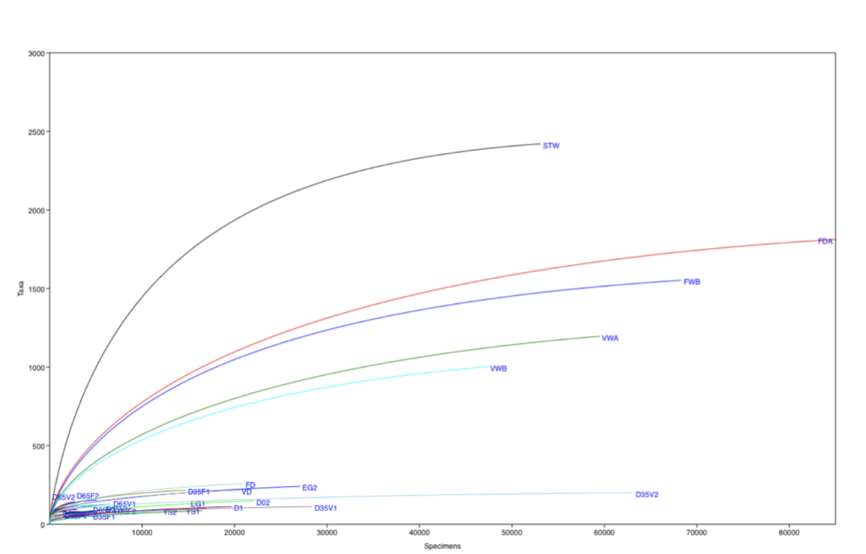

Figure S2: Rarefaction curves for the number of Taxa (OTUs) observed in all individual samples that analyzed in this study (water, diets and S. salar samples).
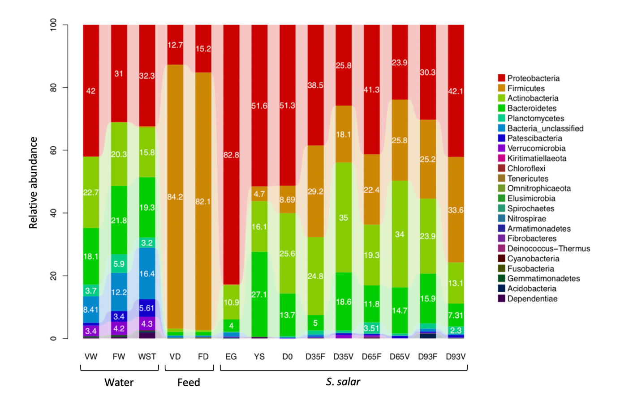
Figure S3: Relative abundance of bacterial phyla in all samples, grouped according to category. Life stages of S. salar (EG, YS, D0, D35F, D35V, D65F, D65V, D93F, D93V), rearing water (VW, FW, STW) and feed (VD, FD) samples.
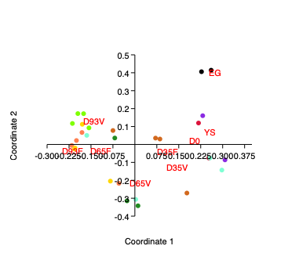
Figure S4. PCoA displays the bacterial communities of S. salar groups (EG, YS, D0, D35F, D35V, D65F, D65V, D93F, D93V) based on Bray-Curtis distance.

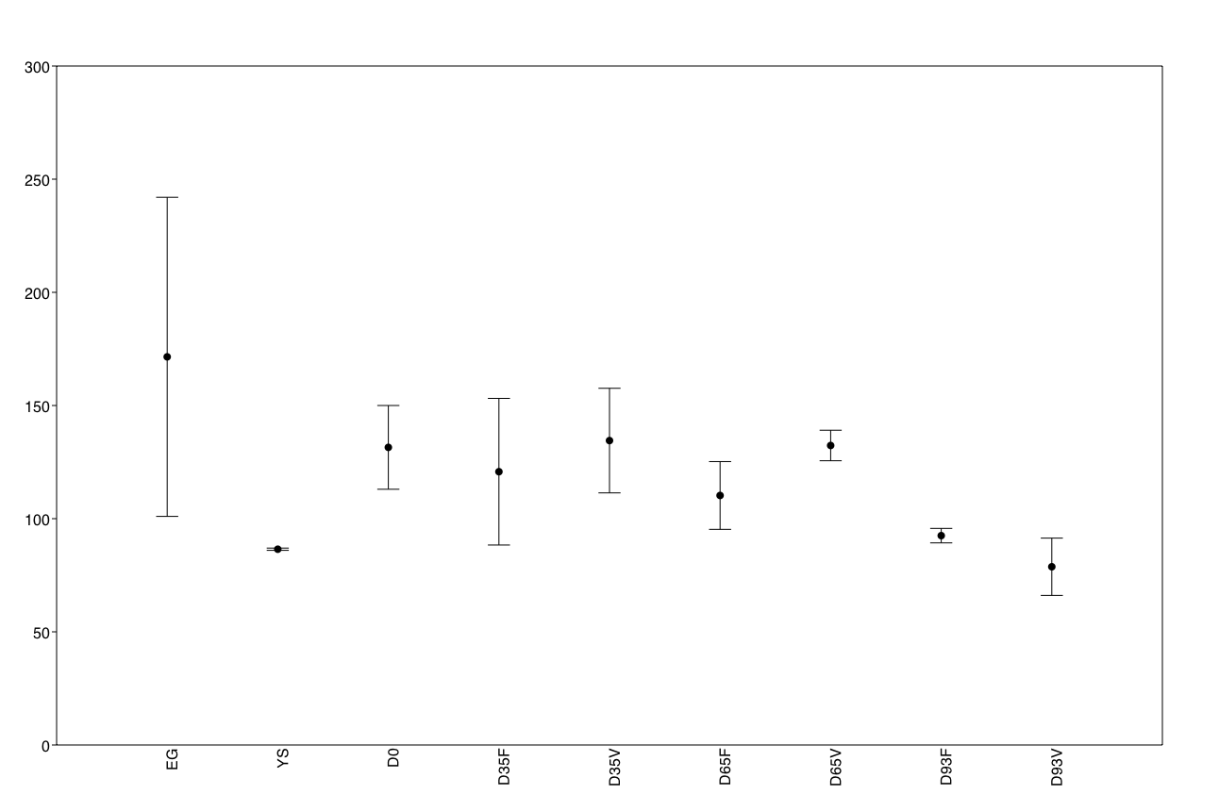

Figure S5: Box-plot of the bacterial operational taxonomic units found in S. salar samples (EG. YS. D0. D35F. D35V. D65F. D65V. D93F. D93V).
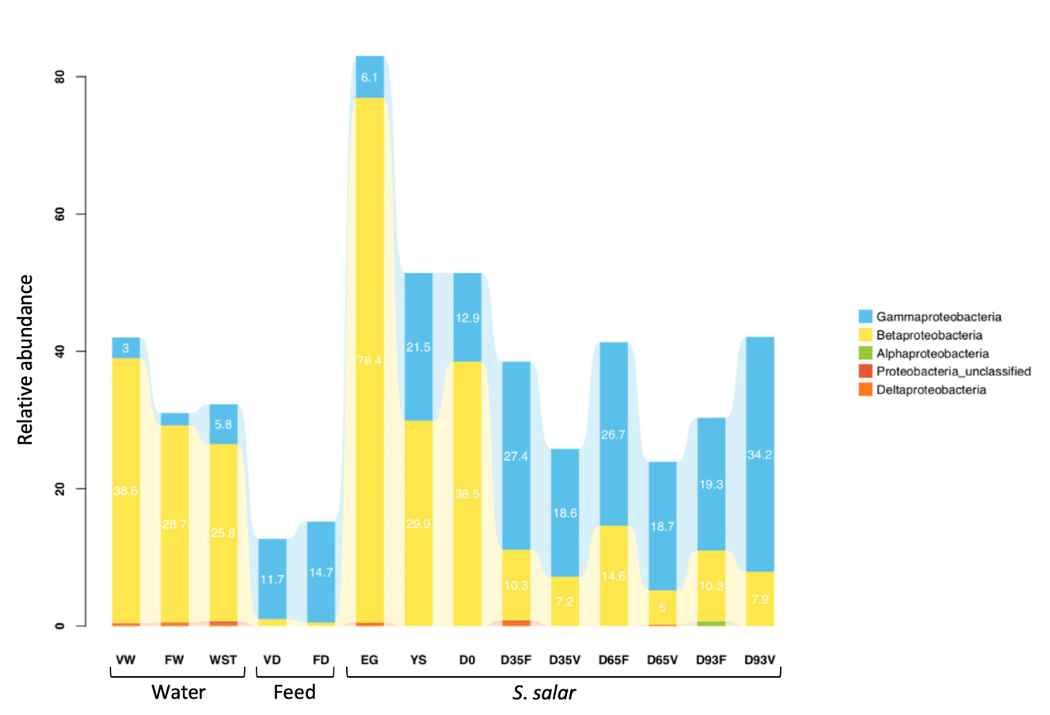
Figure S6: Relative abundance of Proteobacterial subphyla in all sample categories. Life stages of S. salar (EG, YS, D0, D35F, D35V, D65F, D65V, D93F, D93V), rearing water (VW, FW, STW) and feed (VD, FD) samples.

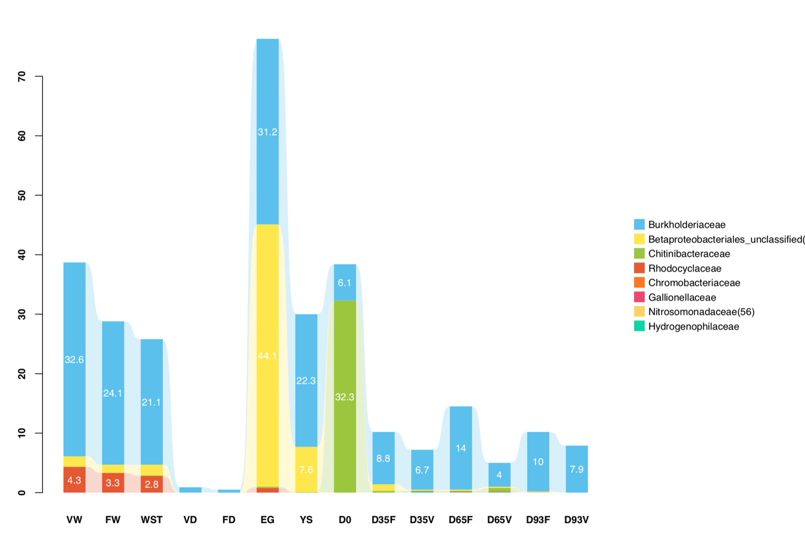

Figure S7: Relative abundance of β-proteobacterial families in all sample categories. S. salar (EG. YS. D0. D35F. D35V. D65F. D65V. D93F. D93V). rearing water (STW. FW. VW) and feed (FD. VD) samples.
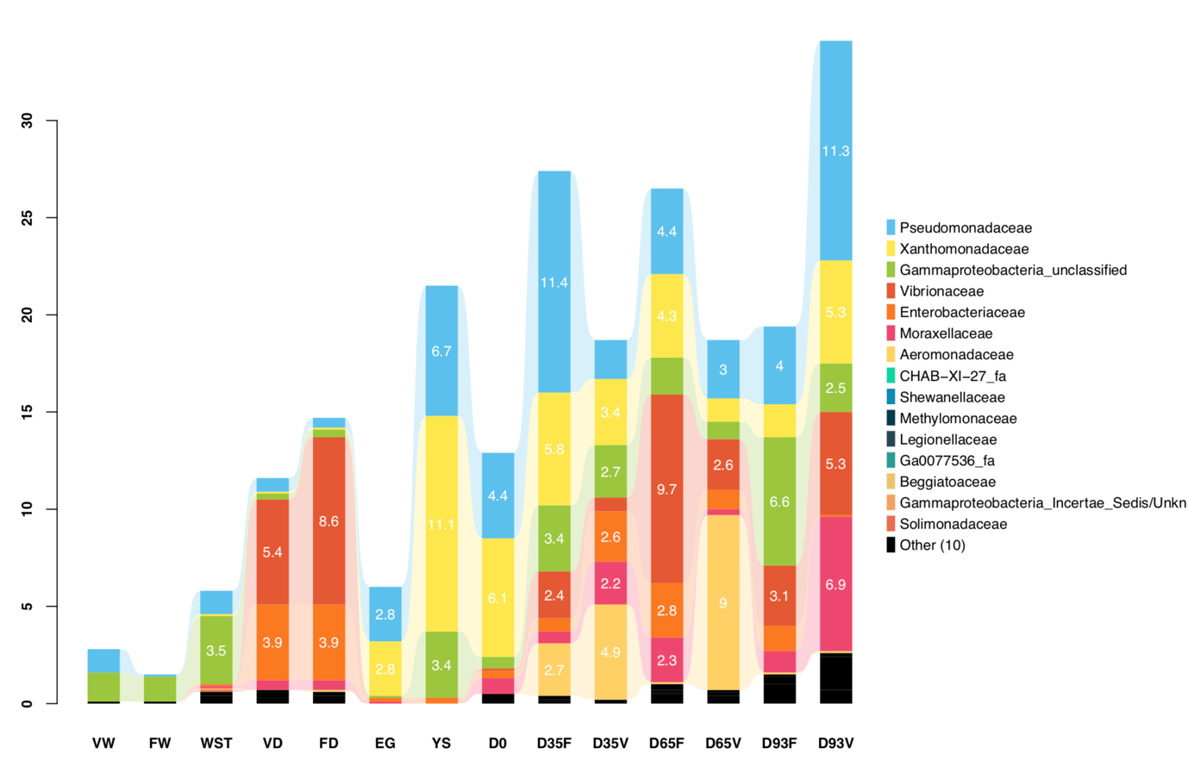
Figure S8: Relative abundance of γ-proteobacterial families in all sample categories. S. salar (EG, YS, D0, D35F, D35V, D65F, D65V, D93F, D93V), rearing water (STW, FW, VW) and feed (FD, VD) samples.

