Supplementary Appendix
Table S1. Full survey-weighted baseline characteristics of NHANES 2007–2018 participants by LE8 category
Panel A. Baseline characteristics including all comorbidity variables.
Characteristics | Total | Low (<50) | Moderate (50–79) | High (≥80) | P value
Participants, n (unweighted) | 18,071 | 1,120 | 12,375 | 4,576
Weighted population, n (in millions) | 165.85 | 7.86 | 108.49 | 49.49
Age, years, mean (SE) | 45.40 (0.30) | 48.69 (0.56) | 47.45 (0.30) | 40.37 (0.45) | <0.001
Age group, years, n (in millions), % |  |  |  |  | <0.001
20-39 | 97.93 (59.05) | 4.01 (50.95) | 58.43 (53.86) | 35.49 (71.71)
40-59 | 52.79 (31.83) | 3.46 (43.94) | 38.29 (35.30) | 11.05 (22.32)
≥60 | 15.12 (9.12) | 0.40 (5.11) | 11.77 (10.85) | 2.95 (5.97)
Sex, n (in millions), % |  |  |  |  | <0.001
Male | 86.05 (51.89) | 4.51 (57.40) | 61.77 (56.94) | 19.76 (39.93)
Female | 79.79 (48.11) | 3.35 (42.60) | 46.71 (43.06) | 29.73 (60.07)
Race / ethnicity, n (in millions), % |  |  |  |  | <0.001
Mexican American | 13.68 (8.25) | 0.54 (6.89) | 9.62 (8.87) | 3.52 (7.11)
Other Hispanic | 8.80 (5.31) | 0.45 (5.72) | 5.78 (5.33) | 2.57 (5.19)
Non-Hispanic White | 114.69 (69.16) | 4.60 (58.44) | 74.16 (68.36) | 35.94 (72.61)
Non-Hispanic Black | 16.05 (9.68) | 1.68 (21.37) | 11.55 (10.65) | 2.82 (5.69)
Other Race | 12.63 (7.61) | 0.60 (7.59) | 7.37 (6.80) | 4.65 (9.40)
Marital status, n (in millions), % |  |  |  |  | 0.091
Other (unmarried) | 61.23 (36.92) | 3.30 (41.97) | 39.61 (36.51) | 18.32 (37.01)
Married / living with partner | 104.62 (63.08) | 4.56 (58.03) | 68.88 (63.49) | 31.18 (62.99)
Education level, n (in millions), % |  |  |  |  | <0.001
Less than high school | 20.05 (12.09) | 1.81 (23.02) | 15.34 (14.14) | 2.91 (5.87)
High school or equivalent | 36.57 (22.05) | 2.72 (34.58) | 28.03 (25.84) | 5.82 (11.76)
Above high school | 109.22 (65.86) | 3.33 (42.40) | 65.12 (60.02) | 40.77 (82.37)
PIR, mean (SE) | 3.10 (0.04) | 2.21 (0.09) | 3.02 (0.04) | 3.43 (0.06) | <0.001
PIR category, n (in millions), % |  |  |  |  | <0.001
≤1.3 | 33.70 (20.32) | 3.03 (38.47) | 23.01 (21.21) | 7.66 (15.49)
1.3-3.5 | 56.35 (33.98) | 3.05 (38.84) | 38.73 (35.70) | 14.57 (29.44)
>3.5 | 75.79 (45.70) | 1.78 (22.68) | 46.74 (43.09) | 27.26 (55.08)
DI-GM score, mean (SE) | 3.73 (0.03) | 3.06 (0.07) | 3.49 (0.02) | 4.37 (0.04) | <0.001
DI-GM category, n (in millions), % |  |  |  |  | <0.001
DI-GM 0-3 | 74.32 (44.81) | 4.94 (62.79) | 55.12 (50.81) | 14.26 (28.80)
DI-GM 4 | 38.23 (23.05) | 1.77 (22.49) | 25.18 (23.21) | 11.29 (22.80)
DI-GM 5 | 29.61 (17.85) | 0.82 (10.47) | 17.28 (15.93) | 11.51 (23.25)
DI-GM ≥6 | 23.69 (14.28) | 0.33 (4.25) | 10.91 (10.05) | 12.45 (25.15)
PHQ-9 score, mean (SE) | 2.87 (0.05) | 5.41 (0.29) | 2.98 (0.06) | 2.23 (0.08) | <0.001
Depression status, n (in millions), % |  |  |  |  | <0.001
No depression (PHQ-9 0-9) | 154.20 (92.98) | 6.31 (80.25) | 100.30 (92.45) | 47.59 (96.16)
Depression (PHQ-9 ≥10) | 11.64 (7.02) | 1.55 (19.75) | 8.19 (7.55) | 1.90 (3.84)
Coronary heart disease, n (in millions), % |  |  |  |  | <0.001
No | 161.10 (97.14) | 7.55 (95.96) | 104.56 (96.38) | 48.99 (98.99)
Yes | 4.74 (2.86) | 0.32 (4.04) | 3.92 (3.62) | 0.50 (1.01)
Heart failure, n (in millions), % |  |  |  |  | <0.001
No | 163.27 (98.45) | 7.48 (95.09) | 106.49 (98.16) | 49.30 (99.61)
Yes | 2.58 (1.55) | 0.39 (4.91) | 1.99 (1.84) | 0.19 (0.39)
Diabetes status, n (in millions), % |  |  |  |  | <0.001
No | 150.53 (90.76) | 5.60 (71.15) | 96.18 (88.66) | 48.75 (98.50)
Borderline / prediabetes | 2.97 (1.79) | 0.19 (2.38) | 2.40 (2.21) | 0.38 (0.76)
Diabetes | 12.35 (7.45) | 2.08 (26.48) | 9.90 (9.13) | 0.37 (0.74)
GI disease, n (in millions), % |  |  |  |  | <0.001
No | 154.80 (93.34) | 6.81 (86.60) | 101.15 (93.24) | 46.84 (94.63)
Yes | 11.04 (6.66) | 1.05 (13.40) | 7.33 (6.76) | 2.66 (5.37)
Kidney disease, n (in millions), % |  |  |  |  | <0.001
No | 162.72 (98.12) | 7.68 (97.67) | 105.98 (97.69) | 49.06 (99.13)
Yes | 3.12 (1.88) | 0.18 (2.33) | 2.51 (2.31) | 0.43 (0.87)
Sleep problem, n (in millions), % |  |  |  |  | <0.001
No | 120.84 (72.86) | 4.16 (52.88) | 77.26 (71.22) | 39.42 (79.65)
Yes | 45.00 (27.14) | 3.71 (47.12) | 31.22 (28.78) | 10.07 (20.35)
Stroke, n (in millions), % |  |  |  |  | <0.001
No | 162.70 (98.10) | 7.46 (94.91) | 106.14 (97.83) | 49.10 (99.20)
Yes | 3.14 (1.90) | 0.40 (5.09) | 2.35 (2.17) | 0.39 (0.80)
Cancer, n (in millions), % |  |  |  |  | <0.001
No | 150.34 (90.65) | 7.27 (92.41) | 97.37 (89.75) | 45.70 (92.33)
Yes | 15.51 (9.35) | 0.60 (7.59) | 11.11 (10.25) | 3.80 (7.67)
Continuous variables: survey-weighted mean (SE); design-based Wald test. Categorical variables: weighted population size (millions) and weighted column % (in parentheses); Rao–Scott chi-square test. Percentages use non-missing observations. Design df = 94.
Abbreviations: DI-GM, Dietary Index for Gut Microbiota; LE8, Life’s Essential 8; PHQ-9, Patient Health Questionnaire-9; PIR, poverty-income ratio; SE, standard error.
Panel B. Pairwise comparisons between LE8 categories (raw and Bonferroni-corrected P values).
Characteristics | Low vs Moderate |  | Low vs High |  | Moderate vs High
Characteristics | Raw P | Bonf. P | Raw P | Bonf. P | Raw P | Bonf. P
Age, years | 0.034 | 0.101 | <0.001 | <0.001 | <0.001 | <0.001
Age group, years | <0.001 | <0.001 | <0.001 | <0.001 | <0.001 | <0.001
Sex | 0.854 | 1.000 | <0.001 | <0.001 | <0.001 | <0.001
Race / ethnicity | <0.001 | <0.001 | <0.001 | <0.001 | <0.001 | <0.001
Marital status | 0.025 | 0.074 | 0.051 | 0.154 | 0.675 | 1.000
Education level | <0.001 | <0.001 | <0.001 | <0.001 | <0.001 | <0.001
PIR | <0.001 | <0.001 | <0.001 | <0.001 | <0.001 | <0.001
PIR category | <0.001 | <0.001 | <0.001 | <0.001 | <0.001 | <0.001
DI-GM score | <0.001 | <0.001 | <0.001 | <0.001 | <0.001 | <0.001
DI-GM category | <0.001 | <0.001 | <0.001 | <0.001 | <0.001 | <0.001
PHQ-9 score | <0.001 | <0.001 | <0.001 | <0.001 | <0.001 | <0.001
Depression status | <0.001 | <0.001 | <0.001 | <0.001 | <0.001 | <0.001
Coronary heart disease | 0.567 | 1.000 | <0.001 | <0.001 | <0.001 | <0.001
Heart failure | <0.001 | <0.001 | <0.001 | <0.001 | <0.001 | <0.001
Diabetes status | <0.001 | <0.001 | <0.001 | <0.001 | <0.001 | <0.001
GI disease | <0.001 | <0.001 | <0.001 | <0.001 | 0.010 | 0.031
Kidney disease | 0.959 | 1.000 | 0.001 | 0.004 | <0.001 | <0.001
Sleep problem | <0.001 | <0.001 | <0.001 | <0.001 | <0.001 | <0.001
Stroke | <0.001 | <0.001 | <0.001 | <0.001 | <0.001 | <0.001
Cancer | 0.047 | 0.141 | 0.952 | 1.000 | 0.002 | 0.005
Each pair is tested on the two-group subset using the same design-based test as Panel A (Wald test for continuous variables; Rao–Scott chi-square for categorical variables). Bonferroni P = raw P × 3 (three pairwise comparisons), capped at 1.000. Design df = 94.
Table S2. Joint association of depression and DI-GM with LE8 cardiovascular health
Parameter | N | Estimate (95% CI) | P value
Primary outcome: LE8 category (ordinal logistic regression), OR (95% CI)
PHQ-9 score (main effect) | 18,071 | 0.93 (0.88, 0.97) | 0.003
DI-GM score (main effect) | 18,071 | 1.48 (1.42, 1.53) | <0.001
PHQ-9 × DI-GM (product term) | 18,071 | 1.00 (0.99, 1.01) | 0.514
No depression + favorable diet (reference) | 5,472 | Ref
No depression + unfavorable diet | 11,215 | 0.33 (0.30, 0.37) | <0.001
Depression + favorable diet | 359 | 0.44 (0.31, 0.64) | <0.001
Depression + unfavorable diet | 1,025 | 0.12 (0.09, 0.18) | <0.001
Multiplicative interaction (ratio of ORs = 1.18) | 18,071 | log-OR 0.169 (−0.293, 0.631) | 0.473
Supporting outcome: LE8 score (survey-weighted linear regression), β (95% CI)
PHQ-9 score (main effect) | 18,071 | −0.489 (−0.689, −0.290) | <0.001
DI-GM score (main effect) | 18,071 | 2.358 (2.162, 2.554) | <0.001
PHQ-9 × DI-GM (product term) | 18,071 | −0.021 (−0.066, 0.024) | 0.362
No depression + favorable diet (reference) | 5,472 | Ref
No depression + unfavorable diet | 11,215 | −6.865 (−7.417, −6.314) | <0.001
Depression + favorable diet | 359 | −5.613 (−7.030, −4.197) | <0.001
Depression + unfavorable diet | 1,025 | −12.934 (−14.271, −11.597) | <0.001
Multiplicative interaction (β for product term) | 18,071 | 0.455 (−1.398, 2.309) | 0.630
Depression = PHQ-9 ≥ 10; favorable diet = DI-GM ≥ 5 (unfavorable = DI-GM < 5). Main effects and product term are from a single model with the PHQ-9 × DI-GM interaction. The 2×2 joint model compares the four exposure combinations to the no-depression + favorable-diet reference. Multiplicative interaction P values test the product term. All models adjust for age, sex, race/ethnicity, marital status, education, and PIR and account for the NHANES complex survey design. Results are consistent with independent, cumulative (not synergistic) associations of depression and DI-GM with LE8.
Table S3. Tests of non-linearity from restricted cubic spline (RCS) models
Exposure | Outcome | Knots (10th/50th/90th pct) | Reference | P-overall | P-non-linear | Form
PHQ-9 score | LE8 score | 0, 1, 8 | 1 | <0.001 | <0.001 | Non-linear
PHQ-9 score | LE8 category | 0, 1, 8 | 1 | <0.001 | 0.008 | Non-linear
DI-GM score | LE8 score | 2, 4, 6 | 4 | <0.001 | 0.001 | Non-linear
DI-GM score | LE8 category | 2, 4, 6 | 4 | <0.001 | <0.001 | Non-linear
DI-GM beneficial sub-score | LE8 score | 0, 2, 3 | 2 | <0.001 | 0.410 | Linear
DI-GM beneficial sub-score | LE8 category | 0, 2, 3 | 2 | <0.001 | 0.925 | Linear
DI-GM unfavorable sub-score | LE8 score | 1, 2, 3 | 2 | <0.001 | 0.987 | Linear
DI-GM unfavorable sub-score | LE8 category | 1, 2, 3 | 2 | <0.001 | 0.275 | Linear
RCS models used three knots placed at the 10th, 50th and 90th percentiles of each exposure. P-overall tests the joint contribution of the spline terms (overall association); P-non-linear tests the non-linear spline term(s) alone. All models adjust for age, sex, race/ethnicity, marital status, education, and PIR and account for the NHANES complex survey design. For the primary exposures (PHQ-9 and DI-GM), the non-linear term reaches significance in this large sample, but the fitted curves remain overall monotonic with no clinically meaningful threshold (see Figure 2); the beneficial and unfavorable sub-scores are approximately linear.
Table S4. Counterfactual mediation of the depression–LE8 association by DI-GM across four exposure–outcome specifications (full sample)
Specification (exposure → outcome) | N | Effect scale | Path a: exposure → DI-GM, β (95% CI) | Total effect (TE) | Natural direct effect (PNDE) | Natural indirect effect (TNIE) | P | % mediated (95% CI)
PHQ-9 continuous → LE8 category (main) | 18,071 | Marginal cumulative OR | −0.0129 (−0.0220, −0.0033) | 0.924 (0.909, 0.939) | 0.928 (0.913, 0.943) | 0.9958 (0.9928, 0.9990) | 0.008 | 5.08 (1.35, 8.87)
PHQ-9 continuous → LE8 score | 18,071 | β (points) | −0.0129 (−0.0220, −0.0033) | −0.598 (−0.673, −0.527) | −0.568 (−0.638, −0.501) | −0.030 (−0.052, −0.008) | 0.009 | 5.04 (1.34, 8.55)
Depression (≥10) → LE8 category | 18,071 | Marginal cumulative OR | −0.1615 (−0.2736, −0.0456) | 0.414 (0.318, 0.529) | 0.436 (0.334, 0.561) | 0.9509 (0.9143, 0.9845) | 0.013 | 3.66 (0.94, 7.74)
Depression (≥10) → LE8 score | 18,071 | β (points) | −0.1615 (−0.2736, −0.0456) | −6.355 (−7.520, −5.260) | −6.013 (−7.114, −4.977) | −0.342 (−0.642, −0.104) | 0.012 | 5.38 (1.57, 9.67)
Mediator = DI-GM score. Effects were identified by g-computation within the counterfactual (potential-outcomes) framework, with a survey-weighted linear mediator model, a survey-weighted cumulative logit (LE8 category) or linear (LE8 score) outcome model including an exposure-by-mediator interaction, the mediator distribution represented by the weighted empirical residual distribution, and standardisation over the covariate distribution of the analytic sample. For ordinal outcomes the effects are marginal cumulative odds ratios and the decomposition is exact (OR_TE = OR_PNDE × OR_TNIE); for continuous outcomes they are on the natural (β) scale with TE = PNDE + TNIE. 95% CIs are percentile intervals from 500 Rao–Wu rescaled bootstrap replicates preserving the NHANES strata and primary sampling units; P values are design-based (df = 94). The Sobel (delta) method was not used. All models adjust for age, sex, race/ethnicity, marital status, education and PIR. Across specifications the indirect effect is consistent in direction and statistically significant, and the % mediated ranges from 3.66% to 5.38%. Effects for ordinal outcomes are marginal and therefore differ numerically from the conditional odds ratios in Table 2 of the main text, as expected given the non-collapsibility of the odds ratio. Cut-point-specific marginal odds ratios, effects on the probability scale, tests of exposure-by-mediator interaction and a comparison with the traditional product-of-coefficients approach are given in Tables S4.1–S4.3.
Table S4.1. Cut-point-specific marginal odds ratios and effects on the probability scale (LE8 category outcome)
Contrast | TE | PNDE | TNIE | P | % mediated
PHQ-9 continuous
Cut point 1: moderate or high vs low | 0.918 (0.897, 0.938) | 0.922 (0.902, 0.942) | 0.9953 (0.9920, 0.9988) | 0.008 | 5.22
Cut point 2: high vs low or moderate | 0.925 (0.911, 0.939) | 0.929 (0.914, 0.943) | 0.9959 (0.9930, 0.9990) | 0.008 | 5.05
P(high LE8), percentage points | −1.732 (−2.101, −1.373) | −1.642 (−2.010, −1.300) | −0.090 (−0.156, −0.022) | 0.009 | 5.18
Depression (≥10)
Cut point 1: moderate or high vs low | 0.404 (0.301, 0.541) | 0.425 (0.314, 0.562) | 0.9505 (0.9128, 0.9844) | 0.014 | 3.54
Cut point 2: high vs low or moderate | 0.418 (0.320, 0.536) | 0.440 (0.336, 0.572) | 0.9511 (0.9148, 0.9845) | 0.013 | 3.69
P(high LE8), percentage points | −15.172 (−18.421, −11.690) | −14.495 (−17.797, −10.619) | −0.678 (−1.266, −0.188) | 0.020 | 4.47
Odds ratios are marginal. The risk-difference rows give the corresponding decomposition on the probability scale, on which TE = PNDE + TNIE holds exactly. Estimation and inference as in Table S4.
Table S4.2. Model components: mediator and outcome paths and test of exposure-by-mediator interaction
Specification | Path a: exposure → DI-GM, β (95% CI) | Path b: DI-GM → outcome (95% CI) | Exposure × mediator interaction (95% CI)
PHQ-9 continuous → LE8 category (main) | −0.0129 (−0.0220, −0.0033); P = 0.007 | 1.478 (1.429, 1.538) | −0.0035 (−0.0144, 0.0069); P = 0.517
PHQ-9 continuous → LE8 score | −0.0129 (−0.0220, −0.0033); P = 0.007 | 2.358 (2.181, 2.549) | −0.0209 (−0.0661, 0.0220); P = 0.359
Depression (≥10) → LE8 category | −0.1615 (−0.2736, −0.0456); P = 0.007 | 1.466 (1.426, 1.514) | −0.0289 (−0.2092, 0.1296); P = 0.752
Depression (≥10) → LE8 score | −0.1615 (−0.2736, −0.0456); P = 0.007 | 2.331 (2.181, 2.484) | −0.2139 (−0.9274, 0.3989); P = 0.549
Path b is taken from the outcome model that includes the exposure-by-mediator interaction and is shown as an odds ratio for ordinal outcomes and as β for continuous outcomes. The interaction was not statistically significant in any specification, so the pure and total natural indirect effects were nearly identical.
Table S4.3. Concordance between the counterfactual estimates and the traditional product-of-coefficients approach
Specification | c | c′ | a × b | Sobel P | % med. | TE | PNDE | % mediated (95% CI)
PHQ-9 continuous → LE8 category (main) | OR 0.91 | OR 0.91 | −0.005 | 0.006 | 5.5 | OR 0.924 | OR 0.928 | 5.08 (1.35, 8.87)
PHQ-9 continuous → LE8 score | β −0.594 | −0.564 | −0.030 | 0.006 | 5.0 | β −0.598 | β −0.568 | 5.04 (1.34, 8.55)
Depression (≥10) → LE8 category | OR 0.39 | OR 0.39 | −0.061 | 0.007 | 6.4 | OR 0.414 | OR 0.436 | 3.66 (0.94, 7.74)
Depression (≥10) → LE8 score | β −6.332 | −5.958 | −0.374 | 0.007 | 5.9 | β −6.355 | β −6.013 | 5.38 (1.57, 9.67)
Columns 2–6 are the traditional product-of-coefficients results reported in the previous version; columns 7–9 are the counterfactual results. The two approaches agreed closely (for example, 5.52% versus 5.08% in the main specification). By contrast, the difference method gave an indirect effect of the opposite sign (c − c′ = +0.00018 versus a × b = −0.00492 on the log-odds scale), reflecting rescaling of coefficients and the non-collapsibility of the odds ratio when a strong mediator is added to a logit model; this motivated the use of the counterfactual framework for the primary analysis. In the traditional analysis the indirect effect was tested by the Sobel (delta) method, whose confidence intervals are analytical and were not obtained by bootstrap resampling.
Table S5. Sensitivity analysis: counterfactual mediation re-estimated with LE8 recomputed without the diet component
Panel A. Path b (DI-GM → LE8, from the outcome model including the exposure-by-mediator interaction), full LE8 vs. LE8 excluding the diet component.
Outcome scale | Full LE8 (8 components) | LE8 excluding diet (7 components)
LE8 category (ordinal), OR | 1.478 (1.429, 1.538) | 1.191 (1.151, 1.240)
LE8 score (linear), β | 2.358 (2.181, 2.549) | 1.095 (0.908, 1.313)

Panel B. Full counterfactual mediation (main specification: PHQ-9 continuous → DI-GM → LE8 category), full LE8 vs. LE8 excluding the diet component.
LE8 definition | TE, OR | PNDE, OR | TNIE, OR | P | % mediated, LE8 category | % mediated, LE8 score
Full LE8 (8 components) | 0.924 (0.909, 0.939) | 0.928 (0.913, 0.943) | 0.9958 (0.9928, 0.9990) | 0.008 | 5.08 (1.35, 8.87) | 5.04 (1.34, 8.55)
LE8 excluding diet (7 components) | 0.933 (0.921, 0.944) | 0.935 (0.923, 0.946) | 0.9981 (0.9967, 0.9995) | 0.012 | 2.65 (0.73, 4.88) | 2.31 (0.64, 4.05)
DI-GM and the LE8 diet component partly overlap, which may inflate path b (DI-GM → LE8). To probe this, LE8 was recomputed as the unweighted mean of the seven non-diet components (physical activity, nicotine exposure, sleep, BMI, blood lipids, blood glucose, blood pressure), and the low/moderate/high categories were re-derived with the same <50 / 50–79 / ≥80 thresholds (full LE8 vs diet-excluded LE8 correlation r = 0.95). Path a (PHQ-9 → DI-GM) is unchanged because it does not involve LE8. Removing the overlapping diet component attenuates path b (ordinal OR 1.478 to 1.191) and the mediated proportion (5.08% to 2.65%), but the natural indirect effect remains statistically significant (P = 0.012), indicating that the mediation is not solely an artefact of the shared diet component. The exposure-by-mediator interaction remained non-significant (P = 0.474). Estimation and inference as in Table S4.

Table S6. Subgroup counterfactual mediation of the depression–LE8 association by DI-GM (main specification)
Main specification: PHQ-9 continuous → DI-GM → LE8 category.
Subgroup | N | Path a: exposure → DI-GM, β (95% CI) | P | TE, OR (95% CI) | PNDE, OR (95% CI) | TNIE, OR (95% CI) | P | % med.
Full sample
Overall | 18,071 | −0.0129 (−0.0216, −0.0032) | 0.006 | 0.924 (0.908, 0.939) | 0.928 (0.912, 0.942) | 0.9958 (0.9930, 0.9990) | 0.007 | 5.1
Age group
20–39 | 9,999 | −0.0057 (−0.0169, 0.0054) | 0.344 | 0.933 (0.912, 0.952) | 0.934 (0.916, 0.953) | 0.9982 (0.9945, 1.0018) | 0.352 | 2.5
40–59 | 5,804 | −0.0244 (−0.0402, −0.0089) | 0.006 | 0.916 (0.887, 0.938) | 0.924 (0.897, 0.944) | 0.9909 (0.9843, 0.9970) | 0.009 | 10.0
≥60 | 2,268 | −0.0323 (−0.0694, 0.0022) | 0.084 | 0.930 (0.880, 0.979) | 0.941 (0.901, 0.982) | 0.9885 (0.9747, 1.0007) | 0.089 | 15.4
Sex
Male | 9,505 | −0.0055 (−0.0195, 0.0091) | 0.446 | 0.934 (0.906, 0.959) | 0.936 (0.910, 0.959) | 0.9980 (0.9926, 1.0033) | 0.450 | 2.9
Female | 8,566 | −0.0186 (−0.0299, −0.0063) | 0.003 | 0.917 (0.901, 0.933) | 0.922 (0.906, 0.937) | 0.9946 (0.9912, 0.9982) | 0.004 | 6.0
Race/ethnicity
Mexican American | 2,524 | 0.0206 (0.0004, 0.0387) | 0.053 | 0.964 (0.932, 0.993) | 0.958 (0.927, 0.984) | 1.0067 (1.0001, 1.0142) | 0.072 | −17.9
Other Hispanic | 1,721 | −0.0213 (−0.0437, 0.0055) | 0.097 | 0.915 (0.890, 0.936) | 0.921 (0.895, 0.941) | 0.9938 (0.9869, 1.0013) | 0.100 | 6.7
Non–Hispanic White | 8,203 | −0.0139 (−0.0264, −0.0006) | 0.031 | 0.922 (0.901, 0.943) | 0.926 (0.906, 0.948) | 0.9954 (0.9912, 0.9998) | 0.033 | 5.4
Non–Hispanic Black | 3,567 | −0.0178 (−0.0338, 0.0008) | 0.056 | 0.932 (0.909, 0.953) | 0.936 (0.913, 0.954) | 0.9954 (0.9900, 1.0002) | 0.076 | 6.3
Other Race | 2,056 | −0.0168 (−0.0401, 0.0032) | 0.136 | 0.914 (0.869, 0.952) | 0.920 (0.877, 0.955) | 0.9944 (0.9869, 1.0009) | 0.139 | 6.0
Marital status
Unmarried | 7,142 | −0.0068 (−0.0204, 0.0027) | 0.265 | 0.922 (0.899, 0.938) | 0.924 (0.902, 0.942) | 0.9979 (0.9940, 1.0008) | 0.274 | 2.4
Married/partnered | 10,929 | −0.0184 (−0.0300, −0.0059) | 0.005 | 0.927 (0.906, 0.952) | 0.933 (0.911, 0.958) | 0.9938 (0.9896, 0.9980) | 0.006 | 8.0
Education
Less than high school | 3,461 | −0.0135 (−0.0310, 0.0039) | 0.147 | 0.935 (0.914, 0.957) | 0.938 (0.916, 0.960) | 0.9965 (0.9908, 1.0007) | 0.191 | 5.0
High school | 4,077 | 0.0087 (−0.0087, 0.0221) | 0.295 | 0.911 (0.882, 0.939) | 0.908 (0.878, 0.938) | 1.0025 (0.9975, 1.0070) | 0.300 | −2.6
Above high school | 10,533 | −0.0225 (−0.0336, −0.0107) | <0.001 | 0.922 (0.897, 0.945) | 0.930 (0.905, 0.950) | 0.9921 (0.9881, 0.9963) | <0.001 | 9.4
PIR category
≤1.3 | 5,293 | −0.0018 (−0.0113, 0.0077) | 0.741 | 0.939 (0.922, 0.955) | 0.940 (0.922, 0.955) | 0.9995 (0.9972, 1.0020) | 0.738 | 0.7
1.3–3.5 | 6,720 | −0.0082 (−0.0223, 0.0059) | 0.279 | 0.913 (0.891, 0.936) | 0.916 (0.894, 0.938) | 0.9975 (0.9928, 1.0019) | 0.287 | 2.7
>3.5 | 6,058 | −0.0340 (−0.0527, −0.0126) | 0.004 | 0.925 (0.895, 0.950) | 0.936 (0.909, 0.959) | 0.9879 (0.9809, 0.9953) | 0.004 | 15.0
Diabetes status
No diabetes | 15,750 | −0.0116 (−0.0210, −0.0006) | 0.026 | 0.928 (0.910, 0.944) | 0.931 (0.914, 0.947) | 0.9963 (0.9928, 0.9998) | 0.030 | 4.8
Borderline | 422 | −0.0159 (−0.0572, 0.0276) | 0.473 | 0.876 (0.817, 0.944) | 0.880 (0.821, 0.949) | 0.9952 (0.9821, 1.0088) | 0.474 | 3.4
Diabetes | 1,899 | −0.0109 (−0.0399, 0.0118) | 0.424 | 0.929 (0.888, 0.964) | 0.932 (0.894, 0.966) | 0.9965 (0.9858, 1.0037) | 0.444 | 4.6
GI disease
No | 16,795 | −0.0079 (−0.0161, 0.0019) | 0.099 | 0.930 (0.911, 0.946) | 0.932 (0.915, 0.948) | 0.9974 (0.9947, 1.0006) | 0.105 | 3.4
Yes | 1,276 | −0.0534 (−0.0780, −0.0284) | <0.001 | 0.901 (0.865, 0.938) | 0.915 (0.879, 0.951) | 0.9847 (0.9760, 0.9930) | <0.001 | 14.2
Kidney disease
No | 17,632 | −0.0133 (−0.0219, −0.0033) | 0.005 | 0.923 (0.907, 0.936) | 0.927 (0.913, 0.939) | 0.9957 (0.9929, 0.9989) | 0.006 | 5.1
Yes | 439 | 0.0147 (−0.0401, 0.0774) | 0.627 | 1.006 (0.879, 1.067) | 1.001 (0.879, 1.060) | 1.0044 (0.9866, 1.0211) | 0.592 | 77.3
Sleep problem
No | 13,470 | −0.0094 (−0.0242, 0.0033) | 0.186 | 0.933 (0.916, 0.950) | 0.936 (0.920, 0.953) | 0.9969 (0.9916, 1.0011) | 0.191 | 4.4
Yes | 4,601 | −0.0137 (−0.0278, 0.0004) | 0.049 | 0.948 (0.926, 0.969) | 0.952 (0.929, 0.972) | 0.9959 (0.9917, 1.0001) | 0.062 | 7.5
Stroke
No | 17,604 | −0.0122 (−0.0206, −0.0022) | 0.012 | 0.925 (0.908, 0.939) | 0.928 (0.913, 0.942) | 0.9961 (0.9932, 0.9993) | 0.014 | 4.9
Yes | 467 | −0.0209 (−0.0601, 0.0250) | 0.332 | 0.934 (0.885, 1.010) | 0.940 (0.897, 1.010) | 0.9934 (0.9755, 1.0058) | 0.431 | 9.3
Cancer
No | 16,488 | −0.0120 (−0.0216, −0.0021) | 0.017 | 0.926 (0.910, 0.942) | 0.929 (0.914, 0.944) | 0.9962 (0.9928, 0.9993) | 0.018 | 4.8
Yes | 1,583 | −0.0209 (−0.0456, 0.0107) | 0.137 | 0.920 (0.879, 0.964) | 0.927 (0.885, 0.971) | 0.9926 (0.9826, 1.0036) | 0.156 | 8.6
Exploratory: Sex x GI disease
Male | No | 8,949 | −0.0023 (−0.0185, 0.0128) | 0.766 | 0.943 (0.914, 0.969) | 0.944 (0.918, 0.967) | 0.9991 (0.9923, 1.0047) | 0.768 | 1.5
Male | Yes | 556 | −0.0374 (−0.0897, 0.0070) | 0.147 | 0.878 (0.800, 0.956) | 0.885 (0.804, 0.970) | 0.9924 (0.9774, 1.0015) | 0.262 | 5.6
Female | No | 7,846 | −0.0125 (−0.0244, 0.0004) | 0.053 | 0.919 (0.900, 0.936) | 0.923 (0.902, 0.940) | 0.9964 (0.9931, 1.0001) | 0.056 | 4.1
Female | Yes | 720 | −0.0609 (−0.0875, −0.0229) | <0.001 | 0.906 (0.868, 0.947) | 0.929 (0.893, 0.959) | 0.9761 (0.9602, 0.9900) | 0.004 | 23.8

Each subgroup was analysed separately by domain estimation; in single-variable strata the model adjusts for the remaining covariates (age, sex, race/ethnicity, marital status, education, PIR) but not the stratifying variable. Effects are counterfactual quantities estimated by g-computation and expressed as marginal cumulative odds ratios; 95% CIs are percentile intervals from 200 Rao–Wu rescaled bootstrap replicates accounting for the NHANES complex survey design. Statistical significance differing between subgroups does not by itself imply a difference in the underlying effect, and no formal interaction test across subgroups was performed; the exploratory Sex × GI-disease cells (n small) are hypothesis-generating only. GI = gastrointestinal.
Table S7. Design-based assessment of the proportional-odds assumption for the LE8 category models
Panel A. Global test and its partition into exposure and covariate components.
Component | df | Wald χ² | P | Design-based F | P
M1: PHQ-9 (per 1 point)
All model terms (global test) | 11 | 152.2 | <0.001 | 12.37 | <0.001
Exposure of interest only | 1 | 3.4 | 0.065 | 3.40 | 0.068
All covariates only | 10 | 126.0 | <0.001 | 11.40 | <0.001
Age, sex, race/ethnicity | 6 | 62.8 | <0.001 | 9.91 | <0.001
Marital status, education, PIR | 4 | 12.4 | 0.015 | 3.00 | 0.023
M2: Depression (≥ 10 vs < 10)
All model terms (global test) | 11 | 155.0 | <0.001 | 12.59 | <0.001
M3: DI-GM (per 1 point)
All model terms (global test) | 11 | 185.2 | <0.001 | 15.04 | <0.001
Exposure of interest only | 1 | 22.8 | <0.001 | 22.78 | <0.001
All covariates only | 10 | 179.5 | <0.001 | 16.23 | <0.001
Age, sex, race/ethnicity | 6 | 88.6 | <0.001 | 13.97 | <0.001
Marital status, education, PIR | 4 | 15.2 | 0.004 | 3.68 | 0.008
M4: DI-GM categories
All model terms (global test) | 13 | 197.0 | <0.001 | 13.22 | <0.001
M5: PHQ-9 + DI-GM (outcome model)
All model terms (global test) | 12 | 184.6 | <0.001 | 13.58 | <0.001
M1 and M3 are the models for which the partitioned tests were computed; the global test is reported for all five models.
Panel B. Cut-point-specific odds ratios for the exposures of interest.
Term | Cut point 1: moderate or high vs low, OR (95% CI) | Cut point 2: high vs low or moderate, OR (95% CI) | Pooled cumulative OR | Difference in log-OR | SE | P
M1: PHQ-9 (per 1 point)
PHQ-9 score (per 1 point) | 0.91 (0.89, 0.92) | 0.92 (0.90, 0.94) | 0.91 | −0.0203 | 0.0110 | 0.068
M2: Depression (≥ 10 vs < 10)
Depression (PHQ-9 ≥ 10 vs < 10) | 0.35 (0.26, 0.46) | 0.45 (0.33, 0.60) | 0.39 | −0.2477 | 0.1540 | 0.111
M3: DI-GM (per 1 point)
DI-GM score (per 1 point) | 1.29 (1.21, 1.38) | 1.52 (1.47, 1.57) | 1.46 | −0.1630 | 0.0341 | <0.001
M4: DI-GM categories
DI-GM 4 (vs 0–3) | 1.39 (1.02, 1.90) | 1.96 (1.69, 2.28) | 1.81 | −0.3460 | 0.1620 | 0.035
DI-GM 5 (vs 0–3) | 2.34 (1.75, 3.14) | 3.16 (2.70, 3.70) | 2.92 | −0.2982 | 0.1764 | 0.094
DI-GM ≥ 6 (vs 0–3) | 4.33 (2.41, 7.77) | 5.99 (5.19, 6.91) | 5.40 | −0.3240 | 0.3030 | 0.288
M5: PHQ-9 + DI-GM (outcome model)
PHQ-9 score (per 1 point) | 0.91 (0.89, 0.92) | 0.93 (0.91, 0.95) | 0.91 | −0.0231 | 0.0112 | 0.041
DI-GM score (per 1 point) | 1.29 (1.22, 1.38) | 1.52 (1.47, 1.57) | 1.46 | −0.1590 | 0.0339 | <0.001
At each cumulative cut point of the LE8 category a separate survey-weighted binary logistic model was fitted with the same covariates, and equality of the coefficient vectors was tested. The covariance matrix of the between-cut-point difference was estimated from 500 Rao–Wu rescaled bootstrap replicates preserving the NHANES strata and primary sampling units; the design-based Wald statistic was referred to an F distribution with the survey design degrees of freedom (df = 94). The Brant test was not used because it does not accommodate survey weights or a stratified multistage design. The global test was rejected in all models, but the departure was driven almost entirely by the covariates; the assumption was not violated for the primary exposure (PHQ-9, P = 0.065; depression, P = 0.111), whereas it was violated for DI-GM (P < 0.001), for which the association was stronger at cut point 2 than at cut point 1 while remaining identical in direction with a monotonic gradient at both cut points.

Figure S1. Forest plot of subgroup natural indirect effects (main specification)
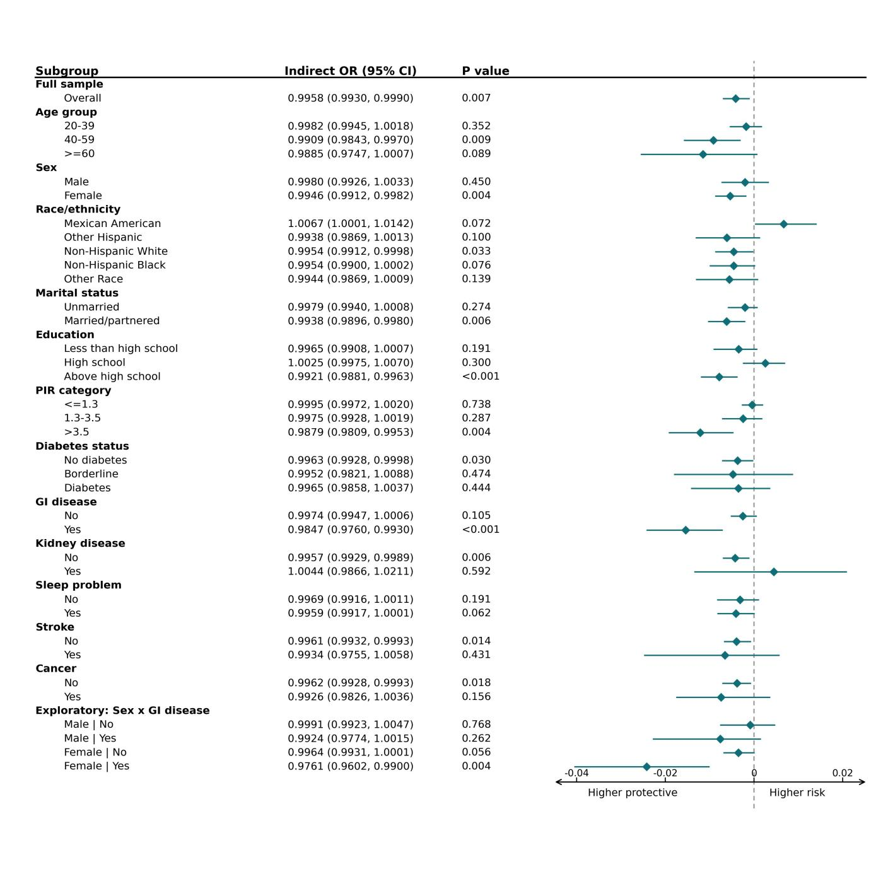
Subgroup natural indirect effects of depression on LE8 cardiovascular health through DI-GM, main specification (PHQ-9 continuous → DI-GM → LE8 category). Markers are the natural indirect effects expressed as marginal cumulative odds ratios; horizontal lines are 95% CIs and the horizontal axis is on the log-odds-ratio scale. Each subgroup model was estimated by domain estimation within the counterfactual framework using g-computation, adjusts for age, sex, race/ethnicity, marital status, education and PIR (excluding the stratifying variable), and accounts for the NHANES complex survey design; 95% CIs are percentile intervals from 200 Rao–Wu rescaled bootstrap replicates. Corresponds to Table S6.
Figure S2. Forest plots of subgroup natural indirect effects for the three alternative exposure–outcome specifications
(A) PHQ-9 continuous → LE8 score
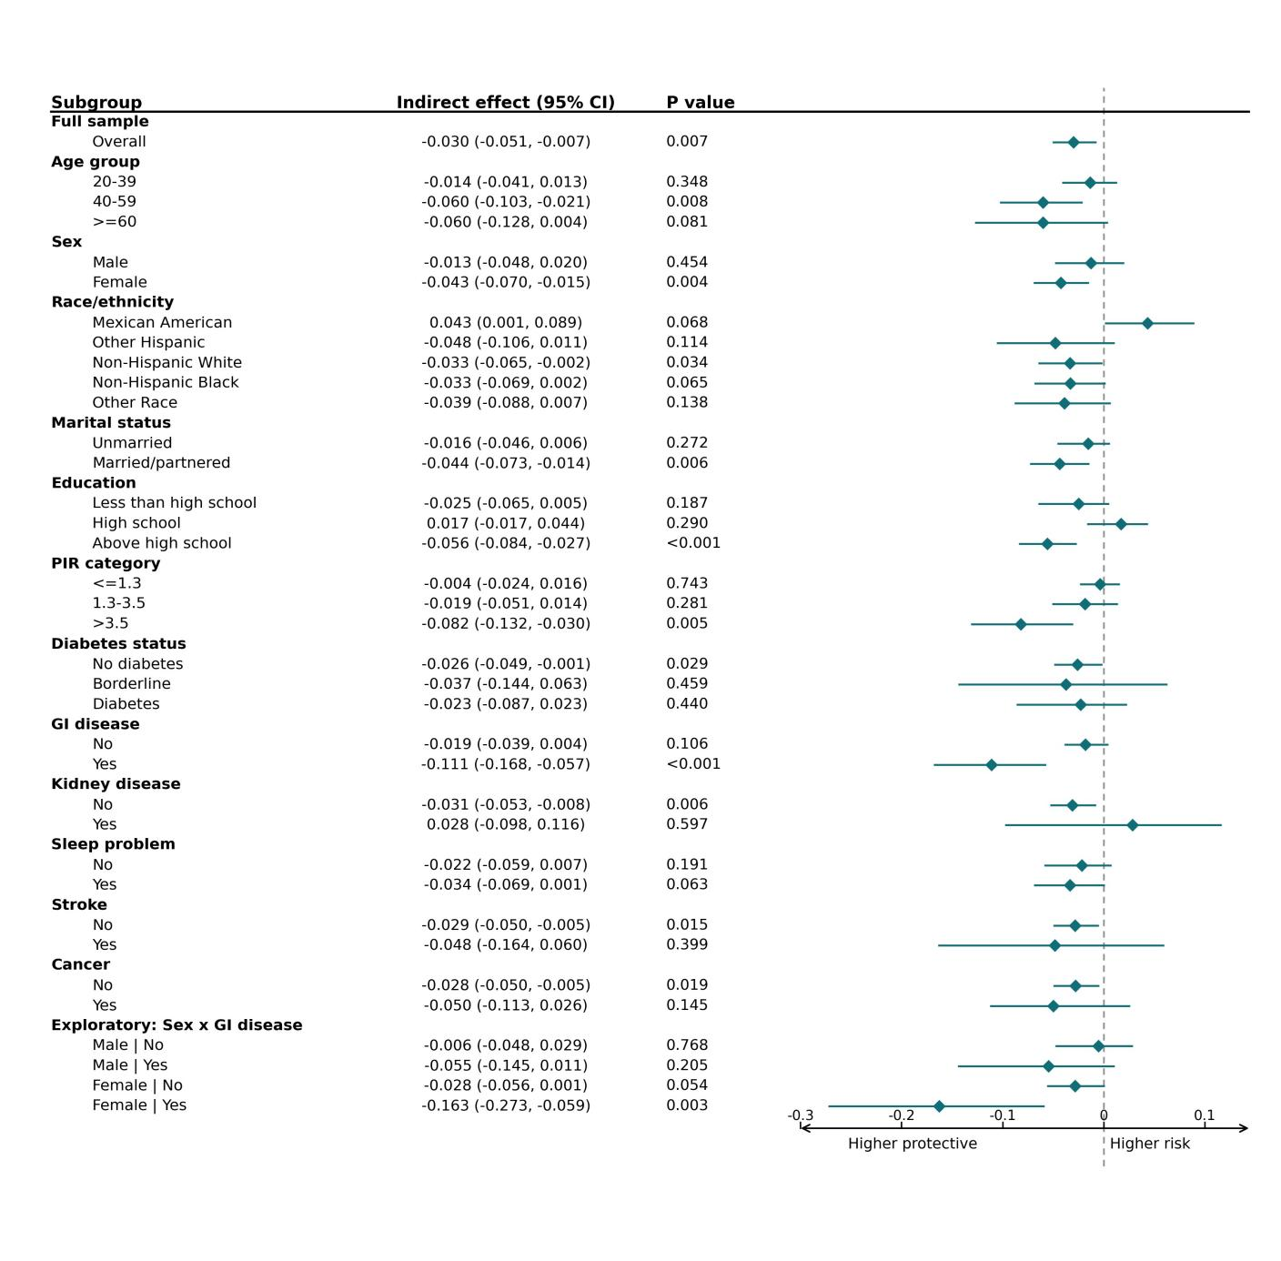
(B) Depression (≥10) → LE8 score
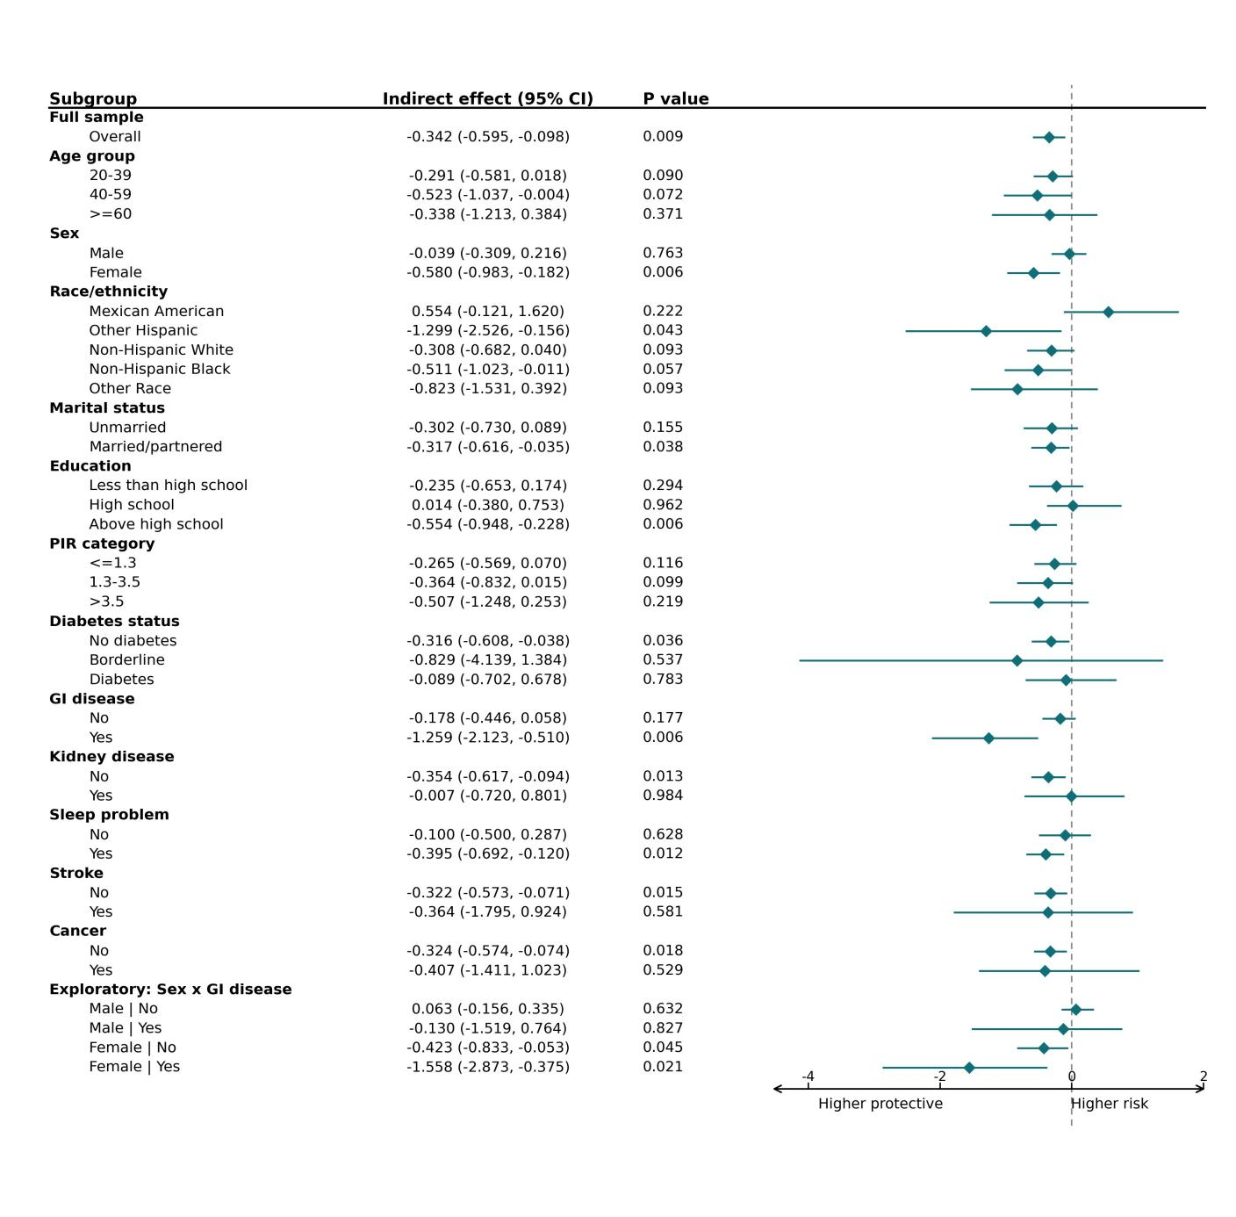
(C) Depression (≥10) → LE8 category
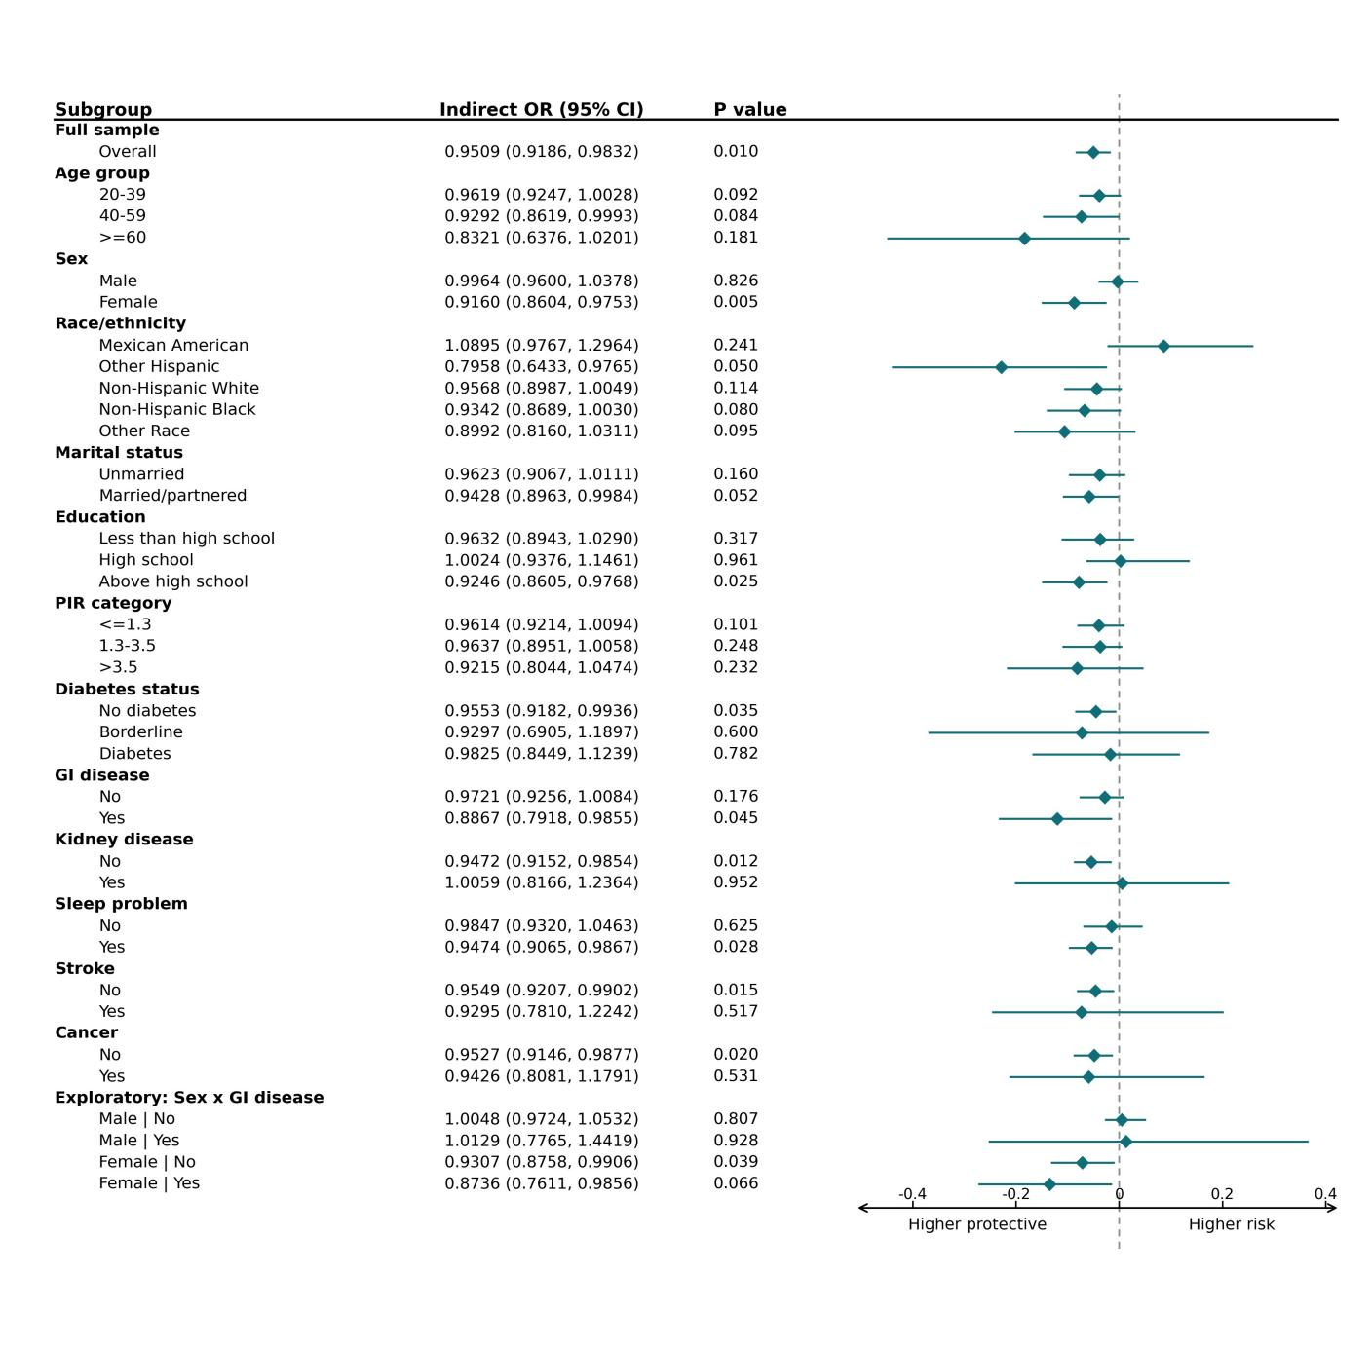
Subgroup natural indirect effects across the three alternative specifications that, together with the main specification (Figure S1), constitute the four exposure–outcome combinations. Panels A and B show indirect effects on the natural (β) scale; panel C shows marginal cumulative odds ratios, with the horizontal axis on the log-odds-ratio scale. Methods, adjustment and bootstrap procedure are as in Figure S1.

