Supplementary Materials

Section S1. WR3D System Configuration and Imaging Protocol
Figure S1 presents a schematic of the Weight-bearing Radiology 3D (WR3D) device ([Anonymized Company]). The device mainly consists of a rotating patient platform, an X-ray tube, and a flat-panel detector (FPD). The system acquires multi-angle fluoroscopic projections during platform rotation, which are subsequently reconstructed into a 3D image. A segmental scanning technique is employed for the spine, where the X-ray tube and detector translate vertically to cover the entire spinal axis.
During imaging, patients stand on a rotating platform with their arms raised overhead, grasping an upper support ring. This posture minimizes the occlusion of spinal structures by the upper extremities and ensures stability during rotation. To prevent falls and reduce motion artifacts, patients were secured to the platform with immobilization straps. The typical scan range extends from the cranial vertex to below the femoral heads.
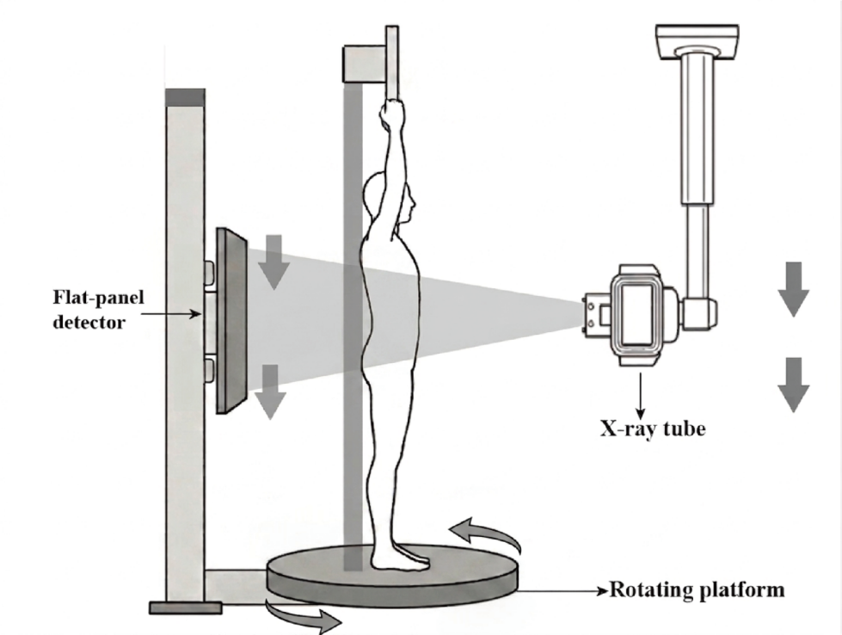
Fig. S1 Schematic of the Weight-bearing Radiology 3D (WR3D) system and patient positioning. The system has an X-ray tube and a flat-panel detector, and a motorized standing platform in between that rotates the scanned patient.

Section S2. Radiographic Measurement Protocols

2.1 Coronal Plane Parameters
Coronal parameters were measured as follows (see Figure S2 for schematic illustration) [1]:
(1) Coronal Cobb Angles:
- Proximal Thoracic curve (PTC): The curve cephalad to the main thoracic curve.
- Main Thoracic Curve (MTC): Defined as the curve with its apex between T2 and the T11–T12 intervertebral disc.
- Thoracolumbar/Lumbar curve (TLC): Subdivided into thoracolumbar curves (apex at T12–L1) and lumbar curves (apex from L1–L2 disc to L5).
For each curve, the upper end vertebra (UEV) and lower end vertebra (LEV) were identified as the most tilted vertebrae at the cranial and caudal ends of the curve, respectively. The Cobb angle was measured between a line parallel to the superior endplate of the UEV and a line parallel to the inferior endplate of the LEV. Curves with a Cobb angle of ≥10° in either imaging modality were measured.
(2) C7 Plumb Line (C7PL): A vertical line dropped from the centroid of the C7 vertebral body.
(3) Center Sacral Vertical Line (CSVL): A vertical line passing through the midpoint of the superior endplate of S1, perpendicular to the horizontal reference line.
(4) Coronal Balance (CB): The horizontal distance between C7PL and CSVL.
(5) Thoracic Trunk Shift (TTS): Applicable when the apical vertebra of the major curve lies between T1 and T12. A horizontal reference line was drawn through the center of the apical vertebra, intersecting the left (point A) and right (point B) inner margins of the thoracic cage. The midpoint (point C) of segment AB was identified, and a vertical trunk reference line (VTRL) was constructed through C. TTS was defined as the horizontal distance between VTRL and CSVL.
(6) T1 Tilt (T1T): The angle between the superior endplate of T1 and the horizontal reference line.
(7) Pelvic Obliquity (PO): The angle between the line connecting the highest points of the iliac crests and the horizontal reference line.
(8) Sacral Obliquity (SO): The angle between the superior endplate of S1 and the horizontal reference line.

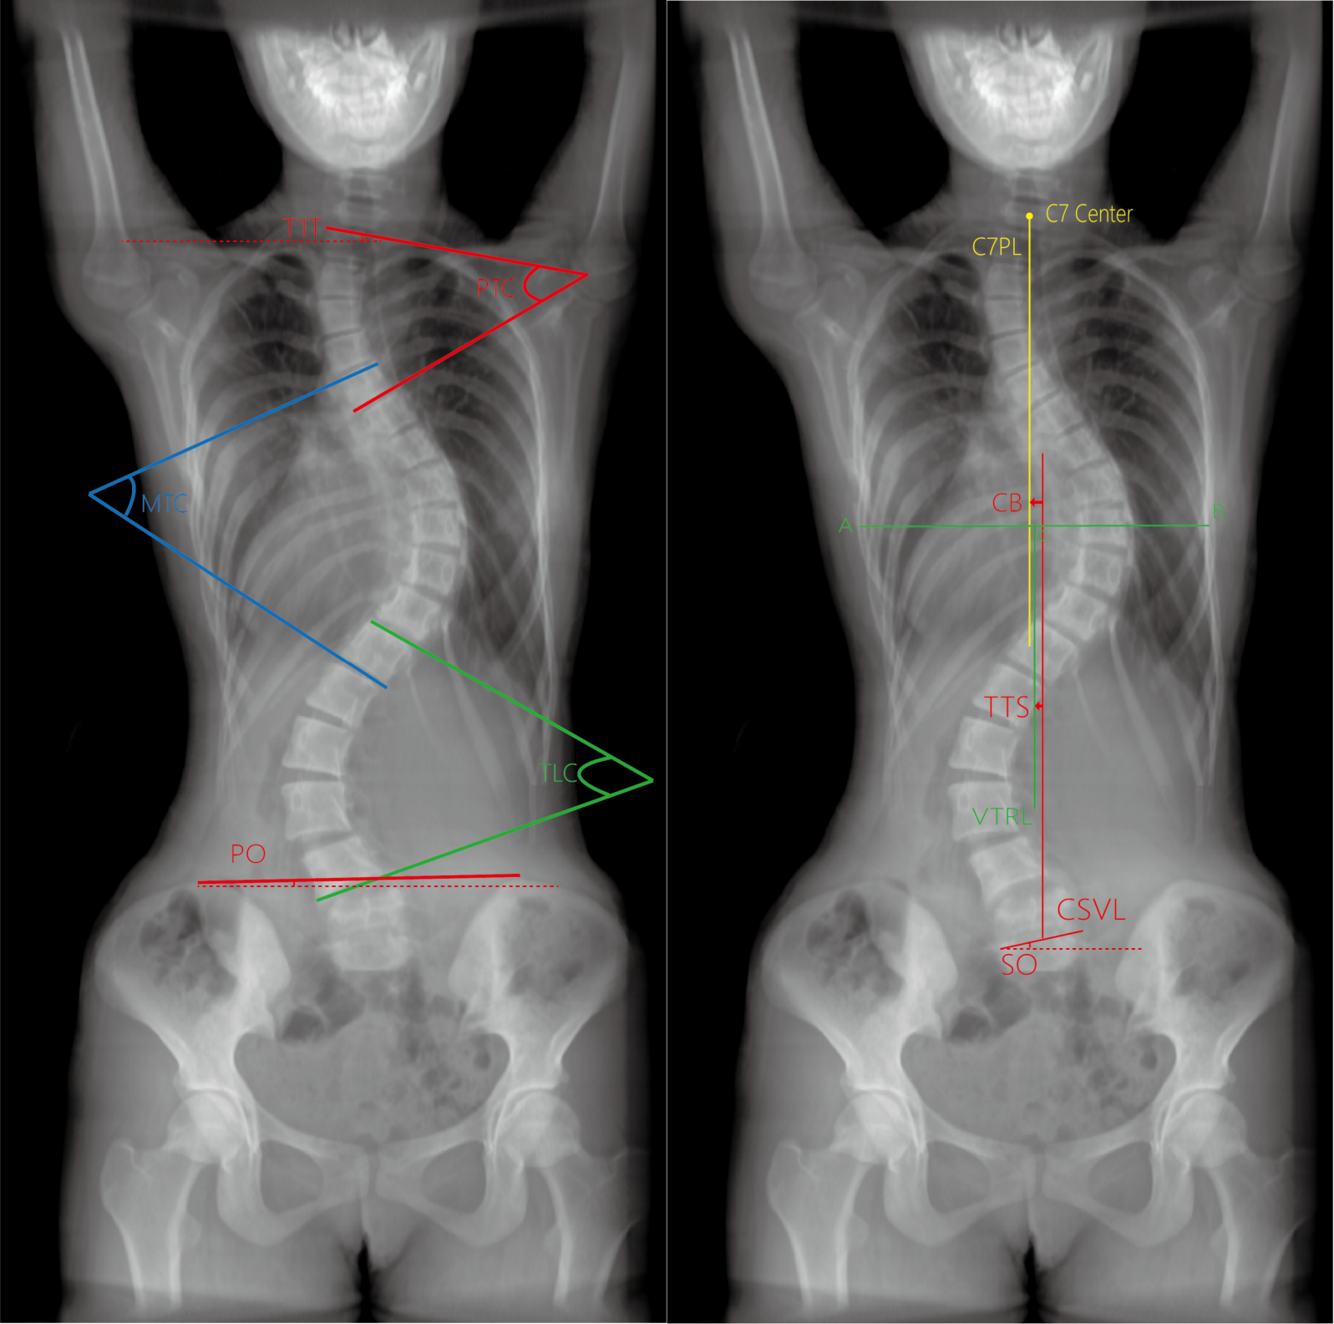
Fig. S2 Schematic diagram of coronal parameter measurement on digitally reconstructed radiograph (DRR), with methods consistent with conventional radiograph.

2.2 Sagittal Plane Parameters
Sagittal parameters were measured as follows (see Figure S3 for a schematic illustration) [1]:
(1) Cervical Lordosis (CL: C2-C7): Cobb angle formed between the inferior endplate of C2 and the inferior endplate of C7.
(2) Thoracic Kyphosis (TK: T2-T5, T5-T12): Measured using the Cobb method, defined as the angle between the superior endplate of the upper end vertebra and the inferior endplate of the lower end vertebra.
(3) Lumbar Lordosis (LL: L1-L4, L4-S1, L1-S1): Measured using the Cobb method, defined as the angle between the superior endplate of the upper end vertebra and the inferior endplate of the lower end vertebra (or the superior endplate of S1 for S1-involved parameters).
(4) Thoracolumbar kyphosis(TLK: T10-L2): Cobb angle between the superior endplate of T10 and the inferior endplate of L2.
(5) T1 Slope (T1S): Angle between the superior endplate of T1 and the horizontal reference line.
(6) Sagittal Balance (SB): Horizontal distance between the C7 plumb line (a vertical line dropped from the centroid of the C7 vertebral body) and the posterosuperior corner of S1.
(7) Sacral Slope (SS): Angle between the superior endplate of S1 and the horizontal reference line.
(8) Pelvic Incidence (PI): Angle formed between a line perpendicular to the midpoint of the S1 superior endplate and a line connecting the same point to the midpoint of the line joining the centers of the bilateral femoral heads.
(9) Pelvic Tilt (PT): Angle between the vertical reference line and the line connecting the midpoint of the S1 superior endplate to the midpoint of the bilateral femoral heads.
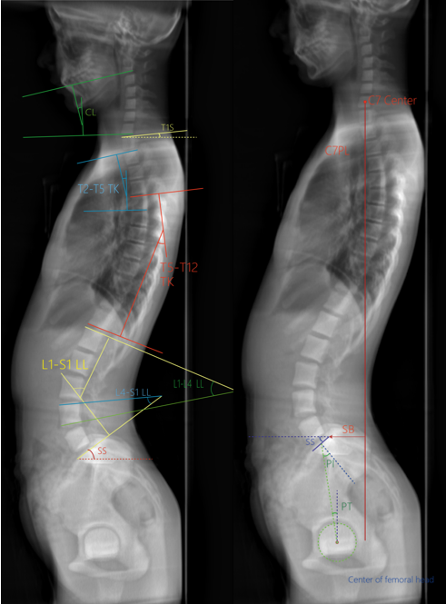
Fig. S3 Schematic diagram of sagittal parameter measurement on digitally reconstructed radiograph (DRR), with methods consistent with conventional radiograph.

Section S3. Detailed Statistical Tables and Figures

3.1 Overall Distribution of Measurements from Radiographs and DRRs
To evaluate the overall distribution of measured parameters, Figure S4 and Figure S5 present box plots showing the distributions of anteroposterior (AP) and lateral (LA) parameter measurements, respectively. For distribution analysis, the final measurement values for each parameter on both DRRs and radiographs images were calculated as the mean of the two observers’ readings.
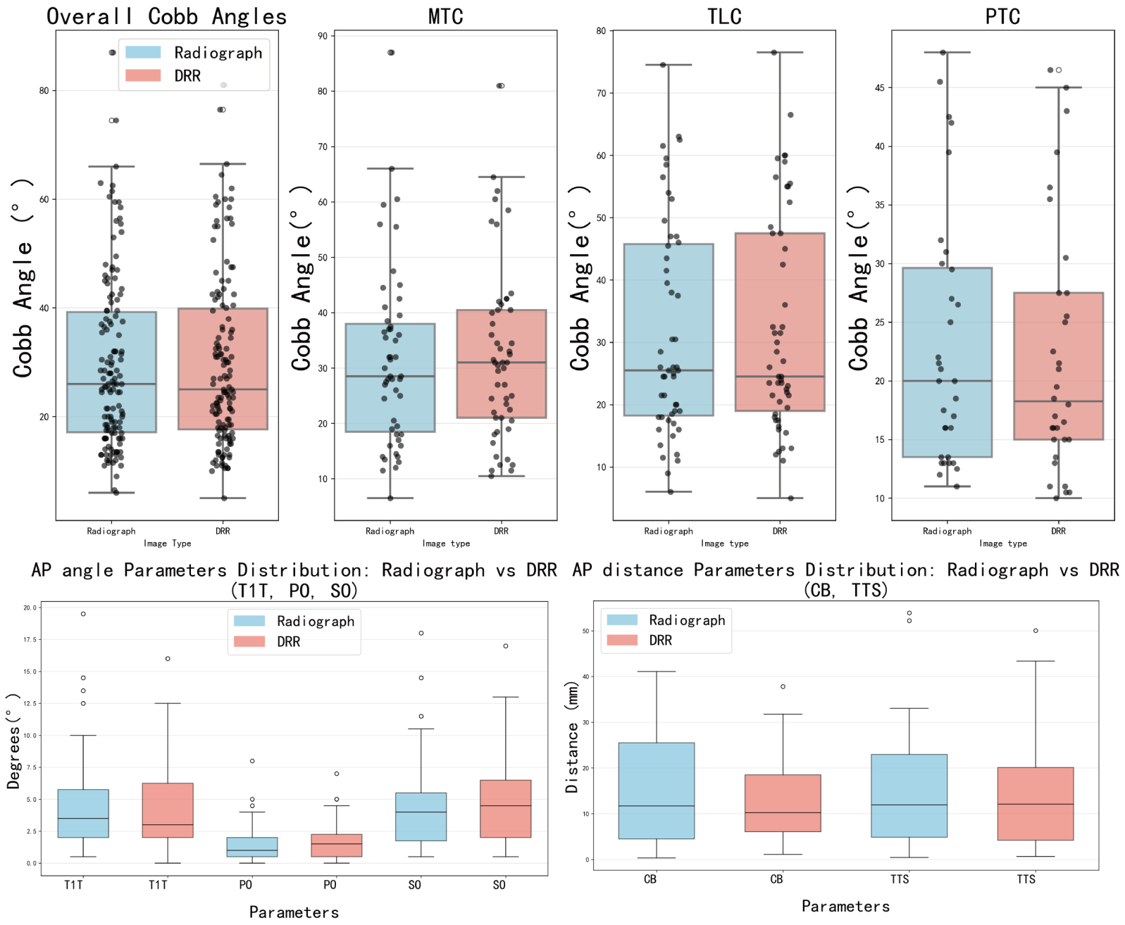
Fig. S4 Box plots of variable distributions for anteroposterior (AP) parameter measurements.

Fig. S5 Box plots of variable distributions for lateral (LA) parameter measurements.

Table S1 presents the overall descriptive statistics—including means, standard deviations, and ranges—for all measured parameters. To assess the overall distribution of parameter measurements, the final value for each measurement on a given imaging modality was determined by averaging the readings from the two observers. Descriptive statistics (mean, standard deviation, maximum, and minimum) were subsequently computed based on these averaged values.
Measurements | n | Radiograph |  |  |  | DRR
Measurements | n | Mean | SD | Min | Max | Mean | SD | Min | Max
coronal
Cobb angle (°) | 134 | 29.57 | 15.79 | 6 | 87 | 29.82 | 15.91 | 5 | 81
MTC (°) | 51 | 31.55 | 16.02 | 6.5 | 87 | 32.25 | 15.65 | 10.5 | 81
PTC (°) | 32 | 23.08 | 10.82 | 11 | 48 | 22.16 | 10.73 | 10 | 46.5
TLC (°) | 51 | 31.67 | 17.27 | 6 | 74.5 | 32.21 | 17.55 | 5 | 76.5
T1T (°) | 67 | 4.52 | 3.62 | 0.5 | 19.5 | 4.43 | 3.27 | 0 | 16
CB (mm) | 67 | 15.15 | 11.90 | 0.35 | 41.1 | 12.52 | 8.75 | 1.1 | 37.8
PO (°) | 67 | 1.51 | 1.47 | 0 | 8 | 1.61 | 1.48 | 0 | 7
SO (°) | 67 | 4.49 | 3.46 | 0.5 | 18 | 4.73 | 3.38 | 0.5 | 17
TTS (mm) | 54 | 14.57 | 12.58 | 0.45 | 53.9 | 14.30 | 11.60 | 0.65 | 50.05
sagittal
CL (°) | 67 | 9.66 | 8.12 | 1 | 42 | 11.05 | 7.35 | 1 | 34
T2-T5 TK (°) | 67 | 13.22 | 7.59 | 0.5 | 47.5 | 8.69 | 5.7 | 0.5 | 26.5
T5-T12 TK (°) | 67 | 25.34 | 14.7 | 0.5 | 73 | 22.34 | 12.84 | 1.5 | 61.5
T10-L2 TLK (°) | 67 | 12.97 | 10.76 | 1 | 48.5 | 11.90 | 8.95 | 0.5 | 43
L1-L4 LL (°) | 67 | 23.27 | 9.06 | 3.5 | 44 | 19.31 | 9.18 | 3.5 | 46
L4-S1 LL (°) | 67 | 32.86 | 8.86 | 7 | 57 | 34.63 | 9.04 | 13.5 | 63.5
L1-S1 LL (°) | 67 | 51.20 | 11.67 | 30.5 | 95 | 51.01 | 13.62 | 4.5 | 98
T1S (°) | 67 | 19.10 | 8.50 | 3.5 | 47.5 | 11.58 | 6.61 | 0 | 25
SB (mm) | 67 | 26.17 | 21.41 | 1.7 | 121 | 17.01 | 13.59 | 0.8 | 68.6
PI (°) | 67 | 44.57 | 9.57 | 21 | 69 | 45.48 | 11.11 | 20.5 | 79
PT (°) | 67 | 9.71 | 6.64 | 0.5 | 32.5 | 9.63 | 6.24 | 0.5 | 34
SS (°) | 67 | 35.95 | 8.15 | 17 | 62 | 38.64 | 9.83 | 1 | 72
Table S1. Overall descriptive statistics (mean, standard deviation, and range) of parameter measurements averaged across two observers. DRR: digitally reconstructed radiograph; SD: standard deviation.
Notes:
n: Denotes the number of parameters that were successfully measured. The sample size (n) varies between parameters due to anatomical and pathological factors. Some patients presented with multiple distinct spinal curves (e.g., double major scoliosis), allowing for the measurement of more than one regional Cobb angle (e.g., MTC, TLC). Conversely, patients diagnosed without scoliosis did not exhibit a measurable curve in a specific spinal region, making the corresponding Cobb angle measurement not applicable. Besides, the thoracic trunk shift (TTS) was only measured in patients with the apical vertebra of the major curve lying between T1 and T12.

3.2 Interrater Reliability Analysis between two observers
The intraclass correlation coefficients (ICCs) based on an absolute-agreement, two-way random-effects model [ICC(2,1)] with 95% confidence intervals (95% CI) for parameter measurements by the two observers on both radiographs and DRRs are presented in Table S2.
Measurements | n | radiograph |  | DRR
Measurements | n | ICC | 95% CI | ICC | 95% CI
coronal
Cobb angle (°) | 134 | 0.99 | (0.98, 0.99) | 0.98 | (0.98, 0.99)
MTC (°) | 51 | 0.98 | (0.97, 0.99) | 0.98 | (0.97, 0.99)
PTC (°) | 32 | 0.98 | (0.96, 0.99) | 0.95 | (0.91, 0.98)
TLC (°) | 51 | 0.99 | (0.98, 0.99) | 0.99 | (0.99, 1.00)
T1T (°) | 67 | 0.80 | (0.60, 0.89) | 0.82 | (0.70, 0.89)
CB (mm) | 67 | 0.97 | (0.95, 0.98) | 0.95 | (0.91, 0.97)
PO (°) | 67 | 0.88 | (0.81, 0.92) | 0.90 | (0.84, 0.93)
SO (°) | 67 | 0.71 | (0.56, 0.81) | 0.69 | (0.44, 0.82)
TTS (mm) | 54 | 0.98 | (0.96, 0.99) | 0.93 | (0.88, 0.96)
sagittal
CL (°) | 67 | 0.78 | (0.66, 0.86) | 0.76 | (0.63, 0.85)
T2-T5 TK (°) | 67 | 0.72 | (0.52, 0.84) | 0.82 | (0.72, 0.88)
T5-T12 TK (°) | 67 | 0.89 | (0.81, 0.94) | 0.96 | (0.93, 0.97)
T10-L2 TLK (°) | 67 | 0.88 | (0.81, 0.92) | 0.81 | (0.71, 0.88)
L1-L4 LL (°) | 67 | 0.82 | (0.72, 0.89) | 0.87 | (0.80, 0.92)
L4-S1 LL (°) | 67 | 0.77 | (0.54, 0.88) | 0.87 | (0.80, 0.92)
L1-S1 LL (°) | 67 | 0.88 | (0.80, 0.93) | 0.94 | (0.90, 0.96)
T1S (°) | 67 | 0.81 | (0.69, 0.88) | 0.84 | (0.75, 0.90)
SB (mm) | 67 | 0.98 | (0.96, 0.99) | 0.99 | (0.98, 0.99)
PI (°) | 67 | 0.70 | (0.53, 0.81) | 0.95 | (0.92, 0.97)
PT (°) | 67 | 0.83 | (0.74, 0.89) | 0.98 | (0.97, 0.99)
SS (°) | 67 | 0.79 | (0.52, 0.90) | 0.94 | (0.90, 0.96)
Table S2. Inter-rater reliability of parameter measurements in patients between two observers. ICC: Intraclass correlation coefficient; 95% CI: 95% upper and lower boundaries for the confidence interval of ICC values.

3.3 Measurement agreement analysis between radiograph and DRR measurements
Figures S6 and S7 present Bland–Altman plots for coronal Cobb angle and other coronal parameter measurements, respectively, while Figure S8 shows the Bland–Altman plot for sagittal plane parameters. For the assessment of measurement agreement, the mean of the two observers’ readings was used as the final measurement value for each radiograph and DRR image. The y-axis represents the measurement difference between radiographs and DRRs (in degrees for angle and mm for distance, i.e., radiograph-DRR measurements), while the x-axis shows their mean value (i.e., (radiograph + DRR)/2). Solid lines show the mean differences, and dashed lines represent the 95% Limits of Agreement (95% LoA), defined as the range of mean difference ± 1.96 standard deviations. Different subplots demonstrate visualized Bland-Altman statistical tables for various parameters.
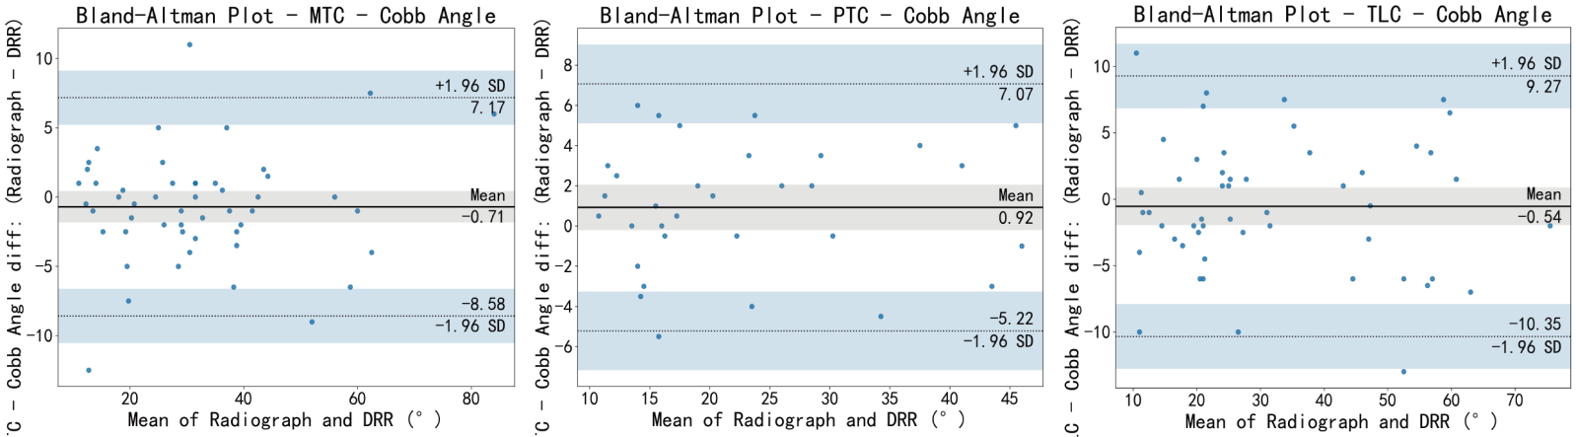
Fig. S6 Bland-Altman plots for Cobb angles between radiographs and digitally reconstructed radiographs (DRRs), stratified by spinal curve type: proximal thoracic curve (PTC), main thoracic curve (MTC), and thoracolumbar/lumbar curve (TLC)

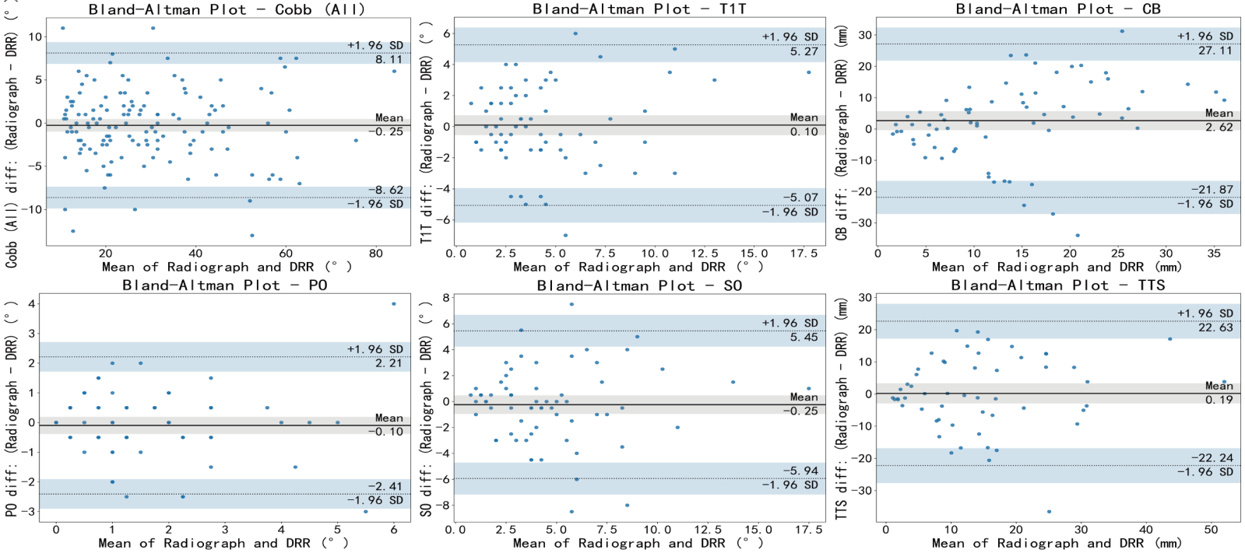
Fig. S7 Bland-Altman plots for other coronal parameters between radiographs and digitally reconstructed radiographs (DRRs)

Fig. S8 Bland-Altman plots for sagittal parameters between radiographs and digitally reconstructed radiographs (DRRs)

Table S3 summarizes the Mean Absolute Error (MAE), mean difference, SD of mean difference, paired t-tests (to detect systematic bias), and 95% LoA of radiograph and DRR measurements. For each parameter, the difference (radiograph minus DRR) was calculated in native units (degrees [°] for angles, millimeters [mm] for distances). The mean and standard deviation of these differences across all measurements are reported. The mean absolute error (MAE) was computed by taking the absolute value of each radiograph – DRR difference and then averaging these absolute values. Table S3 reports paired t-test p-values for systematic bias, adjusted for multiple comparisons using the Benjamini–Hochberg False Discovery Rate (FDR) procedure. The 95% LoA was calculated as described above.
Parameters | MAE | Mean Difference | SD of Difference | 95% CI of  Mean Diff | p | 95% LoA
coronal
Cobb angle (°) | 3.26 | -0.25 | 4.27 | (-0.98, 0.47) | 0.621 | (-8.62, 8.11)
MTC (°) | 2.88 | -0.71 | 4.02 | (-1.81, 0.40) | 0.377 | (-8.58, 7.17)
PTC (°) | 2.67 | 0.92 | 3.13 | (-0.16, 2.01) | 0.240 | (-5.22, 7.07)
TLC (°) | 4.01 | -0.54 | 5.01 | (-1.91, 0.83) | 0.621 | (-10.35, 9.27)
T1T (°) | 2.08 | 0.10 | 2.64 | (-0.53, 0.73) | 0.892 | (-5.07, 5.27)
CB (mm) | 9.72 | 2.62 | 12.49 | (-0.37, 5.62) | 0.237 | (-21.87, 27.11)
PO (°) | 0.84 | -0.10 | 1.18 | (-0.38, 0.19) | 0.621 | (-2.41, 2.21)
SO (°) | 2.10 | -0.25 | 2.91 | (-0.94, 0.45) | 0.621 | (-5.94, 5.45)
TTS (mm) | 8.90 | 0.19 | 11.45 | (-2.86, 3.25) | 0.911 | (-22.24, 22.63)
sagittal
CL (°) | 5.78 | -1.39 | 7.43 | (-3.17, 0.39) | 0.251 | (-15.96, 13.18)
T2-T5 TK (°) | 5.93 | 4.53 | 6.18 | (3.05, 6.01) | <0.001* | (-7.59, 16.65)
T5-T12 TK (°) | 6.10 | 3.00 | 7.57 | (1.19, 4.81) | 0.008* | (-11.84, 17.84)
T10-L2 TLK (°) | 4.64 | 1.07 | 5.50 | (-0.24, 2.39) | 0.240 | (-9.70, 11.85)
L1-L4 LL (°) | 6.02 | 3.96 | 6.78 | (2.34, 5.59) | <0.001* | (-9.33, 17.26)
L4-S1 LL (°) | 5.86 | -1.77 | 7.91 | (-3.66, 0.13) | 0.215 | (-17.27, 13.73)
L1-S1 LL (°) | 6.84 | 0.19 | 8.55 | (-1.86, 2.23) | 0.911 | (-16.57, 16.94)
T1S (°) | 7.79 | 7.52 | 6.10 | (6.06, 8.98) | <0.001* | (-4.44, 19.48)
SB (mm) | 16.38 | 9.16 | 19.05 | (4.60, 13.72) | 0.001* | (-28.17, 46.49)
PI (°) | 4.40 | -0.90 | 6.81 | (-2.53, 0.73) | 0.455 | (-14.26, 12.45)
PT (°) | 3.94 | 0.07 | 5.46 | (-1.23, 1.38) | 0.911 | (-10.62, 10.77)
SS (°) | 5.49 | -2.69 | 7.33 | (-4.45, -0.94) | 0.013* | (-17.06, 11.67)
Table S3. Comparison of radiograph and DRR measurements (observer-averaged values). MAE: Mean Absolute Error (radiograph-DRR); CI: confidence intervals; p, Benjamini–Hochberg FDR-adjusted p-value from paired samples t-test across all 21 parameters; * Statistically significant difference (p < 0.05). LoA (limits of agreement) = mean difference ± 1.96 × SD of differences (Bland-Altman analysis)

3.4 Scatter Plots and Linear Regression Analysis of Radiograph versus DRR Parameters
Figure S9 presents scatter plots of all curves stratified by major thoracic curve (MTC), proximal thoracic curve (PTC), and thoracolumbar/lumbar curve (TLC), while Figure S10 and Figure S11 shows scatter plots for coronal and sagittal plane parameters. For each parameter, linear regression was performed, and the following statistics were reported: Pearson correlation coefficient (r), coefficient of determination (R²), p-value indicating statistical significance, as well as the slope and intercept of the fitted regression line, which together define the equation of the best-fit line. Detailed results for all parameters above are summarized in Table S4. For these plots, the x-axis denotes parameter values measured on radiographs, and the y-axis denotes those measured on DRRs.
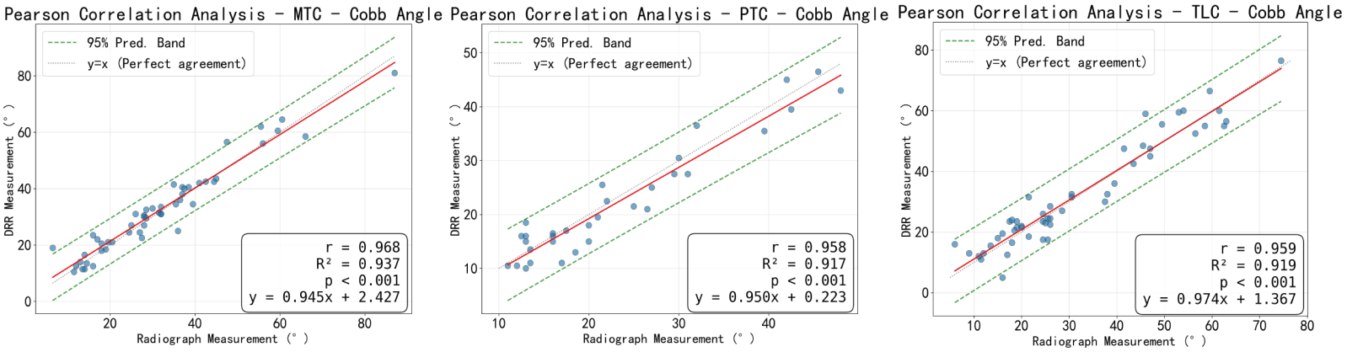
Fig. S9 Scatter plots and linear regression analyses of coronal Cobb angle measurements on radiographs and DRRs, stratified by spinal segment (MTC, PTC, TLC). The x-axis represents the parameter values measured on radiograph images, and the y-axis represents those measured on DRR images. DRR: digitally reconstructed radiograph; r: Pearson correlation; R²: Coefficient of determination

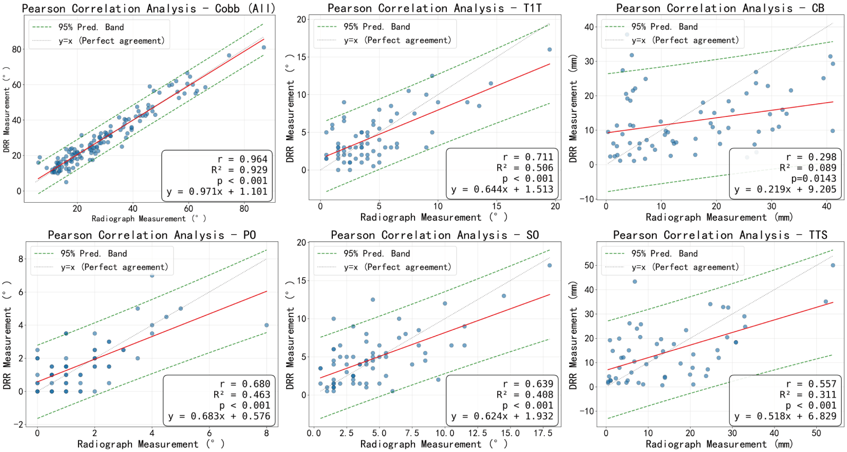
Fig. S10 Scatter plot and linear regression analysis of coronal parameters measured by radiographs and DRRs. DRR: digitally reconstructed radiograph; r: Pearson correlation; R²: Coefficient of determination

Fig. S11 Scatter plot and linear regression analysis of sagittal parameters measured by radiograph and DRR. DRR: digitally reconstructed radiograph; r: Pearson correlation; R²: Coefficient of determination
Parameters | Pearson correlation (r) | p value | R² | Slope | Intercept
coronal
Cobb angle (°) | 0.964 | ＜0.001 | 0.929 | 0.971 | 1.101
MTC (°) | 0.968 | ＜0.001 | 0.937 | 0.945 | 2.427
PTC (°) | 0.958 | ＜0.001 | 0.917 | 0.950 | 0.223
TLC (°) | 0.959 | ＜0.001 | 0.919 | 0.974 | 1.367
T1T (°) | 0.711 | ＜0.001 | 0.506 | 0.644 | 1.513
CB (mm) | 0.298 | 0.014 | 0.089 | 0.219 | 9.205
PO (°) | 0.680 | ＜0.001 | 0.463 | 0.683 | 0.576
SO (°) | 0.639 | ＜0.001 | 0.408 | 0.624 | 1.932
TTS (mm) | 0.557 | ＜0.001 | 0.311 | 0.518 | 6.829
sagittal
C2-C7 CL (°) | 0.542 | ＜0.001 | 0.294 | 0.490 | 6.312
T2-T5 TK (°) | 0.599 | ＜0.001 | 0.359 | 0.450 | 2.738
T5-T12 TK (°) | 0.857 | ＜0.001 | 0.735 | 0.748 | 3.373
T10-L2 TLK (°) | 0.860 | ＜0.001 | 0.740 | 0.715 | 2.623
L1-L4 LL (°) | 0.723 | ＜0.001 | 0.523 | 0.733 | 2.242
L4-S1 LL (°) | 0.610 | ＜0.001 | 0.372 | 0.621 | 14.207
L1-S1 LL (°) | 0.782 | ＜0.001 | 0.612 | 0.912 | 4.308
T1S (°) | 0.701 | ＜0.001 | 0.491 | 0.545 | 1.176
SB (mm) | 0.482 | ＜0.001 | 0.232 | 0.306 | 9.011
PI (°) | 0.793 | ＜0.001 | 0.628 | 0.920 | 4.474
PT (°) | 0.643 | ＜0.001 | 0.413 | 0.604 | 3.766
SS (°) | 0.682 | ＜0.001 | 0.466 | 0.824 | 9.035
Table S4. Correlation and linear regression analysis between radiograph and DRR measurements for all parameters. For each parameter, Pearson correlation coefficient (r), coefficient of determination (R²), p-value for the correlation, and the slope and intercept of the ordinary least squares regression line (DRR = slope × radiograph + intercept) are reported.
Note: P-values for the correlation are presented as unadjusted values for visual clarity. However, all parameters were subjected to False Discovery Rate (FDR) correction for multiple comparisons. After FDR adjustment, the 20 parameters with raw p < 0.001 remained statistically significant (adjusted p < 0.001), and the parameter with raw p = 0.014 also remained significant (adjusted p < 0.05).

Reference
[1]O'Brien MF, Group SDS. Radiographic Measurement Manual: Medtronic Sofamor Danek USA; 2004.

