Supplementary Material
Multi-Excitation Front-Face Fluorescence Spectroscopy with Explainable LSTM for Detection of Lymphatic Tissue Adulteration in Ground Beef
Contents: Figures S1-S3; Tables S1-S13. The tables report the acquisition parameters, design-cell distribution, optimisation grids, partitioning summary, sensitivity analyses and supporting statistics underlying the main text. Sample-level spectra and individual assay replicates are deposited with the Zenodo dataset cited in the Data availability statement.

Figure S1. Architecture of the shared-weight four-input LSTM.
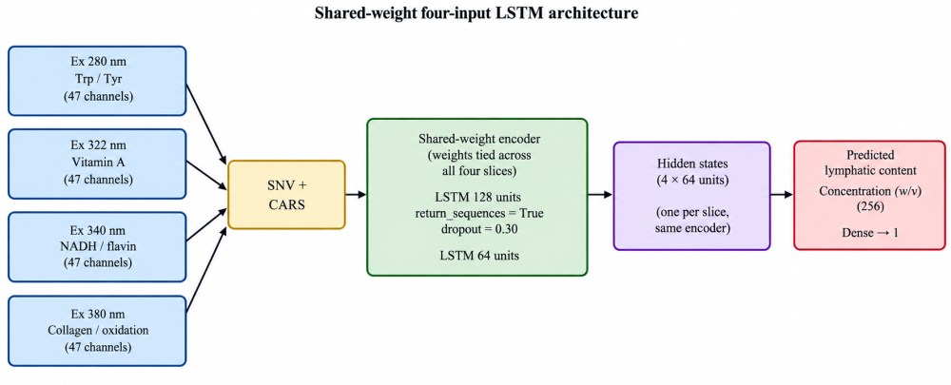
Four excitation-emission slices, each presented as its own ordered sequence. Each slice is encoded independently by same weight matrix, so the physical ordering of the emission channels is preserved. Without the artificial step-jumps that concatenating the four slices into one sequence would introduce, CARS, competitive adaptive reweighed sampling; SNV, standard normal variate
Referenced in Section 2.4. Each excitation slice is presented as its own ordered sequence along its emission axis; the encoder weights are tied across slices, so the model learns one spectral-to-latent mapping rather than four.

Figure S2. Schematic of the front-face fluorescence measurement system.
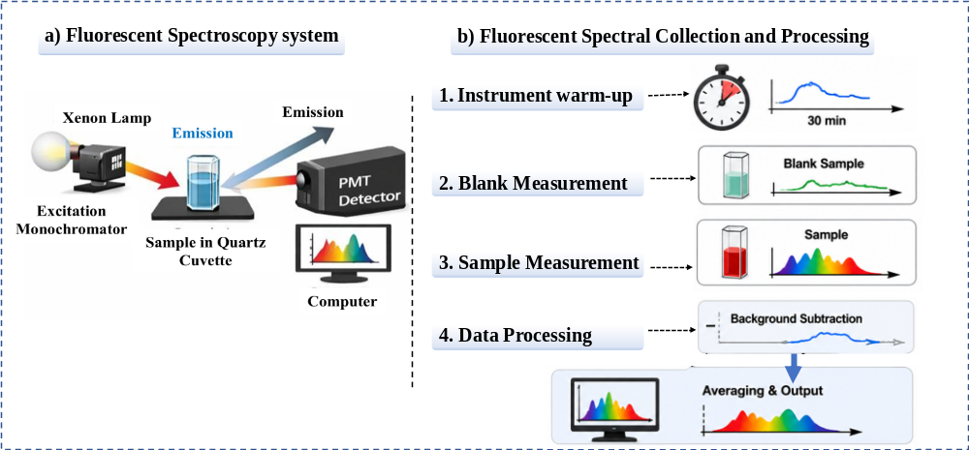
Referenced in Section 2.2. The fibre-optic probe is held at 56° to the sample-surface normal so that specular reflectance and inner-filter effects are minimised. Excitation and emission monochromators, the sample compartment maintained at 4 ± 0.5 °C, and the emission windows recorded for each of the four diagnostic excitation wavelengths (280, 322, 340 and 380 nm) are indicated.

Figure S3. Biochemical dose response across the gravimetric adulteration series.
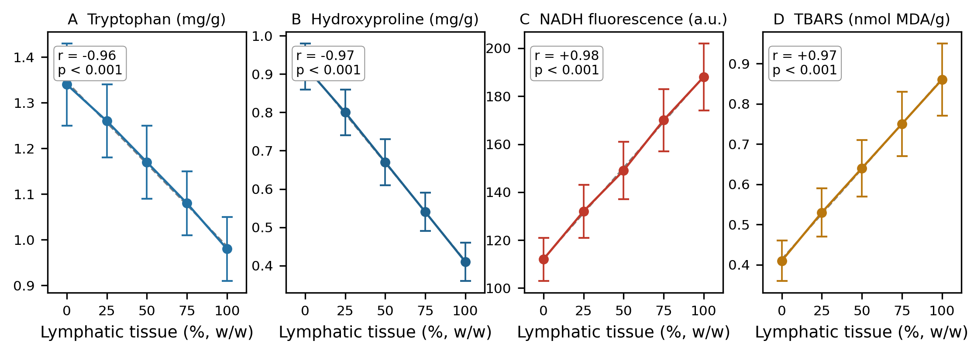
Referenced in Sections 3.1 and 3.6. Mean ± SD (n = 6 per level) for (A) tryptophan, (B) hydroxyproline, (C) NADH fluorescence and (D) TBARS at 0, 25, 50, 75 and 100% (w/w) lymphatic tissue. All four markers change monotonically, matching the sign of the corresponding SHAP effect.

Table S1.
Table S1. Instrumentation and acquisition parameters.
Parameter | Setting
Spectrometer | FluoroMax-4 spectrofluorometer (Horiba Scientific, Kyoto, Japan)
Accessory | Front-face fibre-optic accessory
Front-face geometry | 56° relative to the sample-surface normal
Exploratory excitation range | 250-400 nm, 5 nm steps
Exploratory emission range | 300-800 nm
Emission resolution (modelling) | 1 nm
Diagnostic excitation wavelengths | 280, 322, 340 and 380 nm
Integration time | 0.1 s
Accumulations per scan | 3
Excitation / emission slit widths | 5 nm / 5 nm
Detector setting | Photomultiplier-tube voltage optimised per sample; signal-to-noise ratio > 1000:1, no saturation
Blank correction | Ultrapure deionised water spectrum recorded at the start of each session and subtracted (removes Raman and Rayleigh scattering; also suppresses the water-Raman band near 310 nm)
Technical replication | Three spectra per sample, averaged before analysis
Sample presentation | 30 g cylindrical patties, 5 mm particle size, equilibrated 30 min at 4 ± 0.5 °C
Candidate channels carried into modelling | 188 (47 per excitation slice)

Table S1 (continued). Candidate emission-channel windows of the four excitation slices.
Excitation (nm) | Emission window (nm) | Channels | Principal fluorophores | Emission maximum (nm)
280 | 305-351 | 47 | Tryptophan, tyrosine, phenylalanine residues of myofibrillar proteins | ≈310 (Tyr), ≈340 (Trp)
322 | 336-382 | 47 | Vitamin A (retinol) and esters; aromatic amino-acid cross-peaks via FRET | ≈360-380
340 | 440-486 | 47 | NADH; flavin coenzymes | ≈460 (NADH), ≈525 (flavin)
380 | 410-441 and 514-528 | 47 (32 + 15) | Collagen cross-links (pyridinoline, advanced glycation end-products); fluorescent lipid-oxidation products (Schiff bases) | ≈420-440; ≈515-530
Total candidate variables = 4 × 47 = 188. After competitive adaptive reweighted sampling (CARS), 86 channels were retained (main text, Sections 2.4 and 3.2).

Table S2.
Table S2. RMSECV grid underlying the selection of the preprocessing method (basis of Section 3.2).
Preprocessing method | RMSECV (%) | R²P | RMSEP (%) | RPD
Raw spectra | 5.65 | 0.964 | 5.90 | 5.3
Savitzky-Golay smoothing | 5.10 | 0.971 | 5.35 | 5.8
Polynomial baseline correction | 4.55 | 0.977 | 4.75 | 6.6
Multiplicative scatter correction (MSC) | 3.85 | 0.983 | 4.05 | 7.7
Standard normal variate (SNV) selected | 3.35 | 0.987 | 3.55 | 8.8
PLSR on the 188 candidate channels; internal test set n = 159; reference SD = 31.2% w/w. Savitzky–Golay: second-order polynomial, 11-point window. All preprocessing parameters were derived from the calibration set only and applied unchanged to the remaining sets.

Table S3.
Table S3. Variable-selection methods ranked by RMSECV (basis of Sections 2.4 and 3.2).
Variable selection method | No. of variables | RMSECV (%) | R²P | RMSEP (%) | RPD
CARS selected | 86 | 2.90 | 0.990 | 3.08 | 10.1
Bootstrap resampling (BW) | 94 | 3.15 | 0.988 | 3.35 | 9.3
VCPA | 79 | 3.40 | 0.987 | 3.55 | 8.8
UVE | 120 | 3.65 | 0.985 | 3.80 | 8.2
SNV-preprocessed PLSR; internal test set n = 159. The same ranking is obtained under RMSECV and internal-test RMSEP, so the selection is not an artifact of a particular partition. CARS, competitive adaptive reweighted sampling; VCPA, variable combination population analysis; UVE, uninformative variable elimination; BW, bootstrap resampling. The CARS row is the PLSR reference model reported again in Table 2 of the main text.

Table S3 (continued). Distribution and stability of the 86 CARS-selected channels.
Excitation slice (nm) | Channels retained | Emission sub-window (nm) | Assigned fluorophore | Channels selected in ≥90% of the 50 Monte Carlo runs
280 | 21 | 330-350 | Tryptophan | 19 (90%)
322 | 18 | 358-375 | Vitamin A (retinol) | 16 (89%)
340 | 24 | 452-475 | NADH | 22 (92%)
380 | 23 | 416-440 and 516-532 | Collagen cross-links; lipid-oxidation products | 21 (91%)
Total | 86 | — | — | 78 (91%)
Stability was assessed by recording, for each channel, the proportion of the 50 Monte Carlo runs in which it was retained. RMSECV with the stability-filtered subset (78 channels) was 2.93%, within 1% of the 2.90% obtained with the full 86-channel subset (main text, Section 3.2).

Table S4.
Table S4. Specificity of the LSTM model against four categories of non-lymphatic interferent (n = 8 per condition). Basis of Section 3.4 and Figure 4.
Category | Level | Predicted lymphatic content (%, mean ± SD) | 90% CI of difference vs control | TOST p (Δ = 1.0%) | Tukey p vs control
Control (authentic beef) | 0% | 0.12 ± 0.09 | — | — | —
Adipose tissue | 10% | 0.16 ± 0.11 | −0.02 to 0.10 | <0.001 | 0.94
Adipose tissue | 20% | 0.19 ± 0.13 | −0.01 to 0.15 | <0.001 | 0.86
Adipose tissue | 30% | 0.21 ± 0.14 | 0.00 to 0.18 | 0.002 | 0.71
Saline dilution | 10% | 0.14 ± 0.10 | −0.04 to 0.08 | <0.001 | 0.98
Saline dilution | 20% | 0.22 ± 0.12 | 0.01 to 0.19 | 0.002 | 0.63
Saline dilution | 30% | 0.31 ± 0.15 | 0.07 to 0.31 | 0.008 | 0.28
Muscle cut | LL | 0.11 ± 0.08 | −0.07 to 0.05 | <0.001 | 0.99
Muscle cut | SM | 0.17 ± 0.11 | −0.02 to 0.12 | <0.001 | 0.91
Muscle cut | BF | 0.13 ± 0.09 | −0.06 to 0.08 | <0.001 | 0.99
Lipid oxidation | day 3 | 0.18 ± 0.12 | −0.02 to 0.14 | <0.001 | 0.88
Lipid oxidation | day 7 | 0.31 ± 0.16 | 0.06 to 0.32 | 0.010 | 0.31
Lipid oxidation | day 10 | 0.48 ± 0.21 | 0.19 to 0.53 | 0.021 | 0.06
LL, Longissimus lumborum; SM, Semimembranosus; BF, Biceps femoris. One-way ANOVA across all thirteen conditions (n = 104): F(12, 91) = 1.18, p = 0.31. TOST, two one-sided tests of equivalence against Δ = ±1.0% w/w.

Table S5.
Table S5. Biochemical validation of the SHAP-identified spectral features at the two extremes of the adulteration range. Values are mean ± SD (n = 20 per group). Basis of Sections 2.6 and 3.6.
Biochemical marker | Spectral region (Ex/Em, nm) | Beef (0%) | Lymphatic (100%) | p-value | SHAP direction | Pearson r (n = 40)
Tryptophan (mg/g) | 280/340 | 1.34 ± 0.09 | 0.98 ± 0.07 | <0.001 | Negative ↓ | -0.93
Hydroxyproline (mg/g) | 380/420 | 0.92 ± 0.06 | 0.41 ± 0.05 | <0.001 | Negative ↓ | -0.91
NADH (a.u.) | 340/460 | 112 ± 9 | 188 ± 14 | <0.001 | Positive ↑ | 0.94
TBARS (nmol MDA/g) | 380/520 | 0.41 ± 0.05 | 0.86 ± 0.09 | <0.001 | Positive ↑ | 0.92
TBARS, thiobarbituric acid reactive substances; MDA, malondialdehyde; a.u., arbitrary fluorescence units. Between-group differences by Student's t-test with Bonferroni correction. Pearson r is computed over the 40 paired observations (parallel aliquots of the same 40 scanned samples), not over four group means.

Table S5 (continued). Biochemical assays underlying the SHAP corroboration: methods and in-house verification.
Marker | Assay | In-house verification
Free tryptophan | Reversed-phase HPLC | Linear 0.5-50 µg/mL (r² > 0.999); recovery 96-103%; intra-/inter-day RSD < 3% / < 5%
Hydroxyproline (collagen surrogate) | Woessner colorimetric method | Recovery 94-104%
NADH | Fluorescence of sample extracts (Ex 340 / Em 460 nm, measured directly) | Response verified by standard additions
Lipid oxidation (TBARS) | Thiobarbituric acid reactive substances | Recovery 97-105%
Assays were run on parallel aliquots of the same tissue samples that had been scanned, so each biochemical value is paired, sample by sample, with the mean SHAP contribution of the corresponding fluorophore window.

Table S6.
Table S6. Biochemical dose series across the gravimetric adulteration range (mean ± SD, n = 6 independent preparations per level). Basis of Sections 2.6 and 3.6 and Figure S3.
Lymphatic tissue (%, w/w) | Tryptophan (mg/g) | Hydroxyproline (mg/g) | NADH (a.u.) | TBARS (nmol MDA/g)
0 | 1.34 ± 0.09 | 0.92 ± 0.06 | 112 ± 9 | 0.41 ± 0.05
25 | 1.26 ± 0.08 | 0.80 ± 0.06 | 132 ± 11 | 0.53 ± 0.06
50 | 1.17 ± 0.08 | 0.67 ± 0.06 | 149 ± 12 | 0.64 ± 0.07
75 | 1.08 ± 0.07 | 0.54 ± 0.05 | 170 ± 13 | 0.75 ± 0.08
100 | 0.98 ± 0.07 | 0.41 ± 0.05 | 188 ± 14 | 0.86 ± 0.09
r vs. adulteration level (n = 30) | -0.96 | -0.97 | 0.98 | 0.97
All correlations p < 0.001. The 0% and 100% levels are the same endpoint batches reported in Table S5; the remaining three levels (n = 18) were prepared separately for the dose series (Section 2.6). Individual replicate values are deposited with the Zenodo dataset.

Table S7.
Table S7. Outlier detection by Monte Carlo cross-validation (basis of Section 2.3).
Item | Setting / result
Procedure | Monte Carlo cross-validation on PLSR models (Kvalheim et al., 2019)
Iterations | 1000
Split per iteration | Random 80% calibration / 20% validation
Statistics accumulated per sample | Mean squared prediction residual and leverage, over the iterations in which the sample fell in a validation subset
Residual criterion | Mean squared prediction residual above the 97.5th percentile of the across-sample distribution
Leverage criterion | Leverage above twice the mean leverage
Classification rule | Outlier only if both criteria are met
Samples screened | 540 (calibration cohort, Farms A–C)
Outliers removed | 11 (2.0%)
Samples retained | 529
External and interference sets | Not screened; no samples removed
Outliers were removed before Kennard–Stone partitioning. No sample was removed from either external validation set or from the interference set, so the external results are unaffected by the outlier-screening step.

Table S8.
Table S8. Kennard-Stone partitioning and validation-subset selection (basis of Section 2.3).
Subset | n | Selection method | Role
Calibration set | 370 | Kennard-Stone, 70% of the 529 retained samples | Model fitting; 10-fold cross-validation; CARS variable selection; hyperparameter ranking
— early-stopping validation subset | 74 | Stratified random sampling (20% of the calibration set), strata = the nine gravimetric levels; drawn once and held fixed across all five seeds | Early stopping only (patience = 20 epochs, minimum delta = 1 × 10⁻⁴)
Internal test set | 159 | Kennard-Stone, 30% of the 529 retained samples | Final evaluation; touched once, contributed to no decision
Total analysed (Farms A–C) | 529 | — | —
Kennard–Stone was applied within the 529 retained samples to obtain uniform coverage of the spectral space. Both external validation sets were held out completely and were not used in partitioning.

Table S9.
Table S9. Low-range calibration used for the LOD/LOQ calculation, with sensitivity analyses (basis of Sections 2.7 and 3.7).
Item | Value
Primary regression -levels included | 0, 2 and 5% (w/w lymphatic tissue)
Independent preparations per level | 15
Total n | 45
Farms represented | All five (A-E)
Slope, b (dimensionless) | 0.967
Residual standard deviation, s₀ | 0.58% w/w
LOD = 3S_{o} / b | 1.80% w/w (reported as 1.8% w/w)
LOQ = 10 S_{o} / b | 6.00% w/w (reported as 6.0% w/w)
Reference SD of the full nine-level series | 31.2% w/w
Sensitivity 1- weighted regression (w ∝ 1/x²) | LOD = 1.7% w/w; LOQ = 5.7% w/w (within 5% of the unweighted values; unweighted retained as the more conservative estimate)
Sensitivity 2- pure-error lack-of-fit test | F = 1.38; p = 0.26; no detectable curvature over the 0-5% w/w range
Sensitivity 3- extended range (0, 2, 5 and 10% w/w; n = 60) | LOD = 1.9% w/w; LOQ = 6.3% w/w (within 5% of the reported values)
IUPAC calibration-curve method. Because the LOQ (6.0% w/w) lies above two of the nine spike levels used (2% and 5%), the method detects but does not reliably quantify contamination near 2% w/w (main text, Sections 3.7 and 4.5).

Table S10.
Table S10. LSTM hyperparameter grid, stability assessment and selected configuration (basis of Section 2.5).
Item | Value
Architecture | Shared-weight four-input LSTM over the four excitation slices (Figure S1)
Encoder | Two layers: 128 units (return sequences = True), then 64 units; weights shared across slices
Output | Concatenated 64-unit hidden states (4 × 64) → linear dense output
Grid - LSTM units | {64, 128}
Grid - dropout | {0.20, 0.30, 0.40}
Grid - learning rate | {5 × 10⁻⁴, 1 × 10⁻³}
Optimiser | Adam
Batch size | 32
Maximum epochs | 300
Early stopping | Validation loss, patience = 20 epochs, minimum delta = 1 × 10⁻⁴
Early-stopping subset | 74 samples; stratified random, level-stratified, drawn once, fixed across seeds
Hyperparameter selection criterion | RMSECV (10-fold cross validation within the calibration set)
Random seeds | 5; reported metrics are the mean across seeds
Seed-to-seed SD of RMSEP (final model) | 0.07% w/w
Selected configuration | 128 → 64 units, dropout 0.30, learning rate 1 × 10⁻³
The internal test set and both external validation sets were evaluated once and contributed to no hyperparameter decision.

Table S11.
Table S11. Interferent predictions of the single-excitation ablation models (basis of Table 3 and Section 3.5).
Input excitation slice(s) | Channels after CARS | RMSECV (%) | R²P | RMSEP (%) | RPD | Predicted lymphatic content under interferents (% w/w) | Equivalence to 0% control (Δ = ±1.0% w/w)
Ex 280 nm only | 21 | 8.55 | 0.919 | 8.90 | 3.5 | 3.9-6.8 | Not equivalent (Tukey HSD, p < 0.001)
Ex 322 nm only | 18 | 11.90 | 0.842 | 12.40 | 2.5 | 1.1-2.4 | Not equivalent (Tukey HSD, p < 0.001)
Ex 340 nm only | 24 | 9.20 | 0.905 | 9.60 | 3.3 | 2.2-4.1 | Not equivalent (Tukey HSD, p < 0.001)
Ex 380 nm only | 23 | 10.35 | 0.880 | 10.80 | 2.9 | 1.8-3.6 | Not equivalent (Tukey HSD, p < 0.001)
All four excitations | 86 | 1.45 | 0.997 | 1.60 | 19.5 | 0.11-0.48 | Equivalent (largest TOST p = 0.021)
Identical shared-weight architecture in every row; only the excitation slices supplied as input differ. For the 280 nm model the stated range covers the adipose-tissue and saline-dilution challenges, with values up to 4.1% w/w after accelerated oxidation.

Table S12.
Table S12. Point estimates and approximate 95% confidence intervals for R²P, RMSEP and RPD (basis of Table 2; reported in Section 3.3).
Validation set | Model | RMSEP (% w/w) | RMSEP 95% CI (% w/w) | R²P | R²P 95% CI | RPD | RPD 95% CI
Internal test set (n = 159) | PLSR | 3.08 | 2.74-3.42 | 0.990 | 0.988-0.992 | 10.1 | 9.1-11.4
Internal test set (n = 159) | LSSVM | 2.52 | 2.24-2.80 | 0.993 | 0.992-0.995 | 12.4 | 11.2-13.9
Internal test set (n = 159) | 1D-CNN | 2.04 | 1.82-2.26 | 0.996 | 0.995-0.997 | 15.3 | 13.8-17.2
Internal test set (n = 159) | LSTM | 1.60 | 1.42-1.78 | 0.997 | 0.997-0.998 | 19.5 | 17.6-21.9
External Set A, Farm D (n = 90) | PLSR | 4.10 | 3.50-4.70 | 0.983 | 0.977-0.987 | 7.6 | 6.6-8.9
External Set A, Farm D (n = 90) | LSSVM | 3.55 | 3.03-4.07 | 0.987 | 0.983-0.991 | 8.8 | 7.7-10.3
External Set A, Farm D (n = 90) | 1D-CNN | 3.05 | 2.60-3.50 | 0.990 | 0.987-0.993 | 10.2 | 8.9-12.0
External Set A, Farm D (n = 90) | LSTM | 2.60 | 2.22-2.98 | 0.993 | 0.991-0.995 | 12.0 | 10.5-14.1
External Set B, Farm E (n = 90) | PLSR | 5.20 | 4.44-5.96 | 0.972 | 0.964-0.980 | 6.0 | 5.2-7.0
External Set B, Farm E (n = 90) | LSSVM | 4.60 | 3.93-5.27 | 0.978 | 0.971-0.984 | 6.8 | 5.9-7.9
External Set B, Farm E (n = 90) | 1D-CNN | 3.95 | 3.37-4.53 | 0.984 | 0.979-0.988 | 7.9 | 6.9-9.3
External Set B, Farm E (n = 90) | LSTM | 3.35 | 2.86-3.84 | 0.988 | 0.985-0.992 | 9.3 | 8.1-10.9
Intervals are derived from the sampling distribution of the root-mean-square error over the n predictions in each set, using SE(RMSE) ≈ RMSE / √(2n) and propagating the resulting bounds into R2P = 1 - (RMSEP/SD)2 and RPD = SD/RMSEP with SD = 31.2% w/w. They are approximate intervals for sampling variability at fixed model hyperparameters and do not include the variance component associated with hyperparameter or variable selection; for the LSTM the seed-to-seed SD of RMSEP (0.07% w/w) is an order of magnitude smaller than the interval width, so that component is negligible here. The internal and external intervals do not overlap, confirming that the external performance drop is a real effect.

Table S13.
Table S13. Distribution of preparations across the design cells (basis of Section 2.1).
Sample set | Design cell | Levels per cell | Preparations per cell | Total
Calibration + internal validation (Farms A-C) | Adulteration level (9 levels) | 9 | 60 | 540
 | Muscle cut (LL, SM, BF) | 3 | 180 | 540
 | Slaughter-age group (18-24, 30-36 months) | 2 | 270 | 540
 | Slaughterhouse (Farms A, B, C) | 3 | 180 | 540
External Set A (Farm D, Shandong) | Adulteration level (9 levels; cuts pooled) | 9 | 10 | 90
 | Slaughter-age group | 2 | 45 | 90
External Set B (Farm E, Sichuan) | Adulteration level (9 levels; cuts pooled) | 9 | 10 | 90
 | Slaughter-age group | 2 | 45 | 90
Interference set (Farms A-C) | Adipose tissue (10, 20, 30%) | 3 | 8 | 24
 | Saline dilution (10, 20, 30%) | 3 | 8 | 24
 | Muscle cut (LL, SM, BF at 0%) | 3 | 8 | 24
 | Lipid oxidation (days 3, 7, 10) | 3 | 8 | 24
 | Shared authentic-beef control (0%) | 1 | 8 | 8
Biochemical dose series (Section 2.6) | Adulteration level (0, 25, 50, 75, 100%) | 5 | 6 | 30
The 30 dose-series samples are prepared separately and are not included in the 824-sample total; 813 of the 824 prepared samples were analysed after removal of 11 spectral outliers. Each preparation is an independent gravimetric blend from an independently sourced tissue pool, not a subsample of a single homogenate. Breed is nested within slaughterhouse, so breed effects cannot be separated from farm effects (Section 2.1).

