Online Resource 2
Codebook, supplementary tables and figure
Adherence to Chest Wall Trauma Guidelines Reduces Critical Care Burden Across Ventilation Phenotypes: A Two-Era Cohort Study
European Journal of Trauma and Emergency Surgery
David Sutori, Peter Zsoldos, Laszlo Sandor Erdelyi, Laszlo Zavori, Istvan A. Harmati, Balazs Sreter, Thomas W. White, Zachary M. Bauman, Christopher Spering
Corresponding author: David Sutori, Thoracic Surgery Unit, Department of Surgery, Aladar Petz University Teaching Hospital, Vasvari Pal ut 2-4, 9024 Gyor, Hungary; david.sutori@gmail.com
Table S1: Summary of the Era 3 institutional chest wall trauma protocol
Stage of care | Protocol element
Emergency department | CT of the chest when the injury mechanism is suggestive of significant chest wall injury, or when three or more rib fractures are visible on the initial chest radiograph.
Admission to the ward or ICU | Protocolized multimodal oral analgesia commenced at admission.
Escalation of analgesia | Regional fascial plane block if multimodal oral analgesia proves inadequate. The block is selected according to the level and distribution of the fractures; a serratus anterior plane block is used for lateral fracture patterns and an erector spinae plane block for posterior or multilevel patterns.
Surgical stabilization | SSRF on contemporary guideline indications, performed within 72 hours of injury wherever the physiological state and operating capacity allow.
Intraoperative adjuncts | Video-assisted thoracoscopy at the time of SSRF, with a paravertebral catheter placed under direct thoracoscopic vision.
Rescue analgesia | Thoracic epidural analgesia if the paravertebral catheter is ineffective or cannot be placed.
Respiratory management | Early extubation wherever the respiratory and neurological state permits, with structured respiratory physiotherapy.
Mobilization | Early mobilization, supported by portable chest-drain suction so that the patient is not confined to the bed.
Overall framework | Chest wall trauma ERAS principles applied wherever feasible, with multidisciplinary review and dedicated dietetic input.
CT, computed tomography; ERAS, enhanced recovery after surgery; ICU, intensive care unit; SSRF, surgical stabilization of rib fractures. The table sets out the intended sequence of the Era 3 (2023–2025) pathway rather than a fixed algorithm; individual elements were applied according to clinical judgement and availability, and adherence was not audited prospectively. None of these elements existed as institutional protocol in Era 1 (2013–2017), in which analgesia was intravenous and individualized, respiratory support was managed case by case, and SSRF was performed as a rescue procedure. The era-level comparison of care components is given in Table 1 of the main text.

Codebook S1: Operational criteria for adjudication of the ventilation phenotype
This form was completed independently by each reviewer for every invasively ventilated ICU-managed patient, using documentation from the first 24 hours after admission or intubation only, from which operative documentation had been withheld.
1. Chest wall contribution
Mark if present:
☐ Multiple/severely displaced rib fractures or flail morphology
☐ Clinically relevant chest wall instability/deformity
☐ Pain-related hypoventilation or impaired respiratory mechanics
☐ Pulmonary contusion contributing to respiratory failure
☐ Thoracic injury considered sufficient to substantially contribute to the need for ventilation
2. Extrathoracic contribution
Mark if present:
☐ Traumatic brain injury / impaired consciousness
☐ Hemorrhagic shock
☐ Major abdominal or pelvic injury
☐ Spinal/spinal cord injury
☐ Other non-thoracic indication for invasive ventilation
3. Relevant comorbidity
☐ Significant pre-existing pulmonary, cardiac, neurological or other disease reducing respiratory reserve
4. Dominant indication for invasive ventilation
Key question: Would the patient probably still have required invasive mechanical ventilation if the chest wall injury had been absent?
☐ Chest-wall related — chest wall injury was the predominant reason for ventilation
☐ Extrathoracic — ventilation would probably have been required irrespective of the chest wall injury
☐ Indeterminate / mixed — no predominant indication could be assigned reliably
Important: fulfilment of contemporary SSRF indications does not determine the ventilation phenotype. A patient meeting SSRF criteria may still be classified as extrathoracic if another injury was the predominant reason for mechanical ventilation.
Table S2: Blinded re-adjudication of the ventilation phenotype and re-estimated interaction analyses
Item | Value or estimate | 95% CI; p value
Blinded adjudication (n=167)
Reviewer 1: chest-wall related / extrathoracic / indeterminate-mixed, n | 67 / 97 / 3 | —
Reviewer 2: chest-wall related / extrathoracic / indeterminate-mixed, n | 70 / 91 / 6 | —
Raw inter-rater agreement, n/N (%) | 153/167 (91.6) | —
Cohen's κ (three categories) | 0.84 | 0.75 to 0.91
Final consensus: chest-wall related / extrathoracic / indeterminate-mixed, n | 67 / 93 / 7 | —
Concordance with the recorded indication, n/N (%) | 160/167 (95.8) | no crossover between strata
Re-estimated interaction models (consensus phenotype; indeterminate-mixed excluded)
SSRF × phenotype, restricted mean ICU time, days (n=160) | −11.18 | −19.67 to −2.70; p=0.010
SSRF × phenotype, ventilator days (n=149) | −8.38 | −14.74 to −2.01; p=0.010
Era 3 × phenotype, restricted mean ICU time, days | −4.67 | −9.70 to 0.35; p=0.068
Era 3 × phenotype, ventilator days | −4.82 | −9.38 to −0.27; p=0.038
Era 3 vs Era 1, chest-wall related stratum, ICU time, days | −6.23 | −9.79 to −2.67; p=0.001
Era 3 vs Era 1, extrathoracic stratum, ICU time, days | −1.97 | −5.37 to 1.43; p=0.257
CI, confidence interval; ICU, intensive care unit; ISS, Injury Severity Score; SSRF, surgical stabilization of rib fractures. Two independent clinicians classified all 167 invasively ventilated ICU-managed patients using only documentation from the first 24 hours after admission or intubation, from which operative documentation was withheld, blinded to SSRF status, extubation timing and all subsequent outcomes, according to predefined operational criteria for chest-wall related, extrathoracic and indeterminate-mixed ventilation. Cohen’s κ was calculated before any consensus discussion; the 95% confidence interval derives from a nonparametric bootstrap with 5,000 resamples. Disagreements were resolved by consensus after the independent classifications had been locked. No patient crossed between the chest-wall related and extrathoracic strata under blinded review. Re-estimated models repeat the interaction analyses of Table S3 and of Table 6 in the main text with the final consensus phenotype, adjusted for age, sex, ISS, thoracic AIS and flail chest. Negative values indicate fewer days associated with SSRF, or with Era 3, in the chest-wall related stratum.
Table S3: Formal interaction tests and sensitivity analyses
Sensitivity analysis | Estimate | 95% CI | p
Censoring: transfers require 3 further ICU days | −2.60 days | −4.94 to −0.26 | 0.029
Censoring: transfers require 7 further ICU days | −2.90 days | −5.24 to −0.56 | 0.015
Censoring: transfers require 14 further ICU days | −3.44 days | −5.89 to −0.99 | 0.006
Censoring: transfers remain in ICU to day 28 | −3.94 days | −6.56 to −1.32 | 0.003
Era × phenotype interaction: ICU time | −4.69 days | −9.71 to 0.34 | 0.067
Era × phenotype interaction: ventilator days | −4.79 days | −9.35 to −0.22 | 0.040
Era × phenotype, NISS-adjusted: ICU time | −4.42 days | −9.43 to 0.60 | 0.084
Era × phenotype, a priori phenotype: ICU time | −5.07 days | −10.36 to 0.23 | 0.061
Era × phenotype, baseline-predicted: ICU time | −6.89 days | −12.49 to −1.29 | 0.016
SSRF × phenotype, baseline-predicted: ICU time | −9.30 days | −17.97 to −0.64 | 0.035
SSRF × phenotype, baseline-predicted: ventilator days | −9.93 days | −19.30 to −0.56 | 0.038
SSRF × phenotype, a priori (AIS ≥4 or flail): ICU time | −10.45 days | −21.16 to 0.26 | 0.056
Liberation from ventilation, death treated as never liberated | HR 2.03 | 1.08–3.83 | 0.028
AIS, Abbreviated Injury Scale; CI, confidence interval; HR, hazard ratio; ICU, intensive care unit. Censoring rows report the adjusted Era 3 versus Era 1 difference in restricted mean ICU time through day 28 under alternative assumptions about the unobserved post-transfer ICU course of the 18 right-censored patients; all transfers represented continued intensive care elsewhere, so the ICU durations observed in these patients are themselves a lower bound. Interaction rows report the Era 3 × chest-wall related, or SSRF × chest-wall related, interaction term from a pooled model containing the exposure, phenotype, their interaction and the same covariates. Baseline-predicted and a priori rows use phenotype definitions containing no outcome information; the baseline-predicted phenotype is the dichotomised (probability ≥ 0.5) prediction of a logistic regression of the chest-wall related indication on age, sex, ISS, thoracic AIS, flail chest, head AIS and total rib-fracture count, the single missing head AIS value being imputed at the median. Ventilator-day models are restricted to patients with a completely observed ventilation course. Negative values indicate fewer days in the chest-wall related stratum.
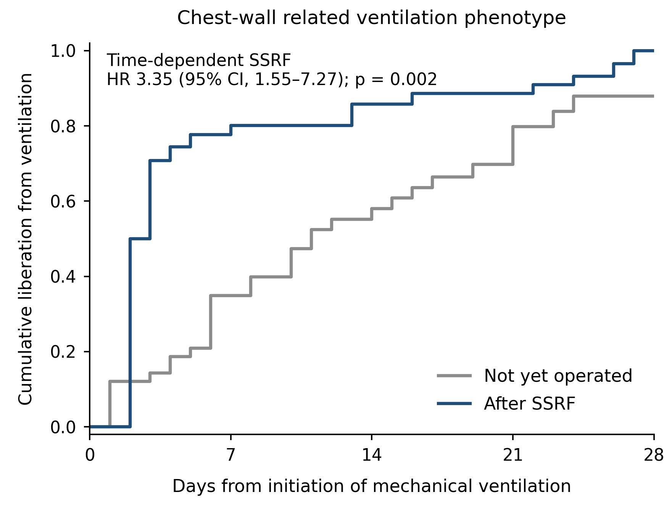
Figure S1. Liberation from mechanical ventilation within the chest-wall related stratum. Time to liberation, measured from the initiation of ventilation, with SSRF handled as a landmark-free time-dependent exposure, so that each patient contributes to the not-yet-operated curve until the day of fixation and to the post-SSRF curve thereafter; the curves are therefore extended (Simon–Makuch-type) rather than conventional Kaplan–Meier estimates. The corresponding adjusted hazard ratio was 3.35 (95% CI, 1.55–7.27; p=0.002).

