Plant-based dietary transitions shift global food production from large to small farms

Supplementary Material

Supplementary Methods

This supplementary information documents the spatial price equilibrium model (SPEM) that generates the crop production and bilateral trade flow projections used in our analysis. The model solves for equilibrium prices, quantities, and bilateral flows for 32 crop commodities from 2020 to 2050 in fiver-year steps. Full model details are provided in Jain et al. (2026), the sections below outline the components needed to interpret the results of this analysis.

S1. Input data
The model is built on several input datasets. First, we construct a baseline of crop production and trade flows. Second, we construct dietary scenarios representing five consumption pathways, including food, feed, and other uses. Third, we incorporate crop yield projections, along with demand and supply elasticities. Fourth, we assemble producer prices and bilateral trade cost data.

S1.1 Production and trade baseline
National production and bilateral trade flows are obtained from FAOSTAT (FAO, 2025) and harmonised in two steps before use. A reliability index procedure (Gehlhar, 1996) is used to resolve discrepancies between the volume of trade reported by the importer and exporter for the same flow, retaining the volume from the partner whose overall reporting is more consistent. A re-export algorithm (Croft et al., 2018) then ensures that no country’s reported exports exceed what it produces plus imports, and links the source of production with the destination of import. Harmonised flows are aggregated from FAO commodities to the 32 model crop categories and averaged over 2013-2017 and 2018-2022. The earlier window initializes trade patterns, and the later window serves as the calibration target (see S2). Supplementary Table 1 provides the complete mapping between 13 EAT-Lancet food groups, 32 IMPACT crop categories, and FAO commodities (~120 produced, over 150 traded).

S1.2 Dietary scenarios
Consumption pathways are derived from the EAT-Lancet dataset (Willett et al., 2019), which provides consumption estimates (per person per day) by food group, country, and year. These food groups are broad dietary categories (such as wheat, fruits, vegetable oils, beef): 13 of these are vegetal foods and are mapped to the 32 crop categories modelled here, while 7 animal-product food groups are used to derive feed demand (below). We use five dietary scenarios: benchmark (i.e., business-as-usual, BMK), flexitarian (FLX), pescetarian (PSC), vegetarian (VEG), and vegan (VGN); and the 2500 kcal scenario for this analysis. Rather than imposing an instantaneous switch, we phase each diet in linearly from a wholly business-as-usual composition in 2020 to full adoption of the target diet by 2050, interpolated at five-year intervals. Per-capita intake is combined with SSP2 population projections to estimate total food demand.

Although our analysis is limited to vegetal commodities, we track animal-product consumption under each dietary scenario to derive feed requirements. For terrestrial animal products (beef, milk, lamb, poultry, eggs, and pork), we use country-specific feed conversion ratios (FCRs) from Herrero et al. (2013). Feed conversion ratios for seafood products are from Tilman and Clark (2014), which provide FCRs grouped by eight economic groups. Countries are assigned to economic groups based on 2030 GDP projections in the EAT-Lancet dataset. We assume 50% of seafood is farmed globally and compute feed requirements accordingly (FAO, 2020).

We incorporate trade in animal products when computing feed requirements: production and trade data for terrestrial animal products are processed from FAOSTAT (FAO, 2025) and that for seafood are processed from FishStat (FAO, 2024). Supplementary Table 2 provides a description of commodities from FAOSTAT and FishStat used for estimating trade flows for animal products. We assume animal product trade patterns remain constant across years and dietary scenarios, and use the processed flows to estimate, for each country, the shares of animal product demand met by domestic production vs imports. For each scenario and animal product, feed demand is assigned to the producing country, using post-trade supply allocations and that country’s FCRs.

We also include demand for ‘other uses’, i.e., industrial use, seed, and waste. For each country and food group, ‘other’ quantities are obtained from FAOSTAT food balance sheets (FBS) and supply utilization accounts (SUA) and averaged over 2018-2022. Supplementary Table 3 provides the mapping between EAT-Lancet food groups and FAOSTAT sources (FBS or SUA) used for computing other uses. Demand for other uses is assumed to grow at the same rate as food and feed demand under the BMK dietary scenario, and this trajectory is held constant across dietary scenarios.

Total quantity demanded is calculated as the sum of demand for food, feed, and other uses. For each food group, diet, country, and year, we compute a demand change ratio from the EAT-Lancet projections, i.e., projected demand divided by its 2020 level. Each food group corresponds to one or more of the 32 modelled crop categories (Supplementary Table 4), so the demand change ratio computed for a food group is applied to every crop category it contains. These ratios are used to parameterize the demand-side scenarios for forward modelling (see S2.3).

S1.3 Climate pathway and elasticities
Yield and supply projections are obtained from IFPRI’s IMPACT model (Robinson et al., 2024), under RCP 7.0, on SSP2 socioeconomic assumptions. These are averaged across five General Circulation Models (GFDL, IPSL, MPI, MRI, UKESM) to limit sensitivity to individual model biases. These trajectories incorporate projected technological progress, onto which climate impacts are overlaid (Rosegrant et al., 2024). Supply projections from IMPACT reflect both area and yield changes under business-as-usual demand. For each crop category, country, and year, we compute a supply change ratio and a yield change ratio from the IMPACT projections, i.e. projected supply/yield divided by their 2020 level. These ratios are used to parameterize the supply-side scenarios for forward modelling (see S2.3). IMPACT provides trajectories under several climate pathways, but we use RCP 7.0 throughout this analysis, and the results are largely insensitive to this choice (Jain et al., 2026).

Additionally, we use demand and supply elasticities given by the IMPACT model (Sulser et al., 2026). Demand elasticities vary by region, crop, and year, while supply elasticities vary by region and crop.

S1.4 Producer prices and trade cost data
Farm-gate producer prices are taken from FAOSTAT where reported, and gap-filled elsewhere with a regression on GDP, production, yield, and regional fixed effects (Jain et al., 2026). Bilateral transport costs are obtained from Verschuur et al. (2025), which estimates the cost to ship agricultural commodities between any pair of countries. These costs incorporate hinterland transportation from farm to port or border, port handling and fees, maritime transport cost, intermodal transfers, and custom and border compliance. Bilateral ad valorem tariff rates are obtained from the MAcMap-HS6 database (Guimbard et al., 2012), at the HS6 product level and averaged across the HS codes mapped to each model crop. Supplementary Table 5 provides the HS code mapping for each crop category.

S1.5 Geographic coverage

The underlying IMPACT framework covers 158 countries and country groups (e.g., Caribbean islands); of these, 157 are covered in the EAT-Lancet dataset, and 153 have corresponding data in FAOSTAT. These constitute the coverage of the trade model in Jain et al. (2026). This analysis additionally requires spatially explicit farm-size data, restricting it to the 146 countries and country groups for which production, trade, and farm-size data are jointly available. These 146 units comprise 158 individual countries, of which 19 are aggregated into 7 groups, to result in 146 countries and country groups (Supplementary Table 6).

S2. Spatial price equilibrium model
The model follows the Enke-Samuelson-Takayama-Judge formulation for homogeneous goods (Takayama & Judge, 1964). A separate SPEM is set up for each of the 32 crops ($c$) considered, without considering cross-commodity substitution effects. The reference period ($t$) for the model is the 2018-2022 average trade network, while the previous period ($t-1$) is the 2013-2017 average trade network. Below, we describe the trade cost formulation used, the calibration process, and the model setup for projecting forward.

S2.1 Trade cost formulation
Total trade costs ($TTC$) comprise transport costs $\left(C^{transport}\right)$, tariff costs $\left(C^{tariff}\right)$, market entry costs $\left(C^{entry}\right)$, and a calibrated residual term ($C^{calib})$ that absorbs trade-cost elements and non-cost frictions (geopolitics, agreements) not otherwise modelled. We distinguish between trade costs at the intensive margin (for region pairs that already trade) and at the extensive margin (for region pairs that do not currently trade).
$TTC_{int}=\left(C_{i,j,t,c}^{tariff}+C_{i,j,c}^{calib}\right)×T_{i,j,t,c}+\left[\frac{ε}{1+ε}\right]×C_{i,j,c}^{transport}×{\left(\frac{T_{i,j,t,c}}{T_{i,j,t-1,c}}\right)}^{\frac{1+ε}{ε}}×T_{i,j,t,c}$
$TTC_{ext}= \left(C_{i,j,t,c}^{tariff}+C_{i,j,c}^{calib}+C_{i,j,c}^{transport}+C_{i,j,t,c}^{entry}\right)×T_{i,j,t,c}+0.5×σ×T_{i,j,t,c}^{2}$

where $T_{i,j,t,c}$ is the bilateral trade flow from region $i$ to region $j$ for crop $c$ at time $t$, and $T_{i,j,t-1,c}$ is the trade flow in the previous period. The parameters $ε$ and $σ$ reflect non-linear trade expansion costs that capture the logistics costs of expanding trade beyond existing capacity and enable persistence in existing supply networks (Janssens et al., 2022). Higher $σ$ and lower $ε$ make it costlier to source from new suppliers (extensive) and to increase trade from existing suppliers (intensive), respectively.

Transport costs $\left(C^{transport}\right)$ are time-invariant and include hinterland transport, border compliance, intermodal handling, port fees, maritime transport, and customs compliance (Verschuur et al., 2025). Tariff costs are calculated using the ad-valorem tariff rate $\left(adv_{i,j,c}\right)$.

$C_{i,j,t,c}^{tariff}=adv_{i,j,c}×(P_{i,t,c}^{producer}+C_{i,j,c}^{transport})$

Market entry costs for new trade links are set at 20% of producer prices, following Verschuur et al. (2026).

$C_{i,j,t,c}^{entry}=0.2×P_{i,t,c}^{producer}$

Trade between regions occurs when the sum of producer price and trade costs equals the consumer price in the destination region.

Intensive margin $\left(P_{i,t,c}^{producer}+C_{i,j,t,c}^{tariff}+C_{i,j,c}^{calib}\right)+C_{i,j,c}^{transport}×{\left(\frac{T_{i,j,t,c}}{T_{i,j,t-1,c}}\right)}^{\frac{1}{ε}}=P_{j,t,c}^{consumer}$
Extensive margin $\left(P_{i,t,c}^{producer}+C_{i,j,t,c}^{tariff}+C_{i,j,c}^{calib}+C_{i,j,c}^{transport}+C_{i,j,t,c}^{entry}\right)+σT_{i,j,t,c}=P_{j,t,c}^{consumer}$

S2.2 Baseline calibration

Calibration follows the bi-level programming approach of Verschuur et al. (2026), which was introduced by Jansson and Heckelei (2009). The calibration uses two time periods: 2013-2017 $(t-1)$ to initialize trade patterns and 2018-2022 $(t)$ as the calibration target.

The inner problem (first calibration) serves as the input to the outer problem (second calibration) and minimizes total trade costs across all bilateral flows.

$minimize \sum_{i,j}{TTC_{i,j,t,c}}$

subject to market equilibrium and non-negativity constraints:

$e_{i,j,c}+\sum_{j}{\left(T_{i,j,t,c}-T_{j,i,t,c}\right)=0}$

$T_{i,j,t,c}≥0$

where $e$ is the excess demand (consumption $-$ domestic production). This results in trade flows based on minimum trade costs, assuming homogenous producer price across countries. These flows are then used as inputs to the outer problem.

The outer problem then jointly minimizes the total deviations from observed trade flows, producer prices, and transport costs, plus a price chain residual penalty ($pen$).

The total deviation is calculated as follows. Variables with hats denote observed values, and $w_{t}$, $w_{p}$, and $w_{tr}$ are the weights associated with the errors from trade flows, producer prices, and transport costs, respectively.

$z=w_{t}\sum_{ij}{{\left(T_{i,j,t,c}-{\hat{T}}_{i,j,t,c}\right)}^{2}+}w_{p}\sum_{i}{{\left(P_{i,t,c}-{\hat{P}}_{i,t,c}\right)}^{2}+}w_{tr}\sum_{ij}{{\left(C_{i,j,t,c}^{transport}-{{\hat{C}}^{transport}}_{i,j,t,c}\right)}^{2}}$

The price chain residual ($π$) is added to the price chain formula at the intensive and extensive margin as follows.
Intensive margin $\left(P_{i,t,c}^{producer}+C_{i,j,t,c}^{tariff}+C_{i,j,c}^{calib}\right)+C_{i,j,c}^{transport}×{\left(\frac{T_{i,j,t,c}}{T_{i,j,t-1,c}}\right)}^{\frac{1}{ε}}=P_{j,t,c}^{consumer}+π_{i,j,t,c}$
Extensive margin $\left(P_{i,t,c}^{producer}+C_{i,j,t,c}^{tariff}+C_{i,j,c}^{calib}+C_{i,j,c}^{transport}+C_{i,j,t,c}^{entry}\right)+σT_{i,j,t,c}=P_{j,t,c}^{consumer}+π_{i,j,t,c}$

The total penalty is calculated as:
$pen=μ\sum_{ij}{\left(π_{i,j,t,c}×T_{i,j,t,c}\right)}$

where $μ$ is the weight associated with the price chain residual penalty. Finally, the objective function that the outer problem minimizes becomes:

$minimize zz=z+pen$
with $π_{i,j,t,c}≥0$

The outer problem is solved iteratively, with the penalty weight μ increasing to force $pen$ to go towards zero. Calibration is achieved once $zz$ converges, yielding calibrated values of producer prices, consumer prices, trade flows, transport costs, and the calibration constant $C^{calib}$.

Supplementary Table 7 reports calibration performance for all 32 crop categories.

S2.3 Projection framework

To project future trade patterns, we shift country-level demand and supply curves to reflect scenario-specific changes in food demand and agricultural production. Our long-term framework assumes markets fully adjust to structural changes over decadal timescales. Stocks are not modelled, and each year (2025, 2030, 2035, 2040, 2045, 2050) is solved sequentially, with each period initialised from the previous period's solution.

For projection years $t>2020$, we initialize quantities and prices from the previous period's equilibrium solution $(t-5)$, adjusted by scenario-specific scaling factors.

Quantity demanded $D$ is scaled using demand change ratios:

$$D_{i,t,c}=D_{i,t-5,c}×\left(\frac{r_{i,t,c}^{demand}}{r_{i,t-5,c}^{demand}}\right)$$

where $r_{i,t,c}^{demand}$ is the demand scaling factor for region $i$, crop $c$, in year $t$ relative to 2020.

Quantity supplied $S$ is scaled using supply change ratios:

$$S_{i,t,c}=S_{i,t-5,c}×\left(\frac{r_{i,t,c}^{supply}}{r_{i,t-5,c}^{supply}}\right)$$

where $r_{i,t,c}^{supply}$ is the supply scaling factor for region $i$, crop $c$, in year $t$ relative to 2020.

Producer prices are adjusted to reflect both supply expansion (movement along the supply curve) and yield changes (shift of the supply curve):

$$P_{i,t,c}^{producer}=P_{i,t-5,c}^{producer}×{\left[1+\frac{1}{ζ_{i,c}}×\left(\frac{r_{i,t,c}^{supply}}{r_{i,t-5,c}^{supply}}-1\right)\right]}/{\left(\frac{r_{i,t,c}^{yield}}{r_{i,t-5,c}^{yield}}\right)}$$

where $ζ_{i,c}$ is the (time-invariant) supply elasticity. The numerator captures the price change associated with movements along the supply curve as quantities expand or contract. The denominator captures the price change resulting from shifts of the supply curve driven by yield improvements or declines.

Consumer prices are initialised from the previous period’s equilibrium values.

Demand elasticities are updated for time period $t$, based on IMPACT.

Using the initialised values, we compute demand and supply curves for the new time period. Consumer prices follow the demand curve.
$$α_{i,t,c}-β_{i,t,c}{×D}_{i,t,c}≤P_{i,t,c}^{consumer}$$

where the slope and intercept are derived from the initialised values:
$β_{i,t,c}=\frac{P_{i,t,c}^{consumer}}{D_{i,t,c}×η_{i,t,c}}$
$α_{i,t,c}=P_{i,t,c}^{consumer}+β_{i,t,c}×D_{i,t,c}$

Producer prices follow the supply curve:
$$γ_{i,t,c}+δ_{i,t,c}{×S}_{i,t,c}≥P_{i,t,c}^{producer}$$

where the slope and intercept are derived from the initialised values:
$δ_{i,t,c}=\frac{P_{i,t,c}^{producer}}{S_{i,t,c}×ζ_{i,c}}$
$$γ_{i,t,c}=P_{i,t,c}^{producer}-δ_{i,t,c}×S_{i,t,c}$$

S2.4 Trade constraints
Without trade constraints, the most efficient trade solution typically concentrates imports on the lowest-cost producers. Trade constraints are hence used to impose floors on self-sufficiency and ceilings on dependence on any single supplier. For each projection year t > 2020, minimum domestic supply must satisfy:

$$T_{i,i,t,c}≥λ^{SS}×\left(\frac{T_{i,i,2020,c}}{D_{i,2020,c}}\right)×D_{i,t,c}$$

where $λ^{SS}$ is the self-sufficiency preservation parameter. This ensures domestic supply maintains at least $λ^{SS}$ of its 2020 share of demand.

Maximum imports from any single trading partner are constrained by the tighter of two ceilings. The first limits a partner’s share of the importer’s demand:

$$T_{j,i,t,c} ≤ max\left(λ^{SD},\frac{T_{j,i,2020,c}}{D_{i,2020,c}}\right)×D_{i,t,c}$$

where $λ^{SD}$ is the supplier diversification parameter. This limits dependence on any single foreign supplier to either $λ^{SD}$ of demand or the 2020 share, whichever is larger.

The second limits a partner’s share of the importer’s imports:

$$T_{j,i,t,c} ≤ max\left(λ^{ID},\frac{T_{j,i,2020,c}}{M_{i,2020,c}}\right)×\hat{M_{i,t,c}}$$

where $λ^{ID}$ is the import diversification parameter, $M_{i,2020,c}$ is a country’s total imports in 2020, and $\hat{M_{i,t,c}}$ is a reference import volume for year $t$. This limits dependence on any single foreign supplier to either $λ^{ID}$ of total imports or the 2020 share, whichever is larger. $\hat{M_{i,t,c}}$ is taken as the largest of imports from time step $t-1$ scaled by the demand scaling factor, the demand-supply gap in time step $t$, and 2% of demand, the last acting as a floor so that near-self-sufficient countries are not blocked from importing.

The second ceiling prevents concentration of a country’s imports on a single partner in cases where the demand-share ceiling is slack.

In this analysis, we use $λ^{SS}$ = 0.7, $λ^{SD}$ = 0.3, and $λ^{ID}$ = 0.5.

S2.5 Model solution

The model solves for equilibrium by finding bilateral trade flows, prices, and quantities that satisfy the following conditions.

Interregional trade must be constrained by supply and demand.

$$S_{i,t,c}=\sum_{j}{T_{i,j,t,c}}$$
$$D_{i,t,c}=\sum_{j}{T_{j,i,t,c}}$$

In addition, the price chain relationship at the intensive and extensive margin must hold.

Intensive margin $\left(P_{i,t,c}^{producer}+C_{i,j,t,c}^{tariff}+C_{i,j,c}^{calib}\right)+C_{i,j,c}^{transport}×{\left(\frac{T_{i,j,t,c}}{T_{i,j,t-1,c}}\right)}^{\frac{1}{ε}}≥P_{j,t,c}^{consumer}$
Extensive margin $\left(P_{i,t,c}^{producer}+C_{i,j,t,c}^{tariff}+C_{i,j,c}^{calib}+C_{i,j,c}^{transport}+C_{i,j,t,c}^{entry}\right)+σT_{i,j,t,c}≥P_{j,t,c}^{consumer}$

The model is implemented in Python using the Pyomo optimization framework and solved using the IPOPT nonlinear solver.

Supplementary Figures
Supplementary Figure 1. 2020 baseline volume and small-farm production and consumption shares, by region and crop group. a) Production volume (million tonnes). b) Consumption volume (million tonnes). c) Small-farm share of production (% of total production from farms <5 ha). d) Small-farm share of consumption (% of total consumption from farms <5 ha).
Region abbreviations: CNE Central-Northern Eurasia, EAP East Asia Pacific, EUR Europe, LAC Latin America and Caribbean, MEN Middle East-North Africa, NAM North America, SAS South Asia, SSA Sub-Saharan Africa.
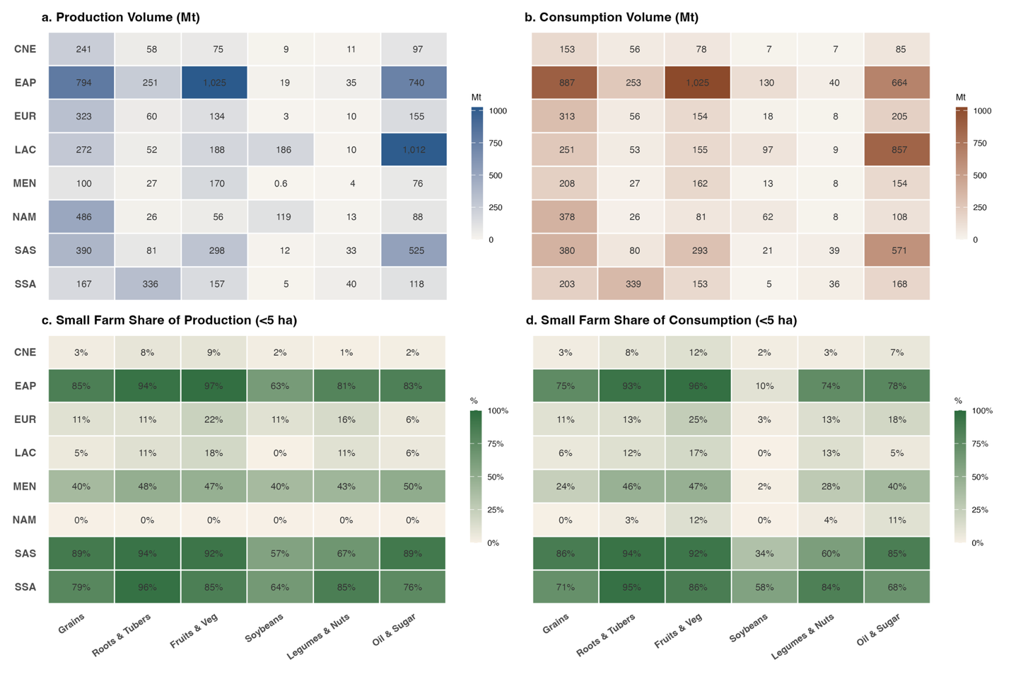

Supplementary Figure 2. Distribution of country-level percent change in production volume from 2020 to 2035 by farm-size class (assuming evolving farm-size distributions). Boxes show the median and interquartile range (25th-75th percentile) of country-level percent change (n = 146 countries). The y-axis is truncated for visibility; some outliers fall outside this range.
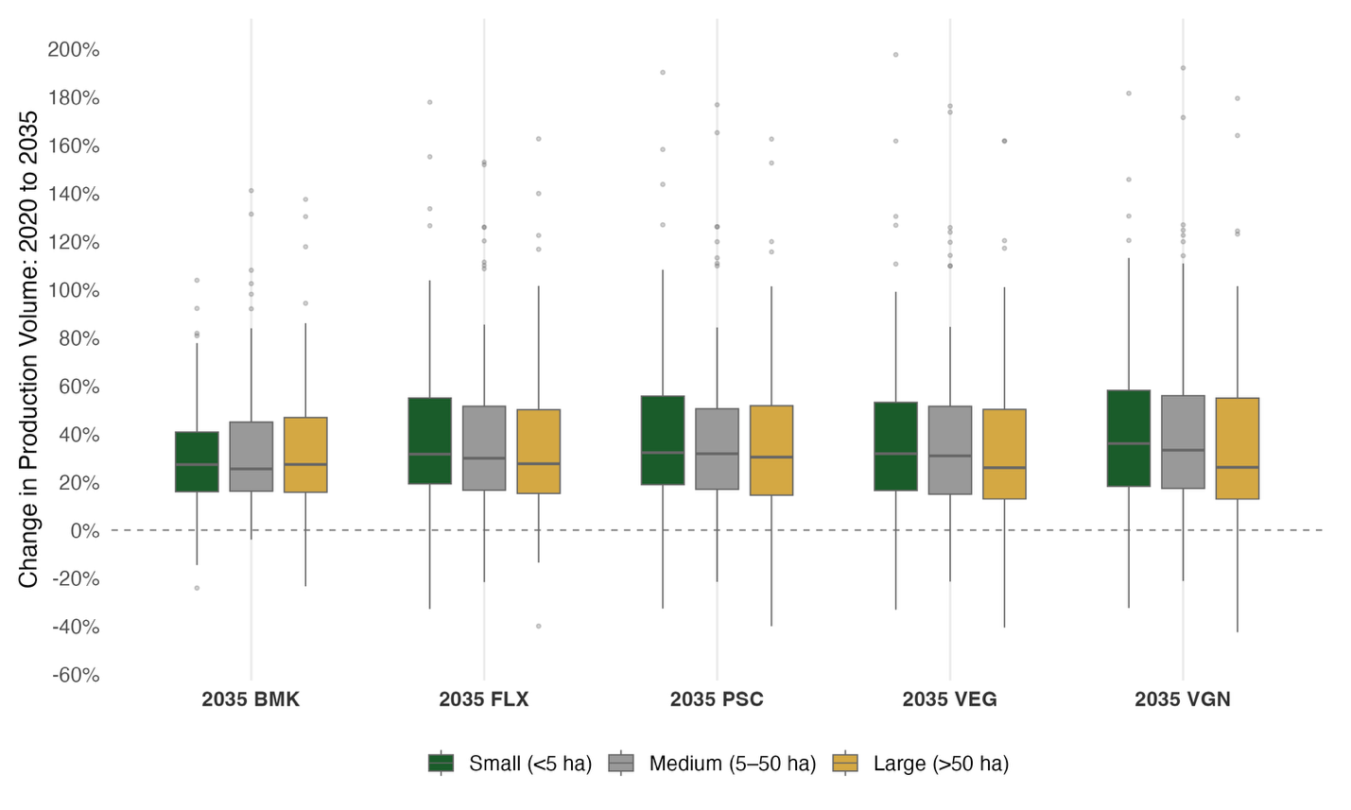

Supplementary Figure 3. Distribution of country-level percent change in production volume from 2020 to 2050 by farm-size class (assuming static farm-size distributions). Boxes show the median and interquartile range (25th-75th percentile) of country-level percent change (n = 146 countries). The y-axis is truncated for visibility; some outliers fall outside this range.
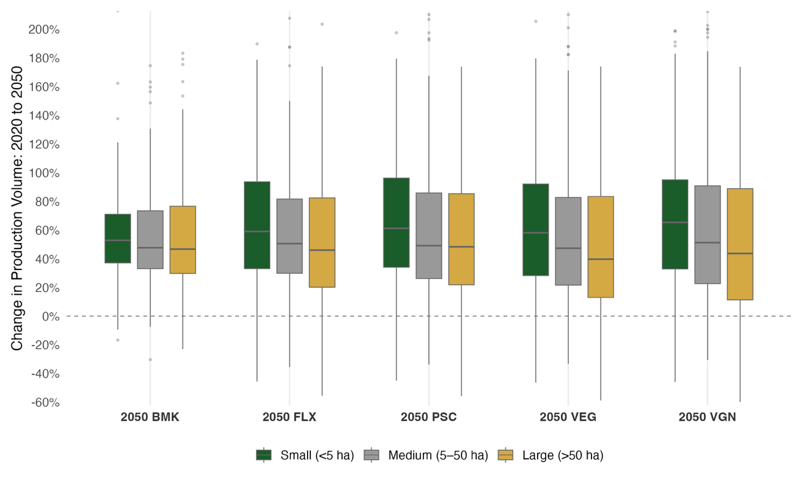

Supplementary Figure 4. Share of total production by farm-size class (11 bins) in 2020 and under each 2050 dietary scenario, assuming a) evolving, and b) static farm-size distributions. Note that the 20-50 ha class accounts for <1% of production and is not visible.
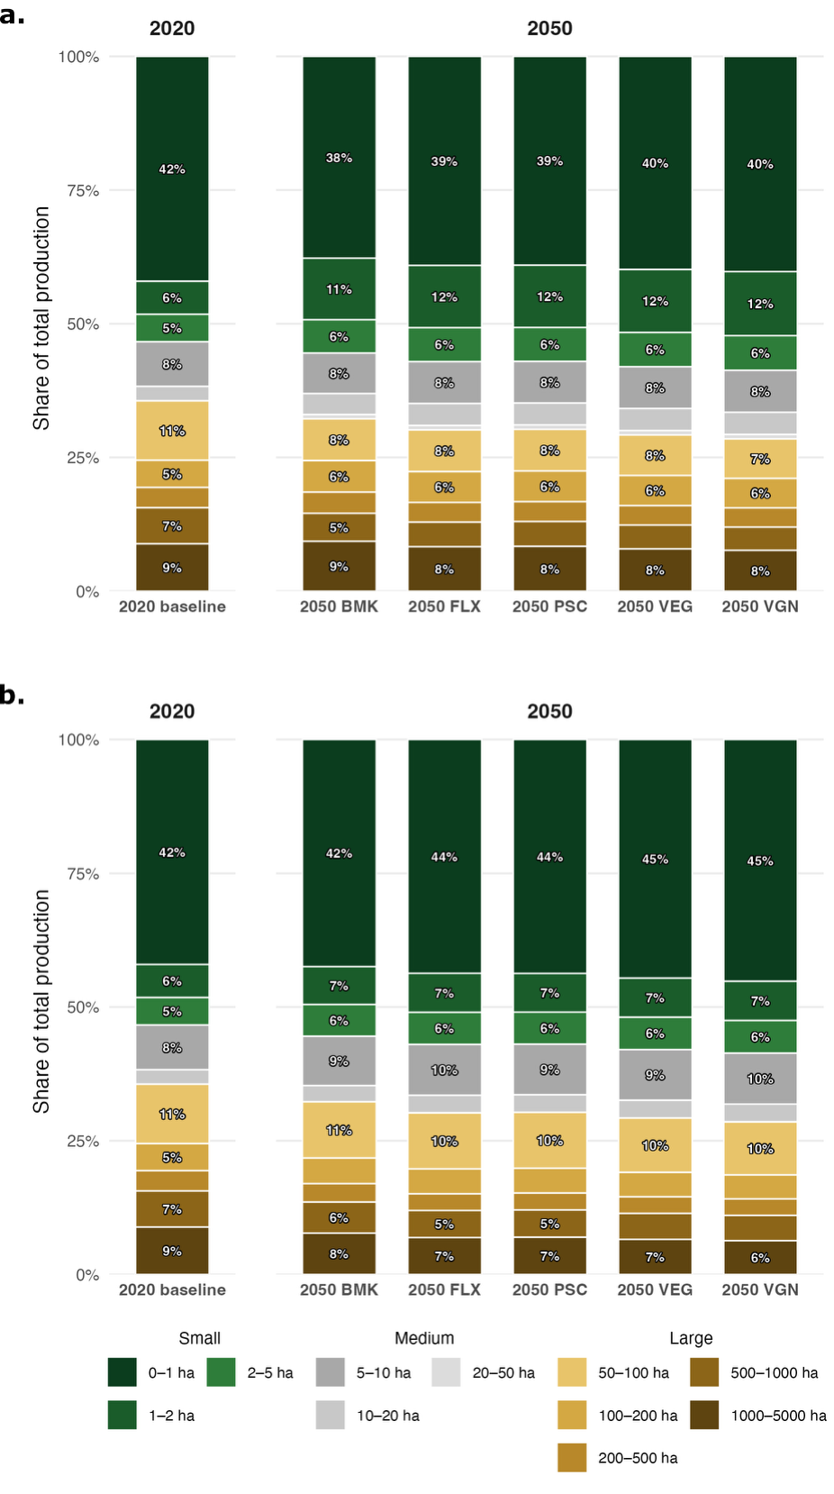

Supplementary Figure 5. Share of global production by farm size and crop group, comparing 2020 with five 2050 dietary scenarios (assuming evolving farm-size distributions).
Dietary scenarios: BMK benchmark (business-as-usual), FLX flexitarian, PSC pescatarian, VEG vegetarian, VGN vegan.
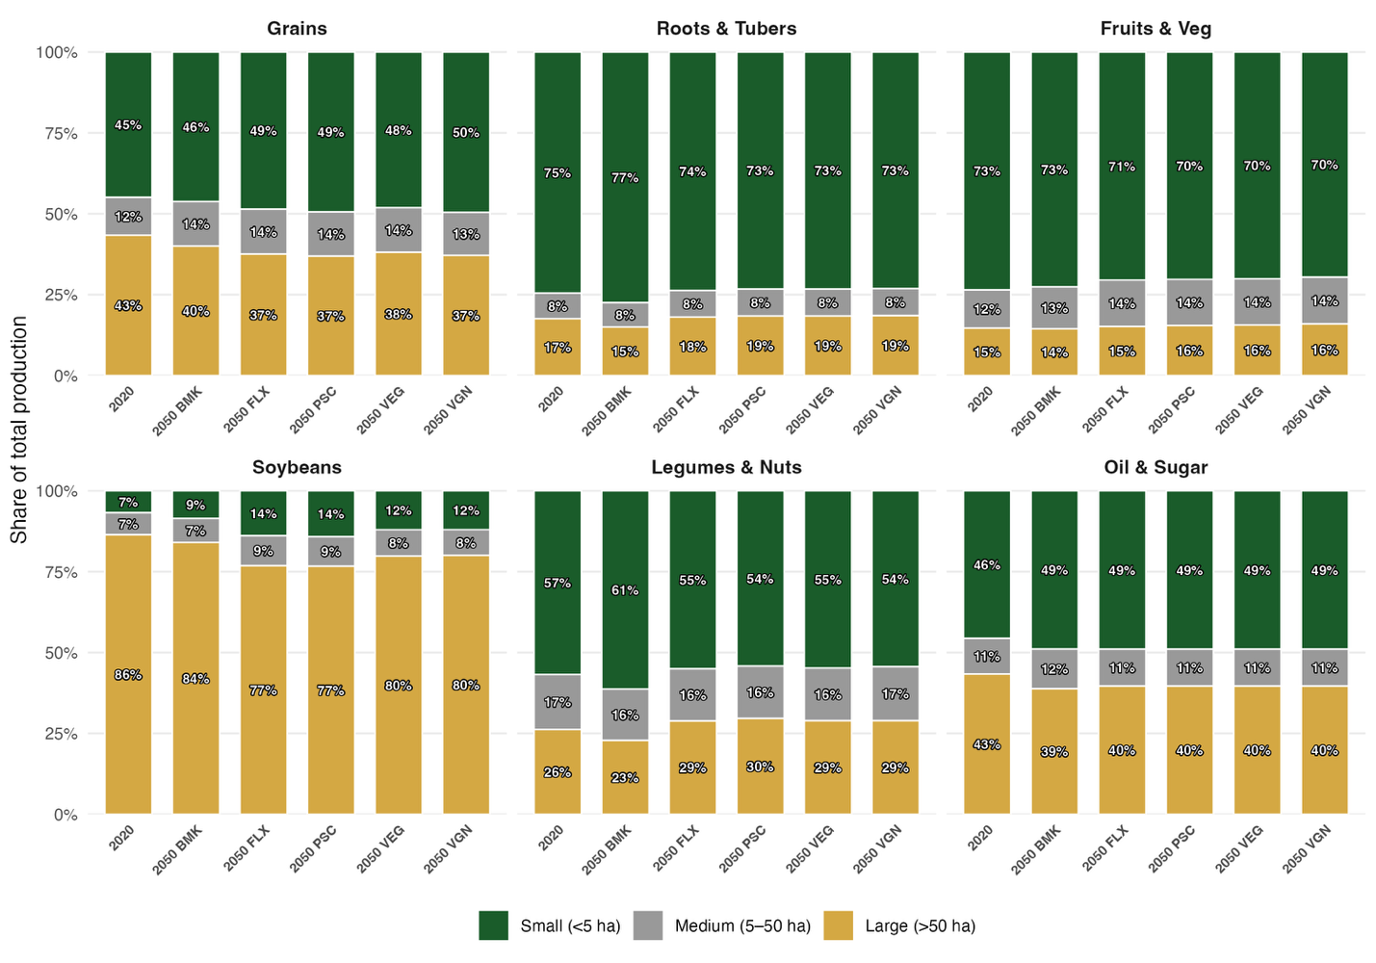

Supplementary Figure 6. Global production volume (million tonnes) by crop group, for 2020 and five 2050 dietary scenarios (assuming evolving farm-size distributions). The change from the 2020 baseline is decomposed into contributions from small (<5 ha), medium (5–50 ha), and large (>50 ha) farms.
Dietary scenarios: BMK benchmark (business-as-usual), FLX flexitarian, PSC pescatarian, VEG vegetarian, VGN vegan.
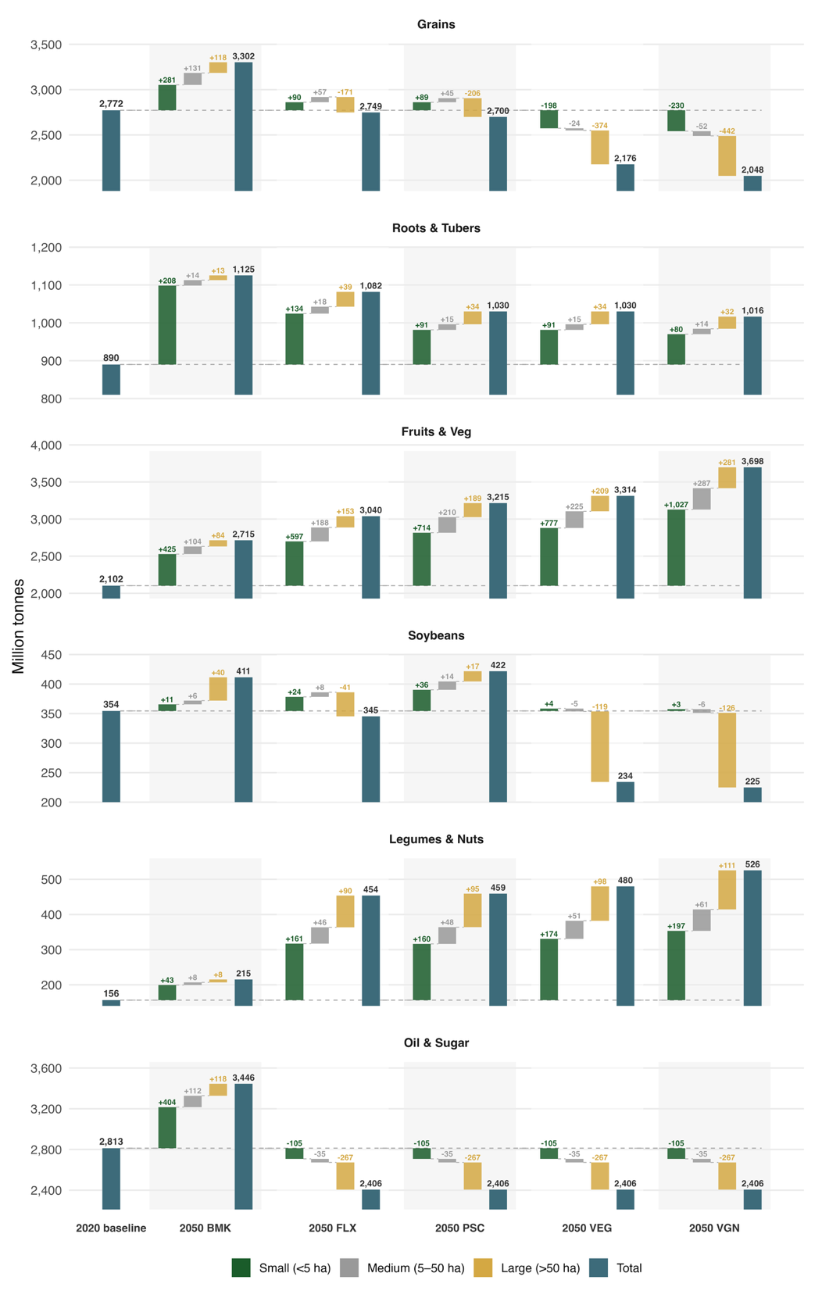
Supplementary Figure 7. Share of production (%) by region and crop group, from small (<5 ha) and large (>50 ha) farms, comparing 2020 with the range across 2050 dietary scenarios (assuming evolving farm-size distributions).
Dietary scenarios: BMK benchmark (business-as-usual), FLX flexitarian, PSC pescatarian, VEG vegetarian, VGN vegan.
Region abbreviations: CNE Central-Northern Eurasia, EAP East Asia Pacific, EUR Europe, LAC Latin America and Caribbean, MEN Middle East-North Africa, NAM North America, SAS South Asia, SSA Sub-Saharan Africa.
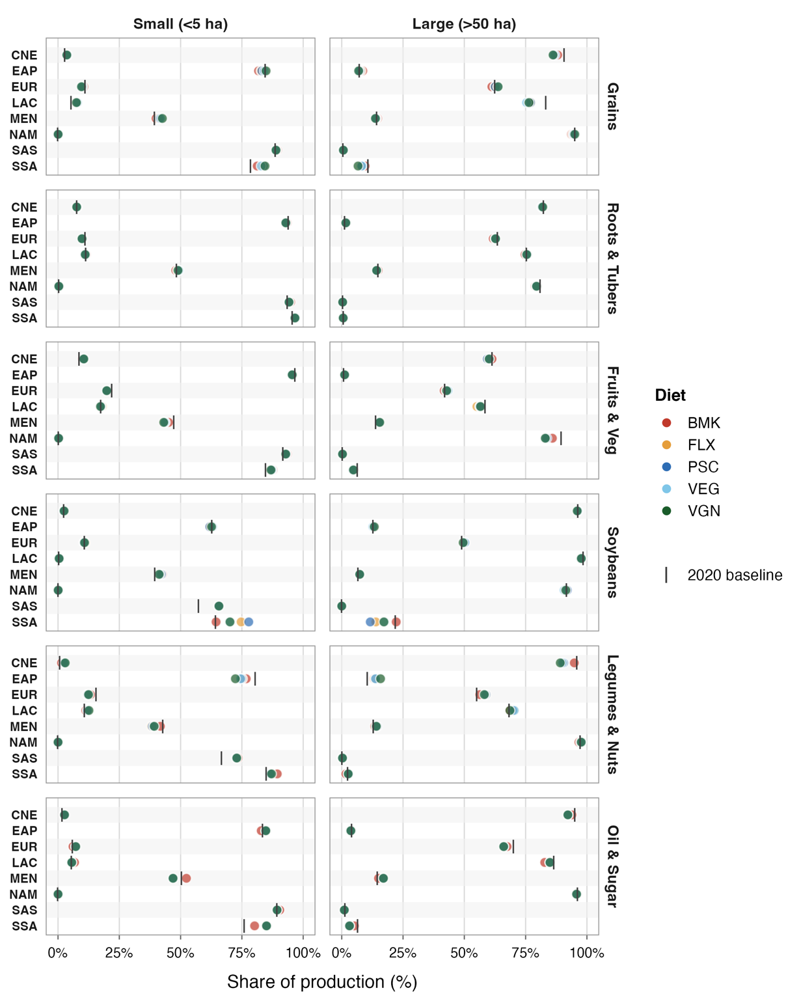
Supplementary Figure 8. Production volume by region and crop group, from small (<5 ha) and large (>50 ha) farms, comparing 2020 with the range across 2050 dietary scenarios (assuming evolving farm-size distributions).
Dietary scenarios: BMK benchmark (business-as-usual), FLX flexitarian, PSC pescatarian, VEG vegetarian, VGN vegan.
Region abbreviations: CNE Central-Northern Eurasia, EAP East Asia Pacific, EUR Europe, LAC Latin America and Caribbean, MEN Middle East-North Africa, NAM North America, SAS South Asia, SSA Sub-Saharan Africa.
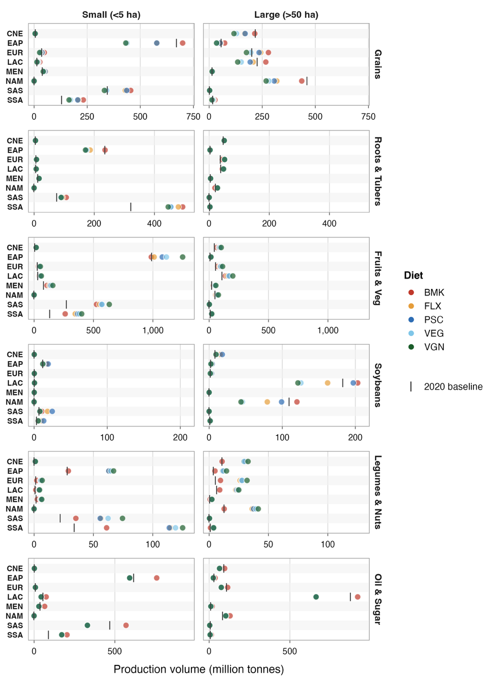
Supplementary Figure 9. Production volume by region and crop group, comparing 2020 with the range across 2050 dietary scenarios.
Dietary scenarios: BMK benchmark (business-as-usual), FLX flexitarian, PSC pescatarian, VEG vegetarian, VGN vegan.
Region abbreviations: CNE Central-Northern Eurasia, EAP East Asia Pacific, EUR Europe, LAC Latin America and Caribbean, MEN Middle East-North Africa, NAM North America, SAS South Asia, SSA Sub-Saharan Africa.
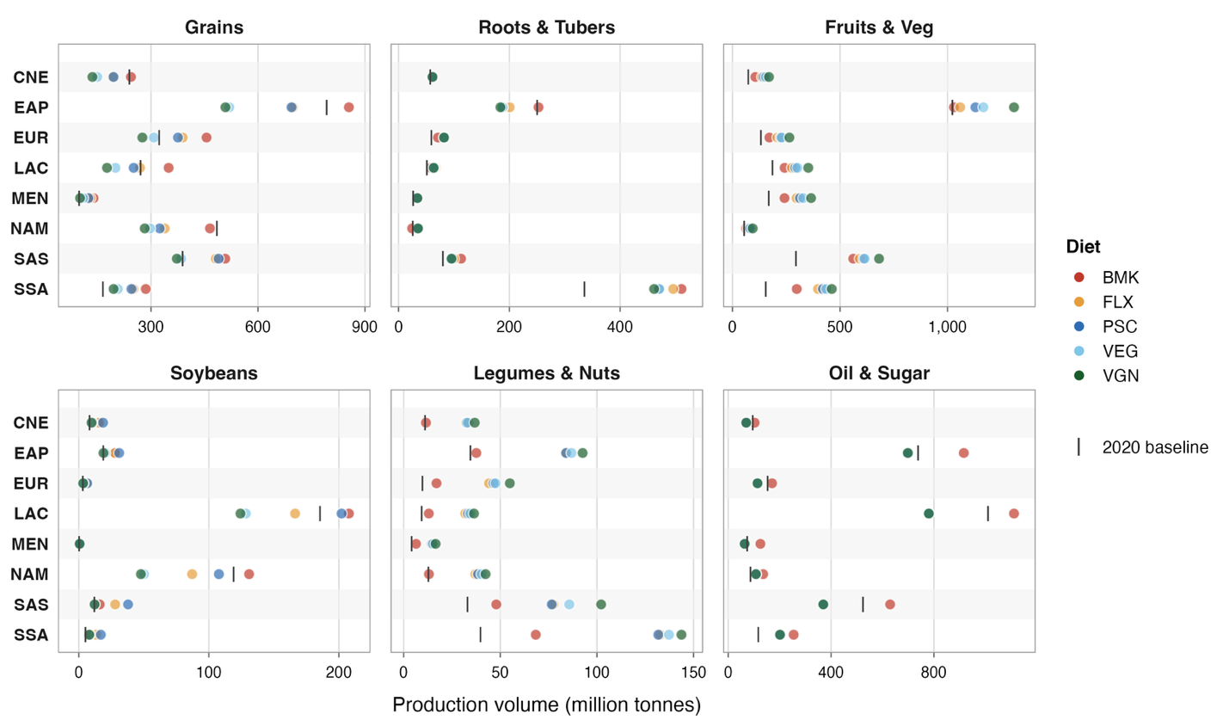

Supplementary Figure 10. Consumption volume by region and crop group, from small (<5 ha) and large (>50 ha) farms, comparing 2020 with the range across 2050 dietary scenarios (assuming evolving farm-size distributions).
Dietary scenarios: BMK benchmark (business-as-usual), FLX flexitarian, PSC pescatarian, VEG vegetarian, VGN vegan.
Region abbreviations: CNE Central-Northern Eurasia, EAP East Asia Pacific, EUR Europe, LAC Latin America and Caribbean, MEN Middle East-North Africa, NAM North America, SAS South Asia, SSA Sub-Saharan Africa.
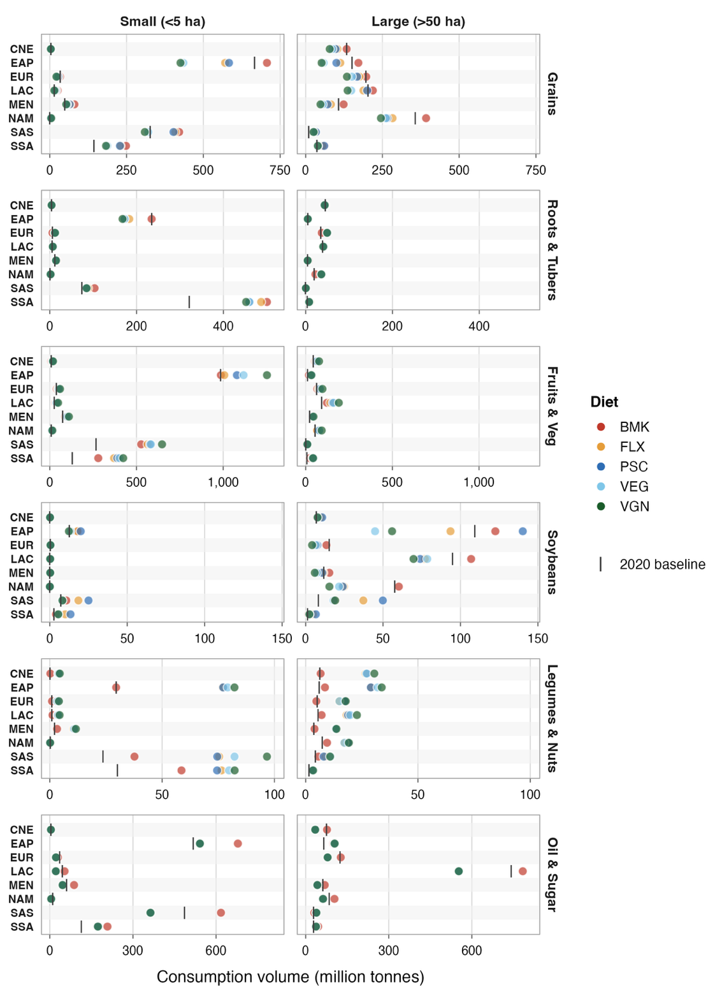
Supplementary Figure 11. Consumption volume by region and crop group, comparing 2020 with the range across 2050 dietary scenarios.
Dietary scenarios: BMK benchmark (business-as-usual), FLX flexitarian, PSC pescatarian, VEG vegetarian, VGN vegan.
Region abbreviations: CNE Central-Northern Eurasia, EAP East Asia Pacific, EUR Europe, LAC Latin America and Caribbean, MEN Middle East-North Africa, NAM North America, SAS South Asia, SSA Sub-Saharan Africa.
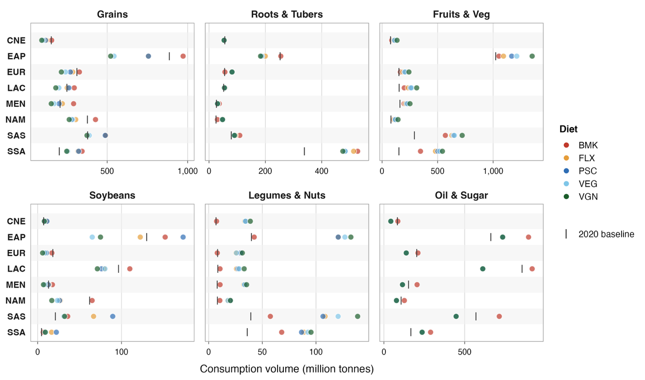

Supplementary Figure 12: Small-farm (<5 ha) share of national consumption in 2020 and 2050, by country. Each country shows its 2020 value (dark) and 2050 value (light), with the connecting line indicating the change; countries are ordered by their 2020 share. The left panel shows 2050 under the business-as-usual scenario (BMK) and the right panel under the flexitarian scenario (FLX). OECD countries are marked with crosses and non-OECD countries with circles.
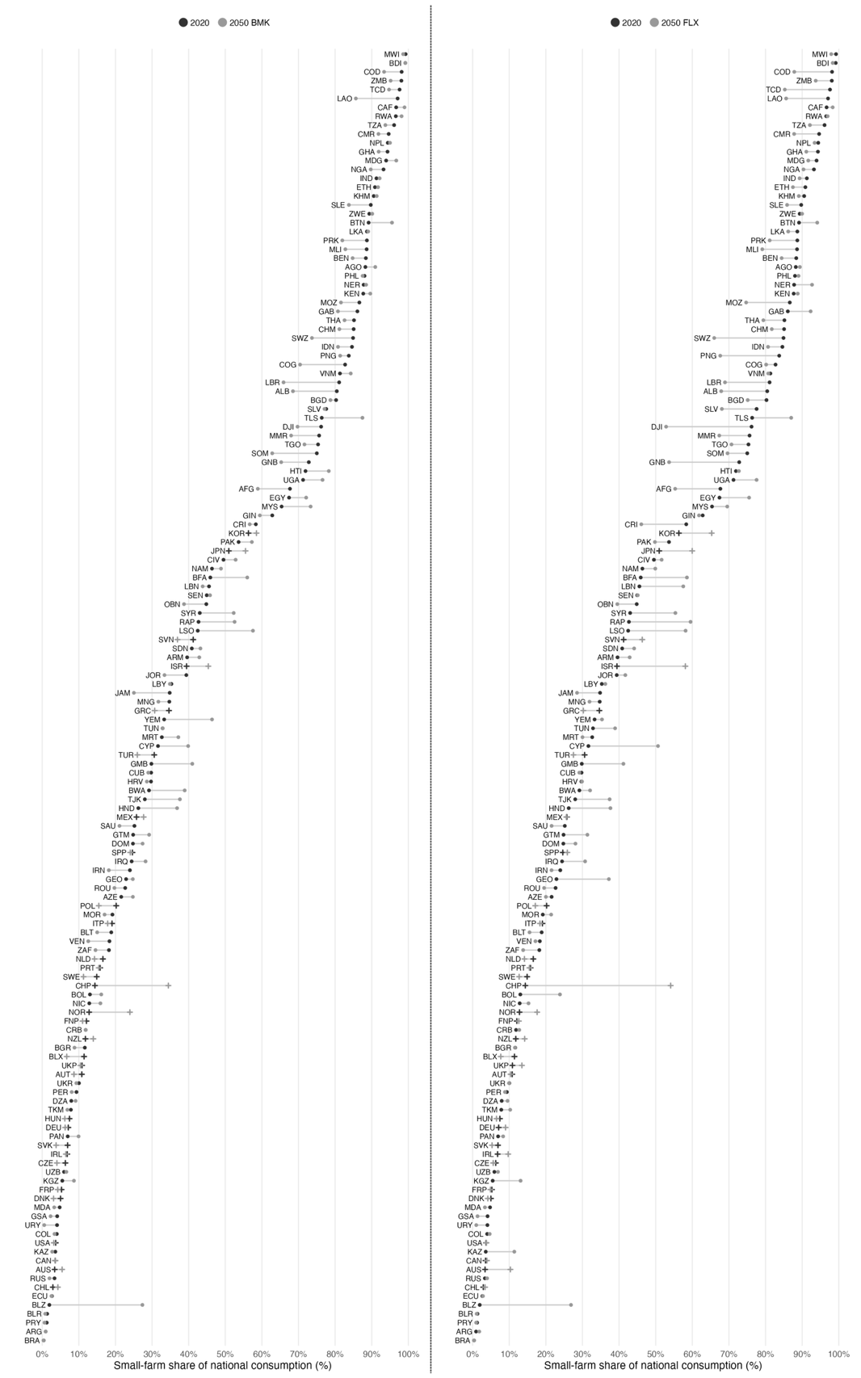
Supplementary Figure 13. 2020 trade flows between regions, by farm size. Each chord represents bilateral trade volume between two regions; chord thickness encodes flow magnitude. Colour denotes the exporting region.
Region abbreviations: CNE Central-Northern Eurasia, EAP East Asia Pacific, EUR Europe, LAC Latin America and Caribbean, MEN Middle East-North Africa, NAM North America, SAS South Asia, SSA Sub-Saharan Africa.
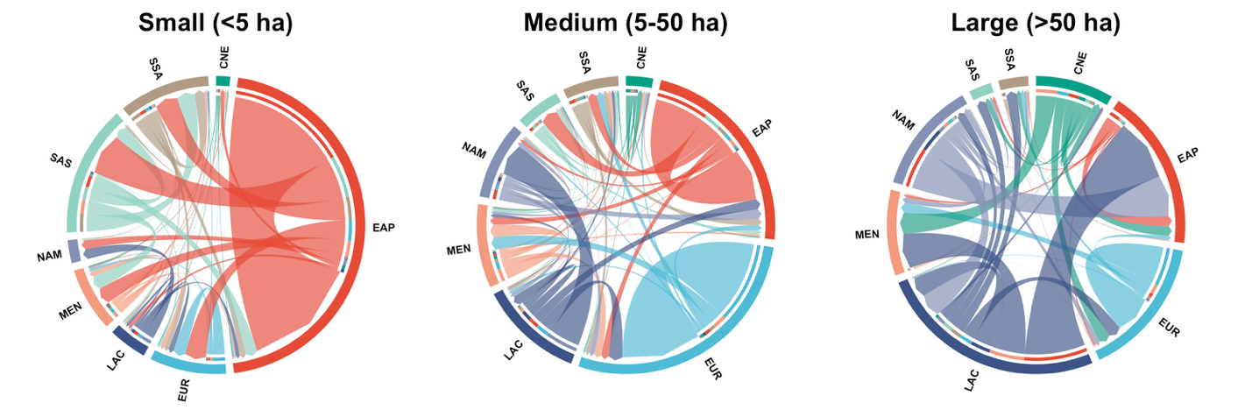

Supplementary Figure 14. Trade flows by farm size, comparing 2020 (left column) with the BMK (benchmark) 2050 scenario (right column); the right column shows the change from 2020 (assuming evolving farm-size distributions). Rows show small (<5 ha), medium (5-50 ha), and large (>50 ha) farms. Arrow thickness is on a common scale across all panels.
Region abbreviations: CNE Central-Northern Eurasia, EAP East Asia Pacific, EUR Europe, LAC Latin America and Caribbean, MEN Middle East-North Africa, NAM North America, SAS South Asia, SSA Sub-Saharan Africa.
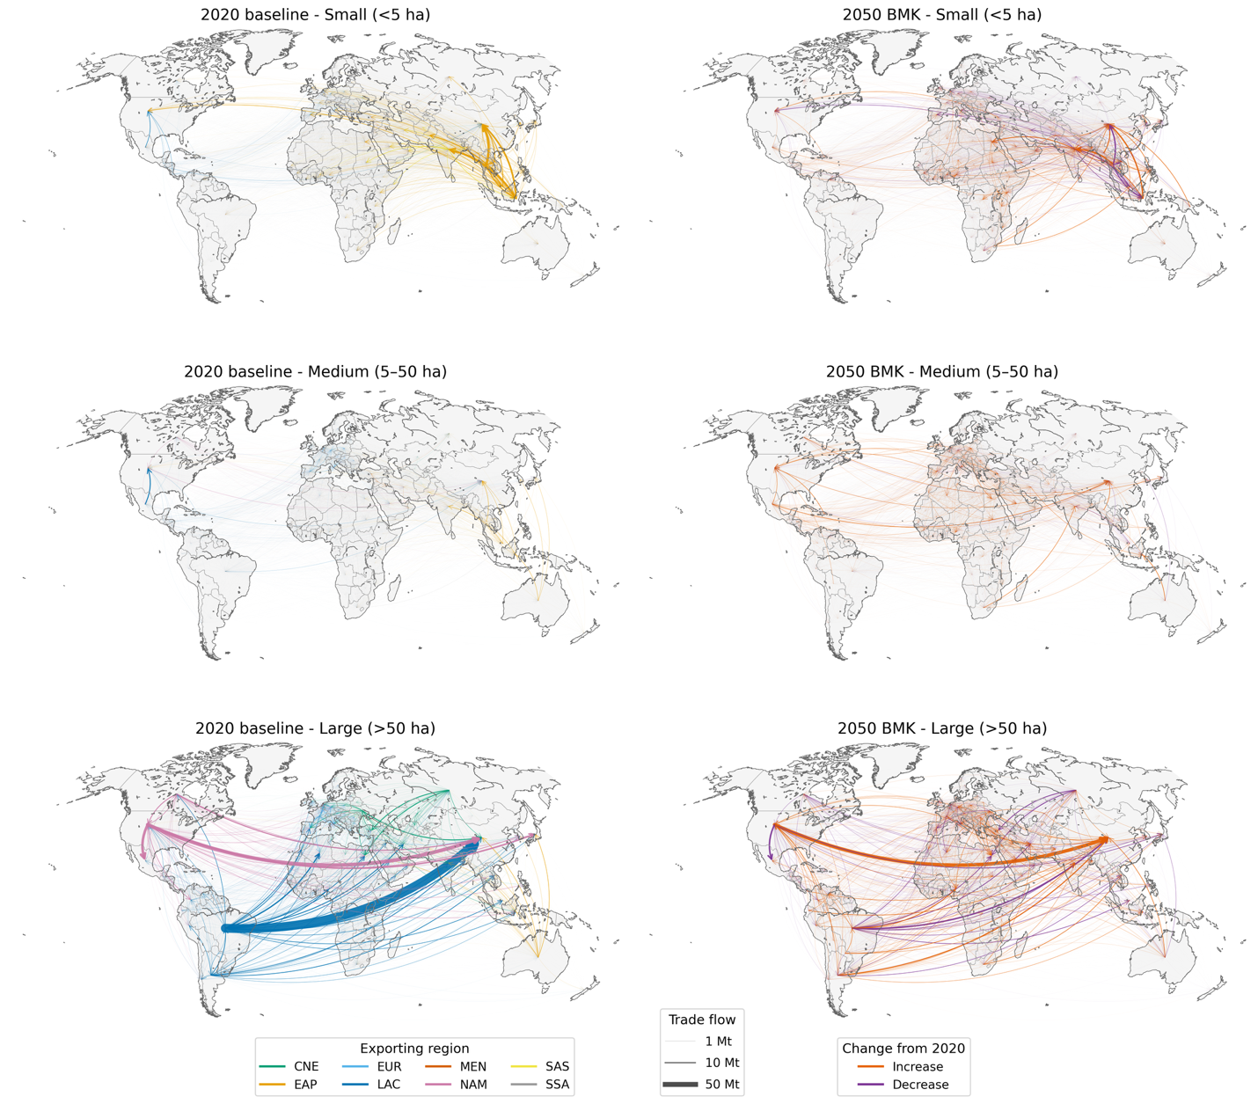

Supplementary Figure 15. Share of exports (%) by region and crop group, from small (<5 ha) and large (>50 ha) farms, comparing 2020 with the range across 2050 dietary scenarios (assuming evolving farm-size distributions).
Dietary scenarios: BMK benchmark (business-as-usual), FLX flexitarian, PSC pescatarian, VEG vegetarian, VGN vegan.
Region abbreviations: CNE Central-Northern Eurasia, EAP East Asia Pacific, EUR Europe, LAC Latin America and Caribbean, MEN Middle East-North Africa, NAM North America, SAS South Asia, SSA Sub-Saharan Africa.
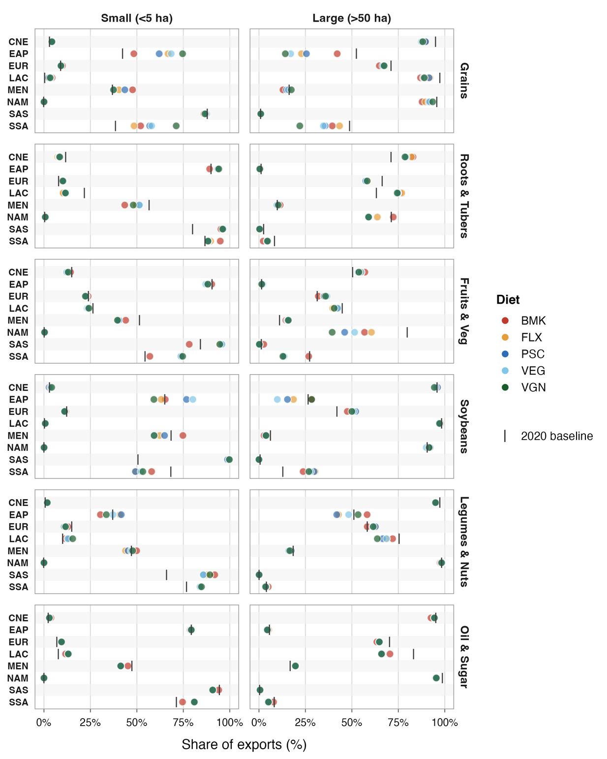
Supplementary Figure 16. Export volume by region and crop group, from small (<5 ha) and large (>50 ha) farms, comparing 2020 with the range across 2050 dietary scenarios (assuming evolving farm-size distributions).
Dietary scenarios: BMK benchmark (business-as-usual), FLX flexitarian, PSC pescatarian, VEG vegetarian, VGN vegan.
Region abbreviations: CNE Central-Northern Eurasia, EAP East Asia Pacific, EUR Europe, LAC Latin America and Caribbean, MEN Middle East-North Africa, NAM North America, SAS South Asia, SSA Sub-Saharan Africa.
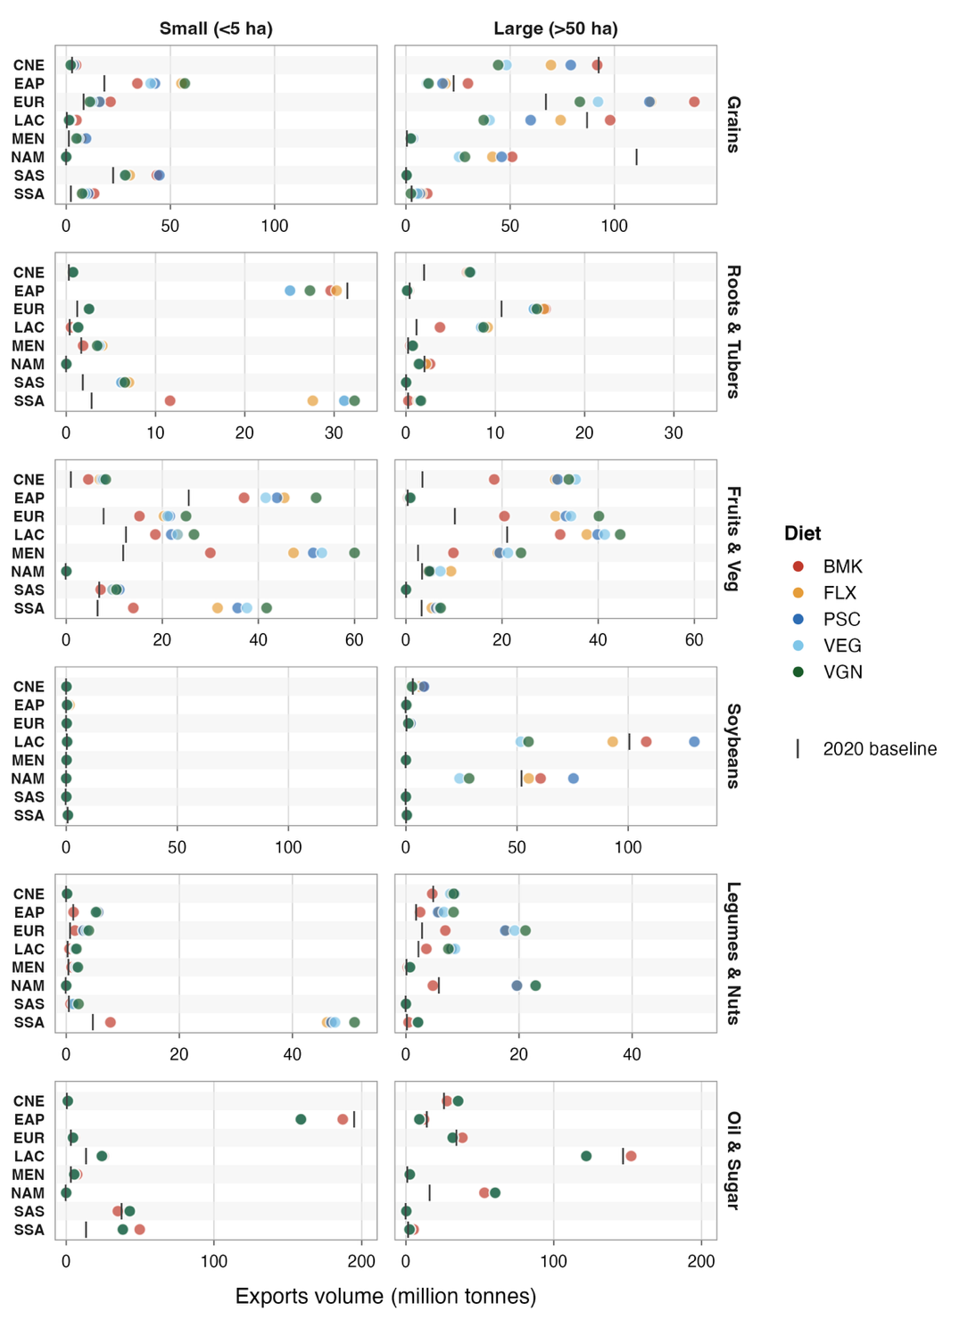

Supplementary Tables
Supplementary Table 1: Mapping between EAT-Lancet food groups, IMPACT crop categories, and FAO commodities for production and trade data.

EAT-Lancet food group | IMPACT crop category | Production | Trade | Notes
wheat | wheat | Wheat | Wheat,  Germ of wheat,  Wheat and meslin flour
rice | rice | Rice | Rice, paddy (rice milled equivalent),  Flour of rice
maize | maize | Maize (corn) | Maize (corn),  Germ of maize,  Flour of maize,  Bran of maize,  Cake of maize,  Forage and silage, maize
other grains | barley | Barley | Barley,  Barley flour and grits,  Barley, pearled,  Bran of barley,  Pot barley
other grains | sorghum | Sorghum | Sorghum,  Flour of sorghum,  Bran of sorghum
other grains | millet | Millet | Millet,  Flour of millet,  Bran of millet
other grains | other cereals | Rye | Rye,  Flour of rye,  Bran of rye
other grains | other cereals | Buckwheat | Buckwheat,  Flour of buckwheat
other grains | other cereals | Oats | Oats,  Oats, rolled,  Bran of oats
other grains | other cereals | Quinoa | Quinoa
other grains | other cereals | Canary seed | Canary seed
other grains | other cereals | Fonio | Fonio
other grains | other cereals | Mixed grain | Mixed grain,  Flour of mixed grain,  Bran of mixed grain
other grains | other cereals | Triticale | Triticale
other grains | other cereals | Cereals N.E.C. | Cereals n.e.c.,  Flour of cereals n.e.c.,  Bran of cereals n.e.c.
roots | cassava | Cassava, fresh | Cassava, dry,  Cassava, fresh,  Flour of cassava,  Starch of cassava,  Tapioca of cassava | Processing factors applied to convert traded commodities into equivalent quantities of crops.  Cassava dry: 2.5  Flour of cassava: 4  Starch of cassava: 5  Tapioca of cassava: 5  Tapioca of potatoes: 5
roots | potatoes | Potatoes | Potatoes,  Potatoes, frozen,  Tapioca of potatoes
roots | sweet potatoes | Sweet potatoes | Sweet potatoes
roots | yams | Yams | Yams
roots | other roots | Taro | Taro
roots | other roots | Edible roots and tubers with high starch or inulin content, n.e.c., fresh | Edible roots and tubers with high starch or inulin content, n.e.c., fresh
vegetables | vegetables | Artichokes | Artichokes
vegetables | vegetables | Asparagus | Asparagus
vegetables | vegetables | Broad beans and horse beans, green | Broad beans and horse beans, green
vegetables | vegetables | Cabbages | Cabbages
vegetables | vegetables | Carrots and turnips | Carrots and turnips
vegetables | vegetables | Cauliflowers and broccoli | Cauliflowers and broccoli
vegetables | vegetables | Chillies and peppers, green (Capsicum spp. and Pimenta spp.) | Chillies and peppers, green (Capsicum spp. and Pimenta spp.)
vegetables | vegetables | Cucumbers and gherkins | Cucumbers and gherkins
vegetables | vegetables | Eggplants (aubergines) | Eggplants (aubergines)
vegetables | vegetables | Green corn (maize) | Green corn (maize)
vegetables | vegetables | Green garlic | Green garlic
vegetables | vegetables | Leeks and other alliaceous vegetables | Leeks and other alliaceous vegetables
vegetables | vegetables | Lettuce and chicory | Lettuce and chicory
vegetables | vegetables | Mushrooms and truffles | Canned mushrooms,  Dried mushrooms,  Mushrooms and truffles
vegetables | vegetables | Okra | Okra
vegetables | vegetables | Onions and shallots, dry (excluding dehydrated) | Onions and shallots, dry (excluding dehydrated)
vegetables | vegetables | Onions and shallots, green | Onions and shallots, green
vegetables | vegetables | Other beans, green | Other beans, green
vegetables | vegetables | Other vegetables, fresh n.e.c. | Other vegetables, fresh n.e.c.,  Other vegetables provisionally preserved,  Other vegetable juices,  Sweet corn, frozen,  Sweet corn, prepared or preserved,  Vegetables frozen,  Vegetables preserved (frozen),  Vegetables preserved nes (o/t vinegar),  Vegetables, dehydrated,  Vegetable products, fresh or dry n.e.c.,  Vegetables, pulses and potatoes, preserved by vinegar or acetic acid
vegetables | vegetables | Peas, green | Peas, green
vegetables | vegetables | Pumpkins, squash and gourds | Pumpkins, squash and gourds
vegetables | vegetables | Spinach | Spinach
vegetables | vegetables | String beans | String beans
vegetables | vegetables | Tomatoes | Paste of tomatoes,  Tomato juice,  Tomatoes,  Tomatoes, peeled (o/t vinegar)
fruits | bananas | Bananas | Bananas | For olives and coconuts: Production and trade split between fruits and oils.  Oil converted to oil crops using processing factors.
fruits | plantains | Plantains and cooking bananas | Plantains and cooking bananas
fruits | sub-tropical fruits | Apricots | Apricots,  Apricots, dried
fruits | sub-tropical fruits | Avocados | Avocados
fruits | sub-tropical fruits | Cantaloupes and other melons | Cantaloupes and other melons
fruits | sub-tropical fruits | Cashewapple | Cashewapple
fruits | sub-tropical fruits | Dates | Dates
fruits | sub-tropical fruits | Figs | Figs,  Figs, dried
fruits | sub-tropical fruits | Kiwi fruit | Kiwi fruit
fruits | sub-tropical fruits | Lemons and limes | Juice of lemon,  Lemon juice, concentrated,  Lemons and limes
fruits | sub-tropical fruits | Locust beans (carobs) | Locust beans (carobs)
fruits | sub-tropical fruits | Mangoes, guavas and mangosteens | Juice of mango,  Mangoes, guavas and mangosteens,  Mango pulp
fruits | sub-tropical fruits | Oranges | Orange juice,  Orange juice, concentrated,  Oranges
fruits | sub-tropical fruits | Other citrus fruit, n.e.c. | Citrus juice, concentrated n.e.c.,  Juice of citrus fruit n.e.c.,  Other citrus fruit, n.e.c.
fruits | sub-tropical fruits | Other fruits, n.e.c. | Fruit prepared n.e.c.,  Juice of fruits n.e.c.,  Other fruit n.e.c., dried,  Other fruits, n.e.c.,  Raisins
fruits | sub-tropical fruits | Other tropical fruits, n.e.c. | Other tropical fruit, dried,  Other tropical fruits, n.e.c.
fruits | sub-tropical fruits | Papayas | Papayas
fruits | sub-tropical fruits | Pineapples | Juice of pineapples, concentrated,  Pineapple juice,  Pineapples,  Pineapples, otherwise prepared or preserved
fruits | sub-tropical fruits | Pomelos and grapefruits | Grapefruit juice,  Grapefruit juice, concentrated,  Pomelos and grapefruits
fruits | sub-tropical fruits | Tangerines, mandarins, clementines | Juice of tangerine,  Tangerines, mandarins, clementines
fruits | sub-tropical fruits | Watermelons | Watermelons
fruits | sub-tropical fruits | Coconuts, in shell | Coconuts, in shell,  Coconuts, desiccated,  Coconut oil
fruits | temperate fruits | Apples | Apple juice,  Apple juice, concentrated,  Apples
fruits | temperate fruits | Blueberries | Blueberries
fruits | temperate fruits | Cherries | Cherries
fruits | temperate fruits | Cranberries | Cranberries
fruits | temperate fruits | Currants | Currants
fruits | temperate fruits | Grapes | Grape juice,  Grapes
fruits | temperate fruits | Gooseberries | Gooseberries
fruits | temperate fruits | Other berries and fruits of the genus vaccinium n.e.c. | Other berries and fruits of the genus vaccinium n.e.c.
fruits | temperate fruits | Other pome fruits
fruits | temperate fruits | Other stone fruits | Other stone fruits
fruits | temperate fruits | Peaches and nectarines | Peaches and nectarines
fruits | temperate fruits | Pears | Pears
fruits | temperate fruits | Persimmons | Persimmons
fruits | temperate fruits | Plums and sloes | Plums and sloes,  Plums, dried
fruits | temperate fruits | Quinces | Quinces
fruits | temperate fruits | Raspberries | Raspberries
fruits | temperate fruits | Sour cherries | Sour cherries
fruits | temperate fruits | Strawberries | Strawberries
fruits | temperate fruits | Olives | Olives,  Olives preserved,  Olive oil
legumes | beans | Bambara beans, dry | Bambara beans, dry
legumes | beans | Beans, dry | Beans, dry
legumes | beans | Broad beans and horse beans, dry | Broad beans and horse beans, dry
legumes | chickpeas | Chick peas, dry | Chick peas, dry
legumes | cowpeas | Cow peas, dry | Cow peas, dry
legumes | lentils | Lentils, dry | Lentils, dry
legumes | pigeon peas | Pigeon peas, dry | Pigeon peas, dry
legumes | other pulses | Other pulses n.e.c. | Flour of pulses,  Other pulses n.e.c.
legumes | other pulses | Peas, dry | Peas, dry
legumes | other pulses | Lupins
legumes | other pulses | Vetches
soybeans | soybeans | Soya beans | Cake of soya beans,  Soya beans,  Soya curd,  Soya paste,  Soya sauce,  Soya bean oil
nuts and seeds | groundnuts | Groundnuts, excluding shelled | Groundnuts, excluding shelled,  Groundnuts, shelled,  Prepared groundnuts,  Groundnut oil | For groundnuts, linseed, hempseed, sunflower seed, safflower seed, sesame seed: Production and trade split between nuts & seeds and oils.  Oil converted to oil crops using processing factors.
nuts and seeds | other | Almonds, in shell | Almonds, in shell,  Almonds, shelled
nuts and seeds | other | Brazil nuts, in shell | Brazil nuts, in shell,  Brazil nuts, shelled
nuts and seeds | other | Cashew nuts, in shell | Cashew nuts, in shell,  Cashew nuts, shelled
nuts and seeds | other | Chestnuts, in shell | Chestnuts, in shell
nuts and seeds | other | Hazelnuts, in shell | Hazelnuts, in shell,  Hazelnuts, shelled
nuts and seeds | other | Other nuts (excluding wild edible nuts and groundnuts), in shell, n.e.c. | Other nuts (excluding wild edible nuts and groundnuts), in shell, n.e.c.
nuts and seeds | other | Pistachios, in shell | Pistachios, in shell
nuts and seeds | other | Walnuts, in shell | Walnuts, in shell,  Walnuts, shelled
nuts and seeds | other | Linseed | Linseed,  Oil of linseed
nuts and seeds | other | Hempseed | Hempseed
nuts and seeds | other | Sunflower seed | Sunflower seed,  Sunflower-seed oil, crude
nuts and seeds | other | Safflower seed | Safflower seed,  Safflower-seed oil, crude
nuts and seeds | other | Poppy seed | Poppy seed
nuts and seeds | other | Sesame seed | Sesame seed,  Oil of sesame seed
vegetable oil | rapeseed | Rape or colza seed | Rape or colza seed, Rapeseed or canola oil, crude | For olives, coconuts, groundnuts, linseed, hempseed, sunflower seed, safflower seed, sesame seed: Production and trade split between oils and fruits/nuts & seeds.  Oil converted to oil crops using processing factors.
vegetable oil | sunflower seed | Sunflower seed | Sunflower seed,  Sunflower-seed oil, crude
vegetable oil | other oilcrops | Groundnuts, excluding shelled | Groundnuts, excluding shelled,  Groundnuts, shelled,  Prepared groundnuts,  Groundnut oil
vegetable oil | other oilcrops | Linseed | Linseed,  Oil of linseed
vegetable oil | other oilcrops | Hempseed | Hempseed
vegetable oil | other oilcrops | Safflower seed | Safflower seed,  Safflower-seed oil, crude
vegetable oil | other oilcrops | Sesame seed | Sesame seed,  Oil of sesame seed
vegetable oil | other oilcrops | Castor oil seeds | Castor oil seeds,  Oil of castor beans
vegetable oil | other oilcrops | Cotton seed | Cottonseed oil
vegetable oil | other oilcrops | Coconuts, in shell | Coconuts, in shell,  Coconuts, desiccated,  Coconut oil
vegetable oil | other oilcrops | Mustard seed | Mustard seed,  Mustard seed oil, crude
vegetable oil | other oilcrops | Olives | Olives,  Olives preserved,  Olive oil
palm oil | palm oil | Oil palm fruit | Palm oil | Oil converted to oil crops using processing factors.
sugar | Sugar beet | Sugar beet | Sugar beet,  Refined sugar,  Raw cane or beet sugar (centrifugal only) | Sugar converted to sugar crops using processing factors.  Refined sugar and raw sugar flows split between sugar cane and sugar beet.
sugar | sugarcane | Sugar cane | Sugar cane,  Refined sugar,  Raw cane or beet sugar (centrifugal only)

Supplementary Table 2: FAO Commodities used to compute production and trade of animal products for allocation of feed.

EAT-Lancet Food group | Production | Trade | Notes
beef | Beef and Buffalo Meat, primary | Bovine meat, salted, dried or smoked,  Meat of buffalo, fresh or chilled,  Meat of cattle boneless, fresh or chilled,  Meat of cattle with the bone, fresh or chilled,  Sausages and similar products of meat, offal or blood of beef and veal
milk | Milk, total | Butter and Ghee,  Buttermilk, curdled and acidified milk,  Buttermilk, dry,  Cheese from whole cow milk,  Cream, fresh,  Evaporated & Condensed Milk,  Ghee from cow milk,  Processed cheese,  Raw milk of cattle,  Skim Milk & Buttermilk, Dry,  Skim milk and whey powder,  Skim milk of cows,  Whey, fresh and dry (milk equivalent),  Whole milk powder,  Whole milk, evaporated,  Butter of cow milk,  Cheese from skimmed cow milk,  Skim milk, condensed,  Whey cheese,  Whole milk, condensed,  Cheese from milk of sheep, fresh or processed,  Skim milk, evaporated | No processing factors were applied to processed items, and by-products weren’t removed resulting in approximate milk equivalent in total amounts
poultry | Meat, Poultry | Meat of chickens, fresh or chilled,  Meat of ducks, fresh or chilled,  Meat of geese, fresh or chilled,  Meat of pigeons and other birds n.e.c., fresh, chilled or frozen,  Meat of turkeys, fresh or chilled,  Poultry meat preparations
eggs | Eggs, Primary | Hen eggs in shell, fresh,  Eggs from other birds in shell, fresh, n.e.c.,  Eggs, dried,  Eggs, liquid
pork | Meat of pig with the bone, fresh or chilled | Meat of pig boneless, fresh or chilled,  Meat of pig with the bone, fresh or chilled,  Pig meat, cuts, salted, dried or smoked (bacon and ham),  Sausages and similar products of meat, offal or blood of pig'
lamb | Sheep and Goat Meat | Meat of goat, fresh or chilled,  Meat of sheep, fresh or chilled
seafood | Freshwater Fish  Demersal Fish  Pelagic Fish  Marine Fish, Other  Crustaceans  Cephalopods  Molluscs, Other | All items in FishStat under SITC codes 34 (Fish, fresh (live or dead), chilled or frozen), 35 (Fish, dried, salted or in brine; smoked fish), 36 (Crustaceans, molluscs and aquatic invertebrates), 37 (Fish, aqua. invertebrates, prepared, preserved, n.e.s.)

Supplementary Table 3: Mapping between EAT-Lancet food groups and FAOSTAT sources (FBS or SUA) used for computing demand for ‘other’ uses.
EAT-Lancet food group | FAOSTAT source | Commodity name | Notes
wheat | FBS | Wheat and products | Processing included in the food category
rice | FBS | Rice and products | Processing included in the food category
maize | FBS | Maize and products | Processing included in the food category
other grains | FBS | Barley and products | Processing included in the food category
other grains | FBS | Sorghum and products | Processing included in the food category
other grains | FBS | Rye and products | Processing included in the food category
other grains | FBS | Oats | Processing included in the food category
other grains | FBS | Millet and products | Processing included in the food category
other grains | FBS | Cereals, Other | Processing included in the food category
roots | FBS | Starchy Roots | Processing included in the food category
vegetables | FBS | Vegetables | Processing included in the food category
fruits | FBS | Fruits | Processing included in the food category
legumes | FBS | Pulses | Processing included in the food category
soybeans | SUA | Soya beans | Processing for beans equals total supply for other soy products (curd, paste, sauce, oil, cake). Hence, processing for beans ignored.  Food, feed, and other aggregated for the 4 soy categories.
soybeans | SUA | Soya curd
soybeans | SUA | Soya paste
soybeans | SUA | Cake of soya beans
soybeans | SUA | Soya bean oil
soybeans | SUA | Soya sauce
nuts and seeds | FBS | Nuts and products | This includes treenuts. Processing already 0.
nuts and seeds | SUA | Groundnuts, excluding shelled | Processing from unshelled groundnuts ignored (it approximately equals the total supply of all groundnut-based commodities, i.e. shelled, prepared, cake, and oil)  Processing from shelled groundnuts included in food.
nuts and seeds | SUA | Groundnuts, shelled
nuts and seeds | SUA | Prepared groundnuts
nuts and seeds | SUA | Linseed | Processing ignored for all (as it approximately equals the total supply for the oils and cakes produced from these seeds).  Melon seeds not included here, as they are not specifically produced for the purpose of seeds.
nuts and seeds | SUA | Hempseed
nuts and seeds | SUA | Sunflower seed
nuts and seeds | SUA | Safflower seed
nuts and seeds | SUA | Poppy seed
nuts and seeds | SUA | Sesame seed
vegetable oil | SUA | Groundnut oil | All these oils have a corresponding SUA commodity for ‘cake’. Total supply for oil and cake together gives an estimate for the required supply of these oil crops.
vegetable oil | SUA | Oil of linseed
vegetable oil | SUA | Oil of hempseed
vegetable oil | SUA | Sunflower seed oil, crude
vegetable oil | SUA | Safflower seed oil, crude
vegetable oil | SUA | Oil of sesame seed
vegetable oil | SUA | Cottonseed oil
vegetable oil | SUA | Mustard seed oil, crude
vegetable oil | SUA | Rapeseed or canola oil, crude
vegetable oil | SUA | Oil of castor beans | Processing for castor oil seeds gives the estimated oil crop supply
vegetable oil | SUA | Castor oil, hydrogenated
vegetable oil | SUA | Olive oil | Processing for olives, ignoring the processed amount going towards preserved olives, gives the estimated oil crop supply.
vegetable oil | SUA | Coconut oil | No clear commodity to estimate by-products. Oil crop supply assumed to be the same as oil supply.  Processing included in the food category.
vegetable oil | SUA |  | Other uses for oil crops before processing ignored, unless there is an overlap with other food groups, in which case other uses for the crops in those other food groups considered.
palm oil | SUA | Palm Oil | Processing included in the food category.  Processing for oil palm fruit gives the estimated oil crop supply.  Kernels not included separately to compute oil crop supply (as they are by-products of palm fruit).  Other uses for palm oil crops before processing ignored.
palm oil | SUA | Oil of palm kernel
sugar | FBS | Sugar crops | Processing included in the food category (for both).  Domestic supply of sugar and sweeteners / Processing for sugar crops gives the conversion factor between sugar and sugar crops.  Other calculated for both, i.e. other uses for sugar crops before processing also considered.
sugar | FBS | Sugar and sweeteners

Supplementary Table 4. Mapping between EAT-Lancet food groups, modelled crop categories and six aggregated crop groups
EAT-Lancet food group | Modelled crop category | Crop group
wheat | wheat | Grains
rice | rice | Grains
maize | maize | Grains
other grains | barley | Grains
other grains | sorghum | Grains
other grains | millet | Grains
other grains | other cereals | Grains
roots | cassava | Roots and tubers
roots | potatoes | Roots and tubers
roots | sweet potatoes | Roots and tubers
roots | yams | Roots and tubers
roots | other roots and tubers | Roots and tubers
vegetables | vegetables | Fruits and vegetables
fruits | bananas | Fruits and vegetables
fruits | plantains | Fruits and vegetables
fruits | sub-tropical fruits | Fruits and vegetables
fruits | temperate fruits | Fruits and vegetables
soybeans | soybeans | Soybeans
legumes | beans | Legumes and nuts
legumes | chickpeas | Legumes and nuts
legumes | cowpeas | Legumes and nuts
legumes | lentils | Legumes and nuts
legumes | pigeon peas | Legumes and nuts
legumes | other pulses | Legumes and nuts
nuts and seeds | groundnuts | Legumes and nuts
nuts and seeds | other nuts and seeds | Legumes and nuts
vegetable oil | rapeseed | Oil and sugar
vegetable oil | sunflower seed | Oil and sugar
vegetable oil | other oil crops | Oil and sugar
palm oil | palm oil | Oil and sugar
sugar | Sugar beet | Oil and sugar
sugar | sugarcane | Oil and sugar

Supplementary Table 5: Mapping between Harmonized System (HS) codes and IMPACT crop categories for bilateral tariff data.

EAT-Lancet Food group | IMPACT food group | HS codes | Notes
wheat | wheat | 100111, 100119, 100191, 100199 | Flour, starch, gluten, groats, bran etc. not considered.
rice | rice | 100610, 100620, 100630, 100640
maize | maize | 100510, 100590 | Flour, starch, groats, bran etc. not considered.
other grains | barley | 100310, 100390
other grains | sorghum | 100710, 100790
other grains | millet | 100821, 100829
other grains | other cereals | 100210, 100290, 100410, 100490, 100810, 100830, 100840, 100850, 100860, 100890
roots | cassava | 071410
roots | potatoes | 070110, 070190, 071010
roots | sweet potatoes | 071420
roots | yams | 071430
roots | other roots | 071440, 071450, 071490
vegetables | vegetables | 070200, 070310, 070320, 070390, 070410, 070420, 070490, 070511, 070519, 070521, 070529, 070610, 070690, 070700, 070810, 070820, 070890, 070920, 070930, 070940, 070951, 070959, 070960, 070970, 070991, 070992, 070993, 070999, 071021, 071029, 071030, 071040, 071080, 071140, 071151, 071159, 071190, 071220, 071231, 071232, 071233, 071239, 071290 | Vegetable preparations not considered
fruits | bananas | 080390 | Fruit preparations not considered
fruits | plantains | 080310 | Fruit preparations not considered
fruits | sub-tropical fruits | 080410, 080420, 080430, 080440, 080450, 080510, 080521, 080522, 080529, 080540, 080550, 080590, 080711, 080719, 080720, 080910, 081050, 081060, 081090, 081310, 080111, 080112, 080119 | Fruit preparations not considered
fruits | temperate fruits | 071120, 080610, 080620, 080810, 080830, 080840, 080921, 080929, 080930, 080940, 081010, 081020, 081030, 081040, 081070, 081110, 081120, 081190, 081210, 081290, 081320, 081330, 081340 | Fruit preparations not considered
legumes | beans | 071331, 071332, 071333, 071334, 071350
legumes | chickpeas | 071320
legumes | cowpeas | 071335
legumes | lentils | 071340
legumes | pigeon peas | 071360
legumes | other pulses | 071310, 071339, 071390, 110610
soybeans | soybeans | 120110, 120190, 120810, 150710, 150790, 210310, 230400
nuts and seeds | groundnuts | 120230, 120241, 120242
nuts and seeds | other | 081350, 080121, 080122, 080131, 080132, 080211, 080212, 080231, 080232, 080241, 080242, 080251, 080252, 080261, 080262, 080270, 080280, 080290, 120400, 120600, 120740, 120760, 120791, 120799
vegetable oil | rapeseed | 100510, 120590, 151411, 151419, 151491, 151499 | Includes both oils and oil crops
vegetable oil | sunflower seed | 120600, 151211, 151219 | Includes both oils and oil crops
vegetable oil | other oilcrops | 120230, 120241, 120242, 120400, 120721, 120729, 120730, 120740, 120750, 120760, 120799, 150810, 150890, 150910, 150990, 151000, 151221, 151229, 151311, 151319, 151511, 151519, 151530, 151550, 151590 | Includes both oils and oil crops
palm oil | palm oil | 120710, 151110, 151190, 151321, 151329 | Includes both oils and oil crops
sugar | sugarbeet | 121291, 170112 | Includes both sugar and sugar crops. Sugar confectionary not considered.
sugar | sugarcane | 121293, 170113, 170114

Supplementary Table 7: Calibration performance for the baseline Spatial Price Equilibrium Model (SPEM).
Crop | Trade links |  |  | Trade flows |  | Demand R² | Supply R² | Producer price R² | Transport cost R²
Crop | accuracy | precision | recall | R² | RMSE (tonnes)
Wheat | 0.90 | 0.87 | 0.72 | 0.99 | 2248 | 0.99 | 0.99 | 0.99 | 0.97
Rice | 0.91 | 0.92 | 0.52 | 0.99 | 1167 | 0.99 | 0.99 | 0.97 | 0.99
Maize | 0.89 | 0.84 | 0.62 | 0.99 | 3372 | 0.99 | 0.99 | 0.99 | 0.98
Barley | 0.92 | 0.58 | 0.65 | 0.99 | 1534 | 0.99 | 0.99 | 0.98 | 0.99
Millet | 0.95 | 0.31 | 0.28 | 0.81 | 201 | 0.99 | 0.99 | 0.99 | 0.99
Sorghum | 0.89 | 0.18 | 0.53 | 0.99 | 1592 | 0.99 | 0.99 | 0.99 | 0.99
Other cereals | 0.90 | 0.84 | 0.48 | 0.99 | 1120 | 0.99 | 0.99 | 0.99 | 0.99
Cassava | 0.94 | 0.55 | 0.45 | 0.99 | 940 | 0.99 | 0.99 | 0.99 | 0.98
Potato | 0.84 | 0.66 | 0.45 | 0.96 | 4210 | 0.99 | 0.99 | 0.99 | 0.91
Yams | 0.99 | 0.74 | 0.48 | 0.99 | 23 | 0.99 | 0.99 | 0.99 | 0.99
Sweet potato | 0.96 | 0.57 | 0.33 | 0.94 | 201 | 0.99 | 0.99 | 0.99 | 0.99
Other roots and tubers | 0.98 | 0.71 | 0.36 | 0.99 | 21 | 0.99 | 0.99 | 0.99 | 0.99
Vegetables | 0.66 | 0.83 | 0.38 | 0.99 | 6864 | 0.99 | 0.99 | 0.99 | 0.68
Bananas | 0.94 | 0.49 | 0.53 | 0.99 | 2011 | 0.99 | 0.99 | 0.99 | 0.96
Plantains | 0.98 | 0.53 | 0.47 | 0.99 | 130 | 0.99 | 0.99 | 0.99 | 0.99
Subtropical fruits | 0.73 | 0.93 | 0.43 | 0.99 | 1166 | 0.99 | 0.99 | 0.93 | 0.98
Temperate fruits | 0.84 | 0.92 | 0.43 | 0.99 | 1573 | 0.99 | 0.99 | 0.96 | 0.98
Beans | 0.81 | 0.47 | 0.21 | 0.95 | 1382 | 0.99 | 0.99 | 0.99 | 0.97
Chickpeas | 0.95 | 0.65 | 0.38 | 0.97 | 440 | 0.99 | 0.99 | 0.96 | 0.99
Cowpeas | 0.98 | 0.72 | 0.34 | 0.83 | 28 | 0.99 | 0.99 | 0.99 | 0.99
Lentils | 0.95 | 0.49 | 0.34 | 0.99 | 295 | 0.99 | 0.99 | 0.99 | 0.99
Pigeon peas | 0.99 | 0.82 | 0.44 | 0.99 | 78 | 0.99 | 0.99 | 0.99 | 0.99
Other pulses | 0.88 | 0.70 | 0.32 | 0.99 | 1487 | 0.99 | 0.99 | 0.99 | 0.98
Soybeans | 0.89 | 0.71 | 0.56 | 0.99 | 1404 | 0.99 | 0.99 | 0.99 | 0.98
Groundnuts | 0.93 | 0.78 | 0.40 | 0.95 | 986 | 0.99 | 0.99 | 0.99 | 0.99
Other nuts | 0.73 | 0.75 | 0.16 | 0.73 | 4845 | 0.97 | 0.95 | 0.99 | 0.99
Rapeseed | 0.87 | 0.50 | 0.30 | 0.99 | 1913 | 0.99 | 0.99 | 0.99 | 0.96
Sunflower seed oil | 0.86 | 0.54 | 0.34 | 0.99 | 2157 | 0.93 | 0.99 | 0.99 | 0.96
Other oilseeds | 0.77 | 0.76 | 0.26 | 0.95 | 2886 | 0.99 | 0.99 | 0.99 | 0.89
Palm oil fruit | 0.89 | 0.52 | 0.62 | 0.99 | 2058 | 0.99 | 0.99 | 0.99 | 0.96
Sugar beet | 0.93 | 0.77 | 0.73 | 0.99 | 826 | 0.99 | 0.99 | 0.99 | 0.99
Sugar cane | 0.87 | 0.59 | 0.63 | 0.99 | 4888 | 0.99 | 0.99 | 0.99 | 0.95

References
Croft, S. A., West, C. D., & Green, J. M. H. (2018). Capturing the heterogeneity of sub-national production in global trade flows. Journal of Cleaner Production, 203, 1106–1118. https://doi.org/10.1016/j.jclepro.2018.08.267
FAO. (2020). The State of World Fisheries and Aquaculture 2020. Sustainability in action. FAO. https://doi.org/10.4060/ca9229en
FAO. (2024). FishStat [Dataset].
FAO. (2025). FAOSTAT [Dataset].
Gehlhar, M. (1996). Reconciling Bilateral Trade Data for Use in GTAP. GTAP Technical Paper Series. https://doi.org/10.21642/GTAP.TP10
Guimbard, H., Jean, S., Mimouni, M., & Pichot, X. (2012). MAcMap-HS6 2007, An exhaustive and consistent measure of applied protection in 2007. International Economics, 130, 99–121. https://doi.org/10.1016/S2110-7017(13)60046-3
Herrero, M., Havlík, P., Valin, H., Notenbaert, A., Rufino, M. C., Thornton, P. K., Blümmel, M., Weiss, F., Grace, D., & Obersteiner, M. (2013). Biomass use, production, feed efficiencies, and greenhouse gas emissions from global livestock systems. Proceedings of the National Academy of Sciences, 110(52), 20888–20893. https://doi.org/10.1073/pnas.1308149110
Jain, S., Clark, M., Hall, J. W., & Verschuur, J. (2026). Dietary Transitions Reshape the Geography of Global Food Production and Trade (SSRN Scholarly Paper No. 6901669). Social Science Research Network. https://doi.org/10.2139/ssrn.6901669
Janssens, C., Havlík, P., Boere, E., Palazzo, A., Mosnier, A., Leclère, D., Balkovič, J., & Maertens, M. (2022). A sustainable future for Africa through continental free trade and agricultural development. Nature Food, 3(8), 608–618. https://doi.org/10.1038/s43016-022-00572-1
Jansson, T., & Heckelei, T. (2009). A new estimator for trade costs and its small sample properties. Economic Modelling, 26(2), 489–498. https://doi.org/10.1016/j.econmod.2008.10.002
Robinson, S., Dunston, S., Mishra, A., Sulser, T. B., Mason-D’Croz, D., Robertson, R. D., Cenacchi, N., Thomas, T. S., Zhu, T., Gueneau, A., Pitois, G., Wiebe, K. D., & Rosegrant, M. W. (2024). The International Model for Policy Analysis of Agricultural Commodities and Trade (IMPACT): Model documentation for version 3.6. https://hdl.handle.net/10568/148953
Rosegrant, M. W., Sulser, T. B., Dunston, S., Mishra, A., Cenacchi, N., Gebretsadik, Y., Robertson, R., Thomas, T., & Wiebe, K. (2024). Food and nutrition security under changing climate and socioeconomic conditions. Global Food Security, 41, 100755. https://doi.org/10.1016/j.gfs.2024.100755
Sulser, T., B., Mishra, A., & Hartley, F. (2026). IMPACT model drivers v2.1 [Dataset]. Zenodo. https://doi.org/10.5281/zenodo.19455721
Takayama, T., & Judge, G. G. (1964). An Intertemporal Price Equilibrium Model. American Journal of Agricultural Economics, 46(2), 477–484. https://doi.org/10.2307/1236555
Tilman, D., & Clark, M. (2014). Global diets link environmental sustainability and human health. Nature, 515(7528), 518–522. https://doi.org/10.1038/nature13959
Verschuur, J., Murgatroyd, A., Vittis, Y., Mosnier, A., Obersteiner, M., Godfray, C. J., & Hall, J. W. (2026). Assessing the resilience of global grain supplies to compound climatic and non-climatic shocks. PLOS Climate, 5(5), e0000825. https://doi.org/10.1371/journal.pclm.0000825
Verschuur, J., Vittis, Y., Obersteiner, M., & Hall, J. W. (2025). Heterogeneities in landed costs of traded grains and oilseeds contribute to unequal access to food. Nature Food, 6(1), 36–46. https://doi.org/10.1038/s43016-024-01087-7
Willett, W., Rockström, J., Loken, B., Springmann, M., Lang, T., Vermeulen, S., Garnett, T., Tilman, D., DeClerck, F., Wood, A., Jonell, M., Clark, M., Gordon, L. J., Fanzo, J., Hawkes, C., Zurayk, R., Rivera, J. A., Vries, W. D., Sibanda, L. M., … Murray, C. J. L. (2019). Food in the Anthropocene: The EAT–Lancet Commission on healthy diets from sustainable food systems. The Lancet, 393(10170), 447–492. https://doi.org/10.1016/S0140-6736(18)31788-4

