Supporting Information
Oxygen plasma-engineered resin–carbon interfaces in 3D-printed hollow microneedle electrodes for IL-6 detection
Rafael C. Otoni,¹ Leandro T. Kochi,¹ Ana Cristina H. Castro-Kochi,^{1,2} Ana Carola D. L. V. Reis,¹ Fabíola L. de Castro,¹
Ana Alice Zaneli,¹ Wendel A. Alves ^{1,}*
¹Center for Natural and Human Sciences, Federal University of ABC, 09210‐580, Santo André - SP, Brazil.
²School of Biomedical Engineering, Einstein Hospital Israelita, São Paulo, São Paulo 05521-200, Brazil.

*Corresponding author: wendel.alves@ufabc.edu.br
S1. Charge-transfer kinetics
The influence of scan rate (25 to 200 mV s⁻¹) on the redox response of the [Fe(CN)₆]^{3-/4-} probe (5.0 mmol L⁻¹) was investigated by cyclic voltammetry. For both untreated and oxygen-plasma-treated HMNEs, the peak currents increased linearly with the square root of the scan rate (υ^{1/2}), indicating predominantly diffusion-controlled mass transport (Figure S1). The standard heterogeneous electron-transfer rate constant (k⁰) was estimated using Nicholson’s dimensionless kinetic parameter, ψ, calculated from the empirical relationship proposed by Lavagnini et al.¹:
ψ = (−0.6288 + 0.0021ΔEₚ)/(1 − 0.017ΔEₚ) (1)
where n is the number of electrons involved in the redox process, and ΔEₚ is the peak-to-peak separation between the anodic and cathodic waves. The k⁰ values were obtained from the scan-rate-dependent Nicholson parameter using a diffusion coefficient D = 4.24 × 10⁻⁶ cm² s⁻¹ for the [Fe(CN)₆]^{3-/4-} couple at 25 °C.
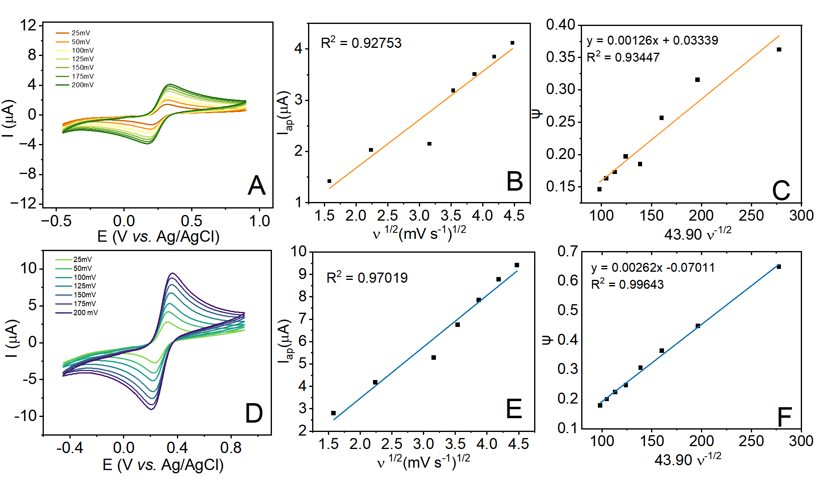
Figure S1. Cyclic voltammograms of the [Fe(CN)₆]^{3-/4-} redox couple recorded at scan rates from 25 to 200 mV s⁻¹ for (A–C) untreated HMNE and (D–F) oxygen-plasma-treated HMNE. Panels show the scan-rate-dependent voltammograms, peak current as a function of υ^{1/2}, and Nicholson parameter ψ as a function of 43.90v⁻¹ᐟ², respectively. Electrolyte: 5 mmol L⁻¹ [Fe(CN)₆]^{3-/4-} in 0.1 mol L⁻¹ KCl.
The untreated HMNE exhibited a k⁰ of 1.26 × 10⁻³ cm s⁻¹, whereas oxygen plasma treatment increased this value to 2.62 × 10⁻³ cm s⁻¹. The ψ parameter further indicated quasi-reversible electron-transfer behavior for both electrodes. The k⁰ values were compared with representative carbon-based and related electrode materials reported in the literature (Table S1).

Table S1. Comparison of heterogeneous electron-transfer rate constants reported for different electrode materials.
Electrode | k⁰ (cm s⁻¹)
Pyrolyzed paper with cellulose acetate³ | 1.5 × 10⁻³
Reduced graphene oxide foam⁴ | 2.4 × 10⁻⁴
Carbon paper⁵ | 1.6 × 10⁻³
ITO⁶ | 2.57 × 10⁻³
Pyrolyzed paper with T20⁷ | 1.2 × 10⁻³
HMNE without oxygen plasma treatment (this work) | 1.26 × 10⁻³
HMNE with oxygen plasma treatment (this work) | 2.62 × 10⁻³
S2. Performance in diluted human plasma
The impedimetric performance of the IL-6 immunosensor was further evaluated in human plasma diluted 1:100. Relative signal recovery was calculated by comparing the Rct responses obtained in diluted plasma and buffer at the same IL-6 concentration. Data are presented as mean ± SD (n = 3), and RSD was calculated as 100 × SD/mean.
Table S2. Relative signal recovery and precision of the HMNE immunosensor for IL-6 detection in diluted human plasma (1:100). Rct values were obtained from Nyquist plots fitted to the Randles equivalent circuit. Electrolyte: 5 mmol L⁻¹ K₄[Fe(CN)₆]/K₃[Fe(CN)₆] in 0.1 mol L⁻¹ KCl.
Added IL-6 (ng mL⁻¹) | R_{ct}, buffer (kΩ) | R_{ct}, diluted human plasma (kΩ) | Relative signal recovery (%) | RSD (%)
0.5 | 6.198 | 5.940 | 95.84 | 14.95
1.0 | 8.729 | 8.059 | 92.32 | 9.19
2.5 | 20.325 | 15.600 | 76.75 | 3.96
Note: Relative signal recovery was calculated as 100 × R_{ct},diluted plasma/R_{ct},buffer.

S3. Comparison with reported microneedle-based cytokine sensors
Table S3 summarizes representative microneedle-based platforms reported for IL-6 and related inflammatory cytokine detection, highlighting differences in electrode architecture, analytical performance, sample matrix, in vivo evaluation, and fabrication strategy.
Table S3. Comparison of microneedle-based platforms reported for detecting IL-6 and related inflammatory cytokines.
Platform / electrode architecture | Target | Detection method | Sample / matrix | Analytical performance | In vivo evaluation | Main characteristics | Ref.
Antibody-functionalized polystyrene microneedle patch with plasmonic-fluor amplification | IL-6 | Fluorescence (p-FLISA) | Artificial media and dermal ISF | LOD: ~0.33 pg mL⁻¹ | Yes; longitudinal IL-6 monitoring in an LPS-induced mouse inflammation model | On-needle capture and ex vivo fluorescent readout; plasmonic nanolabel provides strong signal amplification. | Wang et al., 2021⁸
Metallized microneedle array coated with an electropolymerized molecularly imprinted polymer (MIP) | IL-6 | EIS | Artificial ISF | Range: 1 pg mL⁻¹–10 ng mL⁻¹; lower detectable level: 1 pg mL⁻¹ | No | MIP acts as a synthetic recognition layer; requires metallization, electropolymerization, and template removal. | Oliveira et al., 2022⁹
Wearable microneedle patch with CNT–chitosan conductive biointerface and immobilized antibodies | IL-6 and other inflammatory cytokines | Electrochemical | Artificial ISF and dermal ISF | IL-6 range: 1–5000 pg mL⁻¹; LOD: 0.54 pg mL⁻¹ | Yes; real-time cytokine monitoring in rats | Integrated capture and electrochemical monitoring; CNT-based interface, oriented antibody immobilization, and antifouling/blocking steps. | Xu et al., 2023¹⁰
SLA-printed hollow resin microneedle electrode with carbon paste confined within internal channels and oxygen-plasma-treated resin–carbon interface | IL-6 | EIS | Buffer, simulated ISF, and human plasma diluted 1:100 | Range: 0.5–7.5 ng mL⁻¹; LOD: 0.178 ng mL⁻¹ | No | Integrated hollow microneedle/electrode architecture; comparatively simple SLA + carbon-paste fabrication; no metal microfabrication; plasma used for interfacial tuning. | This work

References
1. Lavagnini, I.; Antiochia, R.; Magno, F. An Extended Method for the Practical Evaluation of the Standard Rate Constant From Cyclic Voltammetric Data. Electroanalysis 2004, 16, 505–506.
2. Nicholson, R. S.; Shain, I. Theory of Stationary Electrode Polarography. Single Scan and Cyclic Methods Applied to Reversible, Irreversible, and Kinetic Systems. Anal. Chem. 1964, 36, 706–723.
3. Damasceno, S.; Corrêa, C. C.; Gouveia, R. F.; Strauss, M.; Bufon, C. C. B.; Santhiago, M. Delayed Capillary Flow of Elastomers: An Efficient Method for Fabrication and Nanofunctionalization of Flexible, Foldable, Twistable, and Stretchable Electrodes from Pyrolyzed Paper. Adv. Electron. Mater. 2020, 6, 1900826.
4. Baptista-Pires, L.; de la Escosura-Muñiz, A.; Balsells, M.; Zuaznabar-Gardona, J. C.; Merkoçi, A. Production and Printing of Graphene Oxide Foam Ink for Electrocatalytic Applications. Electrochem. Commun. 2019, 98, 6–9.
5. Torrinha, A.; Martins, M.; Tavares, M.; Delerue-Matos, C.; Morais, S. Carbon Paper as a Promising Sensing Material: Characterization and Electrocatalysis of Ketoprofen in Wastewater and Fish. Talanta 2021, 226, 122111.
6. de Lima, L. F.; Ferreira, A. L.; Maciel, C. C.; Ferreira, M.; de Araujo, W. R. Disposable and Low-Cost Electrochemical Sensor Based on the Colorless Nail Polish and Graphite Composite Material for Tartrazine Detection. Talanta 2021, 227, 122200.
7. Nicoliche, C. Y.; Pascon, A. M.; Bezerra, I. R.; de Castro, A. C.; Martos, G. R.; Bettini, J.; Lima, R. S. In Situ Nanocoating on Porous Pyrolyzed Paper Enables Antibiofouling and Sensitive Electrochemical Analyses in Biological Fluids. ACS Appl. Mater. Interfaces 2022, 14, 2522–2533.
8. Wang, Z.; et al. Microneedle Patch for the Ultrasensitive Quantification of Protein Biomarkers in Interstitial Fluid. Nat. Biomed. Eng. 2021, 5, 64–76. https://doi.org/10.1038/s41551-020-00672-y.
9. Oliveira, D.; Correia, B. P.; Sharma, S.; Moreira, F. T. C. Molecular Imprinted Polymers on Microneedle Arrays for Point of Care Transdermal Sampling and Sensing of Inflammatory Biomarkers. ACS Omega 2022, 7, 39039–39044. https://doi.org/10.1021/acsomega.2c04789.
10. Xu, J.; Yang, B.; Kong, J.; Zhang, Y.; Fang, X. Real-Time Monitoring and Early Warning of a Cytokine Storm In Vivo Using a Wearable Noninvasive Skin Microneedle Patch. Adv. Healthcare Mater. 2023. https://doi.org/10.1002/adhm.202203133.

