Rigid tumors contain soft cancer cells
Thomas Fuhs,^{1,*} Franziska Wetzel,^{1,*} Anatol W. Fritsch,^{1,2*} Xinzhi Li,^{3,*} Roland Stange,¹ Steve Pawlizak,¹ , Tobias R. Kießling,¹ Erik Morawetz,¹ Steffen Grosser, ¹ Frank Sauer, ¹ Jürgen Lippoldt, ¹ Fred Renner, ¹ Sabrina Friebe,^{1,4} Mareike Zink,¹ Klaus Bendrat,^{5,6} Maja Oktay,⁷ John Condeelis,⁸ Susanne Briest,⁹ Benjamin Wolf,⁹ Lars-Christian Horn,¹⁰ Michael Höckel,⁹ Bahriye Aktas, ⁹ M. Cristina Marchetti¹¹, M. Lisa Manning¹², Axel Niendorf,⁵ Dapeng Bi³, Josef A. Käs^{1#}
¹ Soft Matter Physics Division, Leipzig University, 04103 Leipzig, Germany
² Max Planck Institute of Molecular Cell Biology and Genetics (MPI-CBG), Dresden, Germany
³ Department of Physics, Northeastern University, Boston, MA 02115, USA
⁴ Leibniz Institute of Surface Engineering and Surface Physics, University of Leipzig, Leipzig, Germany
⁵ Pathology Hamburg-West, 22767 Hamburg, Germany
⁶ Institute for Biochemistry and Molecular Cell Biology, University Hospital Hamburg-Eppendorf, Martinstrasse 52, 20246 Hamburg, Germany
⁷ Department of Pathology, Integrated Imaging Program, Albert Einstein College of Medicine and Montefiore Medical Center, Bronx, NY 10467, USA
⁸ Department of Anatomy and Structural Biology, Gruss Lipper Biophotonics Center, Albert Einstein College of Medicine, Bronx, NY 10461, USA
⁹ Department of Gynecology, Women's and Children's Center, Leipzig University, 04103Leipzig, Germany
¹⁰ Division of Breast, Urogenital and Perinatal Pathology, Institute of Pathology, Leipzig University, Germany
¹¹ Department of Physics, University of California, Santa Barbara, USA
¹² Department of Physics, Syracuse University, USA

* These authors contributed equally to this work.
# Corresponding Author

Contact Information:

Corresponding author: Josef A. Käs

Email: jkaes@physik.uni-leipzig.de
Phone: ++49 341/ 97 32 471

Extended Data
Experimental Procedures
Primary Tissue Samples
This study was approved by the ethics committees of the Medical Faculty of Leipzig University for mamma and cervix carcinoma, and the medical association Hamburg for mamma samples, and for fibroadenoma samples the study was approved by the institutional review board of the Montefiore Hospital, Bronx, NY. A consent document was signed by all patients. Diagnostic relevant parts of the tumor biopsy were used for standard tumor classification done by the responsible pathologists. All patient samples were blinded and pathological staging was received after evaluation of the measurement data. Remaining tissue with vital cells were used for cancer cell extraction. To dissolve a tissue into individual cells, tissue samples were sliced into pieces of about 1 mm thickness and put into a gentleMACS Unique C tube (Miltenyi Biotec) containing 5 ml DMEM/Ham’s F12 medium supplemented with either 1.6 mg/ml collagenase P (Roche) and 20 µg/ml DNAse for breast cancer samples or 0.25 mg/ml collagenase 1A (Sigma), 0.25 mg/ml pronase (Roche) and 20 µg/ml DNAse for cervical cancer samples. C tubes were mounted to the gentleMACS dissociator and stirred using a customized dissociation routine (i.e. 30 s mixing at varying speed). The suspension was then incubated at 37 C for 30 - 60 min. This step was repeated twice until no tissue clusters were visible. The single cell suspension was then centrifuged first at 40 g to collect remaining cell clusters and cell debris. This was followed by another centrifuge step at 300 g for 5 - 10 min. The pellet containing the cells from the tumor sample was then resuspended and cells were cultured first in DMEM/Ham’s F12 supplemented with 10% FCS and 1x Penicillin/Streptomycin/Amphotericin B for 24h, afterwards serum-free medium was used for culture (HuMEC medium (Gibco) for breast cancer cells, Defined Keratinocyte serum-free medium (Gibco) for cervical cancer cells, each supplemented with 1x Penicillin / Streptomycin / Amphotericin B). These media are optimized for epithelia cell culture and promote growth of epithelia cells as well as suppress other cell types by supplementation of growth factors and other components.¹ Fine needle aspiration (FNA) biopsy was used to obtain samples from malignant breast tumors and fibroadenomas, a benign lesion of breast tissue. In contrast to core biopsy, where a small cylinder of tissue is obtained, a smaller needle (21 gauge) was used. By exerting a negative pressure mainly loosely attached cells and sheets of epithelial cells were collected due to capillary effect when inserted into fibroadenomas ². Obtained cells were shortly cultured as described above and all vital cells were used for measurement. Primary human mamma epithelial cells HMEC (Invitrogen) and HMEpC (PromoCell, Heidelberg) were cultured according to the protocols provided.

Biomechanical measurements of cancer cells using the automated microfluidic Optical Cell Stretcher
The Optical Stretcher (OS) is a two-beam laser trap, enabling biomechanical studies without physical contact ^{3,4}. Two opposing infrared laser beams form a stable trap. Suspended cells were injected and delivered through a microfluidic device to the center of the trap where they were stretched for 2 s and held for another 2 s afterwards to observe their relaxation behavior. Measurements were performed fully automated. Phase contrast image sequences taken during measurements were analyzed using custom-made image analysis software to extract the time course of the observed relative cell deformation. Cells measured stay viable after stretching ⁵. The applied laser power exerted a peak tensile stress of about 20 Pa on the cells causing an elongation of 0.5-7% of the cell diameter along the laser axis.

Biomechanical measurements of cancer tissues using atomic force microscopy
Tissue samples from breast and cervix carcinoma, and adjacent healthy tissues were obtained during routine tumor resections. Tissue samples were measured within hours after resection. Tissue samples were chopped into 400 µm thin slices with a McIlwain tissue chopper. Subsequently, slices were glued (Histroacryl, BBraun, Melsungen, Germany) onto microscope slides followed by measurement of the elastic strength (Young’s modulus). The AFM used is a NanoWizard 4 with 300 µm HybridStage (JPK, Berlin, Germany) combined with an Axio Zoom.V16 (Zeiss, Oberkochen, Germany). A CONT (Nanoworld, Neuchâtel, Switzerland) contact mode cantilever was modified with a 6 µm diameter polystyrene bead to increase contact area. Force ramps were recorded with the following parameters: Maxmium force 7.5 nN, z-speed 20 µm/s, z-length 30 µm, 2048 Hz capture rate, the imaging area of up to 1 x 1 mm² was split into smaller squares of 200 - 250 µm side length to fit into the piezo range of the hybrid stage. Maps were recorded with 10 µm data point spacing. AFM data was first analyzed with the JPK data processing software to calculate the Young’s Modulus using a Hertz fit to the smoothed and baseline corrected force-indentation curves. Data was post-processed with a custom written Matlab program (MathWorks, Natick, MA, USA) to fit a log-normal distribution (2000 – 10000 data points per sample). By using simultaneous fluorescence microscopy of DNA-stained cell nuclei we assured that our maps, which we obtained, are from tumor areas with cancer cell clusters and not from the surrounding ECM.

Biomechanical measurements of single cells and multicellular tumor spheroids (MTS)
MCF-10A and MDA-MB436 cells were cultured in cell culture flasks (TPP, Trasadingen, Switzerland) for single cell AFM measurements. MTS were formed on UltraPure agarose gels in a 96 well plate. 20000 cells are added to each well, as they cannot adhere to the agarose they adhere only to the other cells present and form MTS. MDA-MB-436 cells were cultured in 90% DMEM (without sodium pyruvate), 10% Fetal Calf Serum (FCS) and 1% 10000U/ml Penicillin/Streptomycin. MCF-7 cells were cultured in 88% Eagle´s Minimal Essential Medium supplemented with 10 µg/ml Insulin and 1 mM Sodium Pyruvate, 10% Fetal Calf/Bovine Serum (FCS/FBS), 1% Non-Essential Amino Acids (NEAA) and 1% Penicillin/Streptomycin. Cells and MTS were measured with a CellHesion 200 (JPK, Berlin, Germany), and a tipless cantilever (ArrowTM TL1, NanoWorld AG, Switzerland). Single cells and MTS were measured directly after passaging into a Petri dish (TPP), while still being only weakly adherent to reduce the influence of the substrate. The CellHesion is equipped with a custom climate chamber to provide 37°C and 5% CO2 during the measurements.

Biomechanical measurements of cancer tissues using Magnetic Resonance Elastography (MRE)
Tabletop MRE measurements were carried out on 8 mm punch biopsies from the same tissues as described above in the AFM section. The setup consists of a tabletop MRI scanner (Pure Devices, Würzburg, Germany) with a 10 mm bore and a 0.5 T permanent magnet that was customized by an additional gradient amplifier (DC 600, Pure Devices, Würzburg, Germany) and a MRI system controlled piezoelectric driver (Piezosystem Jena, Jena, Germany) covering the frequency range between 200 and 6000 Hz. The tissues samples were placed at the bottom of 7 mm glass tubes protected from evaporation by the addition of a PBS soaked cotton wool ball at the top of the tube and sealed by a plastic plug with a silicon shock absorber at the bottom and a single slice of PVC at the top. The glass tubes with the samples were coupled from the top to the piezo driver and the section with the sample was positioned within the bore of the MRI scanner, which was heated to 37 °C. The vibrations from the piezo actuator are constrained in axial motion and coupled via the glass walls into the sample. A detailed overview of the imaging sequences and motion encoding gradients was described by Braun et al..⁶ In brief, data acquisition time for each frequency was approximately 8 min; a frequency range of 1 kHz to 6 kHz was covered in 500 Hz intervals, resulting in 11 measurement points and a total runtime of approximately 1.5 hrs. The following acquisition parameters were used: repetition time = 500 ms, echo time = 42 ms, slice thickness = 3 mm, matrix size = 56 x 56, field of view = (8.4 x 8.4) mm² resulting in a voxel size of (0.15 x 0.15 x 3) mm³. The acquired data were unwrapped and Fourier-transformed in time to extract complex-valued wave images for each driving frequency. Wave profiles for deflection parallel to the cylinder axis were created and fitted by the analytical solution of shear waves in a z-infinite cylinder,⁶ resulting in the complex wave number k* = k’ + ik’’. Based on that the shear wave speed c and the shear wave penetration rate a can be derived for each frequency:
$c=\frac{2πf}{k^{'}}$ and $a=\frac{f}{k^{''}}$ (S1)
These parameters were directly fitted by a viscoelastic fractional element model to derive shear modulus-related parameters.
$G^{*}=µ^{1-α}η^{α}{\left(i2πf\right)}^{α}$ (S2)
With the two independent variables µ and α. Here µ represents a measure of tissue stiffness and the power law variable α is directly translated to the phase angle of the complex shear modulus G* by multiplication with π/2. More details can be found in Braun et al., and Sauer et al.^{6,7}

Spheroid fusion experiments
Spheroids were formed with the same protocol as for the AFM measurements. Two spheroids were then transferred into a single well and observed with phase contrast microscopy over several hours. The Leica DRM IRB used was equipped with a custom climate chamber to provide 37°C and 5% CO2 during the measurement.

Vertex model of a mechanically heterogeneous tissue
We use the Vertex model (VM) to understand the collective mechanical behavior of dense tumor aggregates. In the vertex model, a 2D confluent epithelial tissue is governed by the energy function^{8–13} $E=\sum_{i=1}^{N}{\left[K_{A}(A_{i}-A_{0}^{i})^{2}+K_{P}(P_{i}-P_{0}^{i})^{2}\right]}$, where cell areas $\left\{A_{i}\right\}$ and perimeters $\left\{P_{i}\right\}$ are functionals of the positions of vertices $\left\{r_{i}\right\}$. $K_{A}$ and $K_{P}$ are the area and perimeter elasticities. The term quadratic in $A_{i}$ results from resistance to cell volume changes.^{10,12} Changes to cell perimeters are related to the deformation of the actomyosin cortex.^{10,12} The term $K_{P}P_{i}^{2}$ corresponds to the energy cost of deforming the cortex. The linear term, $-2K_{P}P_{0}^{i}P_{i}$, is the effective line tension by cell-$i$ which gives rise to a ‘preferred perimeter’ $P_{0}^{i}$. The value of $P_{0}^{i}$ emerges from an interplay of cell-cell adhesion and cortical tension.¹² Here we assume the preferred cell area $A_{0}$ does not vary from cell-to-cell and is set to be the average area per cell ($A_{0}^{i}=\overset{‾}{A}$). The energy can be non-dimensionalized by choosing $K_{P}\overset{‾}{A}$ as the energy unit and $\sqrt{\overset{‾}{A}}$ the length unit
$$ε=\sum_{i=1}^{N}{\left[κ_{A}(a_{i}-1)^{2}+(p_{i}-p_{0}^{i})^{2}\right]}$$
where $a_{i}=A_{i}/\overset{‾}{A}$ and $p_{i}=P_{i}/\sqrt{\overset{‾}{A}}$ are the rescaled area and perimeter of the $i^{th}$ cell. $κ_{A}=K_{A}\overset{‾}{A}/K_{P}$ is the rescaled cell area elasticity and $p_{0}^{i}=P_{0}^{i}/\sqrt{\overset{‾}{A}}$ is the preferred cell shape index.¹⁴
In this model, the cell stiffness is determined by the tension $τ_{m}$ on cell-cell junctions(edges). For an edge with length $l_{m}$, the tension is given by,^{15–17}
$$τ_{m}≡\frac{∂ε}{∂l_{m}}=(p_{i}-p_{0}^{i})+(p_{j}-p_{0}^{j}),$$
where $p_{i}$ and $p_{j}$ are the rescaled perimeters of cells $i,j$ adjacent to the edge $m$. As a result, the cell stiffness is directly tuned by the preferred cell shape indices. To capture the experimental heterogeneities in single-cell stiffnesses and in cell-cell interactions,^{18–21} we introduce variations in the preferred shape indices $\left\{p_{0}^{i}\right\}$.¹⁵ The majority of this work uses a log-normal distributed set of $\left\{p_{0}^{i}\right\}$. The results are insensitive to the form of distribution for $\left\{p_{0}^{i}\right\}$.
To initialize the simulation, Voronoi cells²² are used to provide a set of initial vertex positions. Then each cell is assigned a value of $p_{0}$ drawn from a Log-normal distribution. The set of $p_{0}$remain as quenched variables. We use a combination of the FIRE and conjugate-gradient algorithms^{23,24} to minimize the tissue energy under periodic boundary conditions with a fixed equilibrium cell area $A_{0}=\overline{A}=1$. This algorithm produces stable states where the net residual force on vertices is $<{10}^{-10}$. For this work, we simulate tissues with $N=100$ cells. Each tissue is characterized by a mean ($μ_{p_{0}}$ ) and standard deviation ($σ_{p_{0}})$ of the single cell $p_{0}$ values. We have systematically studied a large range of these parameters: $μ_{p_{0}}=3.75-3.95$, $σ_{p_{0}}=0.05–0.3$. Following a previous theoretical study,¹⁵ we define the fraction of rigid cell $f_{r}$ as the fraction of cells with $p_{0}<3.812$, which can be written as
$f_{r}=\int_{-∞}^{μ^{*}}{F_{μ,σ}}\left(p_{0}\right)dp_{0}$.
Here $F_{μ,σ}\left(p_{0}\right)$ is the distribution function of $p_{0}$. For a Log-normal distributed $p_{0}$, the fraction of rigid cell is given analytically by
$f_{r}=(1/2)\text{erfc}[(μ-{log(μ}^{*}))/(\sqrt{2}σ)]$.
Here erfc is the complementary error function, $μ$ and $σ$ are control parameters of the Log-normal distribution for which the mean and standard deviation can be calculated as
$${μ_{p_{0}}=e}^{μ+\frac{σ^{2}}{2}}$$
$σ_{p_{0}}=\left(e^{σ^{2}}-1\right)e^{2μ+σ^{2}}$.

Calculating mechanical response at the tissue level
At the tissue level, its mechanical response is characterized by the shear modulus $G$. A non-zero $G$ corresponds to a solid-like tissue while $G$ vanishes for a fluid state. We obtain $G$ by calculating the linear response to an infinitesimal affine strain $γ$ via the Born-Huang formulation²⁵
$G=G_{\text{affine}}-G_{\text{non-affine}}=\frac{1}{A_{total}}{\left[\frac{∂^{2}E}{∂γ^{2}}-Ξ_{iμ}M_{iμjν}^{-1}Ξ_{jν}\right]}_{γ=0}$ .
In the above equation, $Ξ_{iμ}$ is the derivative of the force on vertex $i$ with respect to strain given by
$Ξ_{iμ}≡\frac{∂^{2}E}{∂γ∂r_{iμ}}$ ,
where $r_{iμ}$ is the position of vertex $i$ and $μ=x,y$ is the Cartesian index. $A_{total}=\sum_{i}^{N}{A_{i}}$ is the total area of the tissue. $M$ is the Hessian matrix given by the second derivative of the tissue energy $E$ with respect to position vectors of vertices $i$ and $j$ ^{15,17}
$M_{iμjν}=\frac{∂^{2}E}{∂r_{iμ}∂r_{jν}}$ .

Taking into account the measured distributions of cell stiffness
The experimental data for breast and cervix cancer cells are well-described by Log-normal distributions. The rigidity of the tissue with $p_{0}$ values given by these distributions can be obtained. We stress that only the relative cell stiffness can be inferred from the experimental data, but not the actual value of $p_{0}$ for each cell. This is because $p_{0}$ is controlled by the interplay between cortical tension and cell-cell adhesion, while the optical stretcher only measures the mechanical tension i.e. stiffness of the single cell cortex in the absence of any cell-cell interactions. These data do not infer the effective tension the cells experience in a confluent tissue. Nonetheless, this analysis provides an understanding of how soft cancer cells impact the mechanical behavior of tissues. In particular, it suggests the possibility that a tumor, while containing cells that are on average softer than that of the healthy tissue, could actually still exhibit rigidity at the collective tissue level due to the broadness of the distribution.
Fraction of rigid cells can be extracted from relative deformations of various tissue types. For each cell type, we use the mean deformation value of the non-cancer cells (Main Text Figure 2) to define the single cell rigidity threshold for both the non-cancer and cancer phenotypes. $f_{r}$ for each cell type is then calculated by computing the fraction of cells with deformation values smaller than the mean deformation value of their non-cancer counterpart. This allows mapping each cell type in each tumor category to the solid-fluid nexus predicted within the theory.

Heterogeneity and cellular invasion
Here we use a dynamic vertex model²⁶ to simulate a tissue where only a single-cell is invasive to study the effect of the heterotypic cellular environment on cell migration. The invading cell has a propulsive force $v_{0}$ along a polarity vector $\hat{n}$, which undergoes random rotational diffusion²² at a slow rate. This mimics the directional motility of a metastatic cell under the influence of strong chemotactic signals.²⁷ In the model each vertex $ν$ evolves according to the overdamped equation of motion, with a viscous drag $Γ$
$$Γ\frac{dr_{μ}}{dt}=\left\{\begin{matrix}-\frac{∂ϵ}{∂r_{μ}}+v_{0}\hat{n} & \text{vertices of invading cell}, \\ -\frac{∂ϵ}{∂r_{μ}} & \text{for other vertices.}\end{matrix}\right.$$
The polarity vector undergoes random rotational diffusion
$$\begin{matrix}∂_{t}θ_{i} & =η_{i}(t) \\ ⟨η_{i}(t)η_{j}(t')⟩ & =2D_{r}δ(t-t')δ_{ij}\end{matrix}$$
where $θ_{i}$ is the polarity angle that defines $\hat{n}$, and $η_{i}\left(t\right)$ is a white noise process with zero mean and variance $2D_{r}$. The value of angular noise $D_{r}$ determines the memory of stochastic noise in the system, giving rise to a persistence time scale $τ=1/D_{r}$ for the polarization vector $\hat{n}$. The time scale $τ=1/D_{r}$ controls the persistence of the cell motion.
We numerically simulate the model using molecular dynamics by performing ${10}^{5}$ integration steps at step size $Δt={10}^{-2}$ using Euler’s method with propulsive force $v_{0}=0.4$ and rotational noise $D_{r}=0.01$ of $N=100$ cells under periodic boundaries. With heterogeneity, tissues in the range of $0<f_{r}<1$ become accessible and cells moving through must interact with rigid as well as soft neighboring cells along its path of invasion. This results in a highly intermittent migration dynamics for the invading cell.
Emergence of stream-like collective behavior
To reveal the motility patterns in a heterogeneous tissue, we assume a log-normal distribution of $p_{0}$ values based on the broad distribution of cell deformations from the optical stretcher. Since cancer cells are also shown to be more contractile and the contractility mechanism is also responsible for cell traction, we assume that soft cells ($p_{0}>3.812$) have larger motility than rigid cells ($p_{0}<3.812$).
To analyze the motion of the invading cell, we always orient the invading cell such that its direction of motion is along the x-axis, i.e. we choose a frame of reference in which the invading cell is located at (x=0, y=0). To correlate the motion of the invading cell and other cells in its vicinity, we compute the correlation function²³
$$C_{vv}(x,y)=<v_{active}•v\left(x,y\right)>$$
Positions are in units of the mean cell diameter. When $f_{r}=0.11$, directly behind the invading cell, the correlations are long ranged indicating that up to 3-4 cells tend to “follow” the invading cell. However, lateral to the invading cell the correlations are weaker and decay beyond 1-cell diameter. This directional anisotropy is indicative of a cellular stream forming behind the invading cell. With the increasing of $f_{r}$, the anisotropy disappears. To further quantify the behavior of stream anisotropy with changing $f_{r}$, we calcualte the correlation lengths $ξ_{x}, ξ_{y}$ in the $x,y$directions where the correlation $C_{vv}(x,y)$ decays to a threshold ${10}^{-3}$. Then the stream anisotropy parameter is given by the ratio $ξ_{x}/ ξ_{y}$ and we plot it as a function of $f_{r}$ in Extended Data Figure 5.

Extended Data References

References
1. Hammond, S. L., Ham, R. G. & Stampfer, M. R. Serum-free growth of human mammary epithelial cells: rapid clonal growth in defined medium and extended serial passage with pituitary extract. Proceedings of the National Academy of Sciences 81, 5435–5439; 10.1073/pnas.81.17.5435 (1984).
2. Rosa, M., Mohammadi, A. & Masood, S. The value of fine needle aspiration biopsy in the diagnosis and prognostic assessment of palpable breast lesions. Diagnostic cytopathology 40, 26–34; 10.1002/dc.21497 (2012).
3. Guck, J., Ananthakrishnan, R., Moon, T. J., Cunningham, C. C. & Käs, J. Optical deformability of soft biological dielectrics. Physical review letters 84, 5451–5454; 10.1103/PhysRevLett.84.5451 (2000).
4. Lincoln, B., Wottawah, F., Schinkinger, S., Ebert, S. & Guck, J. High‐Throughput Rheological Measurements with an Optical Stretcher. In Cell mechanics, edited by Y.-L. Wang & D. E. Discher (Elsevier Academic Press, Amsterdam, 2007), Vol. 83, pp. 397–423.
5. Wetzel, F. et al. Single cell viability and impact of heating by laser absorption. European biophysics journal : EBJ 40, 1109–1114; 10.1007/s00249-011-0723-2 (2011).
6. Braun, J. et al. A compact 0.5 T MR elastography device and its application for studying viscoelasticity changes in biological tissues during progressive formalin fixation. Magnetic resonance in medicine 79, 470–478; 10.1002/mrm.26659 (2018).
7. Sauer, F. et al. Collagen networks determine viscoelastic properties of connective tissues yet do not hinder diffusion of the aqueous solvent. Soft matter 15, 3055–3064; 10.1039/c8sm02264j (2019).
8. Hufnagel, L., Teleman, A. A., Rouault, H., Cohen, S. M. & Shraiman, B. I. On the mechanism of wing size determination in fly development. Proceedings of the National Academy of Sciences 104, 3835–3840; 10.1073/pnas.0607134104 (2007).
9. Li, B. & Sun, S. X. Coherent motions in confluent cell monolayer sheets. Biophysical journal 107, 1532–1541 (2014).
10. Staple, D. B. et al. Mechanics and remodelling of cell packings in epithelia. The European physical journal. E, Soft matter 33, 117–127; 10.1140/epje/i2010-10677-0 (2010).
11. Fletcher, A. G., Osterfield, M., Baker, R. E. & Shvartsman, S. Y. Vertex models of epithelial morphogenesis. Biophysical journal 106, 2291–2304; 10.1016/j.bpj.2013.11.4498 (2014).
12. Farhadifar, R., Röper, J.-C., Aigouy, B., Eaton, S. & Jülicher, F. The influence of cell mechanics, cell-cell interactions, and proliferation on epithelial packing. Current Biology 17, 2095–2104; 10.1016/j.cub.2007.11.049 (2007).
13. Honda, H. Description of cellular patterns by Dirichlet domains: The two-dimensional case. Journal of theoretical biology 72, 523–543; 10.1016/0022-5193(78)90315-6 (1978).
14. Bi, D., Lopez, J. H., Schwarz, J. M. & Manning, M. L. A density-independent rigidity transition in biological tissues. Nature Phys 11, 1074–1079; 10.1038/nphys3471 (2015).
15. Li, X., Das, A. & Bi, D. Mechanical Heterogeneity in Tissues Promotes Rigidity and Controls Cellular Invasion. Physical review letters 123, 58101; 10.1103/PhysRevLett.123.058101 (2019).
16. Yang, X. et al. Correlating cell shape and cellular stress in motile confluent tissues. PNAS 114, 12663–12668; 10.1073/pnas.1705921114 (2017).
17. Le Yan & Bi, D. Multicellular Rosettes Drive Fluid-solid Transition in Epithelial Tissues. Phys. Rev. X 9; 10.1103/physrevx.9.011029 (2019).
18. Ciasca, G. et al. Nano-mechanical signature of brain tumours. Nanoscale 8, 19629–19643; 10.1039/C6NR06840E (2016).
19. Wu, D. et al. CD138-negative myeloma cells regulate mechanical properties of bone marrow stromal cells through SDF-1/CXCR4/AKT signaling pathway. Biochimica et biophysica acta 1853, 338–347; 10.1016/j.bbamcr.2014.11.019 (2015).
20. Fujii, Y. et al. Spontaneous Spatial Correlation of Elastic Modulus in Jammed Epithelial Monolayers Observed by AFM. Biophysical journal 116, 1152–1158; 10.1016/j.bpj.2019.01.037 (2019).
21. Plodinec, M. et al. The nanomechanical signature of breast cancer. Nature nanotechnology 7, 757–765 (2012).
22. Bi, D., Yang, X., Marchetti, M. C. & Manning, M. L. Motility-driven glass and jamming transitions in biological tissues. Physical Review X 6, 21011 (2016).
23. Allen, M. P. & Tildesley, D. J. Computer simulation of liquids. Michael P. Allen (Department of Physics, University of Warwick, UK, H.H. Wills Physics Laboratory, University of Bristol, UK), Dominic J. Tildesley (Centre Européen de Calcul Atomique et Moléculaire (CECAM), EPFL, Switzerland) (Oxford University Press, Oxford, 2017).
24. Bitzek, E., Koskinen, P., Gähler, F., Moseler, M. & Gumbsch, P. Structural relaxation made simple. Phys. Rev. Lett. 97, 170201; 10.1103/physrevlett.97.170201 (2006).
25. Maloney, C. E. & Lemaître, A. Amorphous systems in athermal, quasistatic shear. Physical review. E, Statistical, nonlinear, and soft matter physics 74, 16118; 10.1103/PhysRevE.74.016118 (2006).
26. Mitchel, J. A. et al. The unjamming transition is distinct from the epithelial-to-mesenchymal transition (2019).
27. Clark, A. G. & Vignjevic, D. M. Modes of cancer cell invasion and the role of the microenvironment. Current opinion in cell biology 36, 13–22; 10.1016/j.ceb.2015.06.004 (2015).

Extended Data Figures

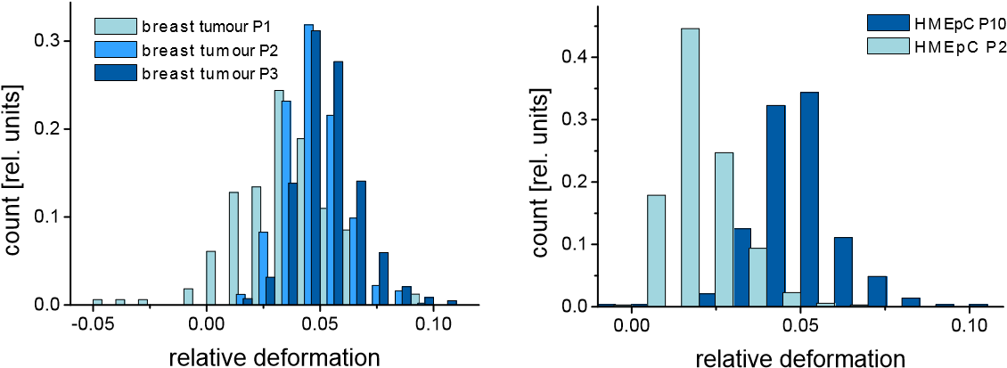

Extended Data Figure 1: Effect of passaging on the deformability of primary breast tumor and normal epithelial cells. Distribution of the maximum relative cell deformations (observed at t = 3 s) for a breast cancer sample stretched at the end of passage number 1-3 (sample size: P1 = 164 cells, P 2= 496 cells, P3 = 309 cells) and epithelial cells from breast reduction (HMEpC) stretched at the end of passage number 2 and 10 (sample size: P2 = 352 cells, P10 = 702 cells). With increasing passage number more and more deformable cells are found. Time between passaging was 7 to 10 days.
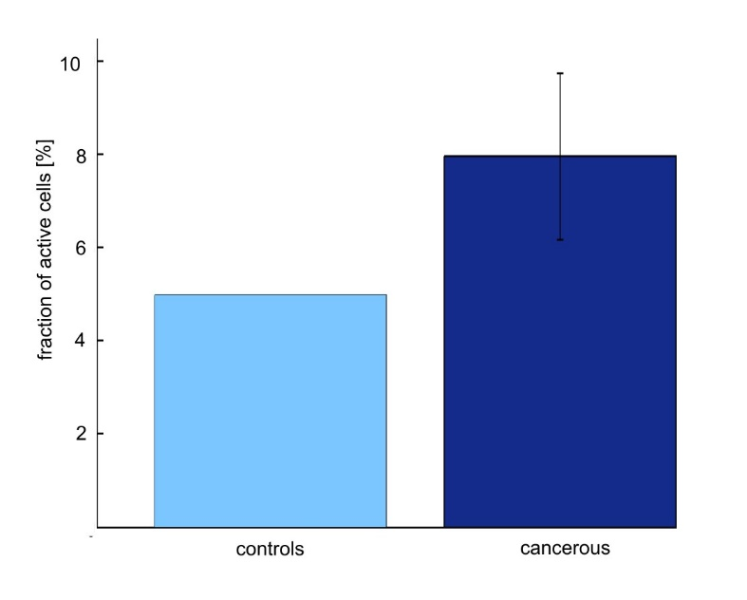
Extended Data Figure 2: Occurrence of contracting cells in breast tumor samples (dark blue, 13 samples) with respect to cells from breast reductions (light blue, one sample). Cells were counted as contracting if the slope of the deformation graph during stretching phase turned negative (compare Figure 2a, main script). Error bars indicate variations (standard deviation) between individual samples. The number of contractile cells nearly doubles in the tumor samples.

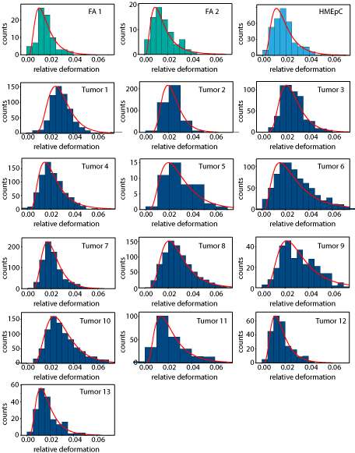Extended Data Fig. 3: Individual Histograms of the relative deformation of breast tumor samples. Cells isolated from 13 breast tumors were measured in the optical stretcher, 2 fibroadenomas and HMEpC cells serve as control. Log-Normal distributions were fitted to the histograms; details of the fits can be found in Extended Data Table 1.

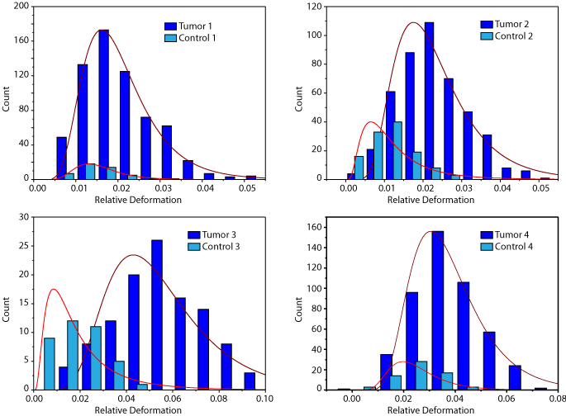
Extended Data Figure 4: Individual Histograms the relative deformation of Cervix Tumors. Cells were isolated from 4 cervix tumors and normal cervix tissue from the same patient as control. Log-Normal distributions were fitted; details of the fits can be found in Extended Data Table 1.
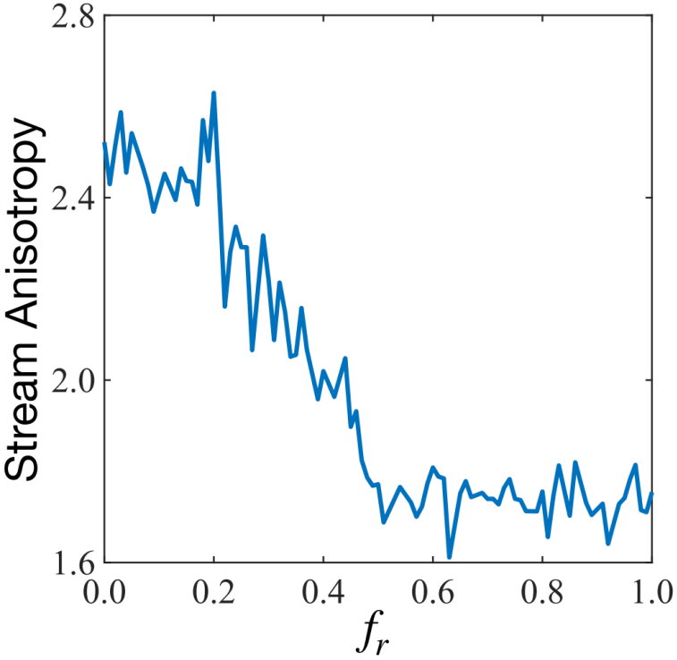

Extended Data Figure 5: The stream anisotropy parameter $ξ_{x}/ ξ_{y}$ as a function of $f_{r}$ for the invading cell.

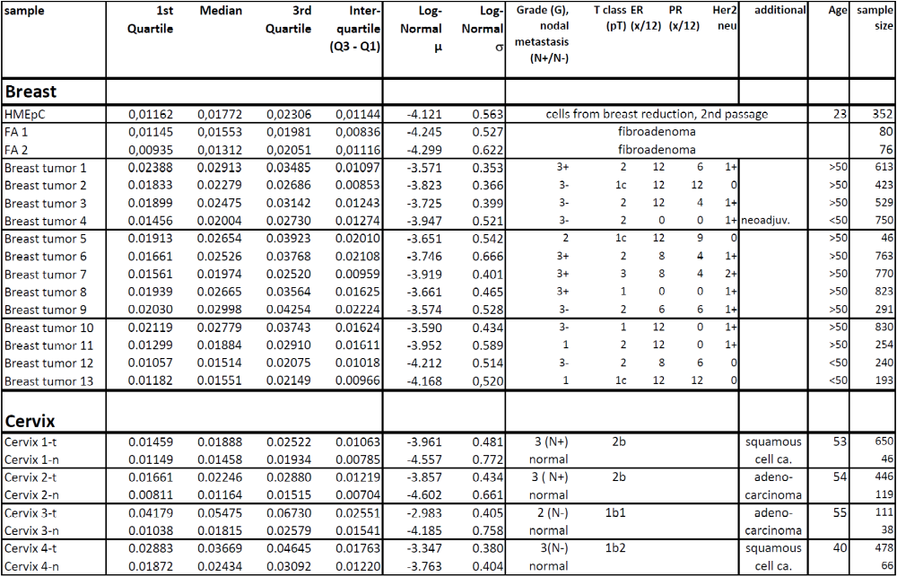
Extended Data Table 1: Statistic quantities (median, 1st- and 3rd-quartile, interquartile (Q3-Q1)) and parameters µ and σ of the Log-Normal fits, characterizing the distributions of relative deformation at the end of the stretching phase of the measured samples, exact staging of all measured breast tumor samples (invasive ductal carcinoma) and amount of measured cells. Breast tumor staging was done according to UICC TNM-classification (where grade 3, N+/N- means with/without nodal metastasis). Additionally, estrogen, progesterone (immune-reactive score IRS) and HER2neu receptor status are given. Cervical cancer was staged according to the International Federation of Gynecology and Obstetrics (FIGO) staging system. Neighboring normal cervical epithelia tissue was used as control.

Extended Data Movie 1: Vital imaging of tumor fragment. A small fragment of a cervix tumor was vital stained with SiR-DNA to record the movement of cell nuclei. The movie is 600x real time.
Extended Data Movie 2: Cell nuclei tracking in tumor fragment. We tracked the cell nuclei shown in Extended Data Movie 1. Color encodes cell speed with blue color representing slower and red colors representing faster cell.

