Supplementary Figure S1. Recursive feature elimination performance curve for candidate predictor selection.

Supplementary Figure S2. Univariate AUC ranking of candidate predictors for acute kidney injury.

Supplementary Figure S3. Spearman correlation matrix of candidate predictors.

Supplementary Figure S4. Feature importance ranking of the AdaBoost model.

Supplementary Figure S5. Feature importance ranking of the KNN model.

Supplementary Figure S6. Feature importance ranking of the LightGBM model.

Supplementary Figure S7. Feature importance ranking of the logistic regression model.

Supplementary Figure S8. Feature importance ranking of the neural network model.

Supplementary Figure S9. Feature importance ranking of the SVM model.

Supplementary Figure S10. Feature importance ranking of the XGBoost model.

Supplementary Figure S11. Confusion matrices of the AdaBoost model across the internal test and external validation cohorts. A, MIMIC-IV internal test cohort; B, eICU external validation cohort; C, MIMIC-III external validation cohort; D, Guangxi local external validation cohort.

Supplementary Figure S12. Confusion matrices of the KNN model across the internal test and external validation cohorts. A, MIMIC-IV internal test cohort; B, eICU external validation cohort; C, MIMIC-III external validation cohort; D, Guangxi local external validation cohort.

Supplementary Figure S13. Confusion matrices of the LightGBM model across the internal test and external validation cohorts. A, MIMIC-IV internal test cohort; B, eICU external validation cohort; C, MIMIC-III external validation cohort; D, Guangxi local external validation cohort.

Supplementary Figure S14. Confusion matrices of the logistic regression model across the internal test and external validation cohorts. A, MIMIC-IV internal test cohort; B, eICU external validation cohort; C, MIMIC-III external validation cohort; D, Guangxi local external validation cohort.

Supplementary Figure S15. Confusion matrices of the neural network model across the internal test and external validation cohorts. A, MIMIC-IV internal test cohort; B, eICU external validation cohort; C, MIMIC-III external validation cohort; D, Guangxi local external validation cohort.

Supplementary Figure S16. Confusion matrices of the SVM model across the internal test and external validation cohorts. A, MIMIC-IV internal test cohort; B, eICU external validation cohort; C, MIMIC-III external validation cohort; D, Guangxi local external validation cohort.

Supplementary Figure S17. Confusion matrices of the XGBoost model across the internal test and external validation cohorts. A, MIMIC-IV internal test cohort; B, eICU external validation cohort; C, MIMIC-III external validation cohort; D, Guangxi local external validation cohort.

Supplementary Figure S18. SHAP dependence plot for total calcium in the logistic regression model.

Supplementary Figure S19. SHAP dependence plot for heart failure (HF) in the logistic regression model.

Supplementary Figure S20. SHAP dependence plot for magnesium in the logistic regression model.

Supplementary Figure S21. SHAP dependence plot for pH in the logistic regression model.

Supplementary Figure S22. SHAP dependence plot for partial pressure of oxygen (PO2) in the logistic regression model.

Supplementary Figure S23. SHAP dependence plot for partial thromboplastin time (PTT) in the logistic regression model.

Supplementary Figure S24. SHAP dependence plot for weight in the logistic regression model.

Supplementary Table S1. Optimized hyperparameter settings for the seven machine learning models.
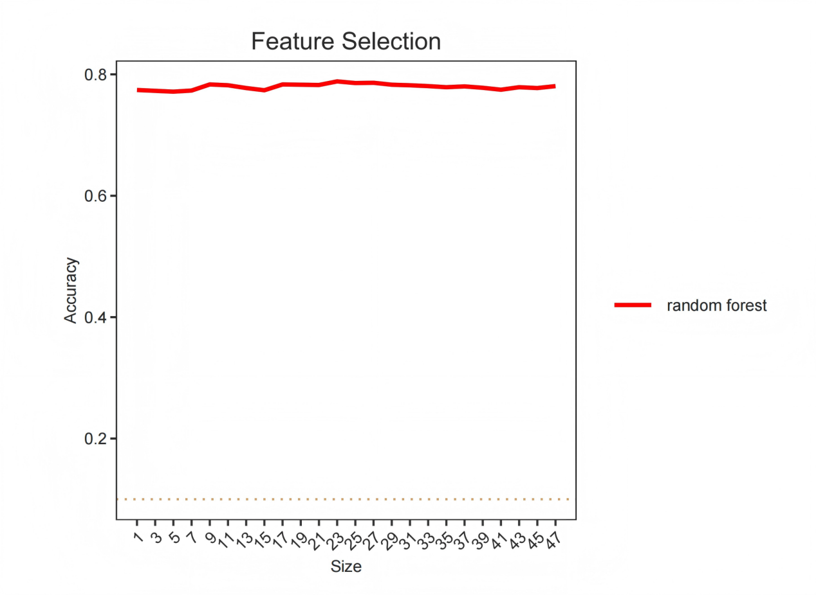
Supplementary Figure S1. Recursive feature elimination performance curve for candidate predictor selection.
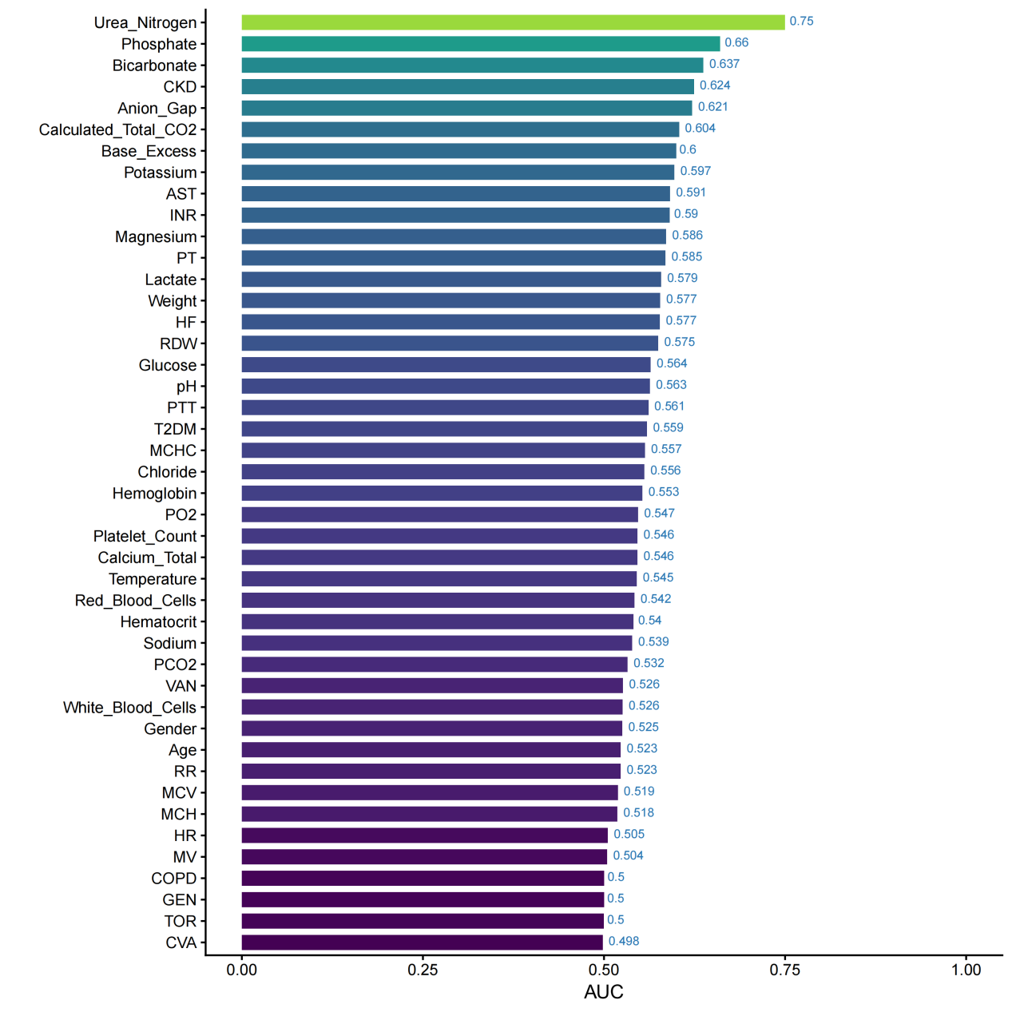
Supplementary Figure S2. Univariate AUC ranking of candidate predictors for acute kidney injury.
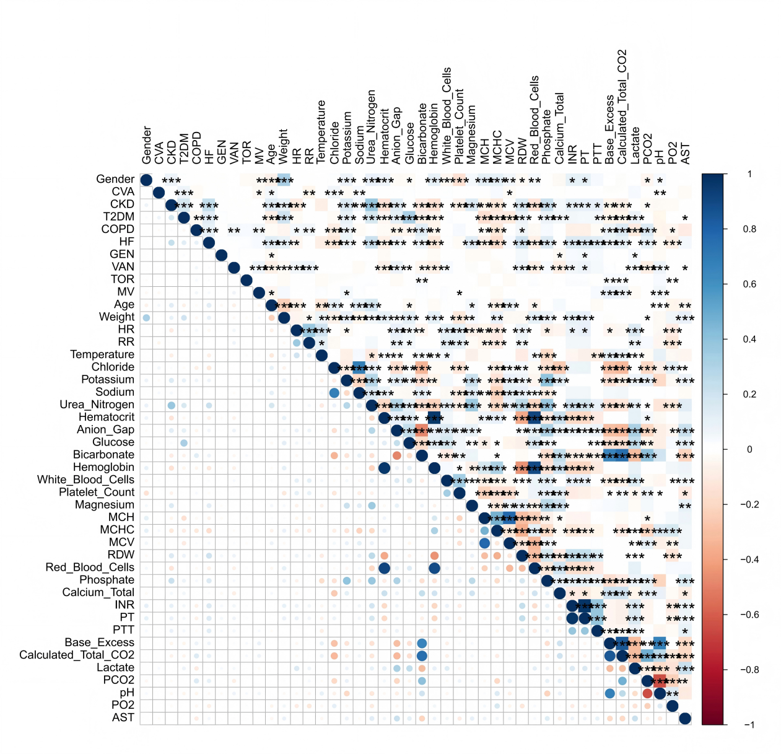
Supplementary Figure S3. Spearman correlation matrix of candidate predictors.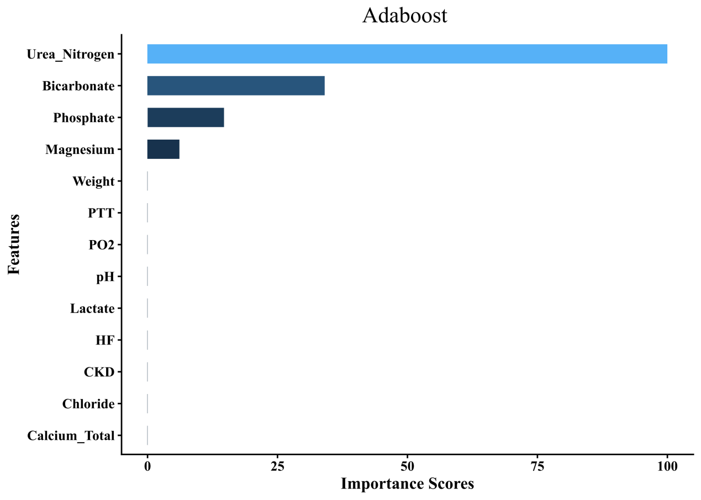
Supplementary Figure S4. Feature importance ranking of the AdaBoost model.
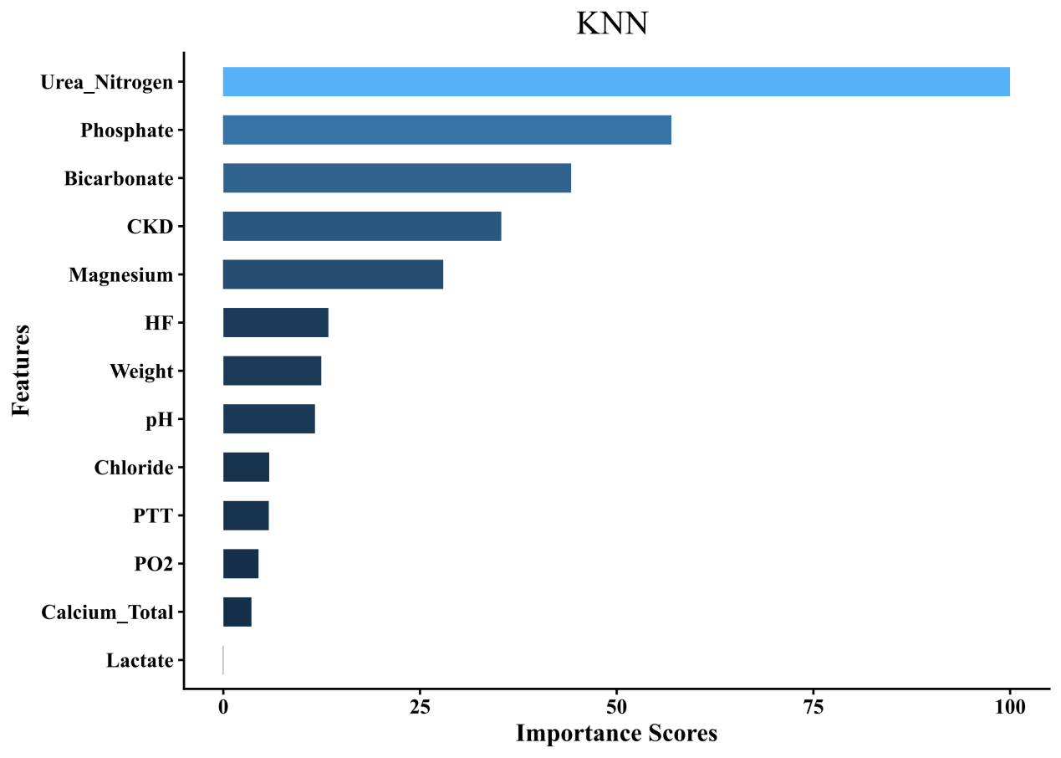
Supplementary Figure S5. Feature importance ranking of the KNN model.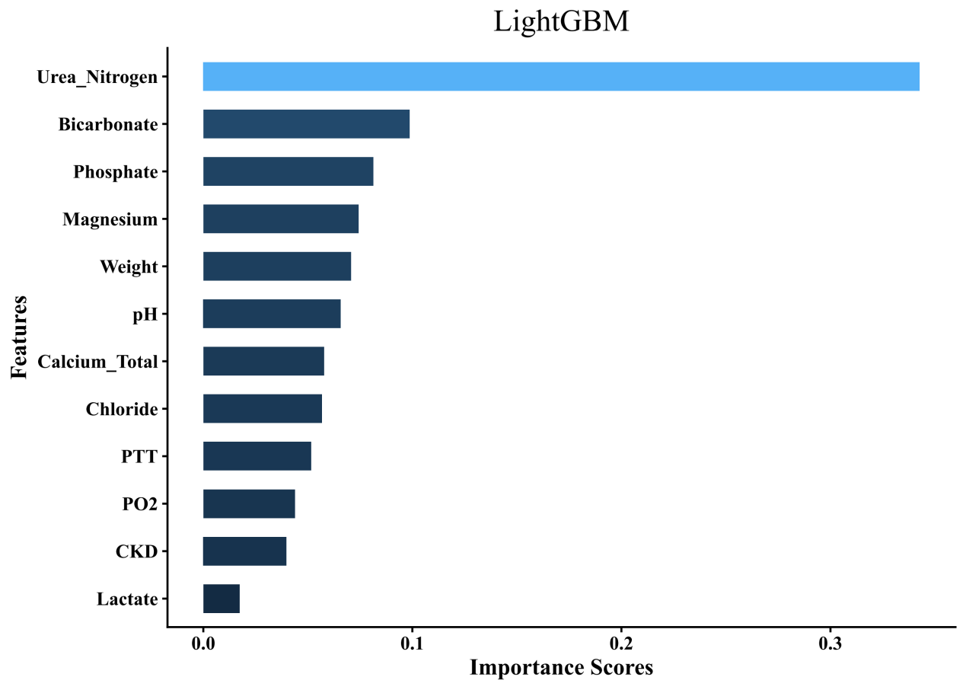
Supplementary Figure S6. Feature importance ranking of the LightGBM model.
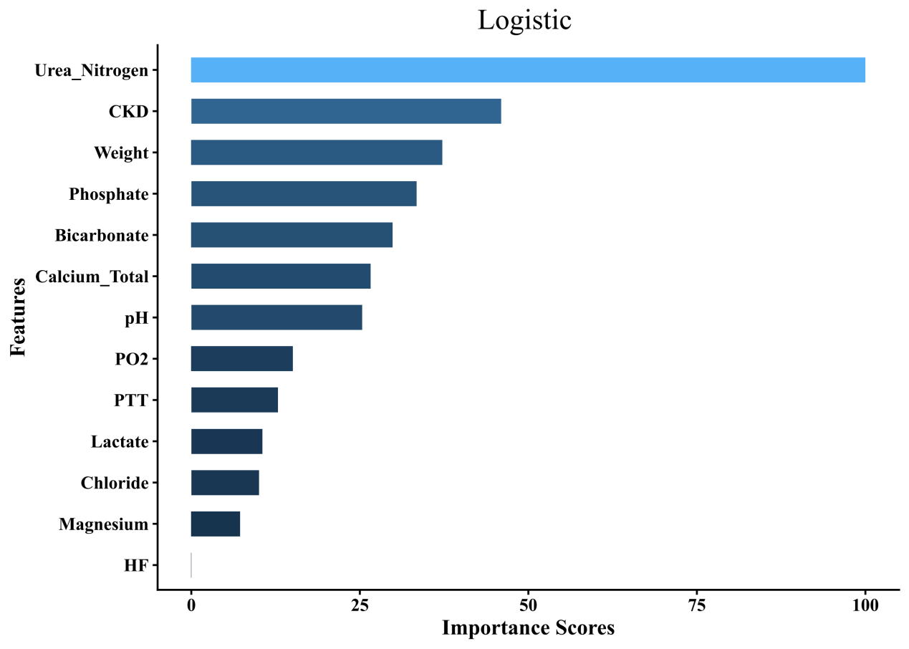
Supplementary Figure S7. Feature importance ranking of the logistic regression model.
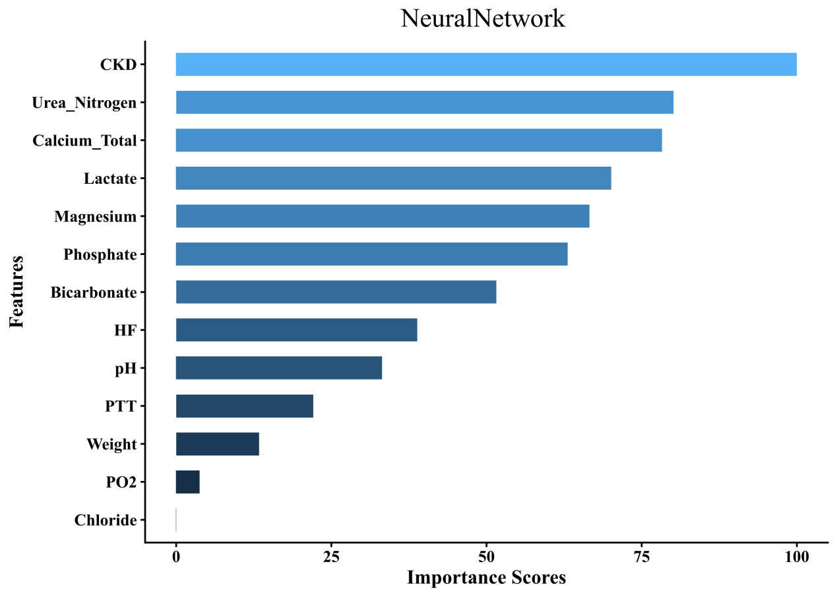
Supplementary Figure S8. Feature importance ranking of the neural network model.
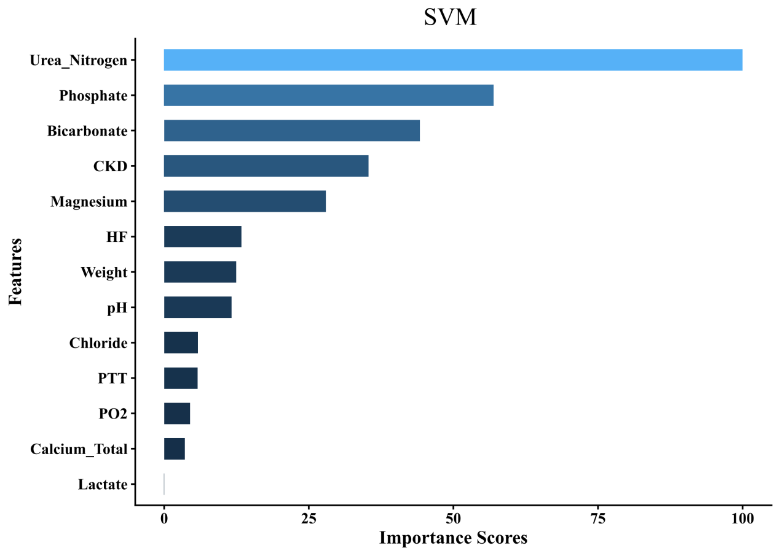
Supplementary Figure S9. Feature importance ranking of the SVM model.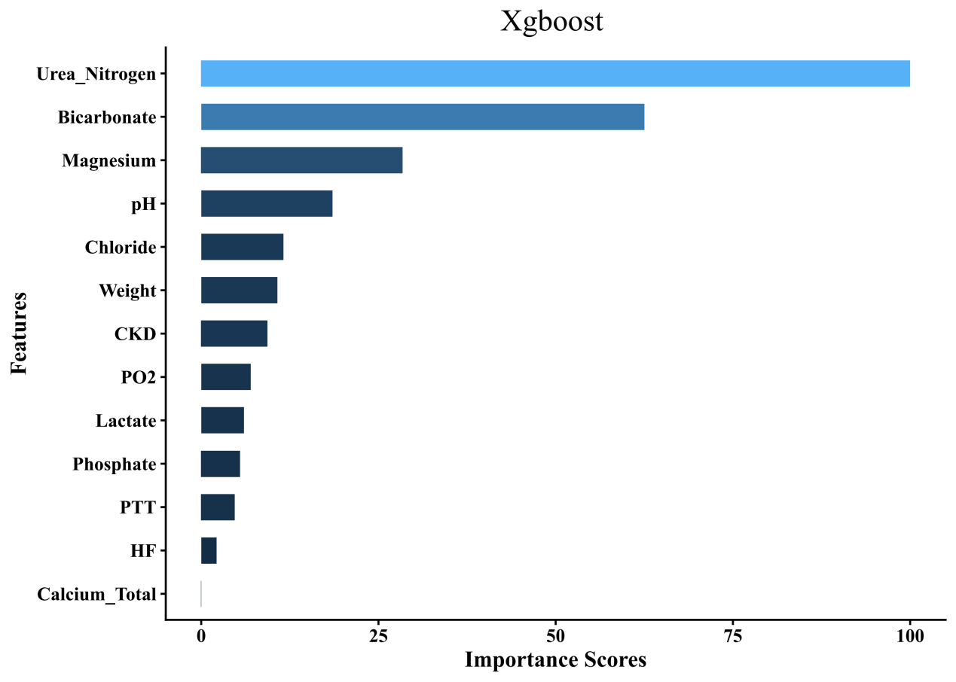
Supplementary Figure S10. Feature importance ranking of the XGBoost model.

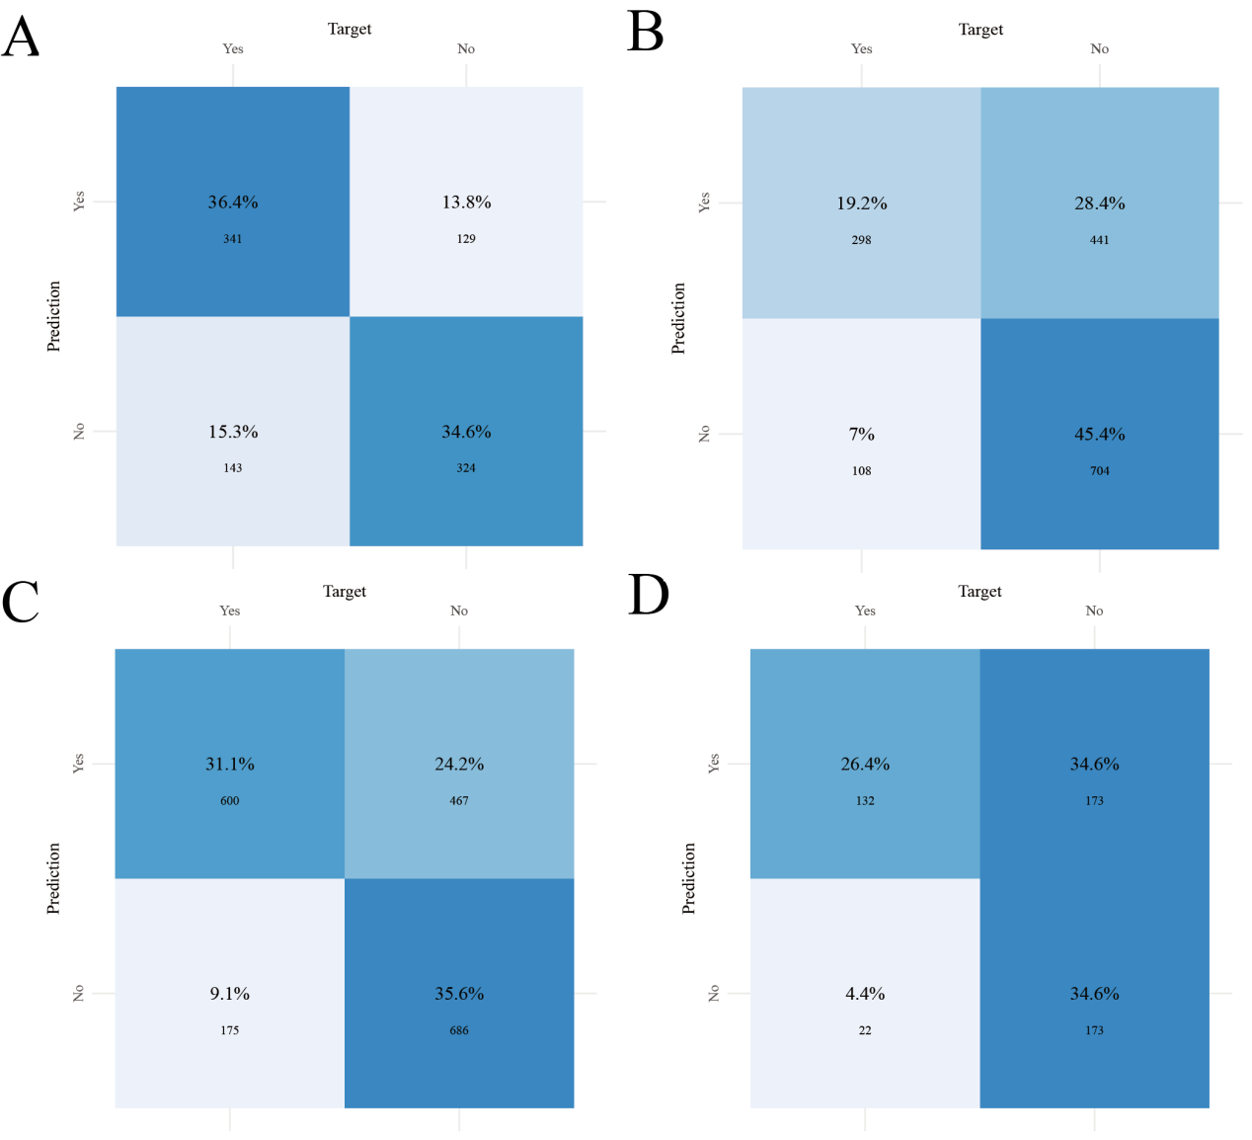
Supplementary Figure S11. Confusion matrices of the AdaBoost model across the internal test and external validation cohorts. A, MIMIC-IV internal test cohort; B, eICU external validation cohort; C, MIMIC-III external validation cohort; D, Guangxi local external validation cohort.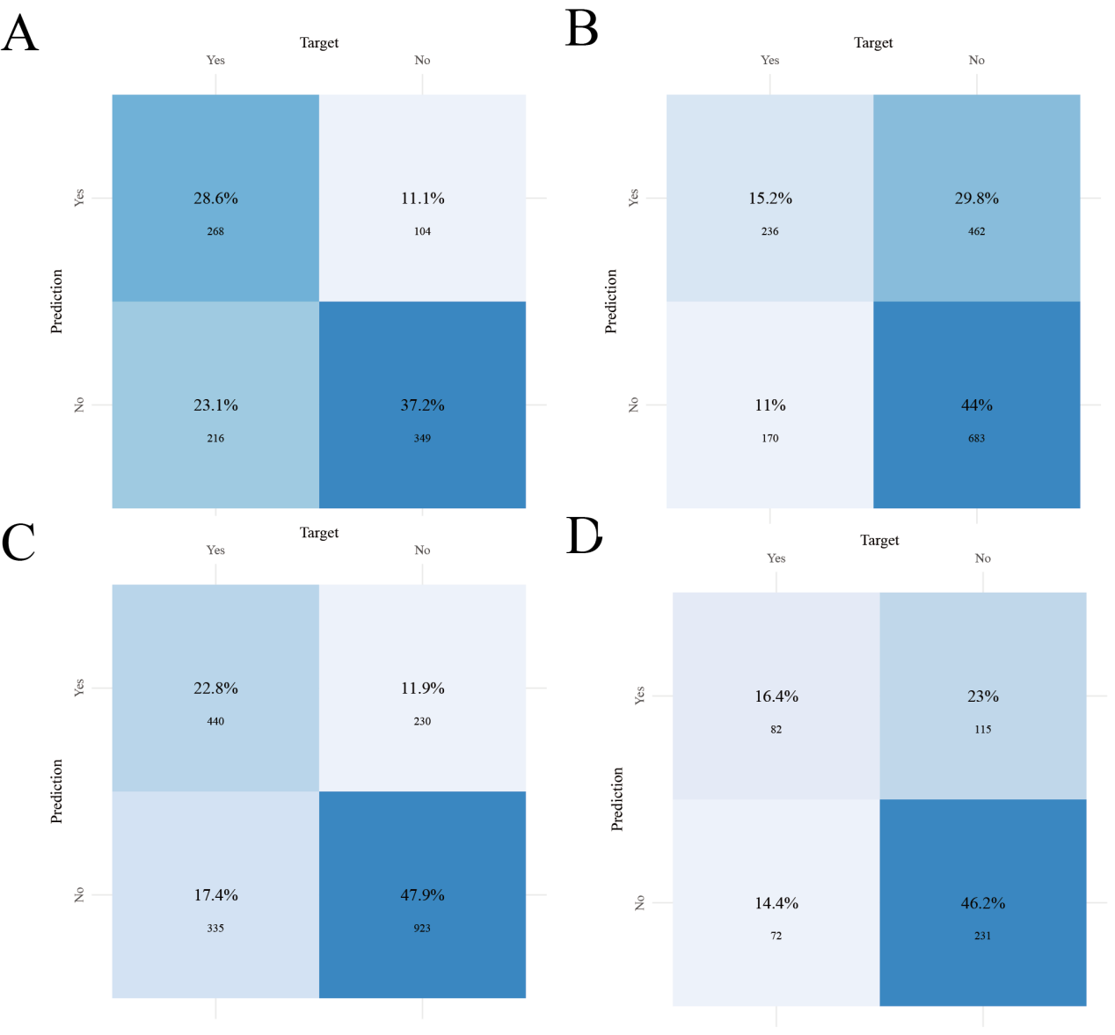
Supplementary Figure S12. Confusion matrices of the KNN model across the internal test and external validation cohorts. A, MIMIC-IV internal test cohort; B, eICU external validation cohort; C, MIMIC-III external validation cohort; D, Guangxi local external validation cohort.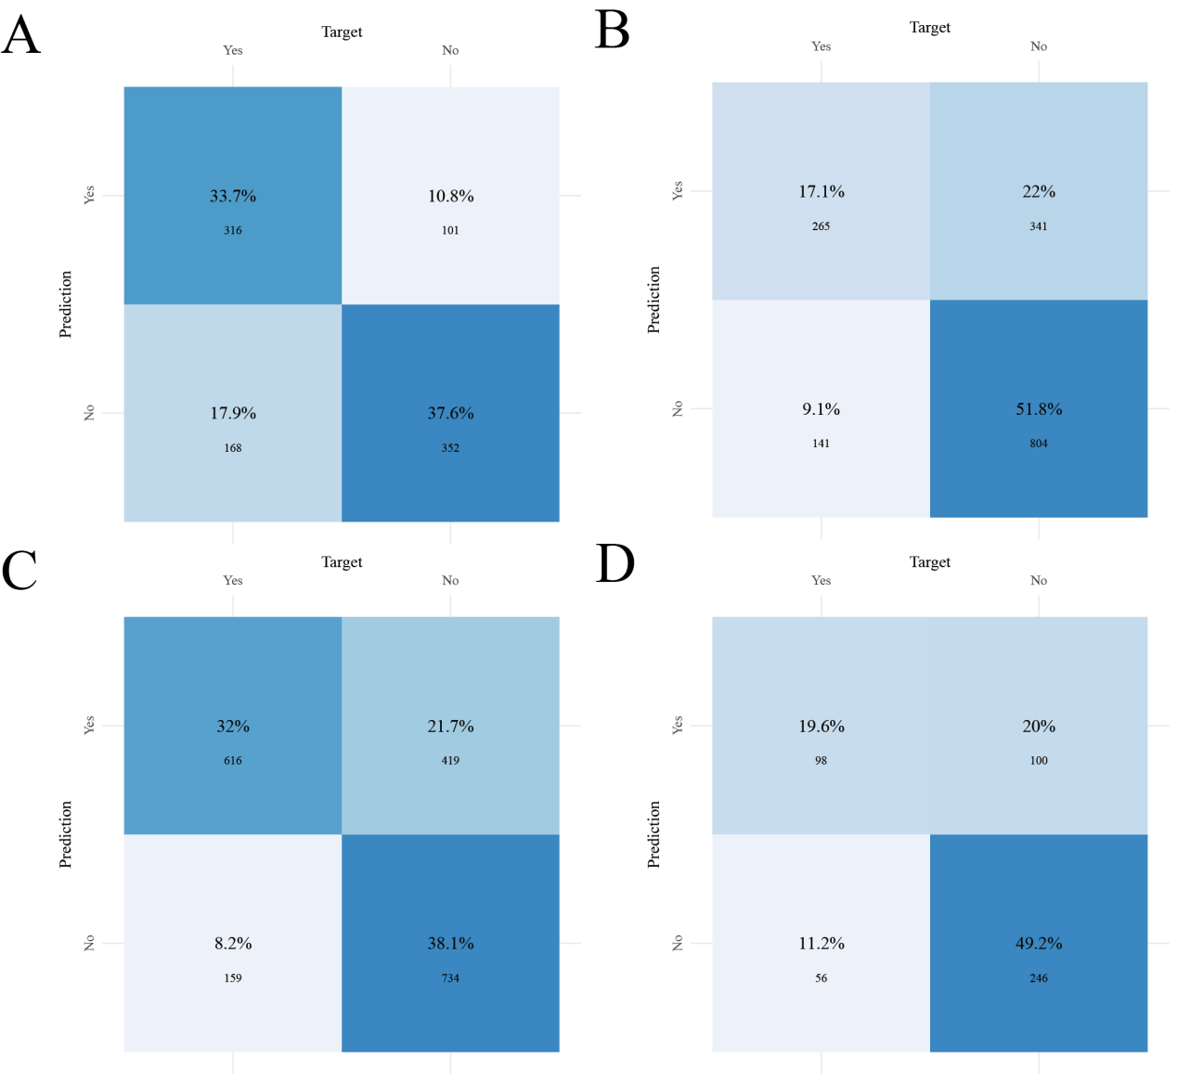
Supplementary Figure S13. Confusion matrices of the LightGBM model across the internal test and external validation cohorts. A, MIMIC-IV internal test cohort; B, eICU external validation cohort; C, MIMIC-III external validation cohort; D, Guangxi local external validation cohort.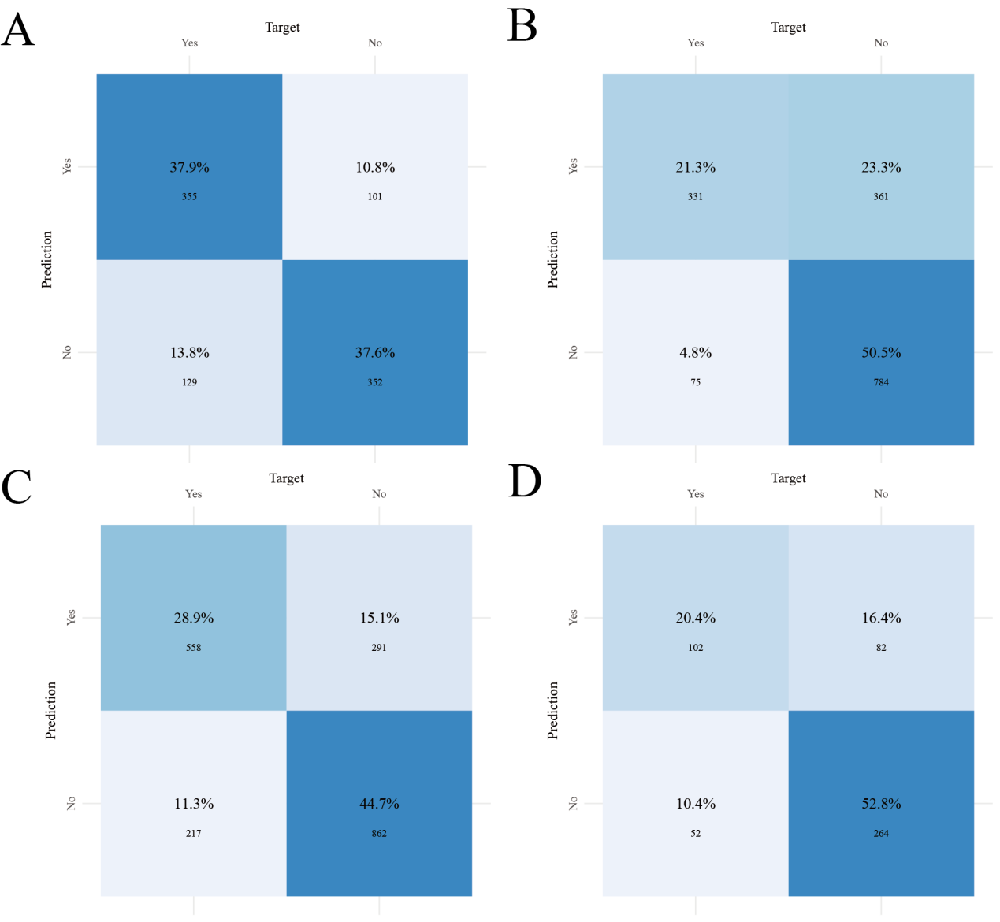
Supplementary Figure S14. Confusion matrices of the logistic regression model across the internal test and external validation cohorts. A, MIMIC-IV internal test cohort; B, eICU external validation cohort; C, MIMIC-III external validation cohort; D, Guangxi local external validation cohort.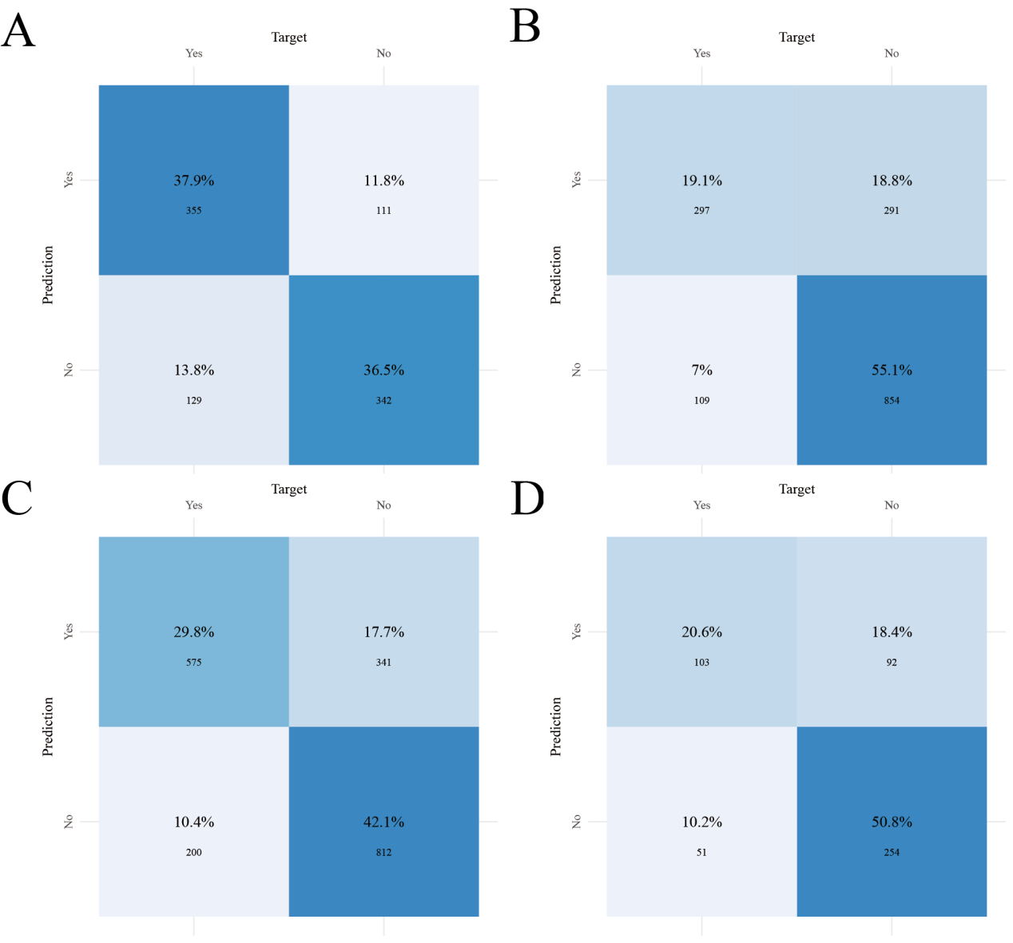
Supplementary Figure S15. Confusion matrices of the neural network model across the internal test and external validation cohorts. A, MIMIC-IV internal test cohort; B, eICU external validation cohort; C, MIMIC-III external validation cohort; D, Guangxi local external validation cohort.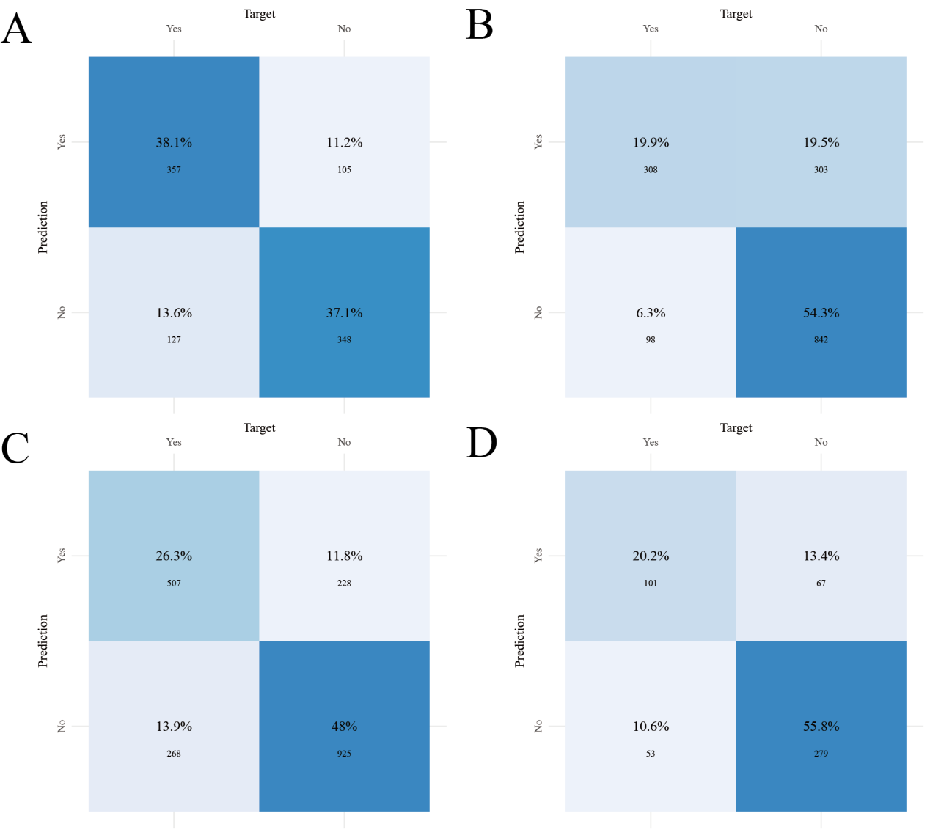
Supplementary Figure S16. Confusion matrices of the SVM model across the internal test and external validation cohorts. A, MIMIC-IV internal test cohort; B, eICU external validation cohort; C, MIMIC-III external validation cohort; D, Guangxi local external validation cohort.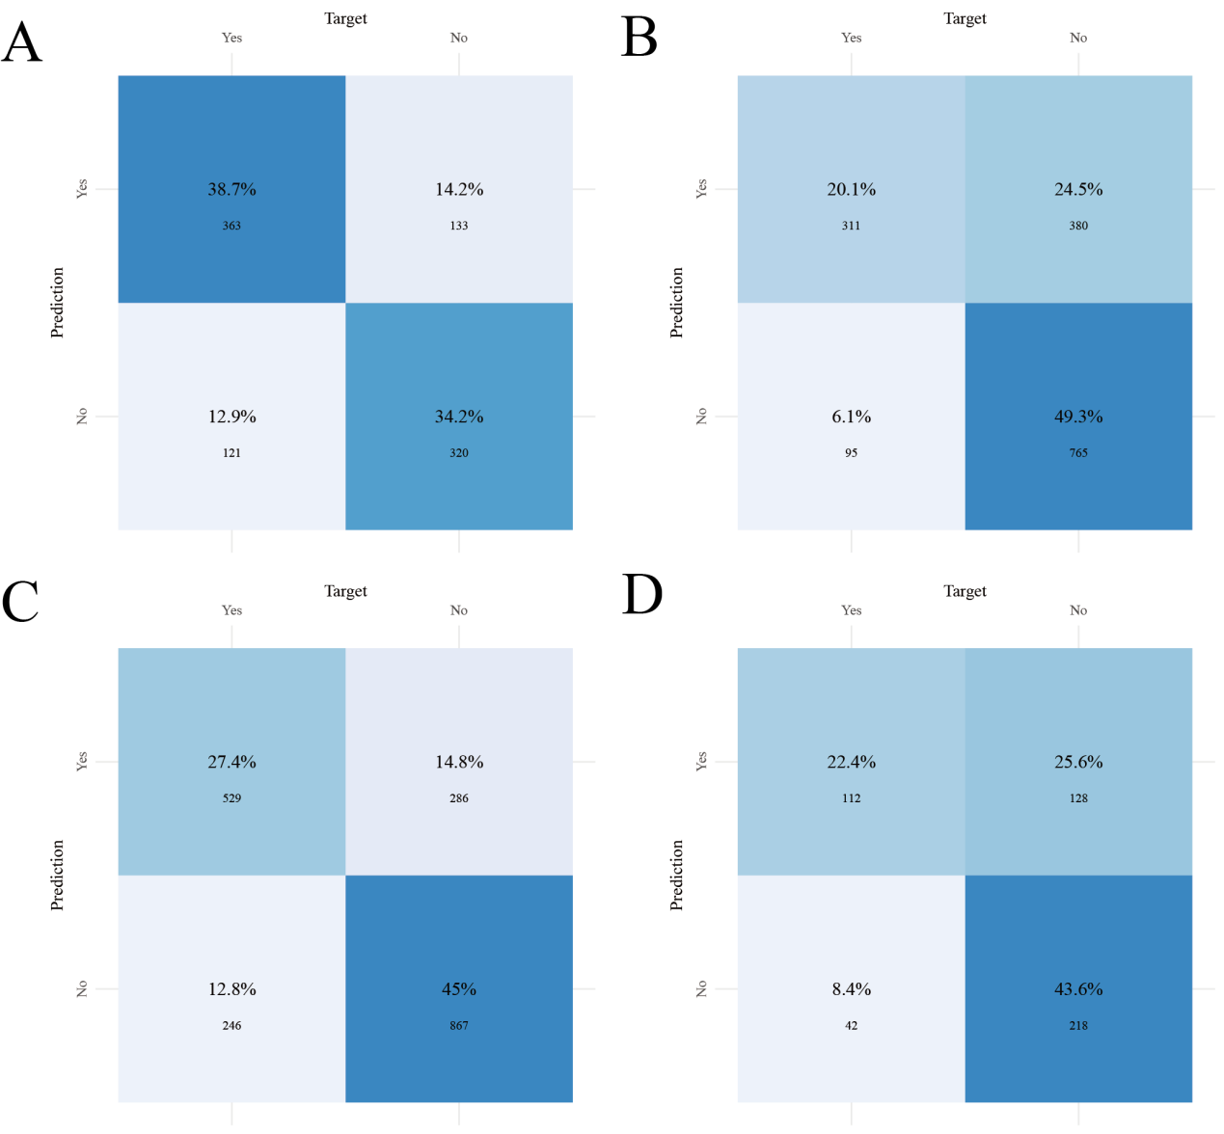
Supplementary Figure S17. Confusion matrices of the XGBoost model across the internal test and external validation cohorts. A, MIMIC-IV internal test cohort; B, eICU external validation cohort; C, MIMIC-III external validation cohort; D, Guangxi local external validation cohort.

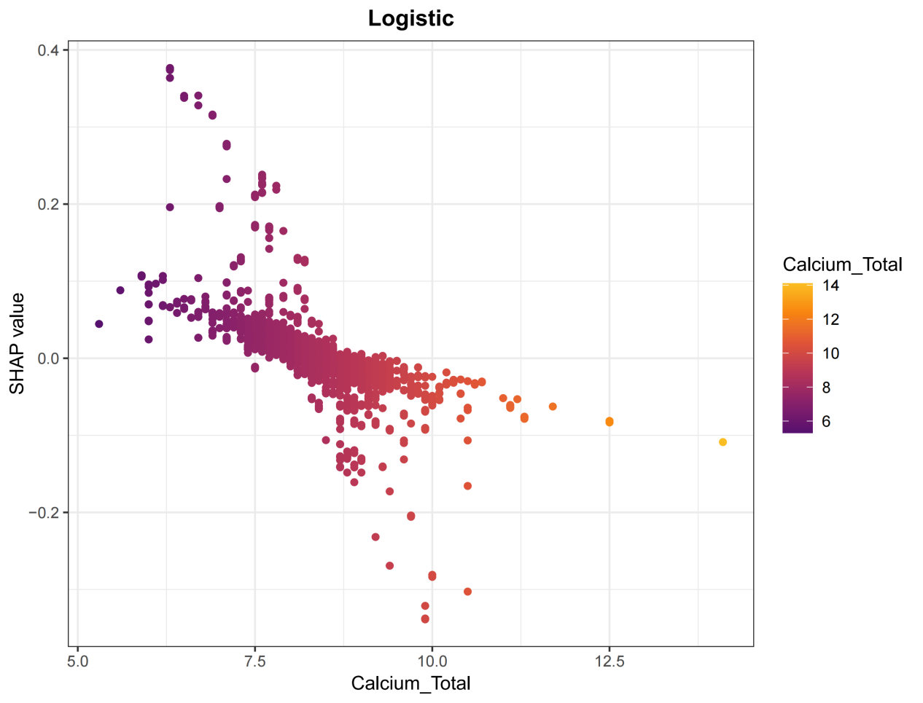
Supplementary Figure S18. SHAP dependence plot for total calcium in the logistic regression model.
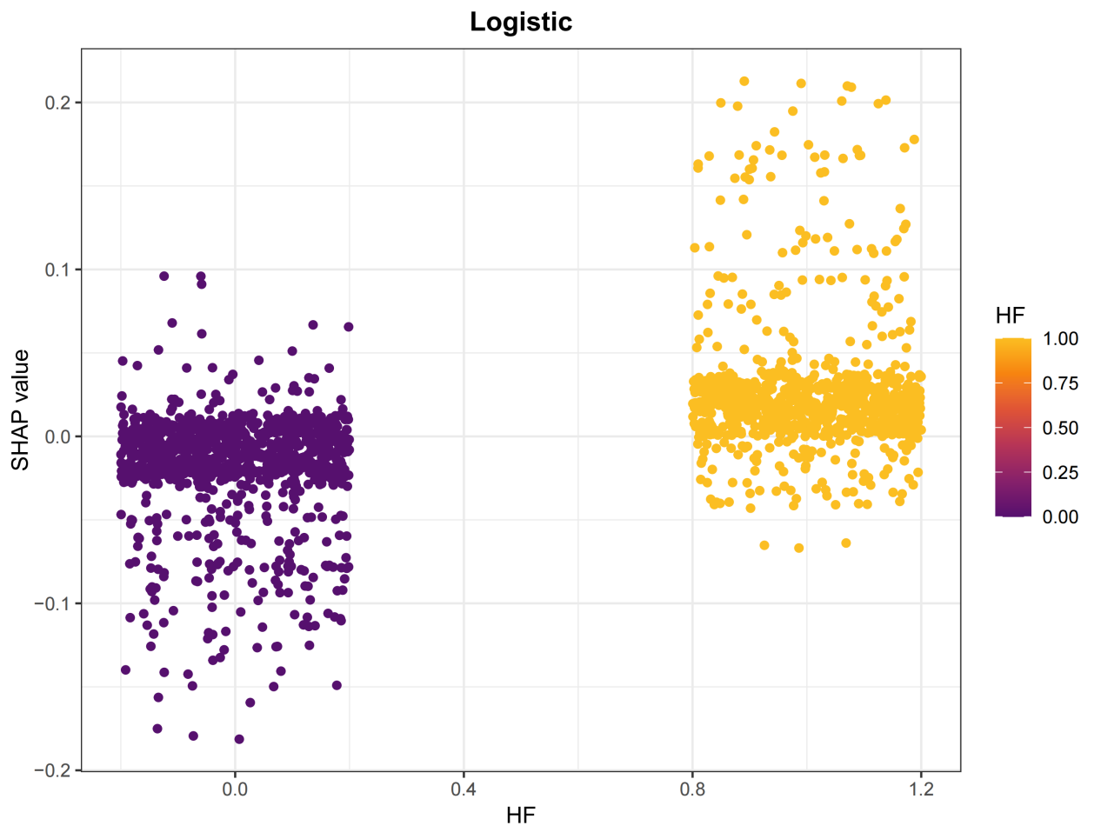
Supplementary Figure S19. SHAP dependence plot for heart failure (HF) in the logistic regression model.
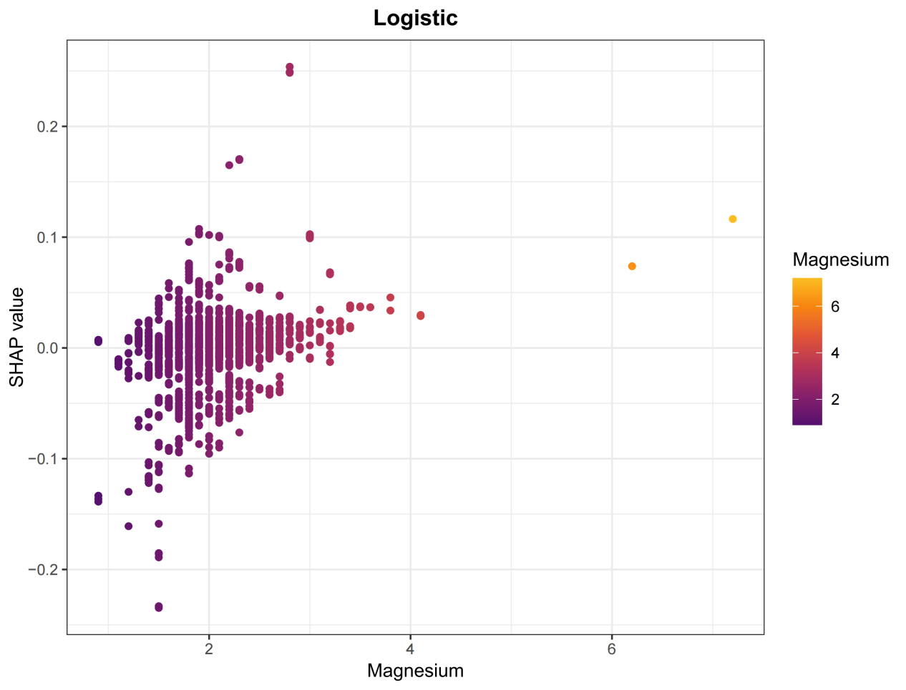
Supplementary Figure S20. SHAP dependence plot for magnesium in the logistic regression model.
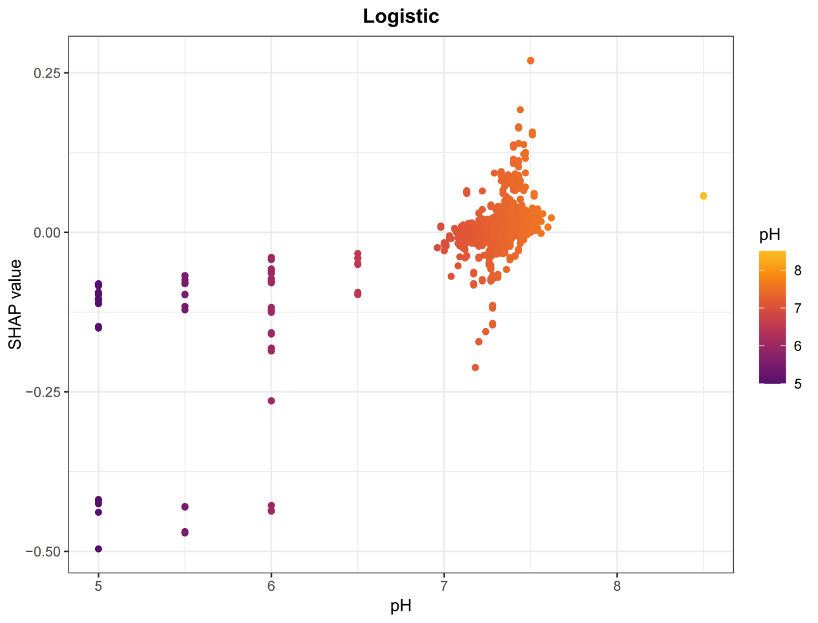
Supplementary Figure S21. SHAP dependence plot for pH in the logistic regression model.
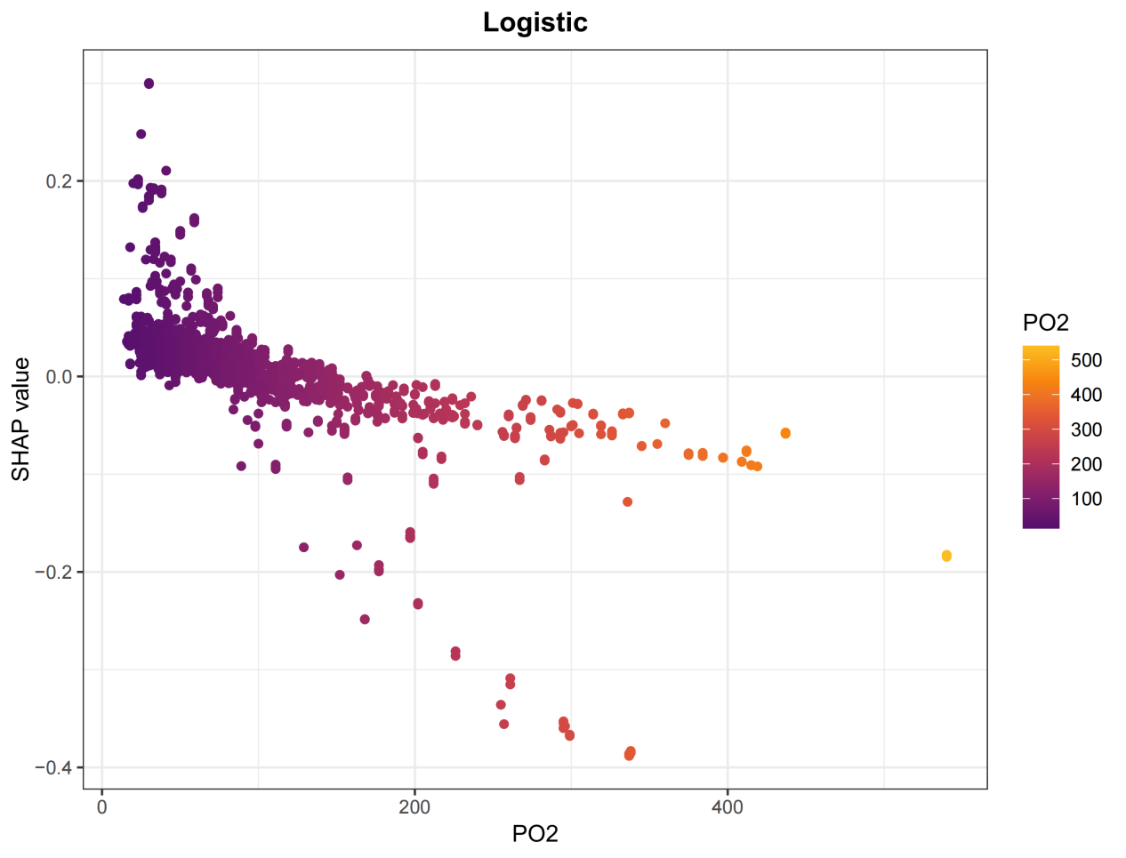

Supplementary Figure S22. SHAP dependence plot for partial pressure of oxygen (PO2) in the logistic regression model.
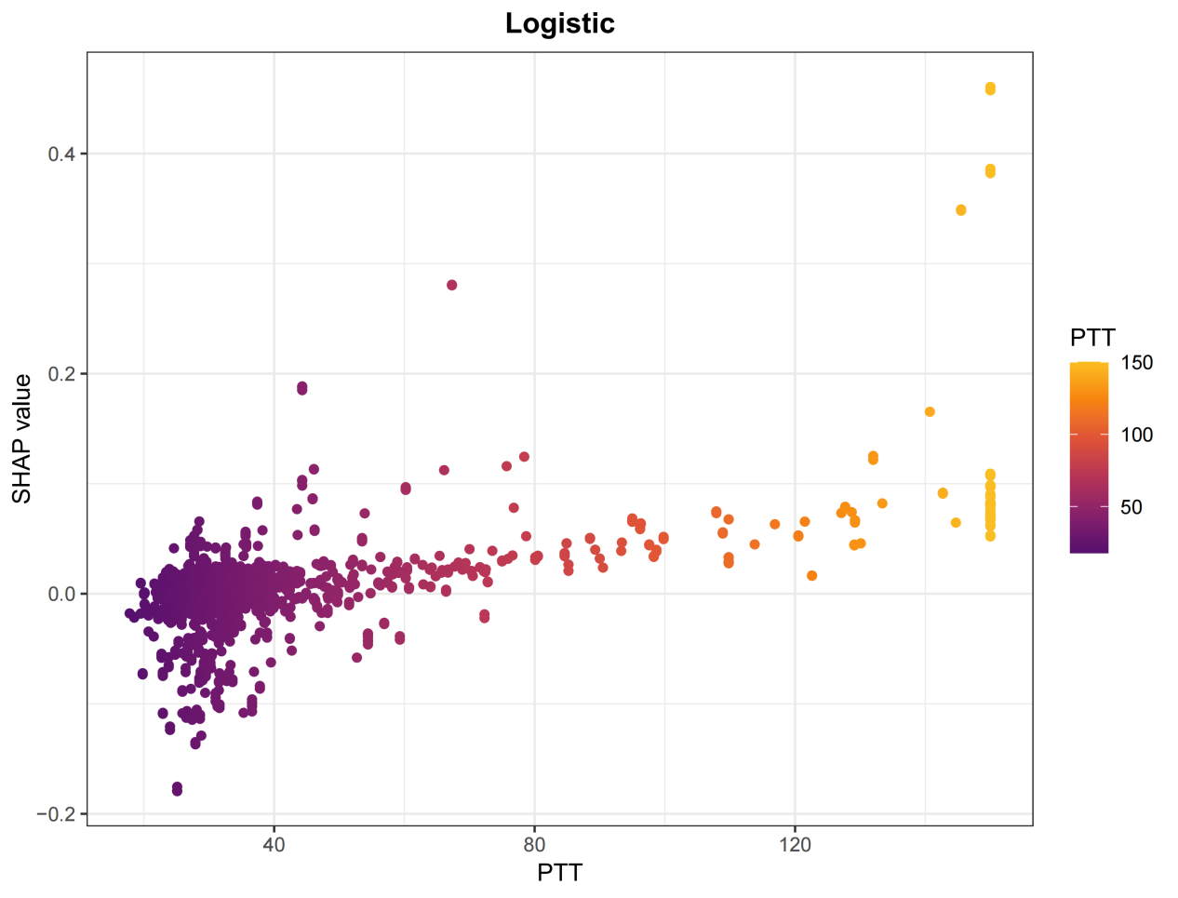
Supplementary Figure S23. SHAP dependence plot for partial thromboplastin time (PTT) in the logistic regression model.
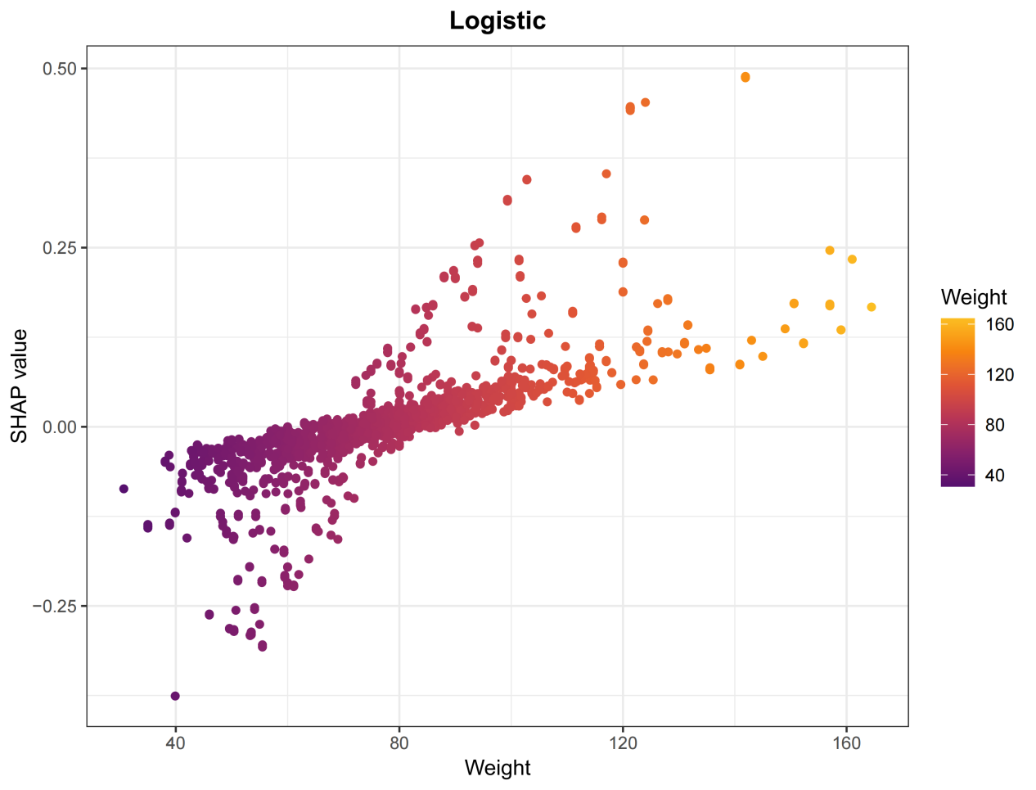
Supplementary Figure S24. SHAP dependence plot for weight in the logistic regression model.

Supplementary Table S1. Optimized hyperparameter settings for the seven machine learning models.
Model | Optimized hyperparameter settings
Logistic regression | No tuning parameters
Support vector machine | sigma = 0.001; C = 0.09
Neural network | size = 4; decay = 0.4
K-nearest neighbor | kmax = 12; distance = 1; kernel = optimal
XGBoost | nrounds = 10; max_depth = 4; eta = 0.001; gamma = 10; colsample_bytree = 0.5; min_child_weight = 1; subsample = 0.6
AdaBoost | mfinal = 2; maxdepth = 2; coeflearn = Zhu
LightGBM | objective = binary; metric = AUC; min_data = 1; learning_rate = 0.6; num_threads = 2; force_col_wise = TRUE

