A Catch-Curve Approach to Product Cohort Mortality: Estimating Discard and Export Rates from Observational Data Without Stock Registers
Thomas Potempa¹[0000-0003-4823-0924]
¹ Institut für Recycling, Ostfalia Hochschule für angewandte Wissenschaften, Wolfenbüttel, Germany
potempa@ostfalia.de

Appendix A Supplementary Information (SI)

Content
S1. Sensitivity to inflow-data uncertainty 3
S2. Full age-determination protocol 5

S1. Sensitivity to inflow-data uncertainty
Referenced from Section 3.4 of the main text.
Sections 3.1–3.3 of the main text assume that, where inflows I(t) are used at all (e.g. in a life-table reconstruction of the kind used by Krych & Pettersen, 2025), they are known precisely. In practice, many available sales statistics — trade-association aggregates (ZVEI, GfK; Section 1.1), customs proxies, or older records — are reported as rounded or approximate figures. This section quantifies what such imprecision does to two different reconstruction strategies applied to the same underlying data: a life-table method that uses I(t) directly, and the catch-curve estimators (V0.1, V0.5) that do not.
The life-table method estimates the hazard schedule of a single sales cohort by dividing its observed discards at each age by its (known) original inflow:
$$h\left(age\right)= \frac{D\left(age\right)}{S\left(age\right)} ,$$
with $D(age) = \frac{C_{d}(age,t)}{I(τ)}$

for a cohort born in year τ. Because every age-specific hazard value for that cohort is anchored to the same single inflow figure I(τ), any error in I(τ) propagates directly through the entire estimated hazard schedule for that cohort — and, critically, differently for different cohorts if reporting precision varies across years, which is the typical situation for long-run sales series (Section 1.1).
We test this using the real, reconstructed inflow and discard series for dishwashers (Section 3.1). We compare the hazard schedule of two cohorts (born 1985 and 2005; ages 0–5) under (a) the true inflow values and (b) 500 Monte Carlo draws in which each year's inflow is independently perturbed by ±15% i.i.d. noise — representative of rounded, approximate sales-statistic precision. The quantity of interest is the ratio of the two cohorts' mean hazard (2005-cohort ÷ 1985-cohort), which is what a life-table-based trend claim would report.
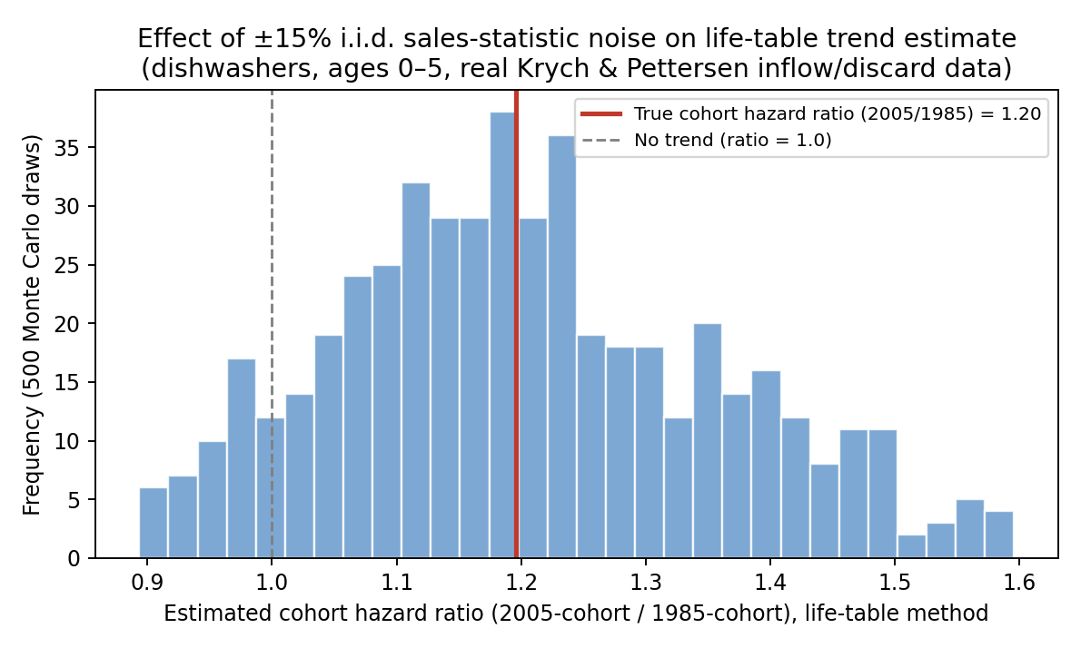
Figure S1. Distribution of the estimated 2005-vs-1985 cohort hazard ratio under ±15% i.i.d. inflow-reporting noise (life-table method), against the true ratio computed from exact inflow values.
The true cohort hazard ratio is 1.20 (a genuine 20% increase in hazard between the two cohorts). Under independent ±15% inflow noise, the life-table estimate of this same ratio has a 90% interval of 0.97 to 1.48 — spanning from no apparent trend at all to a more than doubled apparent effect size, purely as an artefact of inflow-reporting imprecision, with no change to the underlying discard data.
The catch-curve estimators V0.1 and V0.5 are unaffected by this source of error by construction: neither Z_obs(age) = −ln[C(age+1,t)/C(age,t)] nor Z_{v05}(age,t) = −ln[C(age+1,t+1)/C(age,t)] references I(t) at all. Both are pure ratios of field-observed counts. This does not exempt them from the biases documented in Sections 3.2–3.3 (recruitment/cohort-strength bias for V0.1; the hazard-shape bias for both estimators applied to discard-at-age counts) — but it does mean that, unlike the life-table approach, their accuracy does not additionally degrade when available inflow statistics are approximate rather than exact.
This refines Research Question 1 (Section 1.4): the relevant condition for the catch-curve approach to add value is not only the absence of inflow data, but also the presence of inflow data too imprecise to anchor a life-table reconstruction reliably — arguably the more common real-world condition for the aggregate, rounded sales statistics described in Section 1.1.

S2. Full age-determination protocol
Referenced from Section 4.2 of the main text.
In the proposed protocol, product age would be determined from the manufacturer date code on the type plate (Typenschild), following a standardised four-step procedure:
1. Locate type plate: typically affixed inside the door, on the rear panel, or on the base of the product.
2. Read manufacture date: format varies by manufacturer but typically encodes year and month (e.g., '04/2015', '2015-04', 'W16 2015' for week 16 of 2015).
3. Compute age: age (years) = (observation date − manufacture date) / 365.25. Where only the year is available, age is computed to year-resolution.
4. Assign a quality flag: QF = 0 (exact month known); QF = 1 (year only, age estimated ±0.5 year); QF = 2 (type plate unreadable — excluded from the C(s,t) analysis but counted in raw totals).
The QF = 2 rate is a critical diagnostic: if it exceeds 20% in the 15+ year age classes, the C(s,t) estimate for those classes is flagged as unreliable. This is expected to be the primary source of systematic bias in older product cohorts, where type plates may be worn, faded, or removed.

