Supporting information:
Rational design of a novel highly folding-tolerable Edgewo-rthia chrysantha Lindi-derived substrate for versatile flexible pressure sensors
Danning Fuª, Ruibin Wang^{b}, * Rendang Yangª,*
ª State Key Laboratory of Pulp and Paper Engineering, South China University of Technology, Guangzhou 510641, China.
^{b} College of Chemistry and Chemical Engineering, University of South China, Hengyang 421001, China.
Dr. D. N. Fu
E-mail: 1539544993@qq.com
* Prof. R. B. Wang
E-mail: rbwang@usc.edu.cn
* Corresponding author: Prof. R. D. Yang
E-mail: rendangyang@163.com
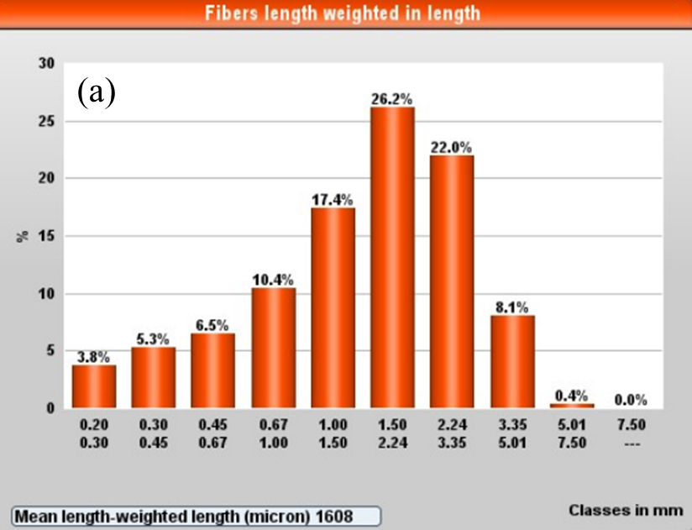
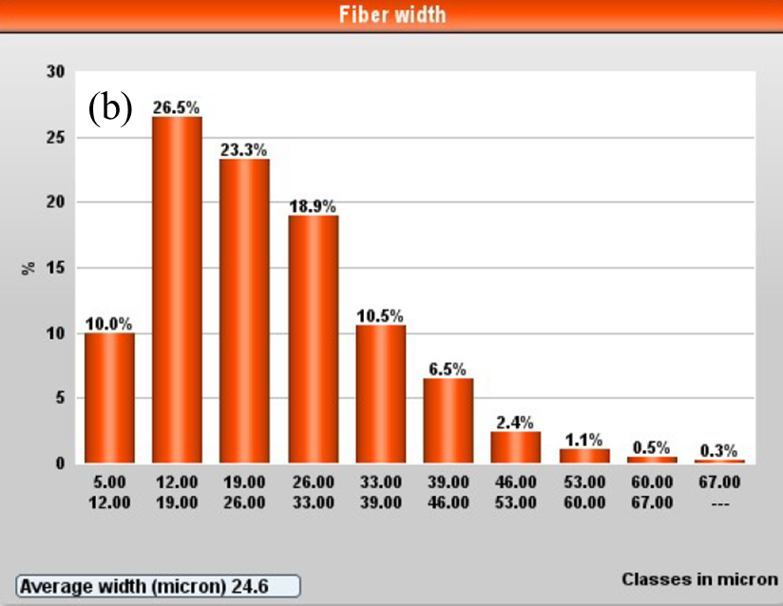
Fig. 1. The length (a) and diameter (b) distribution of ERCL fibers.

