Metabolomic spectra for phenotypic prediction of malting quality in spring barley
Xiangyu Guo^{1, 2 *}, Ahmed Jahoor^{3, 4}, Just Jensen¹, Pernille Sarup³
¹ Center for Quantitative Genetics and Genomics, Aarhus University, 8830 Tjele, Denmark
² SEGES, Pig Research Centre, 8200, Aarhus, Denmark
³ Nordic Seed A/S, 8300 Odder, Denmark
⁴ Department of Plant Breeding, The Swedish University of Agricultural Sciences, 2353 Alnarp, Sweden
*Correspondance:
Dr. Xiangyu Guo
Xiangyu.Guo@qgg.au.dk

Supplementary Material

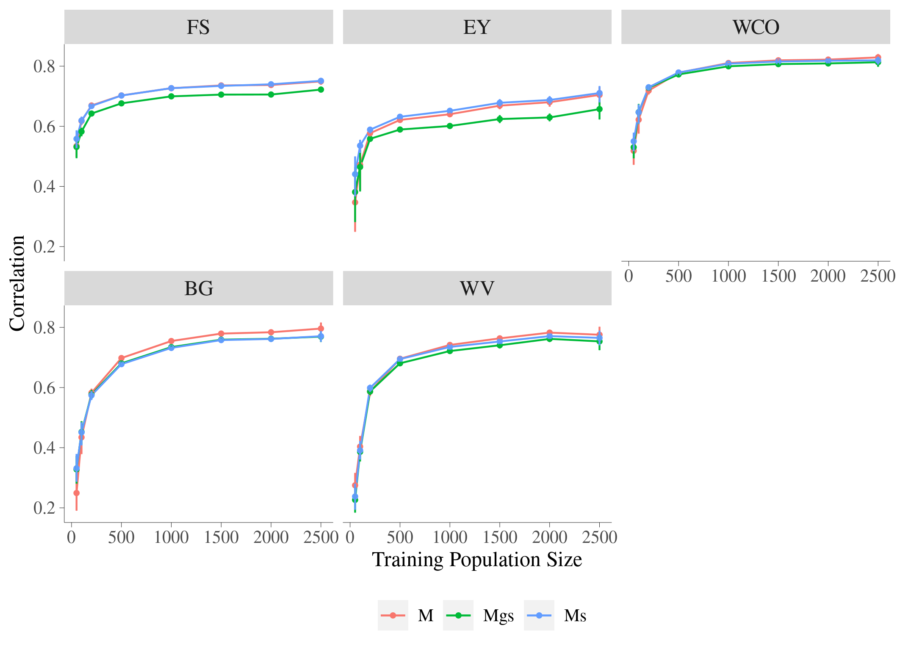

Figure S1 Accuracy of prediction for malting quality traits using MBLUP models with different sets of metabolomic features
Trait: FS = filtering speed, EY = extract yield, WCO = wort color, BG = beta glucan, WV = wort viscosity; x-axis is training population size, y-axis is accuracy of prediction which is the correlation between observed and predicted phenotypes; MBLUP is metabolomic best linear unbiased prediction model, M is MBLUP using all metabolomic features, Mgs is MBLUP using metabolomic features having significant genetic correlation with each trait and significantly heritable, Ms is MBLUP using metabolomic features significant heritable.

