Supplementary Information
Hybridization–Ionicity Mapping for Descriptor-Guided Design of Amorphous Ge–Sb–Se Selector-Only Memory

Inchan Oh¹, Won Hee Jeong¹, Min Kyu Yang², and Gun Hwan Kim^{1, 3}

¹Department of System Semiconductor Engineering, Yonsei University, Seoul 03722, Republic of Korea

²Department of AI Convergence, Sahmyook University, Seoul, 01795, Republic of Korea.

³Department of Materials Science and Engineering, Yonsei University, Seoul 03722, Republic of Korea

Corresponding author: Min Kyu Yang (dbrophd@syu.ac.kr), Gun Hwan Kim (kgh@yonsei.ac.kr)

Supplementary Material 1 | Electrical switching and compositional characterization of Ge–Sb–Se–Sn SOM devices based on hybridization–ionicity mapping.
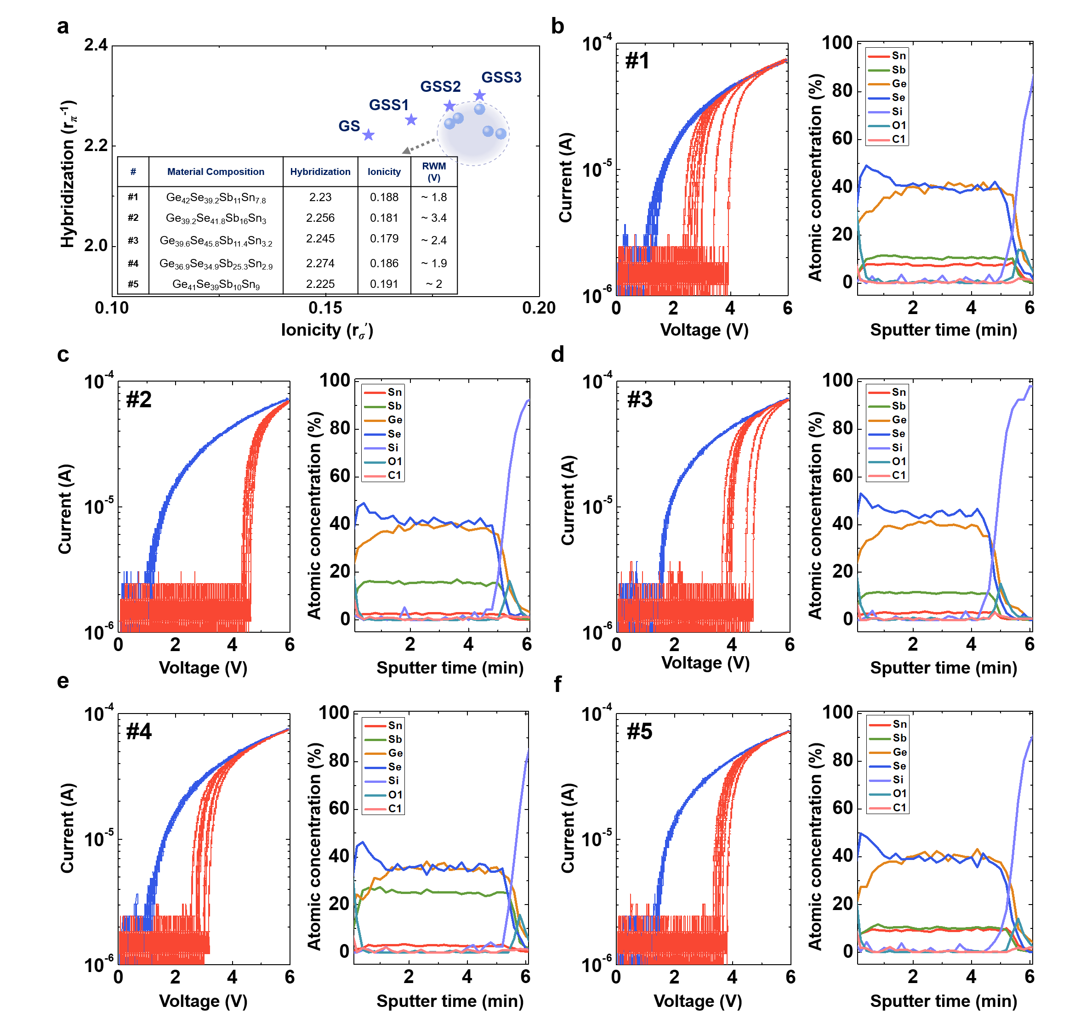
Fig S1. Experimental validation of the hybridization–ionicity mapping framework using additional GeSbSeSn-based SOM compositions. a Hybridization–ionicity mapping of five Sb-containing GeSbSeSn compositions. b–f Ten consecutive PIV cycles and corresponding AES depth profiles of the fabricated devices. All five compositions exhibited reproducible SOM characteristics, further supporting the applicability of the proposed mapping framework to the Sb-based SOM region in Fig. 1
Supplementary Material 2 | Pulse measurement setup and write–read schemes for SOM electrical characterization.
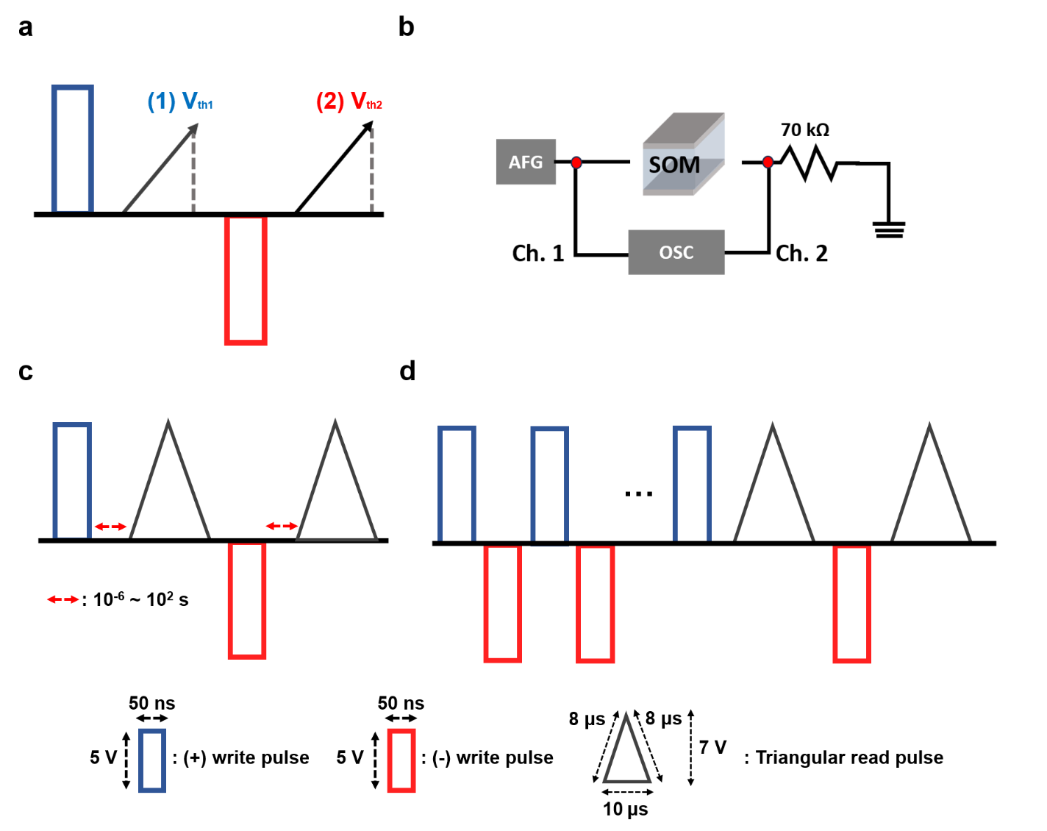
Fig S2. Pulse schemes and measurement configuration used for the electrical characterization of SOM devices. a Write–read pulse sequence for evaluating the basic SOM characteristics and extracting V_{th1} and V_{th2} after positive and negative write pulses, respectively. b Schematic of the pulse measurement setup using an AFG and OSC. c Pulse sequence for evaluating V_{th} drift as a function of the delay time between the write and read pulses. d Pulse sequence for endurance measurements using repeated write operations followed by read pulses to monitor the programmed threshold states.
Supplementary Material 3 | Arrhenius analysis of the programmed states in GS and GSS1–3 SOM devices.
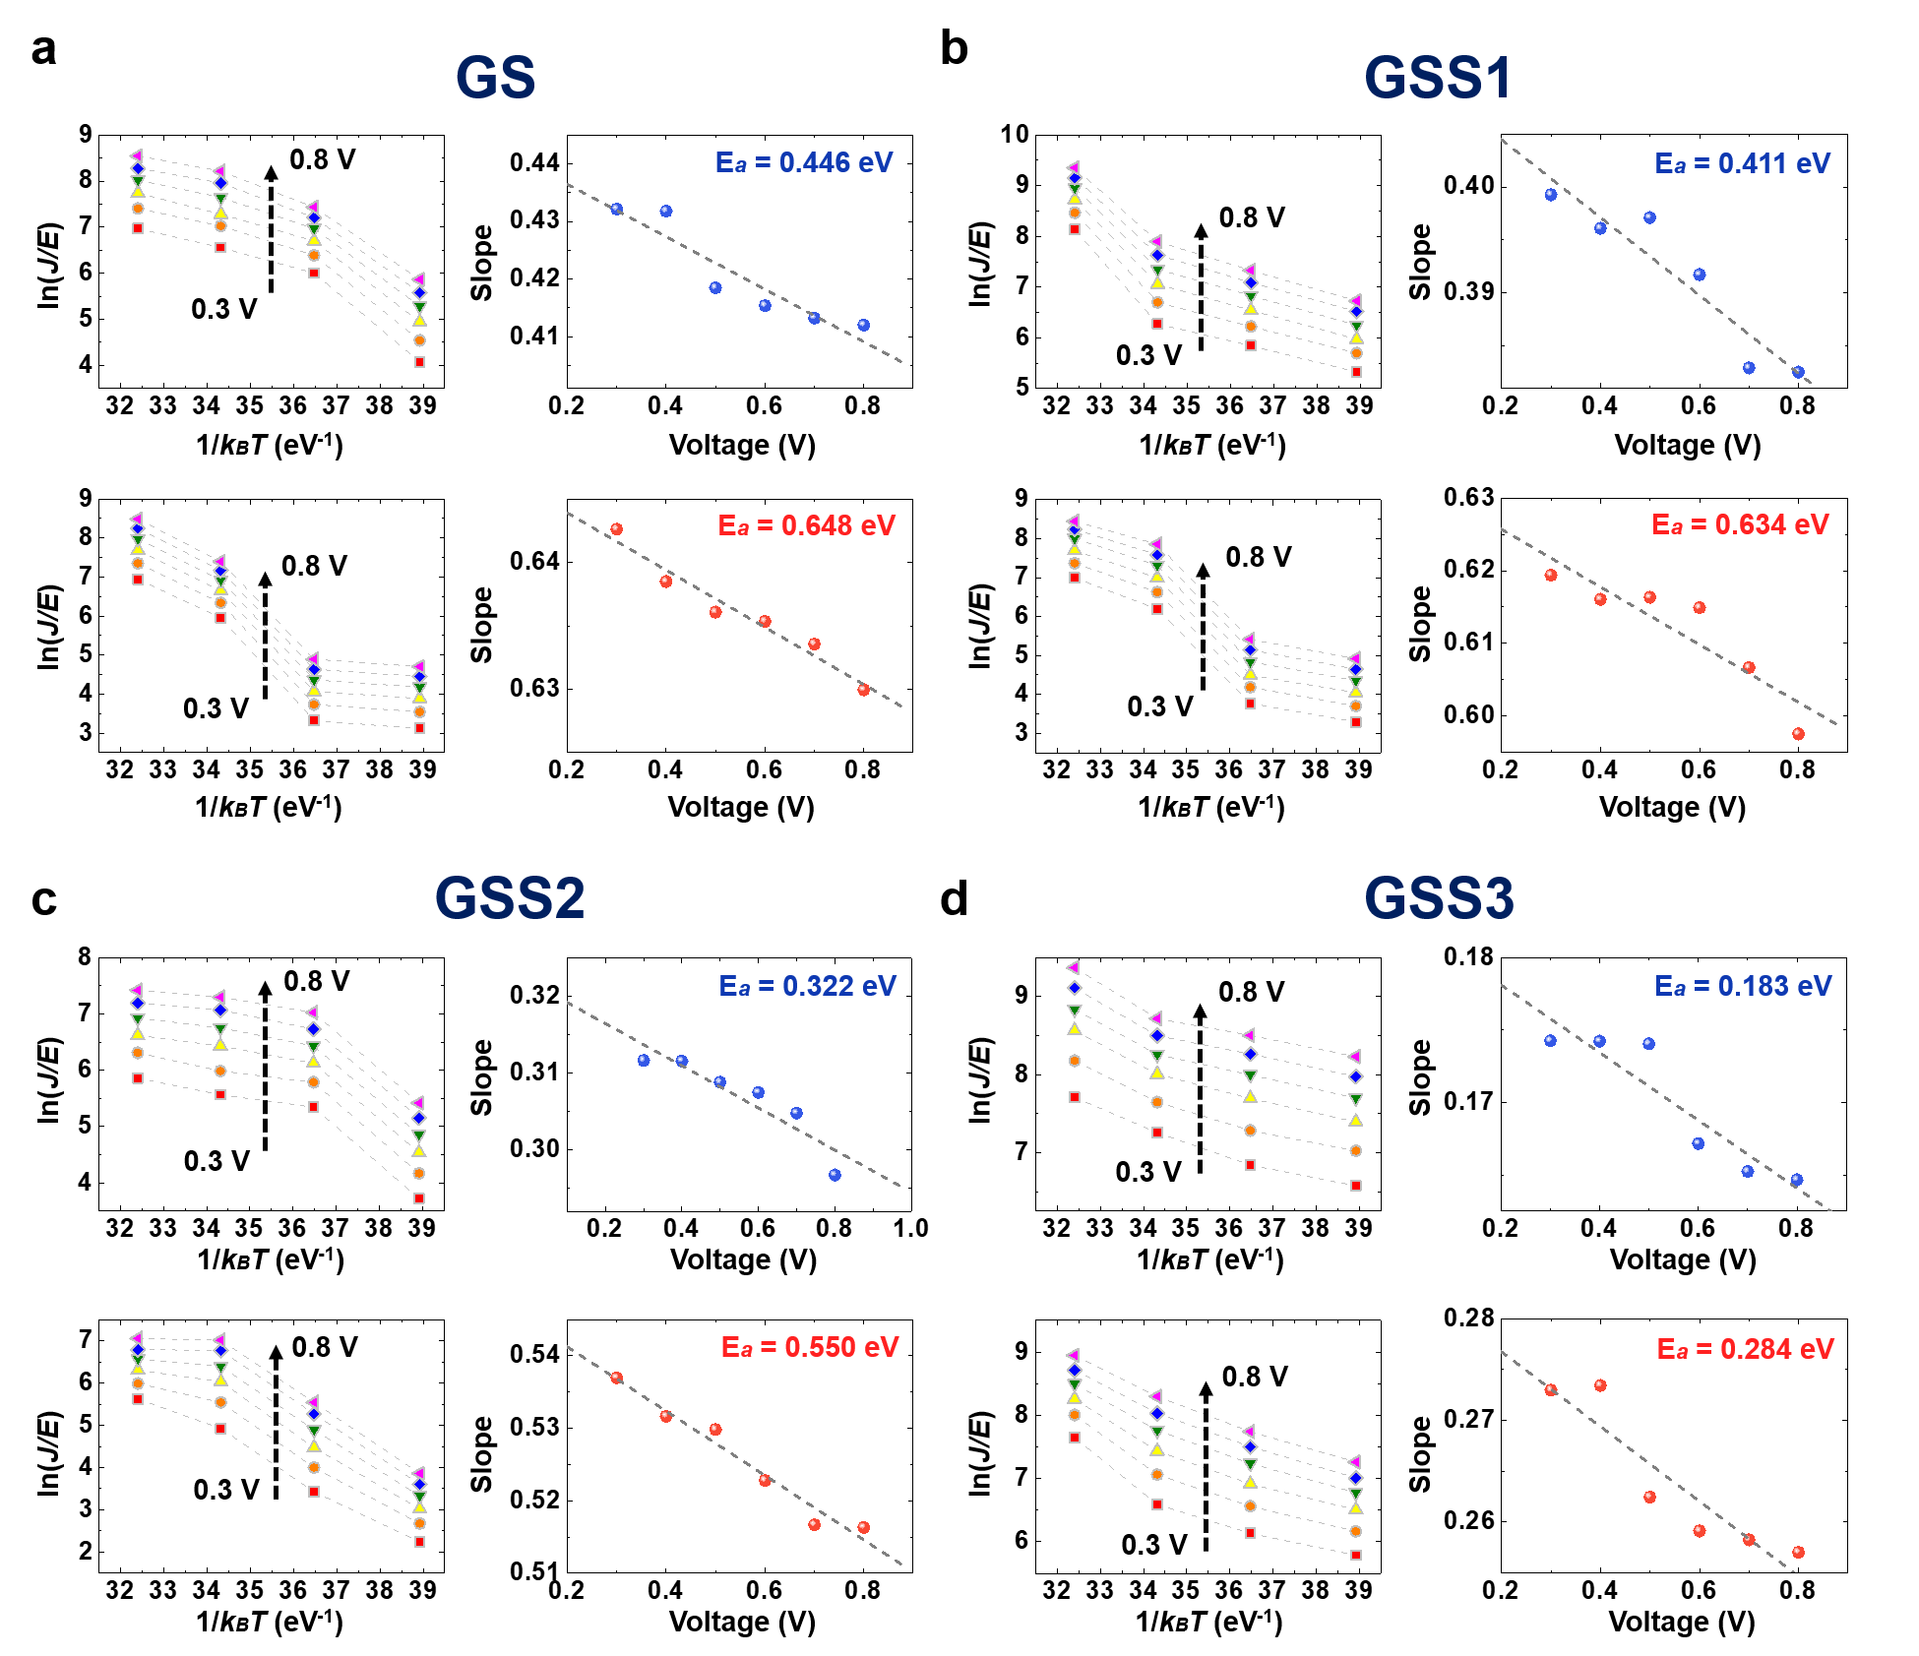
Fig S3. Arrhenius analysis of the programmed states in the GS and GSS SOM devices. Temperature-dependent ln(J/E) characteristics measured at fixed DC biases ranging from 0.3 to 0.8 V and corresponding Arrhenius plots of the V_{th1} and V_{th2} states for a GS, b GSS1, c GSS2, and d GSS3. The E_{a} for each programmed state was extracted from the linear fitting of ln(J/E) as a function of 1/(k_{B}T).

Supplementary Material 4 | Poole–Frenkel analysis of the programmed states in GS and GSS1–3 SOM devices.
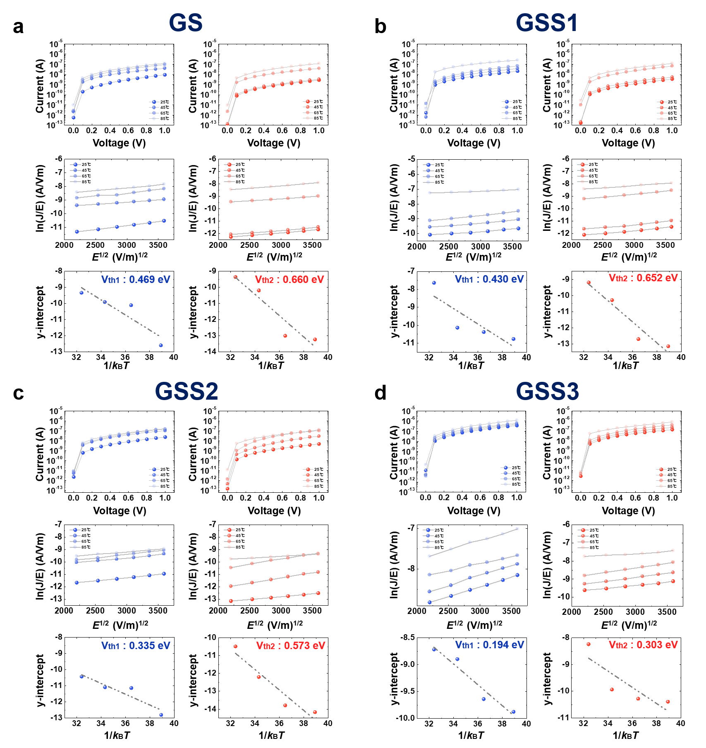
Fig S4. PF analysis of the programmed states in the GS and GSS SOM devices. Temperature-dependent DC I–V characteristics, corresponding ln(J/E) versus E^{1/2} plots, and temperature dependence of the extracted PF intercepts for the V_{th1} and V_{th2} states of a GS, b GSS1, c GSS2, and d GSS3. Measurements were performed at 25, 45, 65, and 85 °C. Φ_{t} were extracted from the linear fitting of the PF intercepts as a function of 1/(k_{B}T).
Supplementary Material 5 | Electronic bandgap structure characterization of the GS and GSS1–3 SOM devices using UPS and UV–vis spectroscopy.
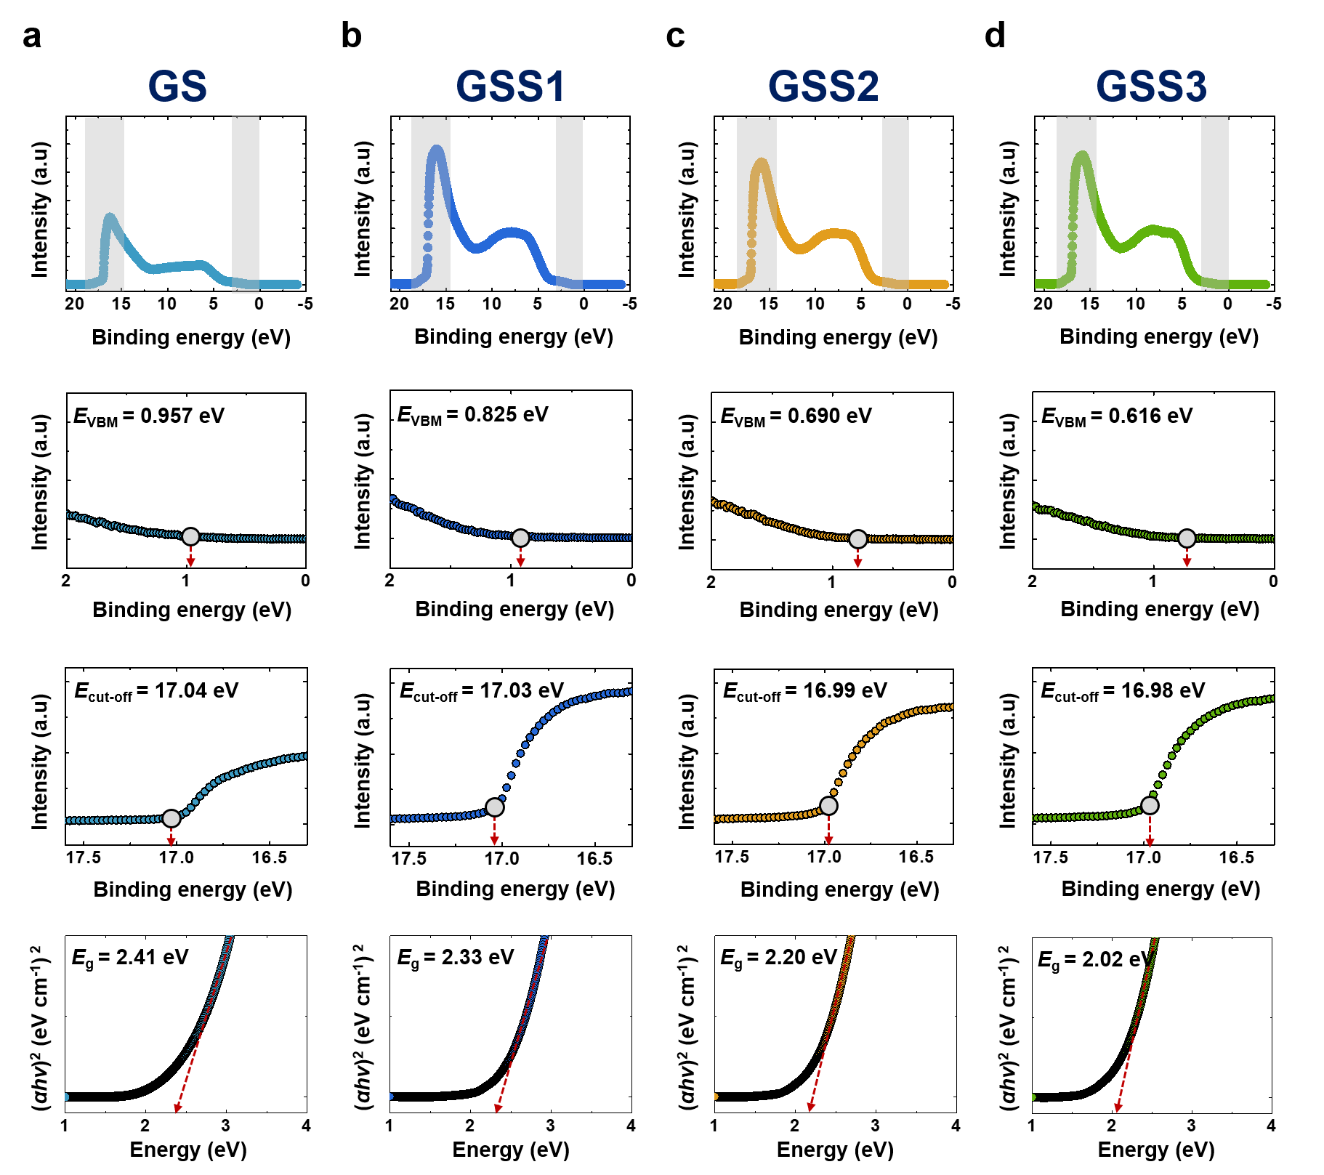
Fig S5. UPS spectra and Tauc plots for a GS, b GSS1, c GSS2, and d GSS3. The E_{cut-off} and E_{VBM} were determined from linear fitting of the UPS spectra, while the E_{g} was extracted from the Tauc plots of (αhν)² versus hν.

Supplementary Material 6 | Ge 3d XPS spectra and peak deconvolution of GS and GSS1–3 films.
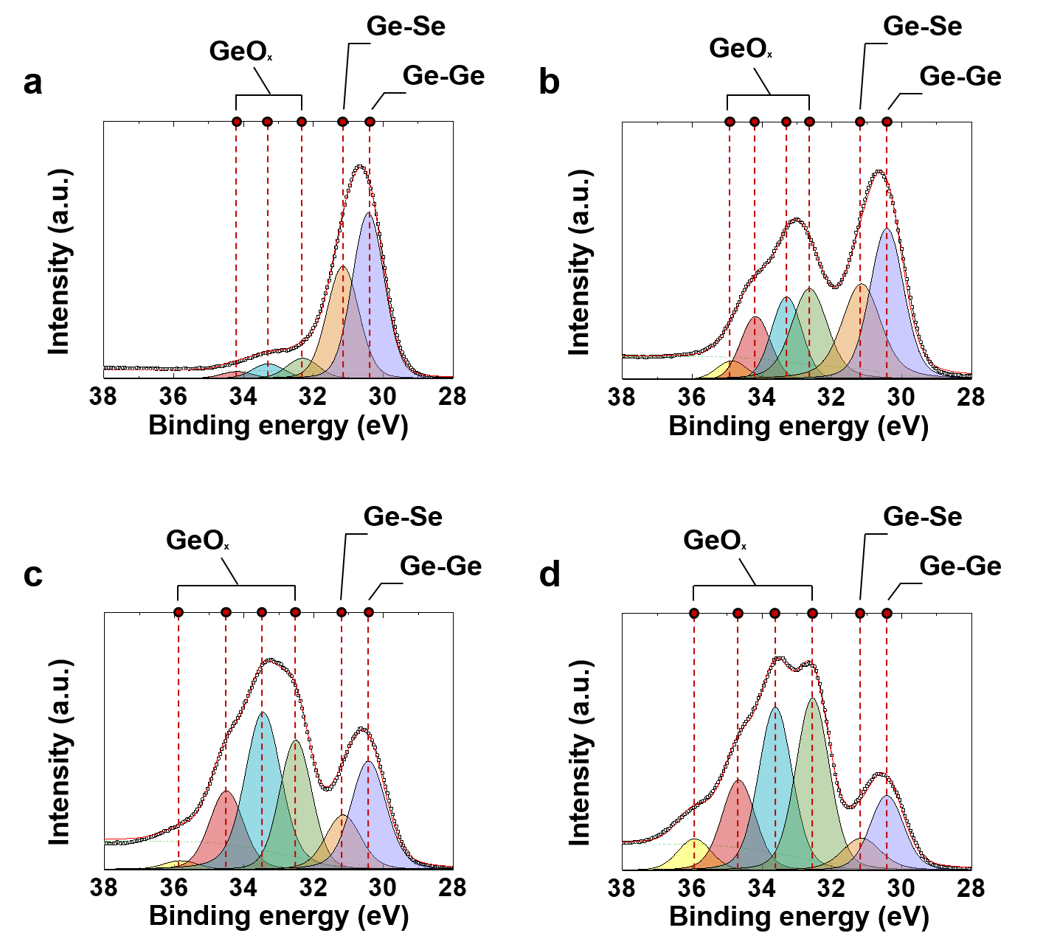
Fig S6. Ge 3d XPS spectra and peak deconvolution of the GS and GSS SOM devices. High-resolution Ge 3d spectra and corresponding fitted bonding components for a GS, b GSS1, c GSS2, and d GSS3, showing the evolution of Ge-related chemical bonding configurations with increasing Sb concentration.

Table S1. Calculated ionicity and hybridization values of previously reported SOM materials used for the hybridization–ionicity mapping in Fig. 1.
Material composition | Ionicity | Hybridization
Ge₂₉Se₃₀Te₄₁ ^{[17]} | 0.085 | 2.140
Ge₃₆Sb₂₁Se₄₃ ^{[18]} | 0.178 | 2.278
Ge₂₄Sb₂₁Se₂₉Te₂₆ ^{[18]} | 0.122 | 2.221
Ge₃₁Se₃₈Sb₃Te₂₈ ^{[19]} | 0.109 | 2.174
Ge₃₂Se₃₈Sb₃Te₂₇ ^{[19]} | 0.111 | 2.174
Ge₃₅Se₃₅Sb₃Te₂₇ ^{[19]} | 0.107 | 2.171
Ge₃₇Se₃₄Sb₃Te₂₆ ^{[19]} | 0.107 | 2.170
Ge₂₀Se₄₂Te₃₈ ^{[26]} | 0.098 | 2.154
Ge₃₄Se₄₅Te₂₁ ^{[27]} | 0.119 | 2.176
Ge₂₆Se₂₃Te₅₁ ^{[27]} | 0.070 | 2.125
Ge₂₀S₇Se₄₃Te₃₀ ^{[28]} | 0.120 | 2.185
In₂(Ge₂₂Sb₃Se₃₄Te₄₁)₉₈ ^{[29]} | 0.113 | 2.115
In₆(Ge₂₂Sb₃Se₃₄Te₄₁)₉₄ ^{[29]} | 0.145 | 2.041
Ge₂₂Sb₃Se₃₄Te₄₁ ^{[29]} | 0.095 | 2.161
Se₄₀(Si₁₅Te₃₄As₄₂Ge₉)₆₀ ^{[30, 31]} | 0.052 | 2.474
Se₅₀(Si₁₅Te₃₄As₄₂Ge₉)₅₀ ^{[30, 31]} | 0.063 | 2.489
Se₆₀(Si₁₅Te₃₄As₄₂Ge₉)₄₀ ^{[30, 31]} | 0.072 | 2.502
Ge₂₀As₃₀Se₅₀ ^{[32]} | 0.106 | 2.451
Ge₅₆Se₄₄ ^{[33]} | 0.160 | 2.222
Ge₂₉Se₄₃Te₂₈ ^{[34]} | 0.108 | 2.149
Ge₂₅Se₃₈Te₃₇ ^{[34]} | 0.095 | 2.128
Ge₂₂Se₃₃Te₄₅ ^{[34]} | 0.086 | 2.113
Ge₂₀Se₃₀Te₅₀ ^{[34]} | 0.079 | 2.101

Table S2. Relative bonding ratios extracted from the Se 3d and Sb 3d XPS spectra of the GS, GSS1, GSS2, and GSS3 devices shown in Fig. 6. The integrated area of each deconvoluted bonding component was normalized to the total fitted peak area of the corresponding core-level spectrum and expressed as a percentage.

Bonding ratio (%) | GS | GSS1 | GSS2 | GSS3
Se-Ge | 71.97 | 49.20 | 43.21 | 37.41
Se-Sb | X | 24.29 | 40.00 | 44.31
Se-Se | 28.03 | 26.51 | 16.78 | 18.28
Se 3d

Bonding ratio (%) | GS | GSS1 | GSS2 | GSS3
Sb-Se | X | 10.85 | 28.97 | 19.09
Sb-Sb | X | 69.04 | 60.27 | 71.37
SbO_{x} | X | 20.11 | 10.76 | 9.54
Sb 3d

