Supplementary Information
Title: Nakazawaea odontotermitis f.a., sp. nov., a novel yeast isolated from the gut of Odontotermes horni in India.

Snigdha Tiwari^{1, 2}, Bhaskar C. Behera^{1,} ², Abhishek Baghela^{1, 2}*

Author affiliations:
¹Biodiversity and Palaeobiology Group, MACS-Agharkar Research Institute, G.G. Agarkar Road, Pune, 411004, India.
²Savitribai Phule Pune University, Ganeshkhind, Pune, 411007, India.

Correspondence:
*Abhishek Baghela - abhishekcsbaghela@gmail.com, Telephone No.: +91 20 25325105

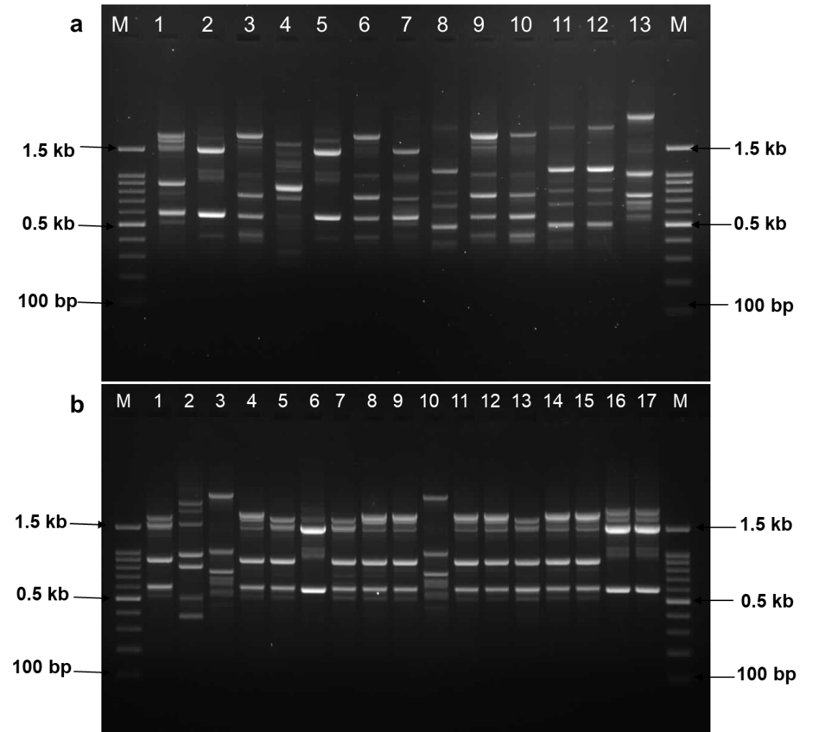
Fig S1. MSP-PCR banding patterns of 13 yeast isolates (SMT1.1 to SMT1.13) from SMT1 (a) and 17 yeast isolates (SMT2.1 to SMT2.17) from SMT2 (b).

Table S1. Detailed growth characteristics of Nakazawaea SMT1.3 sp. nov. in comparison with N. siamensis DMKU-RK467.
Characteristics | Nakazawaea sp. nov. | Nakazawaea siamensis*
Fermentation
D-Glucose | + | +
D-Galactose | − | −
Sucrose | − | −
Maltose | − | −
Lactose | − | −
Raffinose | − | −
α α-trehalose | − | −
D-Xylose | − | −
Cellobiose | − | −
Growth on carbon compounds
D-Glucose | + | +
Inulin | − | +
Sucrose | + | +
Raffinose | – | −
Melibiose | − | −
D-Galactose | W | S
Lactose | − | −
α α-Trehalose | + | +
Maltose | + | +
Melezitose | + | +
Soluble starch | + | +
Cellobiose | S^{a, b}/ W^{c} | +
Salicin | + | +
L-Sorbose | + | S
L-Rhamnose | W | +
D-Xylose | + | +
L-Arabinose | + | L
D-Arabinose | + | S
D-Ribose | + | +
Methyl-α-D-glucoside | − | +
Methanol | − | −
Ethanol | + | +
Glycerol | + | +
Erythritol | − | +
Ribitol (Adonitol) | W | +
Galactitol | − | L
D-Mannitol | + | +
myo-Inositol | − | −
D-Sorbitol (glucitol) | + | +
Arabinitol | + | +
DL-Lactate | − | −
Succinic acid | + | +
Citric acid | + | +
Arbutin | + | +
Glucono-δ-lactone | + | +
D-Gluconate | S | S
N-acetyl D-glucosamine | + | +
D-Glucosamine | + | −
Hexadecane | − | −
Growth on nitrogen compounds
Nitrate | + | −
Nitrite | − | −
Ethylamine | W | +
L-Lysine | S^{a, c}/W ^{b} | W
Cadaverine | + | +
Growth on other compounds
D-Glucuronate | − | −
2-keto-D-gluconate | + | W
Xylitol | + | +
Cycloheximide (0.01%) | + | +
Cycloheximide (0.1%) | + | W
Amino acid-free | + | ND
Vitamin-free | − | −
Growth at 30°C | + | +
Growth at 37°C | + | +
Growth at 40°C | − | +
50% Glucose agar | + | +
60% Glucose agar | + | +
10% NaCl/5% glucose | + | +

+ positive; − negative; ND not determined; W weak; V variable; S: slow; L: latent
ª SMT1.3= MTCC 13105^{T}
^{b} SMT1.10
^{c} SMT2.2
*Data obtained from R. Kaewwichian and S. Limtong et. al. 2014

