Supplementary Materials

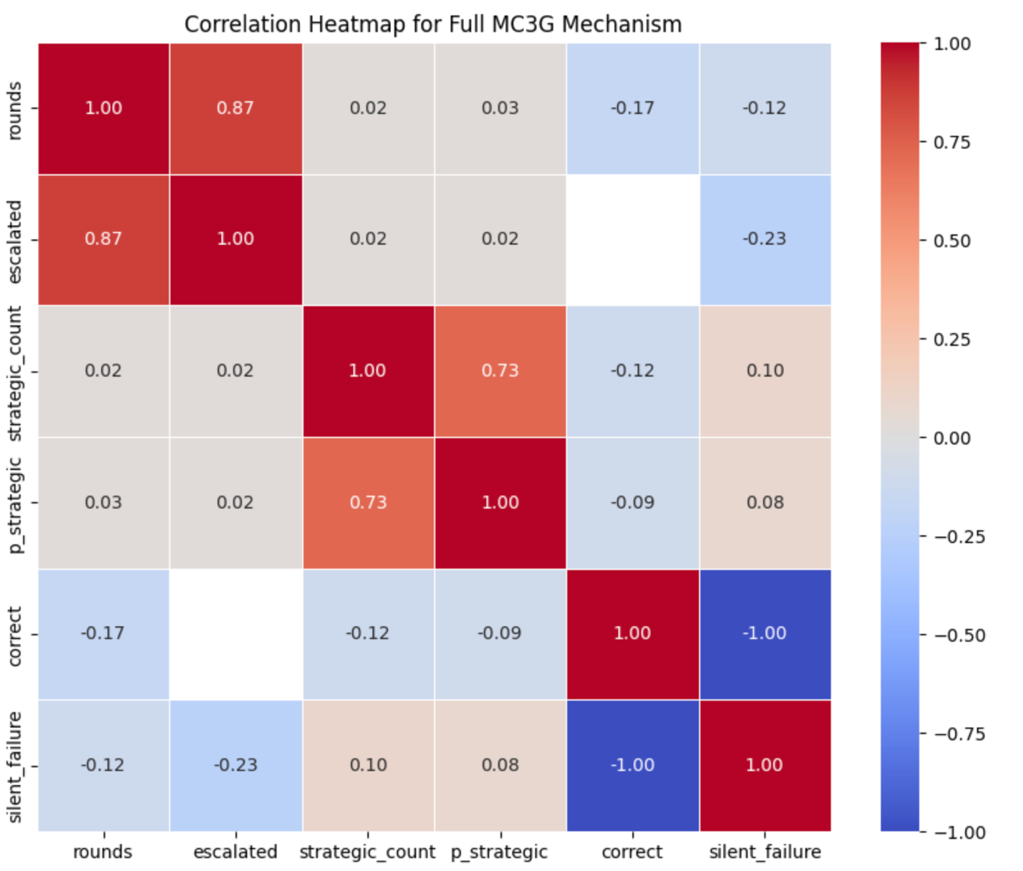
Supplementary Figure 1: Correlation Heat map for Full MC3G Framework

