Additional file 1
Supplementary information for: Combined DCS–DRS Characterization of Cerebral Flow–Metabolic Responses in Behaviorally Defined Groups During Graded Isoflurane Exposure in Rats
Supplementary Methods
1. Epoch definitions and extraction windows
All six hemodynamic and metabolic measures were summarized using predefined extraction rules on each animal’s time base. Awake and recovery values were calculated as the median over 120-s windows that met signal-stability criteria: coefficient of variation (CV) < 6% for tissue oxygen saturation (StO₂) and < 8% for total hemoglobin concentration (THb). Values at 2.5, 2.0, and 1.5% isoflurane were calculated as the median of the final 60 s of each stage. For animals classified as ‘not awake during anesthesia’ (NAA) at 1.0%, values were likewise calculated from the final 60 s of the stage. The movement-associated transient in animals classified as ‘awake during anesthesia’ (AA) at 1.0% was analyzed with the group-specific window described in section 2. For the awake reference, the position of the 120-s window was determined by working backward from the end of the awake period; it was not selected by searching multiple candidate intervals or by maximizing an AA–NAA difference. The stability criteria were used to verify that the resulting window provided an acceptable awake reference. The 120-s duration was used for the primary analysis, and its influence is quantified in Table S4.
2. Selection of the analysis window for the 1.0% movement-associated transient
At 1.0% isoflurane, AA animals showed a brief movement-associated transient rather than a steady plateau. The StO₂ peak was used as a reproducible temporal anchor. For each AA animal, the same 60-s interval centered on this peak (peak ± 30 s) was applied to relative cerebral blood flow (rCBF), StO₂, concentration changes from the awake baseline in oxygenated hemoglobin (ΔOHb), deoxygenated hemoglobin (ΔRHb), and total hemoglobin (ΔTHb), and derived relative cerebral metabolic rate of oxygen (rCMRO₂). Median values were calculated over this interval. NAA animals did not show a comparable movement-associated transient, so their 1.0% values were calculated from the final 60 s of the stage. These group-specific windows compare the AA transient with the NAA end-of-stage period and should not be interpreted as equivalent steady-state measurements. The raw traces and applied windows are shown in Figure S3.
3. Derivation of optical measures
3.1 Diffuse reflectance spectroscopy (DRS): oxygenation and hemoglobin measures
Each reflectance spectrum was normalized to its value at 500 nm, and the 620–800-nm region was fitted using steady-state diffuse-reflectance formulations^{24,25} and the blood-volume and oxygenation parameterization described by Kim et al.³⁰. The measured reflectance spectrum was represented as
$R_{measured}\left(λ\right) ≈ R_{model}\left[μ_{a}\left(λ\right), {μ_{s}}^{'}\left(λ\right), ρ\right]$,
where $λ$ denotes wavelength, and $R_{\text{measured}}$ and $R_{\text{model}}$ denote measured and modeled reflectance, respectively.
The symbols $μ_{a}$, $μ_{s}^{\text{'}}$, and $ρ$ denote the absorption coefficient, reduced scattering coefficient, and source–detector separation, respectively. Absorption was modeled from the blood volume fraction, tissue oxygen saturation, and oxy- and deoxyhemoglobin extinction coefficients²⁷:
$μ_{a}\left(λ\right) = C\left(λ\right)v_{BL}\left\{{StO}_{2} ε_{{HbO}_{2}}\left(λ\right) + \left[1 - {StO}_{2}\right]ε_{Hb}\left(λ\right)\right\}$,
where $v_{\text{BL}}$ is the blood volume fraction, and $ε_{\text{HbO2}}\text{(}λ\text{)}$ and $ε_{\text{Hb}}\text{(}λ\text{)}$ are the extinction coefficients of oxyhemoglobin and deoxyhemoglobin, respectively.
The vessel-packaging correction was represented by $C\text{(}λ\text{)}$ as described previously²⁶. Wavelength-dependent reduced scattering was represented by combined Mie and Rayleigh components²⁸:
${μ_{s}}^{'}\left(λ\right) = a\left\{\left(1 - f_{Ray}\right){\left(\frac{λ}{λ_{0}}\right)}^{-b_{Mie}} + f_{Ray}{\left(\frac{λ}{λ_{0}}\right)}^{-4}\right\}$.
In the scattering model, $a$ is the reduced scattering amplitude at the reference wavelength $λ_{\text{0}}$, $f_{\text{Ray}}$ is the Rayleigh scattering fraction, and $b_{\text{Mie}}$ is the Mie scattering power. The symbols $\text{[}{\text{HbO}}_{\text{2}}\text{]}$ and $\text{[Hb]}$ denote oxyhemoglobin and deoxyhemoglobin concentrations, respectively.
Tissue oxygen saturation was defined as ${\text{StO}}_{\text{2}}\text{ = [}{\text{HbO}}_{\text{2}}\text{]/([}{\text{HbO}}_{\text{2}}\text{] + [Hb])}$. The fitted blood-volume and saturation terms were used to obtain oxygenated hemoglobin (OHb), deoxygenated hemoglobin (RHb), and total hemoglobin (THb) concentrations. ΔOHb, ΔRHb, and ΔTHb were reported as changes in these concentrations from each animal’s awake baseline. For the separate induction-kinetics analysis, OHb, RHb, and THb were instead normalized to their separate pre-induction awake values, as described in section 4.2 and summarized in Table S8.
With the hemoglobin concentration in blood held fixed in the DRS model, THb was proportional to the fitted $v_{\text{BL}}$. The fitted StO₂ was then used to partition THb into oxygenated and deoxygenated components:
$$\begin{aligned}\text{THb(}t\text{) ∝ }v_{\text{BL}}\text{(}t\text{), OHb(}t\text{) = }{\text{StO}}_{\text{2}}\text{(}t\text{) × THb(}t\text{)} \\ \text{RHb(}t\text{) = [1 - }{\text{StO}}_{\text{2}}\text{(}t\text{)] × THb(}t\text{), THb(}t\text{) = OHb(}t\text{) + RHb(}t\text{).}\end{aligned}$$
3.2 Diffuse correlation spectroscopy (DCS): relative cerebral blood flow
The normalized intensity autocorrelation function was calculated from the detected photon-count fluctuations as
$g_{2}\left(τ\right) = \frac{\left\langle I\left(t\right)I\left(t + τ\right)\right\rangle }{{\left\langle I\left(t\right)\right\rangle }^{2}}$,
where $I\text{(}t\text{)}$ is the detected intensity at time $t$, and $τ$ is the delay time.
The normalized intensity autocorrelation function was related to the normalized electric-field autocorrelation function through the Siegert relation as
$g_{2}\left(τ\right) = 1 + β{\left|g_{1}\left(τ\right)\right|}^{2}$.
The measured $g_{\text{2}}\text{(}τ\text{)}$ curve was fitted directly. For a given blood flow index $\text{(BFI = }αD_{B}\text{)}$, $g_{\text{1,model}}\text{(}τ\text{)}$ was calculated using the semi-infinite correlation-diffusion Green’s function¹⁴. The corresponding $g_{\text{2,model}}\text{(}τ\text{)}$ was then calculated from $g_{\text{1,model}}\text{(}τ\text{)}$ using the Siegert relation³³. The coherence factor $β$ and BFI were estimated simultaneously by minimizing the sum of squared residuals between $g_{\text{2,measured}}\text{(}τ\text{)}$ and $g_{\text{2,model}}\text{(}τ\text{)}$³⁴. In this expression, $α$ is the fraction of dynamic scatterers, and $D_{B}$ is their effective diffusion coefficient.
The DCS fit used fixed absorption and reduced scattering coefficients at 852 nm ($μ_{a}\text{ = 0.0334 }{\text{mm}}^{\text{-1}}$ and $μ_{s}^{\text{'}}\text{ = 1.330 }{\text{mm}}^{\text{-1}}$), calculated based on the wavelength-dependent tissue optical-property framework described by Jacques²⁸. These coefficients were held fixed independently of DRS-derived optical properties and are listed in Table S7. Relative cerebral blood flow was calculated as
$rCBF\left(t\right) = 100 × \frac{BFI\left(t\right)}{{BFI}_{awake}}$,
where ${\text{BFI}}_{\text{awake}}$ is the median BFI over the selected awake-baseline window. Thus, rCBF was calculated from DCS alone and did not use DRS-derived optical properties. In the rCBF expression, $t$ denotes time.
3.3 Derived relative cerebral metabolic rate of oxygen
Following the relative oxygen-metabolism formulation established for rodent cortex by Culver et al.¹⁶, cerebral oxygen metabolism was related to flow and oxygen extraction as
${CMRO}_{2} ∝ CBF × \left({SaO}_{2} - {StO}_{2}\right)$,
where ${\text{CMRO}}_{\text{2}}$, $\text{CBF}$, and ${\text{SaO}}_{\text{2}}$ denote the cerebral metabolic rate of oxygen, cerebral blood flow, and arterial oxygen saturation, respectively.
Assuming that arterial oxygen saturation remained constant and close to unity over the measurement period, the relative cerebral metabolic rate of oxygen was calculated as
${rCMRO}_{2}\left(t\right) = 100 × \frac{BFI\left(t\right)}{{BFI}_{awake}} × \frac{1 - {StO}_{2}\left(t\right)}{1 - {StO}_{2,awake}}$.
Here, StO_{2,awake} is the awake-baseline StO₂. Tissue oxygen saturation enters this expression as a fraction between 0 and 1 rather than as a percentage. Because DRS-derived StO₂ and DCS-derived rCBF were acquired at different sampling rates, the StO₂ and rCBF time series were interpolated to a common 10-Hz time base before rCMRO₂ was calculated. rCBF and rCMRO₂ are reported relative to the awake baseline (awake = 100%). StO₂ is reported as an absolute percentage. The hemoglobin measures are reported as concentration changes from the awake baseline in micromolar (µM). rCMRO₂ is a relative, optically derived measure rather than an absolute measurement of cerebral oxygen metabolism.
4. Statistical analysis and induction kinetics
4.1 Statistical procedures
Group summaries are reported as mean ± standard deviation (SD). Given the group size (n = 4 per group), between-group differences at each analysis period were tested with the exact Mann–Whitney U test, and effect-size magnitudes are reported as absolute Hedges’ g (|g|). Dose-dependent trends were assessed with Page’s trend test and the Friedman test (Table S1). For Page’s trend test, the reported two-sided p-value was calculated as twice the smaller of the two exact directional p-values, capped at 1. Within each group, consecutive plotted analysis epochs—awake to 2.5%, each adjacent pair of maintenance concentrations, and 1.0% to recovery—were compared using two-sided paired tests selected for each comparison. A paired t-test was used when normality of the within-animal differences was not rejected by the Shapiro–Wilk test (p > 0.05), and an exact Wilcoxon signed-rank test was used otherwise (Table S3). Within each group, the four maintenance stages and recovery were compared with the awake baseline using two-sided paired t-tests, as shown in Figure 2 in the main text. Reported p-values are given numerically where applicable. Because the study was exploratory, p-values were not adjusted for multiple comparisons. Several of the six hemodynamic and metabolic measures were related. ΔOHb, ΔRHb, ΔTHb, and StO₂ were obtained from the same DRS measurements, and rCMRO₂ was derived from rCBF and StO₂. Findings across these related measures were therefore not treated as independent replications. Accordingly, each p-value was interpreted descriptively together with the corresponding effect size and per-animal values. All analyses were performed in Python using SciPy.
4.2 Induction kinetics
For each animal, a 300-s pre-induction awake interval was used as the reference for blood flow index (BFI), StO₂, OHb, RHb, and THb. Each series was normalized to its own mean over this common interval, defined as 100%. The DRS series was assigned a uniform time base spanning the DCS recording and linearly interpolated to the DCS time points so that all five measures used the same reference interval.
For this induction analysis, the OHb, RHb, and THb concentration series were used before baseline subtraction. ΔOHb, ΔRHb, and ΔTHb were not used because each has a reference value of zero, which precludes normalization to 100%.
For each animal and measure, peak magnitude was the maximum normalized value during the 3.0% isoflurane induction stage. For the rate calculation, the analysis interval extended from the end of the 300-s reference interval through the induction peak. The maximum rate of increase was the largest value of the Gaussian-smoothed first derivative within this interval ($σ$ = 7.25 samples, equivalent to 3.62 s), calculated from the normalized series at the median DCS sampling interval. This fixed Gaussian width was applied to all five measures. Peak and rate values were calculated separately for each animal before group summaries, effect sizes, and p-values were obtained. rCMRO₂ was not included in this component comparison because it is calculated from rCBF and StO₂ and cannot independently identify whether an induction difference originated from blood flow or oxygen extraction.
Figure 3A used a separate alignment for visualization. Each normalized rCBF series was Gaussian-smoothed with $σ$ = 7.25 samples, and the alignment time was defined as the last pre-peak sample at which the smoothed series was below 105% of its reference value. Individual traces were then interpolated to a 1-s grid from −30 to +250 s relative to this trace-derived anchor before the group mean and SD were calculated. This alignment was used only to display the trajectory in Fig. 3(A). It was not used to calculate the per-animal peaks, maximum rates, effect sizes, or p-values in Fig. 3(B) and (C) in the main text. The 120-s awake reference windows examined in Table S4 belong to the separate maintenance-stage sensitivity analysis and were not used for induction.
Supplementary Figures
Figure S1. Per-animal rCMRO₂ values across graded isoflurane. Values are shown for all eight animals. At the 1.0% isoflurane analysis interval, rCMRO₂ was above the awake reference in every AA animal (103–137%) and below the awake reference in every NAA animal (31–91%). The gray vertical band highlights the 1.0% isoflurane stage, for which AA values were calculated from a 60-s interval centered on each animal’s tissue oxygen saturation peak and NAA values from the final 60 s. Abbreviations: AA, awake during anesthesia; NAA, not awake during anesthesia; n, number of animals; rCMRO₂, relative cerebral metabolic rate of oxygen. rCMRO₂ is shown as a percentage of each animal’s awake-baseline value.
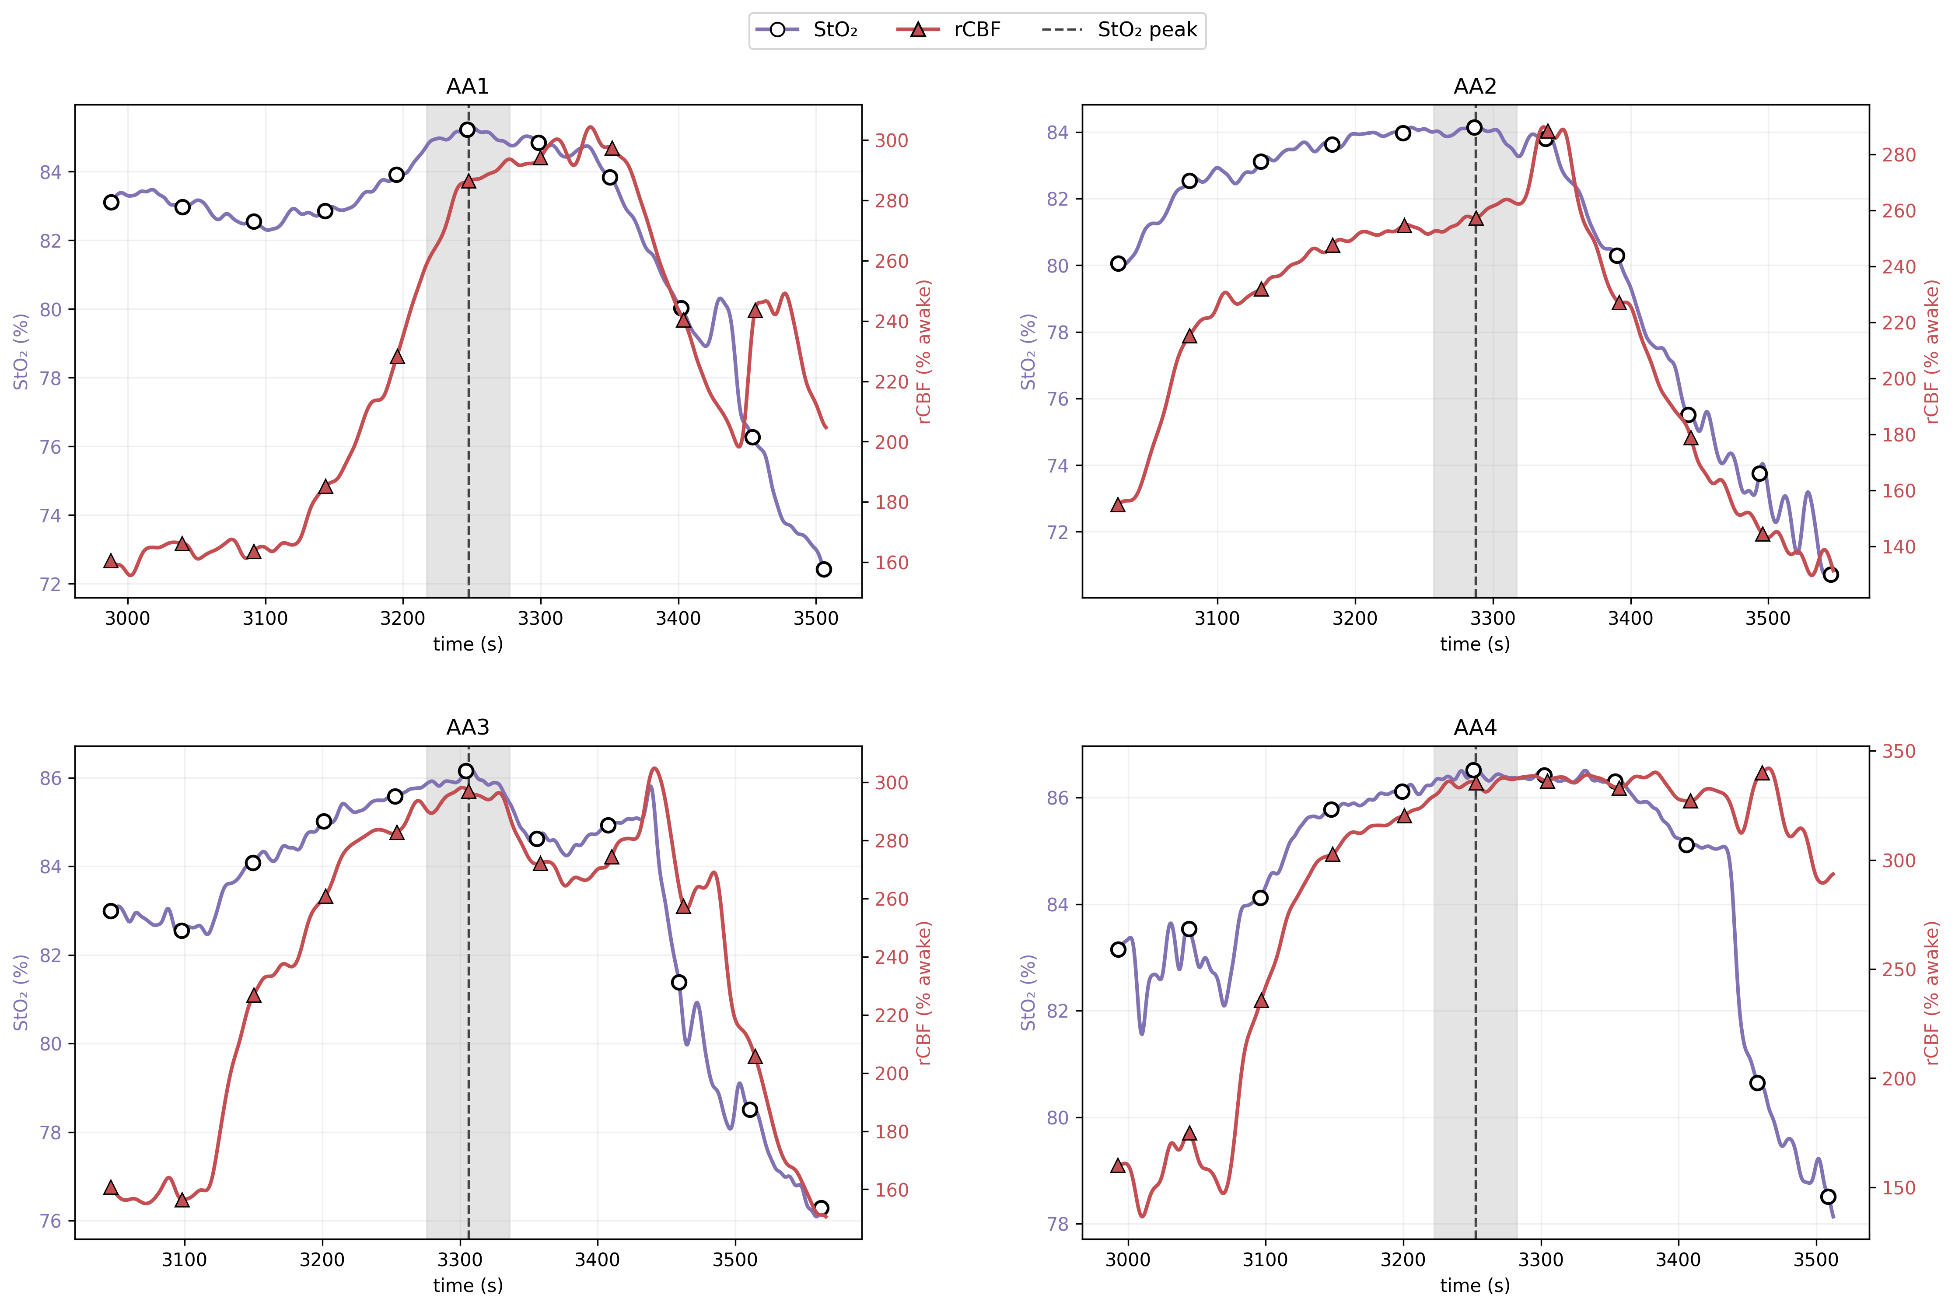
Figure S2. Temporal alignment of rCBF and StO₂ during the 1.0% movement-associated transient. Per-animal AA traces are shown on a common time base after conversion of each modality to absolute time. At the 0.5-s temporal resolution of the DCS data, no consistent lead–lag between the rCBF and StO₂ increases could be resolved. Differences shorter than 0.5 s could not be assessed. The dashed line marks the StO₂ peak, and the shaded band marks the 60-s extraction window applied to all six hemodynamic and metabolic measures within each animal. Abbreviations: AA, awake during anesthesia; DCS, diffuse correlation spectroscopy; rCBF, relative cerebral blood flow; StO₂, tissue oxygen saturation. rCBF is expressed as a percentage of the awake-baseline value, whereas StO₂ is absolute saturation.
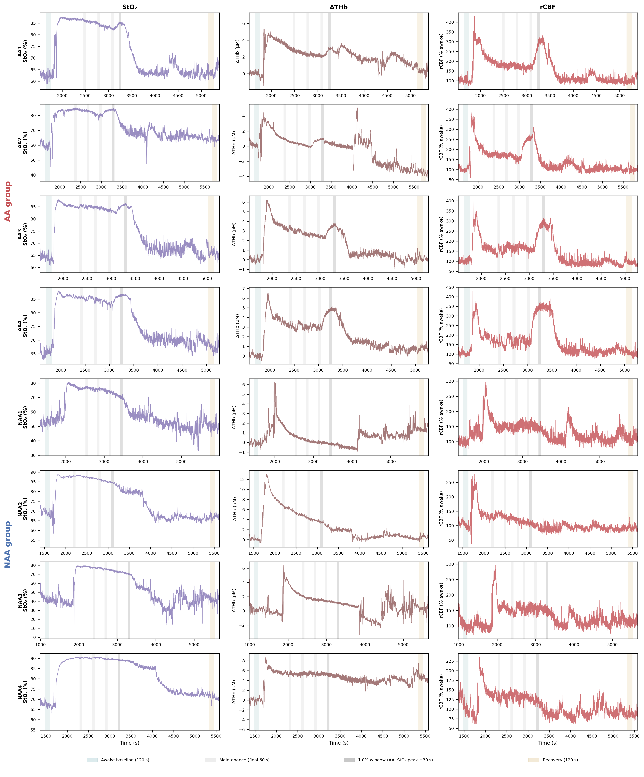
Figure S3. Extraction-window verification. Raw per-animal traces show the selected awake, maintenance, group-specific 1.0%, and recovery windows. The shaded overlays show the primary 120-s awake and recovery windows; the awake window was defined by working backward from the end of the awake period rather than selected from multiple eligible intervals. They also show the final 60 s of each maintenance stage, the same StO₂-peak-centered 60-s interval for all six hemodynamic and metabolic measures in each AA animal at 1.0%, and the final 60 s for each NAA animal at 1.0%. Abbreviations: AA, awake during anesthesia; NAA, not awake during anesthesia; rCBF, relative cerebral blood flow; StO₂, tissue oxygen saturation; ΔTHb, change in total hemoglobin concentration from the awake baseline; µM, micromolar. rCBF is shown as a percentage of the awake-baseline value, whereas StO₂ is absolute saturation.

Supplementary Tables
Table S1. Within-group ordered-trend statistics across the maintenance stages for each group (NAA: 2.5, 2.0, 1.5, 1.0%; AA: 2.5, 2.0, 1.5%). For each measure and group, the Page’s trend test and Friedman test p-values are reported. StO₂, ΔOHb, ΔRHb, ΔTHb, and derived rCMRO₂ showed significant ordered trends in both groups, whereas rCBF showed no significant ordered trend in either group. AA trends excluded the movement-associated 1.0% transient and used the 2.5, 2.0, and 1.5% stages. Full values at each stage and paired comparisons between consecutive plotted analysis epochs are given in Tables S2 and S3, respectively. Baseline-window sensitivity is reported in Table S4. Abbreviations: AA, awake during anesthesia; NAA, not awake during anesthesia; rCBF, relative cerebral blood flow; rCMRO₂, relative cerebral metabolic rate of oxygen; StO₂, tissue oxygen saturation; ΔOHb, ΔRHb, and ΔTHb, changes from the awake baseline in oxygenated, deoxygenated, and total hemoglobin concentrations, respectively; µM, micromolar.
Metric | Group | Page p-value | Friedman p-value | Significant trend
rCBF (% awake) | NAA | 0.101 | 0.058 | No
rCBF (% awake) | AA | 0.218 | 0.368 | No
rCMRO₂ (% awake) | NAA | 0.001 | 0.026 | Yes
rCMRO₂ (% awake) | AA | 0.002 | 0.018 | Yes
StO₂ (%) | NAA | <0.001 | 0.007 | Yes
StO₂ (%) | AA | 0.002 | 0.018 | Yes
ΔOHb (µM) | NAA | <0.001 | 0.007 | Yes
ΔOHb (µM) | AA | 0.002 | 0.018 | Yes
ΔRHb (µM) | NAA | 0.008 | 0.026 | Yes
ΔRHb (µM) | AA | 0.002 | 0.018 | Yes
ΔTHb (µM) | NAA | <0.001 | 0.007 | Yes
ΔTHb (µM) | AA | 0.014 | 0.039 | Yes

Table S2. Stage-wise values for all measures (mean ± SD). Values are group means across the awake baseline, the four maintenance stages, and recovery (n = 4 per group). rCBF and rCMRO₂ are reported relative to awake (=100%). StO₂ is reported as absolute saturation, and the hemoglobin measures are reported as concentration changes from awake in µM. Abbreviations: AA, awake during anesthesia; NAA, not awake during anesthesia; n, number of animals; rCBF, relative cerebral blood flow; rCMRO₂, relative cerebral metabolic rate of oxygen; SD, standard deviation; StO₂, tissue oxygen saturation; ΔOHb, ΔRHb, and ΔTHb, changes from the awake baseline in oxygenated, deoxygenated, and total hemoglobin concentrations, respectively; µM, micromolar.
Metric | Group | Awake | 2.5% | 2.0% | 1.5% | 1.0% | Recovery
rCBF (% awake) | NAA | 100.0 ± 0.0 | 132.4 ± 23.0 | 136.4 ± 24.1 | 131.6 ± 25.9 | 123.4 ± 27.5 | 94.7 ± 20.8
rCBF (% awake) | AA | 100.0 ± 0.0 | 168.3 ± 11.5 | 164.5 ± 8.8 | 161.3 ± 7.0 | 297.3 ± 35.3 | 100.7 ± 5.1
rCMRO₂ (% awake) | NAA | 100.0 ± 0.0 | 53.0 ± 18.3 | 56.6 ± 19.4 | 60.1 ± 22.3 | 62.4 ± 26.0 | 95.6 ± 25.6
rCMRO₂ (% awake) | AA | 100.0 ± 0.0 | 66.3 ± 1.4 | 69.9 ± 1.4 | 77.0 ± 3.8 | 117.4 ± 14.2 | 94.1 ± 5.7
StO₂ (%) | NAA | 57.6 ± 12.9 | 83.0 ± 7.1 | 82.3 ± 7.6 | 80.6 ± 8.5 | 78.6 ± 9.7 | 57.4 ± 14.0
StO₂ (%) | AA | 62.9 ± 2.6 | 85.4 ± 0.8 | 84.2 ± 0.9 | 82.3 ± 1.4 | 85.4 ± 1.1 | 65.3 ± 2.2
ΔOHb (µM) | NAA | 0.0 ± 0.0 | 6.3 ± 2.6 | 5.6 ± 2.6 | 5.1 ± 2.6 | 4.6 ± 2.7 | 1.2 ± 1.9
ΔOHb (µM) | AA | 0.0 ± 0.0 | 4.6 ± 0.5 | 4.0 ± 0.5 | 3.6 ± 0.6 | 5.0 ± 0.8 | -0.1 ± 1.1
ΔRHb (µM) | NAA | 0.0 ± 0.0 | -2.5 ± 0.9 | -2.5 ± 0.9 | -2.4 ± 0.8 | -2.2 ± 0.8 | 0.6 ± 0.3
ΔRHb (µM) | AA | 0.0 ± 0.0 | -2.0 ± 0.8 | -2.0 ± 0.8 | -1.7 ± 0.7 | -1.9 ± 0.8 | -0.5 ± 0.9
ΔTHb (µM) | NAA | 0.0 ± 0.0 | 3.7 ± 2.9 | 3.1 ± 2.6 | 2.7 ± 2.4 | 2.4 ± 2.3 | 1.7 ± 2.0
ΔTHb (µM) | AA | 0.0 ± 0.0 | 2.5 ± 1.1 | 2.0 ± 1.2 | 1.9 ± 1.3 | 3.1 ± 1.6 | -0.6 ± 2.0

Table S3. Paired within-group comparisons between consecutive plotted analysis epochs. Values of p are shown for awake to 2.5%, each adjacent pair of maintenance concentrations, and 1.0% to recovery. A paired t-test was used when normality of the within-animal differences was not rejected by the Shapiro–Wilk test. An exact Wilcoxon signed-rank test was used otherwise (n = 4). Abbreviations: AA, awake during anesthesia; NAA, not awake during anesthesia; n, number of animals; rCBF, relative cerebral blood flow; rCMRO₂, relative cerebral metabolic rate of oxygen; StO₂, tissue oxygen saturation; ΔOHb, ΔRHb, and ΔTHb, changes from the awake baseline in oxygenated, deoxygenated, and total hemoglobin concentrations, respectively; µM, micromolar.
Metric | Group | awake→2.5% | 2.5%→2.0% | 2.0%→1.5% | 1.5%→1.0% | 1.0%→Recovery
rCBF (% awake) | NAA | 0.067 | 0.317 | 0.147 | 0.017 | 0.011
rCBF (% awake) | AA | 0.001 | 0.145 | 0.596 | 0.003 | 0.001
rCMRO₂ (% awake) | NAA | 0.014 | 0.125 | 0.119 | 0.320 | 0.007
rCMRO₂ (% awake) | AA | <0.001 | 0.014 | 0.031 | 0.005 | 0.015
StO₂ (%) | NAA | 0.006 | 0.118 | 0.030 | 0.049 | 0.004
StO₂ (%) | AA | <0.001 | 0.006 | 0.008 | 0.002 | <0.001
ΔOHb (µM) | NAA | 0.018 | 0.095 | 0.059 | 0.046 | 0.016
ΔOHb (µM) | AA | <0.001 | 0.012 | 0.048 | 0.005 | <0.001
ΔRHb (µM) | NAA | 0.013 | 0.740 | 0.026 | 0.033 | 0.010
ΔRHb (µM) | AA | 0.016 | 0.067 | 0.009 | 0.020 | 0.009
ΔTHb (µM) | NAA | 0.080 | 0.117 | 0.125 | 0.139 | 0.515
ΔTHb (µM) | AA | 0.019 | 0.020 | 0.182 | 0.010 | 0.003

Table S4. Sensitivity of the selected maintenance-stage between-group comparisons to awake-baseline window length. The 2.5% and 1.0% comparisons were recomputed with awake-baseline windows of 60, 120, 180, 240, and 300 s. For each duration, a single window was anchored to the same endpoint of the awake period; the analysis did not select among multiple qualifying intervals. Values are exact Mann–Whitney p-values with absolute Hedges’ g (|g|) in parentheses. Induction comparisons are omitted because the induction analysis used a separate pre-induction awake baseline. The direction and effect-size magnitude of every AA–NAA comparison were similar across the tested windows. The rCBF and derived rCMRO₂ differences at 1.0% remained significant for every window (p = 0.029). At 2.5%, mean rCBF remained higher in AA than in NAA animals with |g| values of 1.2–1.9, but p < 0.05 was obtained only with the prespecified 120-s window. The primary duration was used to provide a stable awake reference under the stated CV criteria and was not chosen from this sensitivity analysis on the basis of statistical significance. StO₂ is listed as absolute saturation at 1.0% and therefore does not vary with awake-baseline window length. The StO₂ change from the awake baseline in Table 1 in the main text had |g| = 0.30 at p = 0.486. Abbreviations: AA, awake during anesthesia; NAA, not awake during anesthesia; rCBF, relative cerebral blood flow; rCMRO₂, relative cerebral metabolic rate of oxygen; StO₂, tissue oxygen saturation; ΔOHb, ΔRHb, and ΔTHb, changes from the awake baseline in oxygenated, deoxygenated, and total hemoglobin concentrations, respectively.
Metric | 60 s | 120 s | 180 s | 240 s | 300 s
rCBF at 2.5% (deep maintenance) | 0.114 (1.2) | 0.029 (1.7) | 0.057 (1.8) | 0.057 (1.9) | 0.057 (1.8)
rCMRO₂ at 2.5% (deep maintenance) | 0.343 (0.8) | 0.343 (0.9) | 0.343 (0.9) | 0.343 (0.9) | 0.343 (0.8)
rCBF at 1.0% (group-specific windows) | 0.029 (4.2) | 0.029 (4.8) | 0.029 (5.0) | 0.029 (5.0) | 0.029 (4.6)
rCMRO₂ at 1.0% (group-specific windows) | 0.029 (2.1) | 0.029 (2.3) | 0.029 (2.3) | 0.029 (2.4) | 0.029 (2.3)
StO₂ at 1.0% (group-specific windows; absolute saturation) | 0.486 (0.8) | 0.486 (0.8) | 0.486 (0.8) | 0.486 (0.8) | 0.486 (0.8)
ΔOHb at 1.0% (group-specific windows) | 0.686 (0.1) | 0.486 (0.2) | 0.486 (0.2) | 0.486 (0.2) | 0.486 (0.2)
ΔRHb at 1.0% (group-specific windows) | 0.686 (0.3) | 0.686 (0.2) | 0.686 (0.3) | 0.886 (0.2) | 0.886 (0.2)
ΔTHb at 1.0% (group-specific windows) | 0.886 (0.3) | 0.886 (0.3) | 0.886 (0.3) | 0.886 (0.3) | 0.886 (0.3)

Table S5. Per-animal induction rCBF peak and maximum rate of increase. Peak rCBF was defined as the maximum value during the 3.0% isoflurane induction stage and is expressed as a percentage of the 300-s pre-induction awake reference. Maximum rate of increase was defined as the largest Gaussian-smoothed first derivative from the end of the 300-s reference interval through the induction peak ($σ$ = 7.25 samples, equivalent to 3.62 s) and is expressed in percentage points per second. Both quantities were calculated separately for each animal, and the group summaries were calculated from these values rather than from the group-mean trajectory in Fig. 3A. Corresponding group summaries and between-group statistics are provided in Table S8. The rCBF results are also shown in Fig. 3(B) and (C), and Table 1 in the main text. Abbreviations: AA, awake during anesthesia; NAA, not awake during anesthesia; rCBF, relative cerebral blood flow.
Animal | Group | Peak rCBF (% of pre-induction awake value) | Maximum rate of increase (percentage points per second)
NAA1 | NAA | 212.9 | 5.83
NAA2 | NAA | 242.3 | 4.49
NAA3 | NAA | 292.2 | 6.67
NAA4 | NAA | 258.5 | 7.58
AA1 | AA | 374.2 | 11.05
AA2 | AA | 344.0 | 17.29
AA3 | AA | 326.4 | 8.12
AA4 | AA | 339.5 | 11.29

Table S6. Per-animal emergence latency from isoflurane discontinuation to the first spontaneous movement of any kind (eye blink, whisker movement, or whole-body movement). Mean (SD) latency was 580 (105) s in NAA animals and 94 (42) s in AA animals (Figure 6 in the main text). Abbreviations: AA, awake during anesthesia; NAA, not awake during anesthesia; SD, standard deviation.
Animal | Group | Emergence latency (s)
NAA1 | NAA | 670
NAA2 | NAA | 673
NAA3 | NAA | 491
NAA4 | NAA | 488
AA1 | AA | 132
AA2 | AA | 41
AA3 | AA | 122
AA4 | AA | 79
Table S7. Anesthetic protocol stages and optical acquisition/model parameters. The table lists the stepwise isoflurane schedule in 50% oxygen and the DCS/DRS settings used throughout the experiments. Maintenance stages after 2.5% were each held for 5 min. Behavioral emergence was scored as the first spontaneous movement of any kind after isoflurane discontinuation. The fixed absorption and reduced scattering coefficients used in the DCS fit were calculated at 852 nm based on the wavelength-dependent tissue optical-property framework described by Jacques²⁸. Abbreviations: DCS, diffuse correlation spectroscopy; DRS, diffuse reflectance spectroscopy.
Stage | Setting | Notes
Awake baseline | 30 min | Freely moving; individual reference
Induction | 3.0% isoflurane | 3 min, via nasal cone; protocol as described in reference 12
Maintenance 1 | 2.5%, 7 min | Initial 2-min settling period after induction. Stage value calculated from final 60 s.
Maintenance 2 | 2.0%, 5 min | —
Maintenance 3 | 1.5%, 5 min | —
Maintenance 4 | 1.0%, 5 min | Lightest stage; movement under anesthesia scored here
Emergence | Isoflurane off | Until first spontaneous movement
Recovery | 30 min | Freely moving; recorded before return to cage

Optical parameter | Value
DCS laser wavelength | 852 nm
DCS sampling rate | 2 Hz
DRS spectral range | 620–800 nm (normalized at 500 nm)
DRS sampling rate | 3 Hz
Diagonal source–detector separation | Approximately 5 mm
Bilateral optode spacing within each anterior–posterior row | 3.5 mm
Probed site | Prefrontal cortex (frontal skull)
Fixed DCS absorption coefficient at 852 nm $\text{(}μ_{a}\text{)}$ | 0.0334 mm⁻¹
Fixed DCS reduced scattering coefficient at 852 nm $\text{(}μ_{s}^{\text{'}}\text{)}$ | 1.330 mm⁻¹
Table S8. Peak magnitude and maximum rate of increase during induction for rCBF and four DRS-derived measures. All quantities were calculated separately for each animal using the common procedure described in Supplementary Methods section 4.2; group summaries and between-group statistics were then calculated from those per-animal values, not from the Fig. 3A group-mean trajectory. Each series was normalized to its own mean over the same 300-s pre-induction awake reference interval, defined as 100%. The DRS series was interpolated to the DCS time base so that rCBF, StO₂, OHb, RHb, and THb used the same reference interval. Peak magnitude was the maximum normalized value during the 3.0% isoflurane induction stage. Maximum rate of increase was the largest Gaussian-smoothed first derivative from the end of the 300-s reference interval through the induction peak ($σ$ = 7.25 samples, equivalent to 3.62 s). Per-animal rCBF values are provided in Table S5. Values are group means ± SDs, with the exact Mann–Whitney p-value and absolute Hedges’ g (|g|). The group means show the direction of each difference. Only rCBF reached nominal p < 0.05 for both induction measures. rCMRO₂ was not included because it is calculated from rCBF and StO₂ and cannot independently identify whether an induction difference originated from blood flow or oxygen extraction. Maximum rates are reported in percentage points per second. Abbreviations: AA, awake during anesthesia; NAA, not awake during anesthesia; BFI, blood flow index; DCS, diffuse correlation spectroscopy; DRS, diffuse reflectance spectroscopy; OHb, oxygenated hemoglobin concentration; RHb, deoxygenated hemoglobin concentration; THb, total hemoglobin concentration; rCBF, relative cerebral blood flow; SD, standard deviation; StO₂, tissue oxygen saturation.
Metric | Measure | NAA | AA | p | Absolute Hedges’ g
rCBF | Peak (% of pre-induction awake value) | 251.5 ± 33.1 | 346.0 ± 20.2 | 0.029 | 3.00
rCBF | Maximum rate of increase (percentage points per second) | 6.1 ± 1.3 | 11.9 ± 3.8 | 0.029 | 1.75
StO₂ | Peak (% of pre-induction awake value) | 149.2 ± 27.9 | 123.0 ± 5.1 | 0.200 | 1.13
StO₂ | Maximum rate of increase (percentage points per second) | 3.5 ± 3.1 | 2.2 ± 0.9 | 0.686 | 0.51
OHb | Peak (% of pre-induction awake value) | 205.4 ± 61.0 | 142.8 ± 11.7 | 0.343 | 1.24
OHb | Maximum rate of increase (percentage points per second) | 6.8 ± 5.2 | 3.2 ± 1.1 | 0.200 | 0.83
RHb | Peak (% of pre-induction awake value) | 149.4 ± 42.1 | 135.8 ± 31.0 | 0.686 | 0.32
RHb | Maximum rate of increase (percentage points per second) | 5.1 ± 0.6 | 2.9 ± 1.5 | 0.057 | 1.63
THb | Peak (% of pre-induction awake value) | 155.2 ± 35.7 | 123.8 ± 6.5 | 0.343 | 1.06
THb | Maximum rate of increase (percentage points per second) | 3.6 ± 1.1 | 2.0 ± 0.6 | 0.057 | 1.56

Source data. Additional files 2 and 3 contain the per-animal data for Figs. 2, 4–6 in the main text, and S1. Time-series data for Figs. S2 and S3 are available from the corresponding authors on reasonable request. The values in the comma-separated value (CSV) files are rounded to three decimal places, whereas all statistics were calculated from unrounded data. Recalculation from these CSV files may therefore change the third decimal place of a p-value.

