Supplementary Figure 1. Kaplan-Meier cumulative recurrence-free survival curves for patients with HCC using statins stratified by (A) lipophilic or hydrophilic statins and (B) individual statins.
(A)
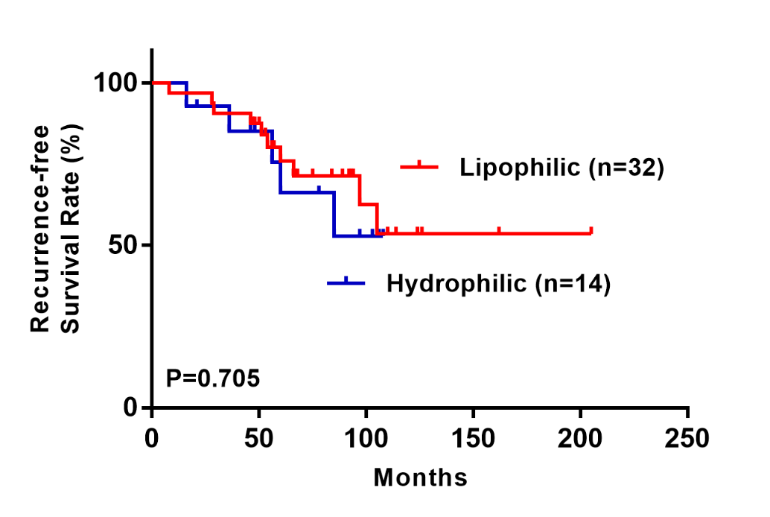
(B)
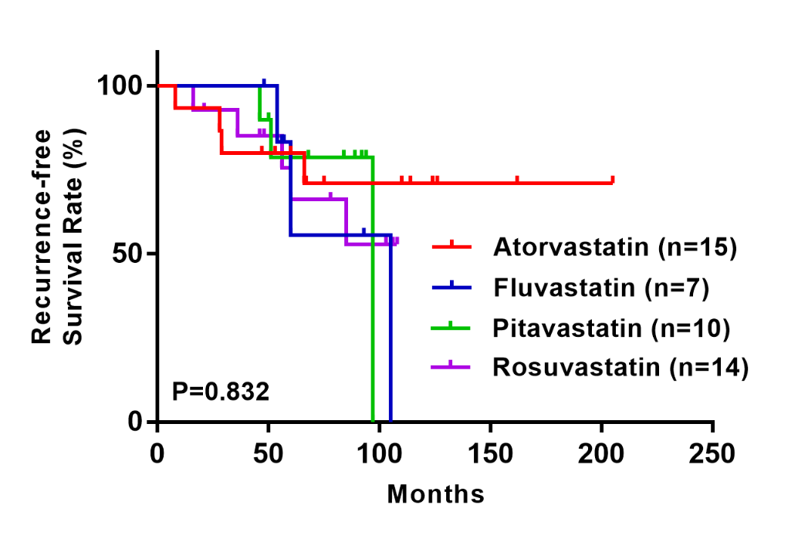

Supplementary Figure 2. Kaplan-Meier (A) liver-related survival and (B) non-liver-related survival curves after curative resection for patients with HCC stratified by statin use.
(A)
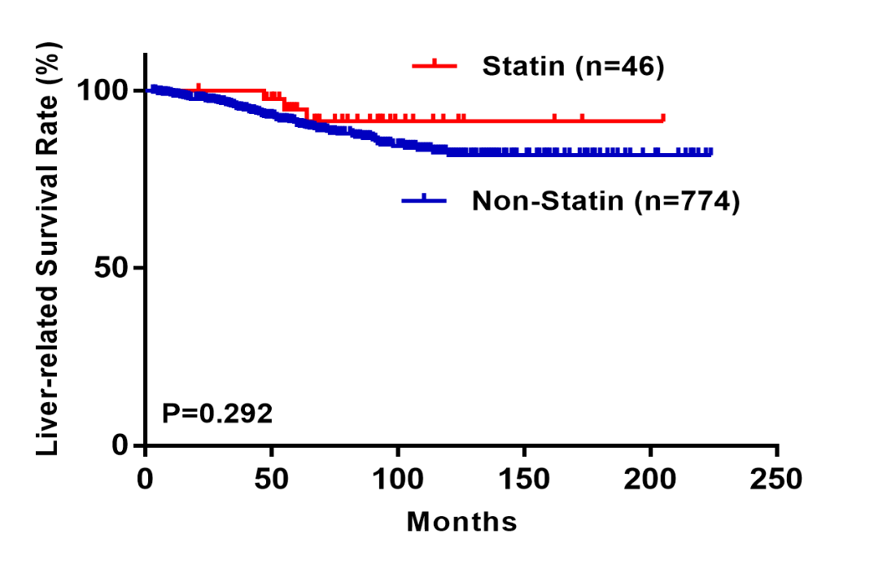
(B)
