Zinc oxide nanoparticles drive the evolutionary emergence of persistent Staphylococcus aureus small colony variants via non-canonical mutations

SUPPLEMENTARY INFORMATION

Supplementary Tables

Table S1: Particle size distribution of ZnO nanoparticles determined by nanoparticle tracking analysis

Parameter | Value (Mean ± SE)  (n=3) | Merged Value
Modal diameter ($D_{\text{mode}}$) | 92.3 ± 3.1 nm | 89.9 nm
Mean diameter ($D_{\text{mean}}$) | 127.9 ± 1.0 nm | 128.0 nm
Standard deviation | 52.2 ± 2.9 nm | 52.4 nm
D₁₀ Percentile | 82.8 ± 0.7 nm | 82.8 nm
D₅₀ Percentile (Median) | 111.4 ± 3.4 nm | 109.8 nm
D₉₀ Percentile | 196.2 ± 5.3 nm | 199.4 nm

Table S2: List of down-regulated proteins associated with metabolism
Metabolic Pathway | Proteins | Number
Glycolysis & Gluconeogenesis | Phospho-pyruvate hydratase  Phosphoglycerate kinase  Glyceraldehyde-3-phosphatedehydrogenase  Glucose-6-phosphate isomerase  Fructose-1,6-bisphosphate aldolase  Acetate--CoA ligase  2,3-bisphosphoglycerate-independent phosphoglycerate mutase  2, 3-bisphosphoglycerate-dependent phosphoglycerate mutase  6-phospho-beta-glucosidase  L-lactate dehydrogenase  Formate acetyltransferase  aldehyde dehydrogenase  SAOUHSC_02822; hypothetical protein regulates glucose metabolism and energy homeostasis | 13
sPentose Phosphate Pathway | Glucose-6-phosphate 1-dehydrogenase  6-phosphogluconate dehydrogenase  Putative transaldolase | 3
Tricarboxylic Acid (TCA) Cycle | Isocitrate dehydrogenase  Fumarate hydratase  Malate:quinone oxidoreductase  Succinyl-CoA synthetase subunit beta  Pyruvate carboxylase | 5
Amino Acid Metabolism | Glutamate dehydrogenase  Aspartate semialdehyde dehydrogenase  Aspartate kinase  D-alanine aminotransferase  Glutamate-1-semialdehyde aminotransferase  1-pyrroline-5-carboxylate dehydrogenase  Ornithine--oxo-acid transaminase  Branched-chain amino acid aminotransferase  L-serine dehydratase  Iron-sulfur-dependent subunit alpha  Imidazolonepropionase | 11
Lipid Metabolism | Acyl carrier protein  Glycerol-3-phosphate acyltransferase  PlsX, Phosphatidate cytidylyltransferase  Lipoyltransferase  lipoate-protein ligase | 5
Urease & Nitrogen Metabolism | Urease subunit alpha  Urease subunit gamma  Assimilatory nitrite reductase [NAD(P)H] large subunit  Nitrate reductase subunit alpha  Nitrate reductase subunit beta  Glycine cleavage system protein H | 6
Carbohydrate Transport & Utilization | Fructose-specific permease  Alpha-D-1,4-glucosidase  Alpha amylase family protein | 3
Purine & Pyrimidine Metabolism | GTP cyclohydrolase  GTP pyrophosphokinase  Pyrimidine-nucleoside phosphorylase  Uracil phosphoribosyltransferase  Purine nucleoside phosphorylase  Adenylosuccinate lyase | 6
Cofactor & Vitamin Metabolism | 4-hydroxy-tetrahydrodipicolinate synthase  Ubiquinone/menaquinone biosynthesis methyltransferase  Heme peroxidase | 3
Protein & Peptide Metabolism | Dipeptidase PepV | 1
Iron-Sulfur Cluster Assembly & Other Functions | Delta-aminolevulinic acid dehydratase  2,3,4,5-tetrahydropyridine-2,6-dicarboxylate N-acetyltransferase | 2
Nucleotide Metabolism | Nucleoside-triphosphatase  Nucleoside diphosphate kinase | 2
Membrane & Transport Proteins | D-alanine--poly(phosphoribitol) ligase subunit 2,  Fructose-specific permease | 2
Other Enzymatic Activities | 7-cyano-7-deazaguanine reductase  Inositol monophosphatase family protein,  Alkaline phosphatase III | 3
Putative Function | SAOUHSC_00656; Putative binding-protein-dependent transport system permease family | 1

Table S3 A: List of up-regulated proteins associated with SCV formation
Up-regulated genes responsible for SCV formation
Protein | Log₂ Fold Change | p-value | SCV Association
MenA | 1.1293 | 0.0197 | Menaquinone biosynthesis, ETC disruption in SCVs
MgrA | 2.8828 | 0.0031 | Global regulator influencing SCV formation and antibiotic resistance
MazF | 2.6628 | 0.0007 | Toxin-antitoxin system, persistence, and SCV phenotype
Obg | 1.9904 | 0.0046 | GTPase regulating stress response and persistence
Pnp | 1.0846 | 0.0066 | Stress adaptation and persistence linked to SCVs
Mfd | 1.3336 | 0.0293 | DNA repair and antibiotic tolerance, SCV association
PdhA | 1.2691 | 0.013 | Central metabolism and slow growth in SCVs
MurA | 1.369845367 | 0.036577 | Peptidoglycan biosynthesis

Table S3 B: List of down-regulated proteins associated with SCV formation
Down-regulated proteins associated with SCV Formation
Proteins | Log₂ Fold  Change | p-value | SCV Association
MscL | -4.2723 | 0.0014 | Mechanosensitive ion channel involved in cell wall stress response
CtsR | -3.2984 | 0.0009 | Stress response regulator affecting heat shock proteins
ClpB | -2.8661 | 0.0021 | Protein disaggregation, stress tolerance, and persistence
ClpC | -1.9214 | 0.0018 | ATP-dependent protease linked to stress adaptation
McsA | -1.8917 | 0.003 | Regulator of clpC, stress response, and persistence
GpmA | -2.1546 | 0.036 | Glycolysis enzyme, impacting energy metabolism
PflA | -2.9642 | 0.012 | Formate metabolism and fermentation, linked to SCV energy shifts
PflB | -2.9219 | 0.0001 | Fermentation and anaerobic metabolism, influencing SCV phenotype
Pgk | -2.3451 | 0.0007 | Glycolysis, contributing to altered energy metabolism
Ldh1 | -2.3225 | 0.0001 | Lactic acid fermentation, affecting energy production
Mqo | -1.1572 | 0.0225 | TCA cycle enzyme, influencing metabolic adaptation
FumC | -1.2744 | 0.0031 | TCA cycle enzyme linked to altered respiration
UreC | -1.4613 | 0.0074 | Urease subunit, contributing to acid resistance and persistence
TrxA | -1.3369 | 0.036 | Redox maintenance, persistence, and antibiotic tolerance
Hpf | -1.3137 | 0.0044 | Stress response protein linked to persistence in SCVs
GroEL | -1.413 | 0.0011 | Chaperone involved in stress response and persistence
GroES | -1.23 | 0.0451 | Chaperone, promoting protein folding under stress
SodA | -1.0805 | 0.0264 | Superoxide dismutase, protecting against oxidative stress
Ndk | -1.1553 | 0.0137 | Nucleoside diphosphate kinase, regulating stress response

Table S4 A: Comparative antibiotic susceptibility profile of S. aureus SAW 1^{C} and SAW 1^{SCV}.
 | Mean zone of inhibition diameter (mm) (n=3)
Antibiotic (conc.) | SAW 1^{C} | SAW 1^{SCV}
CPZ (77 µg) | 20 | 19
CTX (30 µg) | 19 | 21
AMC (30 µg) (20/10) | 20 | 12
CF (30 µg) | 17 | 11
AZM (15 µg) | 0 | 0
AMP (10 µg) | 26 | 11
CFR (30 µg) | 18 | 8
CLR (15 µg) | 0 | 0
CIP (5 µg) | 18 | 16
P 10 units | 29 | 11
E (15 µg) | 0 | 0
CXM (30 µg) | 12 | 10
TGC (15 µg) | 19 | 23
PIT (100/10 µg) | 24 | 26
GEN (10 µg) | 15 | 12
MO (5 µg) | 30 | 31
RIF (5 µg) | 28 | 26
LOM (10 µg) | 26 | 25
NX (10 µg) | 29 | 27
TEI (30 µg) | 13 | 14
NV (30 µg) | 29 | 30
RP (15 µg) | 0 | 0
CPZ: Cefoperazone, CTX: Cefotaxime, AMC: Amoxicillin-Clavulanic acid, CF: Cefaclor, AZM: Azithromycin, AMP: Ampicillin, CFR: Cefadroxil, CLR: Clarithromycin, CIP: Ciprofloxacin, P: Penicillin, E: Erythromycin, CXM: Cefuroxime, TGC: Tigecycline, PIT: Piperacillin-Tazobactam, GEN: Gentamicin, MO: Moxifloxacin, RIF: Rifampicin, LOM: Lomefloxacin, NX: Norfloxacin, TEI: Teicoplanin, NV: Novobiocin, RP: Pristinomycin

Table S4 B: Minimum inhibitory concentration (MIC) values of selected antibiotics against S. aureus SAW 1^{C} and SAW 1^{SCV}
Antibiotic | MIC (µg/ml)
 | WT | SAW 1^{SCV}
Penicillin G | 32 | 512
Ampicillin | 64 | 1024
Ceftazidime | 32 | 64
Amoxicillin-clavulanic acid | 32 | 128
Cefotaxime | 64 | 256

Supplementary Figures
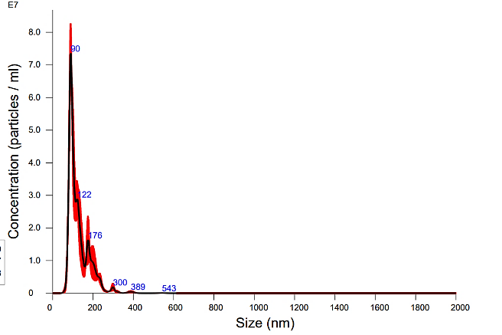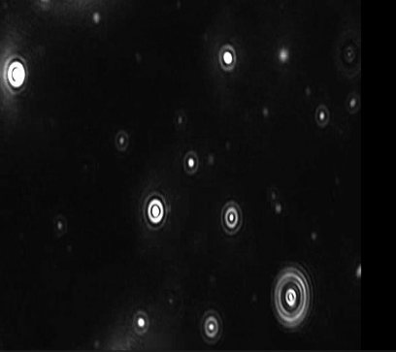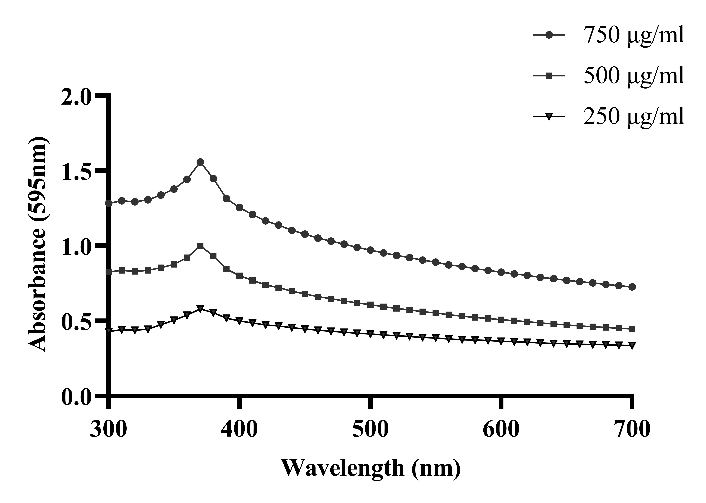
B
C
A

Figure S1: Stability and size distribution of ZnO nanoparticles. (A) UV–visible absorption spectra of ZnO nanoparticles at concentrations of 250, 500, and 750 µg/mL, demonstrating the characteristic absorption peak of ZnO (370 nm) and indicating the stability of the nanoparticle suspension. (B) Representative nanoparticle tracking analysis (NTA) size distribution profile showing the hydrodynamic diameter and particle concentration of ZnO nanoparticles. (C) Representative NTA image capturing individual ZnO nanoparticles undergoing Brownian motion during particle tracking analysis.
Nanoparticle Tracking Analysis video link: https://drive.google.com/file/d/1V2RJBnr2rxVPZ3H01zJ7rTUw3LCKpi7a/view?usp=drive_link

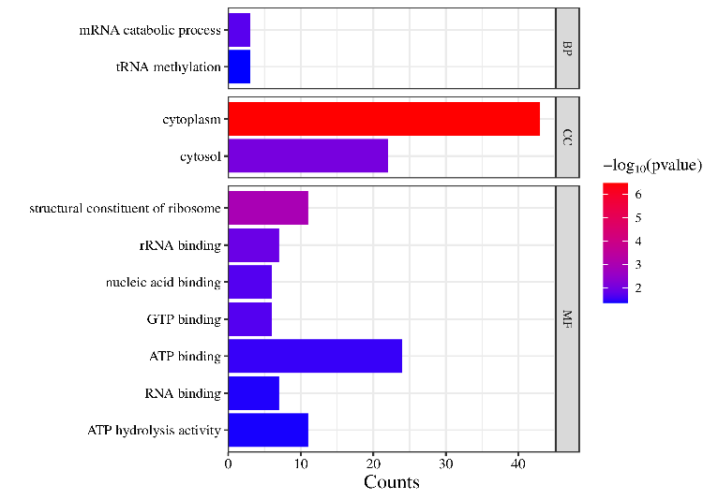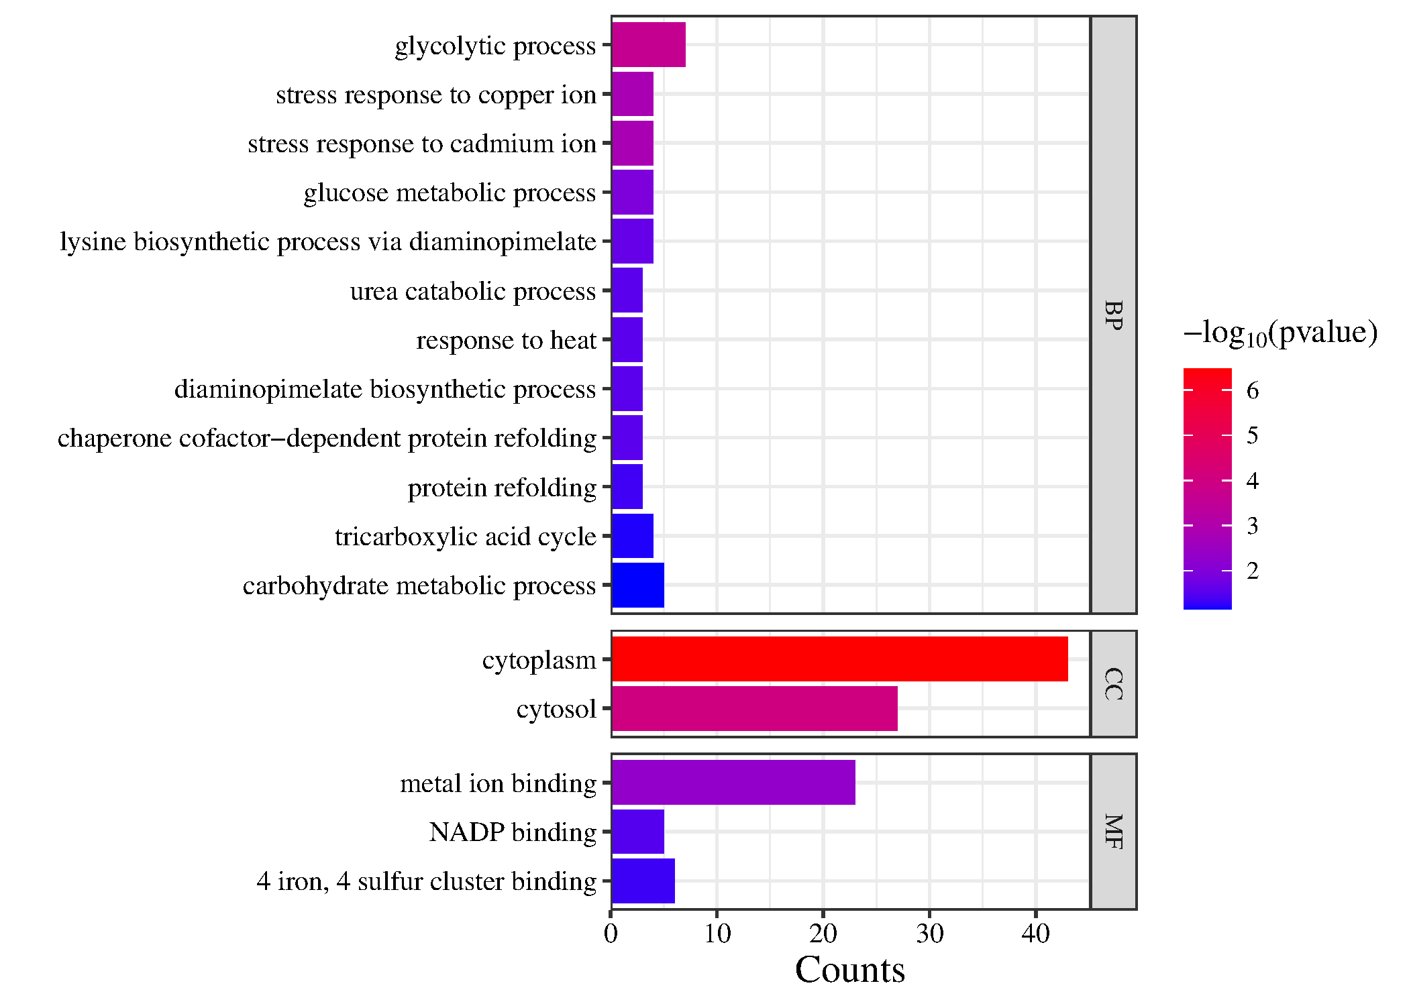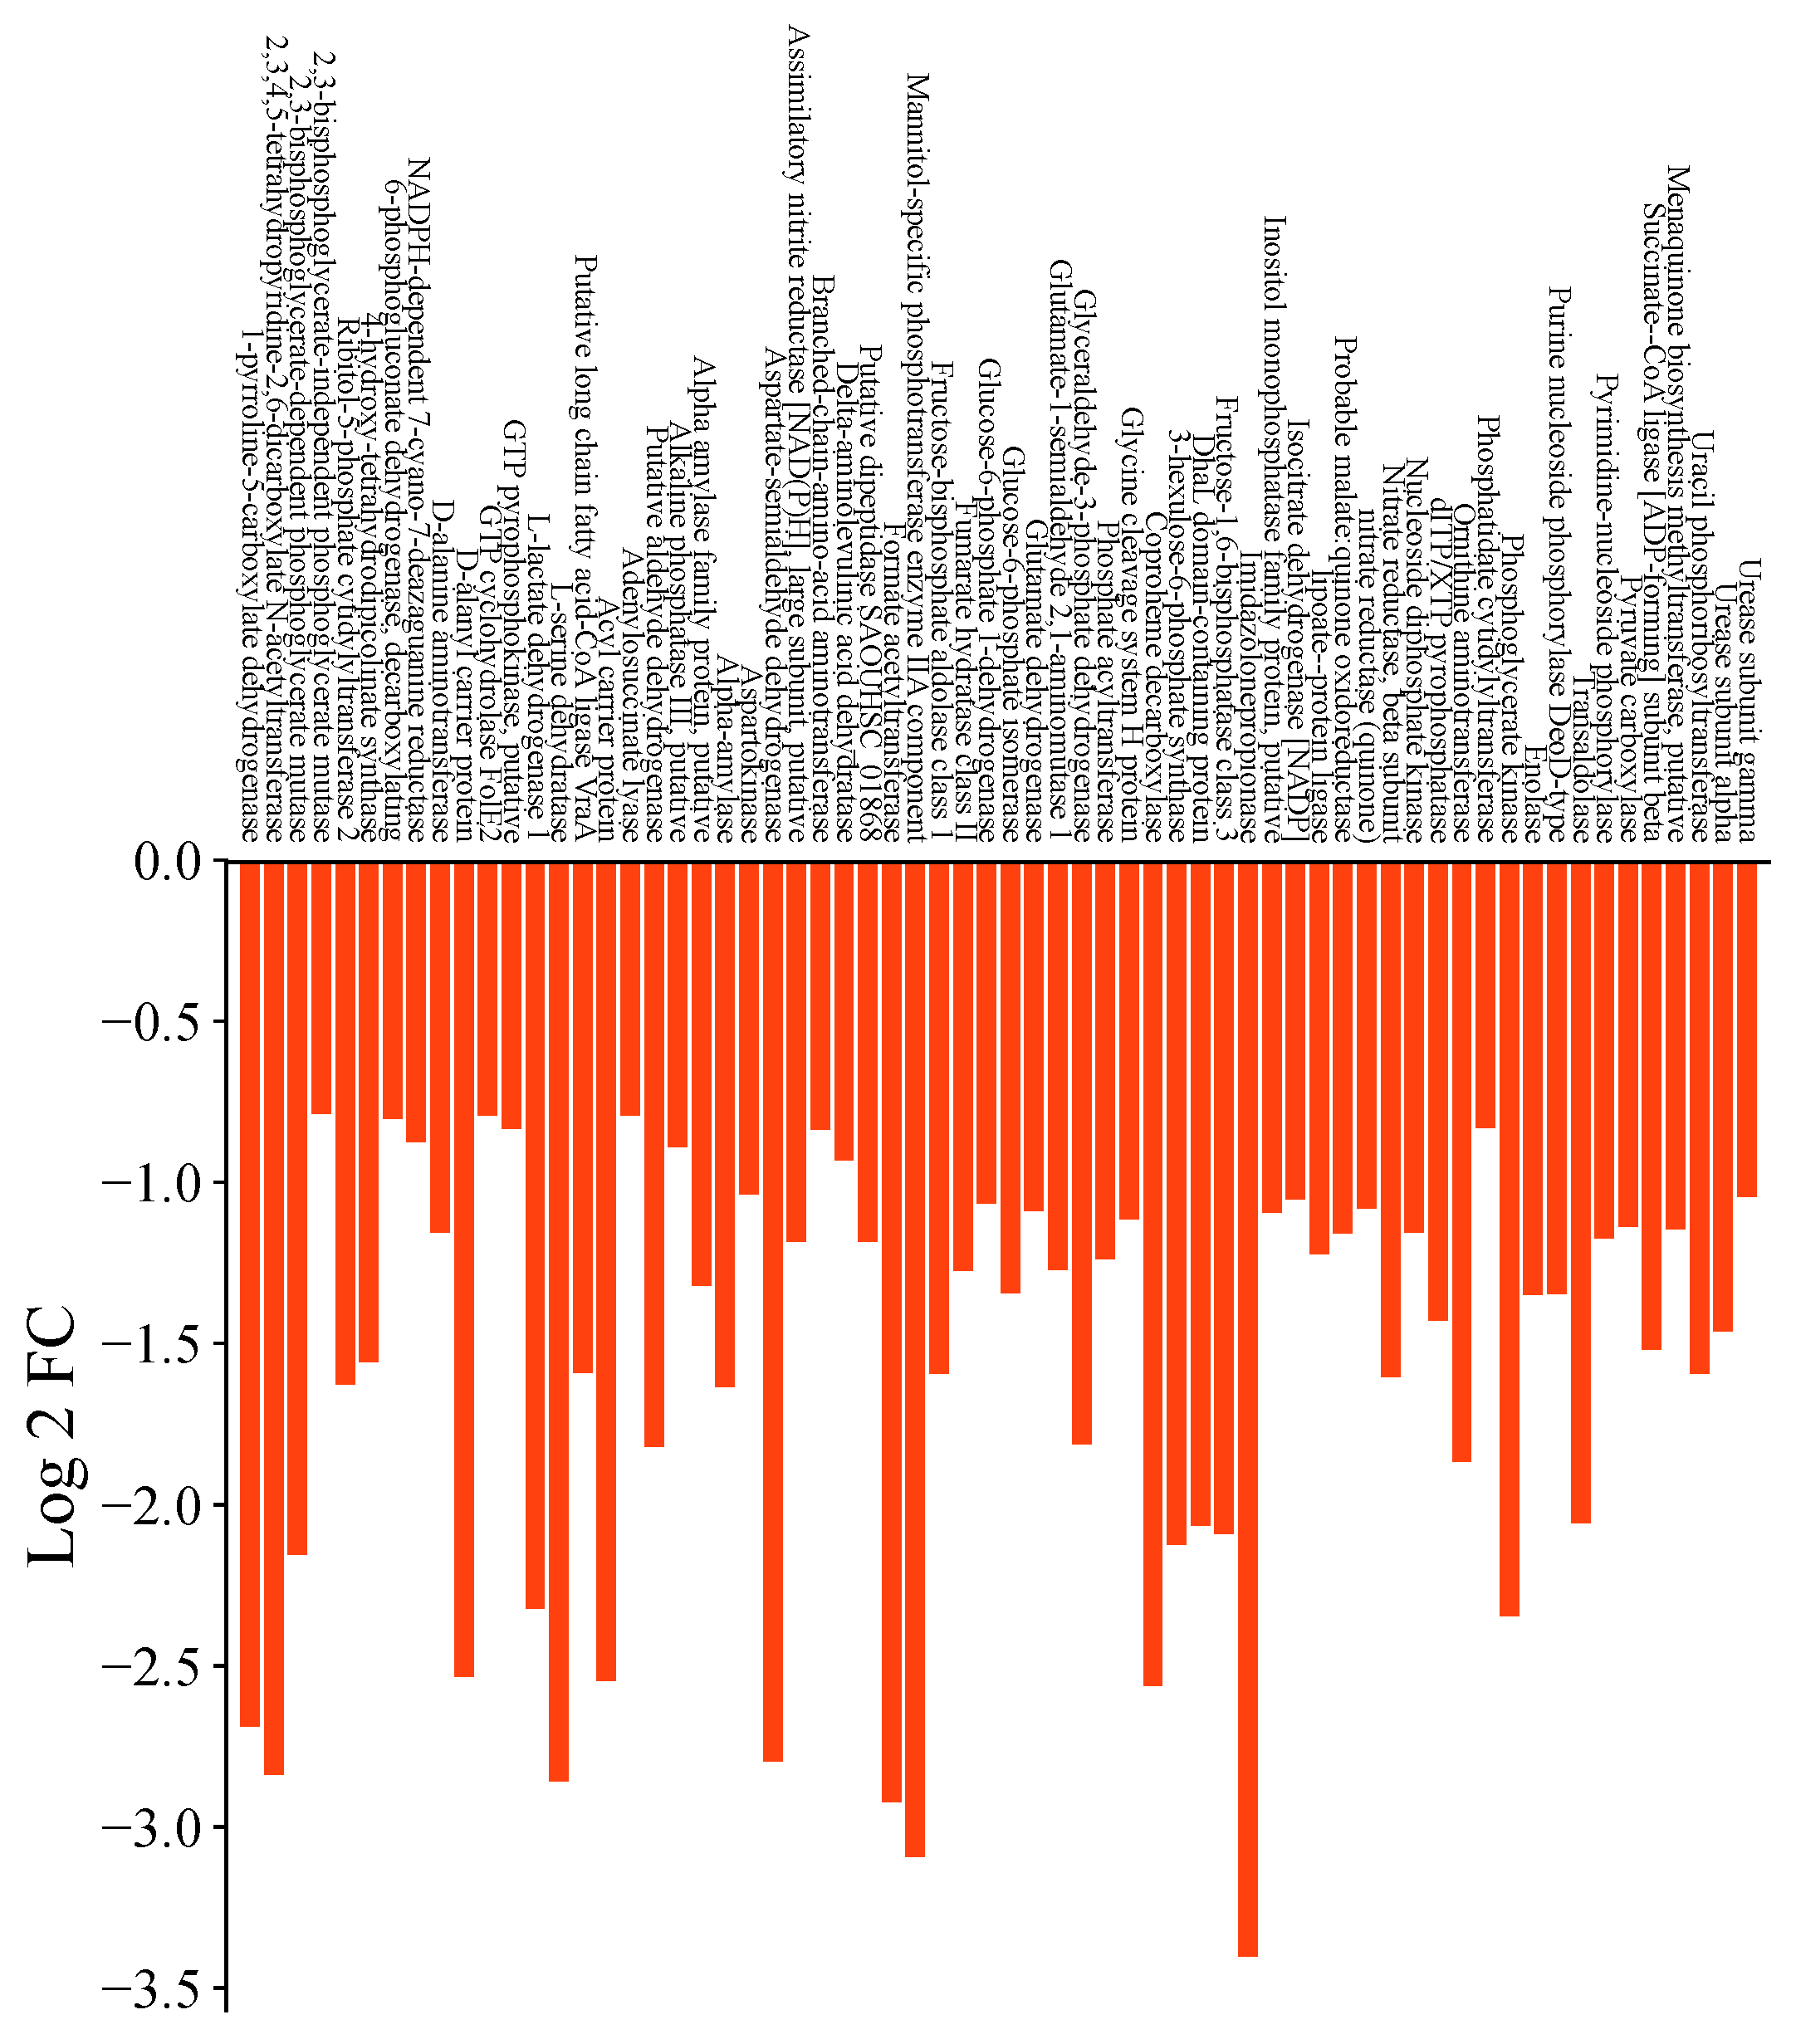
B
C
A

Figure S2 A: KEGG Pathway Enrichment Analysis of Down-regulated Proteins in SCVs. Bar plot representing significantly down-regulated metabolic pathways in small colony variants (SCVs) derived from S. aureus upon ZnO NP-induced adaptation. The x-axis lists enriched KEGG pathways, and the y-axis indicates log₂ fold change in protein abundance. Key pathways affected include glycolysis/gluconeogenesis, purine and pyrimidine metabolism, amino acid biosynthesis, and various cofactor and energy metabolism routes. B-C: Gene Ontology (GO) enrichment analysis of proteins. B: Bar graph representation of significantly enriched GO terms among the up-regulated proteins identified. C: Bar graph representation of significantly enriched GO terms among the down-regulated proteins identified. Enrichment analysis was performed based on GO classifications, including Biological Process (BP), Molecular Function (MF), and Cellular Component (CC). The y-axis lists the GO terms, while the x-axis indicates the number of up-regulated proteins (Counts) associated with each term. Colour gradient represents statistical significance, with -log₁₀(p-value) scale from blue (less significant) to red (highly significant). Only GO terms with p-value ≤ 0.05 are shown.

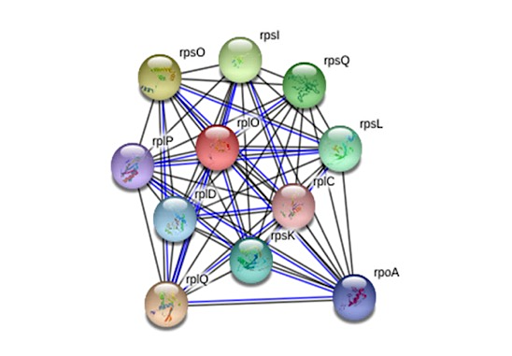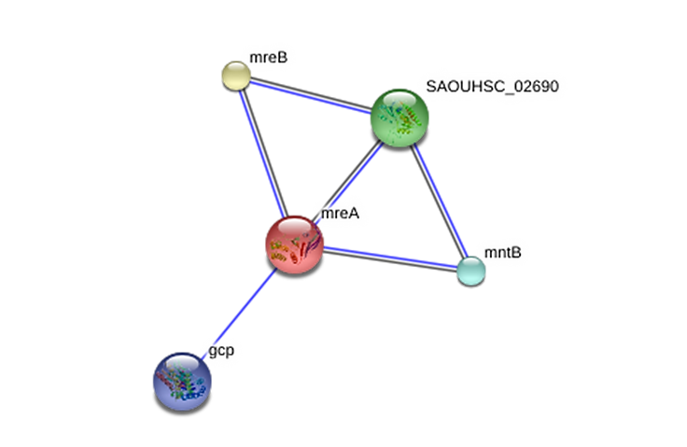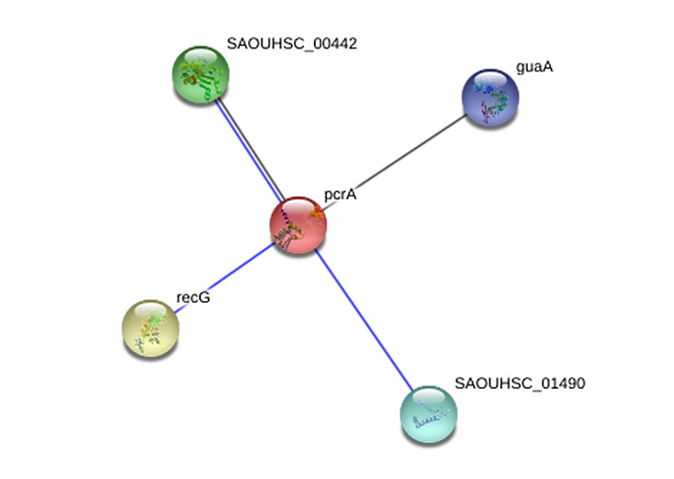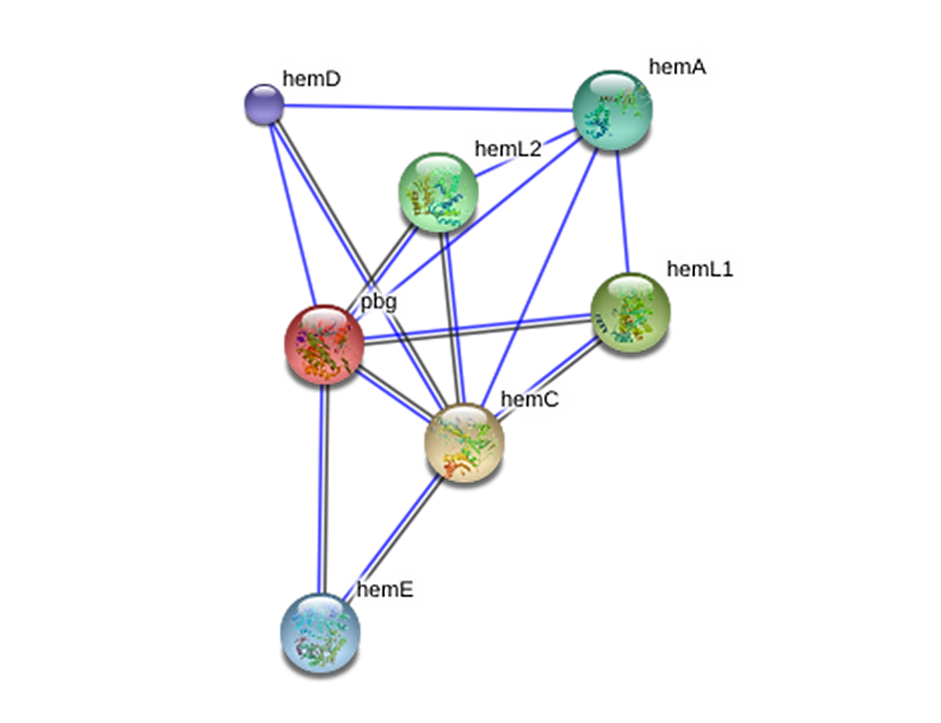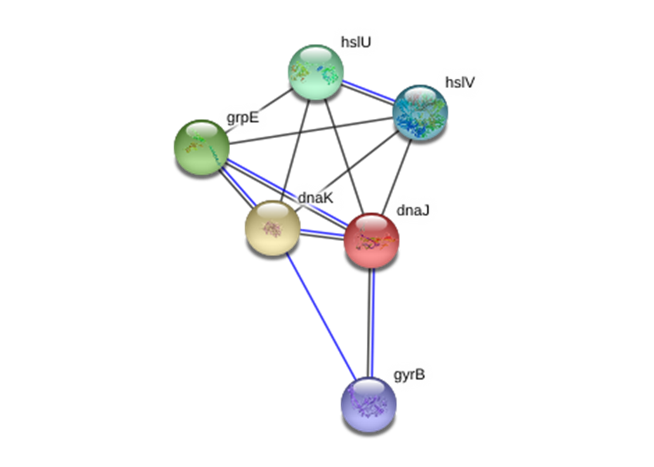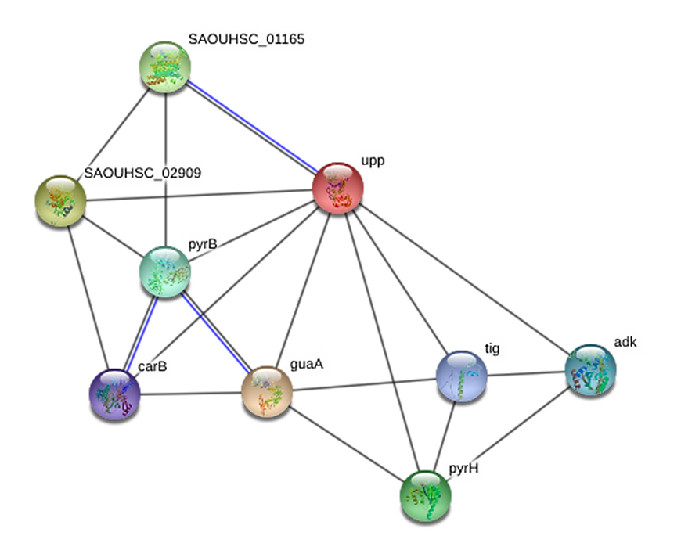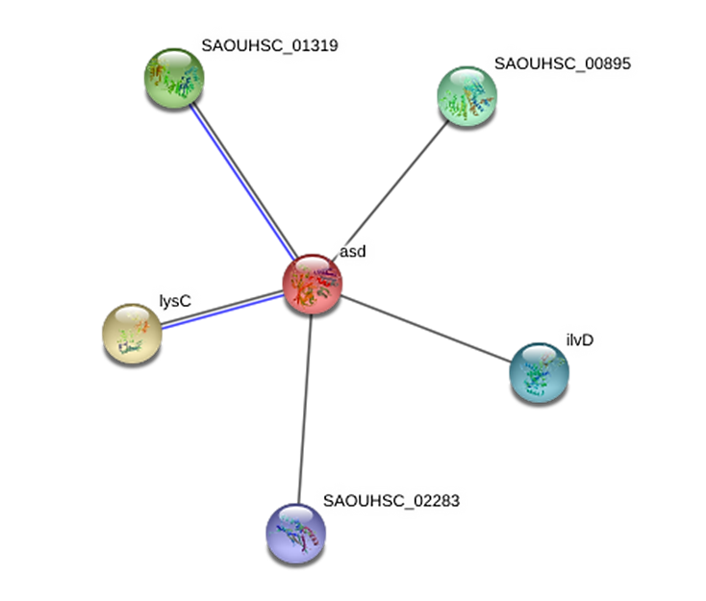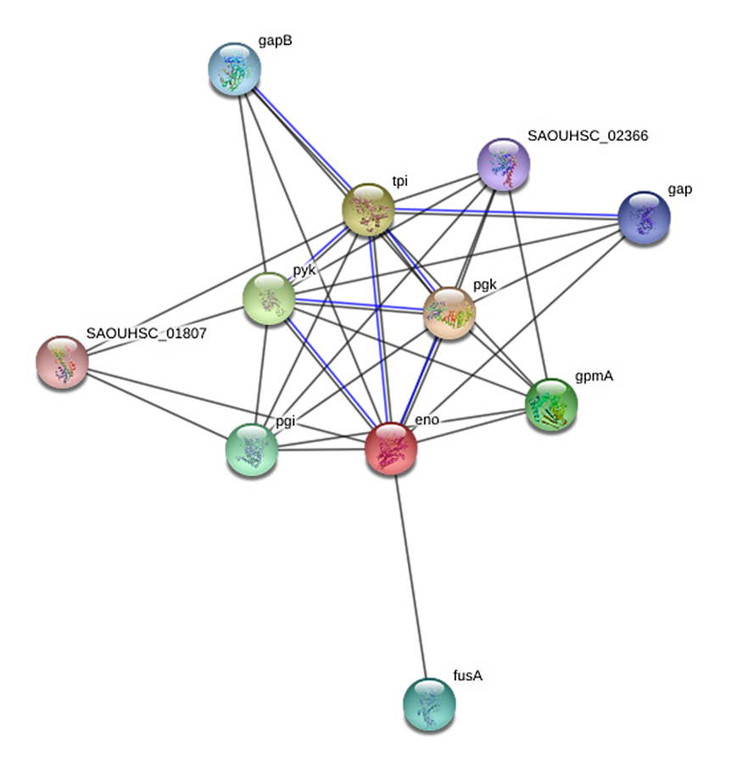
a
b
c
d
e
f
g
h

Figure S3: STRING protein–protein interaction (PPI) network analysis of significantly deregulated genes following nanoparticle treatment.
(a–c) STRING interaction networks of significantly up-regulated genes, and (d–h) networks of significantly down-regulated genes identified under nanoparticle exposure. Networks were generated using STRING v11 with a high-confidence interaction score (>0.700) and a maximum of 10 interactors per query protein. Active interaction sources included gene co-expression (black edges) and gene co-occurrence (blue edges).

In each panel, the red node represents the query protein, while the remaining-coloured nodes correspond to first-shell interacting partners.
(a) Up-regulated ribosomal protein interaction cluster showing dense connectivity among small and large ribosomal subunit proteins, suggesting enhanced or reprogrammed translational activity.
(b) Up-regulated cell shape and membrane-associated network centered on mreA, interacting with mreB and related factors involved in cell wall integrity and morphology.
(c) Up-regulated DNA repair–associated interaction network centered on pcrA, showing connectivity with genome maintenance and nucleotide metabolism genes (guaA, recG).
(d) Down-regulated heme biosynthesis network centered on hemB, showing strong interactions with other enzymes of the tetrapyrrole biosynthetic pathway (hemA, hemC, hemD, hemE).
(e) Down-regulated stress response and DNA replication-associated network centered on dnaJ, interacting with chaperone and proteostasis components (hslU, hslV, grpE).
(f) Down-regulated purine metabolism network centered on upp, displaying extensive connectivity with genes involved in nucleotide biosynthesis and salvage pathways.
(g) Down-regulated amino acid and sulfur metabolism network centered on cysK, interacting with proteins involved in cysteine biosynthesis and sulfur assimilation.
(h) Down-regulated complex regulatory and metabolic interaction network indicating coordinated suppression of transcriptional regulation, metabolic enzymes, and stress-associated proteins.

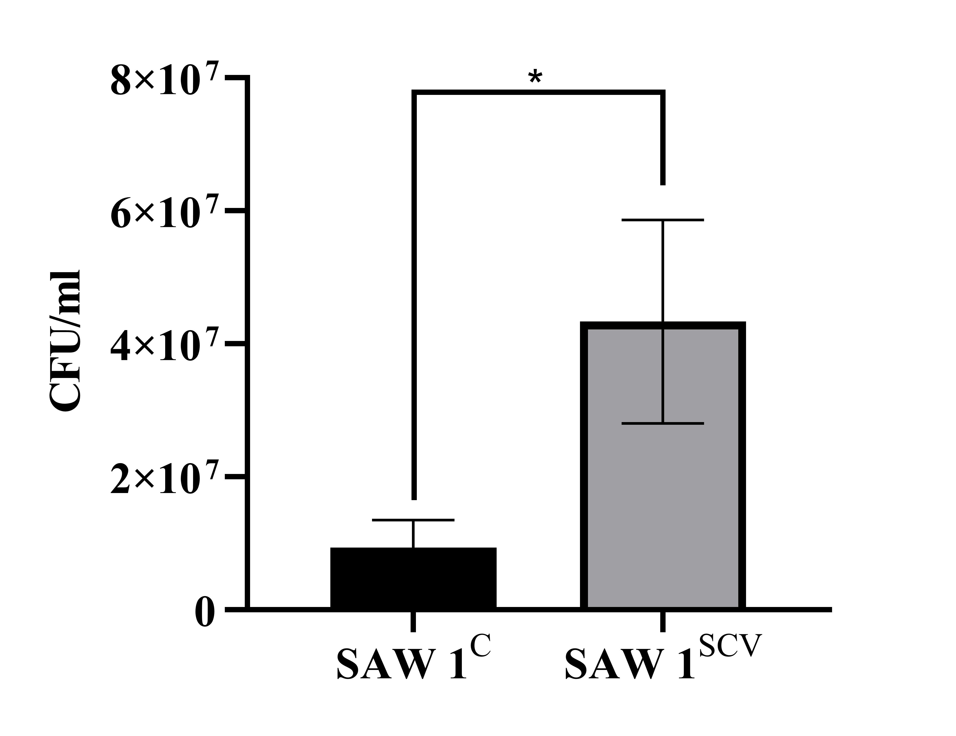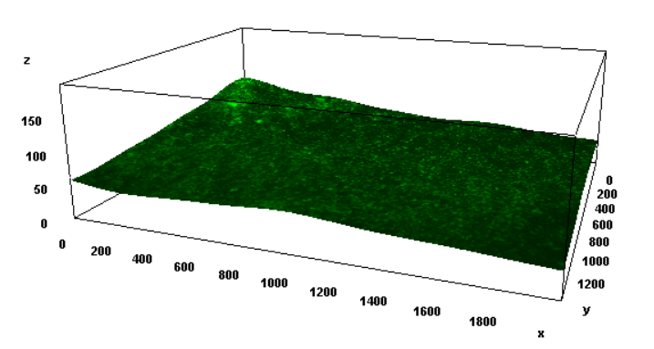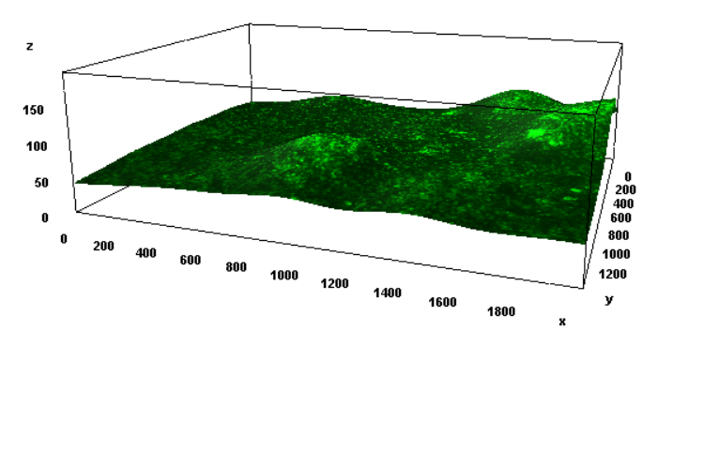
A
B
C
SAW 1^{C}
SAW 1^{SCV}

Figure S4: Biofilm formation by the SAW 1^{C} and evolved SAW 1^{SCV} strains. (A) Quantification of viable biofilm-associated bacteria by CFU enumeration following 24 hours of static growth in TSB supplemented with 0.2% glucose. Data are presented as the mean ± SEM from three independent biological replicates. Statistical significance was determined using an unpaired Student's t-test (P < 0.05). (B-C) Representative three-dimensional fluorescence images of SYTO™ 9-stained biofilms acquired after 24 hours of incubation.

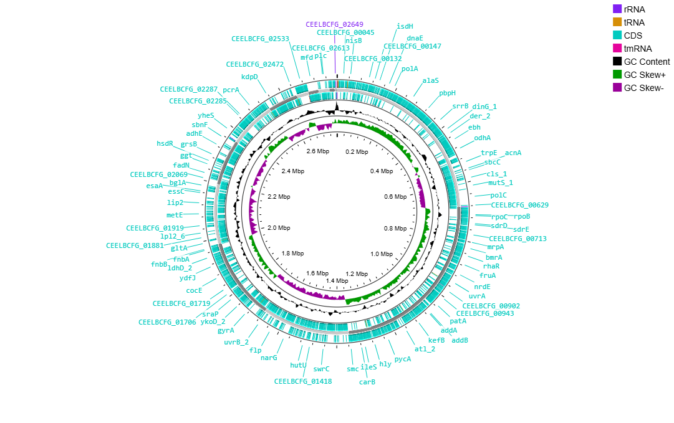

Figure S5: Circular genome map of SAW 1^{SCV} genome. From outer to inner rings: annotated coding sequences on the forward and reverse strands, GC content, and GC skew.

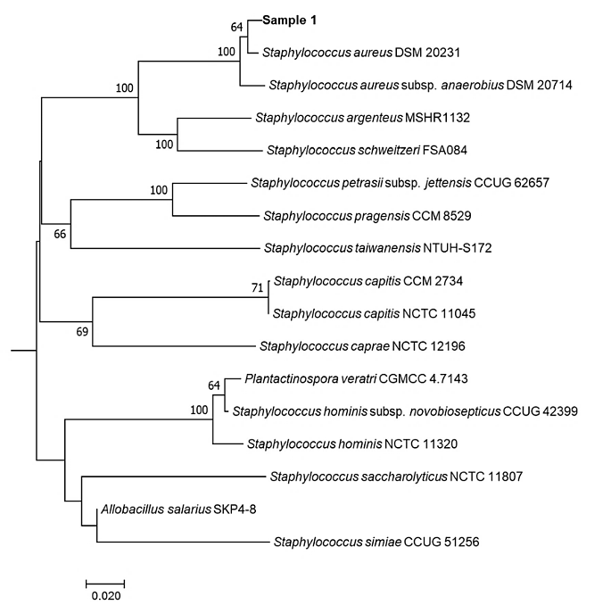
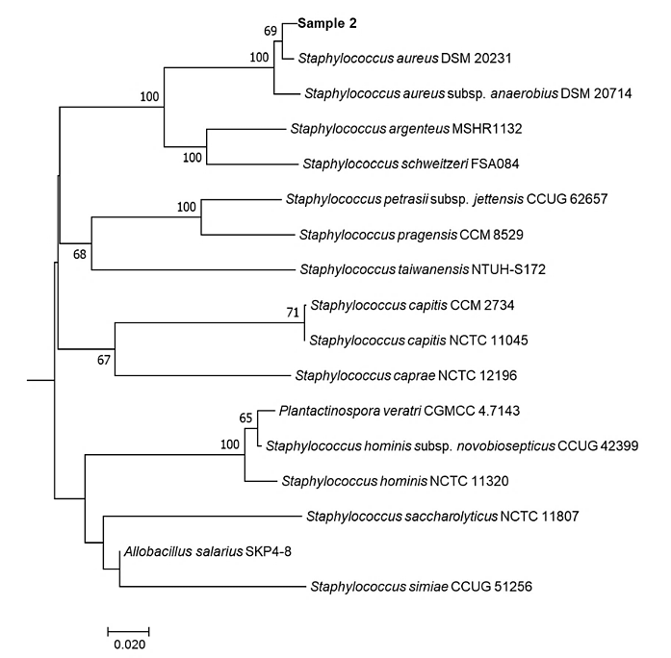

Figure S6: Tree inferred with FastME 2.1.6.1 from GBDP distances calculated from genome sequences of WT (Sample 1) and SAW 1^{SCV} (Sample 2) along with the closest type strains identified by TYGS. The branch lengths are scaled in terms of GBDP distance formula d5. The numbers above branches are GBDP pseudo-bootstrap support values > 60 % from 100 replications, with an average branch support of 23.3 %. The tree was rooted at the midpoint.

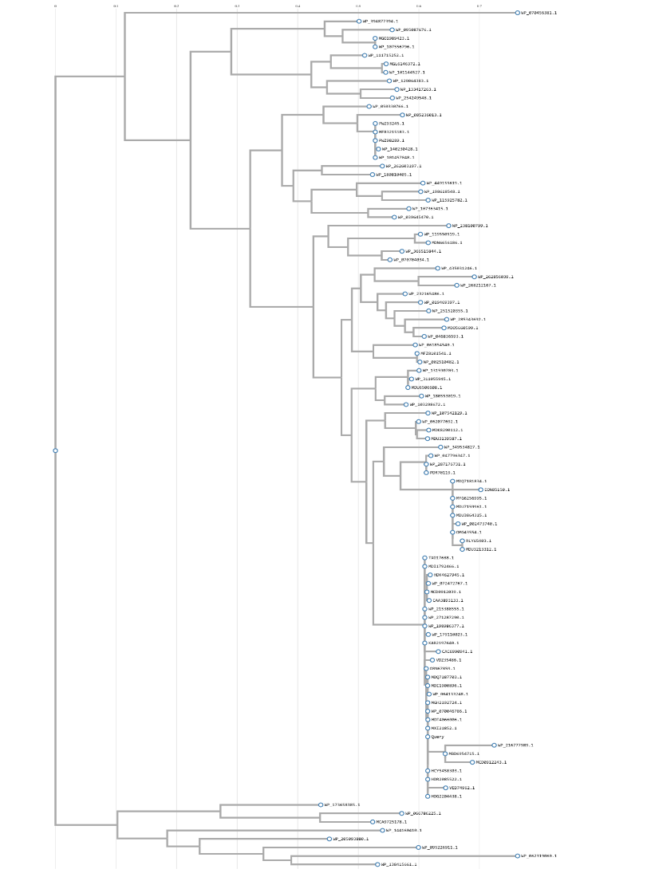
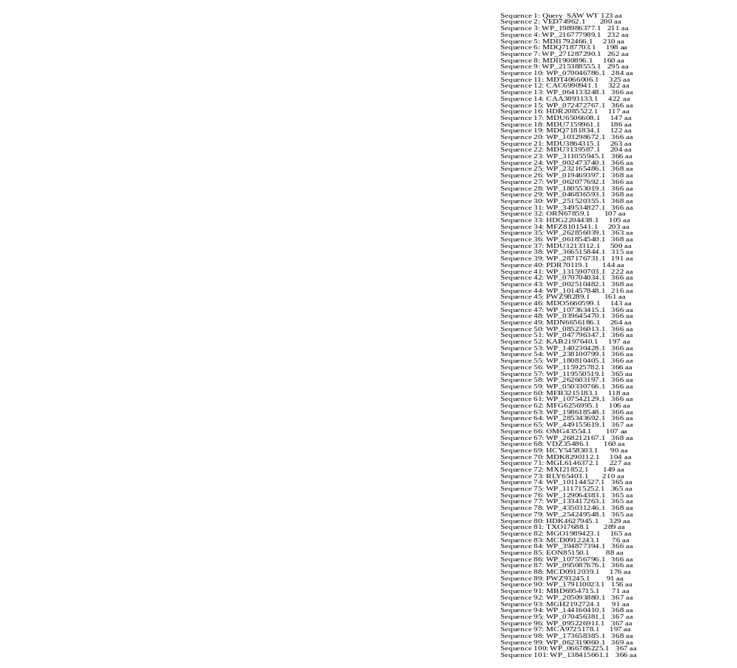

Figure S7: Amino acid variation distance based phylogenetic analysis of most closely associated hundred YqeH proteins, Star indicates the query S. aureus SAW 1 yqeH sequence.

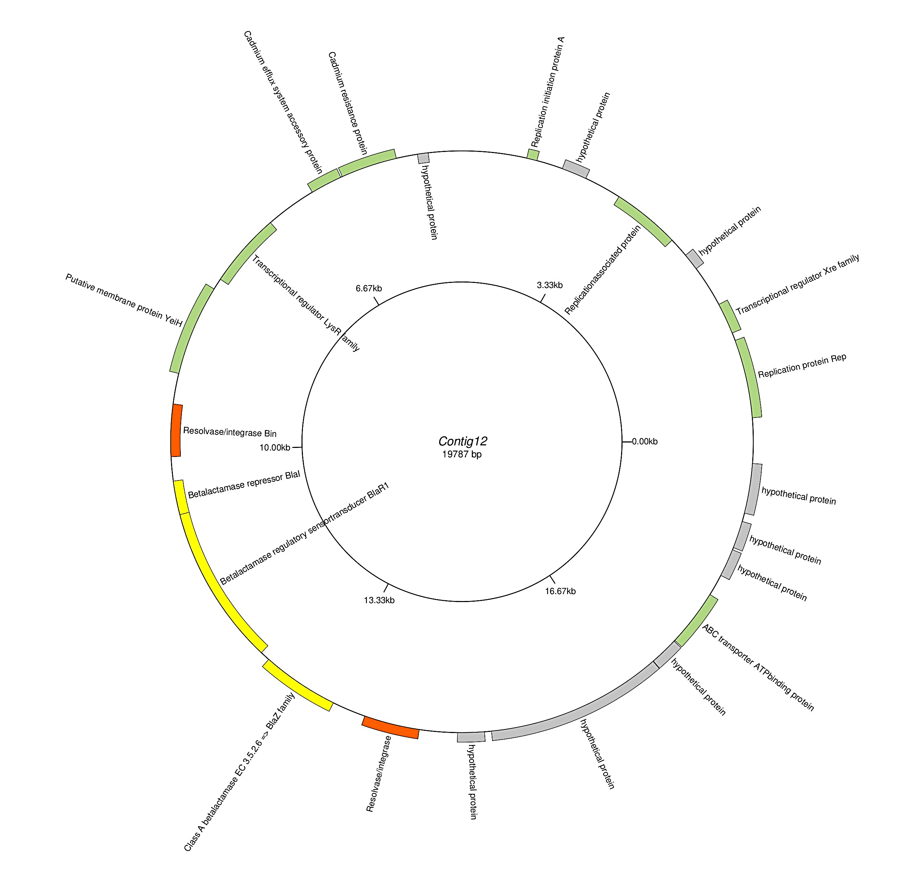
Figure S8: Loss of plasmid (contig 12) in nanoparticle-induced SAW 1^{SCV}.
Annotated gene map of contig 12, corresponding to a plasmid present in the WT but absent in the nanoparticle-induced SAW 1^{SCV}

