Study on the Extraction and Coordination Properties of U(VI) with Four Asymmetric Diglycolamides
Supplementary information
1 ¹H-NMR of Ligands
Characterization data of ligands :
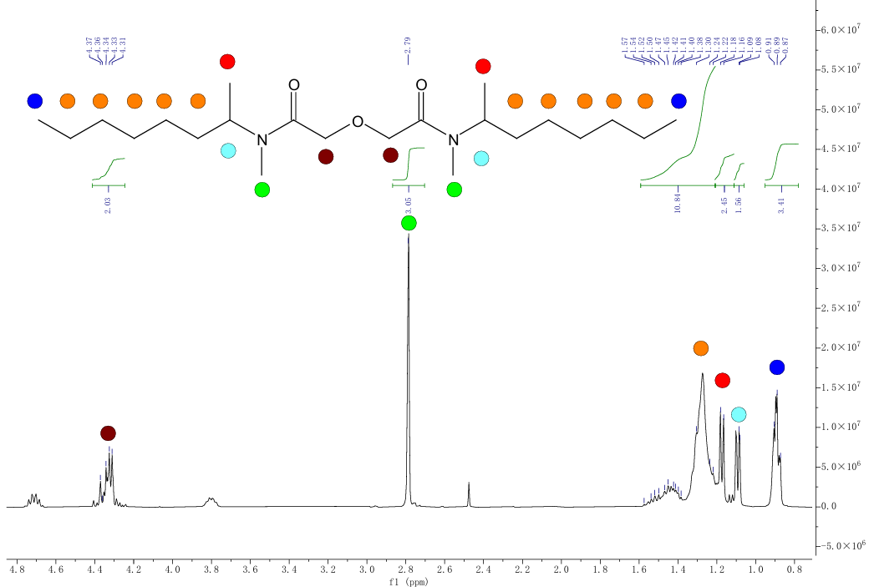
Fig. S1 The 1H-NMR spectrum of L¹ (solvent: CDCl₃, 500MHz)
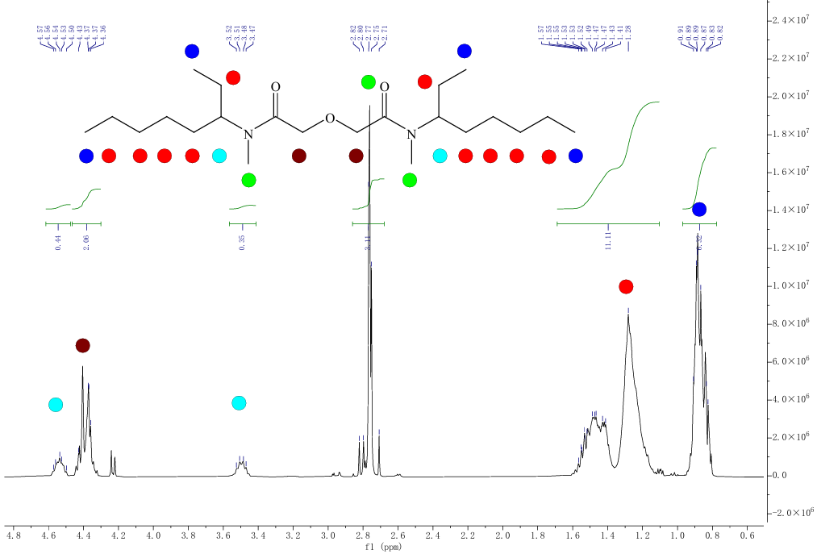
Fig. S2 The 1H-NMR spectrum of L² (solvent: CDCl₃, 500MHz)
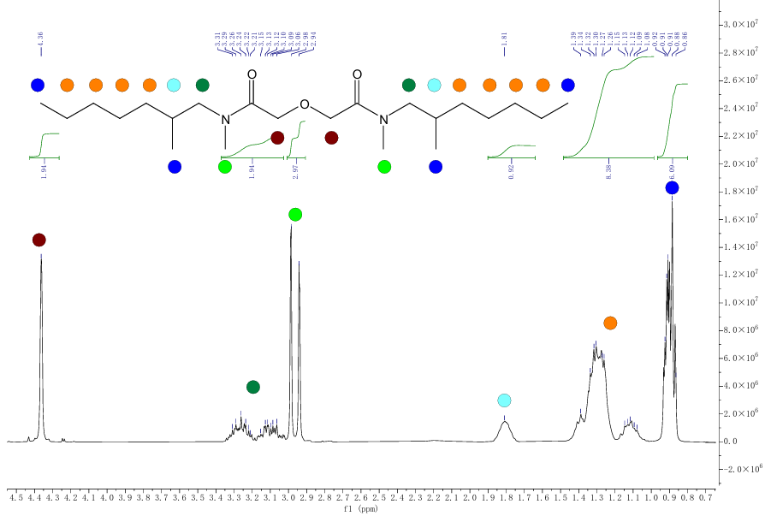
Fig. S3 The 1H-NMR spectrum of L³ (solvent: CDCl₃, 500MHz)
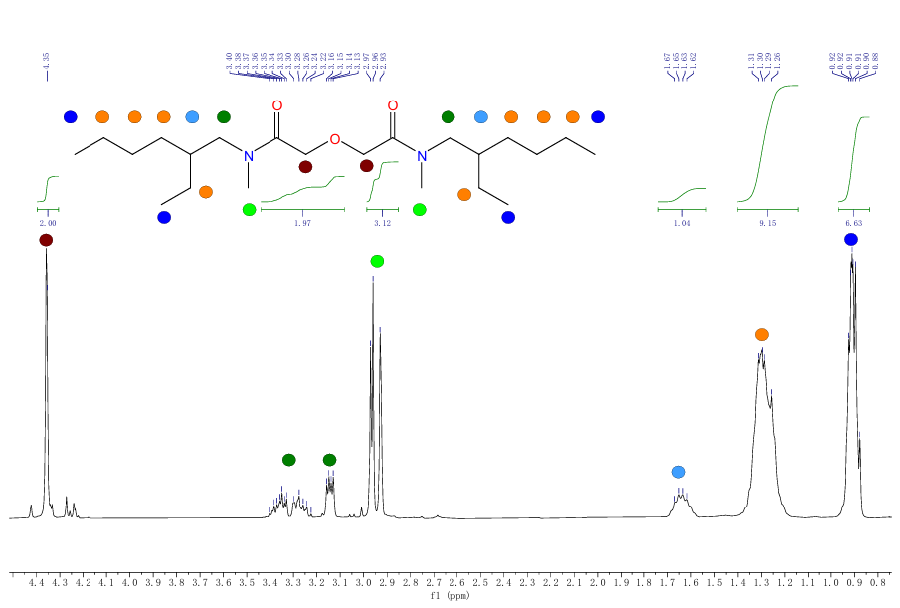
Fig. S4 The 1H-NMR spectrum of L⁴ (solvent: CDCl₃, 500MHz)
2 Synthesis Scheme
Mix bromoalkane and methanolic amine (with a mass fraction of 30~33%) in a molar ratio of 1:8, and react them at 110℃ for more than 24 hours. Remove the methanolic amine from the post-reaction mixture by vacuum distillation under a vacuum pressure of -0.08 MPa and a temperature of 50℃, yielding a brownish-yellow liquid. Add an appropriate amount of chloroform, mix thoroughly, and wash the mixture four times with saturated sodium carbonate solution, then separate the organic phase. Distill off the chloroform under atmospheric pressure at 75~80℃. Transfer the remaining organic phase to a round-bottom flask, first distill off low-boiling impurities below 170℃, then switch the collection flask and heat to 190~195℃ to obtain a colorless liquid of 10~12 mL, with a yield of approximately 70%~80%.
Take the secondary amine synthesized in the previous step and mix it with triethylamine in a molar ratio of 1:1. Add 100 mL of benzene as a solvent and place the mixture in an ice-water bath while stirring. After cooling the temperature to 0~5℃, slowly add a mixture of dianhydride chloride (acyl chloride: secondary amine = 1:2.5) and 20 mL of benzene, controlling the temperature during addition to remain within 0~10℃. React under ice bath for 2 hours, then remove the ice bath and allow the mixture to react fully at room temperature. Filter the product, wash the residue multiple times with benzene to obtain the filtrate. Remove the solvent benzene under a gauge pressure of -0.06 MPa and a temperature of 65℃. After standing and cooling, dissolve the residue in petroleum ether, transfer to a beaker, add excess 3 M nitric acid, stir and stand until a third phase appears. Extract the third phase and wash it multiple times with petroleum ether. Wash the washed third phase sequentially four times with 5% NaOH solution and deionized water, then dry with anhydrous sodium sulfate overnight. Finally, separate the organic phase to obtain a yellow viscous liquid of 5.0 g~5.5 g, with a yield of approximately 60%.

