SUPPLEMENTARY MATERIALS

Supplementary Figures
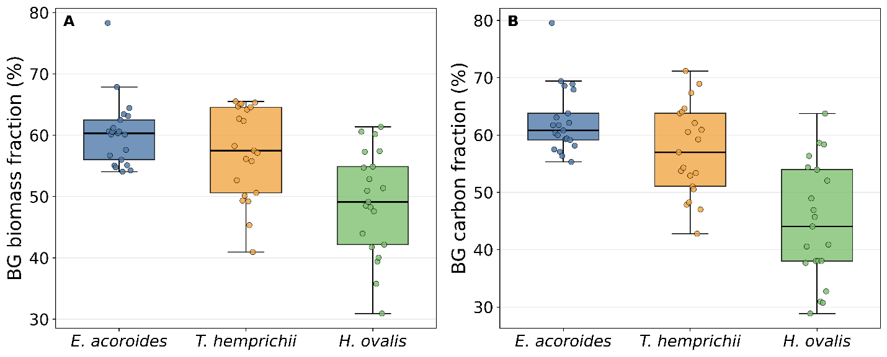
Figure S1. (A) Below-ground biomass fraction and (B) below-ground carbon fraction of the three dominant seagrass species.

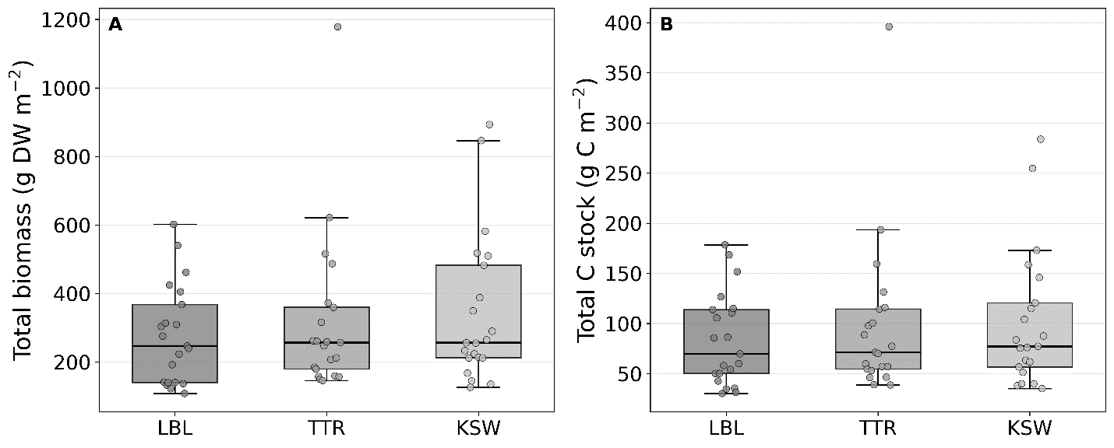
Figure S2. (A) Site-level variation in total biomass and (B) total biomass-based carbon stock across Labuan Lalang, Teluk Terima, and Karang Sewu. Differences among sites were not statistically significant, indicating that site category did not produce a strong monotonic pattern in biomass-based carbon stock.

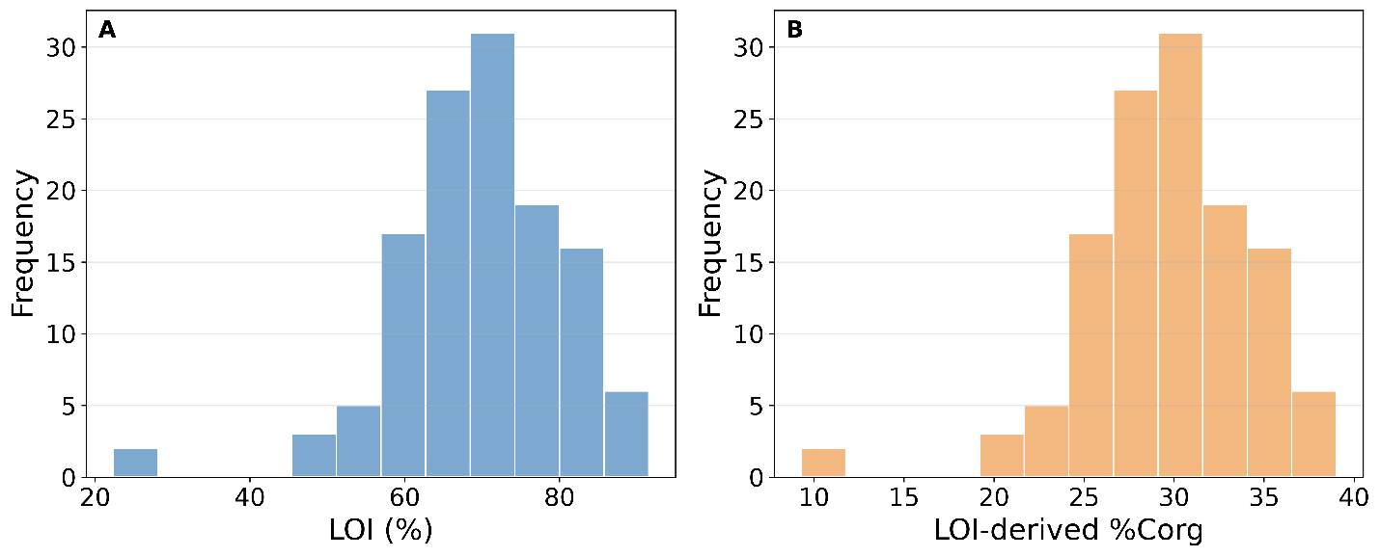
Figure S3. Distribution of (A) Loss on Ignition values and (B) LOI-derived estimated organic carbon concentration across all biomass samples. All LOI values were above 20%, so the second LOI-to-Corg equation was applied to all samples.

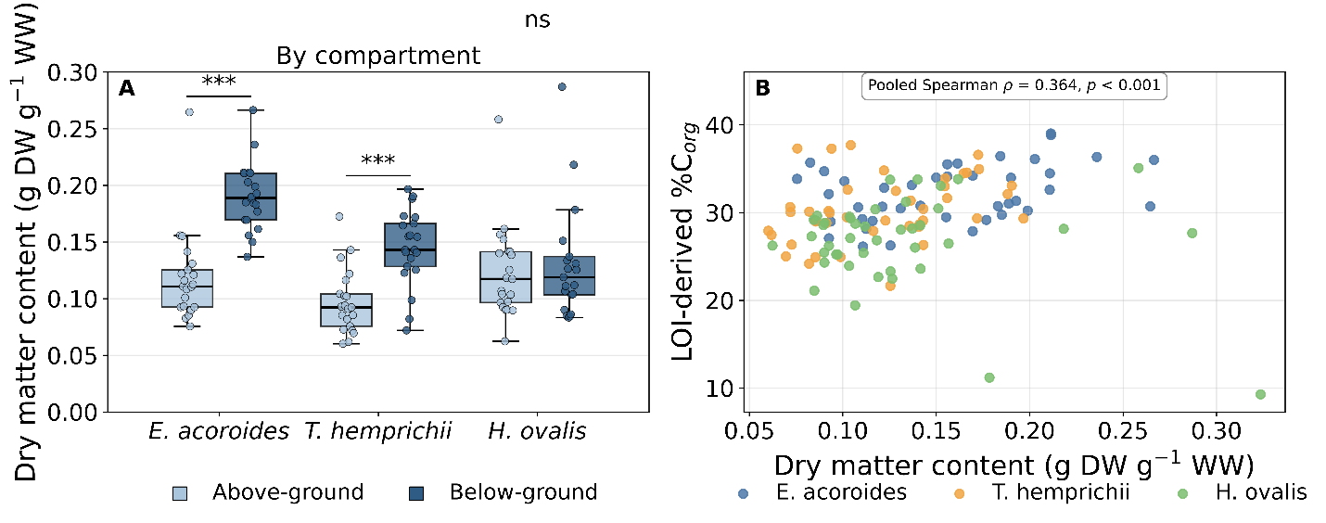
Figure S4. Tissue dry matter content and its relationship with tissue carbon concentration. (A) Above- and below-ground DMC by species; bars show mean ± SD and brackets show Wilcoxon signed-rank results (*** p < 0.001; ns, not significant). (B) Relationship between DMC and LOI-derived %Corg across all 126 compartment-level observations.

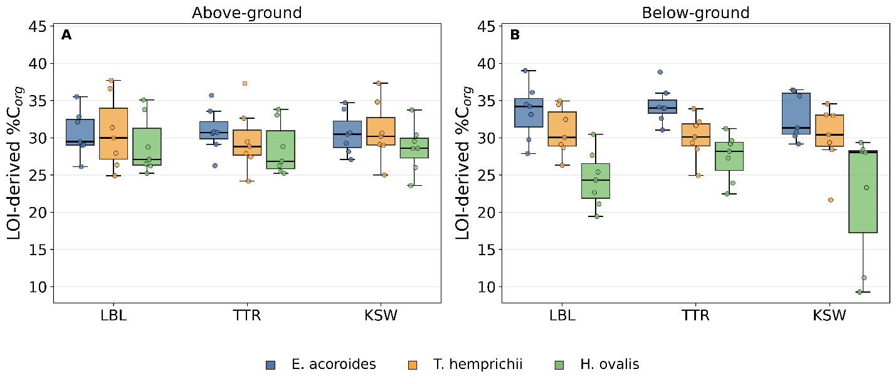
Figure S5. Site-level breakdown of tissue organic carbon concentration (cf. Figure 6). (A) Above-ground and (B) below-ground LOI-derived %Corg by species at each site; bars show mean ± SD (n = 7 per species per site). Differences among sites were not significant within any species or compartment (Kruskal–Wallis, all p ≥ 0.35), whereas species differences were pronounced.

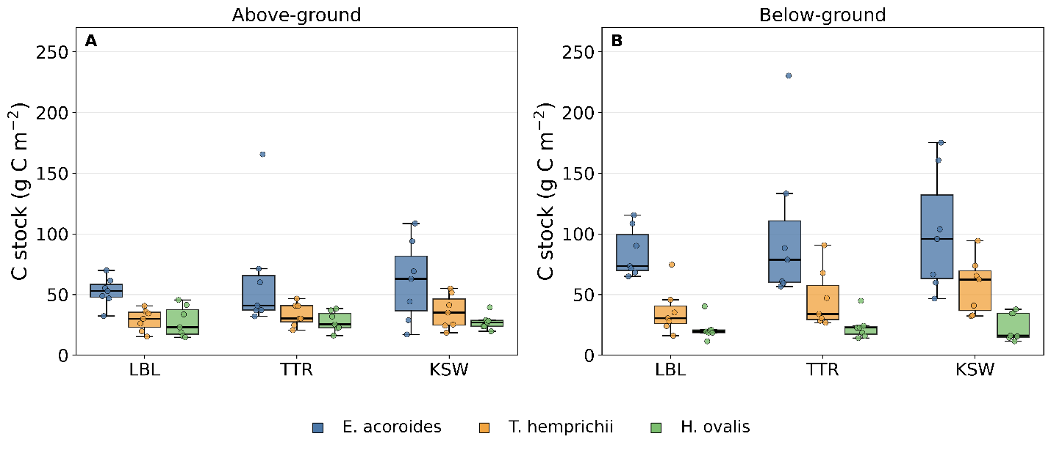
Figure S6. Site-level breakdown of biomass-based carbon stock (cf. Figure 7). (A) Above-ground and (B) below-ground carbon stock by species at each site; bars show mean ± SD (n = 7 per species per site). Differences among sites were not significant within any species (Kruskal–Wallis, all p ≥ 0.20), reinforcing that species identity was more closely associated with biomass carbon stock than broad site category in this dataset.

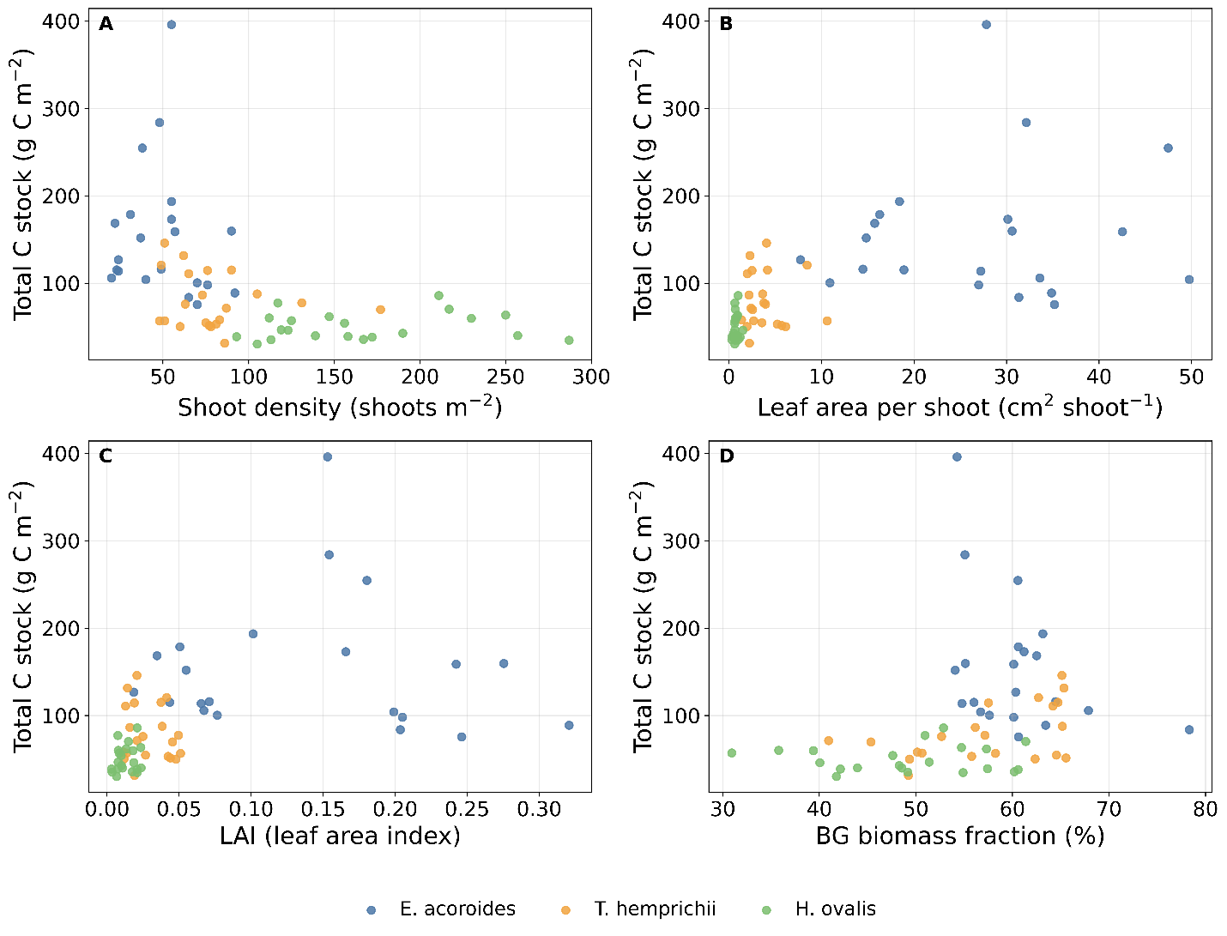
Figure S7. Relationship between total biomass-based carbon stock (g C m⁻²) and (A) shoot density (shoots m⁻²), (B) leaf area per shoot (cm² shoot⁻¹), (C) LAI, and (D) below-ground biomass fraction (%). Spearman correlations are reported in Table S8; no fitted regression line is shown because the association is interpreted descriptively. Pooled relationships show that plant size and biomass allocation were more closely aligned with carbon stock than shoot density alone.

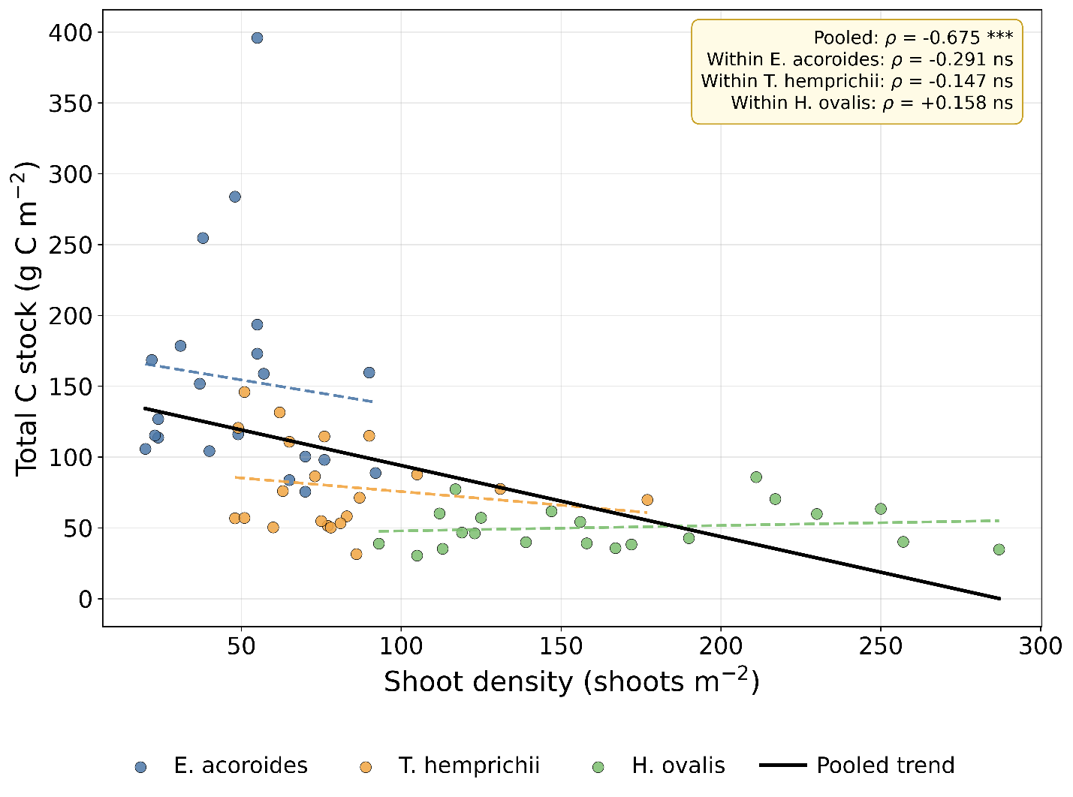
Figure S8. Scale dependence of the shoot density–carbon stock relationship. Points are species-level sampling units (n = 63). The solid black line shows the pooled trend; dashed coloured lines show within-species trends. Coefficients are given in Table S9.

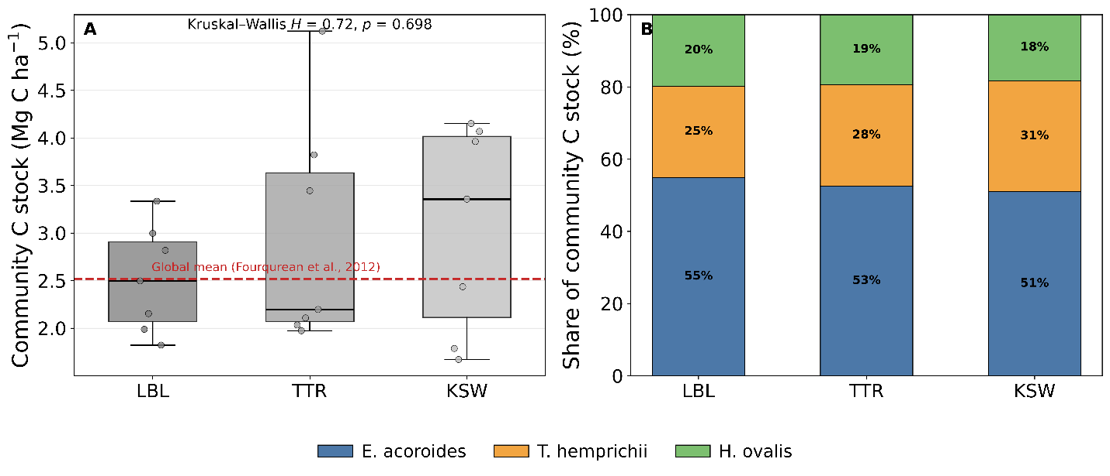
Figure S9. Community-level carbon stock and species composition across sites. (A) Community biomass-based carbon stock per site (mean ± SD, n = 7 lines per site); the dashed red line marks the global mean living biomass carbon stock reported by Fourqurean et al. (2012). (B) Proportional contribution of each species to community carbon stock at each site.

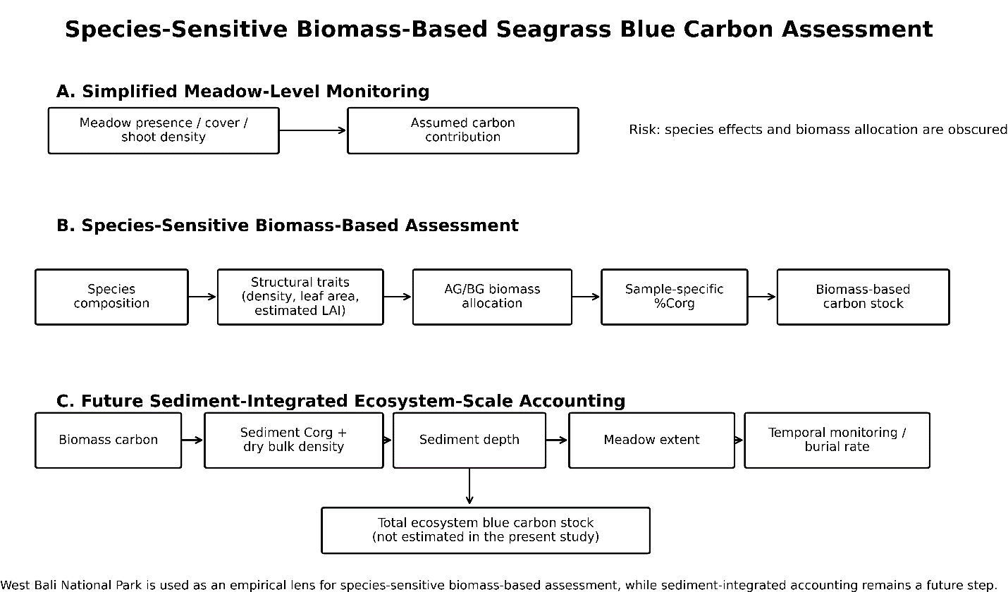
Figure S10. Conceptual model summarizing how empirical evidence from West Bali National Park illustrates the need for species-sensitive biomass-based seagrass blue carbon assessment. The figure distinguishes simplified meadow-level monitoring from species-sensitive biomass-based assessment and future sediment-integrated ecosystem carbon accounting.

Supplementary Tables

Table S1. Structural attributes by site and species.
Site | Species | Shoot density (shoots m⁻²) | Leaf area per shoot (cm² shoot⁻¹) | LAI | Substrate | Pressure category
LBL | E. acoroides | 25.86 ± 5.98 | 19.19 ± 8.59 | 0.0478 ± 0.0173 | Muddy | High
LBL | T. hemprichii | 88.86 ± 39.96 | 2.62 ± 1.59 | 0.0234 ± 0.0161 | Muddy | High
LBL | H. ovalis | 175.43 ± 62.39 | 0.75 ± 0.20 | 0.0133 ± 0.0062 | Muddy | High
TTR | E. acoroides | 69.57 ± 17.37 | 23.45 ± 8.90 | 0.1719 ± 0.0988 | Sandy | Moderate
TTR | T. hemprichii | 80.43 ± 25.35 | 3.20 ± 1.07 | 0.0266 ± 0.0141 | Sandy | Moderate
TTR | H. ovalis | 152.14 ± 52.42 | 0.73 ± 0.37 | 0.0111 ± 0.0059 | Sandy | Moderate
KSW | E. acoroides | 53.29 ± 12.05 | 38.36 ± 8.12 | 0.1988 ± 0.0356 | Muddy-sand | Low
KSW | T. hemprichii | 69.00 ± 22.37 | 5.80 ± 2.71 | 0.0368 ± 0.0106 | Muddy-sand | Low
KSW | H. ovalis | 170.71 ± 59.89 | 0.81 ± 0.28 | 0.0146 ± 0.0080 | Muddy-sand | Low

Table S2. Kruskal–Wallis tests for species and site effects.
Response variable | Grouping factor | H | df | p-value | Interpretation
Shoot density | Species | 43.01 | 2 | <0.001 | Significant
Shoot density | Site | 1.09 | 2 | 0.580 | Not significant
Leaf area per shoot | Species | 54.75 | 2 | <0.001 | Significant
LAI | Species | 42.12 | 2 | <0.001 | Significant
Total biomass | Species | 28.28 | 2 | <0.001 | Significant
Total biomass | Site | 0.98 | 2 | 0.614 | Not significant
BG biomass fraction | Site | 3.42 | 2 | 0.181 | Not significant
%Corg | Species | 31.11 | 2 | <0.001 | Significant
%Corg | Site | 0.14 | 2 | 0.930 | Not significant
Total C stock | Species | 36.98 | 2 | <0.001 | Significant
Total C stock | Site | 0.67 | 2 | 0.714 | Not significant
BG C fraction | Site | 1.16 | 2 | 0.561 | Not significant

Table S3. Pairwise Mann–Whitney U tests with Bonferroni-adjusted p-values.
Response variable | Pairwise comparison | U | Adjusted p-value | Interpretation
Shoot density | E. acoroides vs T. hemprichii | 87.5 | 0.003 | Significant
Shoot density | E. acoroides vs H. ovalis | 0.0 | <0.001 | Significant
Shoot density | T. hemprichii vs H. ovalis | 23.5 | <0.001 | Significant
Leaf area per shoot | E. acoroides vs T. hemprichii | 439.0 | <0.001 | Significant
Leaf area per shoot | E. acoroides vs H. ovalis | 441.0 | <0.001 | Significant
Leaf area per shoot | T. hemprichii vs H. ovalis | 440.0 | <0.001 | Significant
LAI | E. acoroides vs T. hemprichii | 411.0 | <0.001 | Significant
LAI | E. acoroides vs H. ovalis | 436.0 | <0.001 | Significant
LAI | T. hemprichii vs H. ovalis | 366.0 | <0.001 | Significant
Total biomass | E. acoroides vs T. hemprichii | 357.0 | 0.002 | Significant
Total biomass | E. acoroides vs H. ovalis | 423.0 | <0.001 | Significant
Total biomass | T. hemprichii vs H. ovalis | 304.0 | 0.110 | Not significant
Total C stock | E. acoroides vs T. hemprichii | 380.0 | <0.001 | Significant
Total C stock | E. acoroides vs H. ovalis | 438.0 | <0.001 | Significant
Total C stock | T. hemprichii vs H. ovalis | 346.0 | 0.005 | Significant
BG biomass fraction | E. acoroides vs T. hemprichii | 245.0 | 1.000 | Not significant
BG biomass fraction | E. acoroides vs H. ovalis | 385.0 | <0.001 | Significant
BG biomass fraction | T. hemprichii vs H. ovalis | 341.0 | 0.008 | Significant
BG C fraction | E. acoroides vs T. hemprichii | 297.0 | 0.168 | Not significant
BG C fraction | E. acoroides vs H. ovalis | 415.0 | <0.001 | Significant
BG C fraction | T. hemprichii vs H. ovalis | 362.0 | 0.001 | Significant

Table S4. Wilcoxon signed-rank tests for above-ground and below-ground comparisons.
Species | Variable | W | p-value | Interpretation
E. acoroides | Biomass AG vs BG | 0 | <0.001 | BG higher
T. hemprichii | Biomass AG vs BG | 24 | <0.001 | BG higher
H. ovalis | Biomass AG vs BG | 111 | 0.892 | Not significant
E. acoroides | %Corg AG vs BG | 22 | <0.001 | BG higher
T. hemprichii | %Corg AG vs BG | 113 | 0.946 | Not significant
H. ovalis | %Corg AG vs BG | 27 | 0.001 | BG lower
E. acoroides | C stock AG vs BG | 0 | <0.001 | BG higher
T. hemprichii | C stock AG vs BG | 22 | <0.001 | BG higher
H. ovalis | C stock AG vs BG | 61 | 0.060 | Not significant
Supplementary note for Table S4. The significantly lower below-ground than above-ground %Corg in H. ovalis is reported as a species-specific compartment reversal and should be interpreted as a tissue-carbon pattern rather than as evidence of lower below-ground biomass storage.

Table S5. LOI-derived organic carbon concentration by species and compartment (n = 21 per species per compartment).
Species | Compartment | %Corg mean ± SD | n
E. acoroides | Above-ground | 30.72 ± 2.84 | 21
E. acoroides | Below-ground | 33.58 ± 3.08 | 21
T. hemprichii | Above-ground | 30.42 ± 4.21 | 21
T. hemprichii | Below-ground | 30.34 ± 3.37 | 21
H. ovalis | Above-ground | 28.70 ± 3.41 | 21
H. ovalis | Below-ground | 24.80 ± 5.83 | 21

Table S6. Tissue dry matter content (DMC) of above- and below-ground compartments. Mean ± SD (n = 21). W and p from Wilcoxon signed-rank tests on paired compartments.
Species | AG DMC (g g⁻¹) | BG DMC (g g⁻¹) | W | p | Interpretation
E. acoroides | 0.118 ± 0.040 | 0.190 ± 0.030 | 0 | <0.001 | BG significantly denser
T. hemprichii | 0.097 ± 0.028 | 0.145 ± 0.033 | 14 | <0.001 | BG significantly denser
H. ovalis | 0.123 ± 0.041 | 0.138 ± 0.065 | 81 | 0.243 | No significant difference
Note. Both large-bodied species developed significantly denser below-ground tissue; H. ovalis did not, consistent with its fine, non-thickened root–rhizome system.

Table S7. Spearman rank correlations between DMC and LOI-derived organic carbon concentration.
Scope | n | Spearman ρ | p | Interpretation
All species (pooled) | 126 | +0.364 | <0.001 | Significant
E. acoroides (both compartments) | 42 | +0.408 | 0.007 | Significant
T. hemprichii (both compartments) | 42 | +0.394 | 0.010 | Significant
H. ovalis (both compartments) | 42 | +0.127 | 0.424 | Not significant
E. acoroides (below-ground only) | 21 | +0.416 | 0.061 | Not significant
T. hemprichii (below-ground only) | 21 | +0.547 | 0.010 | Significant
H. ovalis (below-ground only) | 21 | −0.078 | 0.737 | Not significant
Note. Tissue density predicted carbon concentration in both large-bodied species but not in H. ovalis.

Table S8. Spearman correlations between structural attributes and total biomass-based carbon stock. Correlations were calculated using species-level sampling units (n = 63 for pooled all-species analyses; n = 21 for species-specific analyses).
Scope | Predictor | Response | Spearman ρ | p-value | Interpretation | n
All species | Shoot density | Total C stock | -0.675 | <0.001 | Significant association | 63
All species | Leaf area per shoot | Total C stock | 0.729 | <0.001 | Significant association | 63
All species | LAI | Total C stock | 0.610 | <0.001 | Significant association | 63
All species | Total biomass | Total C stock | 0.960 | <0.001 | Significant association | 63
All species | BG biomass fraction | Total C stock | 0.473 | <0.001 | Significant association | 63
E. acoroides | Total biomass | Total C stock | 0.984 | <0.001 | Positive association | 21
T. hemprichii | Total biomass | Total C stock | 0.991 | <0.001 | Positive association | 21
H. ovalis | Total biomass | Total C stock | 0.766 | <0.001 | Positive association | 21

Table S9. Spearman rank correlations between shoot density and total biomass-based carbon stock at pooled and within-species scales.
Scope | n | Spearman ρ | p | Interpretation
All species pooled | 63 | −0.675 | <0.001 | Significant negative
Within E. acoroides | 21 | −0.291 | 0.201 | Not significant
Within T. hemprichii | 21 | −0.147 | 0.524 | Not significant
Within H. ovalis | 21 | +0.158 | 0.493 | Not significant (sign reversed)
Note. The pooled negative correlation was not reproduced within any species and reversed in sign in H. ovalis, indicating an aggregation effect of species composition rather than an effect of density.

Table S10. Descriptive biomass–carbon regression by species.
Species | n | R² | p-value | Interpretation
E. acoroides | 21 | 0.984 | <0.001 | Descriptive relationship
T. hemprichii | 21 | 0.973 | <0.001 | Descriptive relationship
H. ovalis | 21 | 0.642 | <0.001 | Descriptive relationship
Note for Table S10: these regressions are reported only as descriptive internal relationships because biomass-based carbon stock was calculated from biomass and sample-specific %Corg.

Table S11. Community-level biomass and biomass-based carbon stock per replicate line. Mean ± SD. Site differences not significant (H = 0.72, p = 0.698).
Site | n lines | Total biomass (g DW m⁻²) | Total C stock (g C m⁻²) | C stock (Mg C ha⁻¹)
Labuan Lalang (LBL) | 7 | 832.78 ± 225.36 | 251.68 ± 56.04 | 2.517 ± 0.560
Teluk Terima (TTR) | 7 | 956.15 ± 396.32 | 295.77 ± 121.04 | 2.958 ± 1.210
Karang Sewu (KSW) | 7 | 1043.65 ± 394.94 | 306.26 ± 108.32 | 3.063 ± 1.083
All sites | 21 | 944.19 ± 342.06 | 284.57 ± 97.18 | 2.846 ± 0.972
Note. Community values were obtained by summing the three co-occurring species within each replicate line, giving 21 independent meadow-scale estimates.

Table S12. Contribution of each species to community shoot density, biomass and biomass-based carbon stock. Mean ± SD of within-line percentages across 21 lines.
Species | Share of shoot density (%) | Share of biomass (%) | Share of C stock (%) | C share ÷ density share
E. acoroides | 16.9 ± 6.6 | 49.8 ± 9.3 | 52.8 ± 9.2 | 3.13×
T. hemprichii | 27.5 ± 10.0 | 28.2 ± 6.1 | 28.0 ± 5.9 | 1.02×
H. ovalis | 55.7 ± 11.2 | 21.9 ± 7.8 | 19.1 ± 6.7 | 0.34×
Note. Shoot density over-represented the carbon contribution of the small-bodied species by roughly threefold and under-represented that of the large-bodied species by a similar factor.

Table S13. Plant-level allometric attributes by species. Mean ± SD (n = 21).
Species | Root:shoot ratio | Biomass per shoot (g DW shoot⁻¹) | C stock per shoot (g C shoot⁻¹)
E. acoroides | 1.588 ± 0.522 | 11.954 ± 6.932 | 3.806 ± 2.154
T. hemprichii | 1.407 ± 0.400 | 3.900 ± 2.594 | 1.137 ± 0.669
H. ovalis | 1.013 ± 0.331 | 1.254 ± 0.480 | 0.330 ± 0.128
Note. Kruskal–Wallis: root:shoot H = 17.88, p < 0.001, ε² = 0.265; biomass per shoot H = 45.42, p < 0.001, ε² = 0.724; carbon stock per shoot H = 48.13, p < 0.001, ε² = 0.769.

Table S14. Kruskal–Wallis statistics and epsilon-squared effect sizes for species differences. ε² = (H − k + 1)/(n − k).
Response variable | H | df | p | ε² | Effect magnitude
Shoot density | 43.01 | 2 | <0.001 | 0.683 | Large
Leaf area per shoot | 54.75 | 2 | <0.001 | 0.879 | Large
LAI | 42.12 | 2 | <0.001 | 0.669 | Large
Total biomass | 28.28 | 2 | <0.001 | 0.438 | Large
Total C stock | 36.98 | 2 | <0.001 | 0.583 | Large
BG biomass fraction | 17.88 | 2 | <0.001 | 0.265 | Large
BG C fraction | 27.01 | 2 | <0.001 | 0.417 | Large
Root:shoot ratio | 17.88 | 2 | <0.001 | 0.265 | Large
Biomass per shoot | 45.42 | 2 | <0.001 | 0.724 | Large
C stock per shoot | 48.13 | 2 | <0.001 | 0.769 | Large
LOI-derived %Corg | 31.11 | 2 | <0.001 | 0.237 | Large
Note. Thresholds: 0.01 small, 0.06 moderate, 0.14 large.

Table S15. Sensitivity of the H. ovalis above- versus below-ground %Corg contrast to progressive exclusion of high-ash samples.
Retention criterion | n pairs | AG %Corg | BG %Corg | Difference (AG - BG) | W | p
All samples retained | 21 | 28.70 | 24.80 | +3.90 | 27 | 0.001
Ash < 50% | 17 | 29.30 | 27.05 | +2.25 | 27 | 0.017
Ash < 45% | 14 | 29.23 | 27.96 | +1.27 | 27 | 0.119
Ash < 40% | 10 | 30.61 | 28.95 | +1.66 | 12 | 0.131
Note. The direction of the contrast was stable under every criterion. Reduced significance at stricter thresholds reflects loss of power at small n.

Table S16. Within-sample contrast in ash content between compartments (n = 21 pairs per species). Positive values indicate higher below-ground ash.
Species | Mean AG ash (%) | Mean BG ash (%) | Difference (BG − AG) | W | p
E. acoroides | 27.79 | 21.14 | −6.65 | 22 | <0.001
T. hemprichii | 28.49 | 28.67 | +0.18 | 112.5 | 0.917
H. ovalis | 32.49 | 41.55 | +9.06 | 27 | 0.001
Note. Elevated below-ground ash was restricted to H. ovalis despite identical harvesting and processing of all species. Below-ground ash in H. ovalis did not differ among sites of contrasting substrate (H = 2.10, p = 0.350).

