Epistemological and social beliefs are associated with support for different open science practices across the social sciences

Supplementary Figure 1
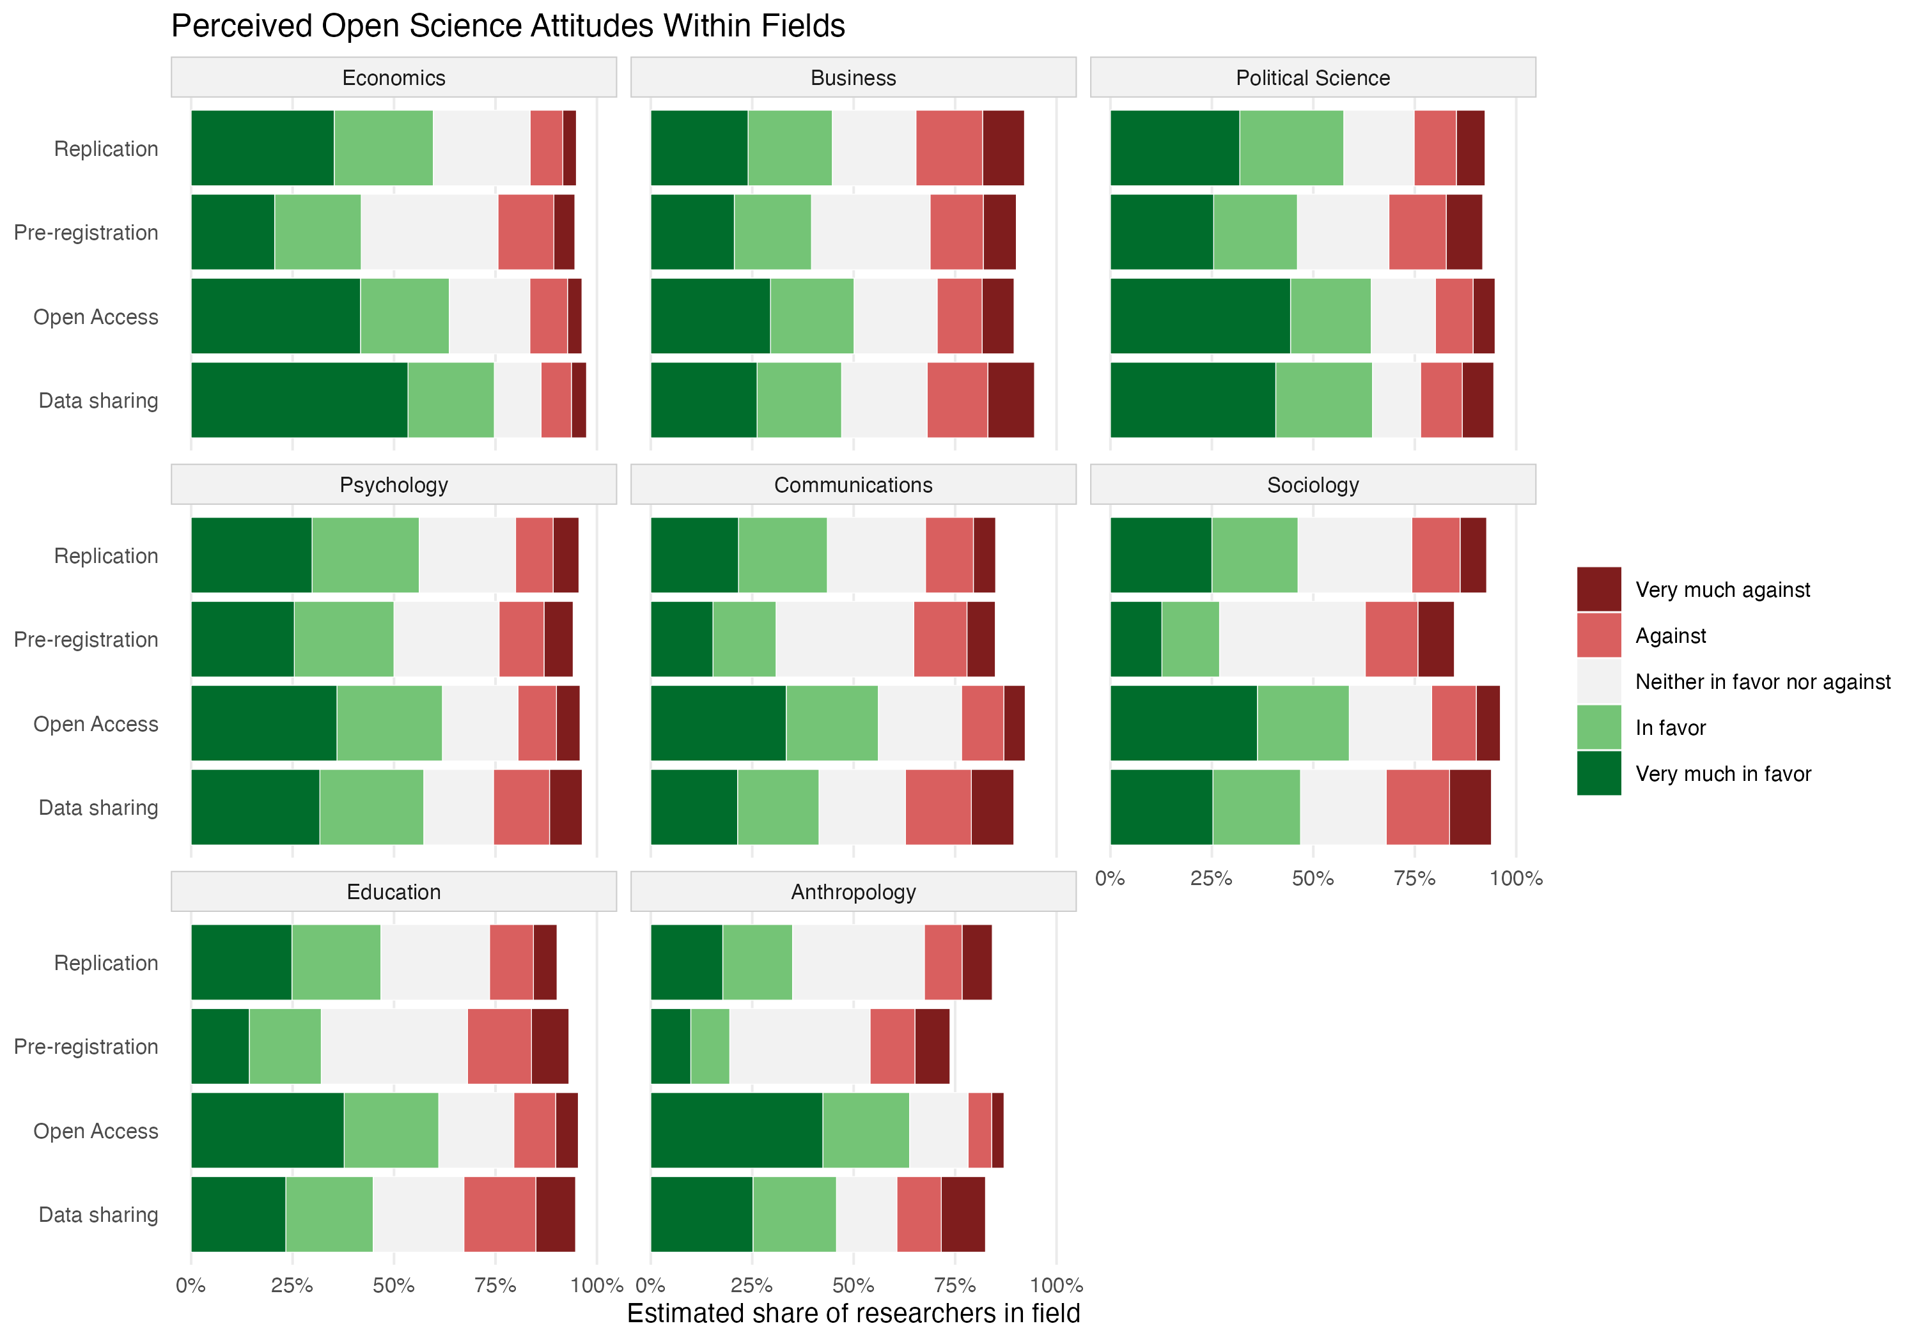
Supplementary Figure 1 | Perceived open science attitudes within disciplines. Respondents estimated the percentage of researchers in their discipline falling in each attitude category.

Supplementary Table 1
Supplementary Table 1 | Sensitivity of the focal associations to the proportional-odds assumption. Odds ratios for Positivism and Perceived Exclusion from the full ordinal logistic model for each attitude outcome (adjusted for discipline and methodological orientation) are compared with odds ratios from binary logistic models fitted at each response threshold using the same covariates and the same complete-case sample.
Outcome | Model / threshold | n | Positivism OR | Perceived Exclusion OR
Data sharing | Ordinal (proportional odds) | 1,112 | 1.33 | 1.18
 | ≥ Neither in favor nor against | 1,112 | 1.43 | 1.00
 | ≥ In favor | 1,112 | 1.35 | 1.20
 | ≥ Very much in favor | 1,112 | 1.32 | 1.20
Open access | Ordinal (proportional odds) | 1,114 | 0.80 | 1.43
 | ≥ In favor | 1,114 | 0.82 | 1.55
 | ≥ Very much in favor | 1,114 | 0.80 | 1.42
Preregistration | Ordinal (proportional odds) | 1,018 | 1.29 | 1.08
 | ≥ Neither in favor nor against | 1,018 | 1.26 | 1.14
 | ≥ In favor | 1,018 | 1.27 | 1.17
 | ≥ Very much in favor | 1,018 | 1.29 | 0.92
Replication | Ordinal (proportional odds) | 1,109 | 1.43 | 1.08
 | ≥ In favor | 1,109 | 1.66 | 1.25
 | ≥ Very much in favor | 1,109 | 1.38 | 1.05

Supplementary Table 2
Supplementary Table 2 | Focal associations under the reported and prespecified model specifications. Odds ratios with 95% confidence intervals for Positivism and Perceived Exclusion from ordinal logistic models of each attitude outcome. The reported model adjusts for discipline and methodological orientation. The prespecified model adds the covariates named in the study protocol: perceived disciplinary composition, years of research, strength of researcher identity and gender. Asterisks mark intervals excluding 1. Seven of the eight associations are unchanged in direction and significance. The exception is Positivism and open access, which attenuates to non-significance; adding the covariates individually shows that years of research accounts for this, being associated with both higher Positivism (r = .20) and weaker open-access support (r = −.27). Variance inflation factors for the reported models did not exceed 1.12 for any term.
Outcome | Term | Reported model | Prespecified model
Data sharing | Positivism | 1.33 [1.14, 1.57]* | 1.29 [1.10, 1.53]*
 | Perceived Exclusion | 1.18 [1.05, 1.33]* | 1.25 [1.10, 1.42]*
Open access | Positivism | 0.80 [0.67, 0.96]* | 0.87 [0.72, 1.06]
 | Perceived Exclusion | 1.43 [1.26, 1.64]* | 1.29 [1.12, 1.48]*
Preregistration | Positivism | 1.29 [1.10, 1.51]* | 1.39 [1.17, 1.64]*
 | Perceived Exclusion | 1.08 [0.96, 1.22] | 0.99 [0.87, 1.13]
Replication | Positivism | 1.43 [1.21, 1.69]* | 1.35 [1.14, 1.61]*
 | Perceived Exclusion | 1.08 [0.95, 1.22] | 1.08 [0.94, 1.23]
n (reported / prespecified) |  | 1,018–1,114 | 1,006–1,100

Supplementary Note 1
Supplementary Note 1 | Prespecified analysis plan and deviations. The hypotheses, measures, sampling design and analysis plan were prespecified in a dated study protocol finalized on 11 November 2025, approximately four weeks before data collection began on 10 December 2025; the three hypotheses reported in the main text were fixed at that point. The study was not preregistered in a public registry. That version of the protocol is deposited, unmodified, at https://doi.org/10.5281/zenodo.22901826. This note records what the protocol specified, what was implemented, and where the two differ.
Implemented as prespecified. The sampling frame (the top 292 U.S. universities with social science graduate programs, stratified by discipline, with a target of at least 150 respondents per field), the a priori power analysis, both belief scales and all nine items, the three nested model structure (discipline; discipline and methodological orientation; discipline, methodological orientation and beliefs), likelihood-ratio and AIC model comparison, and Benjamini–Hochberg correction of p values within each family of related tests were all carried out as specified. Prespecified hypotheses H1 and H2 were supported, as was H4a (positivism associated with stronger support for data sharing and preregistration).
Outcome-neutral checks. The protocol specified three checks before hypothesis testing, all of which were carried out. Internal consistency was computed for each multi-item scale; scales below α = .70 were to be examined item by item before a retention decision, and Positivism (α = .688) was examined in this way, with no item removal improving reliability (alphas from .60 to .67). Respondents failing the attention and bot checks were excluded. Missingness was quantified per respondent and per variable, and respondents missing more than 20% of the items in a scale were excluded from that scale. Variance inflation factors for the reported models did not exceed 1.12 for any term (discipline 1.02, methodological orientation 1.10–1.12, Positivism 1.09–1.10, Perceived Exclusion 1.08–1.09), so the collinearity contingencies set out in the protocol were not triggered.
The protocol covered open science behaviors alongside attitudes, and included a hypothesis (H5) that disciplinary differences in engagement would attenuate once beliefs and methodological orientation were included. The present article reports attitudes only.
The protocol specified linear regression for continuous outcomes and logistic regression for binary outcomes. Because all four attitude outcomes are five-category ordered scales, ordinal logistic models were fitted as primary, with linear regression on the 1–5 scores retained as a robustness check. The two approaches produced the same coefficient directions and the same statistical-significance conclusions for all eight focal associations. The proportional-odds assumption was additionally assessed (Supplementary Table 1).
The protocol required α ≥ .70 for a scale to enter confirmatory analyses, with weaker scales to be examined for problematic items and possibly revised or excluded. Positivism reached α = .688. The specified examination was carried out and the scale was retained unchanged, since no item removal improved reliability and the mean inter-item correlation (r = .31) indicated breadth rather than a single poorly performing item. \
The protocol's confirmatory model also included perceived disciplinary composition, years of research, strength of researcher identity and demographic covariates. The main text reports the more parsimonious specification; the prespecified specification is reported as a robustness check (Supplementary Table 2). Seven of the eight focal associations are unchanged. The exception is the negative association between Positivism and open-access attitudes, which attenuates to non-significance; years of research accounts for this, being associated with both higher Positivism and weaker open-access support. This is noted in the Results.
The protocol specified bootstrapped mediation analyses of indirect effects. Because these concern pathways from beliefs through attitudes to behavior, they were not conducted.
In addition, the Neutrality scale does not appear in the protocol; it was developed for this study and is reported as exploratory throughout. The omnibus tests of H1 and H2, the proportional-odds check and the full coefficient table were also added after the protocol was written.

