Electronic supplementary material

Importance of the Q/N-rich segment for protein stability and activity of endogenous mouse TDP-43.

Toshiya Sato^{1,2,3}, Kanako Oda³, Seiko Sakai³, Rika Kato², Saori Yamamori⁴, Makoto Itakura⁴, Yoshio Kodera⁵, Masatoyo Nishizawa^{6,7}, Toshikuni Sasaoka³, Osamu Onodera⁶, Minesuke Yokoyama^{3,8}

¹Department of Laboratory Animal Science, Kitasato University School of Medicine, Sagamihara 252-0374, Japan.
²Center for Genetic Studies of Integrated Biological Functions, Kitasato University School of Medicine, Sagamihara 252-0374, Japan.
³Department of Comparative and Experimental Medicine, Brain Research Institute, Niigata University, Niigata 951-8585, Japan.
⁴Department of Biochemistry, Kitasato University School of Medicine, Sagamihara 252-0374, Japan.
⁵Department of Physics, Kitasato University School of Science, Sagamihara 252-0373, Japan.
⁶Department of Neurology, Brain Research Institute, Niigata University, Niigata 951-8585, Japan.
⁷Department of Nursing, Niigata University of Health and Welfare, Niigata 950-3198, Japan.
⁸Central Institute for Experimental Animals, Kawasaki 210-0821, Japan.

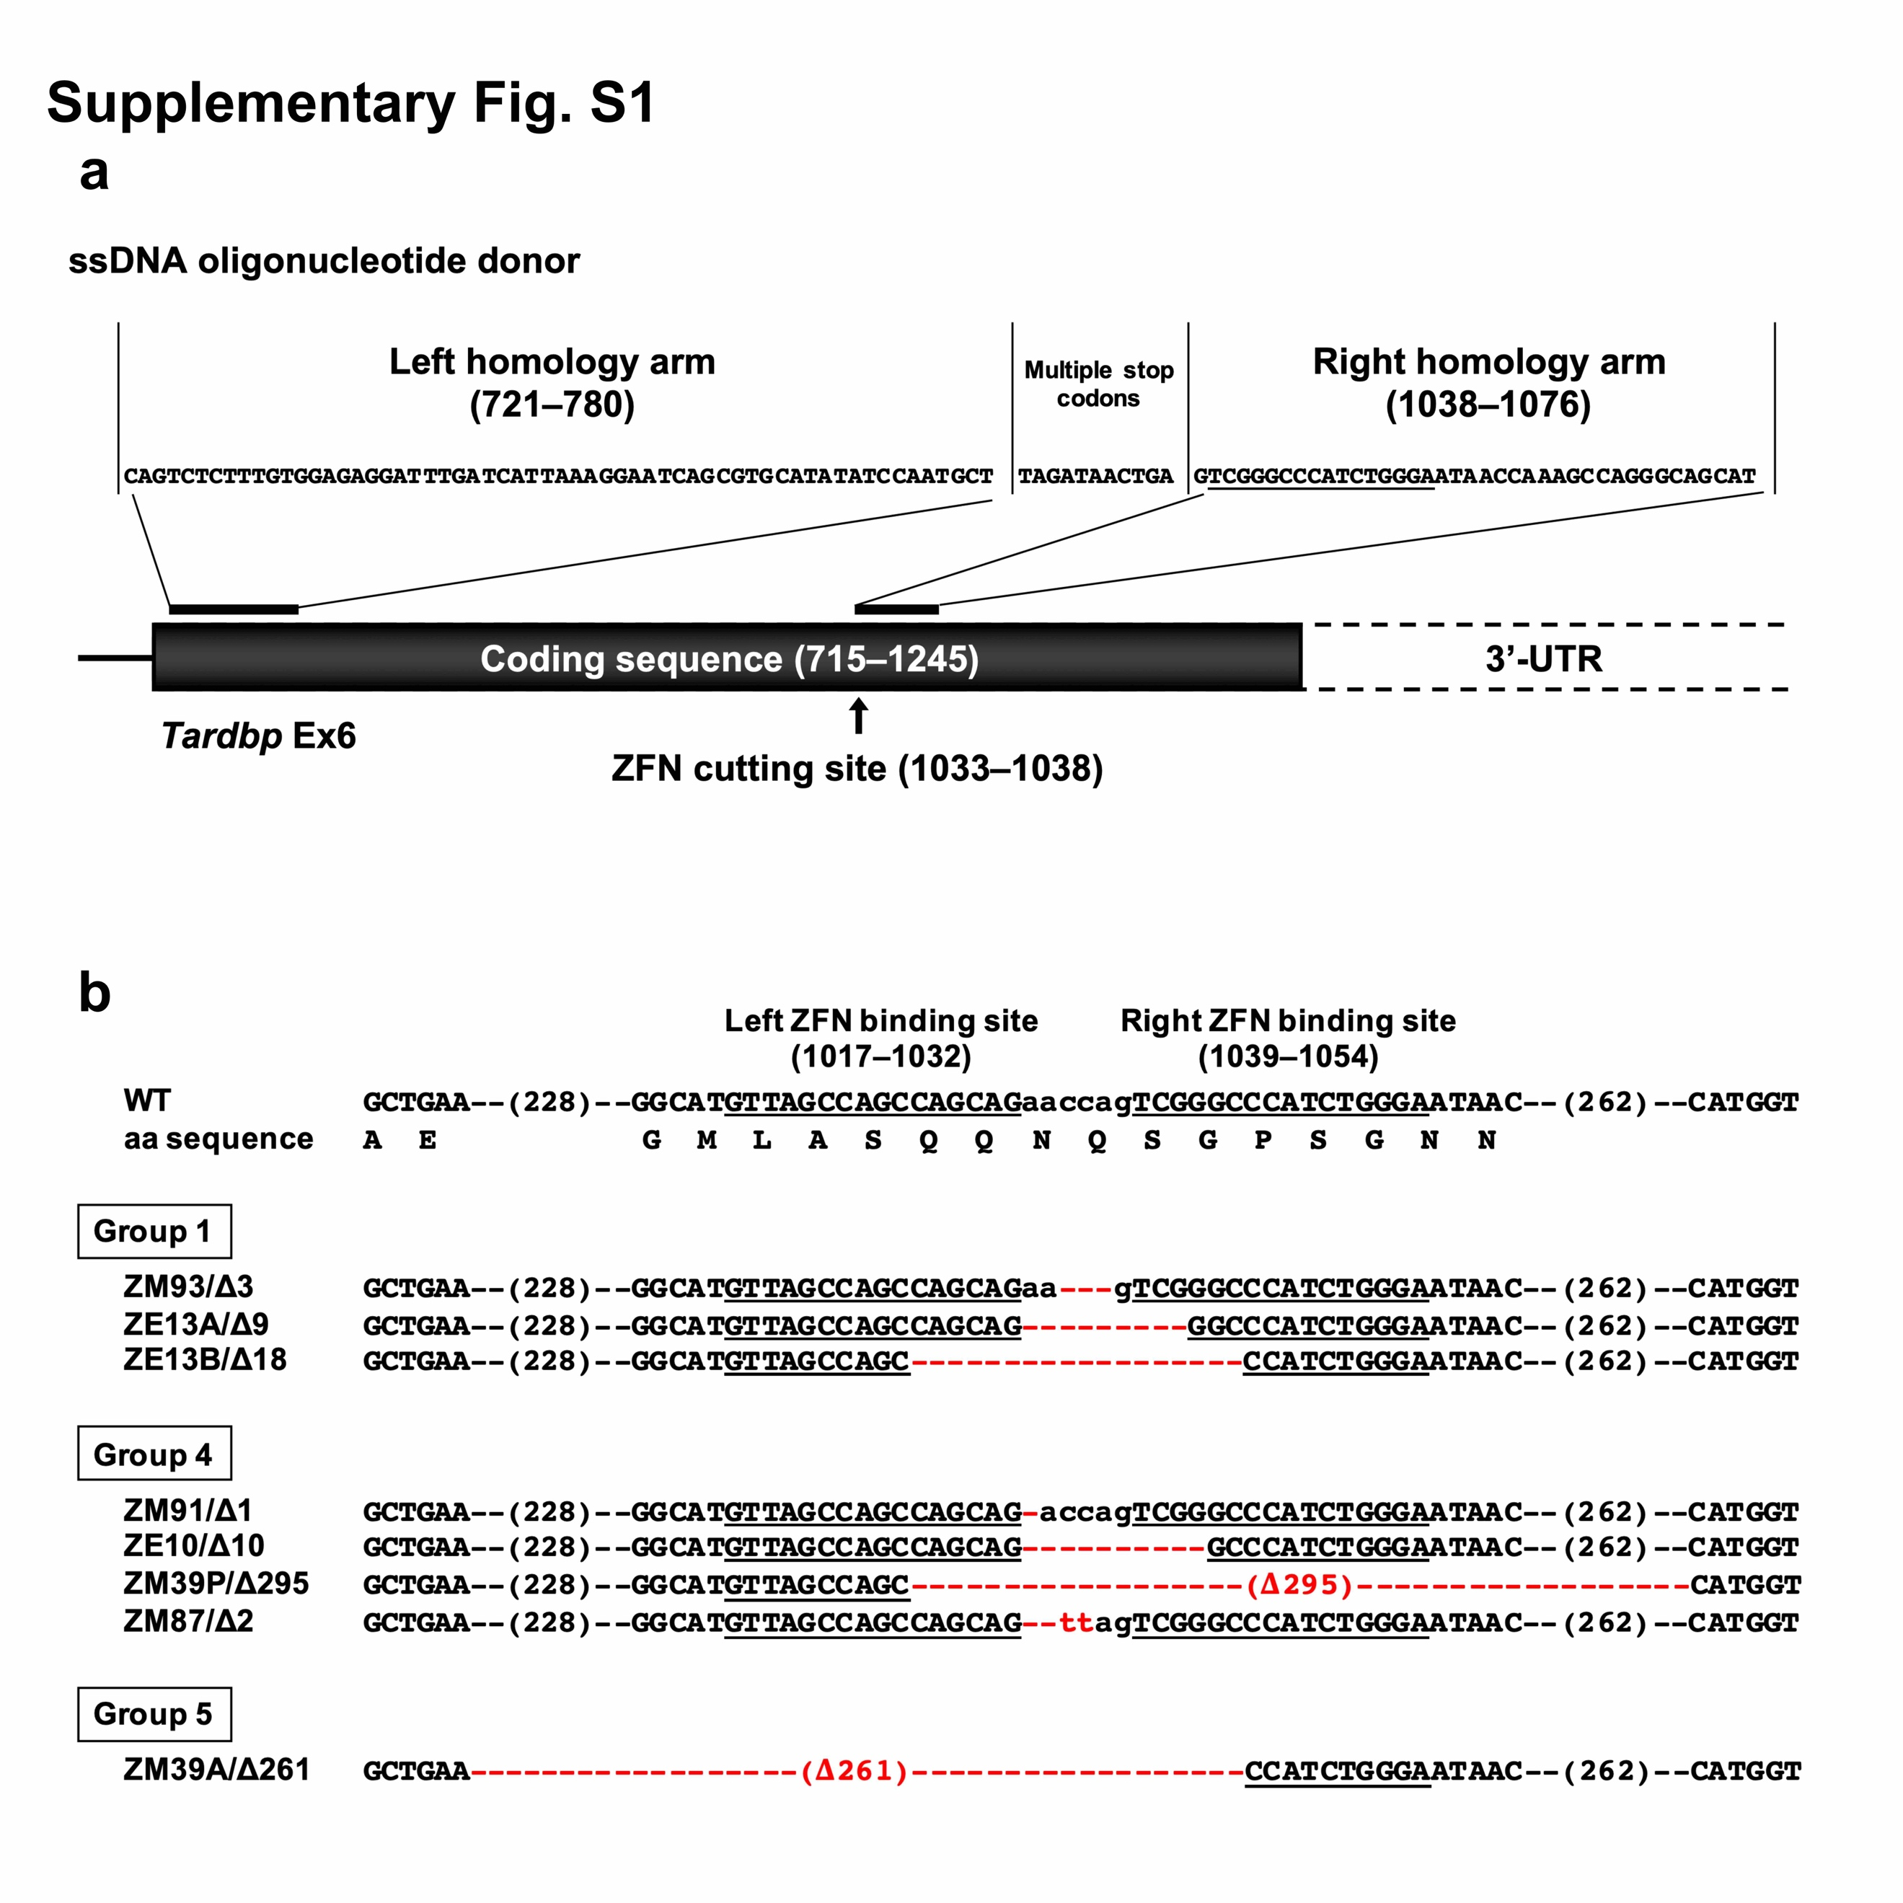
Fig. S1. Generation of ZE and ZM mouse lines. (a) Schematic diagram of Tardbp exon 6 and the ssDNA oligonucleotide co-injected with the ZFN mRNAs as a donor template. The base number of the Tardbp coding sequence is given in parentheses. (b) The nucleotide sequences of the mutant alleles in the ZE and ZM mouse lines. We obtained six founders, including mosaic mice, and separated them into eight mouse lines by mating with C57BL/6 mice. ZFN-mediated nucleotide deletions of 1 to 295 bp were observed around the ZFN target. The nucleotide deletions and substitutions are represented as red dashes and letters, respectively. ZFN binding and cutting sites are indicated by underlining and lowercase letters, respectively. Note that multiple stop codons in the ssDNA oligonucleotide were deleted in the ZM mouse lines. Thus, the resulting ZM lines have only large (ZM39A/Δ261 and ZM39P/Δ295) or small (ZM87/Δ2 and ZM91/Δ1) deletions.
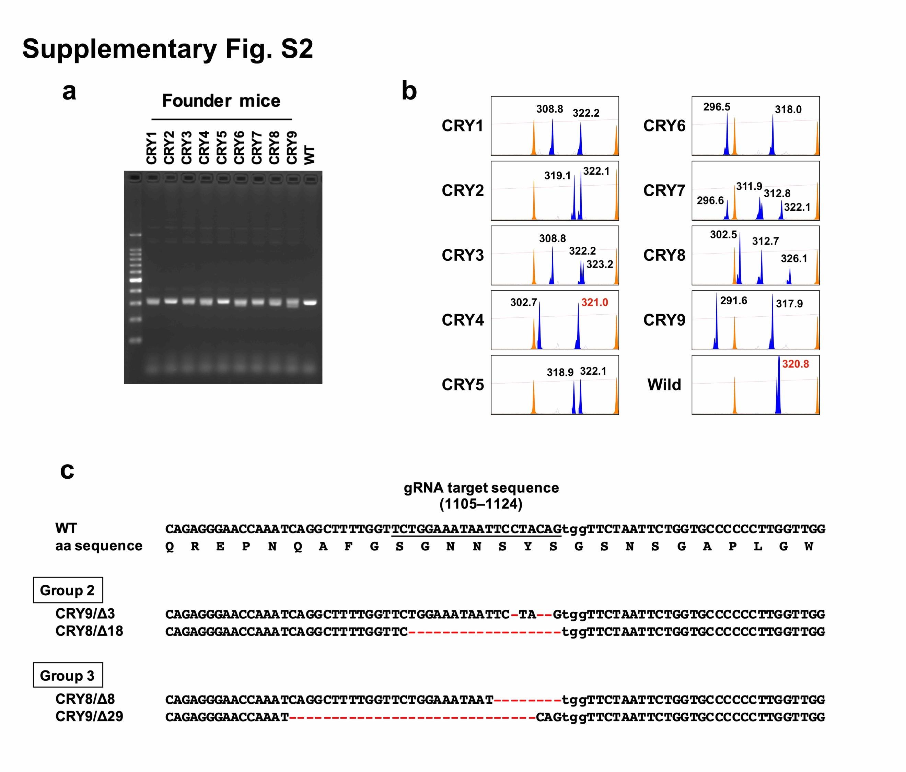
Fig. S2. Generation of CRY mouse lines. (a and b) Genomic PCR products of seven female and two male founder mice (CRY1–9) were electrophoresed using 2% agarose gel (a) and an ABI 3130 xL DNA sequencer (Applied Biosystems, Foster City, CA) (b). The sizes of the PCR products (blue chromatogram) were calculated by Peak Scanner Software v1.0 (Applied Biosystems) using a GeneScan 500 LIZ dye Size Standard (orange chromatogram) and are shown in black (21 mutant alleles) and red (same size as wild type) numbers. (c) The nucleotide sequences of four mutant alleles established from two male founder mice (CRY8–9). CRISPR/Cas9-mediated nucleotide deletions of 3 to 29 bp were observed around the gRNA target. The nucleotide deletions are represented as red dashes. The gRNA target sequence and PAM are indicated by underlining and lowercase letters, respectively.

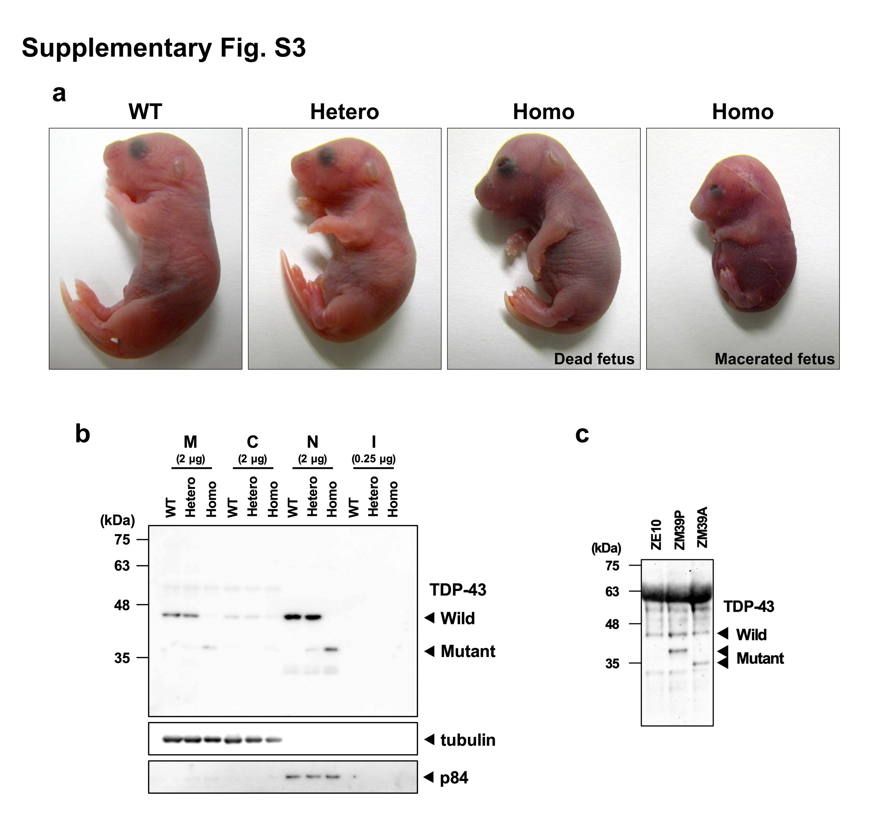
Fig. S3. Developmental analysis of TDP-43 mutant mice. (a) Representative photographs of ZM87/Δ2 fetuses at E19.5 obtained by in vitro fertilization and embryo transfer from heterozygous intercrosses followed by cesarean section. In some cases, ZM87/Δ2 homozygous fetuses grew to approximately the same size as the wild type (Dead fetus, third panel from left), but were edematous and did not start breathing. (b) Western blotting of ZM87/Δ2 mice at E19.5. Membrane (M), cytoplasmic (C), nuclear (N), and insoluble (I) fractions of each cerebrum were subjected to western blotting using the antibodies indicated on the right. Note that the protein in the insoluble fraction was reduced because of poor yield. (c) Western blotting of unfertilized oocytes obtained by superovulation of ZE10/Δ10, ZM39P/Δ295, and ZM39A/Δ261 female mice. To estimate the TDP-43 as maternal products, 10 unfertilized oocytes were directly dissolved in sample buffer and subjected to western blotting.

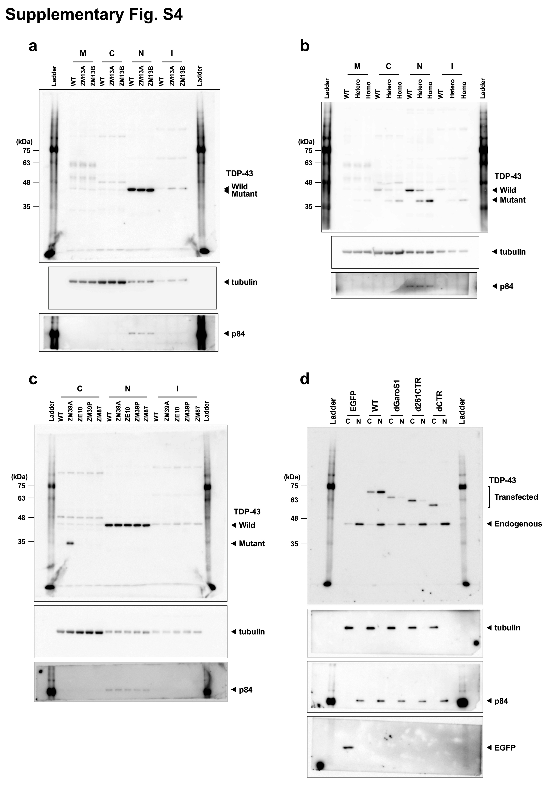
Fig. S4. Full-length blots of Figs 2a (a), 2b (b), 2c (c), and 3d (d). Note that the protein ladders on both sides of the blot (b) stained with the p84 antibody were hidden with paper.

Table S1. PCR primers and conditions

Primers for fragment analysis
Target | Primer | Genotyping | PCR condition
Exon 6 | CAGGGTGGGTTTGGTAACAG | All mice except for ZM39 mice | 95°C 30 s, 55°C 30 s, 72°C 30 s, 35 cycles
 | FAM-GATCCTGCATTTGATGCTGA | All mice except for ZM39 mice | TaKaRa Ex Taq (Takara)
Primers for conventional PCR
Target | Primer | Genotyping | PCR condition
Intron 5 | ACTGCTGTGTTGATATCTGGGTTG | ZM39A/Δ261 | 94°C 15 s, 62°C 15 s, 72°C 30 s, 35 cycles
Exon 6 | TGCCCTGGCTTTGGTTATTCC | ZM39A/Δ261 | KAPATaq Extra (Kapa Biosystems)
Exon 6 | CAGCGTTGCAGAGCAGTTG | ZM39P/Δ295 | 94°C 15 s, 62°C 15 s, 72°C 30 s, 35 cycles
 | CAGCAGTTCACTTTCACCCACTC | ZM39P/Δ295 | KAPATaq Extra (Kapa Biosystems)
Exon 6 | CAGCGTTGCAGAGCAGTTG | CRY9B/Δ29  CRY8A/Δ18 | 94°C 15 s, 71-67°C (-0.5/cycle) 10 s, 72°C 15 s, 30 cycles
 | ATTAAAACCACTGCCCGATCCT | CRY9B/Δ29  CRY8A/Δ18 | KAPATaq Extra (Kapa Biosystems)
Primers for qRT-PCR
Target | Primer | Application | PCR condition
Exon 3 | CTCCCCTGGAAAACAACTGAGC | All mice | 95°C 5 s, 60°C 30 s, 40 cycles
Exon 4 | ATCGAACAAAGCCAAACCCTTTC | All mice | SYBR Premix Ex Taq II (Takara)
Exon 5 | AGAGGACATGACTGCTGAAGAGC | All mice | 95°C 5 s, 60°C 30 s, 40 cycles
Exon 6 | CTCCACAAAGAGACTGGGCAAC | All mice | SYBR Premix Ex Taq II (Takara)
Exon 6 | TAGCCAGCCAGCAGAACCAGT | ZE and ZM lines | 95°C 5 s, 60°C 30 s, 40 cycles
 | GGGGCACCAGAATTAGAACCAC | ZE and ZM lines | SYBR Premix Ex Taq II (Takara)
Exon 6 | TAGCCAGCCAGCAGAACCAGT | CRY lines except for CRY9A/Δ3 | 95°C 5 s, 60°C 30 s, 40 cycles
 | GCACCAGAATTAGAACCACTGTAGG | CRY lines except for CRY9A/Δ3 | SYBR Premix Ex Taq II (Takara)
Hprt1 | Real Time Primer MA031262 (Takara) | All mice | 95°C 5 s, 60°C 30 s, 40 cycles
 |  | All mice | SYBR Premix Ex Taq II (Takara)
λpolyA | Real Time Primer for λpolyA #3786  (Takara) | External control | 95°C 5 s, 60°C 30 s, 40 cycles
 | Real Time Primer for λpolyA #3786  (Takara) | External control | SYBR Premix Ex Taq II (Takara)

Primer sequences are 5’ to 3’.

