Table S1. Pfam identification numbers for each lectin domain family
Family | Pfam Model | BLASTp Model
Agaricus bisporus lectin (ABA) | PF07367
Amaranthin | PF07468
Chitinase related agglutinin (CRA)* | - | ABL98074.1
Cyanovirin | PF08881
Euonymus europaeus lectin (EUL)* | - | ABW73993.1
Galanthus nivalis lectin (GNA) | PF01453
Hevein | PF00187
Jacalin (JRL) | PF01419
Legume | PF00139
LysM | PF01476
Nicotiana tabacum lectin (Nictaba) | PF14299
Ricin-B | PF00652
Table S2. Reference lectin structures and sequences used for carbohydrate-binding site conservation analysis across Mt lectin families
Family | Reference model | PDB ID | UniProt Accession
GNA | GNA | 1MSA | P30617
Legume | ConA | 1CVN | P02866
Nictaba | Literature | — | —
LysM | LysM domain | 5K2L | D8UFB5
Hevein | Literature | — | —
CRA | RobpsCRA | 4URI | A1YZD2
Jacalin (JRL) | Jacalin | 1KU8 | P18671
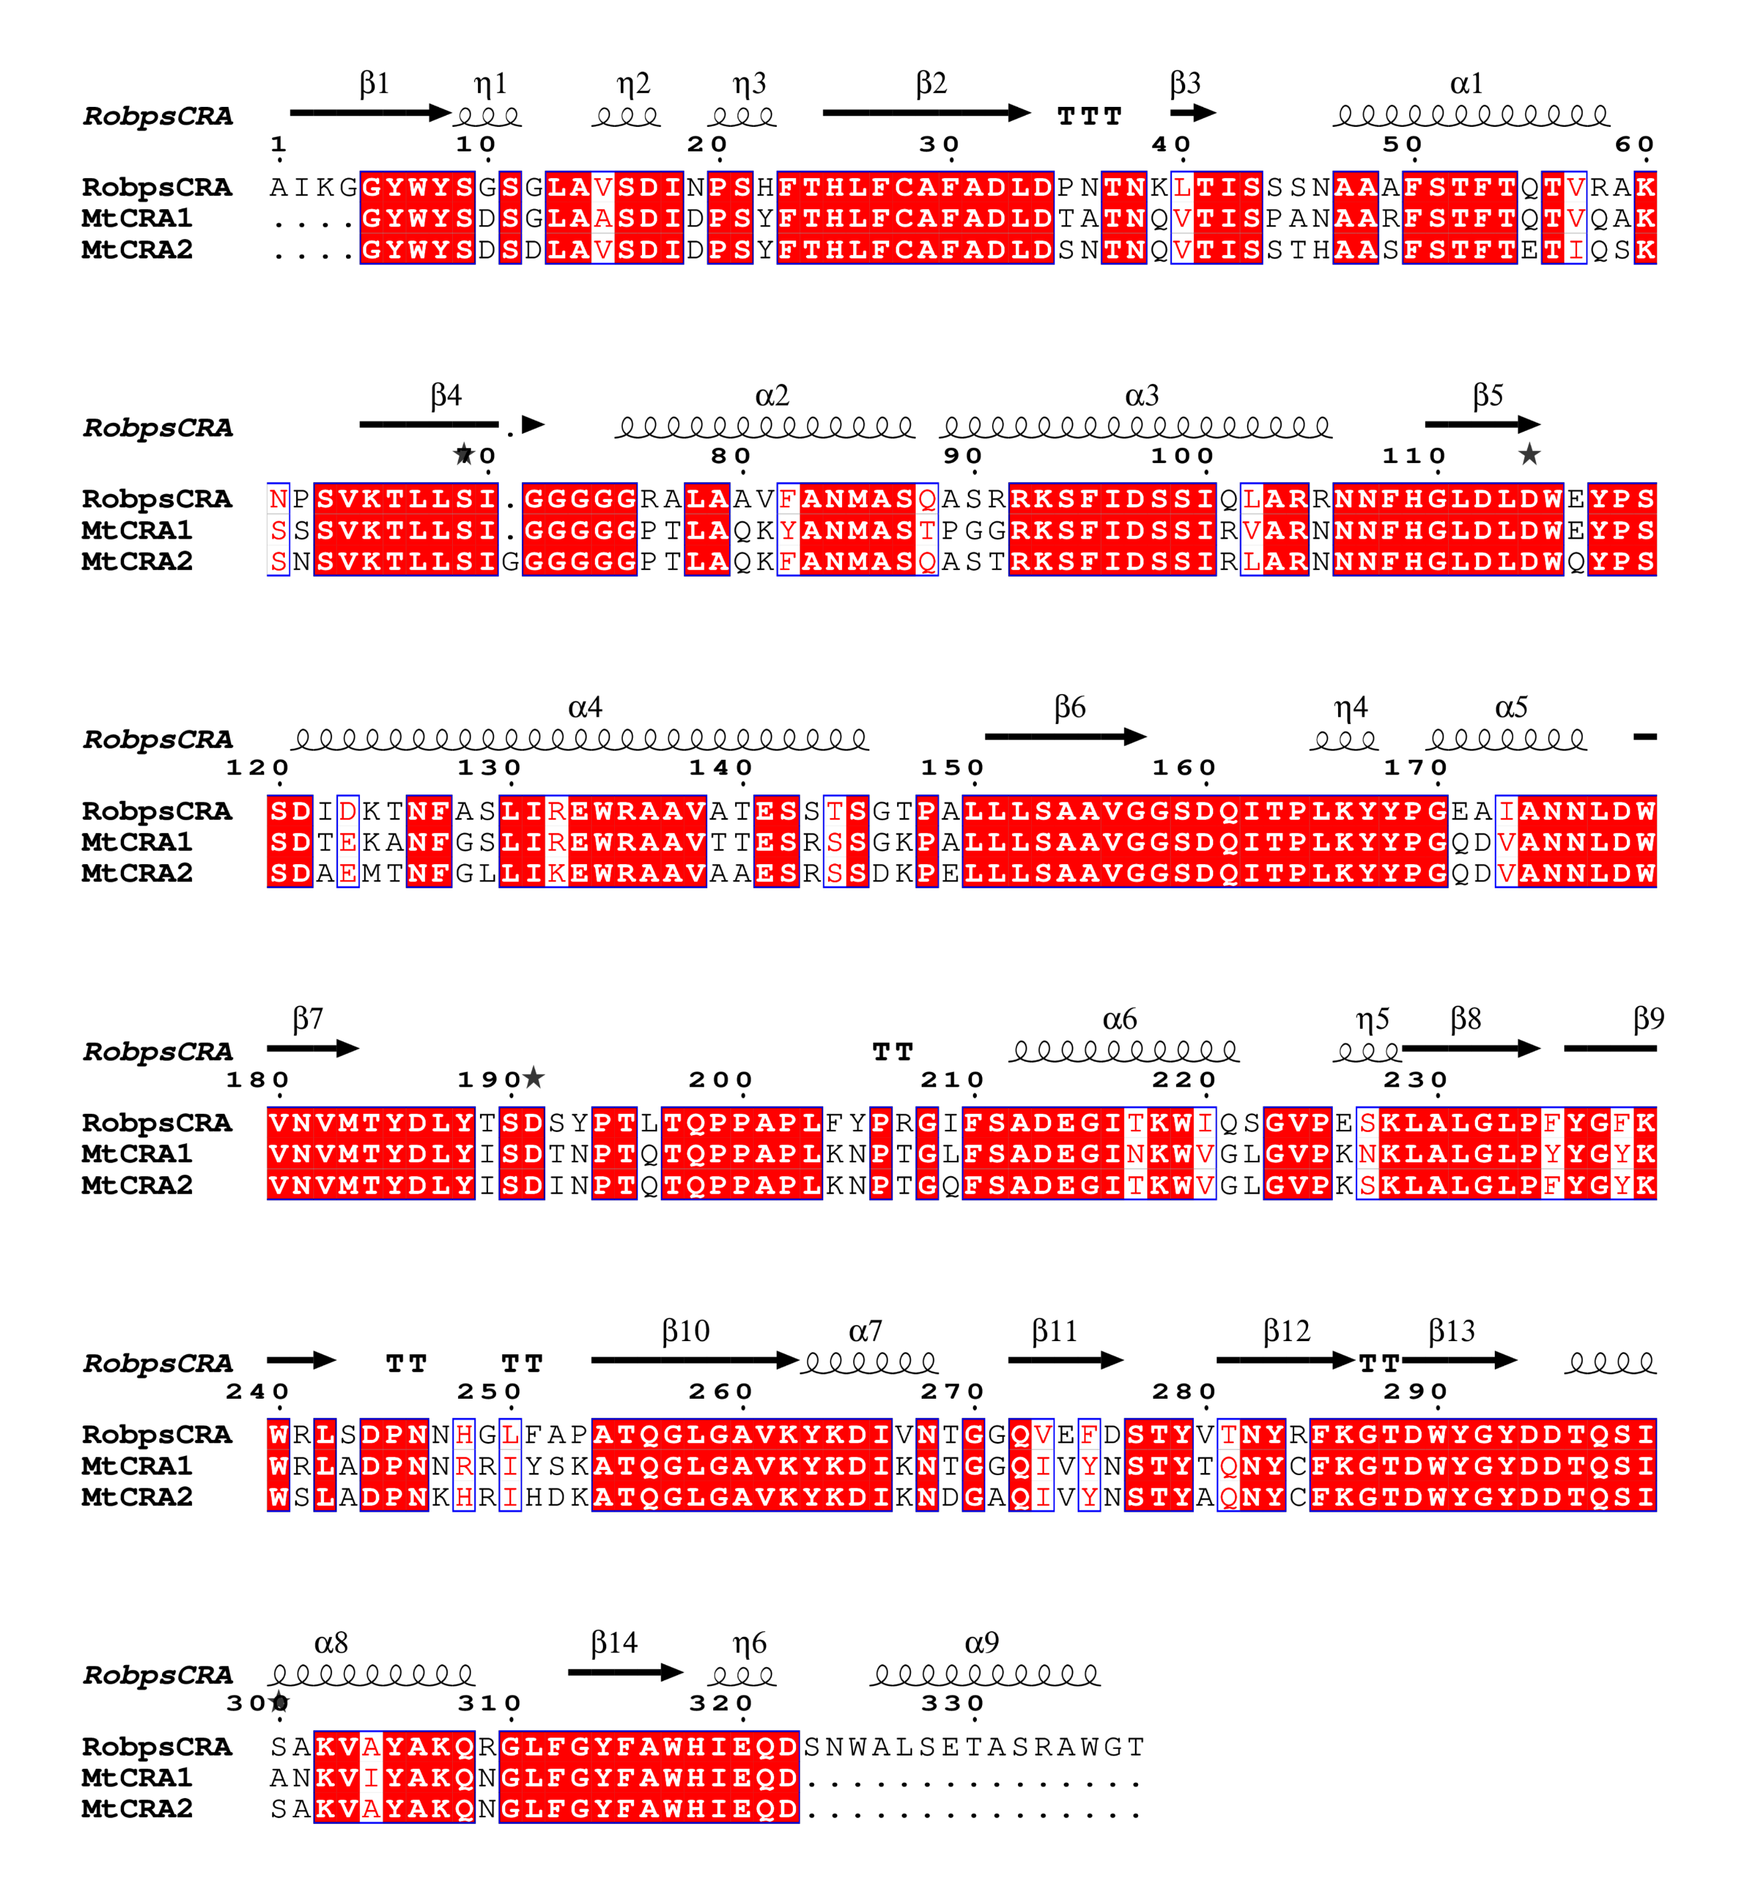
Fig. S1. Multiple sequence alignment of MtCRA1, MtCRA2, and RobpsCRA with mapped secondary structure.
Amino acid sequences of MtCRA1 (XP_013462048.1, Chr3g0140491), MtCRA2 (XP_013462046.2), and RobpsCRA (UniProt A1YZD2) were aligned with MAFFT (L-INS-i) and rendered in ESPript 3.0. Secondary structure elements (α-helices, β-strands, η-helices, β-turns) shown above the alignment were mapped from the RobpsCRA crystal structure (PDB 4URI). Identical residues are shaded red; similar residues are boxed in blue. Numbering follows the RobpsCRA sequence.
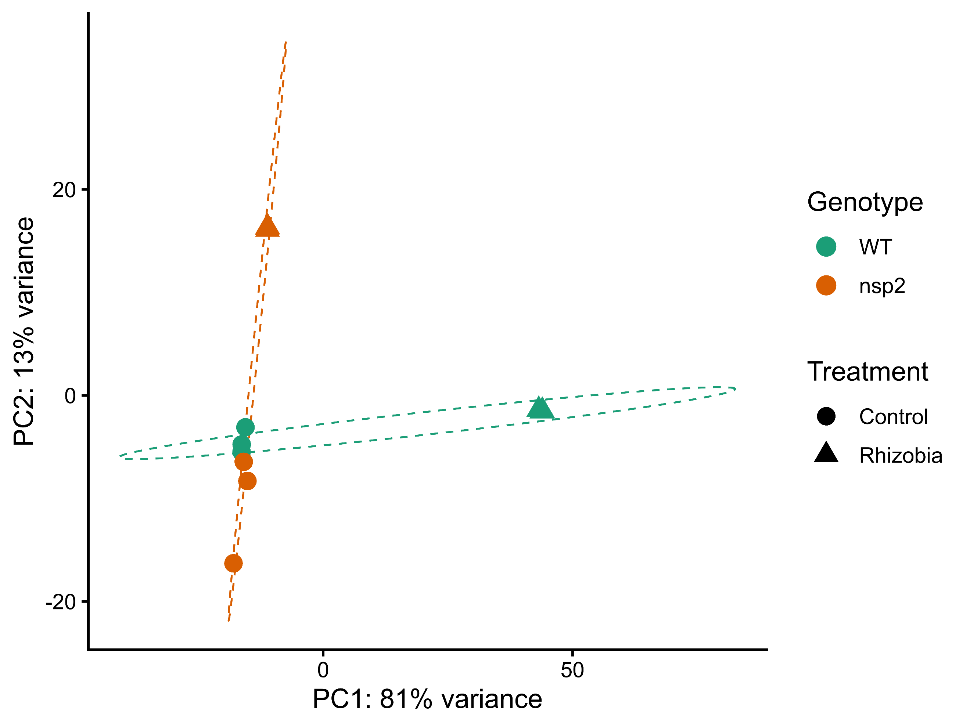Fig. S2. Principal component analysis (PCA) of wild-type and nsp2 mutant Mt roots under control and rhizobial inoculation conditions. PCA was performed on variance-stabilized transformed (VST) counts from all 12 samples, using the top 500 most variable genes. Genotype is shown by color and treatment by point shape. Dashed ellipses represent 80% confidence intervals per genotype.
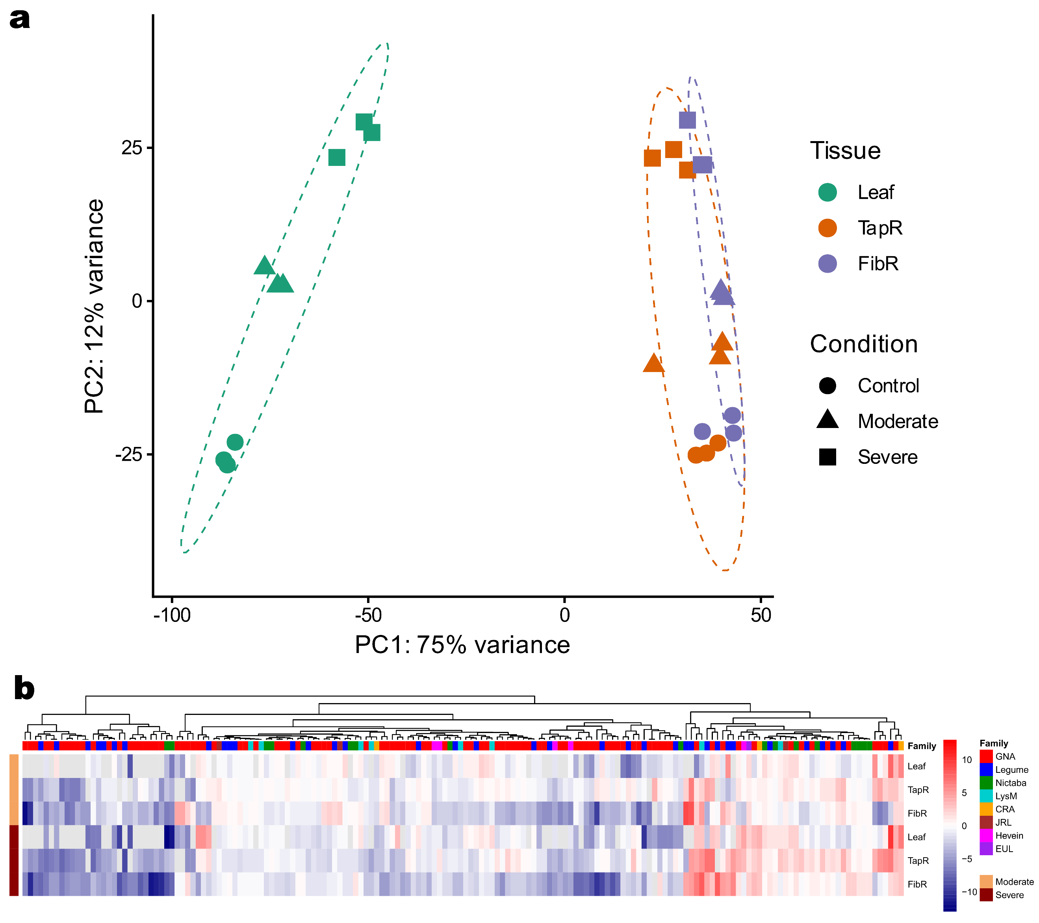Fig. S3. Principal component analysis (PCA) and heatmap of lectin gene expression across tissues and drought conditions. (a) Combined PCA of all 27 RNA-seq samples across leaf, taproot (TapR), and fibrous root (FibR) under control, moderate, and severe drought conditions. PCA was performed on variance-stabilized transformed (VST) counts from all three tissues, with tissue as colour and drought condition as point shape. Dashed ellipses represent 80% confidence intervals per tissue. (b) Heatmap of all significant lectin DEGs. Each cell shows the log2 fold change relative to control, with grey indicating genes not differentially expressed in that tissue and condition. Genes on columns are ordered by hierarchical clustering and annotated by lectin family.

