General-Purpose Vision Models to Dermatology Foundation Models: Comparative Evaluation for Facial Skin Disease Classification

Uchenna Esther Okpete¹, Md Ariful Islam Mozumder¹, Osita Sunday Nnyigide², Haewon Byeon²*, Hee-Cheol Kim¹*
¹Department of Digital Anti-aging Healthcare (BK21), Inje University, Gimhae 50834, South Korea
²Worker's Care & Digital Health Lab, Department of Future Technology, Korea University of Technology and Education, Cheonan 31253, South Korea
Supplementary Information

Table S1. Characteristics of the AI-Hub Skin Disease Diagnostic Medical Images dataset and the balanced study cohort used in the present study.
Class | AI-Hub integrated count | Training set | Testing set
Acne | 19,984 | 1,600 | 200
Atopy | 10,616 | 1,600 | 200
Normal | 10,854 | 1,600 | 200
Psoriasis | 10,207 | 1,600 | 200
Rosacea | 4,357 | 1,600 | 200
Seborrheic | 5,502 | 1,600 | 200
Total | 61,520 | 9,600 | 1,200

Table S2. Multimeric Classification Performance of CNN, Transformer, and Dermatology-Specific Models with XGBoost as the primary classifier
Skin Condition | Model | precision | recall | f1-score
Acne | ResNet50 | 0.8314 | 0.7150 | 0.7688
 | MobileNetV3-Large | 0.8523 | 0.7500 | 0.7979
 | ViT-B/16 | 0.8256 | 0.7100 | 0.7634
 | Swin-T | 0.8424 | 0.6950 | 0.7616
 | DINOv2 | 0.8895 | 0.8050 | 0.8451
 | Derm Foundation | 0.9450 | 0.9450 | 0.9450
 | DermLIP | 0.9213 | 0.8200 | 0.8677
Atopic dermatitis | ResNet50 | 0.8114 | 0.7100 | 0.7573
 | MobileNetV3-Large | 0.8696 | 0.7000 | 0.7756
 | ViT-B/16 | 0.8256 | 0.7100 | 0.7634
 | Swin-T | 0.7722 | 0.6950 | 0.7316
 | DINOv2 | 0.8796 | 0.8400 | 0.8593
 | Derm Foundation | 0.8923 | 0.8700 | 0.8810
 | DermLIP | 0.8634 | 0.7900 | 0.8251
Normal Skin | ResNet50 | 0.9023 | 0.9700 | 0.9349
 | MobileNetV3-Large | 0.8571 | 0.9600 | 0.9057
 | ViT-B/16 | 0.8784 | 0.9750 | 0.9242
 | Swin-T | 0.8884 | 0.9550 | 0.9205
 | DINOv2 | 0.9650 | 0.9650 | 0.9650
 | Derm Foundation | 0.9479 | 1.0000 | 0.9732
 | DermLIP | 0.9128 | 0.9950 | 0.9522
Psoriasis | ResNet50 | 0.6679 | 0.9050 | 0.7686
 | MobileNetV3-Large | 0.6780 | 0.8950 | 0.7716
 | ViT-B/16 | 0.6756 | 0.8850 | 0.7662
 | Swin-T | 0.6579 | 0.8750 | 0.7511
 | DINOv2 | 0.7265 | 0.8900 | 0.8000
 | Derm Foundation | 0.8829 | 0.9050 | 0.8938
 | DermLIP | 0.7565 | 0.8700 | 0.8093
Rosacea | ResNet50 | 0.8531 | 0.7550 | 0.8011
 | MobileNetV3-Large | 0.8333 | 0.7750 | 0.8031
 | ViT-B/16 | 0.7903 | 0.7350 | 0.7617
 | Swin-T | 0.7966 | 0.7050 | 0.7480
 | DINOv2 | 0.8644 | 0.7650 | 0.8117
 | Derm Foundation | 0.8195 | 0.8400 | 0.8296
 | DermLIP | 0.8434 | 0.8350 | 0.8392
Seborrheic dermatitis | ResNet50 | 0.6947 | 0.6600 | 0.6769
 | MobileNetV3-Large | 0.6825 | 0.6450 | 0.6632
 | ViT-B/16 | 0.7043 | 0.6550 | 0.6788
 | Swin-T | 0.6244 | 0.6150 | 0.6196
 | DINOv2 | 0.6699 | 0.6900 | 0.6798
 | Derm Foundation | 0.7935 | 0.7300 | 0.7604
 | DermLIP | 0.7409 | 0.7150 | 0.7277
Table S2. Multimeric Classification Performance of CNN, Transformer, and Dermatology-Specific Models with RBF_SVM as the ablation classifier
Skin condition | Model | Precision | Recall | F1-score
Acne | ResNet50 | 0.8418 | 0.6650 | 0.7430
 | MobileNetV3-Large | 0.8500 | 0.6800 | 0.7556
 | ViT-B/16 | 0.8541 | 0.7900 | 0.8208
 | Swin-T | 0.8773 | 0.7150 | 0.7879
 | DINOv2 | 0.8895 | 0.8050 | 0.8451
 | Derm Foundation | 0.9333 | 0.9100 | 0.9215
 | DermLIP | 0.8624 | 0.8150 | 0.8380
Atopic dermatitis | ResNet50 | 0.7574 | 0.6400 | 0.6938
 | MobileNetV3-Large | 0.7476 | 0.7700 | 0.7586
 | ViT-B/16 | 0.8333 | 0.8750 | 0.8537
 | Swin-T | 0.7921 | 0.8000 | 0.7960
 | DINOv2 | 0.8621 | 0.8750 | 0.8685
 | Derm Foundation | 0.8821 | 0.8600 | 0.8709
 | DermLIP | 0.8624 | 0.8150 | 0.8380
Normal skin | ResNet50 | 0.7343 | 0.9950 | 0.8450
 | MobileNetV3-Large | 0.9095 | 0.9550 | 0.9317
 | ViT-B/16 | 0.9949 | 0.9700 | 0.9823
 | Swin-T | 0.9559 | 0.9750 | 0.9653
 | DINOv2 | 0.9898 | 0.9700 | 0.9798
 | Derm Foundation | 0.8772 | 1.0000 | 0.9346
 | DermLIP | 0.9803 | 0.9950 | 0.9876
Psoriasis | ResNet50 | 0.6602 | 0.8450 | 0.7412
 | MobileNetV3-Large | 0.6380 | 0.8900 | 0.7432
 | ViT-B/16 | 0.7650 | 0.8950 | 0.8249
 | Swin-T | 0.6943 | 0.9200 | 0.7914
 | DINOv2 | 0.7229 | 0.9000 | 0.8018
 | Derm Foundation | 0.8818 | 0.8950 | 0.8883
 | DermLIP | 0.7605 | 0.9050 | 0.8265
Rosacea | ResNet50 | 0.8765 | 0.7100 | 0.7845
 | MobileNetV3-Large | 0.8343 | 0.7050 | 0.7642
 | ViT-B/16 | 0.9012 | 0.7300 | 0.8066
 | Swin-T | 0.8667 | 0.7150 | 0.7836
 | DINOv2 | 0.9108 | 0.7150 | 0.8011
 | Derm Foundation | 0.8877 | 0.8300 | 0.8579
 | DermLIP | 0.8571 | 0.8100 | 0.8329
Seborrheic dermatitis | ResNet50 | 0.7120 | 0.6550 | 0.6823
 | MobileNetV3-Large | 0.6932 | 0.6100 | 0.6489
 | ViT-B/16 | 0.6495 | 0.6950 | 0.6715
 | Swin-T | 0.6866 | 0.6900 | 0.6883
 | DINOv2 | 0.6589 | 0.7050 | 0.6812
 | Derm Foundation | 0.8073 | 0.7750 | 0.7908
 | DermLIP | 0.7059 | 0.7200 | 0.7129
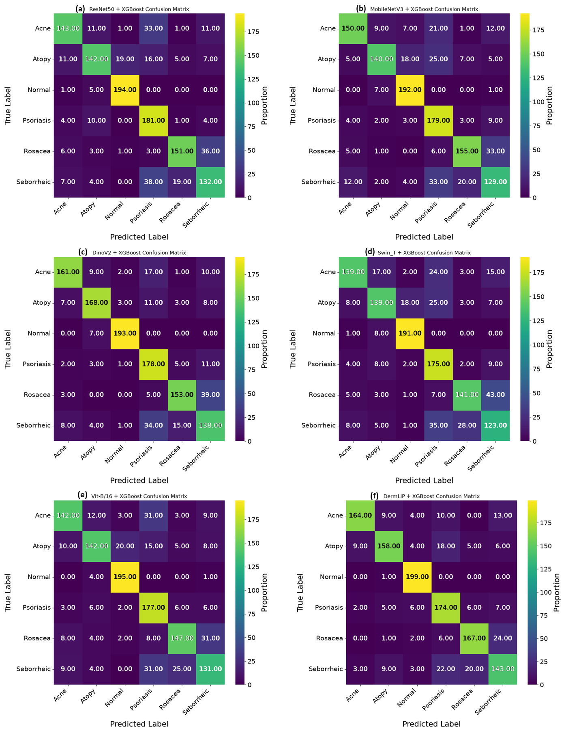
Figure S1. Multi-class confusion matrices showing the classification performance for 6 other feature extractors with XGBoost as the downstream classifiers. (a) ResNet50 (b) MobileNetV3_Large (c) DinoV2 (d) Swin_T (e) Vit-B/16 and (f) DermLIP.
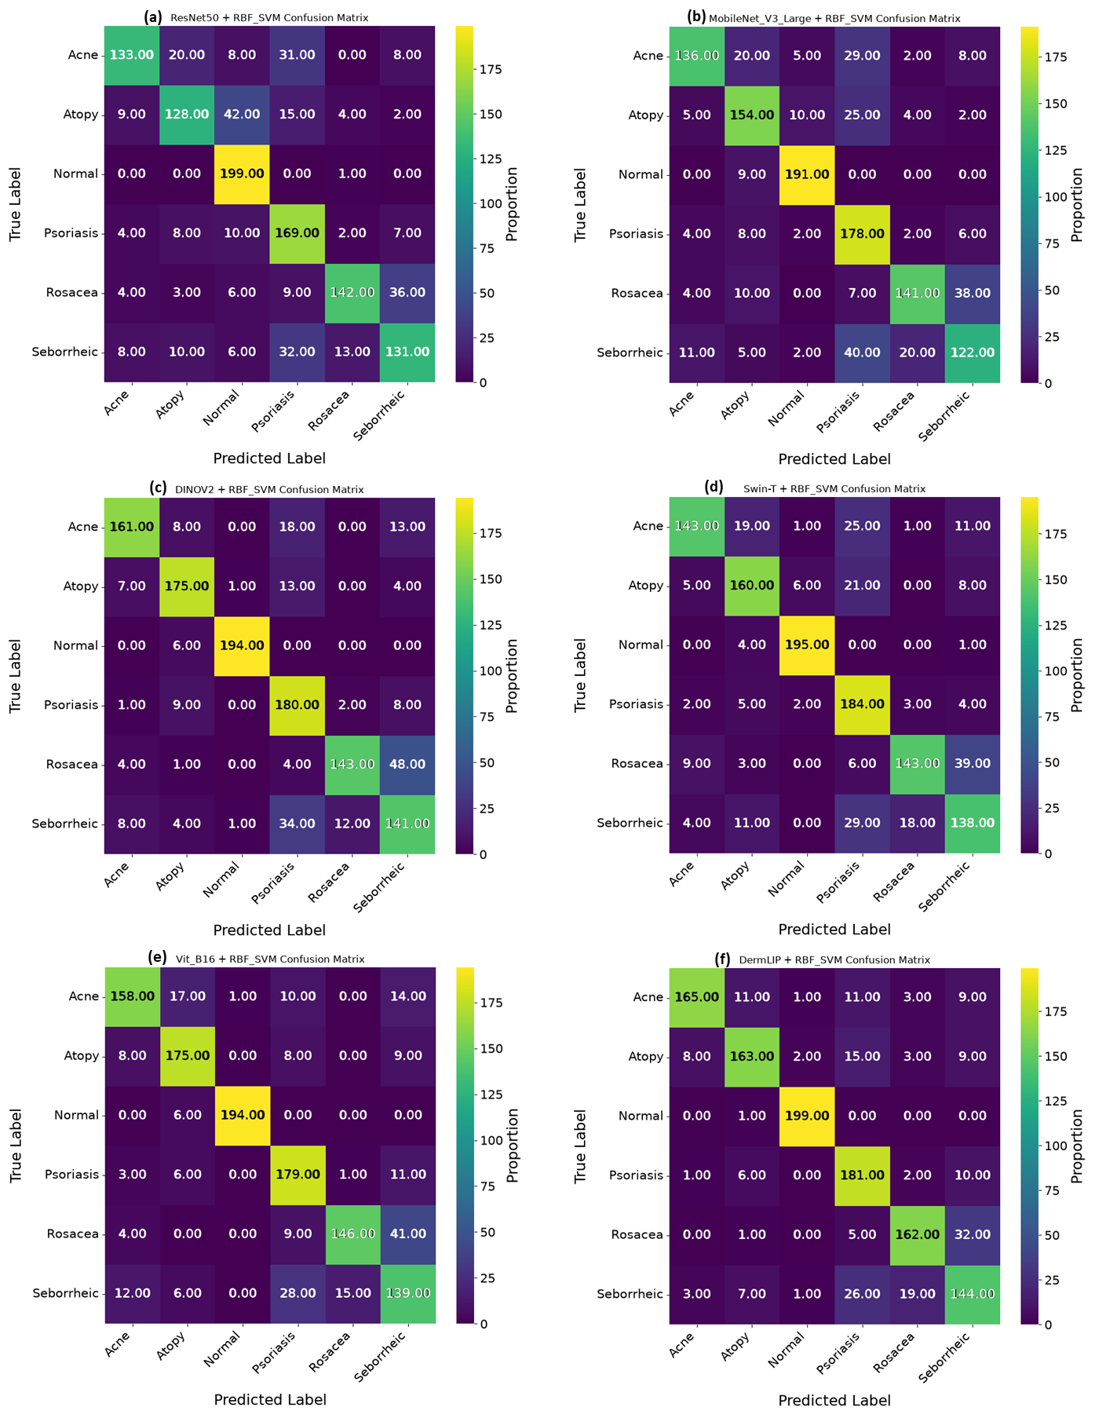
Figure S2. Multi-class confusion matrices showing the classification performance for 6 other feature extractors with RBF-SVM as the ablation classifier. (a) ResNet50 (b) MobileNetV3_Large (c) DinoV2 (d) Swin_T (e) Vit-B/16 and (f) DermLIP.
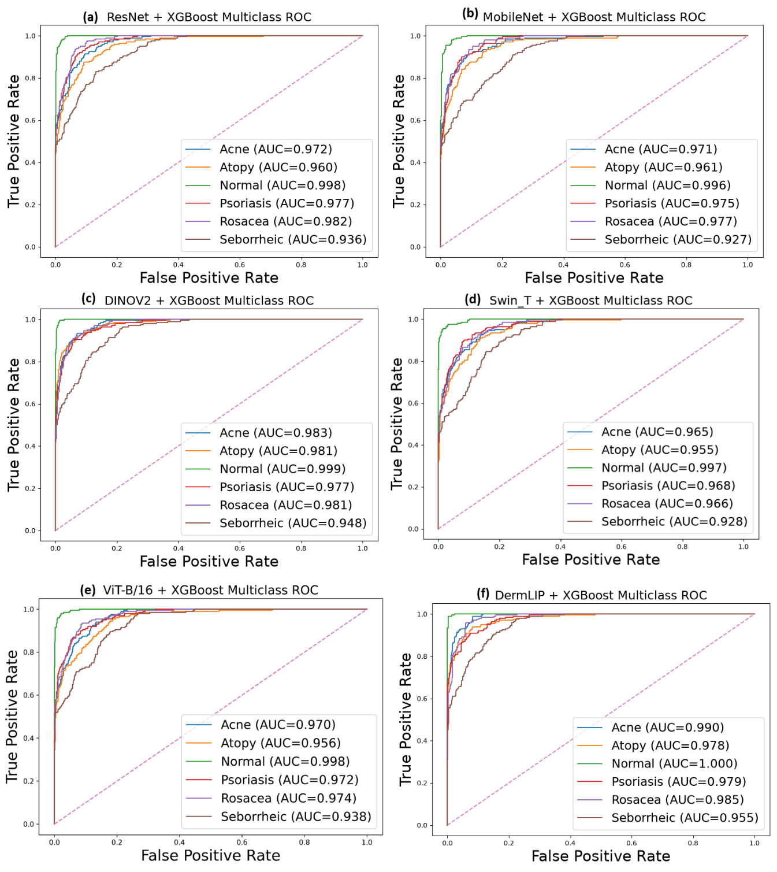
Figure S3. Class-wise Receiver Operating Characteristic (ROC) curves are shown for the 6 other feature representation with XGBoost as the primary classifier on the test dataset (a) ResNet50 (b) MobileNetV3_Large (c) DinoV2 (d) Swin_T (e) Vit-B/16 and (f) DermLIP. The curves and corresponding Area under the ROC Curve (AUROC) metrics are presented individually for each of the six-target facial skin-conditions.
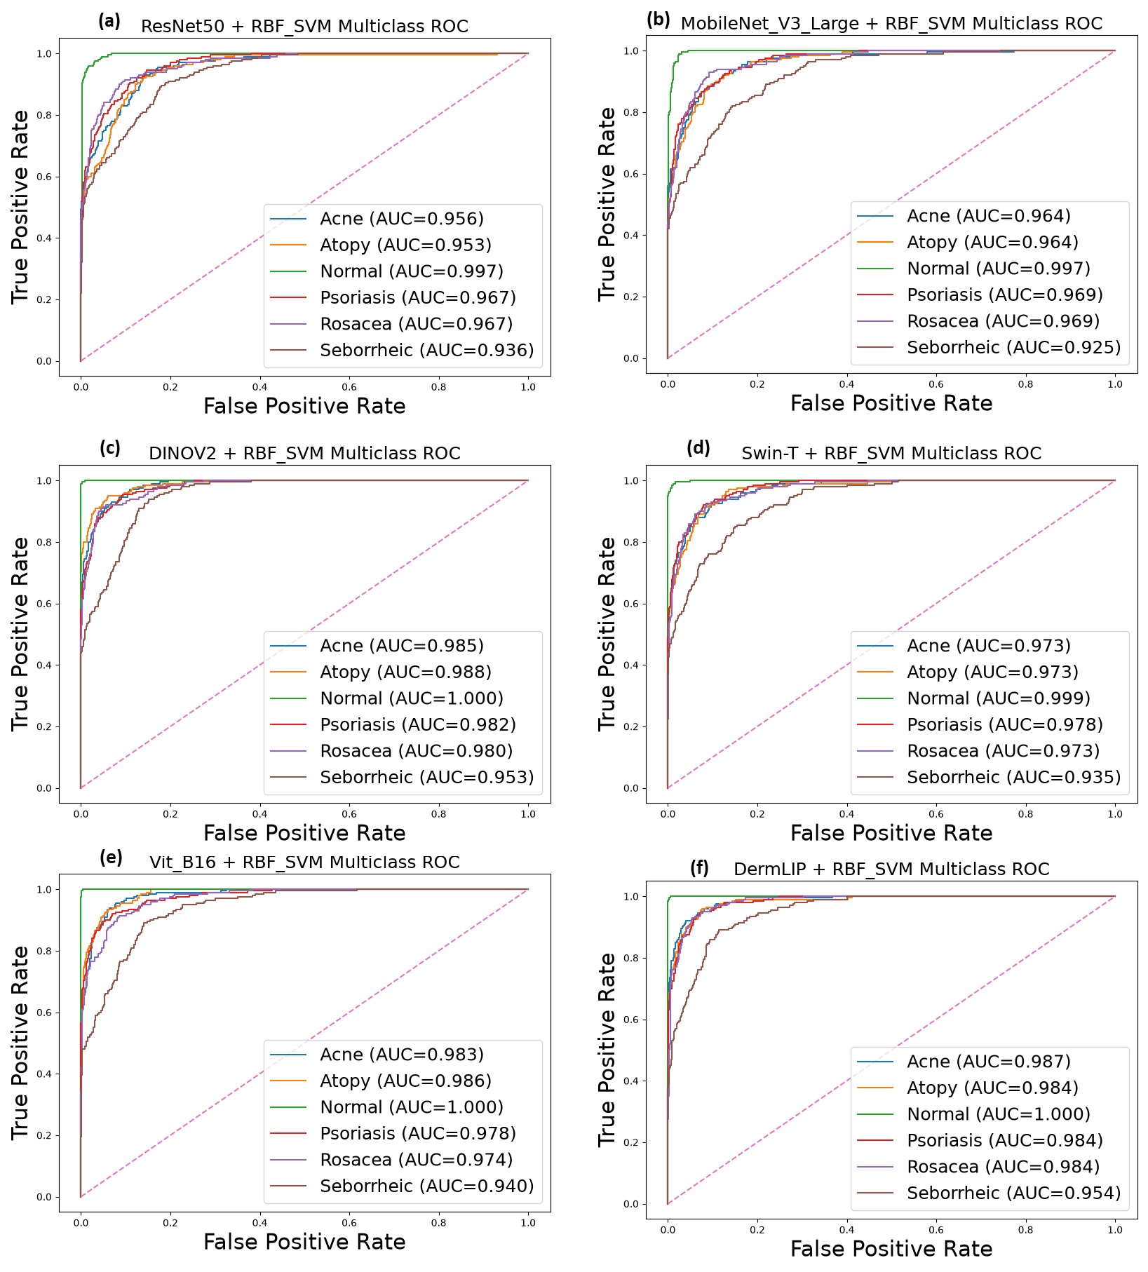
Figure S4. Class-wise Receiver Operating Characteristic (ROC) curves are shown for the 6 other feature representation with RBF_SVM as the ablation classifier on the test dataset (a) ResNet50 (b) MobileNetV3_Large (c) DinoV2 (d) Swin_T (e) Vit-B/16 and (f) DermLIP. The curves and corresponding Area under the ROC Curve (AUROC) metrics are presented individually for each of the six-target facial skin-conditions.
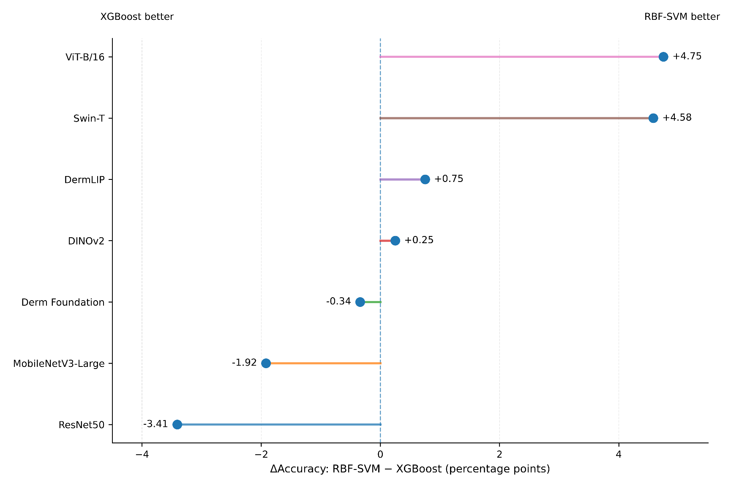
Figure S5. Observed difference in validation accuracy between downstream classifiers. Differences were calculated as calculated as ΔAccuracy = Accuracy_ RBF-SVM − Accuracy_XGBoost for each feature extractor. Positive values indicate higher accuracy with RBF-SVM, whereas negative values indicate higher accuracy with XGBoost. The vertical dashed line represents no difference (ΔAccuracy = 0). Values are expressed as percentage-point differences.

