Supplemental

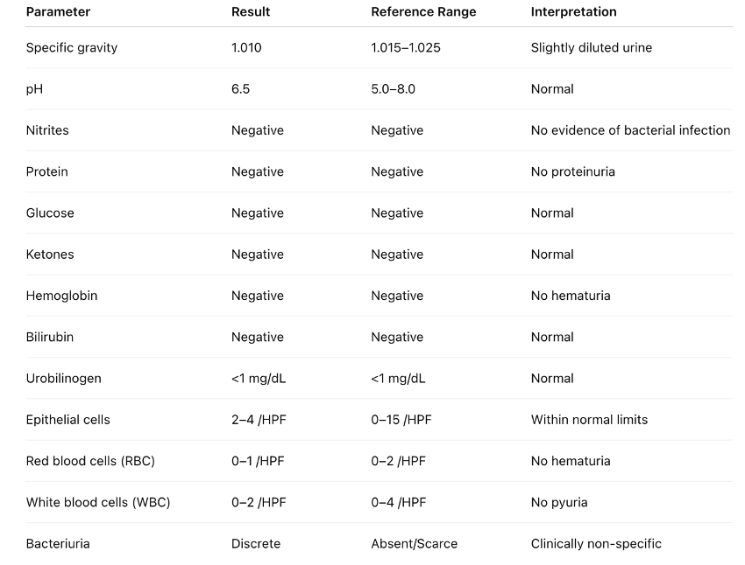
Supplemental 1. Detailed urinalysis findings, showing no evidence of infection or inflammation, with normal sediment parameters and absence of pyuria and hematuria.
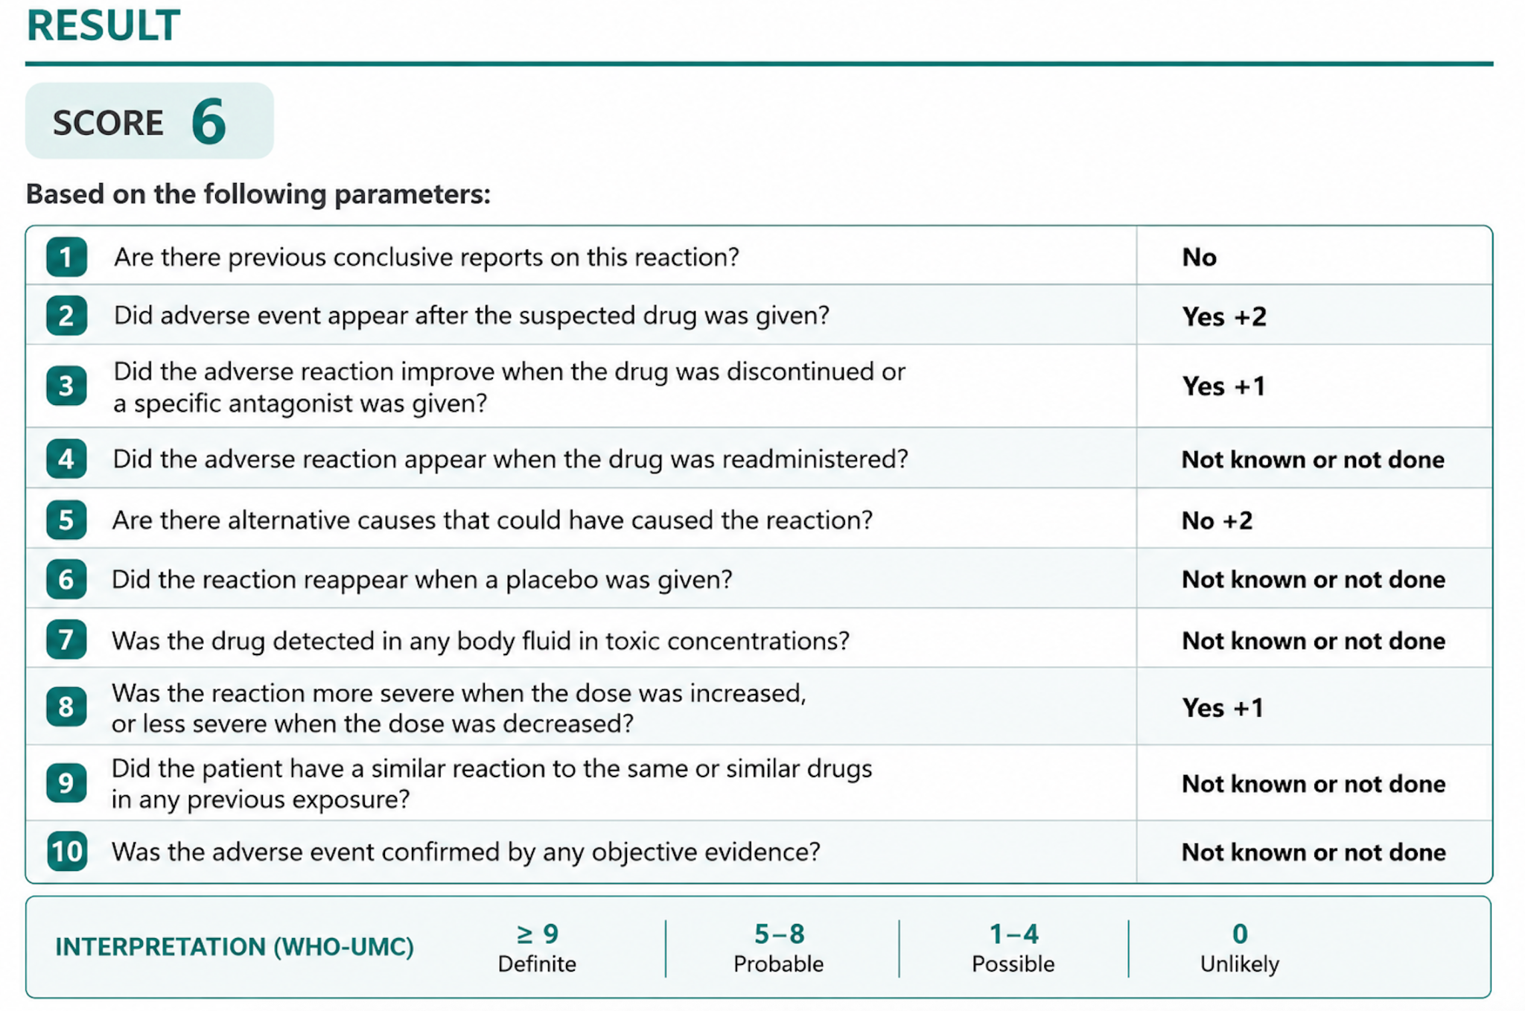
Supplemental 2. Naranjo Adverse Drug Reaction Probability Scale applied to the reported case, yielding a score of 6 (probable adverse drug reaction).

