Remote Patient Management for Cardiac Implantable Electronic Devices (RPM-CIED): ICD

Principal Investigator: Dr. Ratika Parkash,
QEII Health Sciences Centre, Halifax, Nova Scotia

Remote Patient Management for Cardiac Implantable Electronic Devices (RPM-CIED)

  - Background and Rationale

  - Clinical Management of CIEDs
Canada is a country with a diverse geography, of which 19% of the inhabitants are in communities classified as ‘rural’, but many may still have long distances to travel to reach a health care facility.¹ This results in challenges in uniform delivery of health care throughout the country. There are 25,000 pacemaker (PM) implants and 7000 implantable defibrillator (ICD) implants yearly in Canada, with approximately 120 000 patients living with these devices. The recommended follow-up for these devices are based on consensus and position statements, with the majority of patients requiring at least yearly visits to a specialized device clinic during the lifetime of their device .² During the life of these patients, many issues may arise, such as atrial or ventricular arrhythmias that may result in syncope, stroke or sudden death, need for increased monitoring resulting from device advisories, or minor programming adjustments to improve device performance, or simply the need for enhanced surveillance as the device battery depletes and replacement is anticipated.

1.2 Current standard of care
Practice guidelines in Canada recommend that patients receiving CIEDs, undergo routine device follow-up assessment of their CIED at regular intervals (6 months to one year depending upon the kind of device). The purpose of these assessments is to evaluate the patient and the CIED including reprogramming of the device where clinically appropriate. Traditionally, these assessments have been conducted at a designated Device Follow-Up Clinics, which include specialized (with Electrophysiology Service) and/or non-specialized (without Electrophysiology Service) sites for ICDs, and either specialized or non-specialized device clinic for PMs, which might be remote from the patient’s own community. A recent position statement by Yee et al recommended that for CIED patients in whom no device issues are identified, routine follow-up assessment during the maintenance phase should blend remote monitoring (RM) with in-clinic assessments beginning after the 3-month post-implant assessment, alternating assessments between in-clinic and RM transmissions in a 1:1 ratio (Conditional Recommendation, Low-Quality Evidence).²
While remote monitoring technology is currently available and has permitted surveillance and device assessment from any patient location accessible to a landline or mobile phone, the use has been inconsistent in Canada, where only 8500 out of a potential 120 000 patients with CIEDs are enrolled in this program.³ Further, this technology is in widespread use worldwide for all CIEDs but in Canada, it is utilized primarily for implantable defibrillators, but not pacemakers. In addition, new technology has become available that not only permits surveillance, but also remote programming of these devices. The incorporation of remote programming capability, along with automatic recalibration of device settings, allows us to develop a new paradigm of remote patient management where after the patient receives their device, they would remain in the care of their local health team and no longer require travel to the specialized clinics for follow-up. Using this new technology addresses an unmet need in delivery of timely, uniform and efficient care for arrhythmia patients and further integrates the patient and their local healthcare provider in their health outcome. It creates capacity in the specialized centers to focus exclusively on the problematic cases by removing the need for routine checks.
Several early cohort studies, predominantly single centre, were the first to demonstrate the potential benefits of RM for CIEDs⁴⁻¹⁶ including significant reductions in the time required for CIED interrogation with improved patient and clinician satisfaction, reduction in the number of inappropriate shocks delivered to ICD patients through earlier identification of lead and/or device failures, earlier detection of atrial fibrillation (AF) and ventricular arrhythmia events in CIED patients.⁶ Benefits to heart failure management have also been demonstrated. These studies were limited by short durations of follow-up and the lack of a well-designed comparator group.
In the PM population, there have been two multicentre, randomized trials performed, both of which have shown an increase in detection frequency of adverse clinical events and a reduction in reaction time to those events by RM.^{17, 18}
In the ICD population, four published randomized trials have been performed to assess the efficacy of RM for reduction of in clinic visits and earlier detection of clinical events without decreasing patient safety. RM significantly reduced time from clinical event to medical decision by 17.4 days compared to in-office visits (p<0.001).¹⁹⁻²² The most common events were detection of AF or a fast ventricular rate >120 bpm. Number of clinic visits was also significantly reduced by 38%. In another large study (n=1450), Varma et al also demonstrated a 45% reduction in clinic visits by RM overall, with significant reductions in the time from onset to physician evaluation for both atrial and ventricular arrhythmias at 15 months.²² No adverse events were reported in these studies. Two recent landmark studies randomizing patients to RM monitoring vs in-office follow-up have been performed. In the EVATEL study enrolling 1501, there was no difference in the primary endpoint of major adverse events (death, hospitalization, inappropriate ICD therapy). (presented by Mabo et al, European Society of Cardiology, 2011, Paris, France). A significant reduction in inappropriate or ineffective ICD therapy (8.1% vs 5.5%, p=0.04) was noted. In the ECOST study involving 433 patients, RM was found to be non-inferior to in-office follow-up in terms of major safety events including death.²³ However, RM decreased inappropriate ICD shocks by 52% (5.0% vs 10.4%, p=0.03) and decreased hospitalizations by 72% (3 vs 11, p=0.02). Cost-effectiveness analysis from ECOST reveals a significant cost-saving to the remote management strategy as compared to usual follow-up. Over a follow-up of 27 months, the mean non-hospital costs per patient-year were €1695 ± 1131 in the active, vs. €1952 ± 1023 in the control group (P = 0.04), a €257 difference mainly due to device management.
This advancement in technology is very important as it addresses several potential gaps and barriers in the care of patients with CIEDS:
- Long, expensive travel for patients
- Morbidity to patients due to delay in receiving appropriate treatment
- Efficiency in health care delivery
- Patient satisfaction

This is the optimal time point at which to do this study due to the burgeoning population with CIEDs, the need for patient-centered care in this arena and the advancement in the field, from a technology standpoint. In a recent announcement, the Canadian Agency for Drugs and Technology for Health listed remote CIED monitoring as one of the top 10 emerging technologies of 2015. As this is new technology, there are no prior preliminary studies on this topic.
2.0 New Technology
New technology has become available that not only permits surveillance, but also remote programming of these devices. The combination of RM and RP will result in a total care of CIEDs termed Remote Patient Management – CIED (RPM-CIED). The incorporation of remote programming capability, along with automatic recalibration of device settings, allows the development of a new paradigm of remote patient management where after the patient receives their device, they would remain in the care of their local health team. The Remote Programming technology has been approved by Health Canada.
In CANet, a patient-centered virtual computer application was created called VIRTUES. This system will permit patients to access their own data at any time, as well as grant access to health care professionals as desired. This empowers patients to manage their own device and receive appropriate care if they are outside of their jurisdiction. This new system will be applied to ICD patients to evaluate whether this paradigm shift in patient centered care results in increased patient satisfaction and cost savings for the health care system.

Figure 1. Current device clinic models in Canada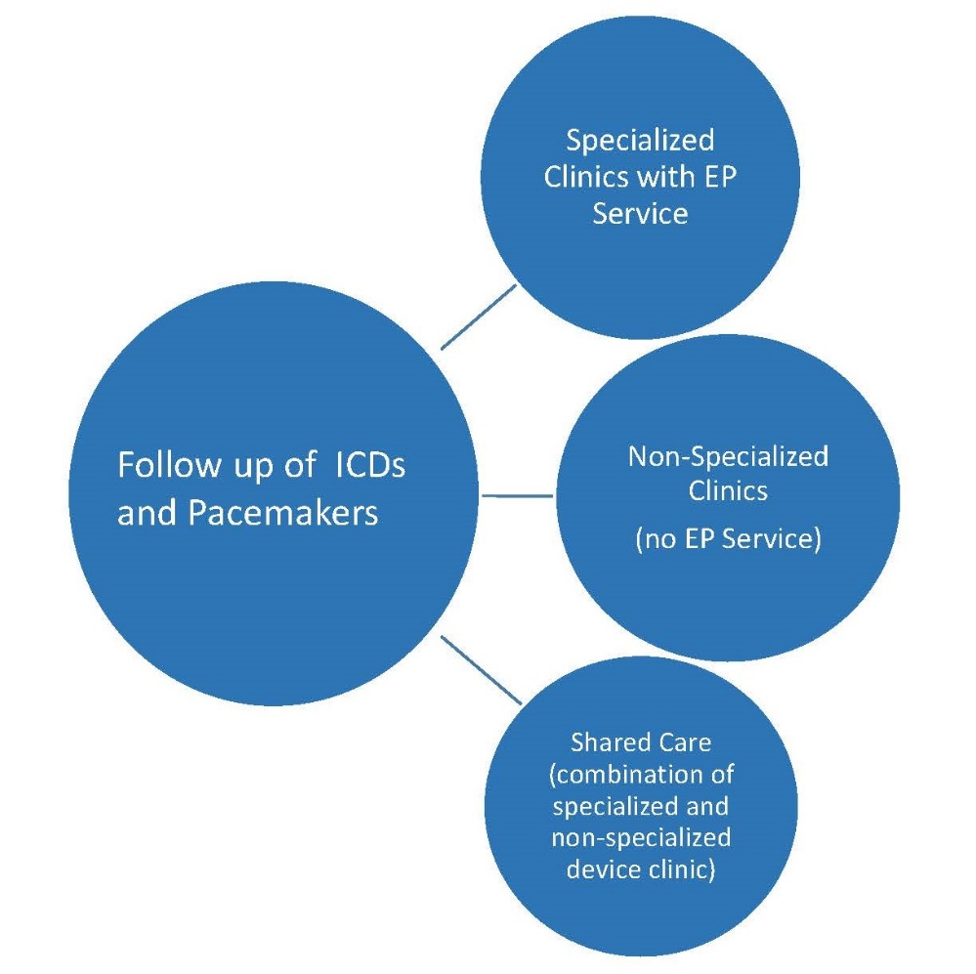

2.1 Results of pilot study
The pilot RPM study was designed to test feasibility of this system in our health care system. A number of barriers were encountered as the study was initiated in 5 centers in Canada. These barriers are shown in Table 1; the strategies to target these barriers are provided.

RPM CIED PILOT | Study Roll out to 7 sites - 28-Oct-15
Barriers to site participation | Strategies to Overcome
Site compensation/staffing/resources | Increased site compensation
Sharing/billing of CIED patients (satellite vs hub) | This will be addressed in project 3 – implementation, but will also be discussed at the knowledge exchange meeting (April, 2017)
Device tender considerations
Barriers to site activation | Strategies to Overcome
Subsite agreement/contract delays/staffing changes | Incentive to achieve site activation within 4 months
Site resources/staffing for ethics app | Incentive to achieve site activation within 4 months
Study approval process (Scientific review/Ethics review) | Incentive to achieve site activation within 4 months
Service agreements with Industry (issues with defining signatories) | Reconciled after multiple communications
Privacy Impact Assessment (NSHA & AHS) | 5 months to reconcile - completed
Internet drops required - satellite clinics (NS, AB) | Additional costs covered by study budget
Alberta Health Services (AHS) - issues with Medtronic Service agreement | Multiple communications with AHS
AHS - IT procurement issues with RemoteView | Multiple communications with AHS
AHS - Security specifications required from UOHI | Provided
 | First site activated 19-Oct-16
Barriers to implementation | Strategies to Overcome
Protocol - Patient refusal to participate because they want to come to referral center | Protocol to reflect normal standard of care
Remote View not released to Canada by the US | Application released on Nov. 11, 2016

In addition to the strategies listed above, a document list was developed to assist with the contract, privacy and IT requirements for this program with the hopes to assuage the difficulties encountered in the pilot. RPM sites were activated in Alberta, Quebec and Nova Scotia.

Survey results – Device Clinic:
An online device clinic survey was completed by 22 clinics (10 in Ontario, 4 in Alberta, 3 in BC, 1 in NS and 4 in Quebec). Of these, 20/22 clinic use remote monitoring as part of their follow-up strategy. One 8/20 (40%) routinely communicate with their patients after a remote transmission is received. Reimbursement strategies differed greatly amongst clinics, 50% of clinics had a professional fee, 50% had a technical fee and 14% had institutional funding. The range in professional fees was $16-$60 for a pacemaker, and $45-$70 for an ICD. Reimbursement fees for remote visits were not universal. Two clinics in Ontario indicated reimbursement fees, two clinics in Montreal and two clinics in Calgary; reimbursement is also available in Nova Scotia. On further discussion with BC, reimbursement for RM has recently been instituted. In terms of patient management regarding health concerns or triggered alerts, most clinics instruct the patient to either present to the closest emergency department or that they will be contacted the next business day; only 2 clinics provide an on call pager number to their patients. A shared care model was used in 60% of the respondents.

2.2 Are there any risks to the safety of participants involved in the trial?

The patients in the intervention arm will no longer be attending a device clinic in person as long as all the findings on the remote transmission do not indicate an issue with the device. If there is an issue detected on the device, then patients will be scheduled to be seen as deemed appropriate by their device clinician. The COMPAS study have examined the safety of remote monitoring only and found no difference as compared to in-clinic visits (17.3% of major adverse events in the remote monitoring group compared to 19.1% in the control group). ¹⁷ The safeguard built into the study in both arms is the requirement that a family physician is required to see the patient annually. This ensures that the patient is followed for any other issues, that may have otherwise been treated at an in-clinic visit for their device. In our pilot study, a remote only follow up did not find any signal of increased adverse outcomes compared to published studies in this area.

3.0 Hypotheses
VIRTUES ICD, using novel technology, is non-inferior in safety and efficacy, but superior to remote monitoring alone in use of health care resources and cost-effectiveness.
Specific research questions:
- Is remote patient management as efficient in delivery of care over routine practice?
- Is remote patient management as safe as routine care?
- What health care systems cost savings can be achieved through a program of VIRTUES ICD?
- Is the quality of life of patients improved by remote patient management in Canadian device follow up centers?

The knowledge gap to be addressed through the research project is: what do we need to know to make them work, and work well, across the diversity of healthcare systems and patients that make up the Canadian context. Patients have need of knowledge of how to incorporate remote assistance with care of their devices and how this will affect their levels of health risk, functionality, and quality of life. Clinicians, remote device technicians, and industry device developers need to know patients' barriers to receiving this new form of care, and the variables (including environmental contingencies) that could thwart uptake. Research-informed evidence is also needed by those responsible for developing and reviewing policy and practice. As Ian Graham argues, across all knowledge users, each is an expert on their own needs, and most often also on the context of implementation—i.e. the realities of the environment in which the research results will be implemented.( http://www.cihr-irsc.gc.ca/e/40618.html) Having knowledge users work collectively to provide solutions to the knowledge gaps in consort—i.e. providing mutual support through a network—means that each is necessary to provide/generate knowledge to effectively address others' needs for knowledge and provide responsive feedback that can be incorporated for improvements on a systems-wide scale. Admittedly, in striving to find systems-wide solutions for management of CIEDs there will be other unforeseen knowledge needs and gaps identified through processes of ongoing consultation and subsequent reform, refinement, or augmentation to the research questions, means of interrogation (and testing), proposals for development, and metrics of evaluation at each stage of the wider program.

4.0 Study Purpose

4.1 Overall Objective: To evaluate and implement a patient oriented CIED management model incorporating advanced technological innovation to promote a paradigm shift to patient-centered care.
4.2 Specific Objectives:
- To determine if VIRTUES ICD is non-inferior to standard of care in safety as defined as major adverse cardiovascular events.
- To determine if VIRTUES ICD is non-inferior in delivery of care for patients with ICDs as defined by time to appropriate action of clinically significant events.
- To determine if VIRTUES ICD is superior in cost-savings to standard of care in patients with ICDs.
5.0 Methods
5.1 Study Design
This is a Canadian multicenter randomized controlled trial to assess remote patient management.

5.2 Participants
The remote patient management strategy will be done in 18 centers across Canada once institutional ethics approval has been obtained.
Population:
- Patients with a Medtronic, Abbott or Boston Scientific defibrillator/CRT-D capable of remote monitoring with Carelink, Merlin or Latitude.
- Able to provide consent.
- Age >/= 18 years
Appropriate consent will be obtained for remote patient management, and participation in the project.
Exclusion:
- No family physician or general practitioner
- Inability to be referred to a specialist
- Currently followed more than every 6 months by a Heart Function Clinic
- Participation in another randomized clinical trial that impacts outcome
- Unreliable automated capture verification by device in pacemaker dependent patient
Randomization: Patients will be randomized (1:1) to remote patient management versus usual care, and will be stratified by site, remote status (determined using patient’s postal code), CRT vs. no CRT. A randomization schedule will be prepared by the data coordinating center at the University of Ottawa Heart Institute, using a computerized random number-generator. Balanced randomization will be maintained at each Clinical Centre using a block randomization scheme with randomly permutating block sizes to help avoid anticipation of treatment allocation. This will be performed using the web-based RedCAP system. Patients in both arms will be programmed in a standardized fashion following current CHRS recommended guidelines (appendix 1) and be on optimal heart failure medical therapy as per current standard guidelines.
Angiotensin Receptor Blocker
Remote Status Substudy
Remote patient management (RPM) has been proposed as a novel model of care which expands on current remote monitoring models by maintaining the quality of post-implant CIED follow-up care, while improving access and consistency of care in all regions of Canada and empowering patients to self-manage their health. RPM eliminates the need for travel to specialty device clinics for routine device checks completely in low-risk patients. This may be especially impactful to rural, remote or isolated patients who often must travel for CIED follow-up with considerable personal or economic burden.
- Describe the characteristics of individuals with CIEDs in rural, remote and isolated communities in Canada.
- Identify the safety, efficacy and cost-effectiveness of RPM for individuals with CIEDs in rural, remote and isolated communities in Canada.
- Identify how study participants self-identify as rural or remote compared to existing remoteness indices for their communities.
Using the postal code provided on the randomization form, the patient’s individual index of remoteness will be categorized for stratification and analysis. The postal code will only be used for the purposes of assigning one of 5 index of remoteness categories to Statistics Canada Census Subdivision. No individually identifiable information will be used or published after the postal code is used to find a participants remoteness strata. See Appendix 3 for further detail.
Intervention:
- Patients will be followed by remote monitoring only. A test transmission will be completed within 1 week of enrollment for patient with existing home monitors. For those patients who require a home monitor be ordered at the time of enrollment, a test transmission will be completed within 1 week of receipt of the home monitor. Transmissions will occur every 6 months, with no in-clinic visits. If there is an actionable event on the remote transmission, patients will be seen at their closest community clinic. Remote programming can be completed for those sites who have the RemoteView technology. If remote programming is not available, appropriate arrangements to permit the necessary specialized care will be done as per caring physician’s discretion. The non-specialized sites will be strongly encouraged to work with the specialized sites to provide specialized care for these patients when needed which includes the following: ICD shock, advanced treatment of ventricular arrhythmias, device malfunction, end of battery life, and need for reprogramming. Patients should be programmed as per the guidelines and checklist (appendix 1).
- All patients will be required to follow up with their family physician or general practitioner at least annually, and their cardiologist/internal medicine specialist at least every 2 years.
- Patients will be contacted by phone at 6 months and 12 months to document their current health status (change in cardiovascular medications, any cardiovascular hospitalizations, in-clinic device checks, or any new cardiovascular testing completed since the last visit)
- Patients will be asked to complete a VIRTUES acceptance and satisfaction questionnaire (ASQ) at the 12 month visit.
Newly implanted ICD patients will be seen in-clinic after the initial implant at within 3 months, as per standard of care. Thereafter, all follow-up will occur through remote monitoring every six months. Unscheduled remote transmissions may also occur. In-clinic device visits may occur if further device management is required.
Any scheduled or unscheduled remote transmissions will be uploaded into VIRTUES. Event documentation: an event causing a change to patient treatment or new cardiac investigations since the baseline (echo, angiogram, ECG, MRI, WMS, etc) will be updated in VIRTUES.
A web-based portal called VIRTUES, developed by CANet, will be instituted in the intervention arm. This CANet initiative is to improve patient empowerment and measure important outcomes in CANet.
- Patients will be provided with real-time knowledge of
a. success of their remote transmission and
b. status of the remote (eg no issues, call clinic, or present to emergency department).
- Virtual patient record – all patient information in the intervention arm will be contained within an information cloud that will be accessible by patients; access to their own data may be granted by the patient themselves to permit delivery of care remotely, and to permit after hours to be performed by the on call personnel.
Communication regarding the remote status will be distributed to the patient, the family physician, cardiologist, the device clinic through the VIRTUES portal. The provider letter will include the CCS Heart Failure therapy guidelines (appendix 4), and will include recommendations for further review if the patient is not optimally treated, as applicable. The VIRTUES electronic platform will contain some patient identifiers including: patient name, date of birth, medical record number, and health card number to ensure accurate and consistent device follow-up. VIRTUES is password protected and encrypted. Only the research coordinator and the electrophysiologists at each respective site will be permitted to add patient reports, personal health information, and patient data. The information contained in VIRTUES will not be shared with any third party entities, and will only be used for research purposes as detailed in this protocol.
Standard:
The standard arm will be required to have blended follow-up, which may include remote monitoring every 6 months , alternating with yearly in-clinic visits at their usual site (see table below). These patients would not have access to the virtual patient cloud or to remote programming. Phone follow-up at 6 & 12 months to assess health status and medication changes will be completed.
Standard of Care with standardized programming | Intervention with standardized programming
Remote monitoring every 6 months, alternating with yearly in-clinic visits at the community (non-specialized) device clinic | RM visits every six months
If a patient is part of community (non-specialized) and specialized clinic shared care model, then visits to the specialized clinic would be mandated every 2 years | In-clinic visits at community device clinics at discretion of the community clinic
 | Actionable event – follow up as deemed clinically appropriate
 | Use of remote view where available
 | All patients will be required to follow up with their family physician at least annually, and their cardiologist at least every 2 years
 | VIRTUES access for all patients

All patients will undergo one phone follow-up at 18 months to capture cardiovascular outcomes and the number of in-clinic and/or remote transmissions, and complete the SF36 questionnaires. Data regarding any of these events would be collected by research personnel through chart review.

5.3 Substudy
The following questionnaires will be collected on 500 consecutive patients to perform a quantitative assessment regarding patients’ attitudes and behavior towards remote patient management at BL and 18 months:
- The Florida patient acceptance survey (Fpas): The FPAS will measure patient acceptance of their cardiac device. The FPAS is a device-specific quality of life measure intended to evaluate how well patients have accommodated their cardiac device into their lives (Burns, Serber, Keim, & Sears, 2005). The FPAS has been validated in both US (Burns et al., 2005) and European samples (Versteeg, Starrenburg, Denollet, Palen, Sears, & Pedersen, 2012). Use of the FPAS is intended to provide additional information to general QoL indices. It is an 18 item measure with four scales evaluating return to functioning since implant, device-related distress, positive appraisal of the ICD, and body image concerns related to having a device implanted. It demonstrated satisfactory internal consistency with Cronbach’s alpha statistics ranging from .74 to .89 for the total questionnaire and all of the scales.
- Brief Illness Perception (BIPQ): The Common Sense Model of Health has been used as a broad patient centric model to account for illness perception (Leventhal, et al. 2008). Illness perceptions are cognitive frameworks that patients use to understand the causes and consequences of illness. Illness perception may play a central role in QOL perception. We will include the Brief Illness Perception Questionnaire (BPIQ) (Broadbent, Petrie, Main, & Weinman, 2006) to examine aspects of personal attributions and control of the course and impact of their condition over time.
- The Florida shock anxiety scale (Fsas) – patients with ICDs only: The FSAS measures specific fears of ICD shocks. The measure has 10 items contributing to two subscales, “triggers” and “consequences” and a total score, which is a sum of the items. Respondents rate each item on a five-point Likert scale ranging from 1 (not at all) to 5 (all the time). Higher scores indicate greater shock anxiety.
Analysis plans include normative comparisons for patient acceptance total, health security, and shock anxiety with reference groups. Additionally, between-group comparisons will also be examined to assess the effects of group assignment.
The analysis will be completed by Dr. Sam Sears, Ph.D., Department of Psychology, East Carolina University, Greenville, North Carolina.

5.4 Response to COVID-19 Pandemic
The VIRTUES technology being used as part of this study will augment the current standards of practice relative to remote monitoring of ICDs. The VIRTUES portal and app were finalized and ready for utilization on March 26, 2020. The consent process during the pandemic will involve contacting patients who have a Medtronic, Abbott Boston Scientific ICD that is compatible of remote monitoring and who have indicated they may be contacted for research. The consent will be either sent electronically via email or regular mail, at the patient’s direction.
The BL visit and patient onboarding to VIRTUES (if randomized to the intervention arm) will be completed by video conferencing through Zoom or over the phone by the research staff, based on patient preference. The current programming of the device will be documented. If not programmed according to protocol, it will be considered a minor protocol deviation, and programming will be mitigated when in-clinic visits resume. The ensuing phone follow-up remains unchanged

6.0 Study Outcomes
6.1 Outcome measures
Objective 1:
The outcome is safety (measured by time to major adverse events). The definition of major adverse events is based upon prior studies performed on remote monitoring.^{22, 24, 25} These include: death, stroke, hospitalization for complications related to the device system, hospitalization for an adverse cardiovascular event (Cardiovascular event is defined as any unplanned hospitalization (admission with an overnight stay in hospital) due to one of the following causes: acute coronary syndrome, presyncope / syncope, transient ischemic attack / stroke, ventricular arrhythmias, atrial fibrillation, atrial flutter, pulmonary embolism / deep vein thrombosis /systemic embolism, worsening congestive heart failure including pulmonary edema or dyspnea of cardiac origin).
Objective 2:
The efficacy outcome is the time from a clinical event to a clinic decision in response to arrhythmias, cardiovascular disease progression and device issues with remote patient management as compared to routine care. A clinical event is defined as AT/AF more than 12 hours, rapid ventricular rate during AF (120 bpm for ≥ 6 hours AT/AF per day), ICD shock, lead impedance out of range, low battery voltage, excessive charge time, need for device programming, > 3 ATP within 24 hours separated by 5 minutes (VT Storm), sustained VT (>30 seconds) in the monitor zone, or an advisory alert).
Objective 3:
An economic evaluation will be conducted to determine the cost-effectiveness of the remote patient management strategy.

Secondary Outcomes;
- Medication compliance to current CCS Heart Failure Guidelines
- Number of clinical events leading to a change in medication
- Minimum programming compliance
- Number of inappropriate shocks
- Number of appropriate shocks
- Time to detection of ventricular arrhythmia events
- Detection of atrial high rate episodes
- Number of cardiovascular related ER visits (< 24 hrs)
- Number of device-related ER visits (<24 hrs) – these would include an audio signal from the device (beeping), shock(s), or a device complication requiring medical attention.
- Rate of syncope
- Quality of Life (FSAS, FPAS, BIPQ, and SF36)

7.0 Statistical Analysis
7.1 Sample Size Calculation
For assessing the co-primary endpoint consisting of the primary safety outcome (time to the composite of death, cardiovascular hospitalization or device-related hospitalization) and the primary efficacy outcome (time to clinical event), a sample size of 1164 (1:1 ratio with 582 in the routine care group, 582 in the VIRTUES group) will have (96)(83)=80% power for the primary endpoint of the trial to be detected (i.e. both endpoints have a p-value < 0.05 or one endpoint had a p-value < 0.025). This sample size is based on the power in the calculation of the sample size for each of the primaries as follows:
(1) For the safety outcome, the study will be powered to evaluate non-inferiority of VIRTUES to routine care. In the Trust study, the rate of events was 17%; using a conservative event rate of 15% in the routine care group and a 30% relative risk increase to 19.5% in the VIRTUES group, a difference of 6.0% or less is considered unimportant (non-inferiority margin).²⁵ Using a log-rank test with an overall sample size of 1140 patients (570 in the routine care group and 570 in the VIRTUES group) achieves 83% power at a 0.050 significance level to detect an upper hazard ratio bound of 1.33 when the routine care group hazard rate is 0.15. The study timeline is 2.5 years of which patient recruitment occurs in the first year and the last patient recruited will be followed for 1.5 years. The loss to follow-up in both groups is 2%, the crossover from the VIRTUES group to routine care is 0% and the crossover from routine care to VIRTUES is 0%, yields the sample size of 1164 patients (582 in the routine care group and 582 in the VIRTUES group)
(2) For the efficacy outcome, the study will be powered to evaluate non-inferiority of VIRTUES to routine care. For routine care, a median of 4.6 days with an interquartile range (1, 3.9) in days to clinical events was identified²¹; based on this, an approximate mean and standard deviation in days to clinical events in routine care was 4.5 days and 2.15 days respectively. A 10% relative risk increase to 5.06 days in the VIRTUES group, is considered unimportant (non-inferiority margin). Using a two-sample equal-variance t-test with an overall sample size of 1008 patients (504 in the routine care group and 504 in the VIRTUES group) achieves 96% power at a 0.050 significance level to detect an upper bound of in the mean difference in days of 0.46 days when the routine care group mean is 4.6 days and the common standard deviation is 2.15 days. Adjustments for loss to follow-up in both groups of 2.0%, crossover from the VIRTUES group to routine care of 0% and crossover from routine care to VIRTUES of 0%, yields the sample size of 1024 patients (512 in the routine care group and 512 in the VIRTUES group).
(3) Economic analysis: The sample size for the cost-effectiveness analysis is based on enough power for the 95% CI to exclude maximum willingness to pay (WTP) per QALY if the treatment is in fact cost-effective.¹ Based on a study by Sapp et al 2021, the standard deviation for usual care of in-person ICD clinic cost is $ 511.90) and the expected mean difference in remote ICD monitoring and usual care is $ 1018 assuming that the patient had to travel to a specialized site for monitoring at least twice a year, in the absence of remote monitoring, and keeping all other costs the same.² The standard deviation of the safety and efficacy effect for usual care (2.15) and the expected mean difference in remote ICD monitoring and usual care (0.46) are based on the assumptions above for the safety and efficacy sample size. For a WTP of $ 20,000 and a conservative expected correlation of the difference in cost (C) and effect (Q) of 0.10, a power of 80% is achieved with an alpha of 0.05, for the 95% CI to exclude maximum WTP with a sample size of 444 per group.

In summary, the assumption for this sample size calculation has taken into consideration the following:
- A non-inferiority margin (NIM) of 6.0% for the primary safety outcome and 10% for the primary efficacy outcome
- 2.0% loss to follow-up
- 5% cross-over from VIRTUES to routine care
- Alpha of 5% and power of 80%
- Beta error adjustment of 96% for the primary safety outcome and 83% for the primary efficacy outcome, so that an overall power is 80% (96*83).
- A serial gate-keeping approach that allows the alpha from Objectives 1 and 2 to be utilized for Objective 3 if non-inferiority is satisfied for both objectives.³

7.2 Analysis
Descriptive statistics will be used to summarize the demographic and clinical variables. Rates of events will be reported as percentages of total population. For ICD patients, patient in-clinic visits at non-specialized clinics will be calculated by number of visits/number of patient-years of follow-up. Descriptive statistics will be used to summarize the demographic and clinical variables. Rates of events will be reported as percentages of total population. . The baseline characteristics of the two study groups will be compared by two-sided χ2 test for nominal, qualitative variables, and by Student’s t-test for normally distributed, quantitative, continuous and discrete variables. The normal distribution of variables will be verified, using the Kolmogorov– Smirnov and Shapiro–Wilk tests. Survival free from the primary outcome will be estimated by the Kaplan–Meier method and compared, using the log-rank test. Cox proportional hazard regression analysis will be used to estimate the likelihood of survival, after verifying the proportional hazard assumption. Friedman’s nonparametric, repeated-measures analysis will be used to compare the SF-36-scale and summary scores. The number of follow-ups per patient-year was estimated, with 95% CI, in each study group, assuming a Poisson distribution. A P-value< 0.05 will be considered significant.

Economic Analysis: Analysis will take the form of a cost utility analysis with cost effectiveness assessed in terms of the incremental cost per quality life year. Analysis will incorporate data on resource use and patients utility values for the period from initiation of remote patient management to 18 months follow-up. Resource use will be assessed through review of patient charts and patient utility values will be derived from the SF-36. The Medical Outcomes Study Short Form-36 (SF-36) is one of the most widely-used and extensively-validated generic measure of health-related quality-of-life.²⁶ From the 36 items, 8 health profiles are derived: Physical Functioning, Social Functioning, Role Limitations – Physical, Bodily Pain, General Medical Health, Mental Health, Role Limitations – Emotional and Vitality. A decision model will be created to estimate long term costs and quality adjusted life years (QALYs) for all comparators. Dr. Doug Coyle (University of Ottawa) will oversee the economic analysis.
The economic evaluation takes two forms. First, a within trial analysis will be conducted whereby we will assess the expected values for the costs and QALYs gained during the trial duration. Secondly, we will develop a Markov model which will incorporate the incidence of the primary clinical outcomes death, stroke, hospitalization for complications related to the device system and hospitalization for an adverse cardiovascular event and extrapolate from the time duration of the clinical trial to a lifetime time horizon. The model will incorporate the short term data on costs, QALYs and clinical outcomes and will further be propagated with data form the literature. The model is being developed as part of the project grant.
8.0 Knowledge Translation & Dissemination
8.1 Knowledge Translation
This is an integrated Knowledge Translation program, and as such the targeted potential knowledge users of the dissemination plan importantly include—though would not be restricted to— the research team. Since there is a diversity of knowledge users involved with the program, there may be knowledge translation needs and relevant challenges for communication across representatives from different fields. Hence the need for a dissemination plan (to assist information flow and knowledge uptake) even within the broader research team itself. The main goal of dissemination within the research team will be to increase knowledge and awareness. The main strategy for these communications will be through email and regular teleconferences. Still, there is benefit to having an opportunity for all members of the research team to attend sessions where two-way knowledge exchange is fostered. Given the size and geographical spread of the research team this would not be possible in person and therefore a virtual seminar as a webinar is planned for once per year at which all will be invited to assist dissemination across not only the team itself. In this regard, team members will be encouraged to invite relevant contacts from within their fields to attend that portion of the webinar which will be made open to the public, with another portion reserved for research members only (if judged necessary by the Steering Committee in conjunction with the Patient Council).
An advisory committee consisting of collaborators, knowledge users, government and industry partners will inform the steering committee of direction, needs and requirements of the developing research program. .
Engaging knowledge users and decision makers both at the start and throughout the program will increase the likelihood that solutions are found which work for, and truly fit the unmet needs of the eventual end-users. Product development and testing of implementation strategies will be more efficient as design flaws and barriers will be more likely to be identified sooner rather than later, with input from a diversity of engaged end-users throughout the research and development process.
The goals of knowledge translation will be to:
- Engage further practitioners, the program will focus on dissemination of the knowledge it generates through conferences, webinars, key opinion leaders and guideline creation.
- Engage policy makers, the program will hold meetings (see dissemination plans) to exchange possible solutions before embarking on the research projects. This will ensure that these solutions are tested, producing outcomes that will have traction and be convincing for policy makers and thus provide and evidentiary basis upon which to institute prospective policy changes.
- Provide feedback and guidance from the Patient Council on how best to educate the wider group of affected patients on this new form of CIED follow up.
- Obtain early involvement of government decision makers at the provincial level will result in early adoption of the knowledge generated by this program.
- Provide a collaborative network of industry partners to evaluate its novel technology.
Knowledge users include the following:
- Patients - A Patient Council has been assembled consisting of 9 patients from participating centres across Canada. The Patient Leader will chair the Council and be a member of the Steering Committee. It is expected that the Patient Partners will help expand the membership of the Patient Council to include membership from those provincial/territorial jurisdictions currently without representation. This research program is motivated by responsiveness to patient demands for patient-centered CIED care, so it is anticipated that Patient partners will advocate for further engagement with relevant health educators and community leaders who are linked to patient organizations to potentially grow patient engagement with the Program.
This program supports a culture change from a paternalist model by which patients are passive recipients of treatment, to building a supportive environment where they are active partners in directing and taking responsibility for their healthcare. To better achieve this, the following have been implemented:
- The Patient Leader is part of the Steering Committee and will be involved in the review of the research proposal, to ensure that relevant patient outcomes and issues are addressed.
- The Patient Council will also be asked to provide direction in the research program, particularly, with respect to the patient surveys that will be carried out as part of Project 1.
- Emphasize mutual responsibility (co-building and co-leadership in partnership of care)

The Patient Council Leader will be an integral part of the research team for each identified project in the program as well as a liaison between the research team and the Patient Council. The Patient Council will meet at quarterly intervals by teleconference. The Patient Leader will provide the Patient Council with regular updates from the monthly Steering Committee meetings. The Patient Leader will also provide regular written reports listing all patient input, and how the Project/Program has incorporated those suggestions and/or recommendations.
- Provincial Health Authorities - Their roles and responsibilities include participation in the survey (Knowledge Exchange Program), assistance with dissemination and feedback on real world application. The strategy is to continue to build interest and engagement with this project through activities that target building relationships and securing future engagement from Health Canada, Provincial and Territorial Ministries of Health and Wellness, Regional and Municipal Hospital Authorities, as well as healthcare system managers, administrators, policy and decision-makers.

This research program will require engagement on all these fronts to enlist motivation and the knowledge necessary for required changes to matters such as clinical practice guidelines, physician reimbursement fees for relevant services, and the infrastructure and human resources needed to make clinical practice align with the scientific findings of this study. Clear linkages with health policy and health care service delivery administrators (at all the various levels) will ensure barriers are addressed prior to guideline changes. The implementation strategy here is to create a structure and contexts for two-way knowledge exchange that builds in end-user investment and response to stakeholder needs, with patient needs at the forefront of these, to generate benefit for all involved.
3.) CIED implant and follow up clinics – including physicians, health system administrators and allied health personnel are other potential knowledge users will be engaged.
8.2 Dissemination
Identified audiences:
- Clinicians/practitioners [150 CIED follow up physicians]
- Health care administrators [25-30 CIED follow up centers]
- Industry [4 companies]
- Policy makers [one representative from each province]
- Patients [as widely as possible through CIED clinics]

Goals & Applications:
- Inform & change clinicians' attitudes, behaviours, practice and facility with new technologies.
- Inform health care administrators so that they can inform and change policy and practice; help identify barriers/supports to facilitate use; evaluate outcomes and consider changes needed for future uptake and sustainability of gains for patients.
- Inform industry to provide knowledge key for research, development, refinement and marketing of the technologies.
- Inform and change attitudes of policy makers to the potential uses of this technology so that they can construct or reform policies to support relevant parameters for physician reimbursement and entrench safety standards and better accessibility for patients.
- Inform and change patients' attitudes and behaviours, which in turn will provide peer support to other patients and potentially act as advocates for overcoming barriers within the healthcare system.

Since knowledge users are experts in their own knowledge needs, relevant members of the research team will have expertise on what knowledge-users in their field find important and need to know regarding the Program's findings. It is expected that champions will rise up and be motivated to share study findings with their colleagues. Cross-fertilization will also be important, and therefore it is expected that champions will also disseminate study findings to other knowledge-user groups, and will furthermore be able to find advice within the research team on the knowledge needs of the group being bridged to.
9.0 Participating Centers
Royal Jubilee Hospital, Victoria, BC, Foothills Hospital, Calgary, AB, St. Boniface Hospital, Winnipeg, MB, London Health Sciences Center, London, ON, St. Michael’s Hospital, Toronto, ON, Southlake Regional Health Care Center, Newmarket, ON, University of Ottawa Heart Institute, Ottawa, ON, Hamilton Health Sciences Center, Hamilton, ON, Memorial University, St. John’s, QEII HSC, Halifax, NS, Centre Hospitalier Universitaire de Sherbrooke, Sherbrooke, QC, Laval Hospital - CRIUCPQ, Quebec, QC, St. Mary’s General Hospital, Kitchener, ON, New Brunswick Heart Center, Saint John, NB, Hopital Sacre-Coeur, Montreal, QC.
10.0 Program Committees & Partners
Advisory Committee - Steve Wilton, Libin Cardiovascular Institute, Calgary, AB; Andrew Krahn, Vancouver General Hospital, Vancouver, BC; Matt Bennett, Vancouver General Hospital, Vancouver, BC; David Birnie, Ottawa Heart Institute, Ottawa, ON; Benoit Coutu, CHUM, Montreal, QC; Isabelle Nault, Hôpital Laval, Quebec, QC; & Jean Campagne, Hôpital Laval, Quebec, QC

Patient Council – Led by a patient council representative

Device Clinic Knowledge Users - Aaron Low, Cardiac Surgeon, Chinook Regional Hospital, Lethbridge, AB; Jennifer Fraser, Kawartha Cardiology Clinic, Peterborough, ON; Debra Campbell, Calgary Health Trust, Calgary, AB; Lisa Gurman, Hamilton HSC, Hamilton, ON

Government Partners - Heather Jackson, BC Provincial Health Services Authority; Blair O’Neill, Alberta Health Services; Neala Gill, Cardiovascular Health Nova Scotia
11.0 Data Safety & Monitoring Committee: will be comprised of a chair with clinical experience as well as one other clinically experienced member and a biostatistician to oversee the safety aspects of the trial. The DMC will have full access to trial documents and data.
12.0 Clinical Events and Device Events Adjudication Committee will be blinded to randomized treatment allocation of enrolled patients and will review de-identified CRFs, source documents, and hospitalization records, and will adjudicate endpoints. Members will not adjudicate events from their own centre.

Appendix 1 – Standardized Programming for ICDs

Table 2. Summary of clinical trials addressing tachycardia programming to minimize shock therapy

Company | Slowest detection  (zone), bpm | VT detection  (zone), bpm | Fast VT detection, bpm duration | VF detection, bpm duration | SVT upper limit, bpm | ATP limit, bpm | Outcomes
Medtronic Inc (Minneapolis, MN) | 182-188 (VF) | n/a | n/a | 182-188; 30-40 beats | 200-230 | 300 | Fewer shocks, trend lower mortality rate
St Jude Medical (St Paul, MN) | 181 (VT) | 181-214; 25 beats | 214-249; 18 beats | > 250/min; 18 beats | 214 | 250 | Fewer shocks, lower mortality rate
Boston Scientific (Marlborough, MA) | 200 (VF) | n/a | n/a | 2.5 seconds | None | 250 | Fewer shocks, lower mortality rate
Boston Scientific (Marlborough, MA) | 170 (VT) | 170-199; 60 seconds | 200-249; 12 seconds | > 250/min;2.5 seconds | 250 | 250 | Fewer shocks, trend lower mortality rate
ATP, antitachycardia pacing therapy; bpm, beats per minute; n/a, not applicable; SVT, supraventricular tachycardia; VF, ventricular ﬁbrillation; VT, ventricular tachycardia.

Philippon et al. Canadian Journal of Cardiology 33 (2017) 977e990

Checklist for standardized programming:
- Optimize ICD programming for shock reduction; tailor programming to patient’s indication for ICD
- Optimize discriminators for SVT vs VT
- Minimize right ventricular pacing
- Optimize CRT (Pacing > 98%)
- Optimize rate responsiveness
- Optimize programming for battery longevity
- Automated capture verification programmed ‘ON’

Appendix 2 – VIRTUES

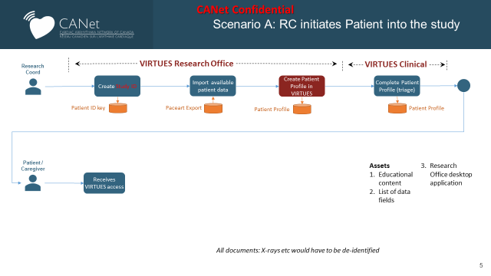

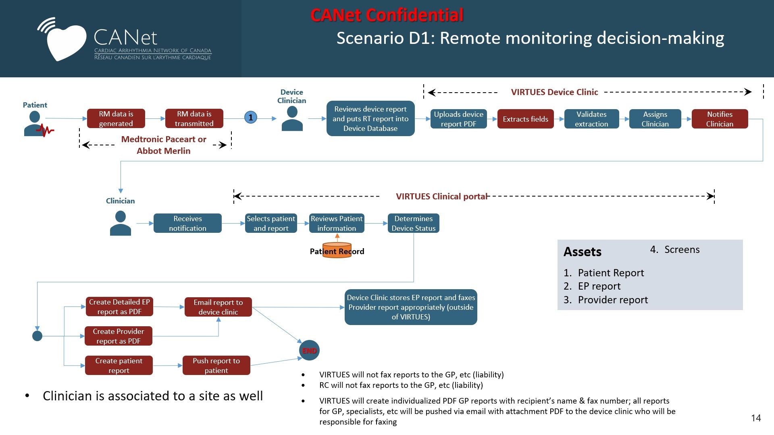

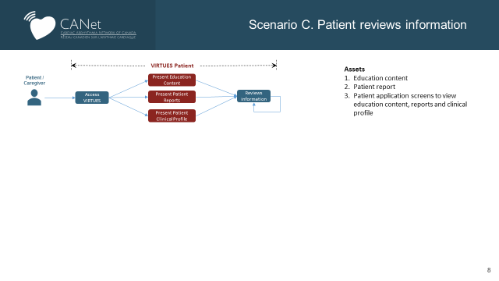

Appendix 3: Substudy in Rural, Remote and Isolated Patients

Primary investigator
This substudy will be led by Shannon Kelly, PhD (c), University of Ottawa, School of Epidemiology and Public Health.

Rationale
Canada is a geographically diverse country that faces challenges in the delivery of high-quality, equitable, universal health care. Individuals living in rural, remote and isolated regions of Canada face unique challenges in accessing primary, specialty and emergency care compared to those in urban settings which contributes to healthcare disparities across many clinical areas. Telemedicine and other technology enabled health interventions have been used for many years in a variety of clinical, diagnostic and support settings to minimize these disparities and the patient and system burden associated with travel. In patients with cardiac arrhythmia issues, remote monitoring has been utilized for follow-up of cardiac implantable electronic devices (CIEDs)(e.g., pacemakers, implantable cardioverter defibrillators (ICDs), cardiac resynchronization therapy (CRT)). Remote monitoring has predominantly been used for ICD follow-up, although newer technology permits patients with compatible pacemakers to utilize remote models of care for their follow-up. Current consensus statements from the Canadian Heart Rhythm Society recommend a blended model of follow-up care employing both remote monitoring and in-clinic visits after device implant. Despite this, uptake across the Canada has been suboptimal and there is no pan-Canadian, uniform approach to remote monitoring of patients with CIEDs. This has led to inconsistencies in care and access to care which may be further exacerbated for patients in remote or isolated communities, or those living in Indigenous communities outside of urban communities.

Methods:
To classify participants according to their remoteness or accessibility, two methods will be applied:
- Using the participants’ postal code, we will use the Statistics Canada Postal CodeOM Conversion File (PCCF)²⁷ to find the participants’ 7-digit, numeric unique census subdivision (CSD) identifier. This unique CSD can then be used to find the value associated with the CSDs index of remoteness (Table 1, Figure 2).
- Enrolled patients will be asked to self-identify as living in a remote or isolated part of Canada (secondary analysis).
The remoteness indices value tied to the participants’ CSD will be used as a stratification factor in the study design to compare how individuals participating in the study self-identify according to remote, rural or urban status.
Table 1. Classification of the index of remoteness by population, score and natural breaks in the distribution.
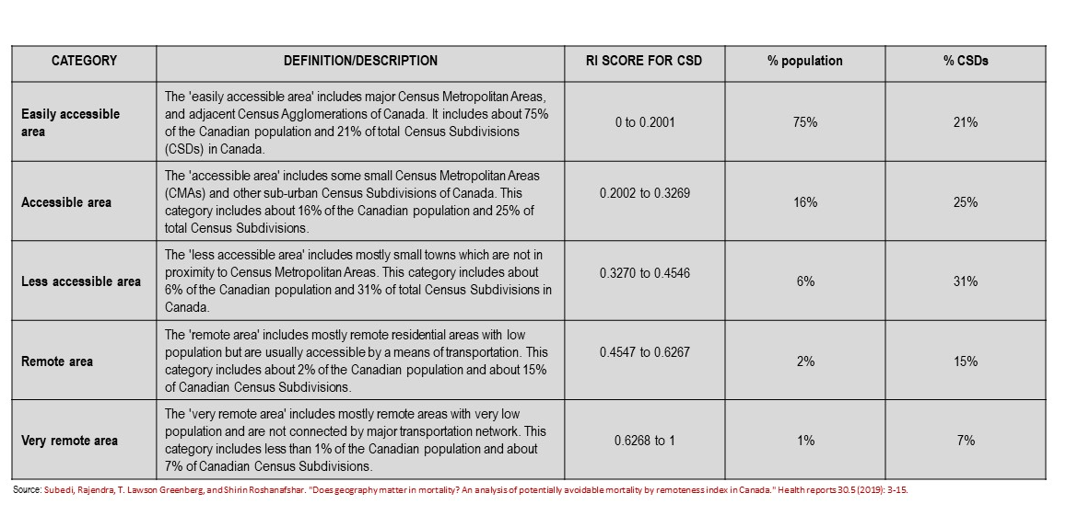

Key definitions
Definitions of rural and remote described in Canada and international organizations vary, and several approaches are described in the literature. There is limited consensus and all definitions provided are either too restrictive (which limits potentially useful data) or fail to adequately represent valid communities considered remote in their local context (e.g., Table 2.
Table 2. Definitions of ‘remote and isolated’ found in the literature²⁸
CADTH | “located a minimum of four hours away from hospital services by ground transportation, with or without road access”
The Organisation for Economic Co-operation and Development (OECD) | A community is considered remote if “at least 50% of its population needs to drive 60 minutes or more to reach a populated centre with more than 50,000 inhabitants.” The OECD notes that the use of this definition requires an accessibility analysis.
Natural Resources Canada | Remote communities are “permanent or long-term (five years or more) and is not currently connected to the North American electrical grid or to the piped natural gas network.”
Registered Nurses’ Association of Ontario and the Rural and Northern Health Care Panel | Have described communities as remote if they either do not have year-round road access or rely on third parties for transportation to a larger centre (e.g., by train, airplane, ferry). However, this definition would exclude remote communities that are very isolated from larger treatment facilities but do have road access.
Canadian Institute for Health Information (CIHI) | Defined “rural and remote” as small towns with a population less than 10,000, a definition that may be overly inclusive as there are some communities with a population less than 10,000 located in geographic proximity to large treatment facilities.
Canadian Association of Emergency Physicians | Uses various categories to define what might be considered remote health care settings, including “rural isolated” and “rural remote.
Statistics Canada created an Index of Remoteness (IOR), which aims to provide a pan-Canadian approach to distinguish urban, rural and remote areas.²⁹ Researchers who developed the index assigned a value to each census subdivision (CSD). This index measures the relative remoteness of Canadian communities (CSDs) on the basis of their size and their proximity to surrounding population centres and services. Considerations for communities with limited or no access to road networks have been made in these indices using ‘travel cost’ as an equitable account for the distance and time measures used comparably in communities with access to road networks. The IOR is a continuous scale (Figure 1), and its strength is that it can be categorized for the classification of Canadian communities by their relative remoteness. This substudy will apply the IOR classification used by Subeti et al. (2019) to distinguish rural and remote areas from urban areas in Canada (Table 1, Figure 2).
Figure 1. Spatial distribution of the index of remoteness for all census subdivision in Canada*
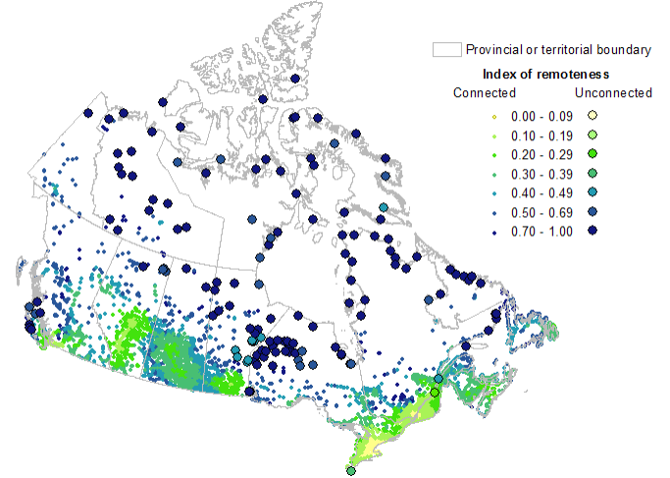
*each dot represents a unique CSD in Canada
Figure 2. Process for assigning remoteness indices to study participants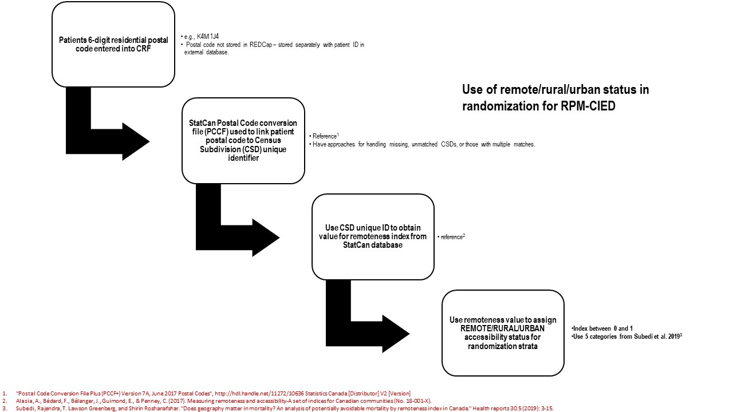
We aim to capture the data above for 100% of RPM-CIED TACHY participants.
Patient characteristics will be compared by remoteness classification. Primary analyses will compare the categories of remoteness for all participants as identified using the IOR for all study outcomes. Patients will be analysed within the group to which they were allocated, irrespective of whether they experienced the intended intervention (intention to treat analysis).
Secondary analyses will compare those who self-identified as rural, remote and urban in the CRF to their assigned IOR classification to see how results compare, using the free text comments for context and qualitative interpretation.

Appendix 4: CCS Heart Failure Therapy Guidelines
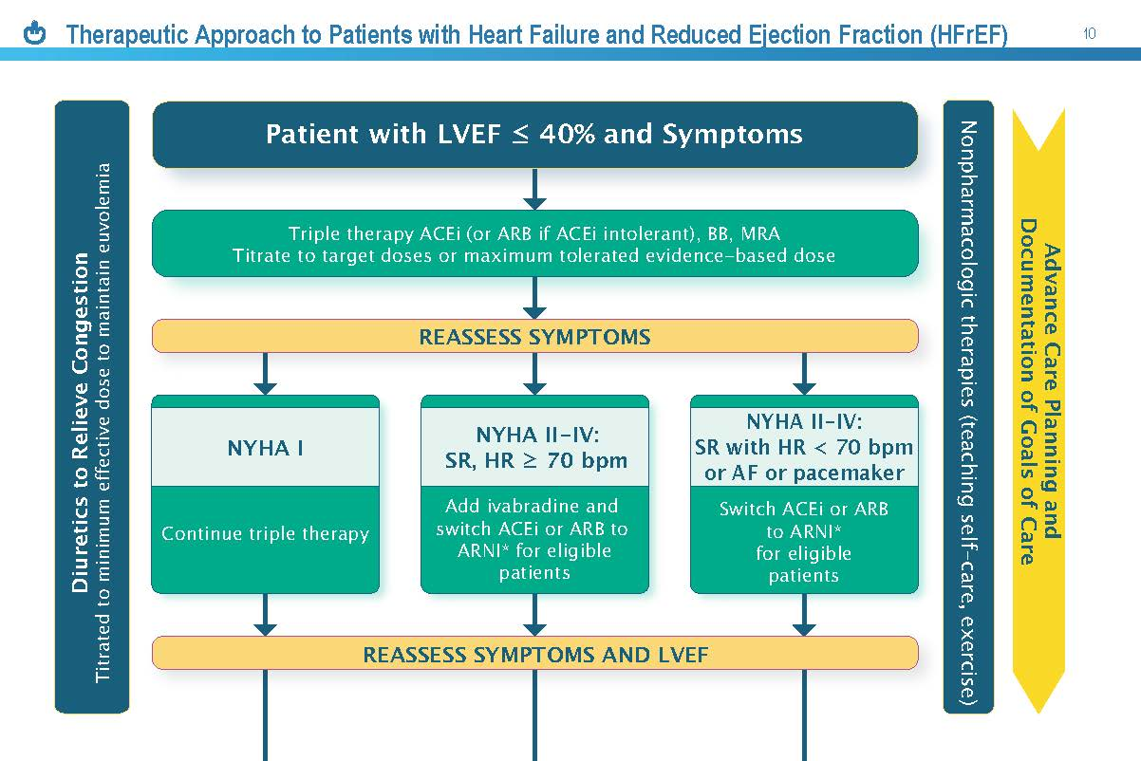
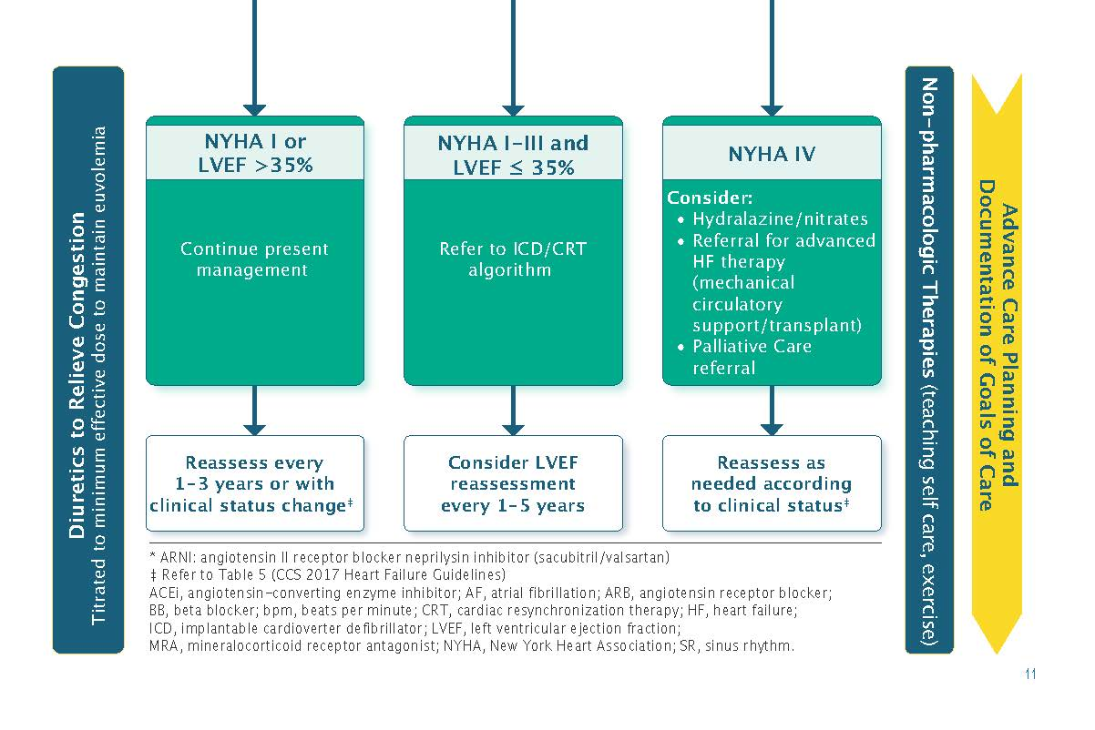

Appendix 4 (continued): CCS Heart Failure Therapy Guidelines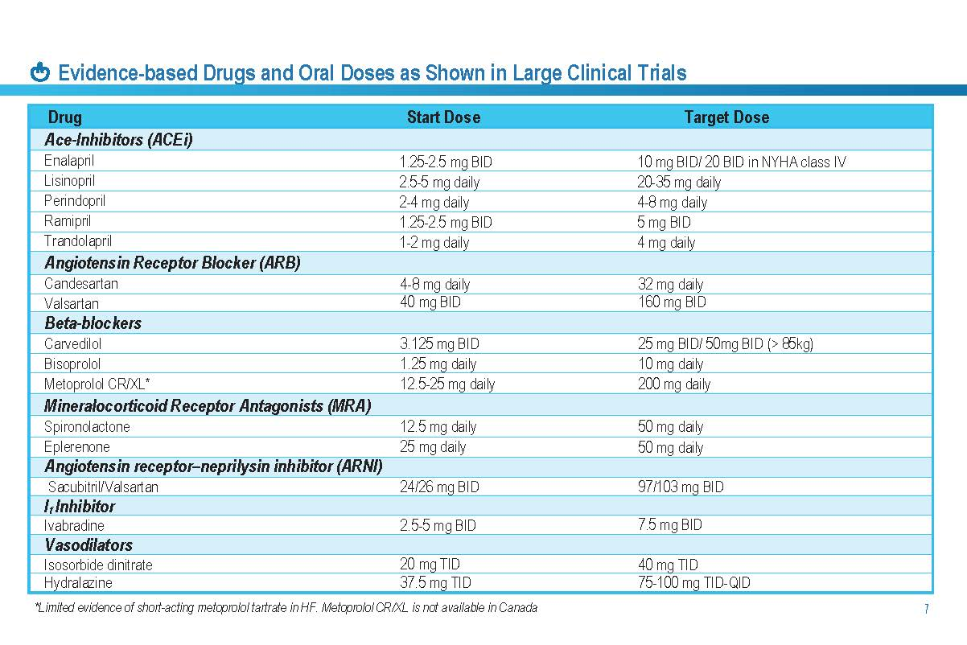

Reference List
(1) Rural Canada: Access to Health CAre. 2014. 2014.

(2) Yee R, Verma A, Beardsall M, Fraser J, Philippon F, Exner DV. Canadian Cardiovascular Society/Canadian Heart Rhythm Society joint position statement on the use of remote monitoring for cardiovascular implantable electronic device follow-up. Can J Cardiol 2013;29:644-51.
(3) Gillis AM. Expert commentary: how well has the call from Heart Rhythm Society/European Heart Rhythm Association for improved device monitoring been answered? Europace 2013;15 Suppl 1:i32-i34.
(4) Hauck M, Bauer A, Voss F, Weretka S, Katus HA, Becker R. "Home monitoring" for early detection of implantable cardioverter-defibrillator failure: a single-center prospective observational study. Clin Res Cardiol 2009;98:19-24.
(5) Joseph GK, Wilkoff BL, Dresing T, Burkhardt J, Khaykin Y. Remote interrogation and monitoring of implantable cardioverter defibrillators. J Interv Card Electrophysiol 2004;11:161-6.
(6) Lazarus A. Remote, wireless, ambulatory monitoring of implantable pacemakers, cardioverter defibrillators, and cardiac resynchronization therapy systems: analysis of a worldwide database. Pacing Clin Electrophysiol 2007;30 Suppl 1:S2-S12.
(7) Marzegalli M, Lunati M, Landolina M, Perego GB, Ricci RP, Guenzati G, Schirru M, Belvito C, Brambilla R, Masella C, Di SF, Valsecchi S, Santini M. Remote monitoring of CRT-ICD: the multicenter Italian CareLink evaluation--ease of use, acceptance, and organizational implications. Pacing Clin Electrophysiol 2008;31:1259-64.
(8) Nielsen JC, Kottkamp H, Zabel M, Aliot E, Kreutzer U, Bauer A, Schuchert A, Neuser H, Schumacher B, Schmidinger H, Stix G, Clementy J, Danilovic D, Hindricks G. Automatic home monitoring of implantable cardioverter defibrillators. Europace 2008;10:729-35.
(9) Raatikainen MJ, Uusimaa P, van Ginneken MM, Janssen JP, Linnaluoto M. Remote monitoring of implantable cardioverter defibrillator patients: a safe, time-saving, and cost-effective means for follow-up. Europace 2008;10:1145-51.
(10) Ricci RP, Morichelli L, Quarta L, Sassi A, Porfili A, Laudadio MT, Gargaro A, Santini M. Long-term patient acceptance of and satisfaction with implanted device remote monitoring. Europace 2010;12:674-9.
(11) Ricci RP, Morichelli L, Santini M. Remote control of implanted devices through Home Monitoring technology improves detection and clinical management of atrial fibrillation. Europace 2009;11:54-61.
(12) Ricci RP, Morichelli L, Santini M. Home monitoring remote control of pacemaker and implantable cardioverter defibrillator patients in clinical practice: impact on medical management and health-care resource utilization. Europace 2008;10:164-70.
(13) Sacher F, Probst V, Bessouet M, Wright M, Maluski A, Abbey S, Bordachar P, Deplagne A, Ploux S, Lande G, Jais P, Hocini M, Haissaguerre M, Le MH, Clementy J. Remote implantable cardioverter defibrillator monitoring in a Brugada syndrome population. Europace 2009;11:489-94.
(14) Schoenfeld MH, Compton SJ, Mead RH, Weiss DN, Sherfesee L, Englund J, Mongeon LR. Remote monitoring of implantable cardioverter defibrillators: a prospective analysis. Pacing Clin Electrophysiol 2004;27:757-63.
(15) Theuns DA, Rivero-Ayerza M, Knops P, Res JC, Jordaens L. Analysis of 57,148 transmissions by remote monitoring of implantable cardioverter defibrillators. Pacing Clin Electrophysiol 2009;32 Suppl 1:S63-S65.
(16) Varma N, Stambler B, Chun S. Detection of atrial fibrillation by implanted devices with wireless data transmission capability. Pacing Clin Electrophysiol 2005;28 Suppl 1:S133-S136.
(17) Crossley GH, Chen J, Choucair W, Cohen TJ, Gohn DC, Johnson WB, Kennedy EE, Mongeon LR, Serwer GA, Qiao H, Wilkoff BL. Clinical benefits of remote versus transtelephonic monitoring of implanted pacemakers. J Am Coll Cardiol 2009;54:2012-9.
(18) Halimi F, Clementy J, Attuel P, Dessenne X, Amara W. Optimized post-operative surveillance of permanent pacemakers by home monitoring: the OEDIPE trial. Europace 2008;10:1392-9.
(19) Al-Khatib SM, Piccini JP, Knight D, Stewart M, Clapp-Channing N, Sanders GD. Remote monitoring of implantable cardioverter defibrillators versus quarterly device interrogations in clinic: results from a randomized pilot clinical trial. J Cardiovasc Electrophysiol 2010;21:545-50.
(20) Bikou O, Licka M, Kathoefer S, Katus HA, Bauer A. Cost savings and safety of ICD remote control by telephone: a prospective, observational study. J Telemed Telecare 2010;16:403-8.
(21) Crossley GH, Boyle A, Vitense H, Chang Y, Mead RH. The CONNECT (Clinical Evaluation of Remote Notification to Reduce Time to Clinical Decision) trial: the value of wireless remote monitoring with automatic clinician alerts. J Am Coll Cardiol 2011;57:1181-9.
(22) Varma N, Epstein AE, Irimpen A, Schweikert R, Love C. Efficacy and safety of automatic remote monitoring for implantable cardioverter-defibrillator follow-up: the Lumos-T Safely Reduces Routine Office Device Follow-up (TRUST) trial. Circulation 2010;122:325-32.
(23) Guedon-Moreau L, Lacroix D, Sadoul N, Clementy J, Kouakam C, Hermida JS, Aliot E, Boursier M, Bizeau O, Kacet S. A randomized study of remote follow-up of implantable cardioverter defibrillators: safety and efficacy report of the ECOST trial. Eur Heart J 2013;34:605-14.
(24) Mabo P, Victor F, Bazin P, Ahres S, Babuty D, Da CA, Binet D, Daubert JC. A randomized trial of long-term remote monitoring of pacemaker recipients (the COMPAS trial). Eur Heart J 2012;33:1105-11.
(25) Varma N, Michalski J, Stambler B, Pavri BB. Superiority of automatic remote monitoring compared with in-person evaluation for scheduled ICD follow-up in the TRUST trial-testing execution of the recommendations. Eur Heart J 2014.
(26) Ware JE. Sf-36 health survey manual and interpretation guide. Boston: The Health Institue, New England Medical Centre; 1993.

(27) "Postal Code Conversion File Plus (PCCF+) Version 7A, June 2017 Postal Codes", http://hdl.handle.net/11272/10636 Statistics Canada [Distributor] V2 [Version]; last accessed July 12, 2019.

(28) Characteristics of remote and isolated health care facilities: an environmental scan. Ottawa: CADTH; 2018. (Environmental scan; no. 73).

(29) Alasia, A., Bédard, F., Bélanger, J., Guimond, E., & Penney, C. (2017). Measuring remoteness and accessibility-A set of indices for Canadian communities (No. 18-001-X).

(30) Subedi, Rajendra, T. Lawson Greenberg, and Shirin Roshanafshar. "Does geography matter in mortality? An analysis of potentially avoidable mortality by remoteness index in Canada." Health reports 30.5 (2019): 3-15.

1. Glick HA. Sample size and power for cost-effectiveness analysis (part 1). PharmacoEconomics. 2011;29:189-98.
2. Sapp JA, Gillis AM, AbdelWahab A, Nault I, Nery PB, Healey JS, Raj SR, Lockwood E, Sterns LD, Sears SF, Wells GA, Yee R, Philippon F, Tang A and Parkash R. Remote-only monitoring for patients with cardiac implantable electronic devices: a before-and-after pilot study. CMAJ Open. 2021;9:E53-E61.
3. Li Y, Wang X, Wang D and Offen W. Applications of general multistage gatekeeping and graphical multiple testing strategies in a clinical trial setting. Contemporary clinical trials. 2019;76:9-15.

