Supplementary Material
Supplemental Figures
The figures below show representative sessions flagged by the automated IQM outlier-detection procedure (Section 2.6) for each MRIQC metric. Note: examples below are currently drawn from a single selection pass; paired random and near-threshold examples for every metric. If only one image is shown, it means the near-threshold and at random were chosen for the same subject, or there are too few outliers to show more than one example subject. For the T1w IQMs, the Freesurfer recon-all surface reconstruction image is shown where the pial surface (blue) and cortical surface (red) lines are shown, and red arrows point to areas of low quality. For the BOLD IQMs, carpet plots of the time-series are shown.
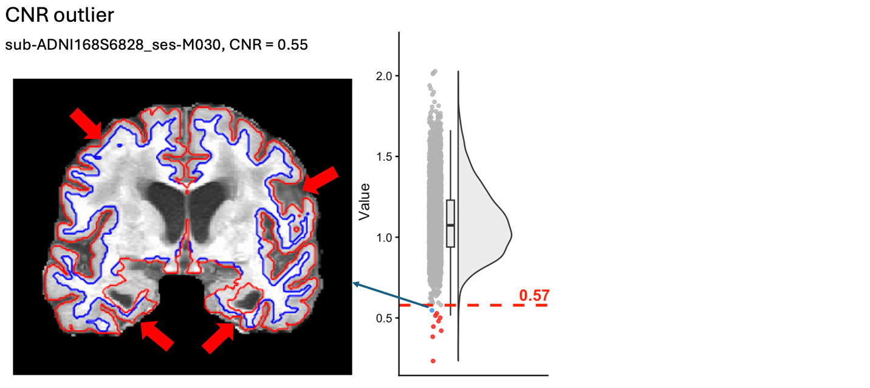Supplementary Figure 1. Example T1w session flagged as a Contrast-to-Noise Ratio (CNR) outlier. The figure on the left is the blue dot near the outlier threshold.
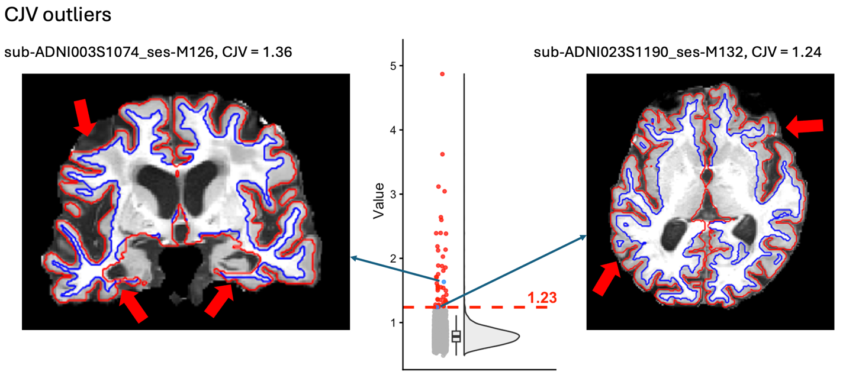Supplementary Figure 2. Example T1w sessions flagged as Coefficient of Joint Variation (CJV) outliers.
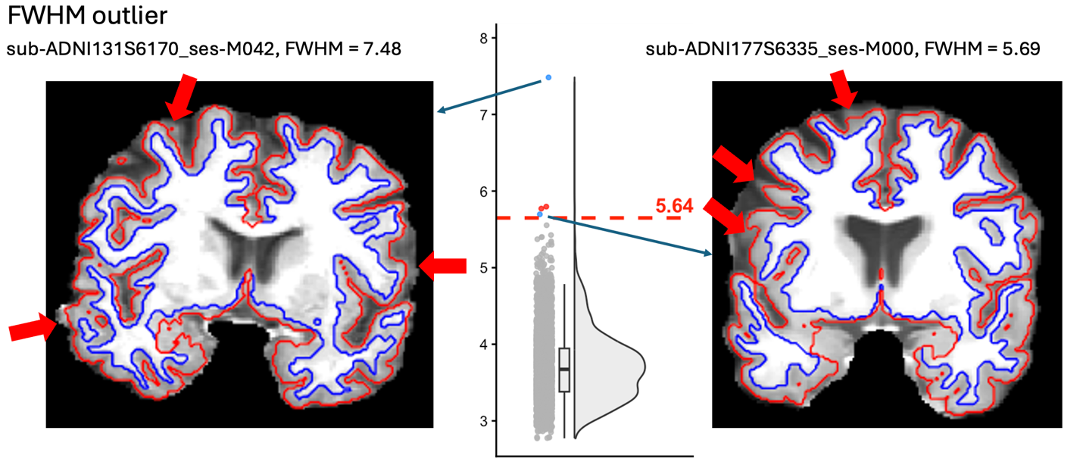Supplementary Figure 3. Example T1w sessions flagged as a Full Width at Half Maximum (FWHM) outlier.
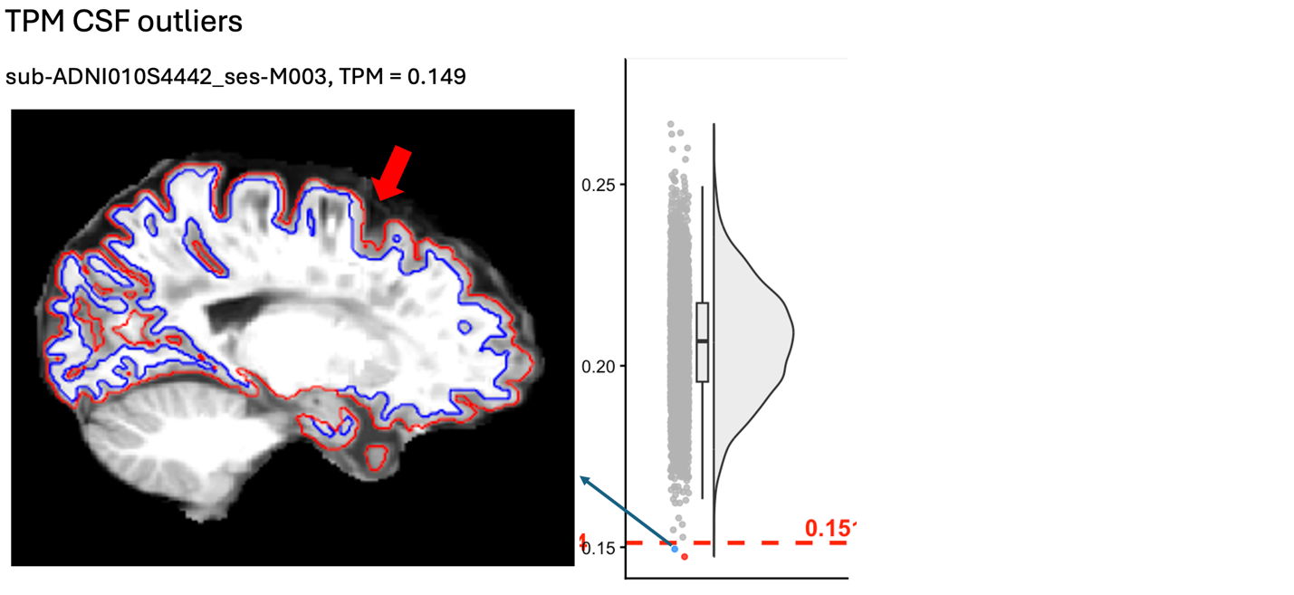
Supplementary Figure 4. Example T1w session flagged as a Tissue Probability Map (TPM) overlap outlier.

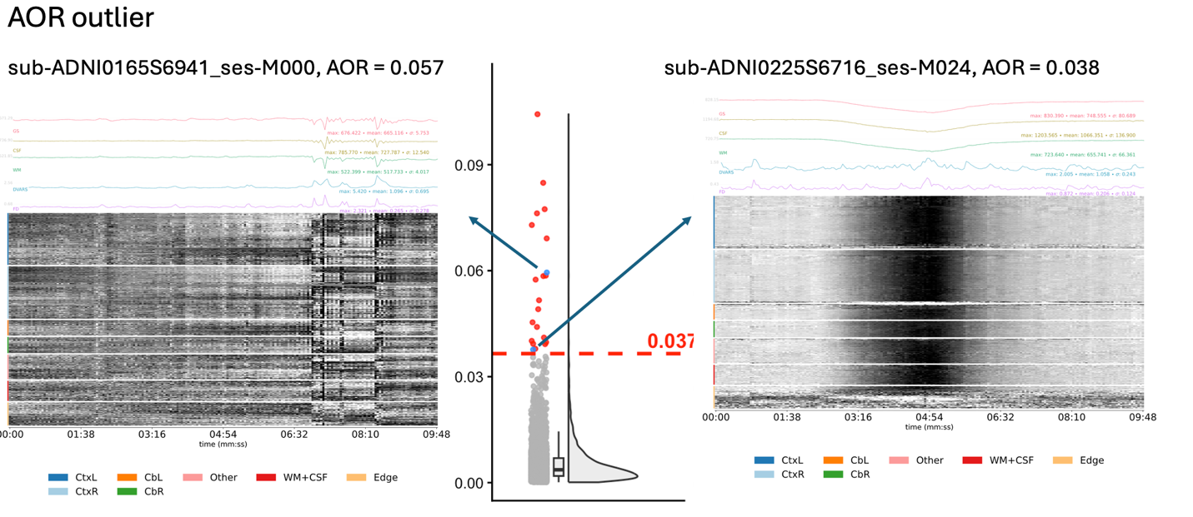Supplementary Figure 5. Example BOLD session flagged as an AFNI outlier ratio (AOR) outlier, shown as a carpet plot with DVARS and FD traces.

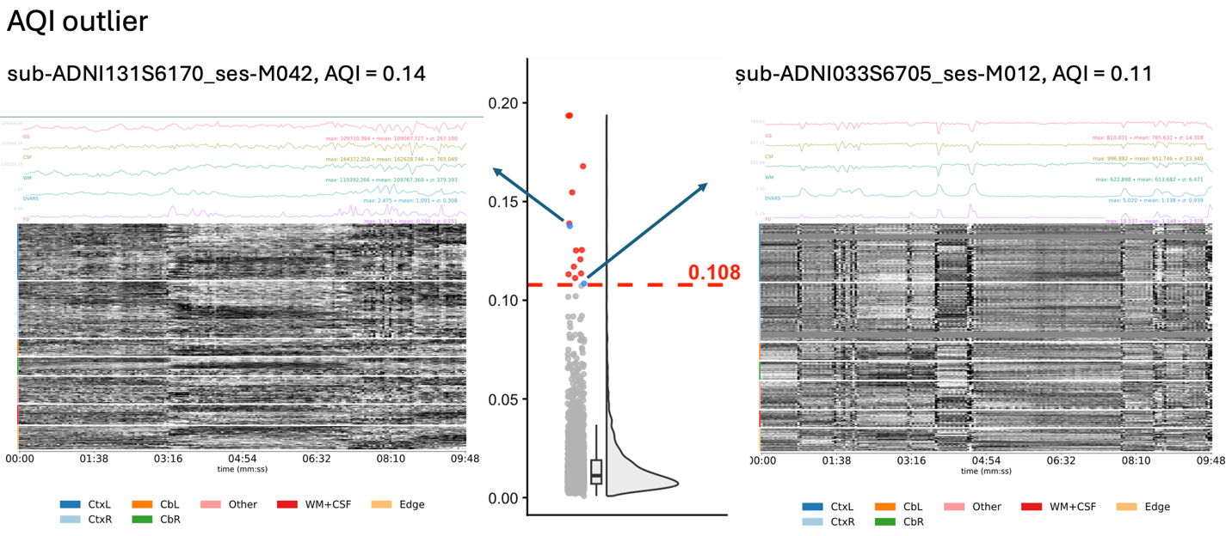
Supplementary Figure 6. Example BOLD session flagged as an AFNI quality index (AQI) outlier, shown as a carpet plot with DVARS and FD traces.

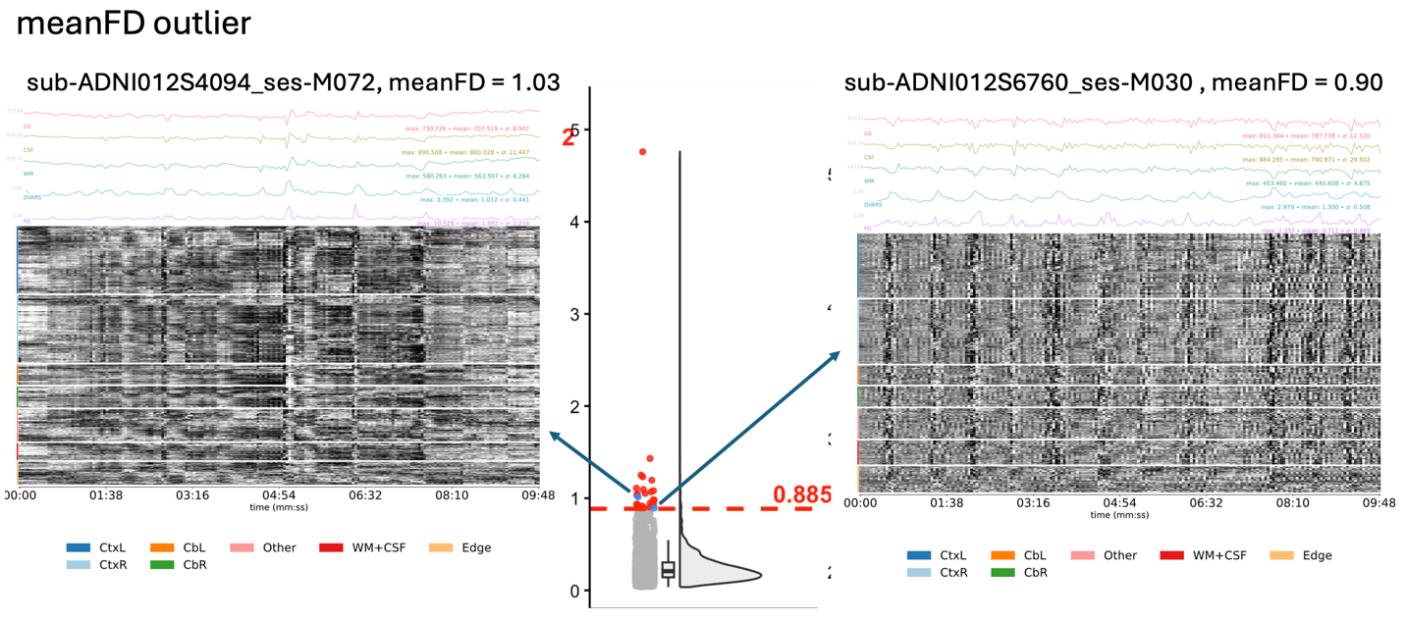Supplementary Figure 7. Example BOLD sessions flagged as a mean Framewise Displacement (meanFD) outlier, shown as a carpet plot with DVARS and FD traces.

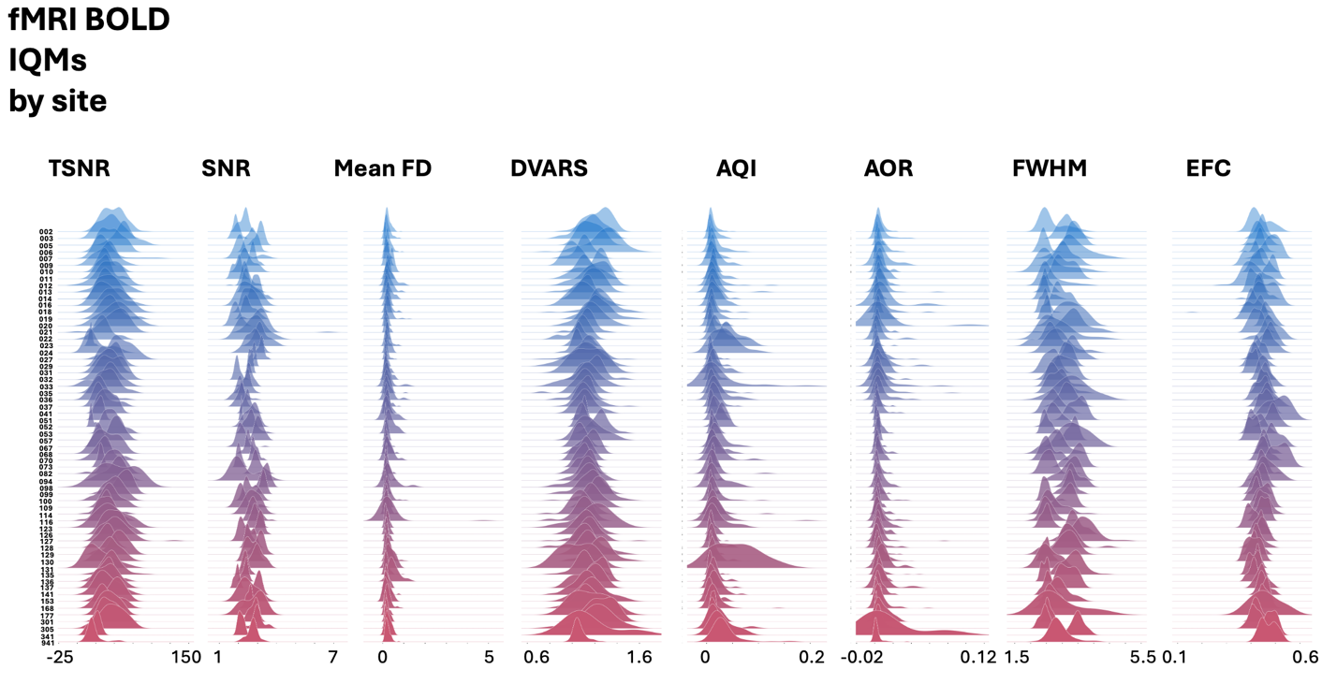Supplementary Figure 8. Distribution of BOLD image quality metrics (IQMs) by site.

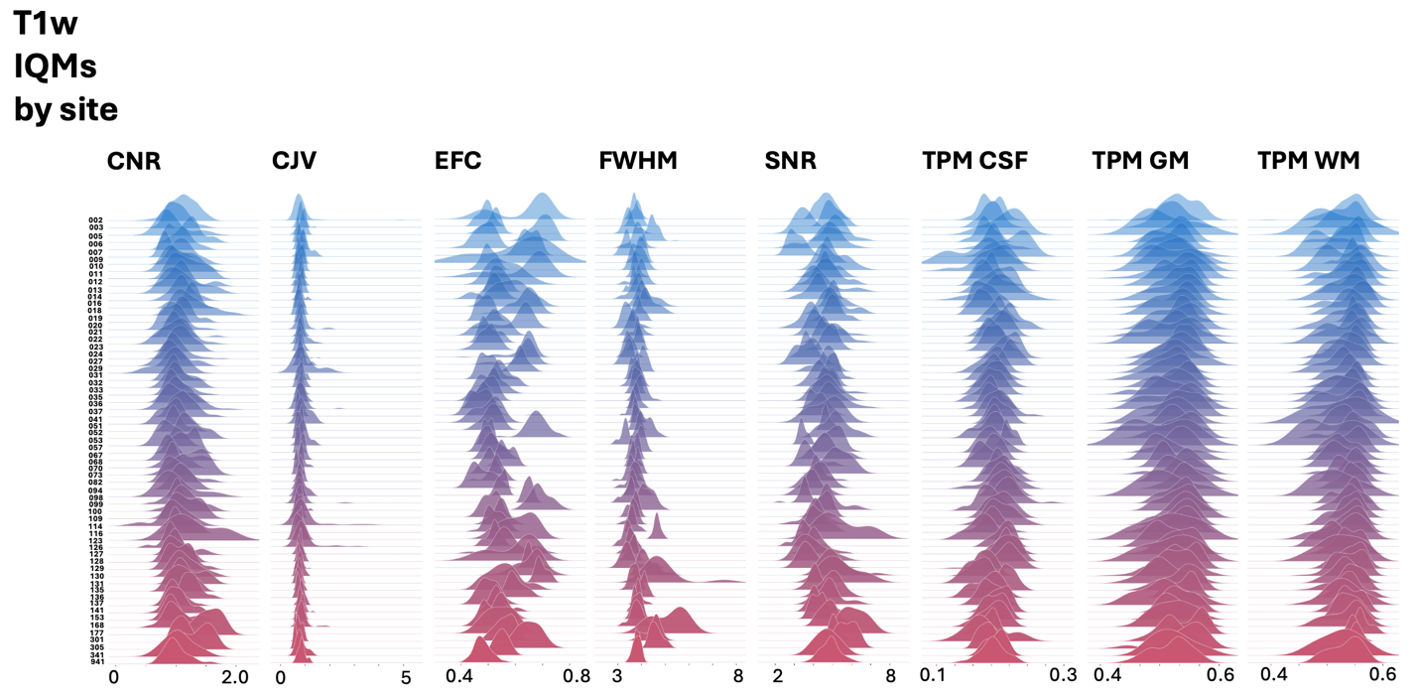Supplementary Figure 9. Distribution of T1w image quality metrics (IQMs) by site.

Supplemental Methods
PubMed Search Strategy
The publication count (Figure 1) was obtained from a PubMed search using the terms "Alzheimer's Disease Neuroimaging Initiative" AND ("fMRI" OR "functional MRI" OR "rsfMRI" OR "resting state"), restricted to records dated through June 2026. Once the list of papers was compiled from PubMed, a research assistant reviewed all papers to confirm a) that the paper used ADNI rs-fMRI data and b) the reported sample size. The exact database of papers (including metadata (i.e., journal, publication date, and author) and their reported sample sizes is included as a supplemental file (ADNI_pubmed_rsfmri_papers.csv).

FMRIPrep preprocessing methods
Anatomical preprocessing
The T1 image for each subject is corrected for intensity non-uniformity (INU) with N4BiasFieldCorrection (Tustison et al., 2010), distributed with ANTs 2.6.2 (Avants et al., 2008), and used as T1 reference throughout the workflow. The T1 reference is then skull-stripped with a Nipype implementation of the antsBrainExtraction.sh workflow (from ANTs), using OASIS30ANTs as target template. Brain tissue segmentation of cerebrospinal fluid (CSF), white-matter (WM) and gray-matter (GM) is performed on the brain-extracted T1 using FSL fast (Zhang et al., 2001). Brain surfaces are reconstructed using recon-all (FreeSurfer 7.3.2) (Dale et al., 1999), and the brain mask estimated previously is refined with a custom variation of the method to reconcile ANTs-derived and FreeSurfer-derived segmentations of the cortical gray-matter of Mindboggle (Klein et al., 2017). A FLAIR image is used to improve pial surface refinement. Brain surfaces are reconstructed using recon-all (FreeSurfer 7.3.2) (Dale et al., 1999), and the brain mask estimated previously was refined with a custom variation of the method to reconcile ANTs-derived and FreeSurfer-derived segmentations of the cortical gray-matter of Mindboggle (Klein et al., 2017). Volume-based spatial normalization to two standard spaces (MNI152NLin6Asym, MNI152NLin2009cAsym) is performed through nonlinear registration with antsRegistration (ANTs 2.6.2), using brain-extracted versions of both T1 reference and the T1 template. The following templates were selected for spatial normalization and accessed with TemplateFlow (Ciric et al., 2022) (25.0.4): FSL's MNI ICBM 152 non-linear 6th Generation Asymmetric Average Brain Stereotaxic Registration Model (Evans et al., 2012) [TemplateFlow ID: MNI152NLin6Asym], ICBM 152 Nonlinear Asymmetrical template version 2009c (Fonov et al., 2009) [TemplateFlow ID: MNI152NLin2009cAsym].
Functional preprocessing
First, a BOLD reference volume is generated for use in head motion correction. Head-motion parameters with respect to the BOLD reference (transformation matrices, and six corresponding rotation and translation parameters) are estimated before spatiotemporal filtering using FSL mcflirt (Jenkinson et al., 2002a). The BOLD reference is then co-registered to the T1 reference using bbregister (FreeSurfer), which implements boundary-based registration (Greve & Fischl, 2009). Co-registration is configured with six degrees of freedom.
Several confounding time series are calculated based on the preprocessed BOLD: framewise displacement (FD), DVARS, and three region-wise global signals. FD is computed using two formulations: the Power formulation (absolute sum of relative motions) (Power et al., 2014) and the Jenkinson formulation (relative root-mean-square displacement between affines) (Jenkinson et al., 2002b). FD and DVARS are calculated for each functional run, both using their implementations in Nipype (following the definitions by Power (Power et al., 2014)). The three global signals are extracted within the CSF, the WM, and the whole-brain masks.
Additionally, a set of physiological regressors are extracted to allow for component-based noise correction (CompCor (Behzadi et al., 2007)). Principal components are estimated after high-pass filtering the preprocessed BOLD time series (using a discrete cosine filter with 128s cut-off) for the two CompCor variants: temporal (tCompCor) and anatomical (aCompCor). tCompCor components were calculated from the top 2% variable voxels within the brain mask. For aCompCor, three probabilistic masks (CSF, WM and combined CSF+WM) are generated in anatomical space. The implementation in fMRIprep differs from that of Behzadi et al. (Behzadi et al., 2007) in that, instead of eroding the masks by 2 pixels on BOLD space, a mask of pixels that likely contain a volume fraction of GM is removed from the WM and CSF masks. This mask is obtained by dilating a GM mask extracted from the FreeSurfer's aseg segmentation, and it ensures components are not extracted from voxels containing a pre-set minimal fraction of GM. Finally, these masks are resampled into BOLD space and binarized by thresholding at 0.99 (as in the original implementation). Components are also calculated separately within the WM and CSF masks. For each CompCor decomposition, the k components with the largest singular values are retained, such that the retained components' time series are sufficient to explain 50 percent of the variance across the nuisance mask. The remaining components are dropped from consideration.
The head-motion estimates calculated in the correction step are also placed within the corresponding confounds file. The confound time series derived from head motion estimates and global signals are expanded with the inclusion of temporal derivatives and quadratic terms for each (Satterthwaite et al., 2013). Frames that exceed a threshold of 0.5 mm FD or 1.5 standardized DVARS are annotated as motion outliers. Additional nuisance timeseries are calculated by means of principal components analysis of the signal found within a thin band (crown) of voxels around the edge of the brain, as proposed by Patriat et al. (Patriat et al., 2017).
The BOLD time series are resampled onto the following surfaces (Freesurfer reconstruction nomenclature): fsnative, fsaverage5, fsLR. The BOLD time series are resampled from T1 native (subject-specific) volumetric space into surface native (subject-specific) space, and then the surface native mesh is resampled onto the left/right-symmetric group-level template "fsLR" using the Connectome Workbench (Glasser et al., 2013). Grayordinates files (Glasser et al., 2013) containing 91k cortical and subcortical coordinates are also generated with surface data transformed directly to fsLR space and subcortical data transformed to 2 mm resolution MNI152NLin6Asym space. All resamplings can be performed with a single interpolation step by composing all the pertinent transformations (i.e., head-motion transform matrices, susceptibility distortion correction when available, and co-registrations to anatomical and output spaces). Gridded (volumetric) resamplings are performed using nitransforms, configured with cubic B-spline interpolation. Non-gridded (surface) resamplings are performed using mri_vol2surf (Freesurfer).

ADNI specific fMRIPrep preprocessing errors

Missing BOLD file errors occur when subjects have multiple session directories but only a subset contain functional data (e.g., ses-M000/, ses-M006/, ses-M012/, ses-M048/, ses-M096/, with BOLD present only in later sessions). To prevent fMRIPrep failures in these cases, the pipeline explicitly inspects session directories prior to submission and dynamically restricts fMRIPrep execution to sessions that contain valid BOLD files. As a result, fMRIPrep jobs are only launched for subject–session pairs that meet minimum data requirements. This logic is implemented in the s7_fmriprep/fMRIPrep_rerun_array.slurm script and is applied uniformly across all subjects.

TemplateFlow binding and memory-related errors affect only three subjects in our data download. These errors are resolved by adjusting resource allocation and ensuring that the TemplateFlow directory is correctly mounted inside the container. The provided fMRIPrep execution scripts automatically download and bind the TemplateFlow directory, allowing these cases to be successfully reprocessed without further intervention.

FreeSurfer recon-all failures reflect unrecoverable errors in cortical surface reconstruction, most likely due to low-quality anatomical data. Subjects with these failures are excluded from downstream analyses, as these errors cannot be reliably corrected.

Syn-sdc failures are caused by missing or invalid PhaseEncodingDirection metadata in the BOLD JSON files, which is common for certain ADNI acquisitions (primarily from Philips scanners). Because PhaseEncodingDirection is required for fieldmap-less distortion correction, these runs fail when syn-sdc is enabled. Our error classification automatically detects this condition (find_syn_pedir_failures.py) and re-runs affected subjects without the –use-syn-sdc flag using s7_fmriprep/fMRIPrep_rerun_synflag_array.slurm. Users may choose to exclude these subjects due to these differences in preprocessing; however, we retain them in the final dataset, as ADNI already contains unavoidable heterogeneity in acquisition parameters and available anatomical images (e.g., presence or absence of T2 scans).

