Modifying the Surface of Silica-Coated Magnesium Cobalt Ferrite with Curcumin to Eliminate Pb(II) and Cd(II) from
Different Environmental Water Samples

Hawar J. Sadiq Hawezy, Layth I. Abd Ali *
Department of Chemistry, Faculty of Science and Health, Koya University, Koya 44023, Kurdistan Region – F.R., Iraq
* Corresponding authors.
E-mail address:
layth.imad@koyauniversityorg (L. I. Abd Ali), ORCID: https://orcid.org/0000-0002-5948-2513

Table S1
The parameters obtained from XRD analysis.
Samples | D_{XRD} (nm) | d-spacing (Å) | Lattice Parameter (Å) | Vcell (Å)
MgCoFe₂O₄ | 19.04 | 2.56 | 8.41 | 595
MgCoFe₂O₄@SiO₂-CPTMS-Cur | 13.03 | 2.53 | 8.36 | 584

Table S2
Ionic compositions for several real water samples (tap water, surface water and lake water)
Types of ionic species | Tap water  (mM) | Surface water  (mM) | Lake water  (mM)
Na⁺ | 0.90 | 0.38 | 0.68
K⁺ | 0.09 | 0.07 | 0.40
Ca²⁺ | 0.36 | 0.62 | 0.79
Mg²⁺ | 0.51 | 0.28 | 0.71
Cl⁻ | 0.98 | 0.21 | 1.41
Zn²⁺ | 0.01 | 0.05 | 0.28
NO₃⁻ | — | 0.02 | 1.52
SO₄⁻ | 0.04 | 0.08 | 1.29

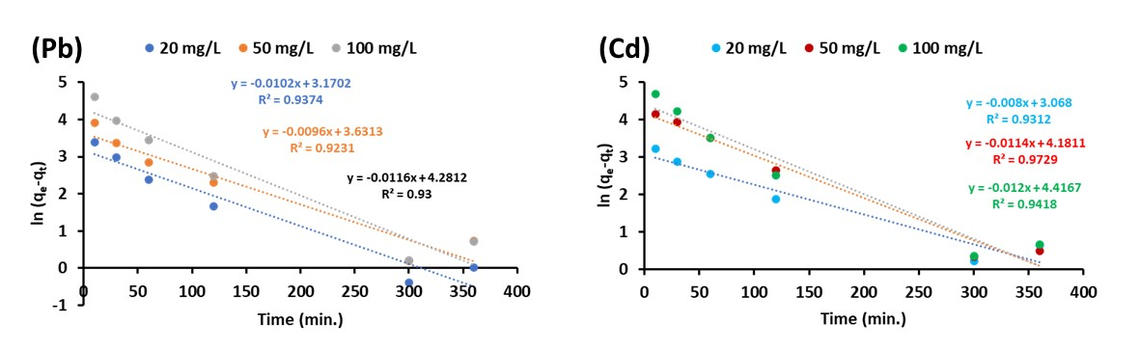
Fig. S1: Pseudo-first-order model plots of adsorption kinetics for Pb(II) and Cd(II) metal ions for MgCF@SiO₂-CPTMS-Cur adsorbent.

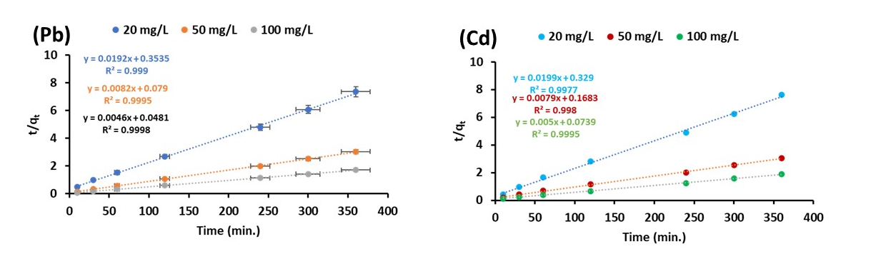
Fig. S2: Pseudo-second-order model plots of adsorption kinetics for Pb(II) and Cd(II) metal ions for MgCF@SiO₂-CPTMS-Cur adsorbent.

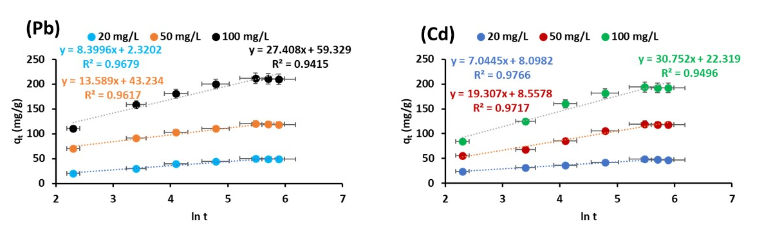
Fig. S3: Elovich model plots of adsorption kinetics for Pb(II) and Cd(II) metal ions for MgCF@SiO₂-CPTMS-Cur adsorbent.

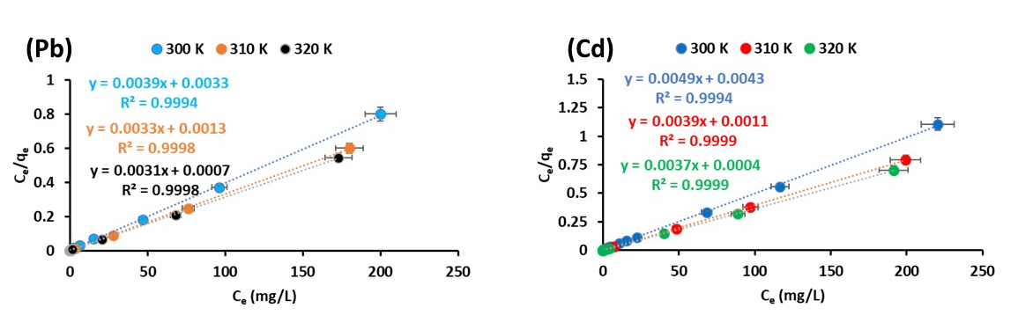
Fig. S4: Langmuir model plots of adsorption isotherm for Pb(II) and Cd(II) metal ions for MgCF@SiO₂-CPTMS-Cur adsorbent.

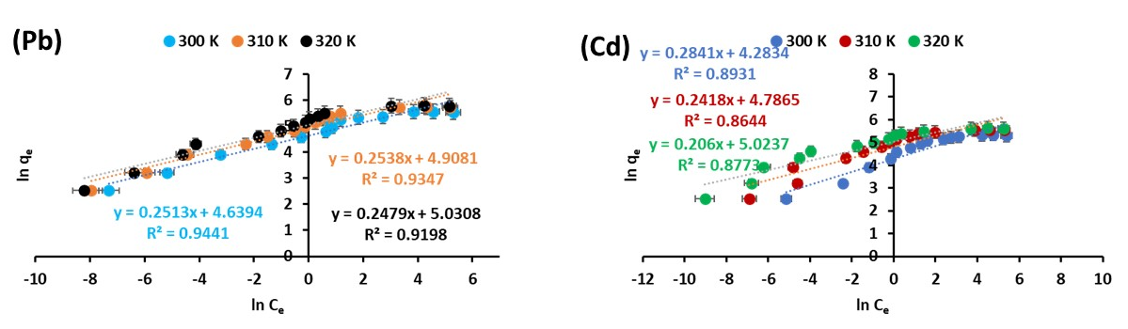
Fig. S5: Freundlich model plots of adsorption isotherm for Pb(II) and Cd(II) metal ions for MgCF@SiO₂-CPTMS-Cur adsorbent.

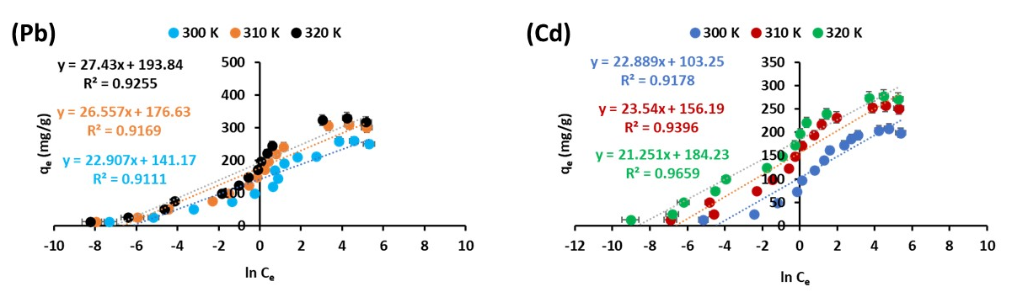
Fig. S6: Temkin model plots of adsorption isotherm for Pb(II) and Cd(II) metal ions for MgCF@SiO₂-CPTMS-Cur adsorbent.

a)
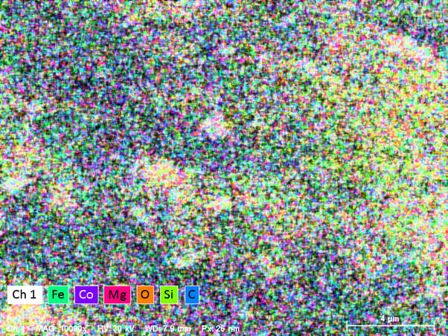
b)
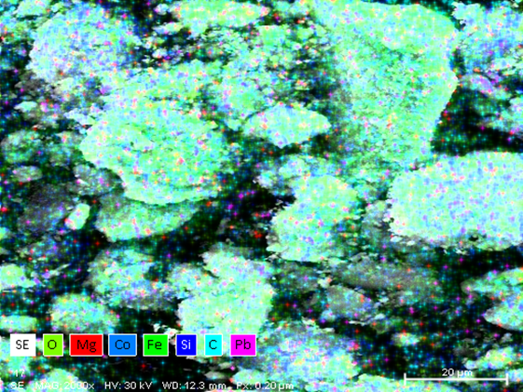

c)
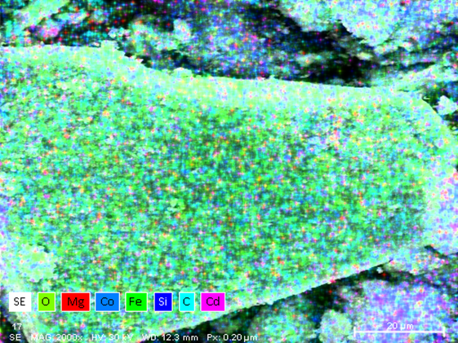

Fig. S8. Elemental maps of MgCF@SiO₂-CPTMS-Cur (a) before adsorption (b) after Pb ion adsorption and (c) after Cd ion adsorption.

