Supplementary Table 1: Names and sequences of primers for Plasmodium infection characterisation by nested PCR
Name of primers | Sequences of primers (5' ------3') | Expected size (bp) | Amplification conditions | References
rPLU6 | TTA AAA TTG TTG CAG TTA AAA CG | 1200 | 95°C for 5 min (1X) ; 94°C for 30 s; 55°C for 1 min; 68°C for 1 min (35x); 68°C 1 min (1X) | Snounou et al. (1993)
rPLU5 | CCT GTT GTT GCC TTA AAC TTC | 1200 |  | Snounou et al. (1993)
rFAL1 | TTA AAC TGG TTT GGG AAA ACC AAA TAT ATT | 205 | 95°C for 5 min (1X) ; 94°C for 30 s; 58°C for 1 min; 68°C for 1 min (35x); 68°C 5 min (1X) | Snounou et al. (1993)
rFAL2 | ACA CAA TGA ACT CAA TCA TGA CTA CCC GTC | 205 |  | Snounou et al. (1993)
rMAL1 | ATA ACA TAG TTG TAC GTT AAG AAT AAC CGC | 140 |  | Snounou et al. (1993)
rMAL2 | AAA ATT CCC ATG CAT AAA AAA TTA TAC AAA | 140 |  | Snounou et al. (1993)
rOva1 | ATCTCTTTTGCTATTTTTTAGTATTGGAGA | 800 |  | Snounou et al. (1993)
rOva2 | GGAAAAGGACACATTAATTGTATCCTAGTG | 800 |  | Snounou et al. (1993)
rOviv1 | CGCTTCTAGCTTAATCCACATAACTGATAC | 120 |  | Snounou et al. (1993)
rOviv2 | ACTTCCAAGCCGAAGCAAAGAAAGTCCTTA | 120 |  | Snounou et al. (1993)

S2 Table. Names and sequences of primers and probes for Plasmodium infection characterization by nested qPCR
Name of primers | Sequences of primers (5' ------3') | 5' | 3'
Name of primers | Sequences of primers (5' ------3') | Modification | Modification |  | Genus/Species
rPLU6 | TTA AAA TTG TTG CAG TTA AAA CG |  |  |  | Plasmodium
rPLU5 | CCT GTT GTT GCC TTA AAC TTC |  |  |  | Plasmodium
Pf-1 | ﻿ATTGCTTTTGAGAGGTTTTGTTACTTT |  |  |  | P. falciparum
Pf-2 | ﻿GCTGTAGTATTCAAACACAATGAACTCAA |  |  |  | P. falciparum
Pf-Probe | ﻿CATAACAGACGGGTAGTCAT | HEX | MGBEQ |  | P. falciparum
Pm-TFwd | ﻿GGTGTTGGATGATAGAGTAA |  |  |  | P. malariae
Pm-Trev | ﻿CCCAAAGACTTTGATTTCTC |  |  |  | P. malariae
Pm-Tprobe | ﻿AGGAAGCTATCTAAAAGAAACACTCAT | HEX | BHQ-1 |  | P. malariae
﻿PO-18S-S-Fwd | ﻿ATTTCAAAGAGTCATGGCGTTTCTG |  |  |  | P. ovale curtisi
﻿POC-18S-S-Rev | ﻿TTGTAAAGGAGACACTTTCTTGAAATCG |  |  |  | P. ovale curtisi
﻿POC-18S-S-Probe | ﻿CTCCTTGGTCGATCTGCCCAGCACT | FAM | BHQ-1 |  | P. ovale curtisi
﻿PO-18S-S-Fwd | ﻿ATTTCAAAGAGTCATGGCGTTTCTG |  |  |  | P. ovale walikeri
﻿POW-18S-S-Rev | ﻿TGTAAAGGAGACAACTTTCTTGGAGCTA |  |  |  | P. ovale walikeri
﻿POW-18S-S-Probe | ﻿TTGATCGCCCAGCACTGACCATCT | HEX | MGBEQ |  | P. ovale walikeri
VIV-F | ﻿GCAACGCTTCTAGCTTAATCCAC |  |  |  | P. vivax
VIV-R | ﻿CAAGCCGAAGCAAAGAAAGTCC |  |  |  | P. vivax
VIV-Probe | ﻿ACTTTGTGCGCATTTTGCTA | HEX | MGBEQ |  | P. vivax
HEX 6-hexachlorofluorescein. FAM 6-carboxyfluorescein. MGBEQ minor groove binder eclipse quencher. BHQ-1 black hole quencher-1.

S3 Table. Names and sequences of primers for P. malariae MSP-1 amplification by nested PCR
Region | Name of primers | Sequences of primers (5’…….3’) | Amplification conditions | Amplicon size (bp)
Fragment 1 | Frag1 N1-F | GCA TCT AAA TGG CTA CTG TGA TAT AC | 94°C 5min(1×);94°C 1min,57°C 2min,72°C 2min(25×); 72 °C 5 min (1×) | 595
Fragment 1 | Frag1 N1-R | GGC ATC TGT AAA TAG ACC ATC C |  | 595
Fragment 1 | Frag1 N2-F | TAA TGA AAA GGA ATT AGA AAT G | 94°C 5min(1×);94°C 1min,47°C 2min,72°C 2min(30×); 72 °C 5 min (1×) | 533
Fragment 1 | Frag1 N2-R | CCA TAT TGA ATA CTA TAT TTT TC |  | 533
Fragment 2 | Frag2 N1-F | CCA TAC TAT TTA ATT GCA CTA AAG | 94°C 5min(1×);94°C 1min,58°C 2min,72°C 2min(25×); 72 °C 5 min (1×) | 723
Fragment 2 | Frag2 N1-R | ACA CAC ATA AGC AGT TTT CAA AAA G |  | 723
Fragment 2 | Frag2 N2-F | AGG GAA ATT GAT AAA TTA AAT ATT TC | 94°C 5min(1×);94°C 1min,58°C 2min,72°C 2min(30×); 72 °C 5 min (1×) | 666
Fragment 2 | Frag2 N2-R | CTT TTC AAG ATA TTG CAA TTT GGA |  | 666
Fragment 3 | Frag3 N1-F | GCA ATG TTC TAC AAA ATC AGT ACA AAG | 94°C 5min (1×); 94°C 1min,56°C 2min,72°C 2min (25×); 72 °C 5 min (1×) | 765
Fragment 3 | Frag3 N1-R | CTA CAA AAG CTG CTA GTA CAT GTC T |  | 765
Fragment 3 | Frag3 N2-F | GAA GAA GAA TGA CAA ACT TAA AAA C | 94°C5min(1×);94°C1min,46°C2min,72°C2min(30×); 72 °C 5 min (1×) | 632
Fragment 3 | Frag3 N2-R | CTT TTA AAA TAC TAT ATT CTT TAA TAT G |  | 632
Fragment 4 | Frag4 N1-F | GAG GTG ATC GTG TTT CCC ATT G | 94°C 5min (1×); 94°C 1min,54°C 2min,72°C 2min (25×); 72 °C 5 min (1×) | 532
Fragment 4 | Frag4 N1-R | CAT TTT CAG TTT TTT TAT CAC CC |  | 532
Fragment 4 | Frag4 N2-F | GTA AGA AAG AAA AGG AAA ATC CAT TAG | 94°C 5min (1×);94°C 1min, 56°C 2min,72°C 2min (30×); 72 °C 5 min (1×) | 443
Fragment 4 | Frag4 N2-R | CTG AGT CTT GTA CAA CTT GGT |  | 443
Fragment 5 | Frag5 N1-F | GAC CAA GTT GTA CAA GAC TCA | 94°C 5min(1×); 94°C 1min,51°C 2min,72°C 2min (25×); 72 °C 5 min (1×) | 737
Fragment 5 | Frag5 N1-R | GTA AGT TAA ACA TAA TTA ATA AAG CTG |  | 737
Fragment 5 | Frag5 N2-F | GGG TGA TAA AAA AAC TGA AAA TG | 94°C 5min (1×); 94°C 1min, 49°C 2min, 72°C 2min (30×); 72 °C 5 min (1×) | 631
Fragment 5 | Frag5 N2-R | GCC GAG GAA ACT TGA AGA AC |  | 631
This size is estimated based on that of the sequence from isolate MM1 deposited in GenBank (#FJ824669), N1: Nested 1; N2: Nested 2

S4 Table. Comparison of the microscopic and sub-microscopic prevalence of Plasmodium spp.
Plasmodium spp. infections | Microscopic | Sub-microscopic
Plasmodium spp. infections | (n= 484) | (n= 402)
Overall prevalence % (n) | 17 (82) | 35.3 (142) **
Mono infection % (n) | 79 (16.3) | 120 (29.9)
Pf | 16.1 (78) | 23.9 (96)
Pm | 0.2 (1) | 6 (24)
Po | 0 (0) | 0 (0)
Co-infection % (n) | 0.6 (3) | 5.5 (22)
Pf +Pm | 0.6 (3) | 5 (20)
Pf + Pow | 0 (0) | 0.2 (1)
Pm + Po | 0 (0) | 0 (0)
Pf + Pm + Pow | 0 (0) | 0.2 (1)
Pf: P. falciparum, Pm: P. malariae, Po: P. ovale, Poc: P. ovale curtisi,
Pow: P. ovale walikeri

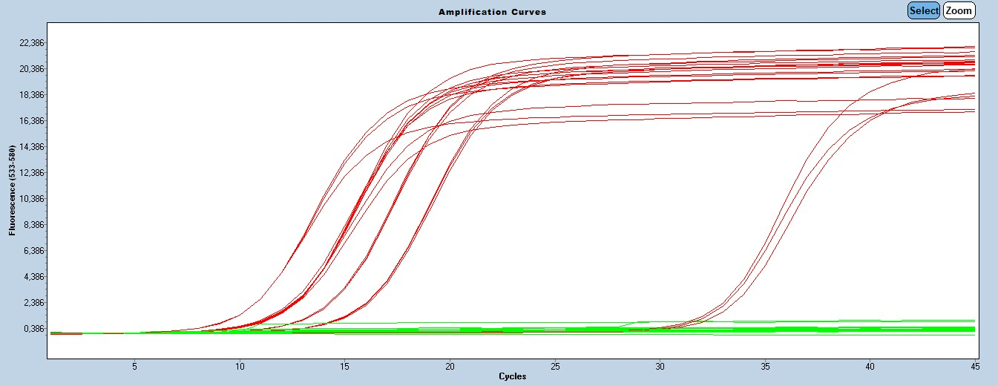
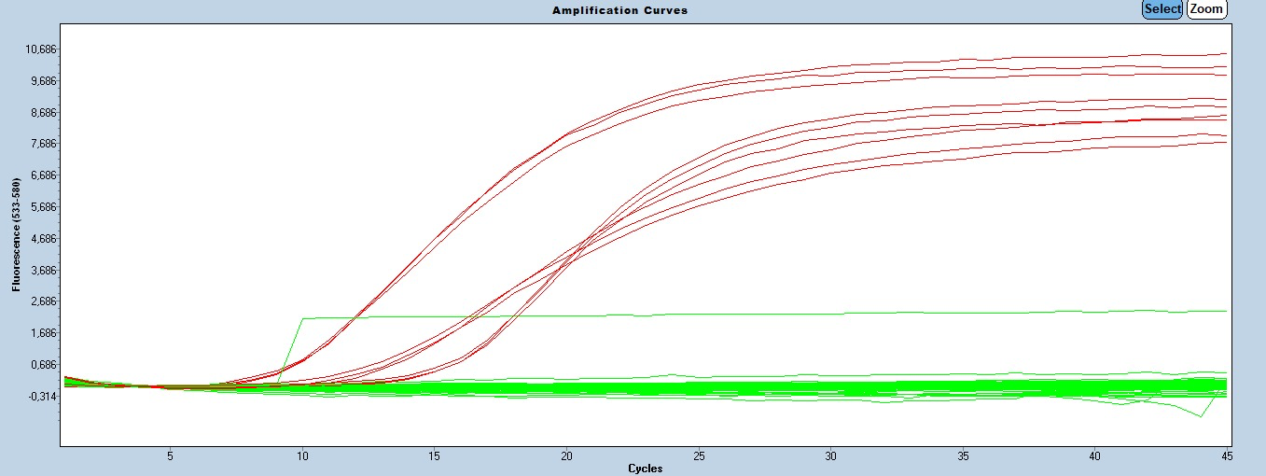
A.
B.

S1 Figure. Amplification curves of P. falciparum (A) and P. malariae (B). Positive samples and positive controls are shown in red, whereas negative samples and the negative control are shown in green, with no detectable amplification.

