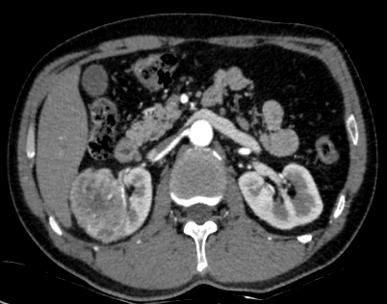
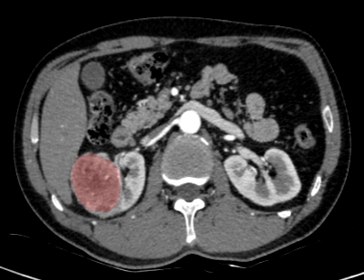
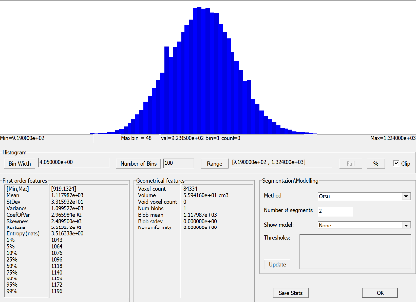
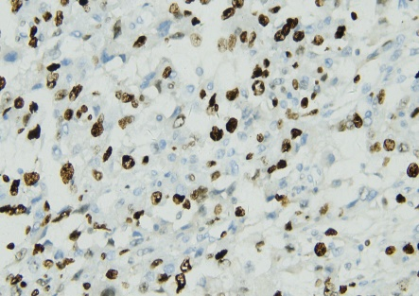
a
b
c
d

D

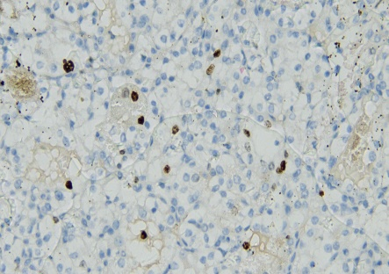
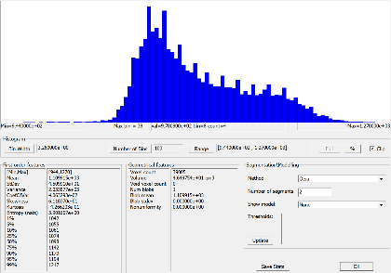
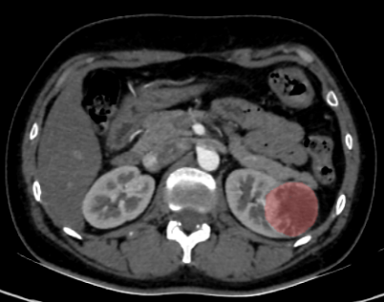
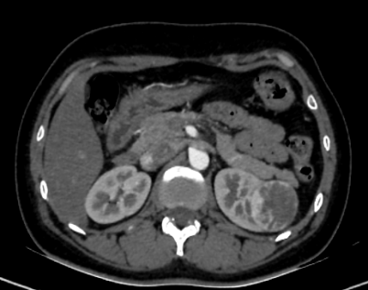
h
g
f
e

Fig.S1 A 41-year-old male with right ccRCC (5.8×5.3 cm). (a) Axial corticomedullary phase CT (≈127 HU). (b) Axial CT with ROI delineated in red. (c) Tumor gray-level histogram from ROI. (d) Histopathology showing Ki-67 index of 60% (×200).A 36-year-old female with left ccRCC (4.7×4.5 cm). (e)Axial corticomedullary phase CT (≈98 HU). (f) Axial CT with ROI delineated in red. (g) Tumor gray-level histogram from ROI. (h) Histopathology showing Ki-67 index of 4% (×200).

