SUPPLEMENTRY INFORMATION MATERIAL
Influence of Chemical Activation on the Structural and Electrochemical Properties of Calophyllum inophyllum Shell-Derived Porous Carbon for Supercapacitor Application
Catherine V ª, A.V Jhone Verjhula ^{a*}
Department of Physics, Ethiraj College for Women (Autonomous),
Affiliated to University of Madras, Chennai, Tamil Nadu, 600008, India.
*Corresponding author: verjhulajhone@gmail.com

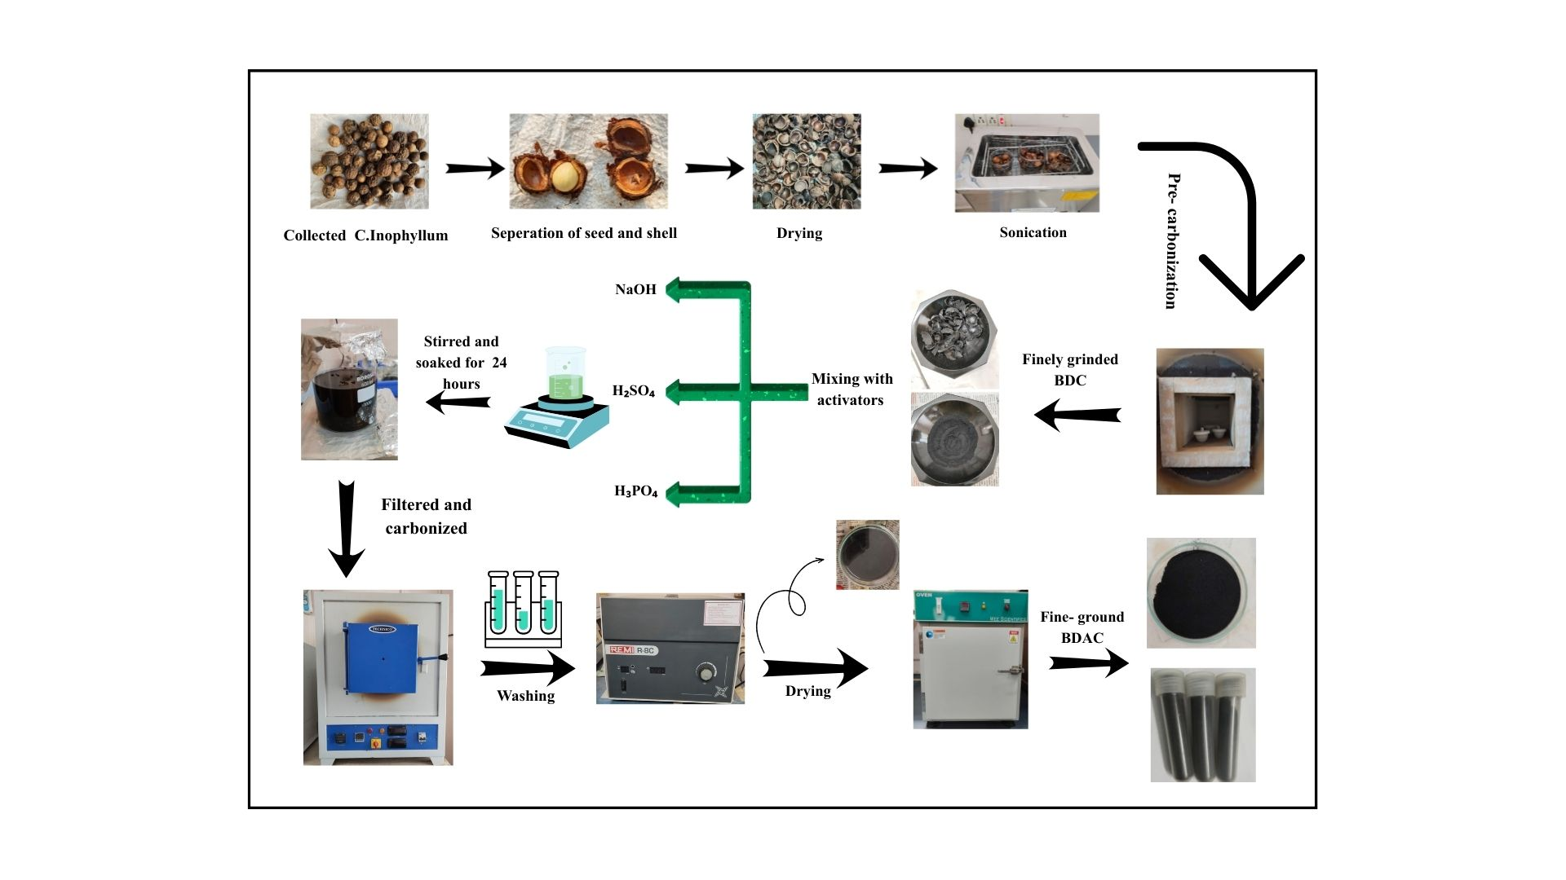
Fig.S1. Schematic representation of the prepared BDC and BDAC
Table S1. Specific surface area, pore volume, and average pore diameter of the prepared carbon samples.

Fig. S2. Comparative XRD patterns of raw carbon (CA-1) and activated carbon samples: (a) CA-2 and CA-3, (b) CA-4 and CA-5, and (c) CA-6 and CA-7.
Fig. S3. EDX spectra and elemental composition analysis of (a) CA-1, (b) CA-2, (c) CA-3, (d) CA-4, (e) CA-5, (f) CA-6, and (g) CA-7.

Fig. S4. XPS surface chemical analysis of CA-1 (a–c), CA-2 (d–f), CA-3 (g–i), CA-4 (j–l), CA-5 (m–o), CA-6 (p–r), and CA-7 (s–u), showing the survey scan, high-resolution C 1s spectrum, and high-resolution O 1s spectrum for each sample.

Table S1. Specific surface area, pore volume, and average pore diameter of the prepared carbon samples.

SAMPLE CODE | SURFACE AREA [m²/g] | PORE SIZE [ nm] | PORE VOLUME [cc/g]
CA-1 | 331.515 m²/g | 1.54nm | 0.539
CA-2 | 328.823 m²/g | 1.688 nm | 0.151
CA-3 | 225.250 m²/g | 1.55 nm | 0.426
CA-4 | 588.993 m²/g | 1.23 nm | 0.235
CA-5 | 609.700 m²/g | 1.23 nm | 0.249
CA-6 | 479.753 m²/g | 1.23 nm | 0.214
CA-7 | 1014.742 m²/g | 1.23 nm | 0.417

