Supplementary materials

Table S1 The concentration of amino acids in the medium before batch culture (mmol/L)

AA | Total amino acids |  | Free amino acids |  | Peptide-bound amino acids
AA | Casein-AA | Casein-PEP | Casein-AA | Casein-PEP | Casein-AA | Casein-PEP
Ala | 7.93 | 6.49 | 4.24 | 4.81 | 3.69 | 1.68
Arg | 8.35 | 12.99 | 3.71 | 2.59 | 4.63 | 10.41
Asp | 13.69 | 10.87 | 6.09 | 1.62 | 7.61 | 9.25
Glu | 19.46 | 16.84 | 17.69 | 2.43 | 1.77 | 14.41
Gln | 9.25 | 8.60 | 8.40 | 4.51 | 1.15 | 4.08
Gly | 7.67 | 6.43 | 3.56 | 1.76 | 4.11 | 4.68
His | 9.55 | 10.42 | 8.37 | 2.17 | 1.18 | 8.16
Ile | 10.52 | 9.10 | 3.29 | 2.48 | 7.23 | 6.62
Leu | 11.27 | 13.23 | 5.75 | 5.50 | 5.52 | 7.73
Lys | 11.01 | 11.08 | 5.15 | 2.26 | 5.85 | 8.83
Met | 3.28 | 3.61 | 1.72 | 1.29 | 1.56 | 2.31
Phe | 4.25 | 4.74 | 2.56 | 1.97 | 1.70 | 2.77
Pro | 8.44 | 10.33 | 7.63 | 3.57 | 0.80 | 6.76
Ser | 5.74 | 3.20 | 3.60 | 1.48 | 2.14 | 1.73
Thr | 7.45 | 9.74 | 1.25 | 0.31 | 6.21 | 9.43
Tyr | 7.50 | 8.10 | 5.70 | 1.73 | 1.80 | 6.36
Val | 8.63 | 7.57 | 4.35 | 2.15 | 4.29 | 5.42
Total | 153.99 | 153.34 | 93.06 | 42.62 | 60.93 | 110.72

Table S2 Primers used for the RT-qPCR analysis of bacterial functional genes and IPEC-J2 cell genes
Items | Primer sequence (F:5'->3') | Primer sequence (R:5'->3')
Bacterial genes (E.coli K88)
argT-lysine/arginine/ornithine  ABC transporter substrate-binding protein | GCCAAAGGTTCACCGATTC | AGGCAGCCGTCAGTTCAG
artJ-ABC transporter arginine-binding protein | TTTAGTCTTTCCGCCACA | GCCAGTTTCGGGTTATCT
adiA-arginine decarboxylase | TTGACCGTAACTGCCATAA | CATTTCCTGCGGATAGATT
speB-agmatinase | GACCACGGCACTATGTTCTA | TCACCCACAATCTGTTTCACT
speE-spermidine synthase | ATGAAACGCTACACGACCAG | GCAGAACGATACGACACCC
cadA-lysine decarboxylase | AACGACCGTGACGACTTA | AGAACAGGCTACCTACCG
16S (reference gene) | CTGGAACTGAGACACGGTCC | GGTGCTTCTTCTGCGGGTAA
IPEC-J2 cell genes
Occludin | ATGCTTTCTCAGCCAGCGTA | AAGGTTCCATAGCCTCGGTC
Claudin-1 | TGGCTCCGCGTCTCAGTCC | TGCGAGGGGTGCAGGTCTAA
ZO-1 | GAGGATGGTCACACCGTGGT | GGAGGATGCTGTTGTCTCGG
β-actin | ATGCTTCTAGACGGACTGCG | GTTTCAGGAGGCTGGCATGA

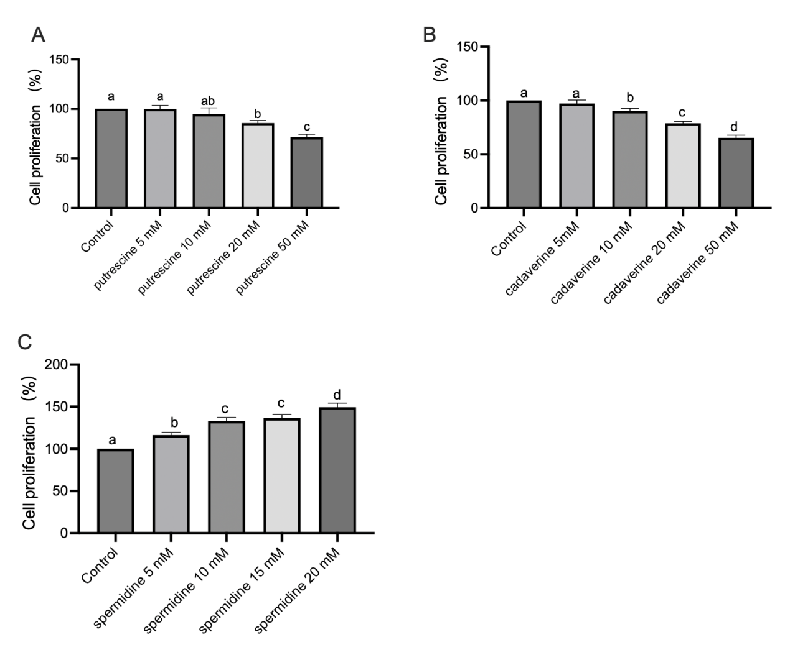
Fig. S1 Effects of putrescine (A), cadaverine (B) and spermidine (C) at graded concentrations on the proliferation of IPEC-J2 cells (CCK-8 assay). Significant differences were determined by one-way ANOVA followed by Duncan's multiple comparison test. Bars not sharing a common letter differ significantly, P < 0.05.

