Immunoproteasome Deficiency Impairs Microglial Clearance and Worsens Tau and Amyloid Pathology

Malavika Srikanth^{1,2,†}, Shan Jiang^{1,2,†}, Steven M. Wellman^{3,†}, Shrita Sarkar^{1,2}, Daniella E. Lorman^{1,2}, Timothy Lantin³, Avery M. Runyan^{1,2}, Mayank Kumar ^{1,2}, Eric Sydney^{1,2}, Helen Y. Figueroa^{1,2}, Mu Yang^{1,2}, Qi Wang^{3,4}, Natura Myeku^{1,2*}
Author affiliations:
¹ Department of Pathology and Cell Biology, Columbia University Irving Medical Center. New York, NY, USA.
² The Taub Institute for Research on Alzheimer’s Disease and the Aging Brain, Columbia University Irving Medical Center. New York, NY, USA.
³ Department of Biomedical Engineering, Columbia University. New York, NY, USA.
⁴ Department of Neurosurgery, Columbia University Irving Medical Center. New York, NY, USA.

†These authors contributed equally to this work.

*Correspondence to: Natura Myeku
E-mail: nm2631@cumc.columbia.edu

F

Supplementary Fig. 1. Representative tau, Aβ and Iba1 immunofluorescence in PS19 and APP/hTau dKI mice alone and with immunoproteasome deficiency -L7M1.
A
B
C
D
E
F
Representative coronal sections from (A) PS19, (B) L7M1/PS19, (C and E) APP/hTau dKI and (D and F) L7M1/APP/hTau dKI mice. pS202/pT205 tau staining is shown for PS19 and L7M1/PS19 mice, and pS396/pS404 tau staining is shown for APP/hTau and L7M1/APP/hTau dKI mice. Bottom panels show representative Aβ staining in APP/hTau dKI and L7M1/APP/hTau dKI mice. Scale bar, 1mm. Magnification 2.5x

Supplementary Fig. 2. Immunoproteasome deficiency does not reduce 26S proteasome activity in PS19 or APP/hTau dKI mice.
(A) Representative native-gel in-gel proteasome activity from male and female PS19 and L7M1/PS19 mice showing doubly capped and singly capped 26S proteasome complexes, labeled as 2-cap 26S and 1-cap 26S, respectively. B–D, Quantification of 26S proteasome activity in (B) male, (C) female, and (D) the combined male and female cohort expressed as a percentage of the PS19 control. (E) Representative native-gel in-gel proteasome activity from male and female hTau/APP dKI and L7M1/hTau/APP dKI mice showing 2-cap and 1-cap 26S proteasome complexes. F–H, Quantification of 26S proteasome activity in (F) male, (G) female, and (H) the combined male and female cohort expressed as a percentage of hTau/APP dKI control. Each point represents an individual mouse. Data are shown as mean ± s.e.m. ns, not significant.

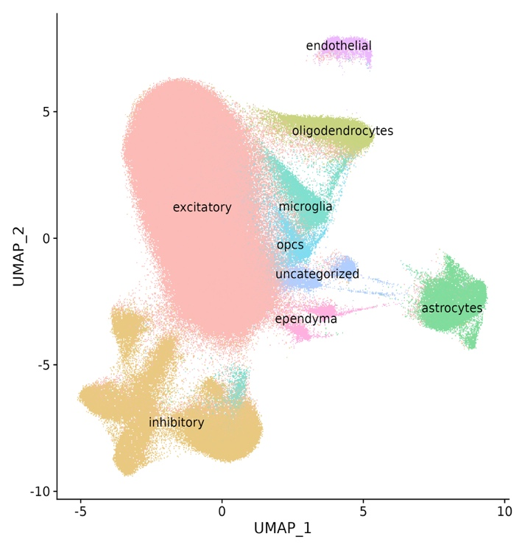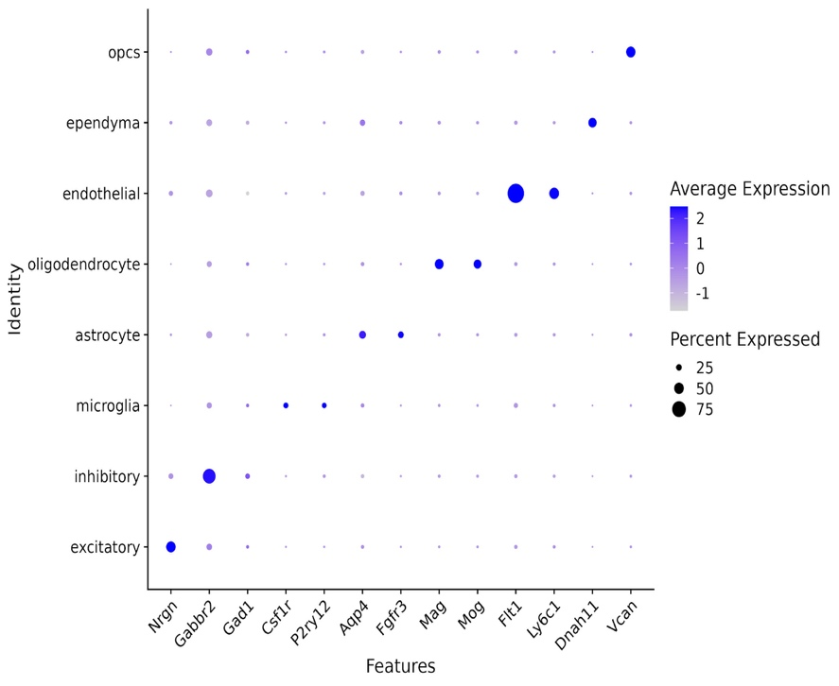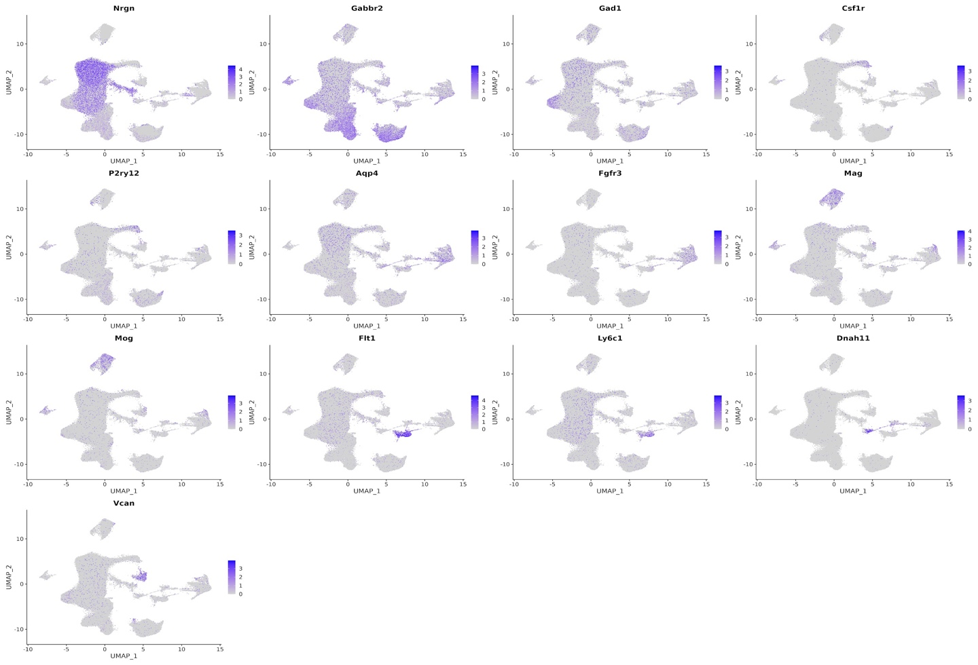
A
B
C

Supplementary Fig. 3. Cell-type annotation of the mouse single-nucleus RNA-seq dataset.
(A) UMAP feature plots showing normalized expression of representative marker genes used to annotate major CNS cell populations, including neuronal, microglial, astrocytic, oligodendrocyte-lineage, endothelial and ependymal markers. (B) UMAP visualization of the annotated single-nucleus RNA-seq dataset, identifying excitatory neurons, inhibitory neurons, astrocytes, microglia, oligodendrocytes, oligodendrocyte precursor cells, endothelial cells, ependymal cells and uncategorized nuclei. (C) Dot plot showing marker-gene expression across annotated cell types. Dot size represents the percentage of nuclei expressing each marker, and color intensity indicates scaled average expression.
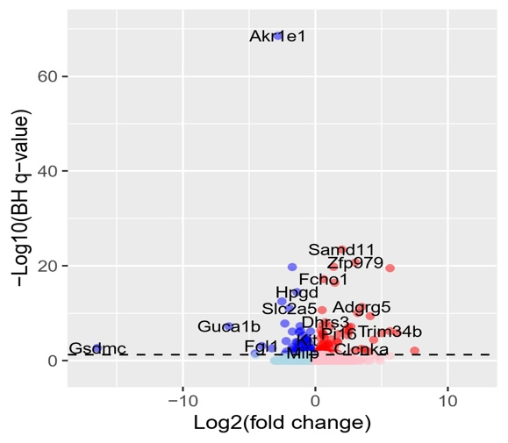
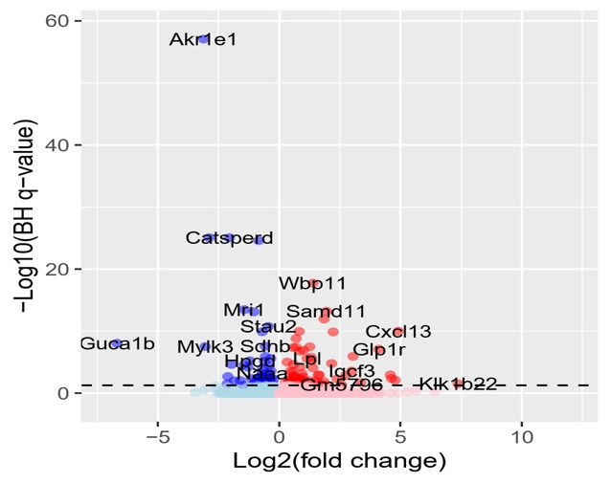
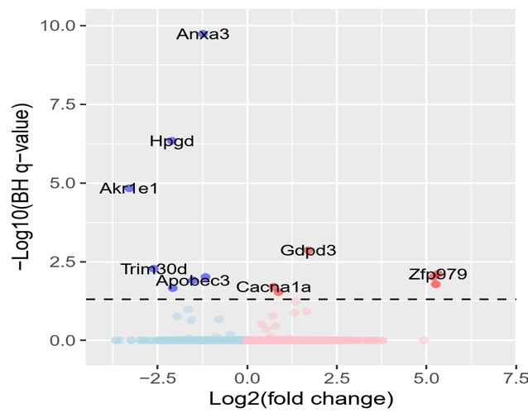
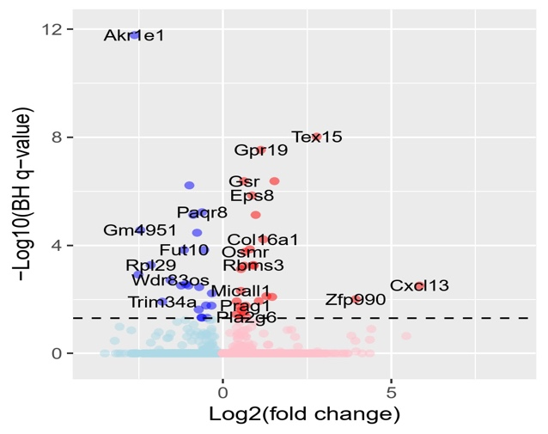
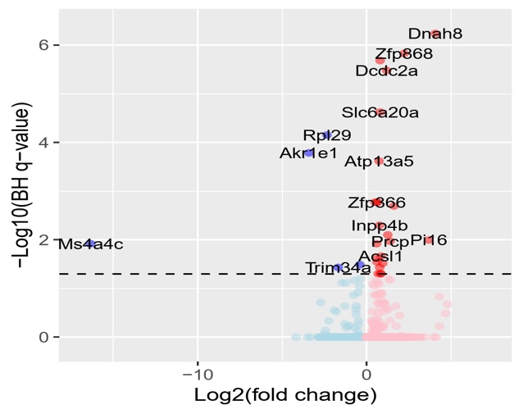
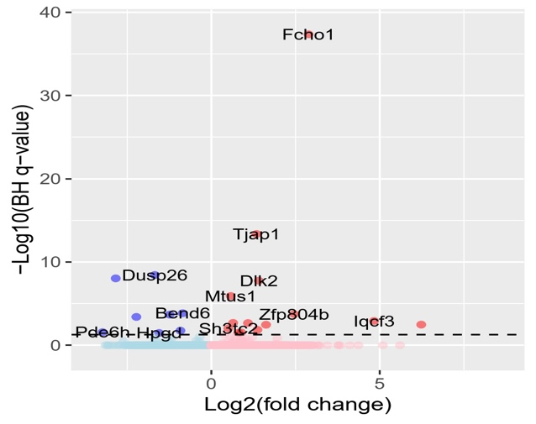
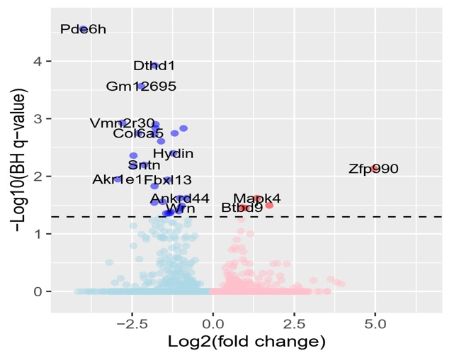
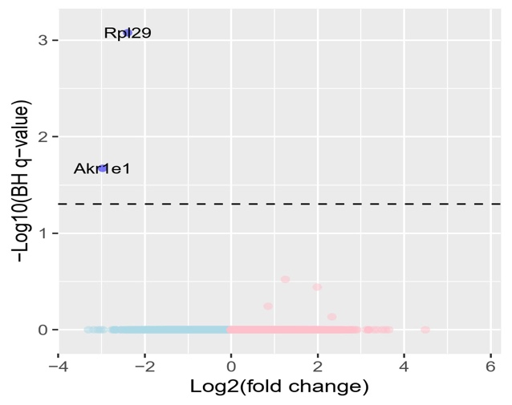
A
B
D
C
E
G
H
F

Supplementary Fig. 4. Cell-type-resolved differential gene expression in APP/hTau dKI mice cohorts
A–H, Volcano plots showing differentially expressed genes between L7M1/APP/hTau dKI and APP/hTau dKI mice within each annotated CNS cell type. (A) excitatory neurons; (B) inhibitory neurons; (C) microglia; (D) astrocytes; (E) oligodendrocytes; (F) oligodendrocyte precursor cells; (G) endothelial cells; and (H) ependymal cells. The x-axis shows log2 fold change, and the y-axis shows −log10 Benjamini–Hochberg-adjusted q value. Genes increased in L7M1/APP/hTau dKI mice are shown on the right, whereas genes reduced in L7M1/APP/hTau dKI mice are shown on the left. The dashed horizontal line indicates the significance threshold of BH-adjusted q < 0.05, corresponding to −log10(q) = 1.30. Selected significantly altered genes are labeled. Differential expression was performed using pseudobulk, mouse-level analysis as described in the Methods, with mouse treated as the biological replicate.
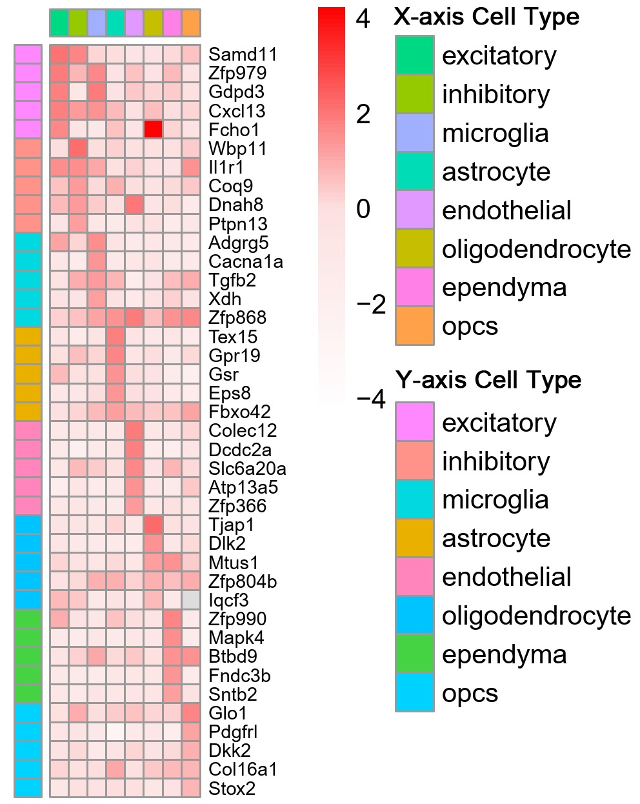
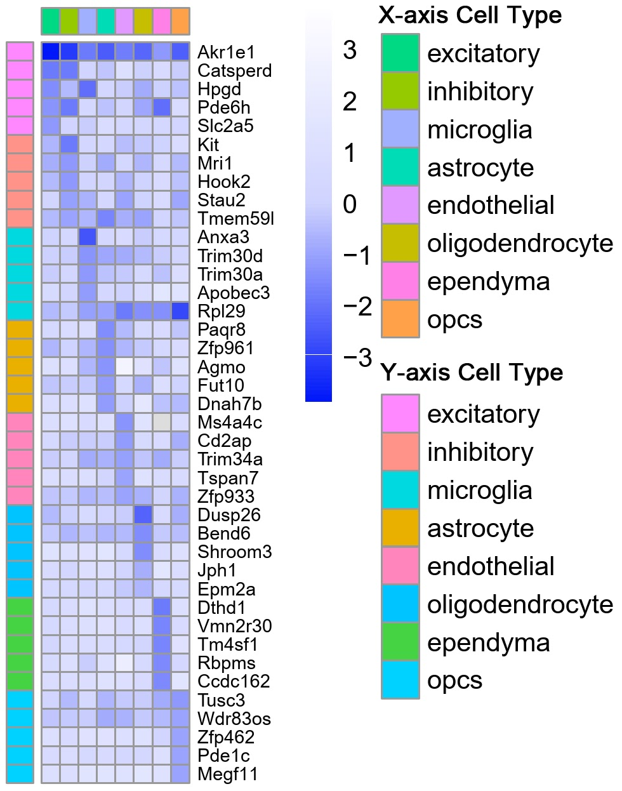

Supplementary Fig. 5. Cross-cell-type distribution of genes altered by immunoproteasome deficiency.
Heatmaps showing differentially expressed genes identified in L7M1/APP/hTau dKI mice relative to APP/hTau dKI controls across annotated CNS cell types. The left heatmap shows genes increased in L7M1/APP/hTau dKI mice, whereas the right heatmap shows genes reduced in L7M1/APP/hTau dKI mice. Columns represent the annotated cell types from Supplementary Fig. 3: excitatory neurons, inhibitory neurons, microglia, astrocytes, endothelial cells, oligodendrocytes, ependymal cells and oligodendrocyte precursor cells (OPCs). Row-side color annotations indicate the cell type in which each gene was identified as differentially expressed. Heatmap color intensity represents the magnitude of differential expression, with red indicating increased expression and blue indicating reduced expression in L7M1/APP/hTau dKI mice.

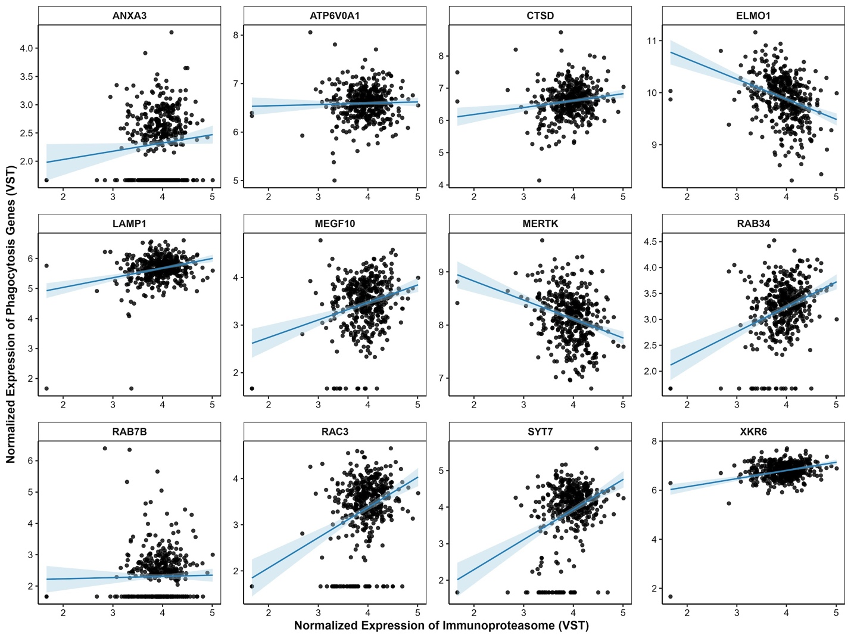

Supplementary Fig. 6. Association between immunoproteasome expression and phagocytosis-related gene programs in human single-nucleus RNA-seq data from Fujita et al.
Scatter plots showing the relationship between normalized immunoproteasome gene-expression scores and normalized expression of selected phagocytosis- and cargo-processing genes in human single-nucleus RNA-seq data from Fujita et al. Genes shown include ANXA3, ATP6V0A1, CTSD, ELMO1, LAMP1, MEGF10, MERTK, RAB34, RAB7B, RAC3, SYT7 and XKR6. Expression values are shown after variance-stabilizing transformation. Each point represents a donor-level microglial expression profile, and blue lines indicate fitted linear trends with confidence intervals. These scatter plots show expression relationships for visualization; the covariate-adjusted summary statistics are shown in Fig. 6D. Associations were assessed using partial correlation between immunoproteasome expression and each cargo-processing gene after adjustment for sex, age, postmortem interval and library size. Positive partial correlations indicate that, after adjustment for covariates, higher immunoproteasome expression is associated with higher expression of the corresponding gene; conversely, lower immunoproteasome expression is associated with lower expression of that gene. Negative partial correlations indicate the opposite relationship. In Fig. 6D, the partial-correlation t statistic is plotted as −t to orient the analysis toward the immunoproteasome-low state. Thus, negative bars indicate genes expected to show lower expression in immunoproteasome-low microglia, whereas positive bars indicate genes expected to show higher expression in immunoproteasome-low microglia. For statistical inference, partial correlation coefficients were converted to t statistics to account for sample size and degrees of freedom using:
$t=\frac{r_{XY|Z \sqrt{n-k-2}}}{\sqrt{1-r_{XY|Z}^{2}}}$,
where $r_{XY|Z}$ is the partial correlation coefficient between immunoproteasome expression $X$ and gene expression $Y$ by controlling for covariates, Z, n is the sample size, and k is the number of covariates. Two-sided P values were calculated from Student’s t distribution with $n-k-2$ degrees of freedom: p=2[1−F_{t,ν}​(∣t∣)]. Where $ν=n-k-2$.

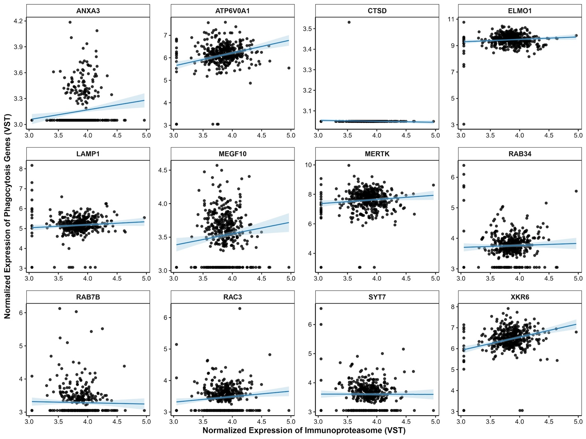

Supplementary Fig. 7. Association between immunoproteasome expression and phagocytosis-related genes in human snRNA-seq data from Mathys et al.
Scatter plots showing the relationship between normalized immunoproteasome transcript expression and normalized expression of selected phagocytosis- and cargo-processing genes in human single-nucleus RNA-seq data from Mathys et al. Low immunoproteasome transcript expression was used as a human transcriptomic proxy for an immunoproteasome-low state. Genes shown include ANXA3, ATP6V0A1, CTSD, ELMO1, LAMP1, MEGF10, MERTK, RAB34, RAB7B, RAC3, SYT7 and XKR6. Expression values are shown after variance-stabilizing transformation. Each point represents a donor-level microglial expression profile, and blue lines indicate fitted linear trends with confidence intervals. These scatter plots show expression relationships for visualization; the covariate-adjusted summary statistics are shown in Fig. 6E. Associations were assessed using partial correlation between immunoproteasome expression and each cargo-processing gene after adjustment for sex, age, race, education, postmortem interval and library size. Positive partial correlations indicate that, after adjustment for covariates, higher immunoproteasome expression is associated with higher expression of the corresponding gene; conversely, lower immunoproteasome expression is associated with lower expression of that gene. Negative partial correlations indicate the opposite relationship. In Fig. 6E, the partial-correlation t statistic is plotted as −t to orient the analysis toward the immunoproteasome-low state. Thus, negative bars indicate genes expected to show lower expression in immunoproteasome-low microglia, whereas positive bars indicate genes expected to show higher expression in immunoproteasome-low microglia. For statistical inference, partial correlation coefficients were converted to t statistics to account for sample size and degrees of freedom using:
$t=\frac{r_{XY|Z \sqrt{n-k-2}}}{\sqrt{1-r_{XY|Z}^{2}}}$,
where $r_{XY|Z}$ is the partial correlation coefficient between immunoproteasome expression $X$ and gene expression $Y$, after controlling for covariates $Z;$ n is the sample size; and $k$ is the number of covariates. Two-sided P values were calculated from Student’s t distribution with $n-k-2$ degrees of freedom: p=2[1−F_{t,ν}​(∣t∣)] where $ν=n-k-2$.

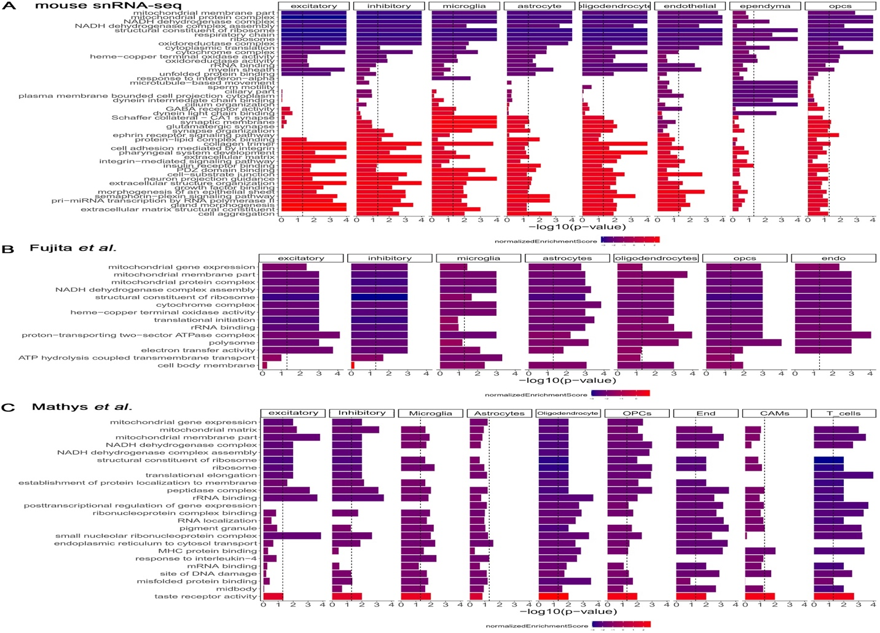

Supplementary Fig. 8. Gene set enrichment analysis of immunoproteasome-deficient and immunoproteasome-low cell states across mouse and human snRNA-seq datasets.
Cell-type-resolved gene set enrichment analysis showing biological pathways associated with immunoproteasome deficiency or low immunoproteasome expression. (A) Enriched gene sets from mouse snRNA-seq comparing L7M1/APP/hTau dKI mice with APP/hTau dKI controls across excitatory neurons, inhibitory neurons, microglia, astrocytes, oligodendrocytes, endothelial cells, ependymal cells and oligodendrocyte precursor cells. (B) Enriched gene sets associated with a human immunoproteasome-low state in the Fujita et al. snRNA-seq dataset across excitatory neurons, inhibitory neurons, microglia, astrocytes, oligodendrocytes, OPCs and endothelial cells. (C) Enriched gene sets associated with a human immunoproteasome-low state in the Mathys et al. snRNA-seq dataset across excitatory neurons, inhibitory neurons, microglia, astrocytes, oligodendrocytes, OPCs, endothelial cells, CNS-associated macrophages and T cells. Bars show −log10(P value), and the dashed vertical line indicates the nominal significance threshold. Bar color represents the normalized enrichment score, with purple/blue indicating negatively enriched pathways and red indicating positively enriched pathways. Across mouse and human datasets, immunoproteasome deficiency or low immunoproteasome expression was consistently associated with reduced enrichment of mitochondrial respiratory-chain, ribosomal and protein-translation programs, with additional cell-type-specific enrichment of extracellular matrix, synaptic, immune and signaling pathways.

Supplementary Fig. 9. Generation of gene-level input scores for GSEA using a human immunoproteasome-low transcriptomic state.
Scatter plots illustrating how gene-level scores were generated for gene set enrichment analysis (GSEA) from human single-nucleus RNA-seq data. For each gene within a given cell type, the partial correlation coefficient between normalized gene expression and normalized immunoproteasome expression was calculated after adjustment for confounding covariates, such as age, sex, PMI and etc. The GSEA input score was calculated as the negated t-statistics, which was converted from the partial correlation coefficient with the formula:
$t=\frac{r_{XY|Z \sqrt{n-k-2}}}{\sqrt{1-r_{XY|Z}^{2}}}$,
where $r_{XY|Z}$ is the partial correlation coefficient between X and Y by controlling for covariates Z, n is the sample size and k is the number of controlled covariates. This scoring approach ranks genes according to their expression trend in an immunoproteasome-low state. Positive scores indicate genes whose expression increases as immunoproteasome expression decreases, whereas negative scores indicate genes whose expression decreases as immunoproteasome expression decreases. (A) Example of a negatively correlated gene, NT5C2, in excitatory neurons. NT5C2 expression is negatively correlated with immunoproteasome expression $\left(R=-0.602\right)$, producing a positive GSEA input score of 15.440. (B) Example of a positively correlated gene, IFI27L2, in excitatory neurons. IFI27L2 expression is positively correlated with immunoproteasome expression $\left(R = 0.864\right)$, producing a negative GSEA input score of −34.935. Each point represents an analyzed donor, blue lines indicate fitted linear trends and shaded regions indicate confidence intervals.

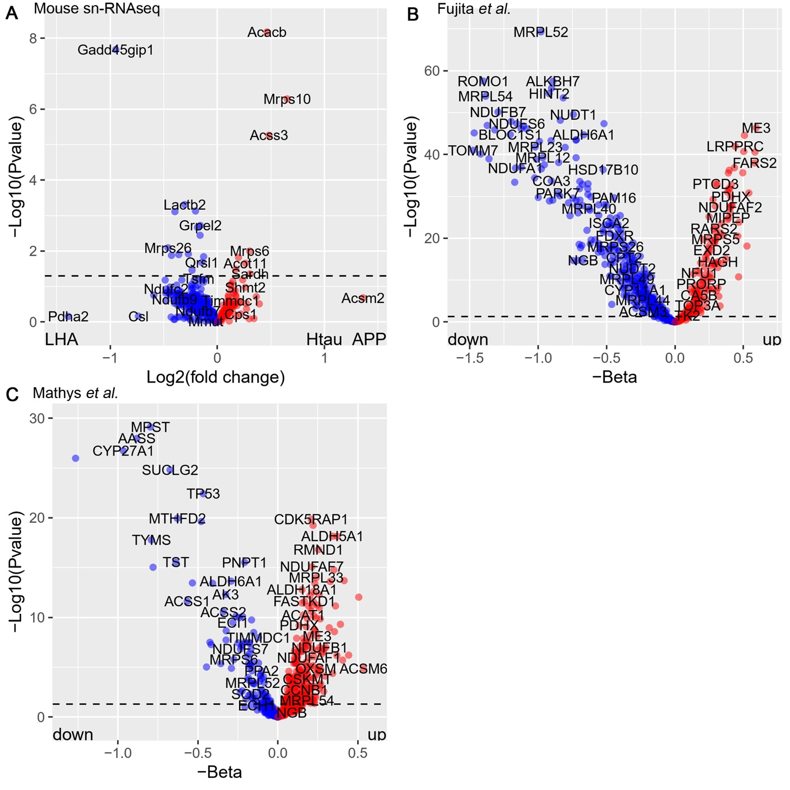

Increased
Decreased
Decreased
Increased

Increased
Decreased

Supplementary Fig. 10. Differential expression of mitochondrial genes in mouse and human immunoproteasome-deficient or immunoproteasome-low states
Volcano plots showing differential expression or association statistics for curated mitochondrial genes across mouse and human datasets. (A) Mouse snRNA-seq comparison of L7M1/APP/hTau dKI versus APP/hTau dKI mice. Genes decreased in L7M1/APP/hTau dKI relative to APP/hTau dKI are shown in blue (315 genes), and genes increased in L7M1/APP/hTau dKI are shown in red (114 genes). (B) Human snRNA-seq data from Fujita et al. showing mitochondrial genes associated with an immunoproteasome-low state. Genes predicted to decrease as immunoproteasome expression decreases are shown in blue (404 genes), whereas genes predicted to increase as immunoproteasome expression decreases are shown in red (197 genes). (C) Human snRNA-seq data from Mathys et al. showing mitochondrial genes associated with an immunoproteasome-low state. Genes predicted to decrease as immunoproteasome expression decreases are shown in blue (192 genes), whereas genes predicted to increase as immunoproteasome expression decreases are shown in red (409 genes). In A, the x-axis shows log2 fold change, and the y-axis shows −log10(P value). In B and C, the x-axis shows the signed IP-low association coefficient, plotted as −β, and the y-axis shows −log10(P value). The dashed horizontal line indicates the significance threshold, and selected genes are labeled.

Supplementary Fig. 11. Citrate synthase activity is unchanged in APP/hTau dKI mice with immunoproteasome deficiency. A, Kinetic citrate synthase activity assay in APP/hTau dKI and L7M1/APP/hTau dKI samples, measured by absorbance at 412 nm over time. B, Quantification of normalized citrate synthase activity in APP/hTau dKI and L7M1/APP/hTau dKI mice. Citrate synthase activity was not significantly different between genotypes, indicating that immunoproteasome deficiency did not detectably alter this marker of mitochondrial content or tricarboxylic acid cycle enzyme activity under the conditions tested. Data are shown as mean ± s.e.m.; each point represents an individual mouse. ns, not significant.

Supplementary Video 1. Live-cell imaging of tau aggregate–bearing cargo handling by WT microglia.
Time-lapse live-cell imaging corresponding to Fig. 4C showing mCherry-expressing WT primary microglia co-cultured with DS9 cells containing tau aggregate-bearing cargo. Images were acquired every ~15 min over 22 h using a BioTek Cytation 5 live-cell imaging system with environmental control. Microglia are shown in red, and DS9-derived tau aggregate–bearing cargo is shown in green. WT microglia engage and internalize green tau cargo, followed by progressive loss or resolution of the internalized signal over time, consistent with efficient post-engulfment cargo processing. The movie was cropped to the representative field of view and contrast-enhanced for visualization; the same display-processing approach was applied to the paired L7M1 movie. The AVI contains 89 frames and is displayed at 4 frames/s.

Supplementary Video 2. Live-cell imaging of tau aggregate–bearing cargo handling by immunoproteasome-deficient L7M1 microglia.
Time-lapse live-cell imaging corresponding to Fig. 4D showing mCherry-expressing L7M1 primary microglia co-cultured with DS9 cells containing tau aggregate-bearing cargo. Images were acquired every ~15 min over 22 h using a BioTek Cytation 5 live-cell imaging system with environmental control. Microglia are shown in red, and DS9-derived tau aggregate–bearing cargo is shown in green. L7M1 microglia engage and internalize green tau cargo, but the internalized signal persists over time, consistent with impaired post-engulfment cargo degradation and intracellular retention of tau aggregate–bearing material. The movie was cropped to the representative field of view and contrast-enhanced for visualization; the same display-processing approach was applied to the paired WT movie. The AVI contains 89 frames and is displayed at 4 frames/s.

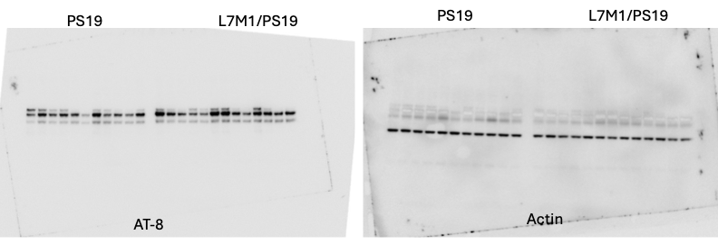

Uncropped western blots for Fig. 1E
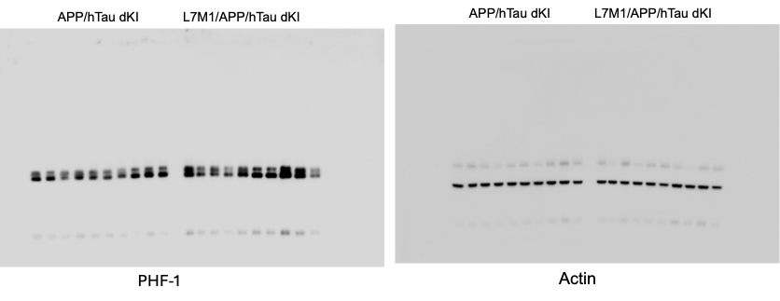
Uncropped western blots for Fig. 2K
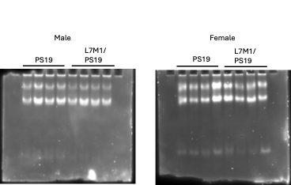
Uncropped in-gel proteasome activity for Supp. Fig. 2A

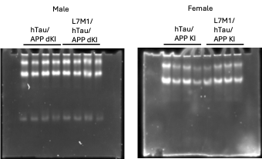
Uncropped in-gel proteasome activity for Supp. Fig 2E

