Appendix 1 Japanese version of the CS-FBD
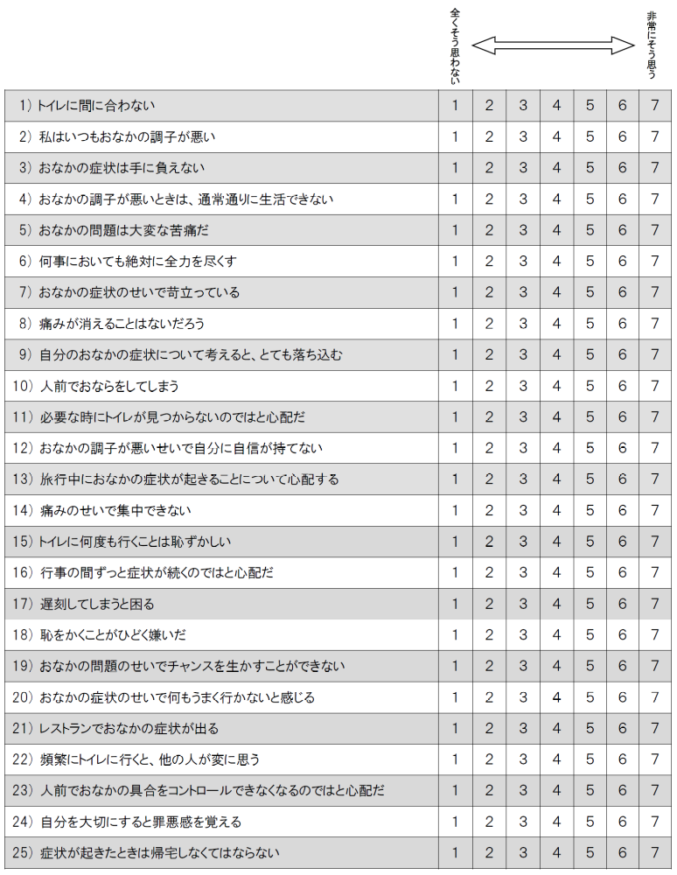

Underlined items: Items 6 and 18 were excluded from the Japanese version of the CS-FBD because of low factor loadings (< 0.40).

