Supplementary Results and Appendices

Supplementary Tables 1
Supplementary Table S1. Search strategies and retrieval counts 1
Supplementary Table S2. Complete effect extraction and analysis-eligibility ledger 6
Supplementary Table S3. Full-text reports excluded and primary reasons 16
Supplementary Table S4. Characteristics of included systematic reviews 22
Supplementary Table S5. Strict-primary review–RCT membership 26
Supplementary Table S6. AMSTAR 2 methodological quality and overall confidence ratings 27
Supplementary Table S7. Leave-one-review-out sensitivity analysis 29
Supplementary Table S8. Mapping coverage and residual limitations 30
Supplementary Table S9. Quality-restricted sensitivity-analysis feasibility 30
Supplementary Table S10. Primary-RCT risk-of-bias evidence supporting the GRADE judgment for the strict primary outcome 31
Supplementary Figures and model diagnostics 33
Figure S1. Pairwise overlap of independent RCT clusters in the strict primary analysis. 33
Figure S2. AMSTAR 2 item-level profile of the 33 included systematic reviews. 34
Figure S3. Change-score sensitivity analysis. 35
Figure S4. Leave-one-review-out analysis for the strict primary model. 36
Figure S5. Active-control subgroup analysis. 37
Figure S6. Follow-up effects by prespecified time window. 38
Figure S7. Network meta-analysis estimates for eligible digital psychological interventions. 39

Supplementary Tables

Supplementary Table S1. Search strategies and retrieval counts
Searches were conducted without date or language restrictions and were completed on 15 July 2026. Search strategies were adapted to each database and records were exported before deduplication.
Database | Complete search strategy | Records
PubMed | (  adolescen*[tiab] OR teen*[tiab] OR youth*[tiab] OR child*[tiab] OR children[tiab] OR juvenile*[tiab] OR student*[tiab] OR undergraduate*[tiab] OR pediatric*[tiab] OR paediatric*[tiab] OR girl*[tiab] OR boy*[tiab] OR kids[tiab] OR highschool*[tiab] OR "young adult"[tiab] OR "young adults"[tiab] OR "young people"[tiab] OR "young person"[tiab] OR "young persons"[tiab] OR "college student"[tiab] OR "college students"[tiab] OR "university student"[tiab] OR "university students"[tiab] OR "high school"[tiab] OR "high schools"[tiab] OR "secondary school"[tiab] OR "secondary schools"[tiab]  OR "Child"[Mesh] OR "Adolescent"[Mesh] OR "Young Adult"[Mesh] OR "Students"[Mesh]  )  AND  (  depress*[tiab] OR "depressive symptom"[tiab] OR "depressive symptoms"[tiab] OR "depressive disorder"[tiab] OR "depressive disorders"[tiab] OR "major depressive disorder"[tiab] OR MDD[tiab] OR dysthymi*[tiab] OR "persistent depressive disorder"[tiab] OR "subthreshold depression"[tiab] OR "subthreshold depressive"[tiab] OR "subclinical depression"[tiab] OR "subclinical depressive"[tiab] OR "mood disorder"[tiab] OR "mood disorders"[tiab] OR "affective disorder"[tiab] OR "affective disorders"[tiab] OR internalizing[tiab] OR internalising[tiab]  OR "Depression"[Mesh] OR "Depressive Disorder"[Mesh] OR "Mood Disorders"[Mesh]  )  AND  (  (  (  digital[tiab] OR online[tiab] OR internet*[tiab] OR web*[tiab] OR website*[tiab] OR computerized[tiab] OR computerised[tiab] OR computer*[tiab] OR "computer-based"[tiab] OR "computer-assisted"[tiab] OR electronic[tiab] OR eHealth[tiab] OR "e-health"[tiab] OR mHealth[tiab] OR "m-health"[tiab] OR mobile*[tiab] OR smartphone*[tiab] OR "smart phone"[tiab] OR "smart phones"[tiab] OR "mobile phone"[tiab] OR "mobile phones"[tiab] OR app[tiab] OR apps[tiab] OR application*[tiab] OR "mobile application"[tiab] OR "mobile applications"[tiab] OR "mobile app"[tiab] OR "mobile apps"[tiab] OR "app-based"[tiab] OR "mobile-based"[tiab] OR email[tiab] OR "e-mail"[tiab] OR videoconferenc*[tiab] OR "video conferenc*"[tiab] OR "social media"[tiab] OR software[tiab] OR telemedicine[tiab] OR "telemental health"[tiab] OR messaging[tiab] OR "text message"[tiab] OR "text messages"[tiab] OR texting[tiab] OR SMS[tiab] OR chatbot*[tiab] OR "conversational agent"[tiab] OR "conversational agents"[tiab] OR "virtual reality"[tiab] OR VR[tiab] OR "serious game"[tiab] OR "serious games"[tiab] OR gamif*[tiab]  OR "Internet"[Mesh] OR "Mobile Applications"[Mesh] OR "Telemedicine"[Mesh] OR "Text Messaging"[Mesh] OR "Virtual Reality"[Mesh] OR "Computer-Assisted Therapy"[Mesh]  )  AND  (  intervention*[tiab] OR treatment*[tiab] OR therap*[tiab] OR psychotherap*[tiab] OR "psychological intervention"[tiab] OR "psychological interventions"[tiab] OR CBT[tiab] OR iCBT[tiab] OR cCBT[tiab] OR dCBT[tiab] OR "cognitive behavio*"[tiab] OR mindfulness[tiab] OR psychoeducation*[tiab] OR "self-help"[tiab] OR "self-guided"[tiab] OR "problem-solving"[tiab] OR "problem solving"[tiab] OR "acceptance and commitment"[tiab] OR "dialectical behavior"[tiab] OR "dialectical behaviour"[tiab] OR DBT[tiab] OR "behavioral activation"[tiab] OR "behavioural activation"[tiab]  OR "Psychotherapy"[Mesh] OR "Cognitive Behavioral Therapy"[Mesh] OR "Behavior Therapy"[Mesh] OR "Mindfulness"[Mesh] OR "Self-Help Groups"[Mesh]  )  )  OR  "online intervention"[tiab] OR "online interventions"[tiab] OR "digital intervention"[tiab] OR "digital interventions"[tiab] OR "internet intervention"[tiab] OR "internet interventions"[tiab] OR "internet-based intervention"[tiab] OR "internet-based interventions"[tiab] OR "internet-delivered intervention"[tiab] OR "internet-delivered interventions"[tiab] OR "web-based intervention"[tiab] OR "web-based interventions"[tiab] OR "mobile intervention"[tiab] OR "mobile interventions"[tiab] OR "app-based intervention"[tiab] OR "app-based interventions"[tiab] OR "online psychotherapy"[tiab] OR "online psychological intervention"[tiab] OR "online psychological interventions"[tiab] OR "digital psychological intervention"[tiab] OR "digital psychological interventions"[tiab] OR "computer-assisted intervention"[tiab] OR "computer-assisted interventions"[tiab] OR "technology-delivered intervention"[tiab] OR "technology-delivered interventions"[tiab] OR "technology-based intervention"[tiab] OR "technology-based interventions"[tiab] OR iCBT[tiab] OR cCBT[tiab] OR dCBT[tiab] OR "digital CBT"[tiab] OR "internet-based CBT"[tiab] OR "computerized CBT"[tiab] OR "computerised CBT"[tiab] OR "mobile-based CBT"[tiab]  )  AND  (  "systematic review"[tiab] OR "systematic reviews"[tiab] OR "meta-analysis"[tiab] OR "meta analysis"[tiab] OR metaanaly*[tiab] OR "network meta-analysis"[tiab] OR "network meta analysis"[tiab] OR "umbrella review"[tiab] OR "umbrella reviews"[tiab] OR "overview of reviews"[tiab]  OR "Systematic Review"[pt] OR "Meta-Analysis"[pt]  ) | 1,874
Embase | #1  'adolescent'/exp OR 'child'/exp OR 'young adult'/exp OR 'student'/exp OR adolescen*:ti,ab,kw OR teen*:ti,ab,kw OR youth*:ti,ab,kw OR child*:ti,ab,kw OR children:ti,ab,kw OR juvenil*:ti,ab,kw OR student*:ti,ab,kw OR undergraduate*:ti,ab,kw OR pediatric*:ti,ab,kw OR paediatric*:ti,ab,kw OR girl*:ti,ab,kw OR boy*:ti,ab,kw OR kids:ti,ab,kw OR highschool*:ti,ab,kw OR 'young adult*':ti,ab,kw OR 'young people':ti,ab,kw OR 'young person*':ti,ab,kw OR 'college student*':ti,ab,kw OR 'university student*':ti,ab,kw OR 'high school*':ti,ab,kw OR 'secondary school*':ti,ab,kw  #2  'depression'/exp OR 'major depression'/exp OR 'dysthymia'/exp OR 'mood disorder'/exp OR depress*:ti,ab,kw OR 'depressive symptom*':ti,ab,kw OR 'depressive disorder*':ti,ab,kw OR 'major depressive disorder':ti,ab,kw OR MDD:ti,ab,kw OR dysthymi*:ti,ab,kw OR 'persistent depressive disorder':ti,ab,kw OR 'subthreshold depress*':ti,ab,kw OR 'subclinical depress*':ti,ab,kw OR 'mood disorder*':ti,ab,kw OR 'affective disorder*':ti,ab,kw OR internalizing:ti,ab,kw OR internalising:ti,ab,kw  #3  (((digital:ti,ab,kw OR online:ti,ab,kw OR internet*:ti,ab,kw OR web*:ti,ab,kw OR website*:ti,ab,kw OR computerized:ti,ab,kw OR computerised:ti,ab,kw OR computer*:ti,ab,kw OR 'computer-based':ti,ab,kw OR 'computer-assisted':ti,ab,kw OR electronic:ti,ab,kw OR ehealth:ti,ab,kw OR 'e-health':ti,ab,kw OR mhealth:ti,ab,kw OR 'm-health':ti,ab,kw OR mobile*:ti,ab,kw OR smartphone*:ti,ab,kw OR 'smart phone*':ti,ab,kw OR 'mobile phone*':ti,ab,kw OR app:ti,ab,kw OR apps:ti,ab,kw OR application*:ti,ab,kw OR 'mobile application*':ti,ab,kw OR 'mobile app*':ti,ab,kw OR 'app-based':ti,ab,kw OR 'mobile-based':ti,ab,kw OR email:ti,ab,kw OR 'e-mail':ti,ab,kw OR videoconferenc*:ti,ab,kw OR 'video conferenc*':ti,ab,kw OR 'social media':ti,ab,kw OR software:ti,ab,kw OR telemedicine:ti,ab,kw OR 'telemental health':ti,ab,kw OR messaging:ti,ab,kw OR 'text messag*':ti,ab,kw OR texting:ti,ab,kw OR SMS:ti,ab,kw OR chatbot*:ti,ab,kw OR 'conversational agent*':ti,ab,kw OR 'virtual reality':ti,ab,kw OR VR:ti,ab,kw OR 'serious game*':ti,ab,kw OR gamif*:ti,ab,kw) AND (intervention*:ti,ab,kw OR treatment*:ti,ab,kw OR therap*:ti,ab,kw OR psychotherap*:ti,ab,kw OR 'psychological intervention*':ti,ab,kw OR CBT:ti,ab,kw OR iCBT:ti,ab,kw OR cCBT:ti,ab,kw OR dCBT:ti,ab,kw OR 'cognitive behavio*':ti,ab,kw OR mindfulness:ti,ab,kw OR psychoeducation*:ti,ab,kw OR 'self-help':ti,ab,kw OR 'self-guided':ti,ab,kw OR 'problem-solving':ti,ab,kw OR 'problem solving':ti,ab,kw OR 'acceptance and commitment':ti,ab,kw OR 'dialectical behavior*':ti,ab,kw OR 'dialectical behaviour*':ti,ab,kw OR DBT:ti,ab,kw OR 'behavioral activation':ti,ab,kw OR 'behavioural activation':ti,ab,kw)) OR 'online intervention*':ti,ab,kw OR 'digital intervention*':ti,ab,kw OR 'internet intervention*':ti,ab,kw OR 'internet-based intervention*':ti,ab,kw OR 'internet-delivered intervention*':ti,ab,kw OR 'web-based intervention*':ti,ab,kw OR 'mobile intervention*':ti,ab,kw OR 'app-based intervention*':ti,ab,kw OR 'online psychotherapy':ti,ab,kw OR 'online psychological intervention*':ti,ab,kw OR 'digital psychological intervention*':ti,ab,kw OR 'computer-assisted intervention*':ti,ab,kw OR 'technology-delivered intervention*':ti,ab,kw OR 'technology-based intervention*':ti,ab,kw OR iCBT:ti,ab,kw OR cCBT:ti,ab,kw OR dCBT:ti,ab,kw OR 'digital CBT':ti,ab,kw OR 'internet-based CBT':ti,ab,kw OR 'computerized CBT':ti,ab,kw OR 'computerised CBT':ti,ab,kw OR 'mobile-based CBT':ti,ab,kw)  #4  'systematic review'/exp OR 'meta analysis'/exp OR 'systematic review*':ti,ab,kw OR 'meta-analysis':ti,ab,kw OR 'meta analysis':ti,ab,kw OR metaanaly*:ti,ab,kw OR 'network meta-analysis':ti,ab,kw OR 'network meta analysis':ti,ab,kw OR 'umbrella review*':ti,ab,kw OR 'overview of reviews':ti,ab,kw  #5  #1 AND #2 AND #3 AND #4 | 3,722
Web of Science Core Collection | TS=(adolescen* OR teen* OR youth* OR child* OR children OR juvenile* OR student* OR undergraduate* OR pediatric* OR paediatric* OR girl* OR boy* OR kids OR highschool* OR "young adult*" OR "young people" OR "young person*" OR "college student*" OR "university student*" OR "high school*" OR "secondary school*")  AND  TS=(depress* OR "depressive symptom*" OR "depressive disorder*" OR "major depressive disorder" OR MDD OR dysthymi* OR "persistent depressive disorder" OR "subthreshold depress*" OR "subclinical depress*" OR "mood disorder*" OR "affective disorder*" OR internalizing OR internalising)  AND  TS=(((digital OR online OR internet* OR web* OR website* OR computerized OR computerised OR computer* OR "computer-based" OR "computer-assisted" OR electronic OR eHealth OR "e-health" OR mHealth OR "m-health" OR mobile* OR smartphone* OR "smart phone*" OR "mobile phone*" OR app OR apps OR application* OR "mobile application*" OR "mobile app*" OR "app-based" OR "mobile-based" OR email OR "e-mail" OR videoconferenc* OR "video conferenc*" OR "social media" OR software OR telemedicine OR "telemental health" OR messaging OR "text messag*" OR texting OR SMS OR chatbot* OR "conversational agent*" OR "virtual reality" OR VR OR "serious game*" OR gamif*) AND (intervention* OR treatment* OR therap* OR psychotherap* OR "psychological intervention*" OR CBT OR iCBT OR cCBT OR dCBT OR "cognitive behavio*" OR mindfulness OR psychoeducation* OR "self-help" OR "self-guided" OR "problem-solving" OR "problem solving" OR "acceptance and commitment" OR "dialectical behavior*" OR "dialectical behaviour*" OR DBT OR "behavioral activation" OR "behavioural activation")) OR "online intervention*" OR "digital intervention*" OR "internet intervention*" OR "internet-based intervention*" OR "internet-delivered intervention*" OR "web-based intervention*" OR "mobile intervention*" OR "app-based intervention*" OR "online psychotherapy" OR "online psychological intervention*" OR "digital psychological intervention*" OR "computer-assisted intervention*" OR "technology-delivered intervention*" OR "technology-based intervention*" OR iCBT OR cCBT OR dCBT OR "digital CBT" OR "internet-based CBT" OR "computerized CBT" OR "computerised CBT" OR "mobile-based CBT")  AND  TS=("systematic review*" OR "meta-analysis" OR "meta analysis" OR metaanaly* OR "network meta-analysis" OR "network meta analysis" OR "umbrella review*" OR "overview of reviews") | 3,234
CINAHL | S1  TI (adolescen* OR teen* OR youth* OR child* OR children OR juvenile* OR student* OR undergraduate* OR pediatric* OR paediatric* OR girl* OR boy* OR kids OR highschool* OR "young adult*" OR "young people" OR "young person*" OR "college student*" OR "university student*" OR "high school*" OR "secondary school*")  OR AB (adolescen* OR teen* OR youth* OR child* OR children OR juvenile* OR student* OR undergraduate* OR pediatric* OR paediatric* OR girl* OR boy* OR kids OR highschool* OR "young adult*" OR "young people" OR "young person*" OR "college student*" OR "university student*" OR "high school*" OR "secondary school*")  OR MH "Child+" OR MH "Adolescence+" OR MH "Young Adult+" OR MH "Students+"  S2  TI (depress* OR "depressive symptom*" OR "depressive disorder*" OR "major depressive disorder" OR MDD OR dysthymi* OR "persistent depressive disorder" OR "subthreshold depress*" OR "subclinical depress*" OR "mood disorder*" OR "affective disorder*" OR internalizing OR internalising)  OR AB (depress* OR "depressive symptom*" OR "depressive disorder*" OR "major depressive disorder" OR MDD OR dysthymi* OR "persistent depressive disorder" OR "subthreshold depress*" OR "subclinical depress*" OR "mood disorder*" OR "affective disorder*" OR internalizing OR internalising)  OR MH "Depression+" OR MH "Depressive Disorder+" OR MH "Mood Disorders+"  S3  ((TI (digital OR online OR internet* OR web* OR website* OR computerized OR computerised OR computer* OR "computer-based" OR "computer-assisted" OR electronic OR eHealth OR "e-health" OR mHealth OR "m-health" OR mobile* OR smartphone* OR "smart phone*" OR "mobile phone*" OR app OR apps OR application* OR "mobile application*" OR "mobile app*" OR "app-based" OR "mobile-based" OR email OR "e-mail" OR videoconferenc* OR "video conferenc*" OR "social media" OR software OR telemedicine OR "telemental health" OR messaging OR "text messag*" OR texting OR SMS OR chatbot* OR "conversational agent*" OR "virtual reality" OR VR OR "serious game*" OR gamif*) OR AB (digital OR online OR internet* OR web* OR website* OR computerized OR computerised OR computer* OR "computer-based" OR "computer-assisted" OR electronic OR eHealth OR "e-health" OR mHealth OR "m-health" OR mobile* OR smartphone* OR "smart phone*" OR "mobile phone*" OR app OR apps OR application* OR "mobile application*" OR "mobile app*" OR "app-based" OR "mobile-based" OR email OR "e-mail" OR videoconferenc* OR "video conferenc*" OR "social media" OR software OR telemedicine OR "telemental health" OR messaging OR "text messag*" OR texting OR SMS OR chatbot* OR "conversational agent*" OR "virtual reality" OR VR OR "serious game*" OR gamif*) OR MH "Internet+" OR MH "Mobile Applications" OR MH "Telemedicine+" OR MH "Text Messaging" OR MH "Virtual Reality" OR MH "Computer Assisted Therapy")  AND  (TI (intervention* OR treatment* OR therap* OR psychotherap* OR "psychological intervention*" OR CBT OR iCBT OR cCBT OR dCBT OR "cognitive behavio*" OR mindfulness OR psychoeducation* OR "self-help" OR "self-guided" OR "problem-solving" OR "problem solving" OR "acceptance and commitment" OR "dialectical behavior*" OR "dialectical behaviour*" OR DBT OR "behavioral activation" OR "behavioural activation") OR AB (intervention* OR treatment* OR therap* OR psychotherap* OR "psychological intervention*" OR CBT OR iCBT OR cCBT OR dCBT OR "cognitive behavio*" OR mindfulness OR psychoeducation* OR "self-help" OR "self-guided" OR "problem-solving" OR "problem solving" OR "acceptance and commitment" OR "dialectical behavior*" OR "dialectical behaviour*" OR DBT OR "behavioral activation" OR "behavioural activation") OR MH "Psychotherapy+" OR MH "Cognitive Therapy+" OR MH "Behavior Therapy+" OR MH "Mindfulness+" OR MH "Psychoeducation" OR MH "Self Help"))  OR  TI ("online intervention*" OR "digital intervention*" OR "internet intervention*" OR "internet-based intervention*" OR "internet-delivered intervention*" OR "web-based intervention*" OR "mobile intervention*" OR "app-based intervention*" OR "online psychotherapy" OR "online psychological intervention*" OR "digital psychological intervention*" OR "computer-assisted intervention*" OR "technology-delivered intervention*" OR "technology-based intervention*" OR iCBT OR cCBT OR dCBT OR "digital CBT" OR "internet-based CBT" OR "computerized CBT" OR "computerised CBT" OR "mobile-based CBT")  OR  AB ("online intervention*" OR "digital intervention*" OR "internet intervention*" OR "internet-based intervention*" OR "internet-delivered intervention*" OR "web-based intervention*" OR "mobile intervention*" OR "app-based intervention*" OR "online psychotherapy" OR "online psychological intervention*" OR "digital psychological intervention*" OR "computer-assisted intervention*" OR "technology-delivered intervention*" OR "technology-based intervention*" OR iCBT OR cCBT OR dCBT OR "digital CBT" OR "internet-based CBT" OR "computerized CBT" OR "computerised CBT" OR "mobile-based CBT")  S4  TI ("systematic review*" OR "meta-analysis" OR "meta analysis" OR metaanaly* OR "network meta-analysis" OR "network meta analysis" OR "umbrella review*" OR "overview of reviews")  OR AB ("systematic review*" OR "meta-analysis" OR "meta analysis" OR metaanaly* OR "network meta-analysis" OR "network meta analysis" OR "umbrella review*" OR "overview of reviews")  OR PT "Systematic Review" OR PT "Meta Analysis"  S5  S1 AND S2 AND S3 AND S4 | 959
APA PsycINFO | S1  TI(adolescen* OR teen* OR youth* OR child* OR children OR juvenile* OR student* OR undergraduate* OR pediatric* OR paediatric* OR girl* OR boy* OR kids OR highschool* OR "young adult*" OR "young people" OR "young person*" OR "college student*" OR "university student*" OR "high school*" OR "secondary school*")  OR AB(adolescen* OR teen* OR youth* OR child* OR children OR juvenile* OR student* OR undergraduate* OR pediatric* OR paediatric* OR girl* OR boy* OR kids OR highschool* OR "young adult*" OR "young people" OR "young person*" OR "college student*" OR "university student*" OR "high school*" OR "secondary school*")  OR SU(adolescence OR adolescents OR youth OR children OR child OR "young adults" OR students OR "college students" OR "university students")  S2  TI(depress* OR "depressive symptom*" OR "depressive disorder*" OR "major depressive disorder" OR MDD OR dysthymi* OR "persistent depressive disorder" OR "subthreshold depress*" OR "subclinical depress*" OR "mood disorder*" OR "affective disorder*" OR internalizing OR internalising)  OR AB(depress* OR "depressive symptom*" OR "depressive disorder*" OR "major depressive disorder" OR MDD OR dysthymi* OR "persistent depressive disorder" OR "subthreshold depress*" OR "subclinical depress*" OR "mood disorder*" OR "affective disorder*" OR internalizing OR internalising)  OR SU(depression OR "major depression" OR "depressive disorders" OR dysthymia OR "mood disorders" OR "affective disorders")  S3  TI(digital OR online OR internet* OR web* OR website* OR computerized OR computerised OR computer* OR "computer-based" OR "computer-assisted" OR electronic OR eHealth OR "e-health" OR mHealth OR "m-health" OR mobile* OR smartphone* OR "smart phone*" OR "mobile phone*" OR app OR apps OR application* OR "mobile application*" OR "mobile app*" OR "app-based" OR "mobile-based" OR email OR "e-mail" OR videoconferenc* OR "video conferenc*" OR "social media" OR software OR telemedicine OR "telemental health" OR messaging OR "text messag*" OR texting OR SMS OR chatbot* OR "conversational agent*" OR "virtual reality" OR VR OR "serious game*" OR gamif*)  OR AB(digital OR online OR internet* OR web* OR website* OR computerized OR computerised OR computer* OR "computer-based" OR "computer-assisted" OR electronic OR eHealth OR "e-health" OR mHealth OR "m-health" OR mobile* OR smartphone* OR "smart phone*" OR "mobile phone*" OR app OR apps OR application* OR "mobile application*" OR "mobile app*" OR "app-based" OR "mobile-based" OR email OR "e-mail" OR videoconferenc* OR "video conferenc*" OR "social media" OR software OR telemedicine OR "telemental health" OR messaging OR "text messag*" OR texting OR SMS OR chatbot* OR "conversational agent*" OR "virtual reality" OR VR OR "serious game*" OR gamif*)  S4  TI(intervention* OR treatment* OR therap* OR psychotherap* OR "psychological intervention*" OR CBT OR iCBT OR cCBT OR dCBT OR "cognitive behavio*" OR mindfulness OR psychoeducation* OR "self-help" OR "self-guided" OR "problem-solving" OR "problem solving" OR "acceptance and commitment" OR "dialectical behavior*" OR "dialectical behaviour*" OR DBT OR "behavioral activation" OR "behavioural activation")  OR AB(intervention* OR treatment* OR therap* OR psychotherap* OR "psychological intervention*" OR CBT OR iCBT OR cCBT OR dCBT OR "cognitive behavio*" OR mindfulness OR psychoeducation* OR "self-help" OR "self-guided" OR "problem-solving" OR "problem solving" OR "acceptance and commitment" OR "dialectical behavior*" OR "dialectical behaviour*" OR DBT OR "behavioral activation" OR "behavioural activation")  S5  TI("online intervention*" OR "digital intervention*" OR "internet intervention*" OR "internet-based intervention*" OR "internet-delivered intervention*" OR "web-based intervention*" OR "mobile intervention*" OR "app-based intervention*" OR "online psychotherapy" OR "online psychological intervention*" OR "digital psychological intervention*" OR "computer-assisted intervention*" OR "technology-delivered intervention*" OR "technology-based intervention*" OR iCBT OR cCBT OR dCBT OR "digital CBT" OR "internet-based CBT" OR "computerized CBT" OR "computerised CBT" OR "mobile-based CBT")  OR AB("online intervention*" OR "digital intervention*" OR "internet intervention*" OR "internet-based intervention*" OR "internet-delivered intervention*" OR "web-based intervention*" OR "mobile intervention*" OR "app-based intervention*" OR "online psychotherapy" OR "online psychological intervention*" OR "digital psychological intervention*" OR "computer-assisted intervention*" OR "technology-delivered intervention*" OR "technology-based intervention*" OR iCBT OR cCBT OR dCBT OR "digital CBT" OR "internet-based CBT" OR "computerized CBT" OR "computerised CBT" OR "mobile-based CBT")  S6  TI("systematic review*" OR "meta-analysis" OR "meta analysis" OR metaanaly* OR "network meta-analysis" OR "network meta analysis" OR "umbrella review*" OR "overview of reviews")  OR AB("systematic review*" OR "meta-analysis" OR "meta analysis" OR metaanaly* OR "network meta-analysis" OR "network meta analysis" OR "umbrella review*" OR "overview of reviews")  S7  S1 AND S2 AND ((S3 AND S4) OR S5) AND S6 | 17
Cochrane Database of Systematic Reviews | #1  (adolescen* OR teen* OR youth* OR child* OR children OR juvenile* OR student* OR undergraduate* OR pediatric* OR paediatric* OR girl* OR boy* OR kids OR highschool* OR (young NEXT adult) OR (young NEXT adults) OR (young NEXT people) OR (young NEXT person) OR (young NEXT persons) OR (college NEXT student) OR (college NEXT students) OR (university NEXT student) OR (university NEXT students) OR (high NEXT school) OR (high NEXT schools) OR (secondary NEXT school) OR (secondary NEXT schools)):ti,ab,kw  #2  (depress* OR (depressive NEXT symptom) OR (depressive NEXT symptoms) OR (depressive NEXT disorder) OR (depressive NEXT disorders) OR (major NEXT depressive NEXT disorder) OR MDD OR dysthymi* OR (persistent NEXT depressive NEXT disorder) OR (subthreshold NEXT depression) OR (subclinical NEXT depression) OR (mood NEXT disorder) OR (mood NEXT disorders) OR (affective NEXT disorder) OR (affective NEXT disorders) OR internalizing OR internalising):ti,ab,kw  #3  (digital OR online OR internet* OR web* OR website* OR computerized OR computerised OR computer* OR computer-based OR computer-assisted OR electronic OR eHealth OR e-health OR mHealth OR m-health OR mobile* OR smartphone* OR (smart NEXT phone) OR (smart NEXT phones) OR (mobile NEXT phone) OR (mobile NEXT phones) OR app OR apps OR application* OR (mobile NEXT application) OR (mobile NEXT applications) OR (mobile NEXT app) OR (mobile NEXT apps) OR app-based OR mobile-based OR email OR e-mail OR videoconferenc* OR (video NEXT conferencing) OR (social NEXT media) OR software OR telemedicine OR (telemental NEXT health) OR messaging OR (text NEXT message) OR (text NEXT messages) OR texting OR SMS OR chatbot* OR (conversational NEXT agent) OR (conversational NEXT agents) OR (virtual NEXT reality) OR VR OR (serious NEXT game) OR (serious NEXT games) OR gamif*):ti,ab,kw  #4  (intervention* OR treatment* OR therap* OR psychotherap* OR (psychological NEXT intervention) OR (psychological NEXT interventions) OR CBT OR iCBT OR cCBT OR dCBT OR (cognitive NEXT behavioral) OR (cognitive NEXT behavioural) OR mindfulness OR psychoeducation* OR self-help OR self-guided OR problem-solving OR (problem NEXT solving) OR (acceptance NEXT commitment) OR (dialectical NEXT behavior) OR (dialectical NEXT behaviour) OR DBT OR (behavioral NEXT activation) OR (behavioural NEXT activation)):ti,ab,kw  #5  ((online NEXT intervention) OR (online NEXT interventions) OR (digital NEXT intervention) OR (digital NEXT interventions) OR (internet NEXT intervention) OR (internet NEXT interventions) OR internet-based NEXT intervention OR internet-based NEXT interventions OR internet-delivered NEXT intervention OR internet-delivered NEXT interventions OR web-based NEXT intervention OR web-based NEXT interventions OR mobile NEXT intervention OR mobile NEXT interventions OR app-based NEXT intervention OR app-based NEXT interventions OR (online NEXT psychotherapy) OR (online NEXT psychological NEXT intervention) OR (online NEXT psychological NEXT interventions) OR (digital NEXT psychological NEXT intervention) OR (digital NEXT psychological NEXT interventions) OR computer-assisted NEXT intervention OR computer-assisted NEXT interventions OR technology-delivered NEXT intervention OR technology-delivered NEXT interventions OR technology-based NEXT intervention OR technology-based NEXT interventions OR iCBT OR cCBT OR dCBT OR (digital NEXT CBT) OR internet-based NEXT CBT OR computerized NEXT CBT OR computerised NEXT CBT OR mobile-based NEXT CBT):ti,ab,kw  #6  #3 AND #4  #7  #6 OR #5  #8  #1 AND #2 AND #7 | 109
Scopus | TITLE-ABS-KEY(adolescen* OR teen* OR youth* OR child* OR children OR juvenile* OR student* OR undergraduate* OR pediatric* OR paediatric* OR girl* OR boy* OR kids OR highschool* OR "young adult*" OR "young people" OR "young person*" OR "college student*" OR "university student*" OR "high school*" OR "secondary school*")  AND TITLE-ABS-KEY(depress* OR "depressive symptom*" OR "depressive disorder*" OR "major depressive disorder" OR MDD OR dysthymi* OR "persistent depressive disorder" OR "subthreshold depress*" OR "subclinical depress*" OR "mood disorder*" OR "affective disorder*" OR internalizing OR internalising)  AND TITLE-ABS-KEY(((digital OR online OR internet* OR web* OR website* OR computerized OR computerised OR computer* OR "computer-based" OR "computer-assisted" OR electronic OR eHealth OR "e-health" OR mHealth OR "m-health" OR mobile* OR smartphone* OR "smart phone*" OR "mobile phone*" OR app OR apps OR application* OR "mobile application*" OR "mobile app*" OR "app-based" OR "mobile-based" OR email OR "e-mail" OR videoconferenc* OR "video conferenc*" OR "social media" OR software OR telemedicine OR "telemental health" OR messaging OR "text messag*" OR texting OR SMS OR chatbot* OR "conversational agent*" OR "virtual reality" OR VR OR "serious game*" OR gamif*) AND (intervention* OR treatment* OR therap* OR psychotherap* OR "psychological intervention*" OR CBT OR iCBT OR cCBT OR dCBT OR "cognitive behavio*" OR mindfulness OR psychoeducation* OR "self-help" OR "self-guided" OR "problem-solving" OR "problem solving" OR "acceptance and commitment" OR "dialectical behavior*" OR "dialectical behaviour*" OR DBT OR "behavioral activation" OR "behavioural activation")) OR "online intervention*" OR "digital intervention*" OR "internet intervention*" OR "internet-based intervention*" OR "internet-delivered intervention*" OR "web-based intervention*" OR "mobile intervention*" OR "app-based intervention*" OR "online psychotherapy" OR "online psychological intervention*" OR "digital psychological intervention*" OR "computer-assisted intervention*" OR "technology-delivered intervention*" OR "technology-based intervention*" OR iCBT OR cCBT OR dCBT OR "digital CBT" OR "internet-based CBT" OR "computerized CBT" OR "computerised CBT" OR "mobile-based CBT")  AND TITLE-ABS-KEY("systematic review*" OR "meta-analysis" OR "meta analysis" OR metaanaly* OR "network meta-analysis" OR "network meta analysis" OR "umbrella review*" OR "overview of reviews") | 3,312

Supplementary Table S2. Complete effect extraction and analysis-eligibility ledger
Review | Effect ID | Outcome | Time point | Comparator/subgroup | Measure | Source-reported effect (95% CI/CrI) | k | I² (%) | Direction | Analytical use | Source location
Magwood et al. (2024) | A01 | Depressive symptoms | Short term | Withheld control | SMD | −0.36 (−0.63 to −0.10) | 3 | NR | Negative favours intervention | Extracted; not pooled | Summary of Findings 1
Magwood et al. (2024) | A02 | Depressive symptoms | Short term | Active control | SMD | −0.27 (−0.53 to −0.01) | 2 | NR | Negative favours intervention | Extracted; not pooled | Summary of Findings 2
Magwood et al. (2024) | A03 | Depressive symptoms | Short term | Withheld control | SMD | −0.40 (−0.80 to 0.01) | 2 | NR | Negative favours intervention | Extracted; not pooled | Summary of Findings 3
Magwood et al. (2024) | A04 | Depressive symptoms | Short term | Active control app | SMD | −0.59 (−0.98 to −0.19) | 2 | NR | Negative favours intervention | Extracted; not pooled | Summary of Findings 4
Magwood et al. (2024) | A05 | Depressive symptoms | Short term | Withheld control | SMD | −0.20 (−0.42 to 0.02) | 2 | NR | Negative favours intervention | Extracted; not pooled | Summary of Findings 5
Noh et al. (2023) | A01 | Depressive symptoms | Posttest | All controls | Cohen’s d | −0.33 (−0.53 to −0.13) | 16 | 76.4 | Negative favours intervention | Extracted; not pooled | Figure 3; PDF p. 7
Noh et al. (2023) | A02 | Depressive symptoms | Posttest | iCBT | Cohen’s d | −0.35 (−0.60 to −0.11) | 11 | 81.6 | Negative favours intervention | Extracted; not pooled | Figure 3; PDF p. 7
Noh et al. (2023) | A03 | Depressive symptoms | 3 months | All controls | Cohen’s d | −0.13 (−0.34 to 0.09) | 3 | 0 | Negative favours intervention | Follow-up synthesis | Figure 3; PDF p. 9
Noh et al. (2023) | A04 | Depressive symptoms | 6 months | All controls | Cohen’s d | 0.01 (−0.17 to 0.20) | 3 | 0 | Negative favours intervention | Follow-up synthesis | Figure 3 continued; PDF p. 9
Noh et al. (2023) | A05 | Depressive symptoms | 12 months | All controls | Cohen’s d | −0.04 (−0.29 to 0.22) | 4 | 67.5 | Negative favours intervention | Follow-up synthesis | Figure 3 continued; PDF p. 9
Wu et al. (2023) | A01 | Depressive symptoms, self-report | Posttest | All controls | SMD | −0.42 (−0.74 to −0.11) | 18 | 89 | Negative favours intervention | Extracted; not pooled | Results 2.4.1 and Figure 3; PDF pp. 4, 7
Wu et al. (2023) | A02 | Depressive symptoms | Posttest | Attention control | SMD | −0.33 (−0.56 to −0.10) | 8 | 58 | Negative favours intervention | Extracted; not pooled | Figure 3; PDF p. 7
Wu et al. (2023) | A03 | Depressive symptoms | 3–6 months | All controls | SMD | −0.66 (−1.10 to −0.23) | 5 | 73 | Negative favours intervention | Follow-up synthesis | Figure 4; PDF p. 7
Wu et al. (2023) | A04 | Depressive symptoms | Post/follow-up mixed | Self-guided | SMD | −0.59 (−0.94 to −0.24) | 11 | 83 | Negative favours intervention | Extracted; not pooled | Figure 5; PDF p. 8
Thabrew et al. (2018) | A01 | Depressive symptoms | Postintervention | Any comparator | SMD | −0.06 (−0.35 to 0.23) | 5 | 40.7 | Negative favours intervention | Extracted; not pooled | Analysis 1.1; printed p. 65/PDF p. 68
Thabrew et al. (2018) | A02 | Depressive symptoms | 3–6 months | Any comparator | SMD | 0.04 (−0.18 to 0.25) | 3 | 0 | Negative favours intervention | Follow-up synthesis | Analysis 1.2; printed p. 65/PDF p. 69
Thabrew et al. (2018) | A03 | Depressive symptoms | Postintervention | Waiting list | SMD | −0.40 (−0.91 to 0.11) | 2 | 28.4 | Negative favours intervention | Strict primary | Analysis 4.1; printed p. 75/PDF p. 78
Wang et al. (2023) | A01 | Depressive symptoms | Postintervention | Mixed controls | SMD | −0.42 (−0.56 to −0.27) | 18 | 67 | Negative favours intervention | Extracted; not pooled | Results 3.4.2; Figure 5
Wang et al. (2023) | A02 | Depressive symptoms | Postintervention | Mixed controls | SMD | −0.49 (−0.61 to −0.37) | 11 | 16 | Negative favours intervention | Extracted; not pooled | Table 2
Wang et al. (2023) | A03 | Depressive symptoms | Postintervention | Mixed controls | SMD | −0.42 (−0.76 to −0.08) | 7 | 76 | Negative favours intervention | Extracted; not pooled | Table 2
Wang et al. (2023) | A04 | Depressive symptoms | Postintervention | Mixed controls | SMD | −0.42 (−0.58 to −0.25) | 14 | 72 | Negative favours intervention | Extracted; not pooled | Table 2
Wang et al. (2023) | A05 | Depressive symptoms | Postintervention | Mixed controls | SMD | −0.52 (−0.82 to −0.22) | 3 | 25 | Negative favours intervention | Extracted; not pooled | Table 2
Wang et al. (2023) | A06 | Depressive symptoms | Postintervention | Mixed controls | SMD | −0.38 (−0.54 to −0.22) | 13 | 64 | Negative favours intervention | Extracted; not pooled | Table 2
Wang et al. (2023) | A07 | Depressive symptoms | Postintervention | Mixed controls | SMD | −0.55 (−0.94 to −0.16) | 5 | 73 | Negative favours intervention | Extracted; not pooled | Table 2
Wang et al. (2026) | A01 | Depressive symptoms | Immediate postintervention | NIC | SMD | 0.44 (−0.02 to 0.91) | NA | NA | Positive favours intervention | Network evidence map | Table 2 and depression network results; 18 RCTs reported for the depression network, but only 17 depression RCTs identifiable in Table 1
Wang et al. (2026) | A02 | Depressive symptoms | Immediate postintervention | All network nodes | SUCRA | 79.3 (CI NA) | NA | NA | Higher ranking is better | Network evidence map | Figure 4 and Results
Pennant et al. (2015) | A01 | Self-rated depression; depressed/elevated sample | Post-treatment | Non-therapeutic control | SMD | −0.62 (−1.13 to −0.11) | 7 | 73 | Negative favours intervention | Strict primary | Table 2
Pennant et al. (2015) | A02 | Clinician-rated depression; depressed/elevated sample | Post-treatment | Non-therapeutic control | SMD | −1.29 (−2.87 to 0.29) | 2 | 86 | Negative favours intervention | Extracted; not pooled | Table 2
Pennant et al. (2015) | A03 | Self-rated depression; general population | Post-treatment | Waiting list | SMD | −0.15 (−0.26 to −0.03) | 1 | NA | Negative favours intervention | Extracted; not pooled | Table 2
Pennant et al. (2015) | A04 | Self-rated depression | Post-treatment | Face-to-face CBT | SMD | 1.65 (0.88 to 2.41) | 2 | 30 | Positive favours intervention | Extracted; not pooled | Table 3
Pennant et al. (2015) | A05 | Self-rated depression | Post-treatment | Face-to-face counselling | SMD | −0.23 (−0.51 to 0.06) | 1 | NA | Negative favours intervention | Extracted; not pooled | Table 3
Madrid-Cagigal et al. (2025) | A01 | Depressive symptoms | Posttest | All controls | Cohen’s d | 0.55 (0.37 to 0.72) | 16 | 72.58 | Positive favours intervention | Extracted; not pooled | Results 3.5 and Figure 2; PDF pp. 12–13
Madrid-Cagigal et al. (2025) | A02 | Depressive symptoms | Posttest | Fully automated | Cohen’s d | 0.53 (0.26 to 0.80) | 8 | NR | Positive favours intervention | Extracted; not pooled | Results 3.5 and Table 3; PDF pp. 12, 14
Madrid-Cagigal et al. (2025) | A03 | Depressive symptoms | Posttest | Guided | Cohen’s d | 0.56 (0.32 to 0.81) | 8 | NR | Positive favours intervention | Extracted; not pooled | Results 3.5 and Table 3; PDF pp. 12, 14
Ebert et al. (2015) | A01 | Depressive symptoms | Posttest | All controls | Hedges’ g | 0.56 (0.31 to 0.82) | 11 | 53.88 | Positive favours intervention | Strict primary | Table 2; PDF p. 9
Ebert et al. (2015) | A02 | Depressive symptoms | Posttest | Depression-targeted interventions | Hedges’ g | 0.76 (0.41 to 1.12) | 4 | 61.42 | Positive favours intervention | Extracted; not pooled | Table 2; PDF p. 9
Harrer et al. (2019) | A01 | Depressive symptoms | Posttest | All controls | Hedges’ g | 0.18 (0.08 to 0.27) | 31 | 44 | Positive favours intervention | Extracted; not pooled | Table 2 and Results 3.3.1; PDF p. 10
Harrer et al. (2019) | A02 | Depressive symptoms | Posttest | Passive controls | Hedges’ g | 0.27 (0.17 to 0.36) | 24 | 23.00 | Positive favours intervention | Strict primary | Table 3, control-group subgroup analysis; Results 3.4; PDF pp. 13–14
Harrer et al. (2019) | A03 | Depressive symptoms | Posttest | Active controls | Hedges’ g | −0.06 (−0.23 to 0.11) | 7 | 50.00 | Positive favours intervention | Active-control subgroup | Table 3, control-group subgroup analysis; Results 3.4; PDF pp. 13–14
Feng et al. (2025) | A01 | Depressive symptoms | Posttest | Mixed controls | Hedges’ g | 0.50 (0.18 to 0.82) | 10 | 89.7 | Positive favours intervention | Extracted; not pooled | Figure 3, overall depression effect
Feng et al. (2025) | A02 | Depressive symptoms | Posttest | Mixed controls | Hedges’ g | 0.61 (0.35 to 0.86) | 9 | 54.90 | Positive favours intervention | Extracted; not pooled | Results, “Depression—Overall Effect,” sensitivity analysis excluding the outlier; PDF p. 6
T. H. Chen et al. (2025) | A01 | Depressive symptoms | Posttest | University students | Mean difference | −1.34 (−2.08 to −0.59) | 3 | 21 | Negative favours intervention | Extracted; not pooled | Figure 4; PDF p. 7
T. H. Chen et al. (2025) | X01 | Depressive symptoms | Posttest | All controls | Mean difference | −0.66 (−1.09 to −0.23) | 9 | 35 | Negative favours intervention | Ineligible for pooling | Figure 3; PDF p. 6
Noh and Kim (2023) | A01 | Depressive symptoms | Posttest change | All controls | Hedges’ g | −0.094 (−0.186 to −0.002) | 11 | NR | Negative favours intervention | Change-score sensitivity | Figure 2 and Results; PDF pp. 7–8
Noh and Kim (2023) | A02 | Depressive symptoms | Posttest change | Universal prevention | Hedges’ g | −0.072 (−0.178 to 0.034) | NR | NR | Negative favours intervention | Extracted; not pooled | Results; PDF p. 9
Noh and Kim (2023) | A03 | Depressive symptoms | Posttest change | Selective prevention | Hedges’ g | −0.140 (−0.321 to 0.042) | NR | NR | Negative favours intervention | Extracted; not pooled | Results; PDF p. 9
Takizawa et al. (2026) | A01 | Depressive symptoms | Posttest | Inactive controls | Hedges’ g | 0.06 (0.02 to 0.11) | 15 | 16.34 | Positive favours intervention | Extended sensitivity | Table 7; PDF p. 14
Takizawa et al. (2026) | A02 | Depressive symptoms | ≥1 month | Inactive controls | Hedges’ g | 0.06 (0.02 to 0.11) | 8 | 0 | Positive favours intervention | Follow-up synthesis | Table 9; PDF p. 14
Takizawa et al. (2026) | A03 | Depressive symptoms | ≥6 months | Inactive controls | Hedges’ g | 0.05 (0.00 to 0.10) | 5 | 0 | Positive favours intervention | Extracted; not pooled | Table 11; PDF p. 15
B. Chen et al. (2025) | P01 | Depressive symptoms | Posttest | iACT vs waiting list | SMD | −1.20 (−2.10 to −0.22) | NA | NA | Negative favours intervention | Network evidence map | Figure 4; PDF p. 6
B. Chen et al. (2025) | P02 | Depressive symptoms | Posttest | iCBT vs waiting list | SMD | −1.10 (−1.80 to −0.59) | NA | NA | Negative favours intervention | Network evidence map | Figure 4; PDF p. 6
B. Chen et al. (2025) | P03 | Depressive symptoms | Posttest | iDBT vs waiting list | SMD | −3.70 (−5.70 to −1.60) | NA | NA | Negative favours intervention | Network evidence map | Figure 4; PDF p. 6
B. Chen et al. (2025) | P04 | Depressive symptoms | Posttest | iPDT vs waiting list | SMD | −1.30 (−2.70 to −0.057) | NA | NA | Negative favours intervention | Network evidence map | Figure 4; PDF p. 6
B. Chen et al. (2025) | P05 | Depressive symptoms | Posttest | iDBT ranking | SUCRA | 0.9902 (CI NA) | NA | NA | Higher ranking is better | Network evidence map | Table 1; PDF p. 7
Wickersham et al. (2022) | A01 | Depressive symptom severity | Longest available follow-up | All eligible controls | SMD | −0.23 (−0.39 to −0.07) | 10 | 59.5 | Negative favours intervention | Extracted; not pooled | Figure 4 and Appendix 5
Wickersham et al. (2022) | A02 | Depressive symptom severity | Longest follow-up | Treatment-focused studies | SMD | −0.22 (−0.46 to 0.03) | 7 | 68.70 | Negative favours intervention | Extracted; not pooled | Table 4, intervention-type stratification (treatment); PDF p. 9
Wickersham et al. (2022) | A03 | Depressive symptom severity | Longest follow-up | Prevention-focused studies | SMD | −0.26 (−0.43 to −0.09) | 3 | 5.90 | Negative favours intervention | Extracted; not pooled | Table 4, intervention-type stratification (prevention); PDF p. 9
Wickersham et al. (2022) | A04 | Depressive symptom severity | Longest follow-up | Active treatment control | SMD | −0.17 (−0.49 to 0.14) | 2 | 32.10 | Negative favours intervention | Extracted; not pooled | Table 4, control-group stratification (active treatment); PDF p. 9
Wickersham et al. (2022) | A05 | Depressive symptom severity | Longest follow-up | Waiting-list/attention/no-intervention controls | SMD | −0.25 (−0.43 to −0.07) | 9 | 61.90 | Negative favours intervention | Extracted; not pooled | Table 4,control-group stratification (other controls, including non-active control conditions); PDF p. 9
Hatoum et al. (2025) | A01 | Depressive symptoms | Longest follow-up, mean 3.05 months | Mostly active digital controls | Hedges’ g | −0.18 (−0.24 to −0.11) | 9 | 0 | Negative favours intervention | Extracted; not pooled | Figure 2 and Results; PDF pp. 12, 14
Li et al. (2021) | A01 | Depressive symptoms | Postintervention | CCBT vs waiting list | SMD | −1.82 (−3.07 to −0.59) | NA | NA | Negative favours intervention | Network evidence map | Results and league table; PDF p. 5
Li et al. (2021) | A02 | Depressive symptoms | Postintervention | CCBT vs education-based therapy | SMD | −1.45 (−2.87 to −0.05) | NA | NA | Negative favours intervention | Network evidence map | Results and league table; PDF p. 5
Li et al. (2021) | A03 | Depressive symptoms | Postintervention | CCBT vs named control | SMD | −1.13 (−2.17 to −0.11) | NA | NA | Negative favours intervention | Network evidence map | Results and league table; PDF p. 5
Li et al. (2021) | A04 | Depressive symptoms | Postintervention | CCBT ranking | SUCRA | 90.47% (95% CrI 0.55 to 1.00) | NA | NA | Higher ranking is better | Network evidence map | Table 2 and Appendix C4; PDF p. 5
Grist et al. (2019) | A01 | Depression-targeted intervention subgroup | Postintervention | All controls | Hedges’ g | 0.43 (0.18 to 0.68) | 13 | NR | Positive favours intervention | Extracted; not pooled | Target-condition subgroup results; PDF p. 15
Välimäki et al. (2017) | A01 | Depressive symptoms | Postintervention | All controls | Author-reported median estimate | 1.68 (0.25 to 3.11) | 10 | NR | Authors describe improvement | Extracted; not pooled | Abstract and Results; PDF pp. 1, 8
Välimäki et al. (2017) | A02 | Depressive symptoms | 3–5 months | All controls | Author-reported median estimate | 2.91 (0.36 to 6.19) | 4 | NR | Authors describe nonsignificant effect | Follow-up synthesis | Results; PDF p. 8
Välimäki et al. (2017) | A03 | Depressive symptoms | ≥6 months | All controls | Author-reported median estimate | 1.78 (0.37 to 3.20) | 3 | NR | Authors describe improvement | Follow-up synthesis | Results; PDF p. 8
Liu et al. (2024) | A01 | Depressive symptom severity | Posttest | All controls | SMD | −0.49 (−0.66 to −0.33) | 16 | 45 | Negative favours intervention | Extracted; not pooled | Figure 3 and GRADE table
Liu et al. (2024) | A02 | Depressive symptom severity | 3 months | All controls | SMD | −0.21 (−0.30 to −0.11) | 10 | NR | Negative favours intervention | Extracted; not pooled | GRADE table
Liu et al. (2024) | A03 | Depressive symptom severity | 6 months | All controls | SMD | −0.18 (−0.35 to −0.02) | 4 | NR | Negative favours intervention | Extracted; not pooled | GRADE table
Liu et al. (2024) | A04 | Depressive symptom severity | 12 months | All controls | SMD | −0.38 (−0.56 to −0.20) | 2 | NR | Negative favours intervention | Extracted; not pooled | GRADE table
Liu et al. (2024) | A05 | Depression remission | Posttest | All controls | RR | 1.74 (1.36 to 2.21) | 7 | 31 | Higher favours intervention | Extracted; not pooled | Figure 4; NNT=4.35
Liu et al. (2024) | A06 | Depression remission | 3 months | All controls | RR | 1.13 (0.89 to 1.44) | 3 | NR | Higher favours intervention | Extracted; not pooled | Figure 4; NNT=16.7
Liu et al. (2024) | A07 | Acceptability, dropout | Posttest | All controls | RR | 1.22 (0.76 to 1.97) | 16 | 51 | Lower favours intervention | Extracted; not pooled | Figure 5
Liu et al. (2024) | A08 | Quality of life | Posttest | All controls | SMD | 0.30 (0.07 to 0.54) | 4 | 0 | Higher favours intervention | Extracted; not pooled | Figure 6
Liu et al. (2024) | A09 | Quality of life | 3 months | All controls | SMD | 0.04 (−0.23 to 0.31) | 3 | NR | Higher favours intervention | Extracted; not pooled | Figure 6
Townsend et al. (2022) | A01 | Depressive symptom severity | Posttest | RCTs only | Hedges’ g | −0.54 (−1.00 to −0.08) | 5 | 84 | Negative favours intervention | Strict primary | Figure 3a
Townsend et al. (2022) | A02 | Anxiety symptoms | Posttest | RCTs only | Hedges’ g | −0.05 (−0.31 to 0.22) | 3 | 6 | Negative favours intervention | Extracted; not pooled | Figure 4a
Garrido et al. (2019) | A01 | Depressive symptom severity | Posttest | No-intervention control | Cohen’s d | 0.33 (0.11 to 0.55) | 9 | 66.69 | Positive favours intervention | Strict primary | Figure 2
Garrido et al. (2019) | A02 | Depressive symptom severity | Posttest | Active control | Cohen’s d | 0.14 (−0.04 to 0.31) | 6 | 45.0 | Positive favours intervention | Active-control subgroup | Figure 3
Garrido et al. (2019) | A03 | Depressive symptom severity | Posttest | No intervention; high interaction | Cohen’s d | 0.52 (0.23 to 0.80) | 5 | NR | Positive favours intervention | Extracted; not pooled | Figure 4
Garrido et al. (2019) | A04 | Depressive symptom severity | Posttest | No intervention; low interaction | Cohen’s d | 0.16 (CI NR) | 2 | NR | Positive favours intervention | Extracted; not pooled | Figure 4
Garrido et al. (2019) | A05 | Depressive symptom severity | Posttest | No intervention; no interaction | Cohen’s d | 0.04 (CI NR) | 2 | NR | Positive favours intervention | Extracted; not pooled | Figure 4
Garrido et al. (2019) | A06 | Depressive symptom severity | Posttest | Active control; high interaction | Cohen’s d | 0.49 (−0.11 to 1.01) | 2 | NR | Positive favours intervention | Extracted; not pooled | Figure 5
Ye et al. (2014) | A01 | Depressive symptoms | Postintervention | Waiting-list control | SMD | −0.16 (−0.44 to 0.12) | 7 | 53.00 | Negative favours intervention | Extended sensitivity | Results, postintervention depression outcome versus waitlist; Figure 2(c); PDF pp. 4 and 6
Ye et al. (2014) | A02 | Depressive symptoms | Postintervention | Face-to-face psychological intervention | SMD | 1.32 (−0.26 to 2.90) | 2 | 82.00 | Source direction retained | Extracted; not pooled | Results, internet-based versus face-to-face intervention; Figure 3(b); PDF p. 4
Lin et al. (2026) | A01 | Depressive symptoms | Postintervention | All controls | SMD | −0.26 (−0.41 to −0.12) | 10 | 20.4 | Negative favours intervention | Extracted; not pooled | Figure 3
Lin et al. (2026) | A02 | Depressive symptoms | Earliest follow-up, 4–16 weeks | All controls | SMD | −0.33 (−0.57 to −0.09) | 5 | 41.7 | Negative favours intervention | Follow-up synthesis | Figure 3
Lin et al. (2026) | A03 | Depressive symptoms | Postintervention | Active controls | SMD | −0.13 (−0.27 to 0.01) | 5 | 0 | Negative favours intervention | Active-control subgroup | Supplementary Table S4
Lin et al. (2026) | A04 | Depressive symptoms | Postintervention | Passive controls | SMD | −0.46 (−0.65 to −0.27) | 5 | 0 | Negative favours intervention | Strict primary | Supplementary Table S4
Sathe et al. (2026) | A01 | Depressive symptom severity | Endpoint | All controls | Cohen’s d | −0.24 (−0.36 to −0.13) | 9 | 0 | Negative favours intervention | Extracted; not pooled | Figure 2
Sathe et al. (2026) | A02 | Anxiety symptoms | Endpoint | All controls | Cohen’s d | −0.16 (−0.38 to 0.05) | 6 | 15.94 | Negative favours intervention | Extracted; not pooled | Supplementary Figure 4
Sathe et al. (2026) | A03 | Any adverse event | Endpoint | All controls | RR | 0.68 (0.45 to 1.04) | 7 | 0 | Lower favours intervention | Extracted; not pooled | Supplementary Figure 5a
Sathe et al. (2026) | A04 | Serious adverse event | Endpoint | All controls | RR | 0.61 (0.09 to 3.98) | 3 | 0 | Lower favours intervention | Extracted; not pooled | Supplementary Figure 5b
Sathe et al. (2026) | A05 | Quality of life | Endpoint | All controls | Cohen’s d | 0.47 (0.18 to 0.75) | 3 | 0 | Higher favours intervention | Extracted; not pooled | Supplementary Figure 6; differs from the value reported in the main text*
Sathe et al. (2026) | A06 | Usability | Endpoint | All controls | Cohen’s d | 0.37 (0.11 to 0.62) | 3 | 0 | Higher favours intervention | Extracted; not pooled | Supplementary Figure 7
Sathe et al. (2026) | A07 | Acceptability | Endpoint | All controls | Cohen’s d | 0.45 (0.02 to 0.89) | 4 | 79.3 | Higher favours intervention | Extracted; not pooled | Supplementary Figure 8
Sathe et al. (2026) | A08 | Completion rate | Endpoint | All controls | RR | 0.98 (0.89 to 1.08) | 9 | 0 | Higher favours intervention | Extracted; not pooled | Supplementary Figure 9
Bevilacqua et al. (2024) | A01 | Depressive symptoms | Postintervention | Technology-assisted CBT vs face-to-face CBT | SMD | 0.12 (−0.42 to 0.46) | 7 | 0 | Positive favours intervention | Extracted; not pooled | Results and Figure 3
Tian et al. (2025) | A01 | Depressive symptoms | Postintervention | Telepsychiatry vs waiting list/control | Hedges’ g | 0.54 (0.23 to 0.85) | 5 | 37 | Positive favours intervention | Strict primary | Figure 4
Tian et al. (2025) | X01 | Depressive symptoms | Postintervention | Post- vs pre-intervention | Hedges’ g | 0.83 (0.59 to 1.08) | 13 | 69 | Positive indicates improvement | Ineligible for pooling | Figure 2 and Table 2
Tian et al. (2025) | X02 | Depressive symptoms | Endpoint | Endpoint vs pre-intervention | Hedges’ g | 1.14 (0.66 to 1.62) | 7 | 82 | Positive indicates improvement | Ineligible for pooling | Table 2
Reangsing et al. (2023) | A01 | Depressive symptoms | Postintervention or nearest assessment | Online MBI vs comparison groups | Hedges’ g | 0.184 (0.024 to 0.344) | 18 comparisons | 61.8 | Positive favours intervention | Extracted; not pooled | Table 2
Bryant et al. (2024) | A01 | Depression severity | Postintervention | All control conditions | Hedges’ g | 0.28 (0.08 to 0.47) | 9 | 53.69 | Positive favours intervention | Extracted; not pooled | Figure 2B
Christ et al. (2020) | A01 | Depressive symptoms | Postintervention | Passive controls; all cCBT targets | Hedges’ g | 0.52 (0.33 to 0.71) | 20 | 68.69 | Positive favours intervention | Strict primary | Table 1
Christ et al. (2020) | A02 | Depressive symptoms | Postintervention | Passive controls; one outlier removed | Hedges’ g | 0.46 (0.29 to 0.63) | 19 | 58.49 | Positive favours intervention | Extracted; not pooled | Table 1
Christ et al. (2020) | A03 | Depressive symptoms | Postintervention | Depression-targeted cCBT vs passive controls | Hedges’ g | 0.60 (0.35 to 0.85) | 13 | 73.27 | Positive favours intervention | Extracted; not pooled | Table 1
Christ et al. (2020) | A04 | Depressive symptoms | Postintervention | Depression-targeted cCBT vs passive controls; outlier removed | Hedges’ g | 0.51 (0.30 to 0.72) | 12 | 61.76 | Positive favours intervention | Extracted; not pooled | Table 1
Christ et al. (2020) | A05 | Depressive symptoms | Postintervention | Depression-targeted cCBT vs active treatment | Hedges’ g | −0.70 (−1.51 to 0.11) | 4 | 90.63 | Positive favours intervention | Active-control subgroup | Table 1
Christ et al. (2020) | A06 | Depressive symptoms | 1–5 months | Passive controls | Hedges’ g | 0.19 (−0.08 to 0.46) | 2 | 0 | Positive favours intervention | Follow-up synthesis | Table 7
Christ et al. (2020) | A07 | Depressive symptoms | 6–12 months | Passive controls | Hedges’ g | 0.27 (0.09 to 0.45) | 3 | 0 | Positive favours intervention | Follow-up synthesis | Table 7
Leech et al. (2021) | A01 | Depressive symptoms | Immediate/short term | All app controls | Hedges’ g | 0.52 (0.18 to 0.84) | 8 | 79.37 | Positive favours intervention | Extracted; not pooled | Table 2
Leech et al. (2021) | A02 | Depressive symptoms | 6 weeks–6 months | Available follow-up studies | Hedges’ g | NR | 2 | NA | Positive favours intervention | Narrative follow-up synthesis | Results 3.7 and 3.7.1; Table 3; PDF pp. 5–7
Eilert et al. (2022) | A01 | Depressive symptoms | Postintervention | Mixed intervention foci and control conditions | Hedges’ g | −0.27 (−0.55 to 0.01) | 13 comparisons from 10 studies | 71.40 | Negative favours intervention | Extracted; not pooled because the target comparison was not separately recoverable | Results, “Random-Effects Model for Depression”; Figure 3; PDF p. 12
Note. Source-reported effect measures and directions are retained as reported by the original reviews. NR indicates that information was not reported or could not be reliably recovered from the available source; NA indicates that the field was not applicable.

Supplementary Table S3. Full-text reports excluded and primary reasons
No. | Title | First author, year | Primary reason for exclusion
1 | Digital Interventions for Anxiety and Depressive Symptoms in Adolescence: Systematic Review | Kuberka, 2025 | No meta-analysis
2 | Impact of Mindfulness-Based Interventions on Stress, Anxiety and Depression Among Nursing Students: A Systematic Review and Meta-analysis | Shen, 2026 | Population or age criteria not met
3 | Effectiveness of Text Messaging Interventions for the Management of Depression: A Systematic Review and Meta-analysis | Senanayake, 2019 | Population or age criteria not met
4 | Effectiveness of Cognitive Behavioral Therapy in Treating Adolescent Depression: A Systematic Review | Pulungan, 2025 | No meta-analysis
5 | The effectiveness of mindfulness-based interventions in reducing anxiety and depression among students: A systematic review and meta-analysis | Alzahrani, 2026 | Not a digital psychological intervention
6 | Interventions to build resilience and to ameliorate negative psychosocial effects of the COVID-19 pandemic on children and adolescents: A systematic review and meta-analysis | Wendel, 2024 | Not a digital psychological intervention
7 | Effectiveness of Mindfulness on Student Anxiety and Depression During the COVID-19 Pandemic: A Systematic Review and Meta-Analysis | Pranata, 2024 | Not a digital psychological intervention
8 | Therapeutic Games to Reduce Anxiety and Depression in Young People: A Systematic Review and Exploratory Meta-analysis of Their Use and Effectiveness | Eve, 2024 | Eligible depression effect not reliably mappable to source RCTs
9 | Effects of nonpharmacological interventions on depressive symptoms and depression among nursing students: A systematic review and meta-analysis | Chen, 2019 | Not a digital psychological intervention
10 | Annual Research Review: Digital health interventions for children and young people with mental health problems: A systematic and meta-review | Hollis, 2017 | No eligible original meta-analysis
11 | A systematic review of prevention programs targeting depression, anxiety, and stress in university students | Rith-Najarian, 2019 | Eligible digital psychological intervention effect not separately extractable
12 | Efficacy and acceptability of internet- and computer-based psychological interventions for children and adolescents with subthreshold depression | Zhang, 2025 | Ineligible publication type: correspondence/to the editor
13 | Psychological intervention for negative emotions aroused by COVID-19 pandemic in university students: A systematic review and meta-analysis | Wang, 2023 | Eligible digital psychological intervention effect not separately extractable
14 | Digital mental health interventions for anxiety and depressive symptoms in university students during the COVID-19 pandemic: A systematic review of randomized controlled trials | Riboldi, 2023 | No meta-analysis
15 | Serious games for the treatment or prevention of depression: A systematic review | Fleming, 2014 | No meta-analysis
16 | A systematic review on TeleMental Health in youth mental health: Focus on anxiety, depression and obsessive-compulsive disorder | Orsolini, 2021 | No meta-analysis
17 | Promoting mental health in children and adolescents through digital technology: A systematic review and meta-analysis | Chen, 2024 | Non-randomized evidence only
18 | Computerised cognitive behavioural therapy for the prevention and treatment of depression and anxiety in children and adolescents: A systematic review | Richardson, 2010 | No meta-analysis
19 | Self-Administered Interventions Based on Natural Language Processing Models for Reducing Depressive and Anxiety Symptoms: Systematic Review and Meta-Analysis | Villarreal-Zegarra, 2024 | Population or age criteria not met
20 | Effects of Mindfulness-Based Stress Reduction on Depression in Adolescents and Young Adults: A Systematic Review and Meta-Analysis | Chi, 2018 | Eligible digital psychological intervention effect not separately extractable
21 | Effects of Internet-Based Acceptance and Commitment Therapy (IACT) on Adolescents: A Systematic Review and Meta-Analysis | Wang, 2023 | Population or age criteria not met
22 | Effects of mindfulness-based interventions on psychological outcomes in college and university students during COVID-19 pandemics: A systematic review and meta-analysis | Reangsing, 2023 | Non-randomized evidence only
23 | Efficacy of mobile applications in treating depression: Systemic review and meta-analysis | Araib, 2026 | Population or age criteria not met
24 | Effects of Mobile Mindfulness Meditation on the Mental Health of University Students: Systematic Review and Meta-analysis | Chen, 2023 | Population or age criteria not met
25 | Effects of online mindfulness-based interventions on the mental health of university students: A systematic review and meta-analysis | Gong, 2023 | Non-randomized evidence only
26 | A Systematic Review and Meta-analysis of Online Mindfulness-Based Interventions for University Students: An Examination of Psychological Distress and Well-being, and Attrition Rates | Alrashdi, 2023 | No separately extractable depression outcome
27 | Digital Interventions for Improving Body Dissatisfaction in Children and Emerging Adults: Systematic Review and Meta-Analysis | Liu, 2025 | No separately extractable depression outcome
28 | Effect of acceptance and commitment therapy for adolescent depression: A meta-analysis | Yu, 2025 | Not a digital psychological intervention
29 | Integrating mindfulness and physical activity: A meta-analysis of mindful movement interventions for symptoms of anxiety and depression among university students | Xu, 2025 | Not a digital psychological intervention
30 | Internet- and Mobile-Based Interventions for Mental and Somatic Conditions in Children and Adolescents: A Systematic Review of Meta-analyses | Domhardt, 2020 | No meta-analysis
31 | Mindfulness in Mental Health and Psychiatric Disorders of Children and Adolescents: A Systematic Review and Meta-Analysis of Randomized Controlled Trials | Carneiro, 2025 | Not a digital psychological intervention
32 | Mental and Physical Health Impacts of Mindfulness Training for College Undergraduates: A Systematic Review and Meta-Analysis of Randomized Controlled Trials | Johnson, 2023 | Eligible digital psychological intervention effect not separately extractable
33 | Meta-Analysis of Psychological Interventions for Reducing Stress, Anxiety, and Depression among University Students during the COVID-19 Pandemic | Malinauskas, 2022 | Eligible digital psychological intervention effect not separately extractable
34 | Meta-analytic Review of Online Guided Self-help Interventions for Depressive Symptoms Among College Students | Ma, 2021 | Population or age criteria not met
35 | Mindfulness-informed (ACT) and Mindfulness-based Programs (MBSR/MBCT) Applied for College Students to Reduce Symptoms of Depression and Anxiety | Ma, 2022 | Not a digital psychological intervention
36 | Problem-solving Training as an Active Ingredient of Treatment for Youth Depression: A Scoping Review and Exploratory Meta-analysis | Krause, 2021 | Not a digital psychological intervention
37 | Psychological Interventions for Social Anxiety Disorder in Children and Adolescents: A Systematic Review and Network Meta-analysis | Xian, 2024 | Population or age criteria not met
38 | Psychological Interventions to Improve Sleep in Young Adults: A Meta-analysis of Randomised Controlled Trials | Kodsi, 2021 | Not a digital psychological intervention
39 | A Meta-Analysis of the Impact of Universal and Indicated Preventive Technology-Delivered Interventions for Higher Education Students | Conley, 2016 | No separately extractable depression outcome
40 | Effect of Mindfulness on Psychological Distress and Well-being of Children and Adolescents: A Meta-analysis | Zhang, 2022 | Not a digital psychological intervention
41 | Effectiveness of internet-based self-help interventions for depression in adolescents and young adults: A systematic review and meta-analysis | Ma, 2024 | No eligible randomized between-group comparative effect
42 | Effectiveness of internet-delivered psychological treatments for children and adolescents with anxiety and/or depressive disorders: Systematic review and network meta-analysis | López-Soler, 2024 | Non-randomized evidence only
43 | Effectiveness of Resilience Interventions for Higher Education Students: A Meta-Analysis and Metaregression | Ang, 2022 | Eligible digital psychological intervention effect not separately extractable
44 | A comparison of the effectiveness of cognitive behavioural interventions based on delivery features for elevated symptoms of depression in adolescents: A systematic review | Bjornstad, 2024 | Eligible digital psychological intervention effect not separately extractable
45 | A Meta-Analysis Examining the Efficacy and Predictors of Change in Mindfulness- and Self-Compassion-Based Interventions (MBSCIs) in Reducing Psychological Distress Among University Students | Buen, 2026 | Not a digital psychological intervention
46 | Acceptability, usage, and efficacy of mindfulness apps for college student mental health: A systematic review and meta-analysis of RCTs | LaMontagne, 2024 | Population or age criteria not met
47 | Application of Positive Psychology in Digital Interventions for Children, Adolescents, and Young Adults: Systematic Review and Meta-Analysis of Controlled Trials | Saboor, 2024 | No separately extractable depression outcome
48 | Computer-Delivered and Web-Based Interventions to Improve Depression, Anxiety, and Psychological Well-Being of University Students: A Systematic Review and Meta-Analysis | Davies, 2014 | Population or age criteria not met
49 | Effectiveness comparisons of various psychosocial therapies for children and adolescents with depression: A Bayesian network meta-analysis | Liang, 2021 | Eligible digital psychological intervention effect not separately extractable
50 | Psychosocial Interventions for Depression Among Young People in Sub-Saharan Africa: A Systematic Review and Meta-analysis | Olisaeloka, 2024 | Eligible digital psychological intervention effect not separately extractable
51 | Precision Optimization of Behavioral Activation for Major and Subthreshold Depression: A Meta-Analysis of Exploring Dose–Response Relationships and Moderating Factors | Huang, 2026 | Eligible digital psychological intervention effect not separately extractable
52 | Primary Prevention of Depression: An Umbrella Review of Controlled Interventions | Salazar de Pablo, 2021 | Eligible digital psychological intervention effect not separately extractable
53 | The Effectiveness of Mindfulness-Based Programs for Mental Health Outcomes in Young Adults: A Systematic Review and Meta-Analysis | Seneviratne, 2026 | Eligible digital psychological intervention effect not separately extractable
54 | Effectiveness of Digital Health Interventions on Stress, Anxiety, and Depression in University Students: A Systematic Review and Meta-Analysis | Zhan, 2026 | Population or age criteria not met
55 | Relative Effectiveness of Online Cognitive Behavioural Therapy with Anxious or Depressed Young People: Rapid Review and Meta-analysis | Howes, 2023 | No separately extractable depression outcome
56 | Smartphone-Based Interventions and Internalizing Disorders in Youth: Systematic Review and Meta-analysis | Buttazzoni, 2021 | Non-randomized evidence only
57 | The Efficacy of Mobile Applications for Reducing Depression in Adolescents and Young Adults: A Meta-analysis of Randomized Control Trials | Lee, 2025 | Population or age criteria not met
58 | Transdiagnostic Effects of Mindfulness-Based Interventions on Emotion Regulation and Psychopathology in Adolescents: A Systematic Review and Meta-analysis | Zhao, 2026 | Not a digital psychological intervention
59 | Using Virtual Reality Technology to Treat Adolescent and Young Adult Depression Disorder: A Systematic Review and Meta-analysis | Pu, 2025 | Non-randomized evidence only
60 | Quality Social Connection as an Active Ingredient in Digital Interventions for Young People with Depression and Anxiety: Systematic Scoping Review and Meta-analysis | Dewa, 2021 | Not a systematic review
61 | School-based intervention for depressive symptoms in upper secondary education: A focused review and meta-analysis of the effect of CBT-based prevention | Kambara, 2021 | Not a digital psychological intervention
62 | Social connection interventions and depression in young adults: A systematic review and meta-analysis | Vazquez Alvarez, 2024 | Not a digital psychological intervention
63 | The Effectiveness of AI Chatbots in Alleviating Mental Distress and Promoting Health Behaviors Among Adolescents and Young Adults: Systematic Review and Meta-Analysis | Hui, 2025 | Population or age criteria not met
64 | The intervention effect of internet-based cognitive behavioral therapy on anxiety, depression, and stress in college students: A systematic review and meta-analysis based on randomized controlled trials | Liu, 2026 | Population or age criteria not met
65 | Youth co-creation in health interventions: A systematic review and meta-analysis | Tao, 2025 | Not a digital psychological intervention
66 | Effectiveness of Cognitive-Based Interventions on Psychological Distress in Adolescents With Physical Disabilities: A Systematic Review and Meta-Analysis | Li, 2024 | Eligible digital psychological intervention effect not separately extractable
67 | Effectiveness of technology-based psychosocial interventions for child, adolescents and young adults undergoing cancer treatment: A meta-analysis of randomised controlled trials | Ozturk, 2022 | No separately extractable depression outcome
68 | Effectiveness of transdiagnostic preventive interventions for anxiety and depression in at-risk adolescents: A systematic review and meta-analysis | Zafra-Palomino, 2026 | No eligible randomized between-group comparative effect
69 | Effectiveness of youth psychotherapy delivered remotely: A meta-analysis | Venturo-Conerly, 2022 | Population or age criteria not met
70 | Effects of Physical Activity-Based Digital Health Interventions on Psychological Outcomes in Overweight and Obese Adolescents: A Systematic Review and Meta-Analysis | Li, 2026 | Not a digital psychological intervention
71 | Emotional management interventions for nursing students: A systematic review and network meta-analysis of randomized controlled trials | Wang, 2025 | Not a digital psychological intervention
72 | Healing Online or Onsite: A Meta-analysis of Online Mental Health RCTs and a Comparison with In-person RCTs Among Children and Adolescents | Zhang, 2026 | No separately extractable depression outcome
73 | Internet interventions for perfectionism: A meta-analysis and proposals for the college setting | Iliakis, 2023 | Not a digital psychological intervention
74 | Is behavioural activation an effective treatment for depression in children and adolescents? An updated systematic review and meta-analysis | Tindall, 2024 | Not a digital psychological intervention
Note. Each report was assigned one primary reason for exclusion. The 74 excluded reports reconcile with the PRISMA flow diagram.

Supplementary Table S4. Characteristics of included systematic reviews
Evidence set | Review | Review design | Population and age scope | Digital intervention scope | Comparator scope | Included evidence
Main | Magwood et al. (2024) | Systematic review and pairwise meta-analysis | 15–24 years | Mobile apps delivering mindfulness, CBT, combined, or other psychological interventions | Withheld and active controls | 36 trials; N = 7,984
Main | Noh et al. (2023) | Systematic review and pairwise meta-analysis | 13–25 years | Website- and mobile-based psychological interventions, predominantly iCBT | Passive and active controls | 16 RCTs reported in 22 articles; no single aggregate N reported
Main | Wu et al. (2023) | Systematic review and pairwise meta-analysis | 11–19 years | Internet- and computer-based CBT for adolescent depression | Waitlist, usual care, and active controls | 18 RCTs; N = 1,683
Main | Thabrew et al. (2018) | Cochrane systematic review and pairwise meta-analysis | Included trials: 10–18 years | E-health psychological interventions for young people with long-term physical conditions | Waitlist, usual care, and attention controls | 5 RCTs; N = 463
Main | Wang et al. (2023) | Systematic review and pairwise meta-analysis | Adolescents and university students | Internet-based self-help interventions, including CBT, third-wave CBT, and problem-solving therapy | Mixed control conditions | 25 comparisons; N = 4,480 (intervention, 2,355; control, 2,125)
Main | Wang et al. (2026) | Systematic review and Bayesian network meta-analysis | 12–25 years | Four categories of digital health intervention, as defined by the source review | No intervention, treatment as usual, and active digital comparators | 18 RCTs overall (N = 5,821); 17 RCTs reported depression outcomes (randomized N = 5,779)
Main | Pennant et al. (2015) | Systematic review and pairwise meta-analysis | 5–25 years; depression analyses concerned young people | Computerized CBT, computerized interpretation-bias modification, computerized problem-solving therapy, and mobile apps | Nontherapeutic and active controls | 27 RCTs; no single aggregate N reported; analysis-specific k and N available
Main | Madrid-Cagigal et al. (2025) | Systematic review and pairwise meta-analysis | Study mean ages: 18.53–25.00 years | Broad digital mental health interventions | Passive and active controls | 34 studies in the narrative synthesis; 21 two-arm RCTs in the meta-analysis; depression k = 16, N = 2,316
Main | Ebert et al. (2015) | Systematic review and pairwise meta-analysis | 6–25 years; age-eligible depression analyses separately extractable | Computerized and internet-based CBT for anxiety and depression | Waitlist and active controls | 13 RCTs; N = 796
Main | Harrer et al. (2019) | Systematic review and pairwise meta-analysis | University students; mean age ≤24 years by eligibility | Internet-based mental health interventions | Passive and active controls | 48 RCTs; depression represented by 31 comparisons; no single aggregate N reported
Main | Eilert et al. (2022) | Systematic review and pairwise meta-analysis | Children and young people | Internet-delivered psychological interventions | Mixed control conditions | 23 studies in the systematic review; 16 in the meta-analysis; N = 1,985 across 21 comparisons (intervention, 977; control, 1,008)
Main | Feng et al. (2025) | Systematic review and pairwise meta-analysis | Average age: 12–25 years | Artificial intelligence-driven conversational agents using natural-language processing or machine learning | Waitlist, information-only, and active controls | 14 articles reporting 15 trials; N = 1,974
Extended | T. H. Chen et al. (2025) | Systematic review and pairwise meta-analysis | Overall range: 14.7–35.3 years; eligible university subgroup mean ages: 18.78–22.90 years | CBT-informed chatbots | Passive and active controls | 10 RCTs overall; depression k = 9; project-eligible subgroup k = 3, N = 205
Main | Noh and Kim (2023) | Systematic review and pairwise meta-analysis | 10–24 years | Online universal and selective prevention interventions | No intervention, waitlist, and active controls | 19 RCTs; depression change-score analysis k = 11, N = 2,687
Extended | Takizawa et al. (2026) | Systematic review and pairwise meta-analysis | Overall range: 5–19 years; depression pool predominantly 10–19 years | Universal digital mental health interventions | No intervention, usual practice, and active controls | 29 RCTs; N = 22,705; depression k = 15
Main | B. Chen et al. (2025) | Systematic review and network meta-analysis | Target range: 10–25 years; samples with mean age ≤25 years could include some older students | Internet-delivered psychotherapies | Waitlist, usual care, and active psychological interventions | 27 reports; total N reported inconsistently as 3,345–3,451
Main | Wickersham et al. (2022) | Systematic review and pairwise meta-analysis | 11–19 years | Computerized CBT for prevention and treatment | Waitlist, usual care, and active controls | 16 RCTs; 13 entered at least one meta-analysis; depression k = 10; total review N = 4,012
Main | Hatoum et al. (2025) | Systematic review and pairwise meta-analysis | 10–24 years; ≥80% of participants age-eligible | Digital single-session interventions | Passive and active controls; some uncontrolled evidence included narratively | 22 articles describing 18 unique digital single-session interventions; 16 RCTs; total N = 9,353; depression follow-up meta-analysis k = 9
Extended | Li et al. (2021) | Systematic review and Bayesian network meta-analysis | Review range: 7–18 years; participants in all three computerized CBT trials were 11–16 years | Broad psychosocial prevention interventions with a separable computerized CBT node | Waitlist and other psychosocial intervention nodes | 27 RCTs; N = 5,976; project-eligible computerized CBT node k = 3
Extended | Grist et al. (2019) | Systematic review and pairwise meta-analysis | 6–18 years; depression-targeted subgroup separately extractable | Computerized, internet-based, app-based, and virtual-reality psychological interventions | Waitlist, treatment as usual, and active controls | 34 RCTs; N = 3,113; depression-targeted subgroup included 13 comparisons
Main | Välimäki et al. (2017) | Systematic review and pairwise meta-analysis | Included studies: 11–24 years | Web-based psychological interventions | Passive and active controls | 22 studies reported in 27 papers; 15 studies entered the meta-analysis, N = 4,979; depression postintervention k = 10
Main | Liu et al. (2024) | Systematic review and pairwise meta-analysis | Study mean ages: 13.35–17.50 years | Self-guided or therapist-guided iCBT | Waitlist, treatment as usual, and active controls | 19 RCTs; 16 in the postintervention depression analysis; preintervention N = 3,399
Main | Townsend et al. (2022) | Systematic review and pairwise meta-analysis | 12–25 years; the review also applied a mean-age criterion | Serious games and gaming interventions | Passive and active controls | 12 studies: 7 RCTs and 5 non-RCTs; RCT effects separately extractable; RCT depression analysis N = 666
Main | Garrido et al. (2019) | Mixed-methods systematic review and pairwise meta-analysis | 12–25 years | Broad digital mental health interventions | No-intervention and active controls | 41 studies in the narrative synthesis; depression meta-analysis included 15 RCT comparisons (9 no-intervention and 6 active-control comparisons); no aggregate N reported
Extended | Ye et al. (2014) | Systematic review and pairwise meta-analysis | Children, adolescents, and young adults; the depression waitlist pool was audited against the project age criterion | Internet-based psychological interventions for anxiety and/or depression | Waitlist and face-to-face psychological interventions | Depression versus waitlist: 7 RCTs, N = 490; internet versus face-to-face intervention: 2 RCTs, N = 66
Main | Lin et al. (2026) | Systematic review and pairwise meta-analysis | Young people without diagnosed mental disorders; samples predominantly comprised students and young adults | Mindfulness-based smartphone apps | Passive and active controls | 19 RCTs in the review; 13 entered at least one meta-analysis; depression k = 10, N = 1,543
Main | Sathe et al. (2026) | Systematic review and pairwise meta-analysis | 13–25 years; the review also referred to a median-age criterion of 10–24 years | Mobile app-based CBT | Passive and active controls | 10 RCTs; depression meta-analysis k = 9; total review N = 1,896; main analysis N = 1,127
Extended | Bevilacqua et al. (2024) | Systematic review and pairwise meta-analysis | Eligibility required age ≤18 years, although one study included participants aged 15–25 years | Technology-assisted versus face-to-face CBT | Face-to-face CBT | 10 RCTs overall; depression k = 7; no single aggregate N reported
Main | Tian et al. (2025) | Systematic review and pairwise meta-analysis | 15–24 years; depressive and/or anxiety disorders | Telepsychiatry-delivered psychological interventions | Waitlist and active controls | 26 studies, N = 1,558; 14 RCTs overall; depression versus waitlist k = 5, N = 293
Main | Reangsing et al. (2023) | Systematic review and pairwise meta-analysis | University students; overall mean age 22.6 years (SD = 3.2); study mean ages 18.2–31.1 years | Online mindfulness-based interventions | Passive and active controls | 15 primary studies contributing 18 comparisons; N = 1,886
Extended | Bryant et al. (2024) | Systematic review and pairwise meta-analysis | Pediatric samples; review eligibility criterion <18 years | Gamified digital mental health interventions | Passive and active controls | 27 RCTs; N = 2,911; depression k = 9, N = 1,332
Main | Christ et al. (2020) | Systematic review and pairwise meta-analysis | Mean age: 12–25 years; elevated depressive symptoms or diagnosis | Computer-, internet-, or smartphone-based CBT | Passive and active controls | 24 RCTs; depression passive-control pool k = 20, N = 1,604; depression-targeted passive-control pool k = 13, N = 1,162
Extended | Leech et al. (2021) | Systematic review and pairwise meta-analysis | 10–35 years; project audit confirmed that ≥75% of the evidence was age-eligible | Standalone smartphone apps | Passive and active controls | 11 independent RCTs; total N = 1,706; depression k = 8, analysis N = 862
Note. The main evidence set comprised 25 reviews and the extended evidence set comprised 8 reviews. Study and participant counts are reported as presented in the source reviews or for the specified project-eligible analysis. Counts should not be summed across reviews because primary RCTs overlap. CBT = cognitive behavioural therapy; cCBT = computerized CBT; iCBT = internet-based CBT; N = number of participants; RCT = randomized controlled trial; SD = standard deviation.

Supplementary Table S5. Strict-primary review–RCT membership
Review | Effect ID | Included RCTs, first author and year | No. of independent RCT clusters | Source
Thabrew et al. (2018) | A03 | Newcombe (2012); Palermo (2009) | 2 | Analysis 4.1 (PDF p. 75)
Pennant et al. (2015) | A01 | Clarke (2009); Ellis (2011); Fleming (2012); Sethi (2010); Sethi (2013); Stallard (2011); Stasiak (2012) | 7 | Figure 5, cCBT in young people subtotal (PDF p. 14)
Ebert et al. (2015) | A01 | Fleming (2012); Keller (2009); Khanna (2010); Makarushka (2012); March (2009); Sethi (2010); Stallard (2011); Stasiak (2012); Storch (2011); Tillfors (2011); Van der Zanden (2012) | 11 | Table 1 and overall depression meta-analysis
Harrer et al. (2019) | A02 | Cavanagh (2013); Day (2013); Ellis (2011; MoodGYM); Geisner (2006); Geisner (2015; combined feedback); Gibbel (2010; spiritual intervention); Hintz (2015; PCI); Lee (2018); Levin (2014); Levin (2017); Lintvedt (2011); Melnyk (2015); Mogoase (2013); Mullin (2015); Musiat (2014); Nguyen-Feng (2015; IPV sample); Räsänen (2016); Sarniak (2009); Sethi (2010) | 19 | Tables 1 and 3, passive-control subgroup
Townsend et al. (2022) | A01 | David (2019); Fleming (2012); Kuosmanen (2017); Merry (2012); Poppelaars (2016) | 5 | Figure 3a and accompanying depression-analysis study information
Garrido et al. (2019) | A01 | Clarke (2009); Hetrick (2017); Kramer (2014); Levin (2014); Lillevoll (2014); Reid (2013); Sekizaki (2017); Smith (2015); Van der Zanden (2012) | 9 | Figure 2 (PDF p. 10)
Lin et al. (2026) | A04 | Conley (2024); Levin (2022); Lew (2025); Min (2024); Nolan (2019) | 5 | Table 1 and Supplementary Table S4
Tian et al. (2025) | A01 | Kageyama (2021); Moeini (2019); Rickhi (2015); Ruehlman and Karoly (2023); Topooco (2019) | 5 | Figure 4 (PDF p. 8)
Christ et al. (2020) | A01 | Botella (2010); Bowler (2012); Clarke (2009); Day (2013); Ellis (2011); Fitzpatrick (2017); Fleming (2012); Ip (2016); Lenhard (2017); Poppelaars (2016); Richards (2016); Sethi (2010); Sethi (2013); Smith (2015); Stallard (2011); Stjerneklar (2019); Tillfors (2011); Topooco (2018); Van der Zanden (2012); Waite (2019) | 20 | Appendix 2, Table 1, and main-text Table 1

Note. RCT membership was mapped at the level of independent randomized-trial clusters. Multiple reports, intervention arms or effect estimates originating from the same randomized trial were counted once within each review. Across the nine reviews, 83 review–RCT incidences represented 62 independent RCT clusters, corresponding to a corrected covered area of 4.23%. cCBT = computerized cognitive behavioural therapy; IPV = intimate partner violence; PCI = personalized feedback intervention; RCT = randomized controlled trial. Effect IDs beginning with “A” identify effects eligible for at least one prespecified quantitative synthesis. Primary RCT author–year labels are used as study identifiers for overlap mapping. Because the quantitative syntheses used review-level rather than RCT-level effect estimates, these primary reports are traceable through the source locations shown and are not separately cited in the main reference list.

Supplementary Table S6. AMSTAR 2 methodological quality and overall confidence ratings
Review | Item 1 | Item 2* | Item 3 | Item 4* | Item 5 | Item 6 | Item 7* | Item 8 | Item 9* | Item 10 | Item 11* | Item 12 | Item 13* | Item 14 | Item 15* | Item 16 | Overall confidence
Magwood et al. (2024) | Y | Y | Y | Y | Y | Y | N | Y | Y | Y | Y | N | Y | Y | Y | Y | Low
Noh et al. (2023) | Y | N | N | N | Y | Y | N | Y | Y | N | Y | N | N | Y | Y | Y | Critically low
Wu et al. (2023) | Y | PY | N | N | Y | Y | Y | Y | Y | N | Y | N | Y | Y | Y | Y | Low
Thabrew et al. (2018) | Y | Y | N | Y | Y | Y | Y | Y | Y | Y | Y | N | Y | Y | Y | Y | Moderate
Wang et al. (2023) | Y | PY | N | N | Y | Y | N | PY | Y | N | Y | N | N | Y | Y | Y | Critically low
Wang et al. (2026) | Y | N | N | PY | Y | Y | N | PY | Y | N | Y | N | Y | Y | Y | Y | Critically low
Pennant et al. (2015) | Y | N | N | N | N | Y | N | Y | Y | N | Y | N | Y | Y | N | Y | Critically low
Madrid-Cagigal et al. (2025) | Y | PY | N | N | Y | Y | N | PY | Y | N | Y | N | N | Y | Y | Y | Critically low
Ebert et al. (2015) | Y | PY | N | PY | Y | Y | N | Y | PY | N | Y | Y | Y | Y | Y | Y | Low
Harrer et al. (2019) | Y | Y | N | N | Y | N | N | Y | Y | N | Y | Y | Y | Y | Y | N | Critically low
Eilert et al. (2022) | Y | Y | N | N | N | Y | N | Y | PY | N | Y | N | Y | Y | Y | Y | Critically low
Feng et al. (2025) | Y | N | N | N | Y | Y | N | PY | Y | N | Y | Y | Y | Y | Y | Y | Critically low
T. H. Chen et al. (2025) | Y | Y | Y | PY | Y | Y | N | PY | PY | N | Y | N | N | N | N | Y | Critically low
Noh and Kim (2023) | Y | N | N | N | Y | Y | N | PY | Y | N | Y | N | N | Y | Y | Y | Critically low
Takizawa et al. (2026) | Y | PY | N | N | Y | N | N | PY | Y | N | Y | N | N | Y | Y | Y | Critically low
B. Chen et al. (2025) | Y | PY | N | PY | Y | Y | N | PY | Y | N | Y | N | N | N | N | Y | Critically low
Wickersham et al. (2022) | Y | PY | Y | N | Y | N | N | Y | Y | N | Y | Y | Y | Y | Y | Y | Critically low
Hatoum et al. (2025) | Y | Y | N | N | Y | Y | N | Y | PY | N | Y | N | Y | Y | Y | Y | Critically low
Li et al. (2021) | Y | N | N | N | Y | Y | N | PY | Y | N | Y | N | Y | Y | Y | Y | Critically low
Grist et al. (2019) | Y | N | N | N | Y | N | N | PY | Y | N | Y | N | Y | Y | Y | Y | Critically low
Välimäki et al. (2017) | Y | N | Y | N | Y | N | N | PY | Y | N | Y | Y | Y | Y | N | N | Critically low
Liu et al. (2024) | Y | PY | Y | PY | Y | Y | N | Y | Y | N | Y | Y | Y | Y | Y | N | Low
Townsend et al. (2022) | Y | PY | N | N | Y | Y | N | PY | Y | N | Y | N | Y | Y | Y | Y | Critically low
Garrido et al. (2019) | Y | N | Y | N | N | Y | N | PY | Y | N | Y | Y | Y | Y | N | Y | Critically low
Ye et al. (2014) | Y | Y | N | N | Y | Y | N | PY | PY | N | Y | Y | Y | Y | N | Y | Critically low
Lin et al. (2026) | Y | Y | N | N | Y | Y | N | PY | Y | N | Y | N | Y | Y | Y | Y | Critically low
Sathe et al. (2026) | Y | PY | Y | PY | Y | Y | N | PY | Y | N | Y | N | Y | Y | Y | Y | Low
Bevilacqua et al. (2024) | Y | Y | N | N | Y | N | N | PY | PY | N | Y | N | N | Y | N | N | Critically low
Tian et al. (2025) | Y | Y | N | N | Y | Y | N | PY | PY | N | Y | N | Y | Y | Y | Y | Critically low
Reangsing et al. (2023) | Y | N | N | N | Y | Y | N | PY | N | Y | Y | Y | Y | Y | Y | Y | Critically low
Bryant et al. (2024) | Y | N | N | N | Y | Y | N | PY | Y | N | N | Y | Y | Y | Y | N | Critically low
Christ et al. (2020) | Y | Y | N | N | Y | Y | N | Y | Y | N | Y | Y | Y | Y | Y | Y | Critically low
Leech et al. (2021) | Y | Y | Y | N | Y | Y | N | PY | Y | N | Y | N | Y | Y | Y | N | Critically low
AMSTAR-2 Items
1. Did the research questions and inclusion criteria for the review include the components of PICO?
2. Did the report of the review contain an explicit statement that the review methods were established prior to the conduct of the review and did the report justify any significant deviations from the protocol?
3. Did the review authors explain their selection of the study designs for inclusion in the review?
4. Did the review authors use a comprehensive literature search strategy?
5. Did the review authors perform study selection in duplicate?
6. Did the review authors perform data extraction in duplicate?
7. Did the review authors provide a list of excluded studies and justify the exclusions?
8. Did the review authors describe the included studies in adequate detail?
9. Did the review authors use a satisfactory technique for assessing the risk of bias (RoB) in individual studies that were included in the review?
10. Did the review authors report on the sources of funding for the studies included in the review?
11. If meta-analysis was performed did the review authors use appropriate methods for statistical combination of results?
12. If meta-analysis was performed, did the review authors assess the potential impact of RoB in individual studies on the results of the meta-analysis or other evidence synthesis?
13. Did the review authors account for RoB in individual studies when interpreting/ discussing the results of the review?
14. Did the review authors provide a satisfactory explanation for, and discussion of, any heterogeneity observed in the results of the review?
15. If they performed quantitative synthesis did the review authors carry out an adequate investigation of publication bias (small study bias) and discuss its likely impact on the results of the review?
16. Did the review authors report any potential sources of conflict of interest, including any funding they received for conducting the review?
Note. Asterisks indicate AMSTAR 2 critical domains. Y = yes; PY = partial yes; N = no. Overall confidence was determined according to the official AMSTAR 2 guidance. Ratings represent consensus judgments following independent assessment by two reviewers, with third-reviewer adjudication when required.

Supplementary Table S7. Leave-one-review-out sensitivity analysis
Omitted review | k | SMD | 95% CI | I² (%) | 95% prediction interval
Thabrew et al. (2018) | 8 | −0.43 | −0.54 to −0.32 | 43.32 | −0.69 to −0.17
Pennant et al. (2015) | 8 | −0.42 | −0.52 to −0.32 | 38.94 | −0.67 to −0.17
Ebert et al. (2015) | 8 | −0.41 | −0.51 to −0.31 | 31.43 | −0.66 to −0.17
Harrer et al. (2019) | 8 | −0.48 | −0.55 to −0.41 | 0.00 | −0.55 to −0.40
Townsend et al. (2022) | 8 | −0.42 | −0.53 to −0.32 | 40.98 | −0.68 to −0.17
Garrido et al. (2019) | 8 | −0.45 | −0.55 to −0.34 | 42.51 | −0.72 to −0.17
Lin et al. (2026) | 8 | −0.43 | −0.54 to −0.31 | 39.13 | −0.71 to −0.15
Tian et al. (2025) | 8 | −0.42 | −0.52 to −0.31 | 37.66 | −0.67 to −0.16
Christ et al. (2020) | 8 | −0.41 | −0.52 to −0.30 | 28.84 | −0.66 to −0.16
Note. Each row presents the strict primary meta-meta-analysis after omission of the indicated review. Negative SMD values favour digital psychological interventions.

Supplementary Table S8. Mapping coverage and residual limitations
Mapping scope | Coverage status | Evidential basis and residual limitation
Strict primary analysis | Complete | The model comprised 83 review–RCT incidences across 62 independent RCT clusters and 9 reviews. All memberships used in the overlap calculation were individually verified; CCA = 4.23%.
Active-control subgroup | Complete | The model comprised 21 review–RCT incidences across 20 independent RCT clusters and 4 reviews. All model memberships were verified; CCA = 1.67%.
Extended evidence-set sensitivity analysis | Complete for model-level overlap assessment | The additional memberships contributed by Takizawa et al. (2026) and Ye et al. (2014) were audited together with the strict-primary memberships; CCA = 3.29%.
Extracted depression effects across included reviews | Complete for reliably extractable reported effects | All depression effect estimates that could be reliably identified in the included reviews and accompanying materials were retained in the analysis ledger. Values not reported or not recoverable from the source materials were recorded as NR and were not imputed.
Analysis-specific membership of every eligible meta-analysis in all 33 reviews | Not claimed | Some source reviews did not report the complete primary-study membership of individual analyses. Complete RCT mapping is therefore claimed only for the prespecified pooled models for which membership could be reliably established.

Supplementary Table S9. Quality-restricted sensitivity-analysis feasibility
Review | AMSTAR 2 overall confidence | Strict-primary effect | 95% CI | Quality-restricted set
Thabrew et al. (2018) | Moderate | −0.40 | −0.91 to 0.11 | Retained
Ebert et al. (2015) | Low | −0.56 | −0.82 to −0.31 | Retained
Pennant et al. (2015) | Critically low | −0.62 | −1.13 to −0.11 | Not retained
Harrer et al. (2019) | Critically low | −0.27 | −0.36 to −0.17 | Not retained
Townsend et al. (2022) | Critically low | −0.54 | −1.00 to −0.08 | Not retained
Garrido et al. (2019) | Critically low | −0.33 | −0.55 to −0.11 | Not retained
Lin et al. (2026) | Critically low | −0.46 | −0.65 to −0.27 | Not retained
Tian et al. (2025) | Critically low | −0.54 | −0.85 to −0.23 | Not retained
Christ et al. (2020) | Critically low | −0.52 | −0.71 to −0.33 | Not retained
Note. Only two reviews met the prespecified quality restriction. A quality-restricted pooled estimate was therefore not calculated because between-review heterogeneity could not be estimated reliably with k = 2.

Supplementary Table S10. Primary-RCT risk-of-bias evidence supporting the GRADE judgment for the strict primary outcome
Source review | RCT-level risk-of-bias evidence | Principal concerns | Robustness or mitigating evidence | Contribution to the GRADE judgment
Thabrew et al. (2018) | Cochrane study-level risk-of-bias assessment and Summary of Findings | The small evidence base included unclear or high-risk judgments in domains including blinding, incomplete outcome data and selective reporting. Sparse evidence also prevented several prespecified sensitivity analyses. | The review incorporated study limitations into its GRADE assessment and interpreted the findings cautiously. The available evidence did not indicate that all contributing trials were at high risk across multiple critical domains. | Supports concern about risk of bias, but not a two-level downgrade by itself.
Pennant et al. (2015) | Study-level methodological-quality and risk-of-bias assessment, with review-level GRADE judgments | Methodological limitations affected masking, attrition and outcome reporting in parts of the evidence base. Reporting was insufficient to reconstruct a uniformly defined low-risk subset for the strict-primary comparison. | The source review incorporated study limitations into its evidence assessment and interpretation. | Contributes to the cumulative justification for a one-level downgrade.
Ebert et al. (2015) | Cochrane risk-of-bias domains and analyses examining study quality or risk of bias | Some trials had limitations involving allocation procedures, masking, incomplete outcome data or selective reporting. | Effects remained evident in analyses restricted to studies judged to have lower risk of bias, reducing concern that the pooled effect was entirely attributable to biased trials. | Supports a one-level rather than a two-level downgrade.
Harrer et al. (2019) | Study-level risk-of-bias profile and sensitivity analyses reported alongside the pooled models | Several trials had unclear or elevated risk in one or more domains, particularly attrition and selective reporting; outcomes were commonly self-reported. | Sensitivity analyses did not show that the pooled estimate depended on a single study or on one clearly identified high-risk feature. | Contributes to an overall judgment of serious risk of bias.
Townsend et al. (2022) | Study-level RoB 2 judgments | The evidence base included trials with some concerns or high-risk judgments, particularly for outcome measurement, missing outcome data and deviations from intended interventions. | No adequately powered pooled estimate restricted to low-risk trials was available for the exact strict-primary comparison. | Adds to the cumulative justification for downgrading one level.
Garrido et al. (2019) | Study-level risk-of-bias assessment and subgroup analysis by methodological quality | Concerns included attrition, self-reported outcomes and selective reporting. | The estimated effect was attenuated in the lower-risk subgroup, indicating that methodological limitations may have inflated the overall effect, although the evidence did not establish that the entire effect was bias-driven. | Provides the clearest direct evidence supporting a one-level downgrade.
Lin et al. (2026) | Cochrane RoB 2 study-level judgments | Some trials were judged as having some concerns, particularly for missing outcome data, outcome measurement and selection of the reported result. | The evidence did not consist predominantly of trials judged at high risk across multiple domains, and the review did not show that removal of all trials with concerns eliminated the depression effect. | Supports serious, but not very serious, risk-of-bias concerns.
Tian et al. (2025) | Study-level risk-of-bias assessment and discussion of methodological limitations | Concerns involved masking constraints, self-reported outcomes, attrition and selective reporting in parts of the evidence base. | The review did not show that the pooled depression effect was contributed exclusively by trials at high risk of bias. | Contributes to the cumulative one-level downgrade.
Christ et al. (2020) | Study-level Cochrane risk-of-bias judgments reported in the review and supplementary material | Several trials had unclear or elevated risk involving masking, incomplete outcome data, outcome measurement or selective reporting. | The review-level analyses and accompanying interpretation did not indicate that the observed effect was wholly attributable to trials at high risk of bias. | Supports a one-level downgrade while retaining moderate certainty.
Note. The GRADE risk-of-bias judgment was based on primary-RCT assessments reported by the contributing reviews rather than on review-level AMSTAR 2 ratings. Collectively, the evidence supported a one-level downgrade for serious risk of bias; a two-level downgrade was not warranted because the evidence was not dominated by trials at high risk across multiple critical domains and available lower-risk or sensitivity analyses did not indicate that bias fully accounted for the pooled effect.

Supplementary Figures and model diagnostics
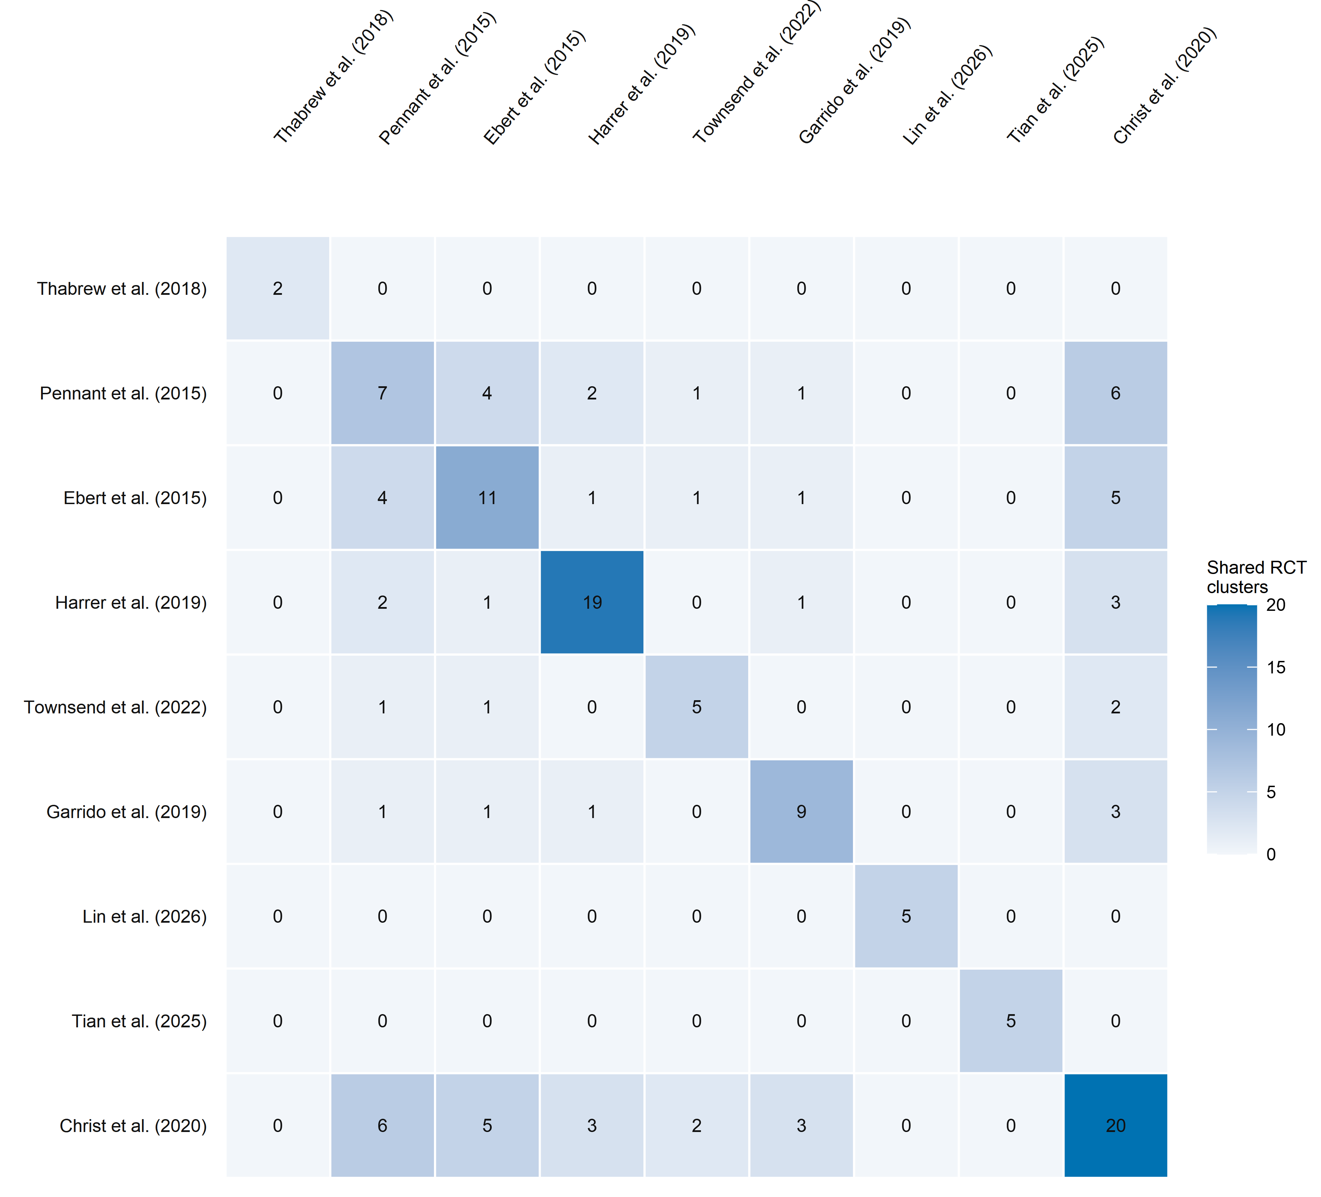

Figure S1. Pairwise overlap of independent RCT clusters in the strict primary analysis.
Note. Diagonal cells show the number of independent RCT clusters contributing to each review-level effect; off-diagonal cells show the number shared by each pair of reviews. Darker shading indicates a larger number of RCT clusters. RCT, randomized controlled trial.
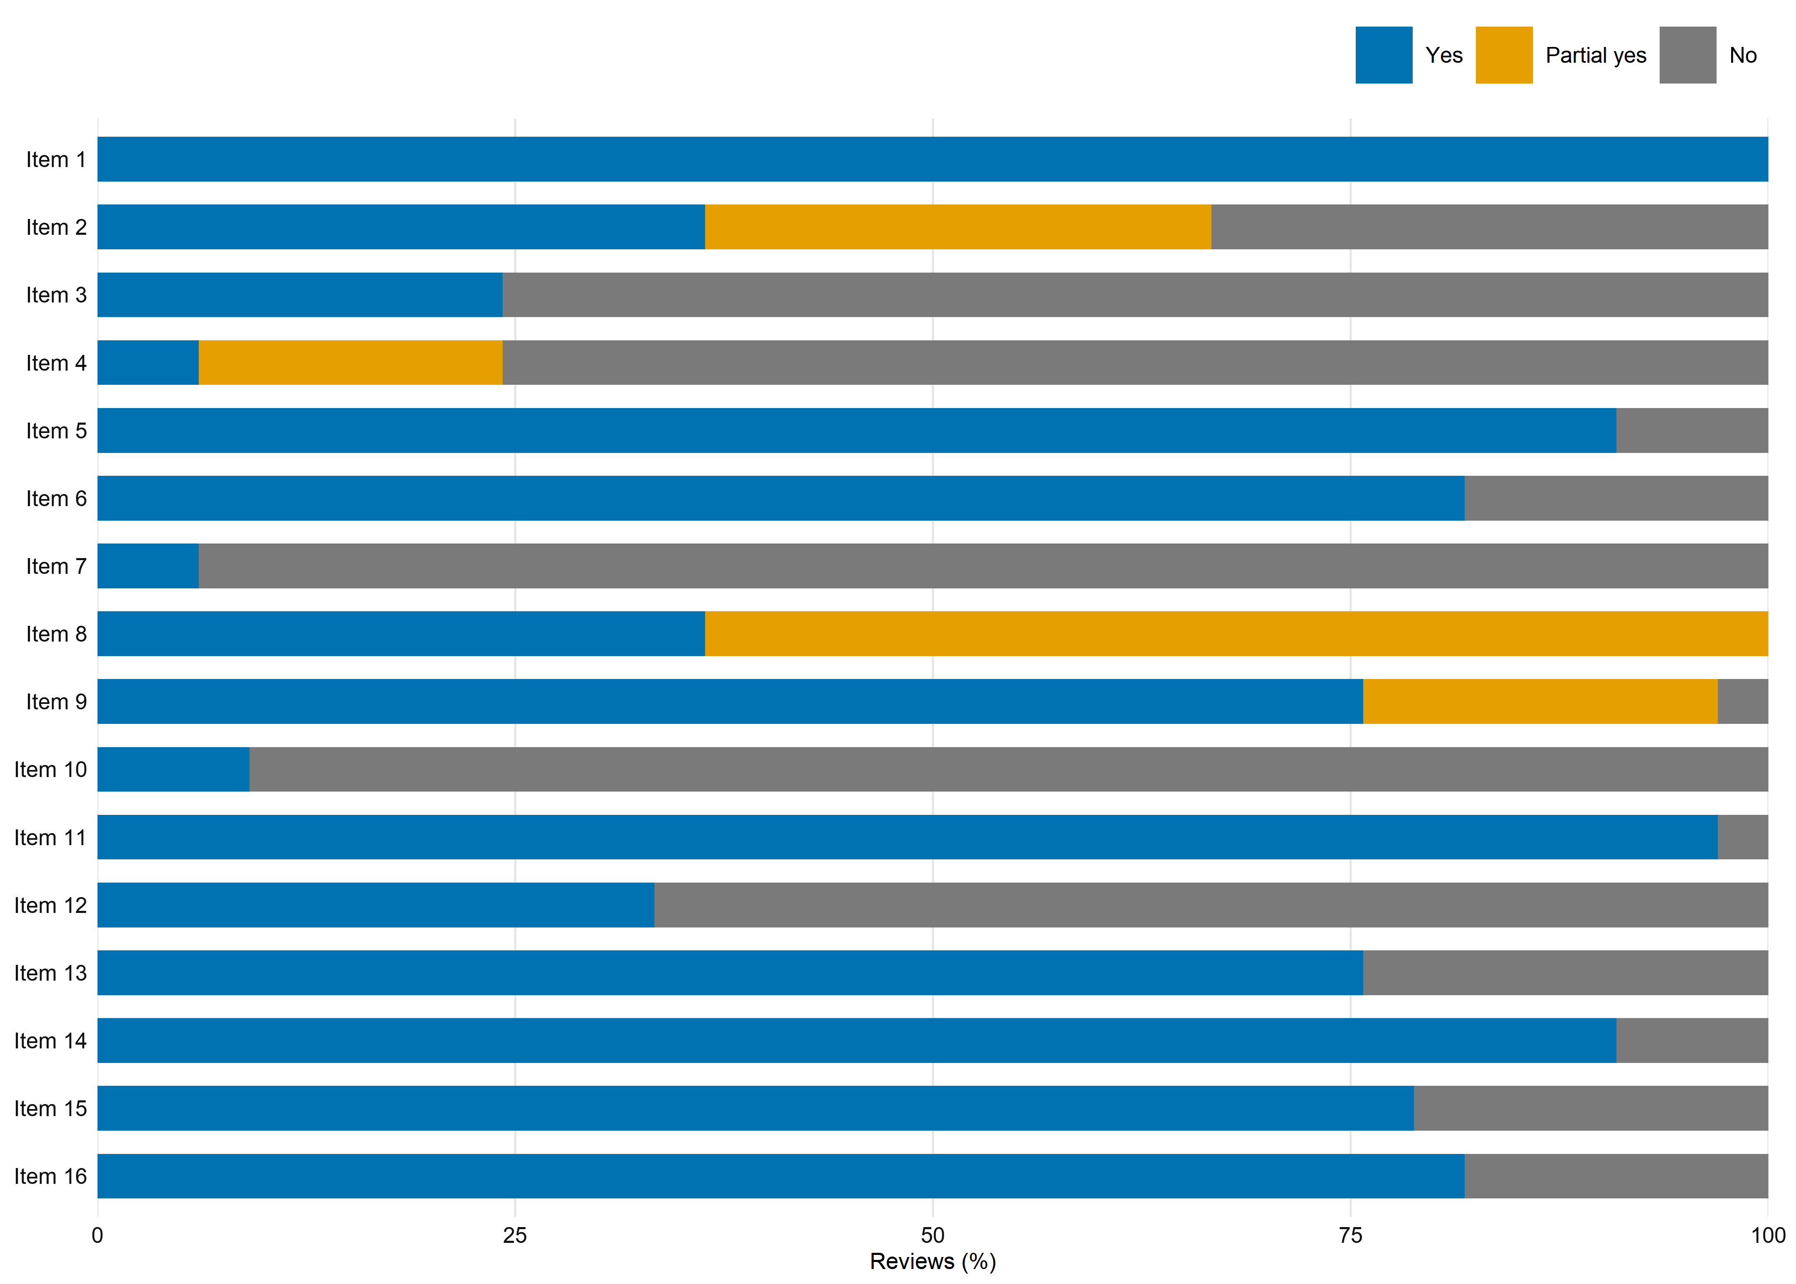

Figure S2. AMSTAR 2 item-level profile of the 33 included systematic reviews.
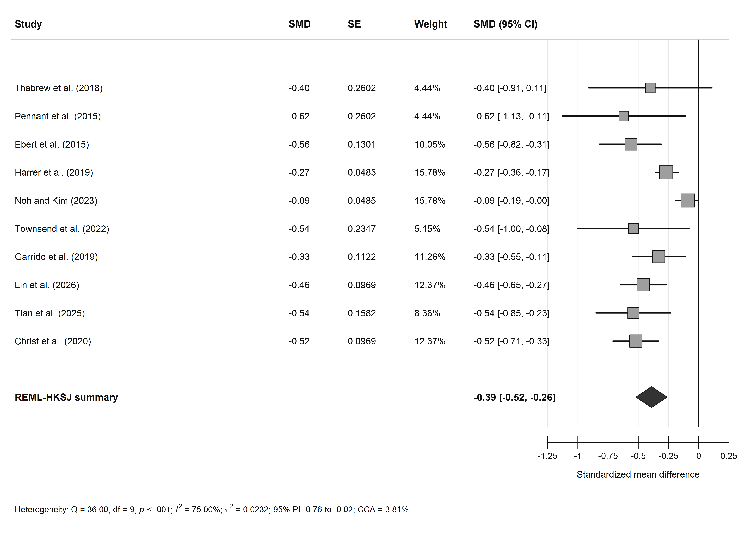

Figure S3. Change-score sensitivity analysis.
Note. This sensitivity analysis added the standardized between-group change-score effect reported by Noh and Kim (2023) to the strict primary model. Negative SMD values favour digital psychological interventions. Squares represent review-level effects, with their sizes proportional to inverse-variance weights; horizontal lines represent 95% confidence intervals. The diamond represents the pooled random-effects estimate obtained using restricted maximum-likelihood estimation and Knapp–Hartung adjustment. CI, confidence interval; CCA, corrected covered area; PI, prediction interval; SMD, standardized mean difference.
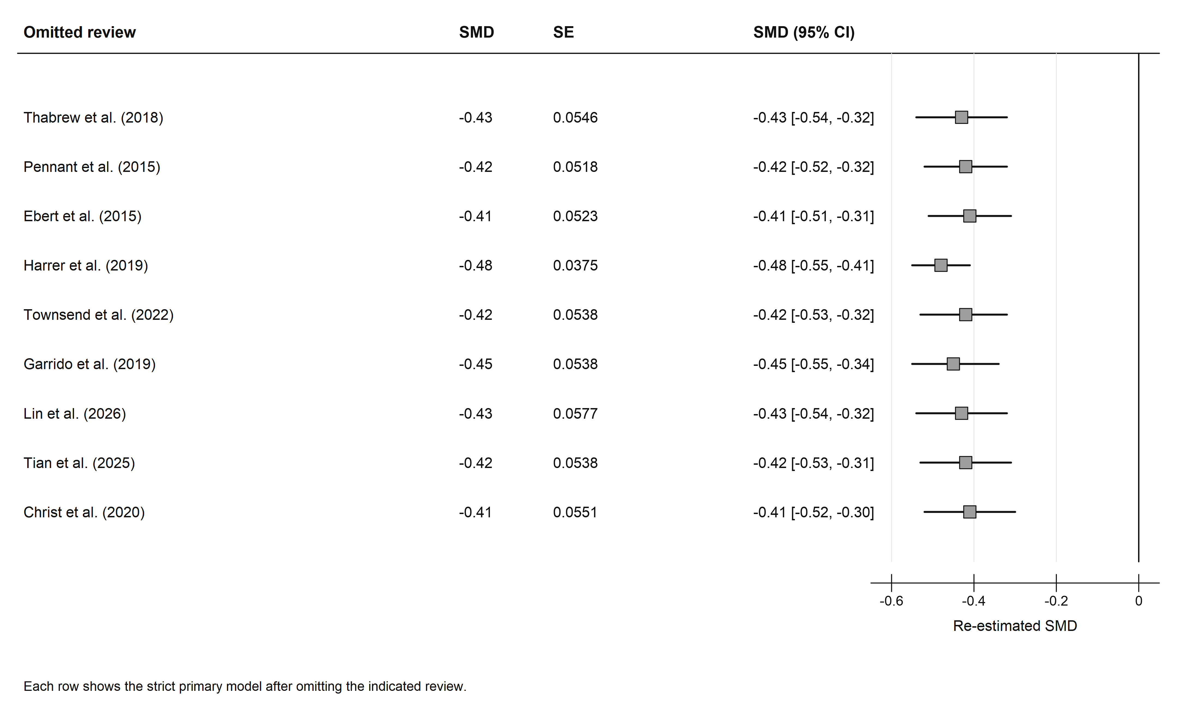

Figure S4. Leave-one-review-out analysis for the strict primary model.
Note. Each row shows the pooled strict-primary estimate after omission of the indicated review. Squares represent the re-estimated pooled SMDs, and horizontal lines represent 95% confidence intervals. Negative values favour digital psychological interventions. CI, confidence interval; SMD, standardized mean difference.
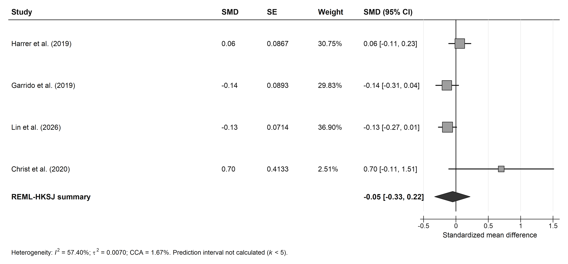

Figure S5. Active-control subgroup analysis.
Note. Review-level effects compare digital psychological interventions with active therapeutic or attention-matched control conditions at post-intervention. Negative SMD values favour digital psychological interventions. Squares represent review-level effects, with their sizes proportional to inverse-variance weights; horizontal lines represent 95% confidence intervals. The diamond represents the pooled random-effects estimate. A prediction interval was not calculated because the model included fewer than five review-level effects. CI, confidence interval; CCA, corrected covered area; SMD, standardized mean difference.
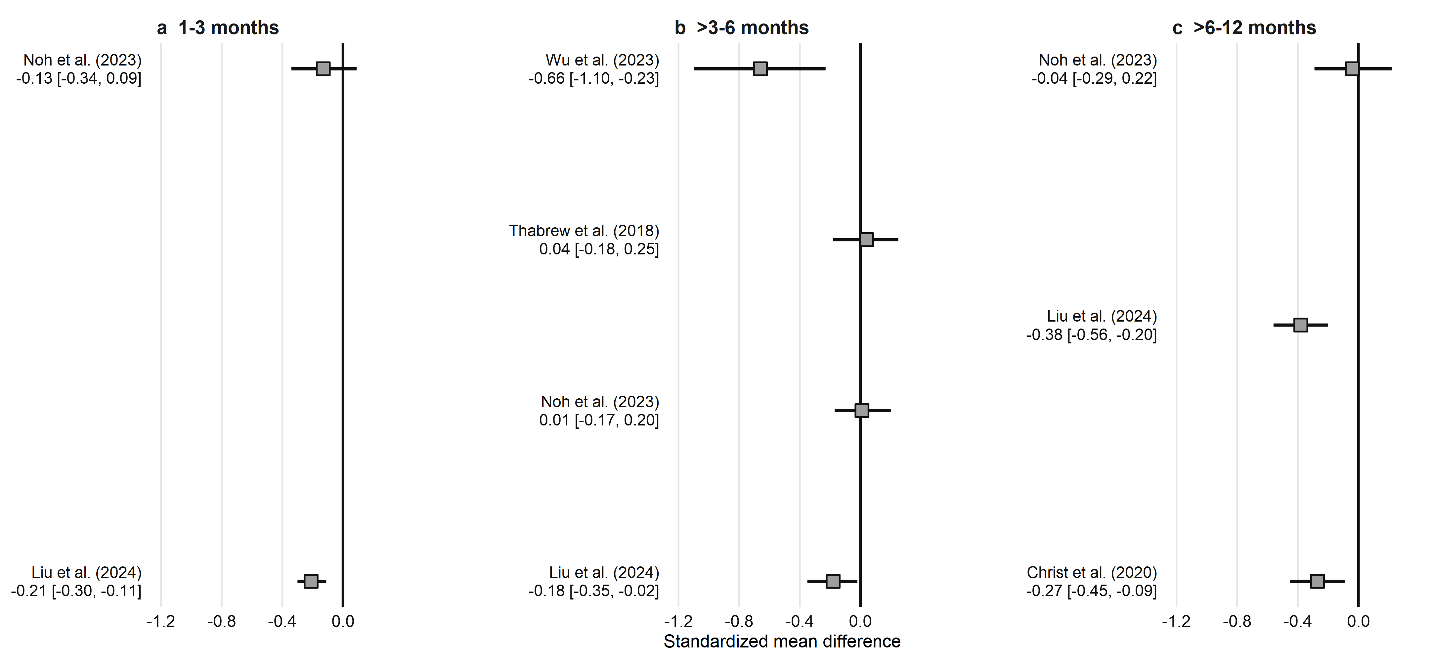

Figure S6. Follow-up effects by prespecified time window.
Note. Review-specific follow-up effects are grouped according to the prespecified 1–3-month, >3–6-month, and >6–12-month time windows. Negative SMD values favour digital psychological interventions. Squares represent review-level effect estimates, and horizontal lines represent 95% confidence intervals. No cross-review pooled estimate was calculated because comparator definitions and follow-up assessments were insufficiently comparable across reviews. Results spanning more than one prespecified time window, or lacking a complete numerical effect estimate and confidence interval, were not plotted. CI, confidence interval; SMD, standardized mean difference.
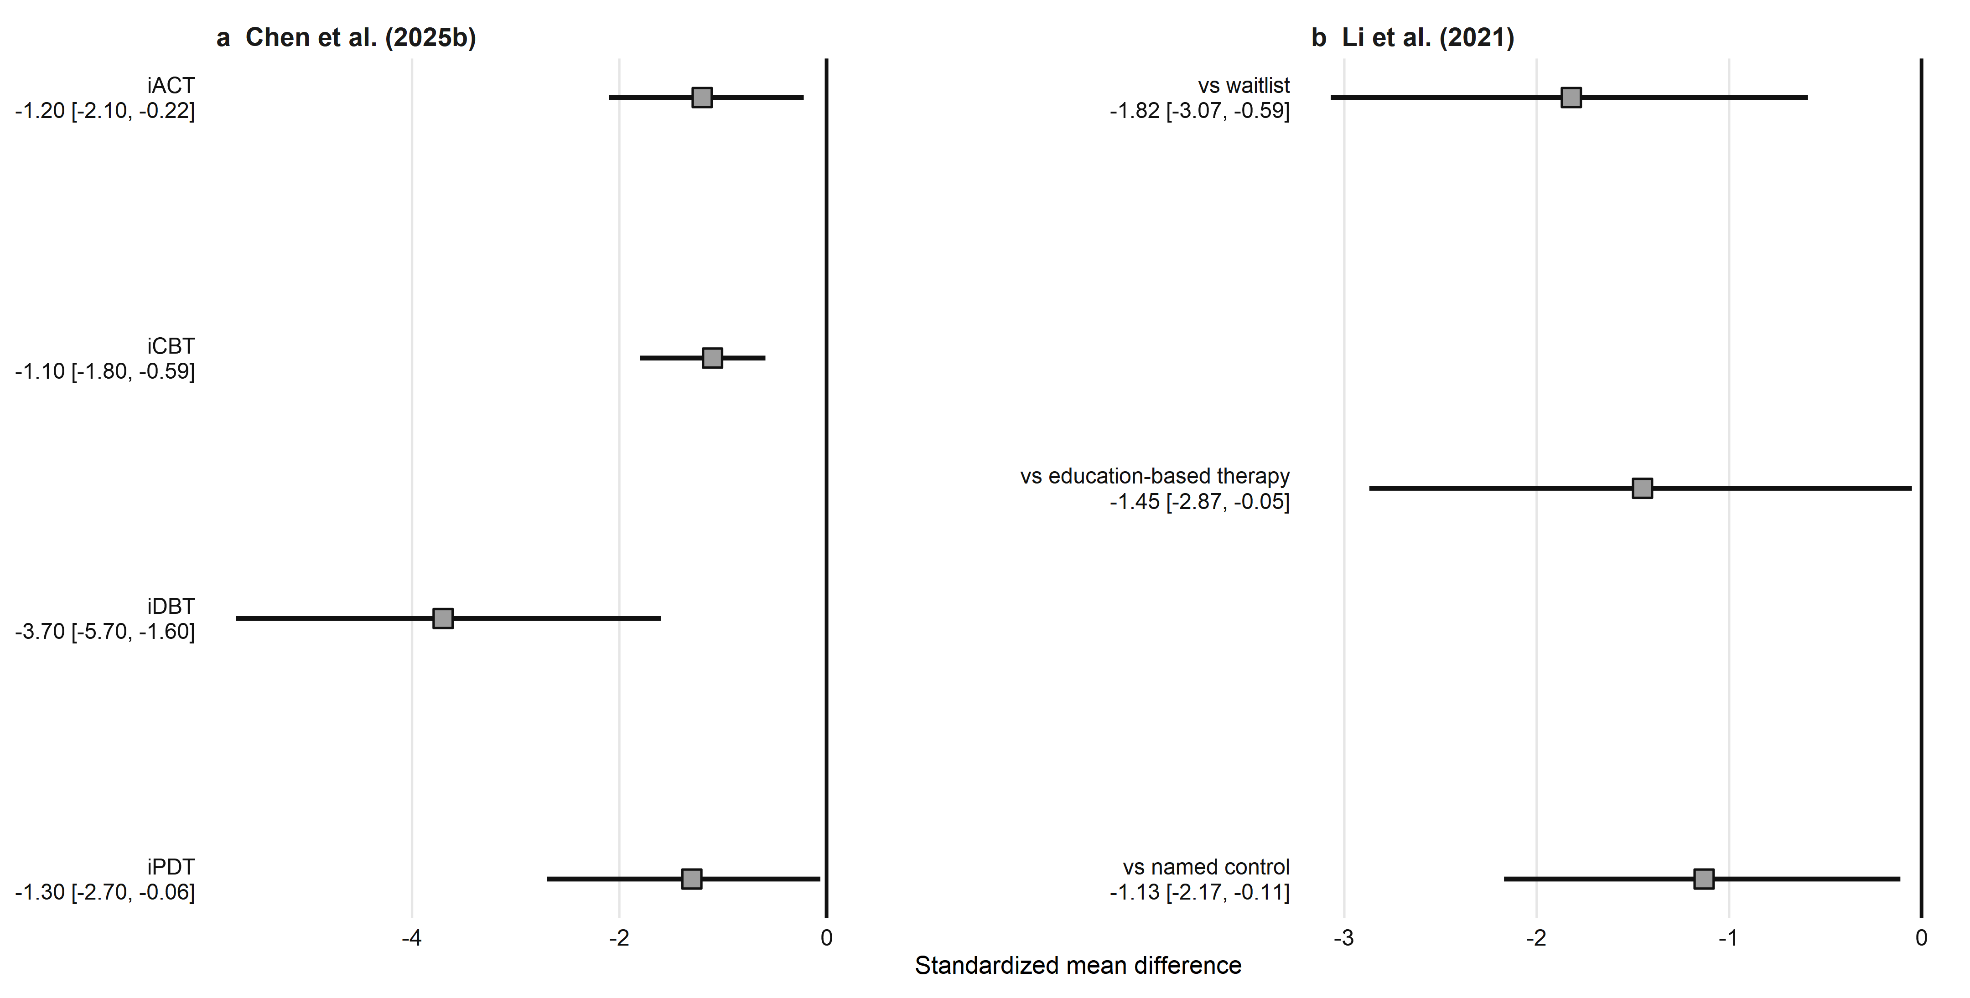

Figure S7. Network meta-analysis estimates for eligible digital psychological interventions.
Note. Squares show review-specific SMD estimates, and horizontal lines show 95% credible intervals (CrIs). Negative values favour digital psychological interventions. The two panels use different horizontal-axis ranges. Estimates were not pooled across reviews, and no cross-review treatment ranking was derived. CrI, credible interval; SMD, standardized mean difference.

