Supplementary Information
Ionic-Layer Engineering Enables Propeller-Type Interstitialcy Oxygen Migration in Close-Packed Perovskite Solid Electrolytes
Yang Zhou,ª Xiaohui Li,^{a*} Cheng Li,^{b} Zhenhong Tan,^{c} Ping Miao,^{c} Qilong Gao,^{d} Kun Lin,^{e} Junliang Sun,^{f} Xianran Xing,^{e} and Xiaojun Kuang^{a,g*}
ª Guangxi Key Laboratory of Electrochemical and Magnetochemical Functional Materials, College of Chemistry and Bioengineering, Guilin University of Technology, Guilin 541004, People’s Republic of China.
^{b} Oak Ridge National Laboratory, Neutron Sciences Directorate, Oak Ridge, TN, 37831-2008, United States of America.
^{c} Songshan Lake Materials Laboratory, Dongguan 523808, China; Spallation Neutron Source Science Center, Dongguan 523803, People’s Republic of China.
^{d} International Laboratory for Quantum Functional Materials of Henan, School of Physics and Microelectronics, Zhengzhou University, Zhengzhou 450001, People’s Republic of China.
^{e} Beijing Advanced Innovation Center for Materials Genome Engineering, Institute of Solid State Chemistry, University of Science and Technology Beijing, Beijing 100083, People’s Republic of China.
^{f} College of Chemistry and Molecular Engineering, Peking University, Beijing National Laboratory for Molecular Science (BNLMS), Beijing 100871, People’s Republic of China.
^{g} Future Energy Interdisciplinary Center, Key Laboratory of Solid-State Energy Conversion and Storage of Jiangxi Education Department, School of Intelligent Manufacturing and Future Energy, Gannan Normal University, Ganzhou, Jiangxi 341000, People’s Republic of China.
*E-mail address: xiaohuili@glut.edu.cn (X.L.); kuangxiaojun@gnnu.edu.cn (X.K.).
Figure S1. Rietveld refinement of XRD pattern for Ca_{3.9}La_{0.1}Nb₂O_{9.05}.

Table S1. The final refined structural parameters of Ca_{3.9}La_{0.1}Nb₂O_{9.05} from SPD data.
Atom | site | x | y | z | Occ. | Beq (Å²) | BVS
Ca1 | 2a | 0.0000 | 0.0000 | 0.0000 | 0.93(2) | 0.0313(1) | 2.12
La1 | 2a | 0.0000 | 0.0000 | 0.0000 | 0.07(2) | 0.0313(1) | 3.58
Ca2 | 2d | 0.50000 | 0.50000 | 0.0000 | 0.98(1) | 0.5242(4) | 2.51
La2 | 2d | 0.50000 | 0.50000 | 0.0000 | 0.02(1) | 0.5242(4) | 4.29
Ca3 | 4e | 0.27986(5) | 0.50411(4) | 0.07367(2) | 0.95(1) | 0.4781(2) | 1.39
La3 | 4e | 0.27986(5) | 0.50411(4) | 0.07367(2) | 0.05(1) | 0.4781(2) | 2.25
Ca4 | 4e | 0.75399(8) | 0.49795(9) | 0.26651(7) | 0.975(2) | 1.6433(4) | 1.88
La4 | 4e | 0.75399(8) | 0.49795(9) | 0.26651(7) | 0.025(2) | 1.6433(4) | 3.10
Ca5 | 4e | 0.7448(1) | -0.02672(1) | 0.09835(5) | 1 | 0.7698(3) | 3.21
Nb1 | 4e | 0.00364(2) | 0.00288(6) | 0.33560(6) | 1 | 1.2347(1) | 4.77
Nb2 | 4e | 0.50439(4) | -0.00493(2) | 0.1682(3) | 1 | 1.6216(3) | 4.42
O1 | 4e | -0.072(8) | 0.200(7) | 0.090(3) | 1 | 1.0516(4) | -1.84
O2 | 4e | 0.47900(5) | 0.78200(8) | 0.24600(3) | 1 | 1.4484(2) | -2.09
O3 | 4e | 0.06589(5) | 0.71579(2) | 0.26954(1) | 1 | 1.6197(1) | -1.97
O4 | 4e | 0.563(4) | 0.270(5) | 0.122(2) | 1 | 0.8476(7) | -1.91
O5 | 4e | 0.051(9) | 0.645(6) | 0.0951(3) | 1 | 0.5131(1) | -2.03
O6 | 4e | 0.406(4) | 0.928(8) | 0.009(2) | 1 | 2.5972(6) | -2.22
O7 | 4e | 0.25835(8) | 0.38568(5) | 0.25527(6) | 1 | 0.47531(8) | -2.06
O8 | 4e | 0.750(7) | 0.590(5) | 0.089(2) | 1 | 2.2668(2) | -2.10
O9 | 4e | 0.266(1) | 0.099(7) | 0.105(3) | 1 | 1.2127(6) | -1.97
*Space group: P2₁/c (14), a = 9.8274(1) Å, b = 5.55656(8) Å, c =17.29054 (2)Å, β = 125.59422(9) º, V = 767.769 (2)Å³, Z = 4.
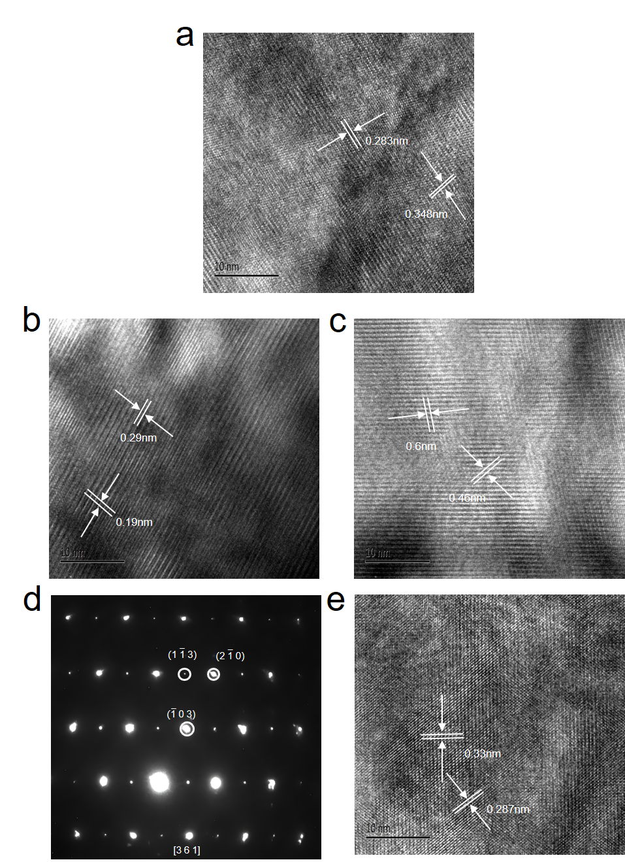
Figure S2. (a-e) High-resolution TEM images and corresponding selected-area electron diffraction (SAED) patterns of Ca_{3.85}La_{0.15}Nb₂O_{9.075}.

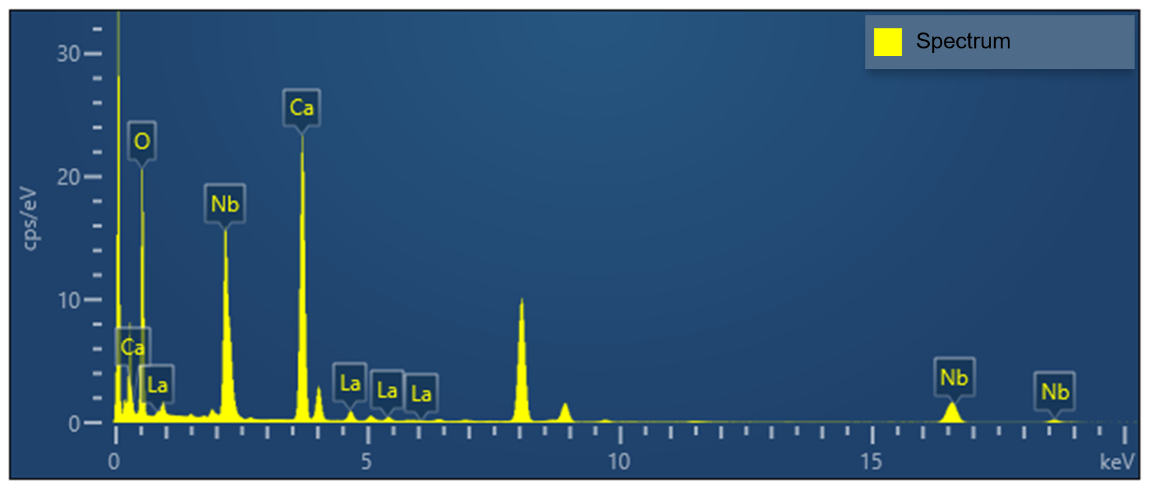
Figure S3. TEM energy dispersive spectra of Ca_{3.9}La_{0.1}Nb₂O_{9.05}.

Figure S4. SEM elemental mapping and energy dispersive spectra of Ca_{3.9}La_{0.1}Nb₂O_{9.05}.

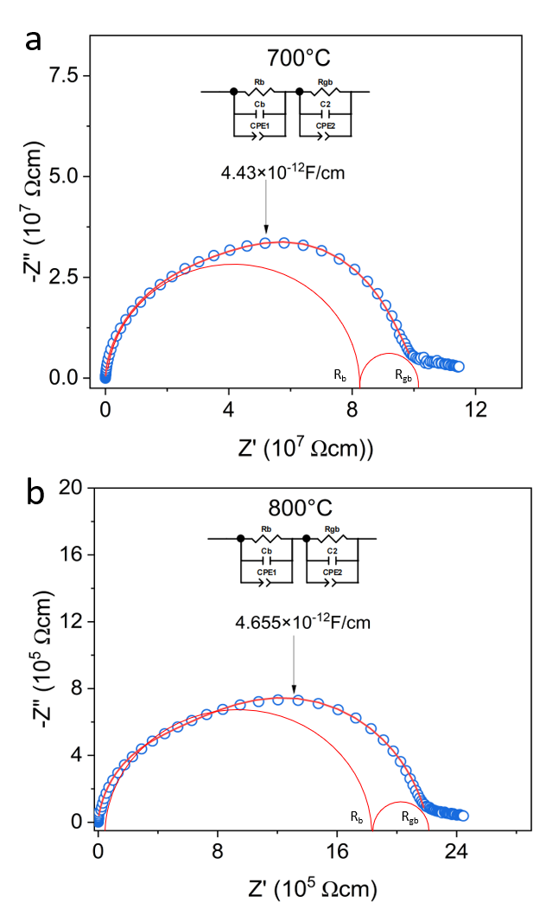
Figure S5. (a, b) Complex impedance plots of parent Ca₄Nb₂O₉ at (a) 700°C and (b) 800°C, respectively. The red semicircular arcs labeled by R_{b} and R_{gb} denote the deconvolution of bulk and grain boundary contributions, respectively.
Supplementary Note 1. Physical meaning of the equivalent-circuit analysis.
To clarify the physical meaning of the equivalent circuit used to fit the impedance spectra, we note that real ceramic electrolytes rarely exhibit ideal RC behavior. Microstructural heterogeneity, grain-boundary effects and distributions of relaxation times commonly give rise to depressed semicircles in complex impedance plots. Therefore, constant-phase element (CPE) was introduced to describe the non-ideal capacitive responses, following the general treatment of non-Debye relaxation in ceramic impedance analysis proposed by Macdonald and Jonscher.¹ In the present work, the high-frequency response is assigned to the bulk contribution of the electrolyte, the intermediate-frequency response to the grain-boundary contribution, and the low-frequency Warburg-type element to electrode diffusion at the electrode/electrolyte interface. The bulk and grain-boundary responses exhibit characteristic capacitance values in ranges typical of intrinsic lattice and grain-boundary processes, respectively, whereas the low-frequency response has a much larger characteristic capacitance consistent with interfacial diffusion.² This separation supports the assignment of the high-frequency and intermediate-frequency components to the electrolyte bulk and grain boundaries, respectively, and the low-frequency Warburg-type element to the electrode/electrolyte interfacial process. Similar equivalent-circuit treatments have been widely used for ceramic ionic conductors and electroceramic materials.³⁻⁵
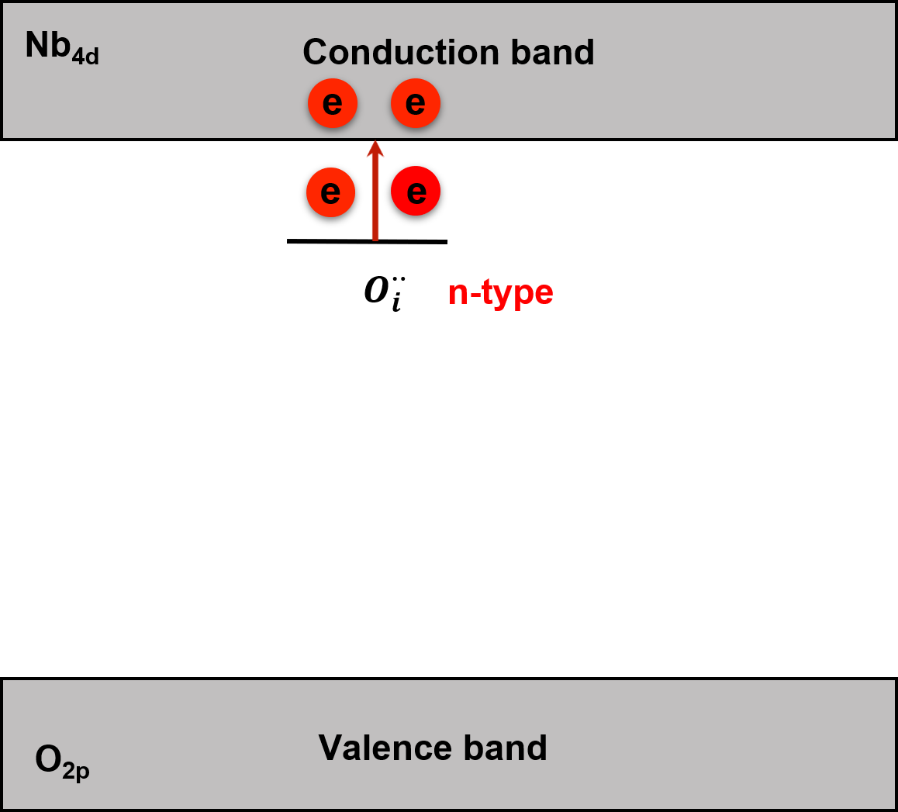
Figure S6. Schematic illustration of the electronic compensation mechanisms associated with interstitial $O_{i}^{''}$ defects. Top: Aliovalent doping stabilizes doubly charged interstitial oxygen defects, with associated electronic states located near the Nb 4d-derived conduction band. Under reducing conditions, electron formation and partial occupation of Nb 4d-derived states give rise to an n-type electronic contribution.

Supplementary Note 2: The n-type electronic response under low-pO₂ conditions.
The n-type electronic response under low-pO₂ environment observed in Figure 3d can be rationalized by the defect chemistry of interstitial oxygen in the donor-doped composition. La substitution at the Ca site introduces positively charged donor defects, ${La}_{Ca}^{∙}$, which are primarily compensated by doubly charged interstitial oxygen defects under oxidizing or moderately reducing conditions, consistent with the nominal composition and the structural evidence for interstitial oxygen presented in this work:
${La}_{2}O_{3}+2{Ca}_{Ca}^{×}→2CaO+O_{i}^{´´}$ (1)
Under sufficiently reducing conditions, the charge-compensation mechanism may shift partially towards electronic compensation. This could be associated with ionization of interstitial oxygen-related defect states and/or a reduction in the interstitial oxygen content, either of which could contribute to electron generation. These processes can be represented by the following limiting defect equilibria:
$O_{i}^{´´}→O_{i}^{×}+2e^{´}$ (2)
and/or
$O_{i}^{''}→\frac{1}{2}O_{2}+2e^{´}$ (3)
As schematically illustrated in the upper panel of Figure S6. The negatively charged interstitial oxygen defects are associated with donor-like electronic states located near the Nb 4d-derived conduction band. Under low-pO₂ conditions, partial electronic compensation may occur through electron formation, giving rise to an n-type electronic contribution.

Figure S7. Variable temperature XRD patterns of Ca_{3.85}La_{0.15}Nb₂O_{9.075} in the temperature region of 25-1000 ºC.

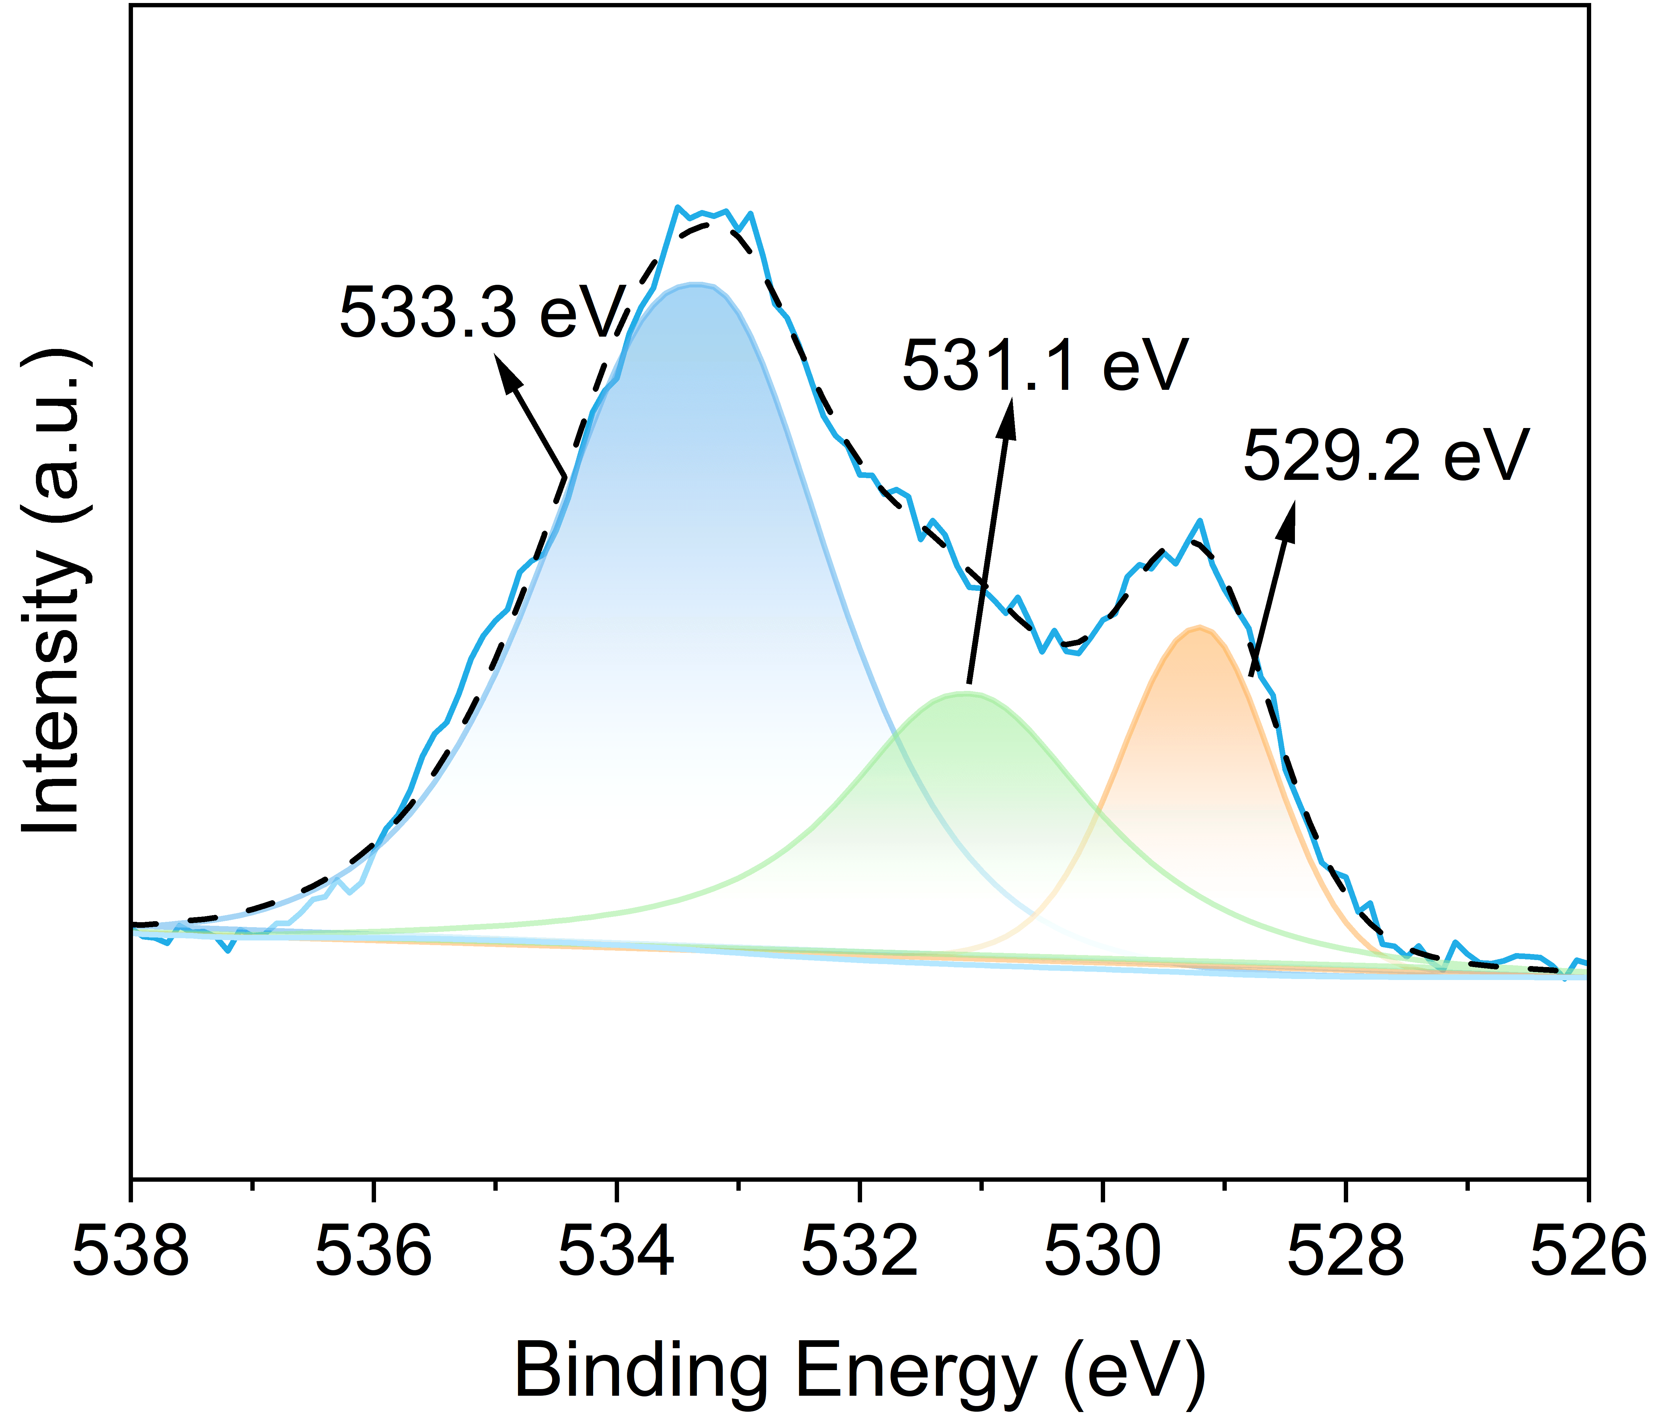
Figure S8. O-1s XPS fine spectra of Ca_{4-x}La_{x}Nb₂O_{9+x/2} with x = 0.1.
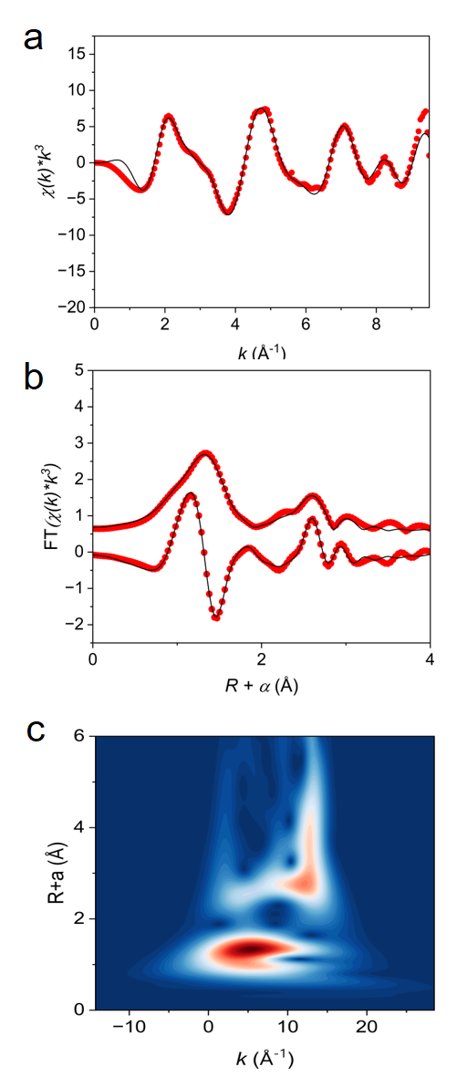
Figure S9. Fourier-transformed (FT) k³-weighted EXAFS (points) and curvefit (line) spectra in both (a) k-space and (b) R-space for parent Ca₄Nb₂O₉. (c) Nb K-edge wavelet transform EXAFS contours of parent Ca₄Nb₂O₉.
Table S2. Curve-fit Parameters of Nb K-edge EXAFS for Ca₄Nb₂O₉.
Path | N | R / Å | d / Å
O5 | 3.0 | 1.91(1) | 1.936
O7 | 1.0 | 2.11(1) | 2.113
Ca5 | 1.0 | 3.24(1) | 3.169
Ca4 | 4.0 | 3.35(1) | 3.257
* △E₀ was refined as a global fit parameter, returning a value of (5±4) eV. Data ranges: 2 ≤ k ≤ 12 Å⁻¹, 1 ≤ R ≤ 4 Å. The number of variable parameters is 19, out of a total of 18.85 independent data points. R factor for this fit is 2.1%.
Table S3. Curve-fit Parameters for Nb K-edge EXAFS for Ca_{3.9}La_{0.1}Nb₂O_{9.05}.
Path | N | R / Å | d / Å
Oi | 1.0 | 1.61(1) | 2.166
O3 | 2.0 | 2.09(1) | 1.926
O4 | 1.0 | 2.42(1) | 2.876
O7 | 1.0 | 2.22(1) | 1.999
O5 | 1.0 | 2.72(1) | 2.789
Ca1 | 6.0 | 3.25(1) | 3.338
* △E₀ was refined as a global fit parameter, returning a value of (-2±4) eV. Data ranges: 2 ≤ k ≤ 12 Å-1, 1 ≤ R ≤ 3 Å. The number of variable parameters is 19, out of a total of 20.7 independent data points. R factor for this fit is 1.2%.
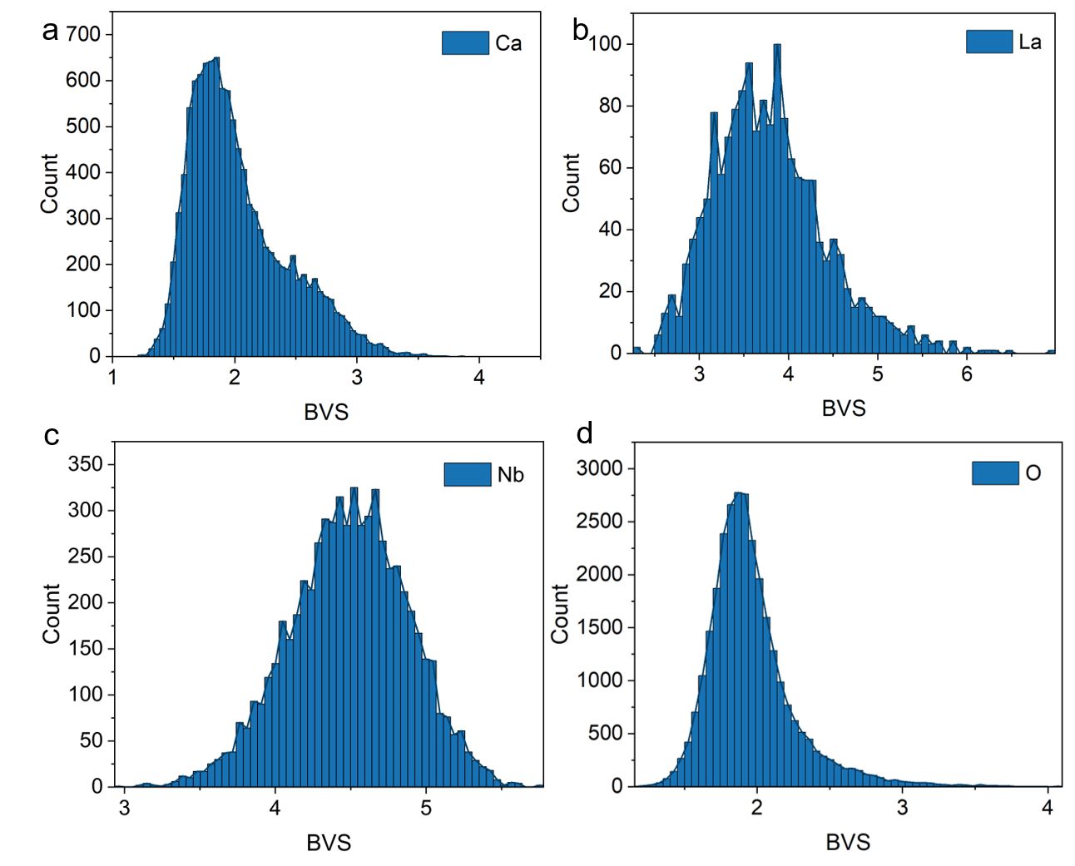
Figure S10. Histograms of the bond valence sum (BVS) distributions for all atomic configurations in the RMC supercell model: (a) Ca, (b) La, (c) Nb, and (d) O.
Supplementary Note 3. Variable-temperature neutron PDF combined with RMC analysis of local structural disorder.
Variable-temperature neutron PDF measurements were performed at 300 K, 873 K and 1073 K to examine the local structural response associated with oxide-ion migration in Ca_{3.9}La_{0.1}Nb₂O_{9.05}. The neutron PDF data show progressive broadening in the low-r region with increasing temperature (Figures S11a-b), indicating an increased spread of local bond-length distributions. The temperature-dependent changes in selected PDF features (Figure S11b) can be mainly assigned to variations in local Ca-O and Nb-Nb correlations, while the partial Nb-O PDF (Figure S11c) further reflects the temperature response of the Nb-centered coordination environment. Consistently, the refined atomic displacement parameters (Tables S4-6) show that the oxygen sublattice exhibits the strongest thermal response. The anisotropic displacement ellipsoid plots at 300 K and 1073 K (Figure S12) directly visualize the enhanced high-temperature anisotropic motion of the atoms, particularly for oxygen atoms. These directionally correlated oxygen displacements point to twisting or rotational distortions of the local Ca- and Nb-centered coordination polyhedra, providing a structural signature of the propeller-type migration mechanism.
The variable-temperature neutron PDF data with RMC modeling (Figure 6a) provide a complementary real-space description of this local dynamic response. In the folded RMC configurations (Figures 6b-c), the oxygen atomic distribution becomes progressively more diffuse with increasing temperature, whereas the cation sublattices remain comparatively less broadened. Quantitative displacement distributions (Figure 6d-e and Figure S13) and root-mean-square (RMS) displacements (Figure 6f) extracted from the RMC configurations show that oxygen exhibits the largest increase in displacement with temperature, followed by Ca and then Nb, indicating substantial flexibility of the Ca-containing ionic layer relative to the more rigid Nb-centered framework. Specifically, the average oxygen displacement at 300 K is below 0.20 Å, with a maximum value below 0.70 Å, whereas at elevated temperature the oxygen displacement distribution broadens substantially, extending to approximately 1.46 Å with an average displacement of about 0.40 Å (Figure 6d). By contrast, the Ca and Nb sublattices show smaller displacement amplitudes, with RMS values of approximately 0.552 Å and 0.348 Å, respectively, at 1073 K, confirming that the oxygen sublattice is the most mobile component while the Nb-centered framework remains comparatively rigid. These results indicate that the oxygen sublattice is the most mobile component and that the Ca-containing ionic layer is more flexible than the Nb-centered framework, consistent with the cooperative local distortions required for the propeller-type interstitial migration mechanism.
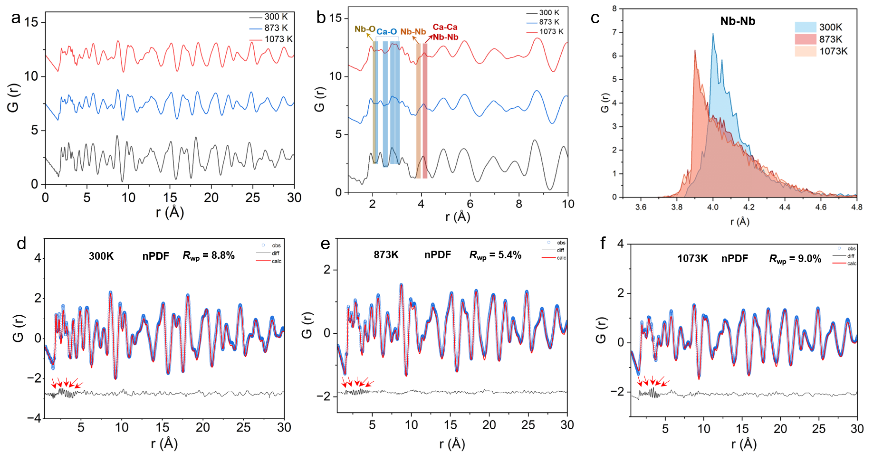
Figure S11. Variable-temperature neutron pair distribution function (PDF) data for Ca_{3.9}La_{0.1}Nb₂O_{9.05}. (a) Overview of the neutron PDF data. (b) Enlarged view of the 1-10 Å region. The yellow and blue shaded regions, together with the orange and dark-red markers, indicate temperature-dependent changes in selected PDF peaks, mainly associated with the evolution of local Nb-O, Ca-O and Nb-Nb distance distributions. (c) Temperature evolution of the partial Nb-O PDF. (d-f) Small-box refinements of the neutron PDF data collected at (d) 300 K, (e) 873 K, and (f) 1073 K.
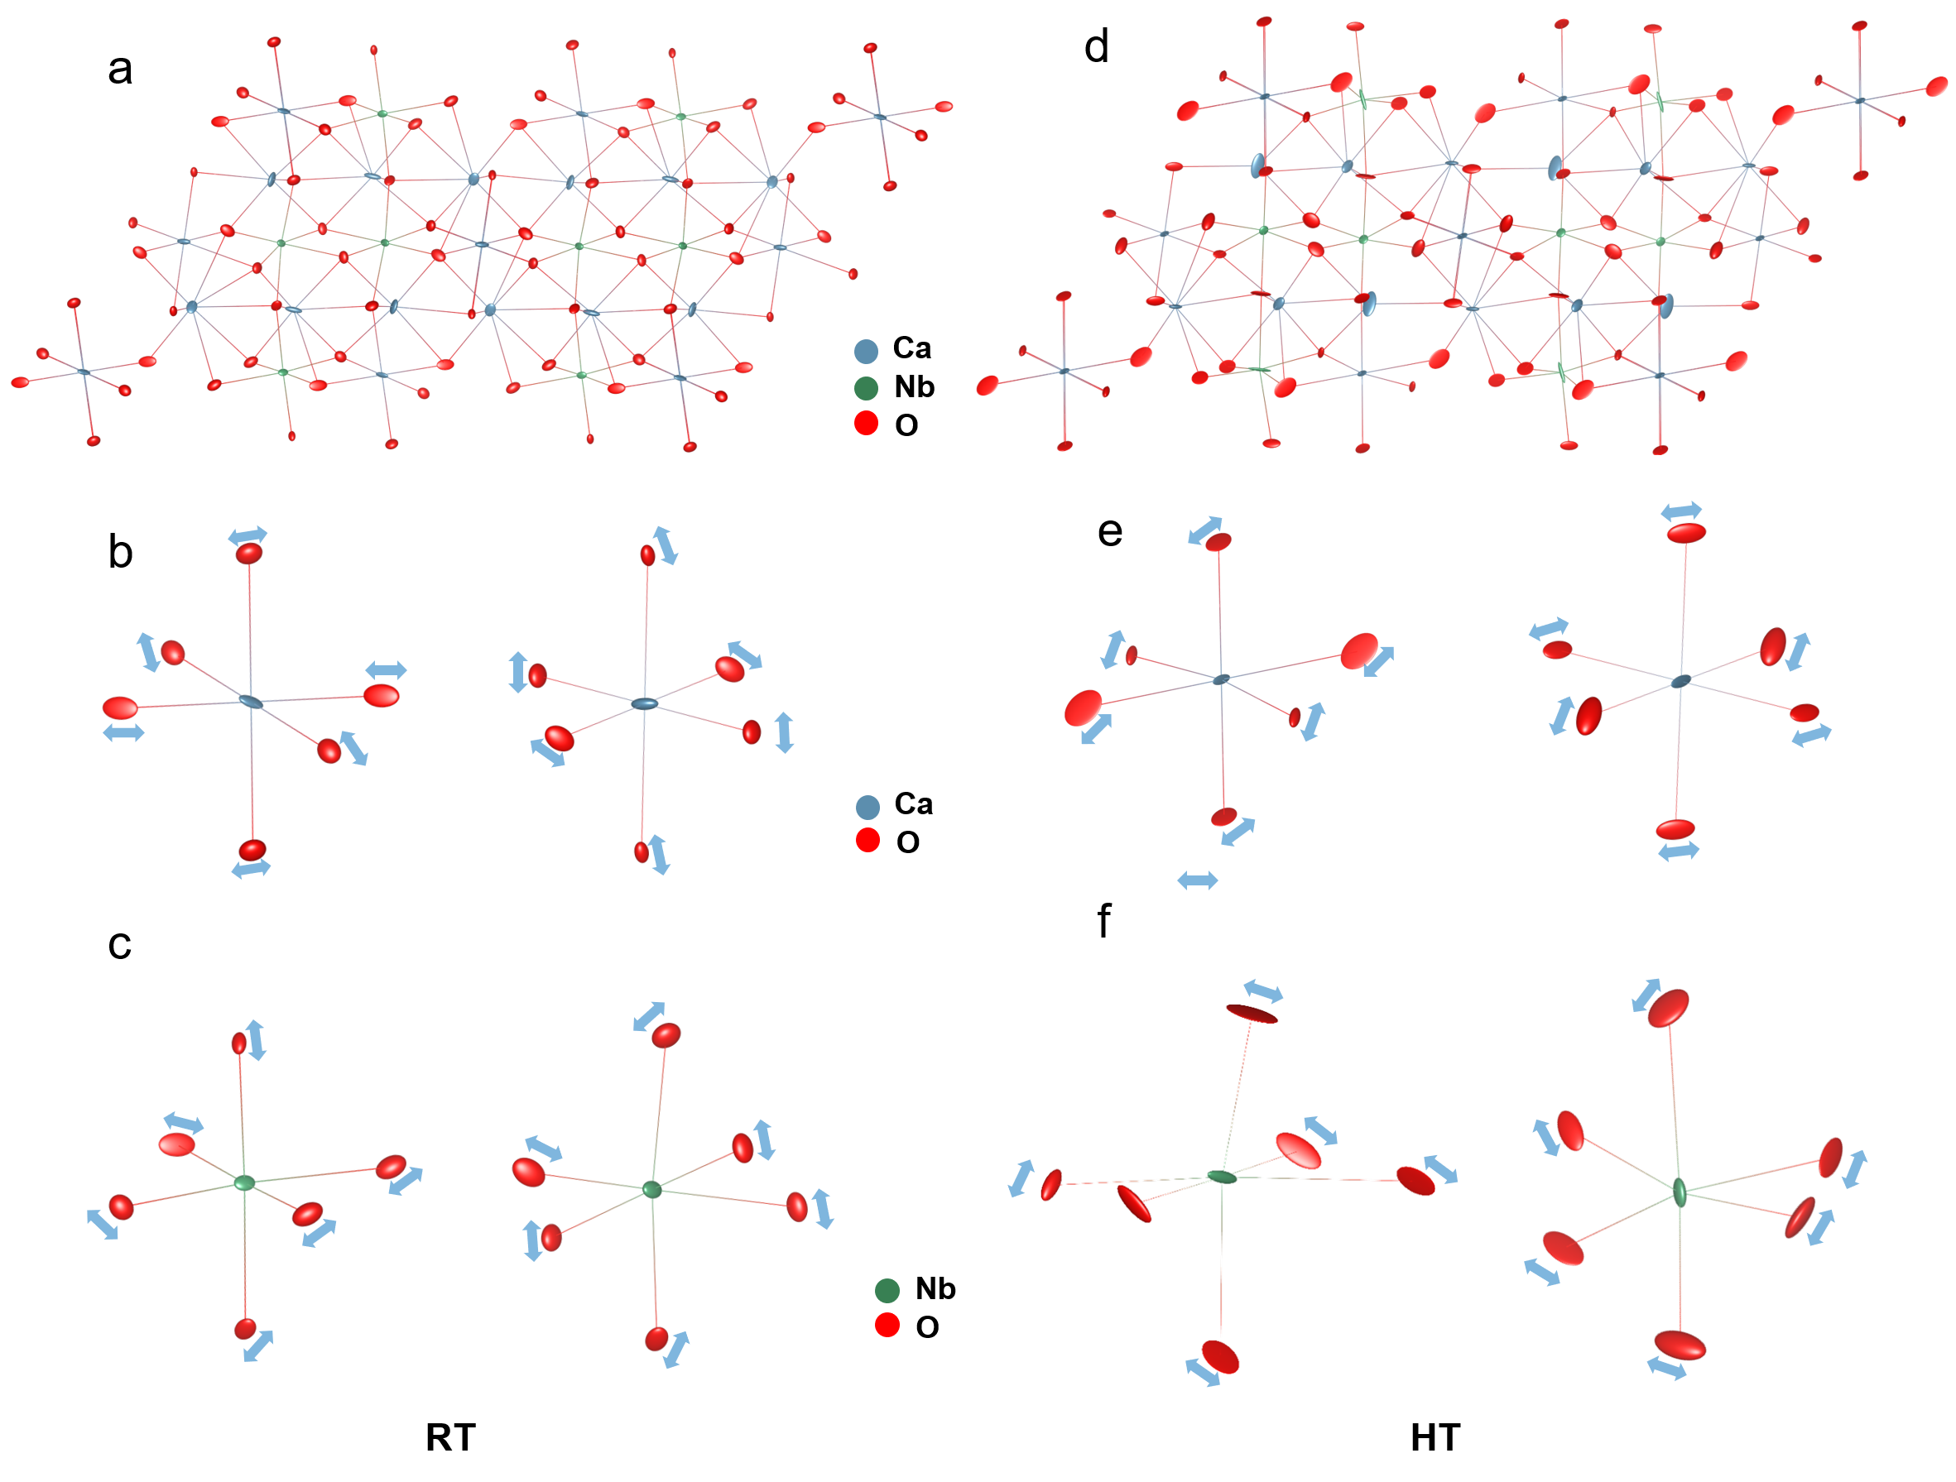
Figure S12. Anisotropic atomic displacement parameters of Ca_{3.9}La_{0.1}Nb₂O_{9.05} at room temperature (RT) and high temperature (HT). (a, d) Average structure shown with anisotropic displacement ellipsoids at RT and HT, respectively, revealing stronger anisotropic thermal motion of the oxygen atoms at elevated temperature. (b, c) Representative Ca- and Nb-centered local coordination environments at RT. (e, f) Representative Ca- and Nb-centered local coordination environments at HT. Blue arrows indicate the principal directions of oxygen displacements, highlighting cooperative local distortions of the coordination polyhedra associated with enhanced oxide-ion dynamics.

Table S4. Refined anisotropic displacement parameters for Ca_{3.9}La_{0.1}Nb₂O_{9.05} at 300 K.
Atom | U11(Å2) | U22(Å2) | U33(Å2) | U12(Å2) | U13(Å2) | U23(Å2)
Ca1 | 0.003252 | 0.011860 | 0.012694 | -0.000389 | 0.004072 | -0.007549
La1 | 0.003252 | 0.011860 | 0.012694 | -0.000389 | 0.004072 | -0.007549
Ca2 | 0.006984 | 0.004294 | 0.005614 | 0.000326 | 0.002723 | 0.004731
La2 | 0.006984 | 0.004294 | 0.005614 | 0.000326 | 0.002723 | 0.004731
Ca3 | 0.021989 | 0.018141 | 0.006395 | 0.001164 | 0.008650 | -0.003006
La3 | 0.021989 | 0.018141 | 0.006395 | 0.001164 | 0.008650 | -0.003006
Ca4 | 0.004098 | 0.008505 | 0.023101 | 0.000622 | 0.006182 | 0.002031
La4 | 0.004098 | 0.008505 | 0.023101 | 0.000622 | 0.006182 | 0.002031
Ca5 | 0.016382 | 0.012510 | 0.010798 | 0.011694 | 0.007913 | 0.004043
Nb1 | 0.004982 | 0.005921 | 0.007372 | 0.002271 | 0.002645 | -0.002204
Nb2 | 0.005450 | 0.013252 | 0.006787 | -0.000563 | 0.003776 | -0.005590
O1 | 0.011652 | 0.003775 | 0.020462 | -0.001051 | 0.005717 | 0.006139
O2 | 0.015718 | 0.006542 | 0.011236 | 0.000918 | 0.010044 | -0.000914
O3 | 0.013341 | 0.008735 | 0.011121 | 0.000432 | 0.003185 | 0.000828
O4 | 0.012895 | 0.009575 | 0.008721 | 0.001630 | 0.007024 | -0.001991
O5 | 0.013070 | 0.007404 | 0.014743 | 0.001741 | 0.009154 | 0.002666
O6 | 0.015641 | 0.005435 | 0.021606 | -0.003512 | 0.013055 | -0.005395
O7 | 0.009958 | 0.011320 | 0.007878 | 0.008293 | 0.004329 | 0.003015
O8 | 0.010020 | 0.006712 | 0.006592 | -0.003485 | 0.006034 | -0.002817
O9 | 0.010702 | 0.011923 | 0.011217 | 0.003315 | 0.004311 | -0.002573

Table S5. Refined anisotropic displacement parameters for Ca_{3.9}La_{0.1}Nb₂O_{9.05} at 873 K.
Atom | U11(Å2) | U22(Å2) | U33(Å2) | U12(Å2) | U13(Å2) | U23(Å2)
Ca1 | 0.003046 | 0.035782 | 0.004407 | 0.003241 | 0.000113 | -0.011200
La1 | 0.003046 | 0.035782 | 0.004407 | 0.003241 | 0.000113 | -0.011200
Ca2 | 0.008953 | 0.017946 | 0.019127 | -0.008156 | 0.003620 | -0.017716
La2 | 0.008953 | 0.017946 | 0.019127 | -0.008156 | 0.003620 | -0.017716
Ca3 | 0.057269 | 0.012973 | 0.020900 | -0.018432 | 0.025440 | -0.013521
La3 | 0.057269 | 0.012973 | 0.020900 | -0.018432 | 0.025440 | -0.013521
Ca4 | 0.015255 | 0.020581 | 0.008191 | -0.009380 | 0.004801 | 0.003566
La4 | 0.015255 | 0.020581 | 0.008191 | -0.009380 | 0.004801 | 0.003566
Ca5 | 0.001615 | 0.017033 | 0.011382 | 0.000248 | 0.001117 | -0.005612
Nb1 | 0.039876 | 0.002768 | 0.026895 | -0.004604 | 0.032122 | -0.004001
Nb2 | 0.007513 | 0.006846 | 0.006092 | -0.003481 | 0.003102 | -0.004683
O1 | 0.035075 | 0.004981 | 0.024552 | 0.004046 | 0.009194 | 0.010616
O2 | 0.021087 | 0.006302 | 0.029104 | -0.006147 | 0.017267 | -0.001561
O3 | 0.016276 | 0.007606 | 0.018766 | 0.010970 | 0.006838 | 0.003693
O4 | 0.006144 | 0.012252 | 0.012554 | 0.003514 | 0.003327 | -0.007560
O5 | 0.010393 | 0.014045 | 0.004565 | 0.008059 | 0.004839 | 0.002225
O6 | 0.027199 | 0.019841 | 0.011519 | 0.016491 | 0.010018 | 0.004074
O7 | 0.002023 | 0.007967 | 0.027229 | 0.002288 | 0.004386 | 0.000414
O8 | 0.007486 | 0.005127 | 0.021136 | -0.003504 | 0.004016 | -0.006962
O9 | 0.009040 | 0.017785 | 0.011291 | -0.011953 | 0.001812 | 0.000277

Table S6. Refined anisotropic displacement parameters for Ca_{3.9}La_{0.1}Nb₂O_{9.05} at 1073 K.
Atom | U11(Å2) | U22(Å2) | U33(Å2) | U12(Å2) | U13(Å2) | U23(Å2)
Ca1 | 0.005787 | 0.016123 | 0.012869 | -0.009763 | 0.003048 | -0.005934
La1 | 0.005787 | 0.016123 | 0.012869 | -0.009763 | 0.003048 | -0.005934
Ca2 | 0.011876 | 0.009283 | 0.015825 | 0.000657 | 0.010907 | 0.008181
La2 | 0.011876 | 0.009283 | 0.015825 | 0.000657 | 0.010907 | 0.008181
Ca3 | 0.013278 | 0.003929 | 0.008758 | -0.002779 | 0.007394 | 0.001947
La3 | 0.013278 | 0.003929 | 0.008758 | -0.002779 | 0.007394 | 0.001947
Ca4 | 0.007258 | 0.020069 | 0.016015 | 0.006452 | 0.009215 | 0.010434
La4 | 0.007258 | 0.020069 | 0.016015 | 0.006452 | 0.009215 | 0.010434
Ca5 | 0.012974 | 0.023775 | 0.009549 | 0.014223 | 0.006875 | 0.009139
Nb1 | 0.002874 | 0.007559 | 0.003025 | -0.001184 | 0.001550 | -0.002198
Nb5 | 0.005862 | 0.011637 | 0.006743 | -0.002886 | 0.002970 | -0.000768
O1 | 0.013985 | 0.003572 | 0.006922 | 0.000299 | 0.002311 | 0.003530
O2 | 0.002140 | 0.017871 | 0.008028 | 0.005545 | -0.001519 | -0.002546
O3 | 0.025825 | 0.003313 | 0.014715 | -0.000063 | 0.015539 | 0.001884
O4 | 0.012823 | 0.009018 | 0.015060 | 0.004072 | 0.008651 | -0.000102
O5 | 0.013506 | 0.004176 | 0.016345 | 0.002915 | 0.005067 | 0.002536
O6 | 0.015510 | 0.030199 | 0.009120 | 0.007600 | 0.005375 | -0.001773
O7 | 0.016595 | 0.006113 | 0.029557 | 0.007337 | 0.011095 | -0.001579
O8 | 0.005510 | 0.005311 | 0.010095 | 0.000922 | 0.004124 | -0.002470
O9 | 0.008041 | 0.012528 | 0.010513 | 0.009077 | 0.002801 | 0.004848

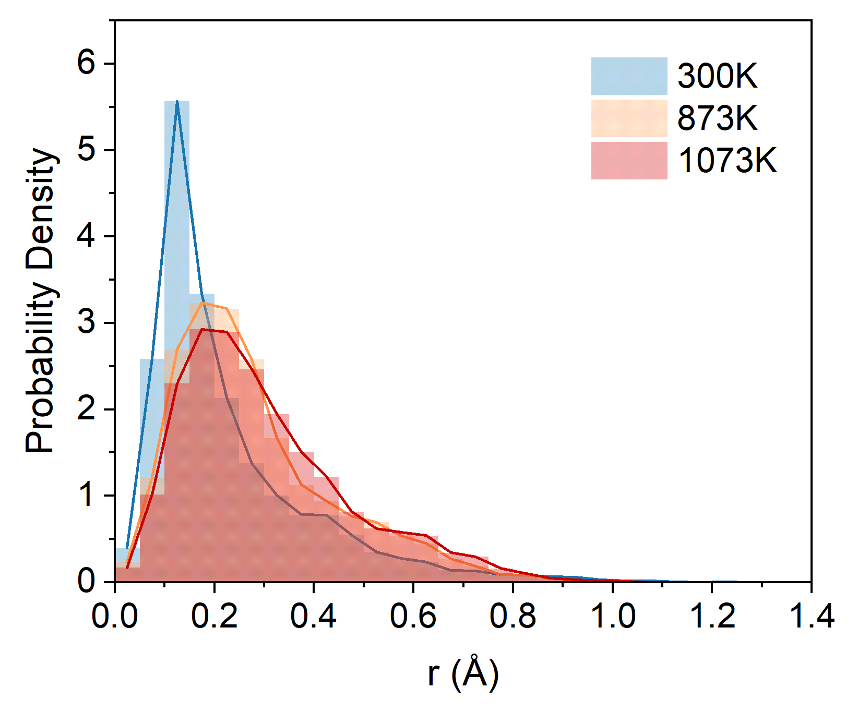
Figure S13. Displacement distributions of Nb atom in Ca_{3.9}La_{0.1}Nb₂O_{9.05}, extracted from the variable-temperature RMC configurations.

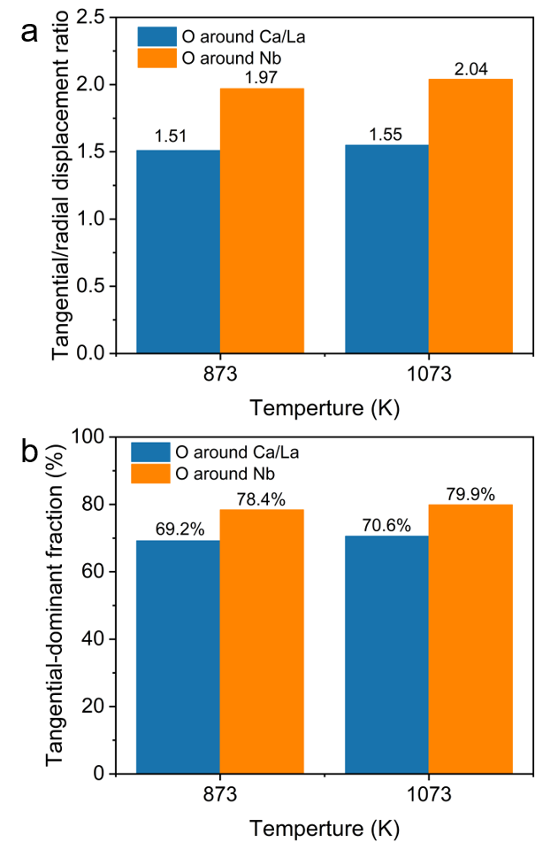
Figure S14. Directional characteristics of oxygen dynamics around Ca/La- and Nb-centered local environments. (a) Tangential-to-radial displacement ratio, R_{tan/rad}, of O atoms relative to the local M-O bond direction at 873 K and 1073 K. Values above unity indicate that transverse oxygen displacements exceed radial M-O bond-length fluctuations. (b) Fraction of O atoms exhibiting tangential-dominant displacements in the corresponding local environments. Oxygen motion around Nb shows a consistently stronger tangential character than that around Ca/La, with a modest enhancement at elevated temperature.

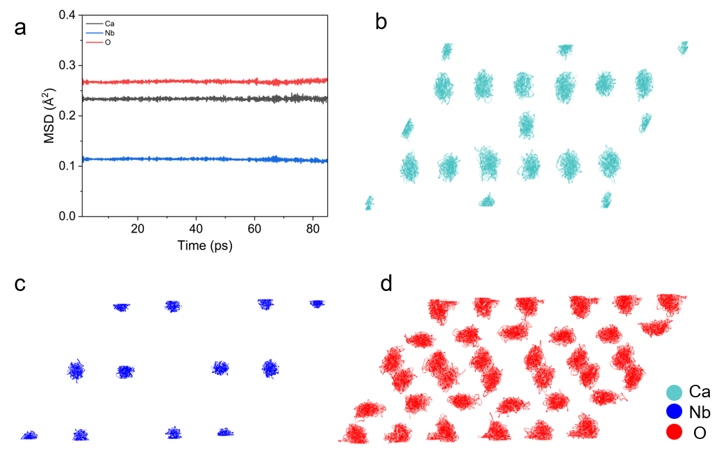
Figure S15. AIMD simulations of parent Ca₄Nb₂O₉ at 1673 K. (a) Mean square displacement (MSD) values of Ca, La, Nb, and O atoms. (b-d) Scatter plots of (b, c) cations and (d) oxide ions viewed along the [001] direction.
Figure S16. Temperature-dependent oxide-ion mean squared displacement (MSD) obtained from AIMD simulations of Ca_{3.9}La_{0.1}Nb₂O_{9.05} at 1273, 1473, 1673, and 1873 K.
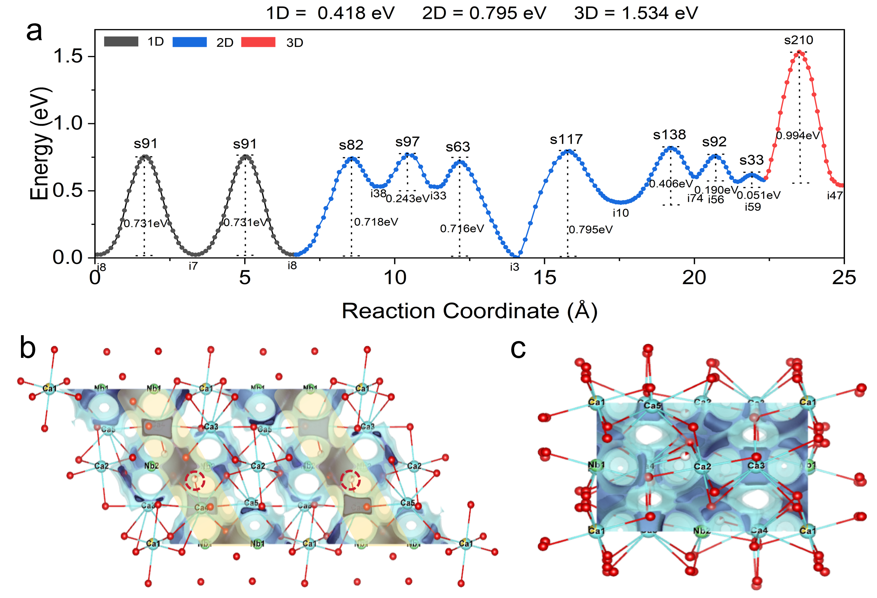
Figure S17. Bond valence site energy (BVSE) calculations for Ca_{3.9}La_{0.1}Nb₂O_{9.05}. (a) BVSE-calculated migration barriers along different dimensional. (b, c) Calculated BVSE maps of oxide-ion migration along the (b) b-axis and (c) c-axis.
Supplementary Note 4: bond valence site energy (BVSE) calculations.
We performed bond valence site energy (BVSE) calculations to construct the migration energy landscape in Ca_{4-x}La_{x}Nb₂O_{9+x/2}. The BVSE-calculated migration barriers (Figure S9a) reveal pronounced dimensionality-dependent behavior, with preferential pathways along specific crystallographic directions. In contrast to the higher migration barrier (~ 1.534 eV, Figures S17a, 17c) for 3D migration, the ac plane (Figure S17b) exhibits low-energy channels (~ 0.795 eV), which correspond to interconnected interstitial sites within the ionic [Ca′O₆] layers, resembling the R-P rock-salt layers, as marked in the visualized BVSE maps (Figure S17b), which act as structural conduits for long-range oxide-ion transport.
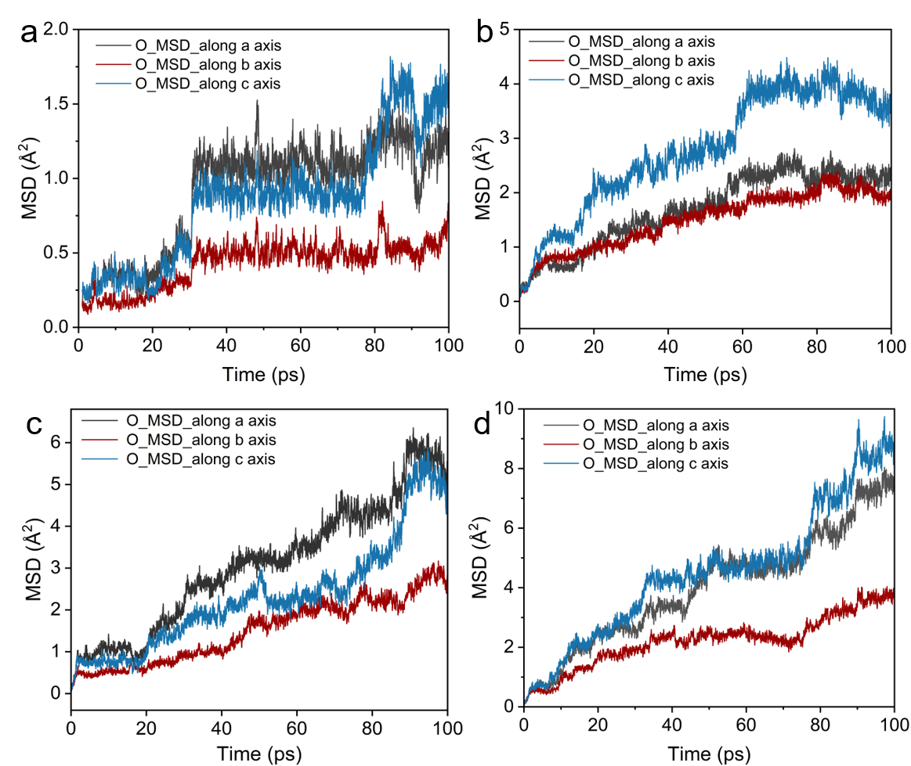
Figure S18. Direction-resolved oxide-ion MSD from AIMD. Oxygen mean-square displacement components along the crystallographic a, b, and c axes over the 0-100 ps AIMD trajectories at (a) 1273 K, (b) 1473 K, (c) 1673 K, and (d) 1873 K. The a- and c-axis components mainly represent in-plane oxide-ion motion within the Ca/La-containing layers, whereas the b-axis component corresponds to out-of-plane motion. The larger in-plane MSD components indicate anisotropic oxide-ion diffusion with preferential migration within the Ca/La-containing layers.

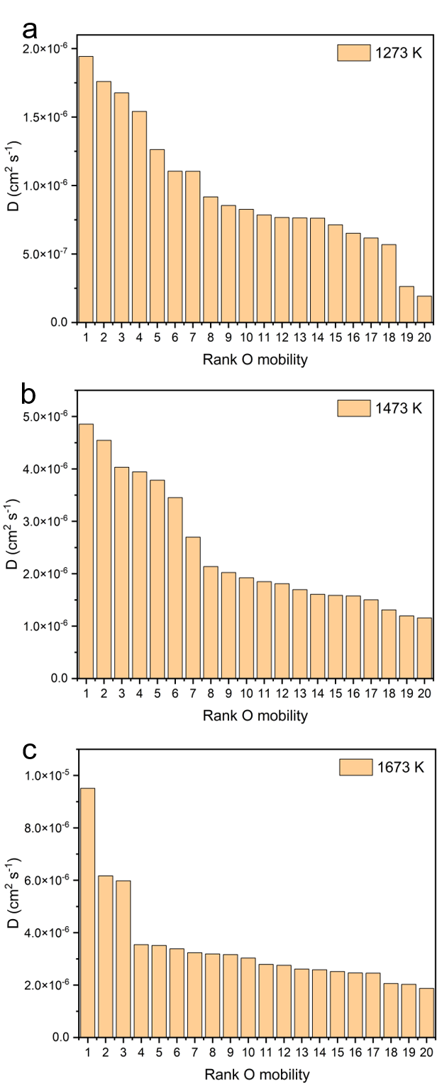
Figure S19. Temperature-dependent apparent diffusivities of the most mobile oxide ions from AIMD. Apparent single-ion diffusivities of the top 20 mobile oxide ions at (a) 1273 K, (b) 1473 K, and (c) 1673 K. The presence of multiple oxygen ions with appreciable diffusivities demonstrates that long-range oxygen transport is distributed over a population of mobile ions rather than being confined to a single isolated interstitial oxygen. The overall increase in apparent diffusivity with temperature further reflects thermally activated multi-ion oxygen transport.
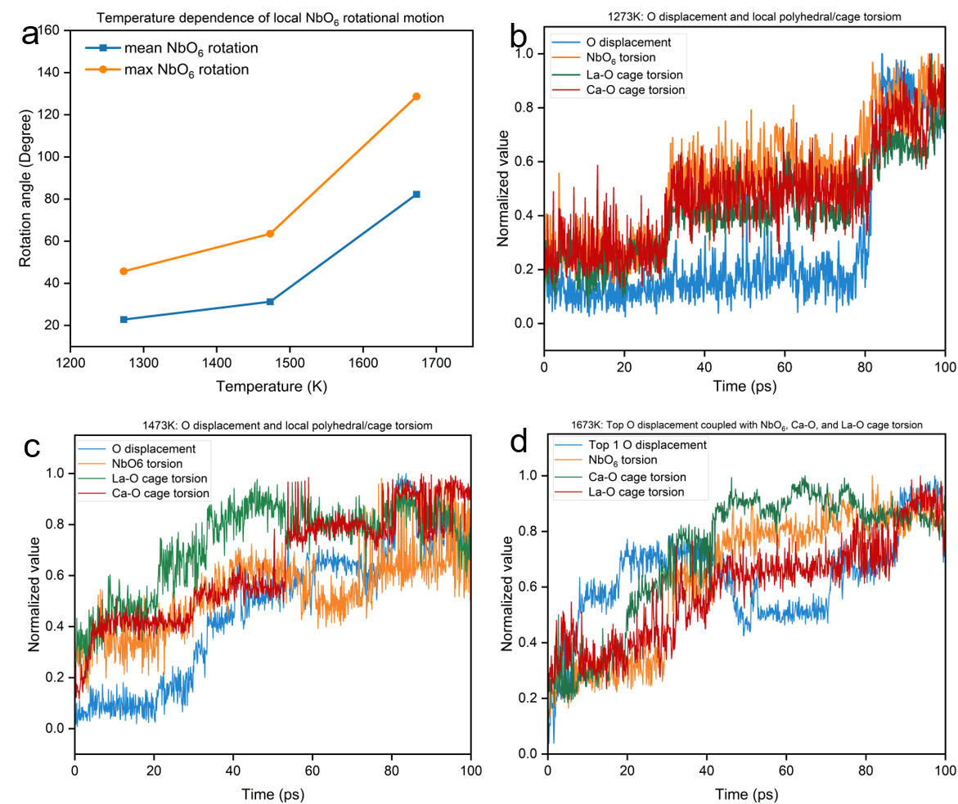
Figure S20. Temperature-dependent local framework dynamics and their cooperative coupling with oxide-ion migration from AIMD. (a) Mean and maximum local NbO_{6​} rotational amplitudes at 1273, 1473, and 1673 K, showing the thermal activation of angular fluctuations within the Nb-centered coordination environment. (b-d) Time evolution of the normalized displacement of the top-ranked mobile oxide ion together with normalized NbO₆​ torsion, Ca-O cage torsion, and La-O cage torsion at (b) 1273 K, (c) 1473 K, and (d) 1673 K, respectively.

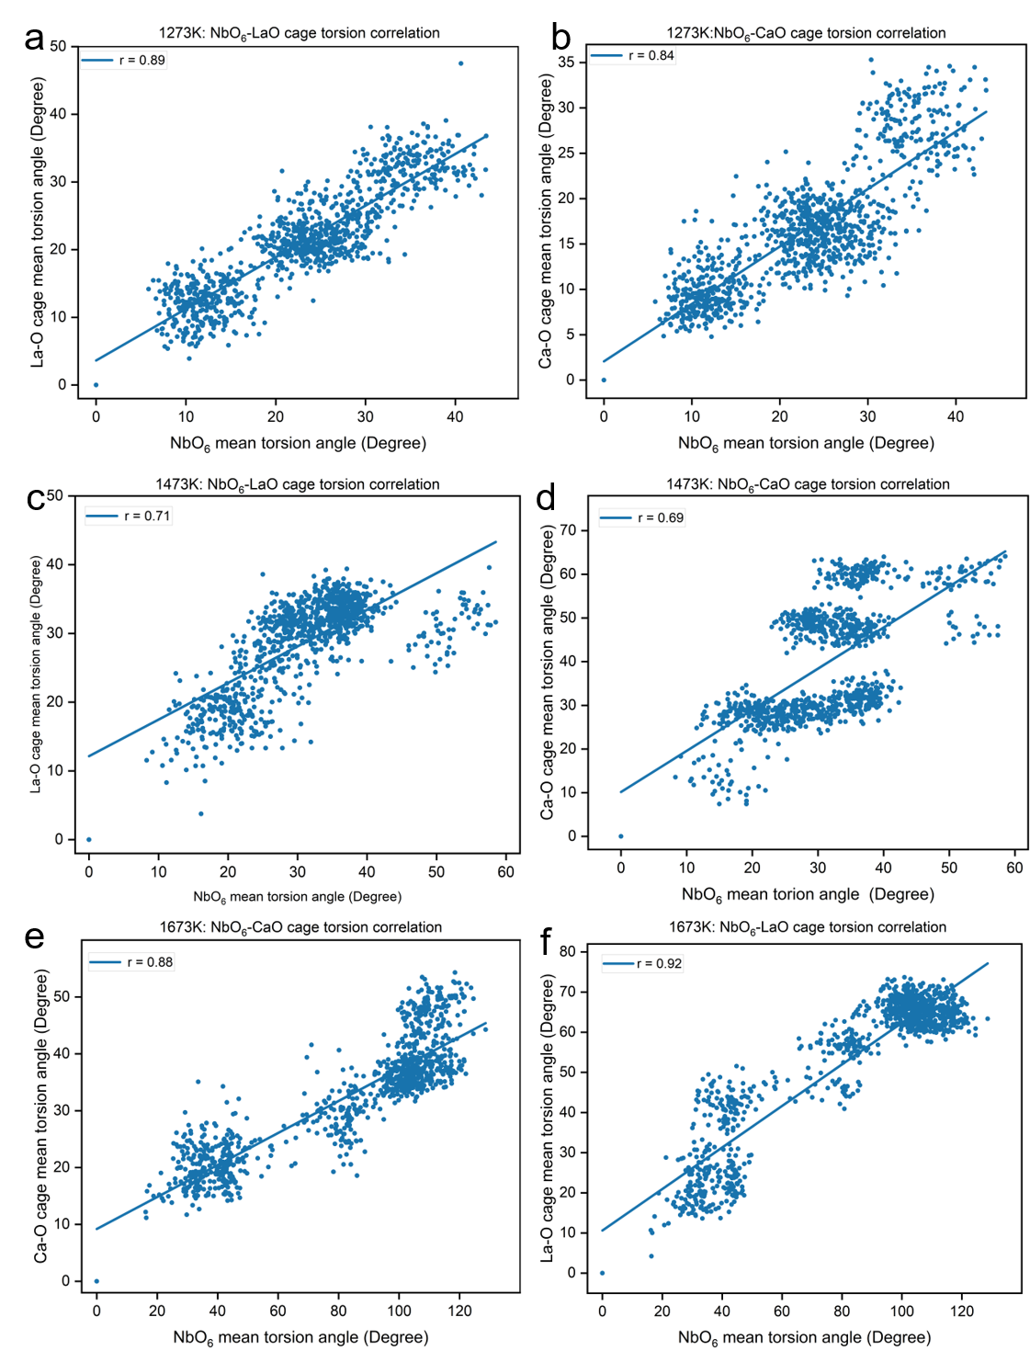
Figure S21. Correlation torsional dynamics of neighboring NbO_{6​} torsion and Ca/La-O cage torsion from AIMD. Scatter plots of the mean NbO_{6​} torsion angle versus the mean La-O or Ca-O cage torsion angle extracted from the 0-100 ps AIMD trajectories. Each point corresponds to one AIMD time frame. The solid lines are linear fits, and the Pearson correlation coefficients r are shown in each panel. (a, b) NbO₆​-LaO (r = 0.89) and NbO₆​-CaO (r = 0.84) cage torsion correlations at 1273 K. (c, d) Corresponding correlations at 1473 K (r = 0.71 and 0.69). (e, f) Corresponding NbO₆​-LaO (r = 0.92) and NbO₆​-CaO (r = 0.88) cage correlations at 1673 K. The consistently positive correlations demonstrate dynamically coupled angular fluctuations among neighboring coordination environments.
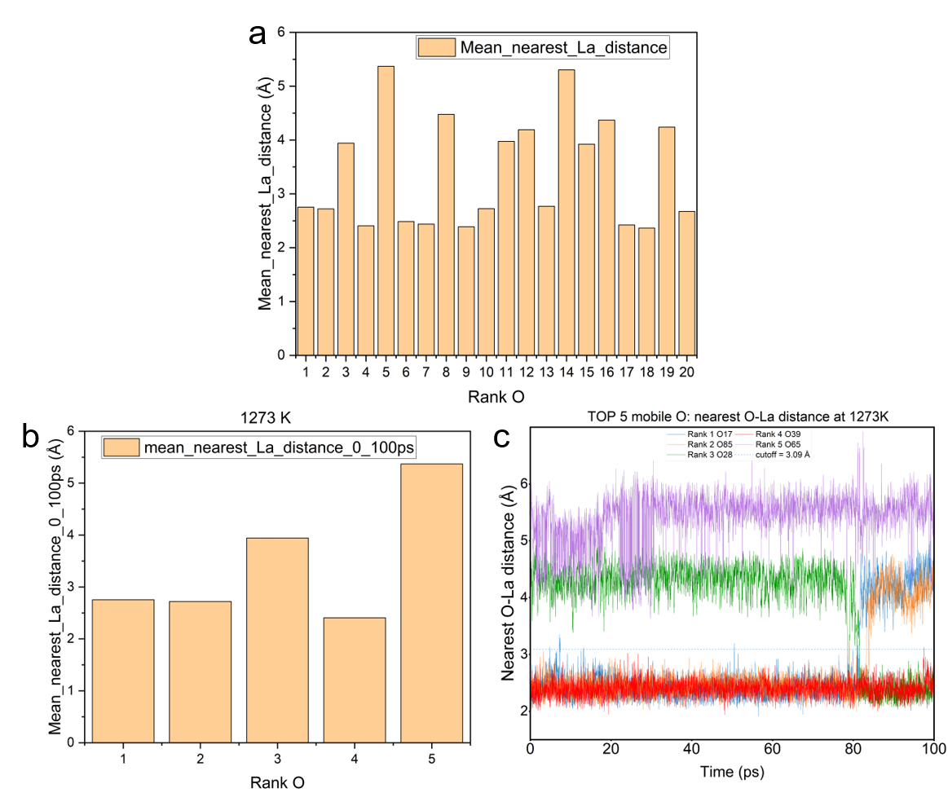
Figure S22. O-La distance analysis of mobile oxide ions from AIMD at 1273 K. (a) Mean nearest O-La distances for the top 20 mobile oxide ions. (b) Mean nearest O-La distances of the top five mobile oxide ions. (c) Time-dependent nearest O-La distances for the top five mobile oxide ions. The top mobile oxide ions were identified from individual-O MSD analysis, and the O-La distances were evaluated over the full 0-100 ps AIMD trajectories. The dashed line denotes the first-shell O-La cutoff of 3.09 Å. The repeated approach to and departure from the La-neighboring shell indicates weak transient La-associated anchoring rather than deep trapping.

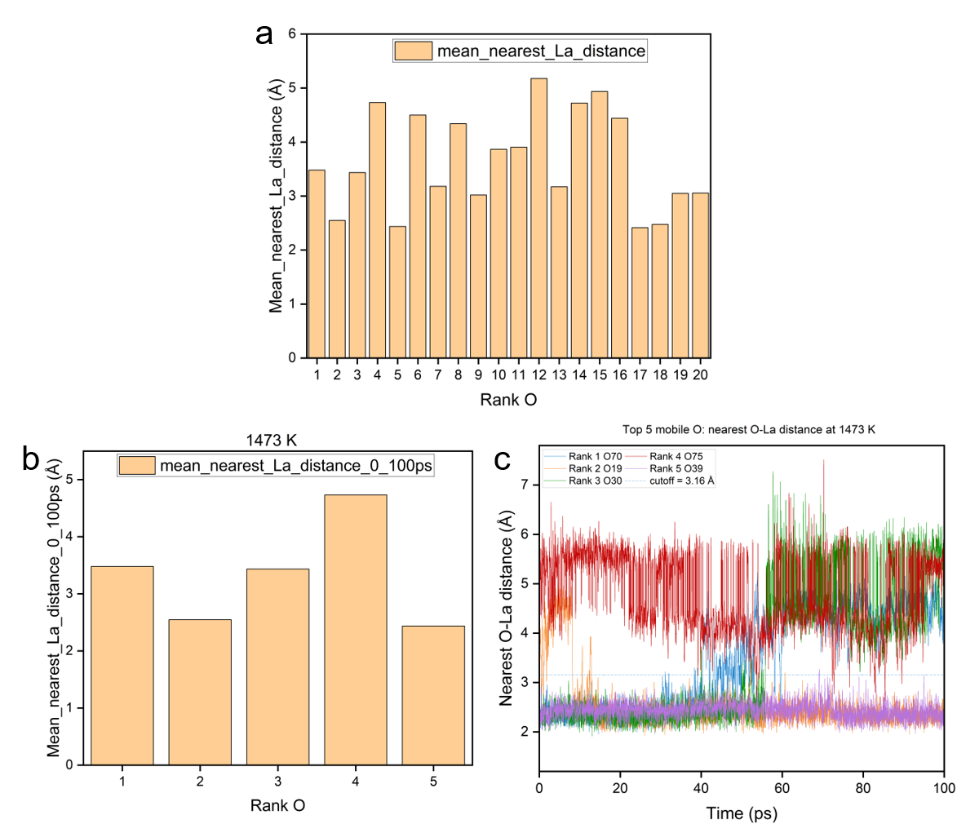
Figure S23. O-La distance analysis of mobile oxide ions from AIMD at 1473 K. (a) Mean nearest O-La distances for the top 20 mobile oxide ions. (b) Mean nearest O-La distances of the top five mobile oxide ions. (c) Time-dependent nearest O-La distances for the top five mobile oxide ions. The top mobile oxide ions were identified from individual-O MSD analysis, and the O-La distances were evaluated over the full 0-100 ps AIMD trajectories. The dashed line denotes the first-shell O-La cutoff of 3.16 Å. These results indicate that the mobile oxide ions can approach and leave the La-neighboring shell, supporting weak La-associated transient anchoring rather than deep trapping.

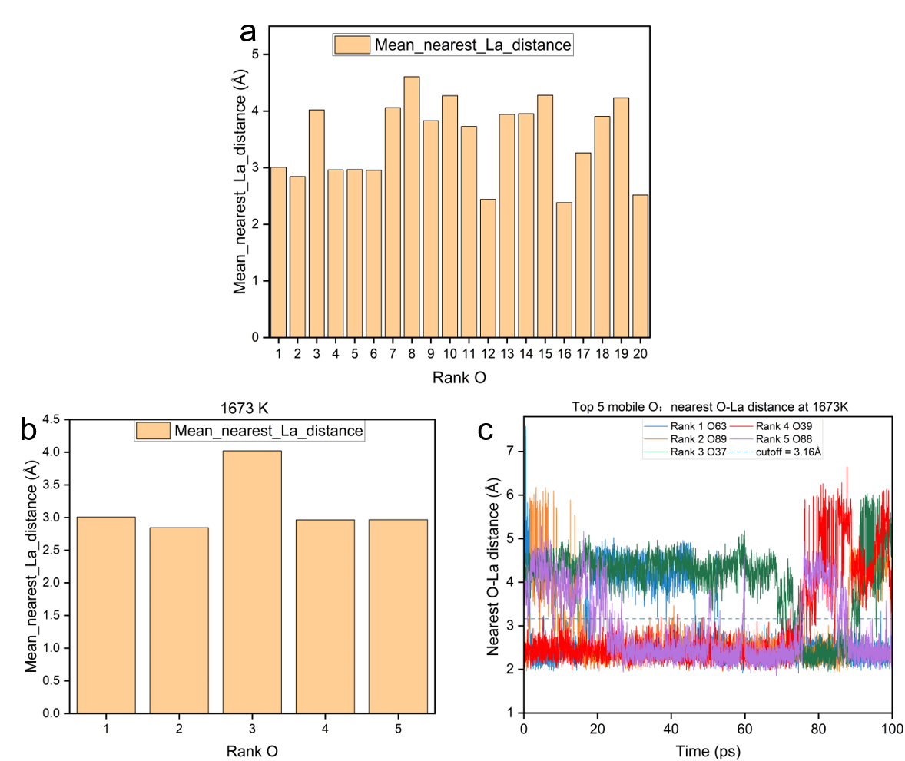
Figure S24. O-La distance analysis of mobile oxide ions from AIMD at 1673 K. (a) Mean nearest O-La distances for the top 20 mobile oxide ions. (b) Mean nearest O-La distances of the top five mobile oxide ions. (c) Time-dependent nearest O-La distances for the top five mobile oxide ions. The top mobile oxide ions were identified from individual-O MSD analysis, and the O-La distances were evaluated over the full 0-100 ps AIMD trajectories. The dashed line denotes the first-shell O-La cutoff of 3.16 Å. The repeated approach to and departure from the La-neighboring shell suggests weak La-associated transient anchoring rather than deep trapping.

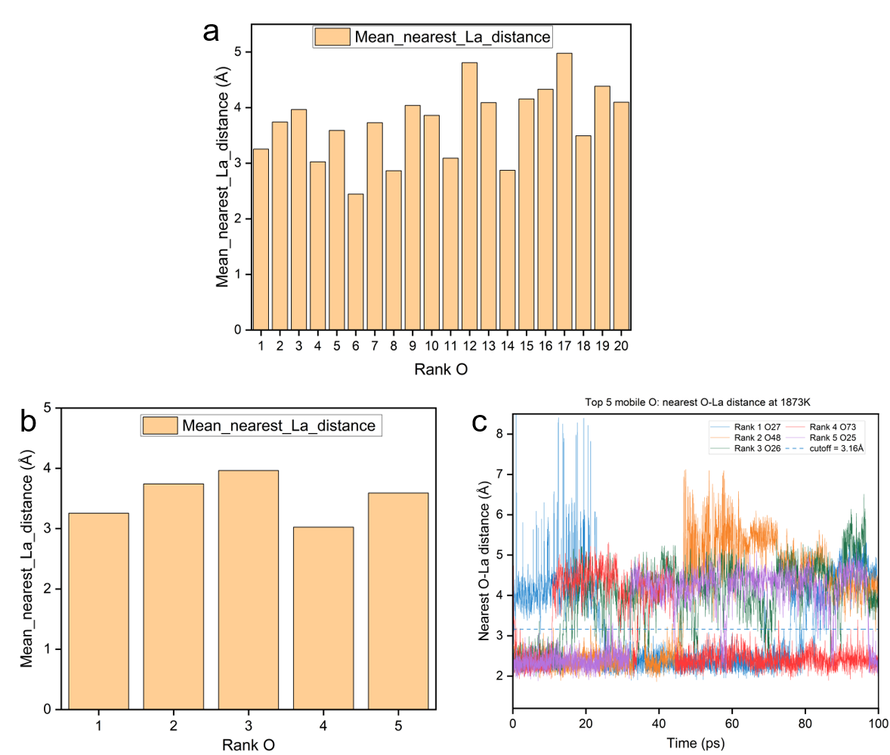
Figure S25. O-La distance analysis of mobile oxide ions from AIMD at 1873 K. (a) Mean nearest O-La distances for the top 20 mobile oxide ions. (b) Mean nearest O-La distances of the top five mobile oxide ions. (c) Time-dependent nearest O-La distances for the top five mobile oxide ions. The top mobile oxide ions were identified from individual-O MSD analysis, and the O-La distances were evaluated over the full 0-100 ps AIMD trajectories. The dashed line marks the first-shell O-La cutoff of 3.16 Å. The frequent crossing of this cutoff indicates that highly mobile oxide ions can repeatedly enter and leave the La-neighboring shell, suggesting weak transient La-associated anchoring rather than deep trapping.

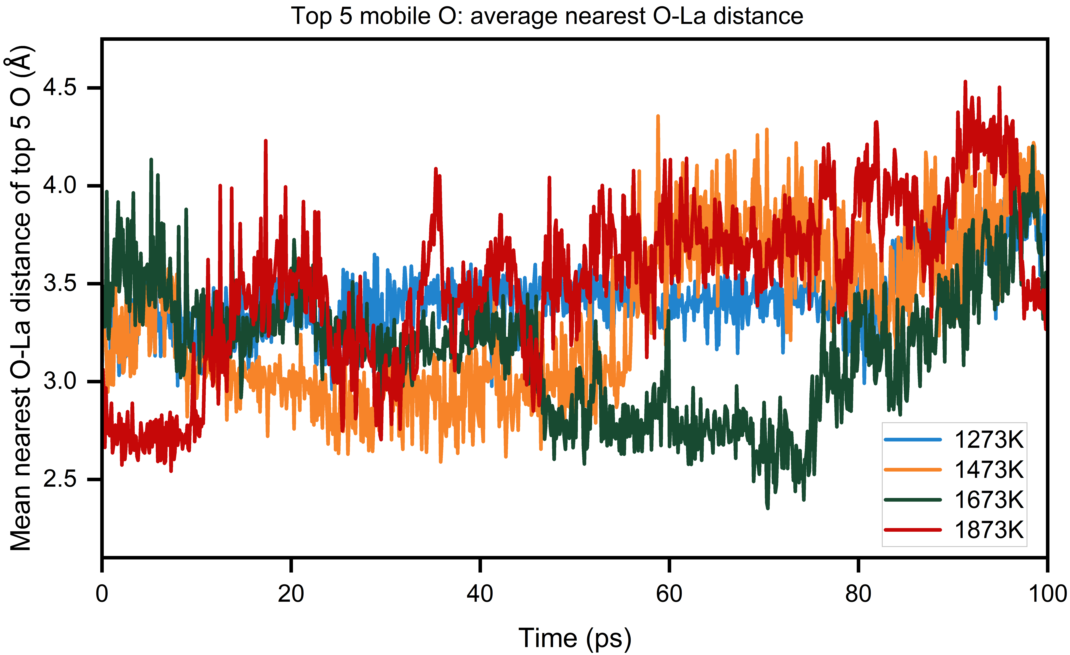
Figure S26. Temperature-dependent average nearest O-La distance of the top five mobile oxide ions from AIMD. Time evolution of the mean nearest O-La distance averaged over the top five mobile oxide ions at 1273, 1473, 1673, and 1873 K during the 0-100 ps AIMD trajectories. The top mobile oxide ions were identified from individual-O MSD analysis. The fluctuating O-La distances indicate that highly mobile oxide ions repeatedly approach and move away from La-neighboring environments rather than remaining permanently bound to La. With increasing temperature, the larger distance fluctuations and intermittent increases in the average O-La distance suggest enhanced oxide-ion mobility and weakened La-associated transient anchoring, supporting that La acts as a shallow local anchoring site rather than a deep trapping center.

Table S7. Initial Buckingham potential energy parameters for Ca_{4-x}La_{x}Nb₂O_{9+x/2}.
Interactions | A(eV) | ρ(Å) | C(eV Å⁶) | Y(e) | K(eV Å⁻²)
Ca-O | 8573.820 | 0.30800 | 560.48 | 0 | /
La-O | 4579.230 | 0.30437 | 0 | 0 | 99999
Nb-O | 3023.184 | 0.30000 | 0 | 0 | /
O-O | 22764.3 | 0.14900 | 27.89 | -2.869 | 74.92

Table S8. Optimized Buckingham potential energy parameters for Ca_{4-x}La_{x}Nb₂O_{9+x/2}.
Interactions | A(eV) | ρ(Å) | C(eV Å⁶) | Y(e) | K(eV Å⁻²)
Ca-O | 8570 | 0.308 | 560 | 0 | 99999
La-O | 4580 | 0.304 | 0 | 0 | 21.53
Nb-O | 3020 | 0.300 | 0 | 0 | 0
O-O | 22800 | 0.149 | 27.9 | -2.869 | 74.92

Table S9. Comparison of experimental values and calculated values for Ca₄Nb₂O_{9.}
Parameters | Calculated | Experimental | Δ(Calc.-Exp.)
a (Å) | 9.6239 | 9.8159 | -0.1920
b (Å) | 5.5879 | 5.53628 | 0.05162
c (Å) | 16.7995 | 17.35016 | -0.55066
Volume (Å³) | 741.204041 | 767.6 | -26.39596
α(°) | 90.00 | 90.00 | 0.000
γ (°) | 90.00 | 90.00 | 0.000
β (°) | 124.8725 | 125.501 | -0.6285
Ca1-O1 (Å) | 2.24867 | 2.275 | -0.02633
Ca1-O5 (Å) | 2.25703 | 2.279 | -0.02197
Ca1-O9 (Å) | 2.24586 | 2.262 | -0.01614
Ca2-O4 (Å) | 2.22317 | 2.254 | -0.03083
Ca2-O6 (Å) | 2.23789 | 2.293 | -0.05511
Ca2-O8 (Å) | 2.23108 | 2.286 | -0.05492
Ca3-O2 (Å) | 2.64511 | 2.341 | 0.30411
Ca3-O5 (Å) | 2.46775 | 2.330 | 0.13775
Ca3-O6 (Å) | 2.64682 | 2.561 | 0.08582
Ca3-O8 (Å) | 2.70356 | 2.502 | 0.20156
Ca3-O9 (Å) | 2.48668 | 2.306 | 0.18068
Ca4-O1 (Å) | 2.6683 | 2.681 | -0.0127
Ca4-O2 (Å) | 2.819 | 2.773 | 0.04600
Ca4-O2 (Å) | 2.80843 | 2.708 | 0.10043
Ca4-O3 (Å) | 2.57122 | 2.435 | 0.13622
Ca4-O4 (Å) | 2.47241 | 2.341 | 0.13141
Ca4-O5 (Å) | 2.70297 | 2.567 | 0.13597
Ca4-O7 (Å) | 2.55271 | 2.354 | 0.19871
Ca4-O9 (Å) | 2.58598 | 2.398 | 0.18798
Ca5-O1 (Å) | 2.45945 | 2.325 | 0.13445
Ca5-O4 (Å) | 2.66997 | 2.698 | -0.02803
Ca5-O6 (Å) | 2.51162 | 2.428 | 0.08362
Ca5-O7 (Å) | 2.74883 | 2.379 | 0.36983
Ca5-O8 (Å) | 2.46395 | 2.310 | 0.15395
Nb1-O1(Å) | 1.86013 | 1.909 | -0.04887
Nb1-O3(Å) | 1.93153 | 2.075 | -0.14347
Nb1-O3(Å) | 1.93364 | 2.151 | -0.21736
Nb1-O5(Å) | 1.85792 | 1.903 | -0.04508
Nb1-O7(Å) | 1.92811 | 2.114 | -0.18589
Nb1-O8(Å) | 1.85658 | 1.927 | -0.07042
Nb2-O2(Å) | 1.92836 | 2.138 | -0.20964
Nb2-O2(Å) | 1.92802 | 2.040 | -0.11198
Nb2-O4(Å) | 1.85510 | 1.927 | -0.07190
Nb2-O6(Å) | 1.86097 | 1.925 | -0.06403
Nb2-O7(Å) | 1.93151 | 2.094 | -0.16249
Nb2-O9(Å) | 1.8572 | 1.903 | -0.0458

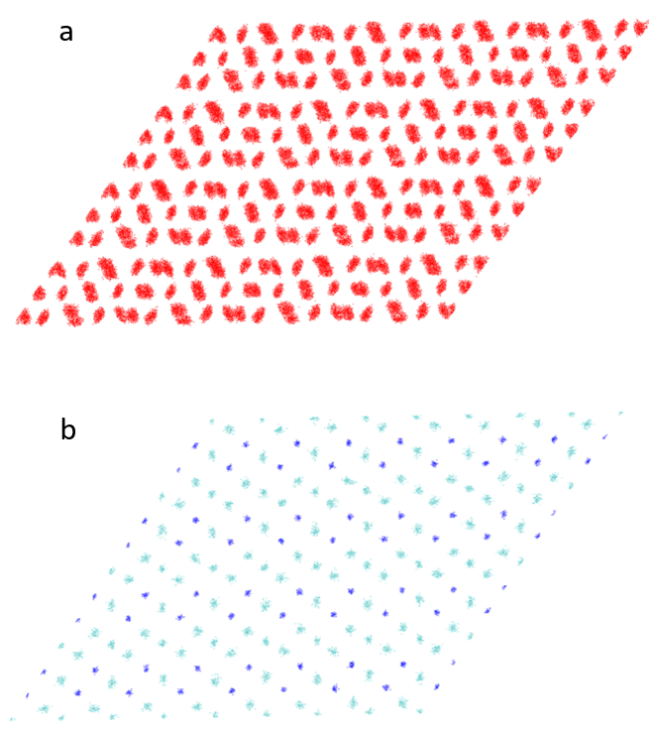
Figure S27. Molecular dynamics simulations based on the interatomic potential method for Ca₄Nb₂O₉. (a) Oxygen ion scatter plot and (b) cation scatter plot along the [010] direction. Light blue, blue and red represent Ca, Nb and O, respectively.

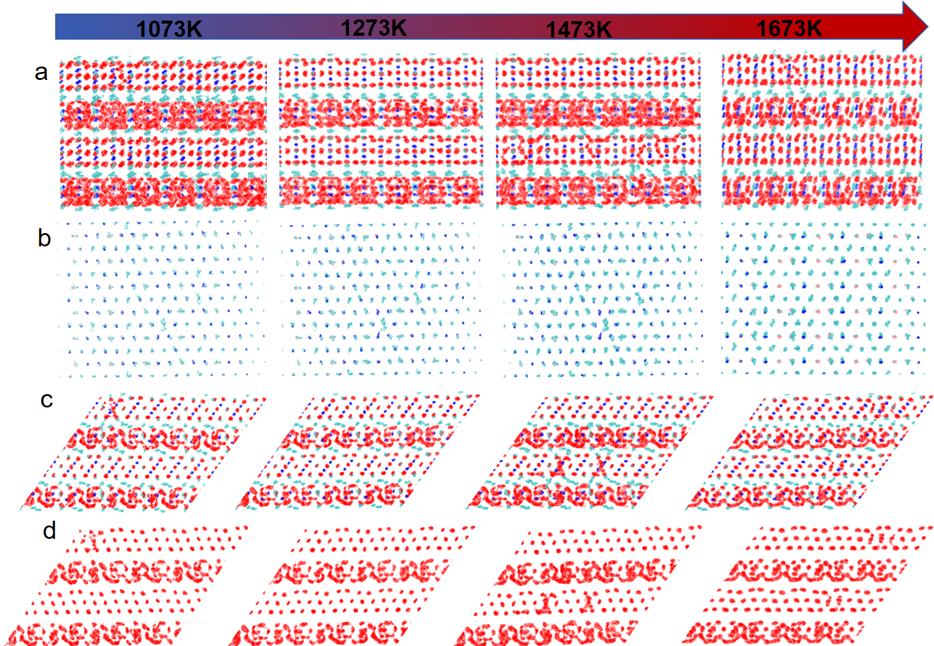
Figure S28. Molecular dynamics simulations based on the interatomic potential method for Ca_{3.9}La_{0.1}Nb₂O_{9.05}. (a) and (c) are scatter plots of all atoms along the [001] and [010] directions, respectively. (b) and (d) are scatter plots of all cations and oxygen ions, respectively. The light blue, blue, pink and red represent calcium, niobium, lanthanum and oxygen, respectively.
Supplementary Note 5: classical molecular dynamics (MD) simulations.
We also performed classical molecular dynamics (MD) simulations based on the interatomic potential method for Ca_{4-x}La_{x}Nb₂O_{9+x/2}. The optimized Buckingham potentials (Table S8), refined from the initial potential parameters (Table S7), reproduce the parent crystal structure (Table S9). Scatter plots of atomic trajectories for parent Ca₄Nb₂O₉ (Figure S27) show only lattice vibrations for all atomic species, indicating the absence of long-range ionic transport. In contrast, in Ca_{3.9}La_{0.1}Nb₂O_{9.05}, the oxygen sublattice (Figure S28) exhibits pronounced long-range displacements characteristic of oxide-ion diffusion, consistent with a propeller-type migration mechanism, while all cations remain localized and display only thermal vibrations. Radial distribution functions (RDFs) for Nb-O (Figures S29-30) and Ca-O (Figures S31-35) interactions further reveal that all the oxygen species are participate in the long-range migration.
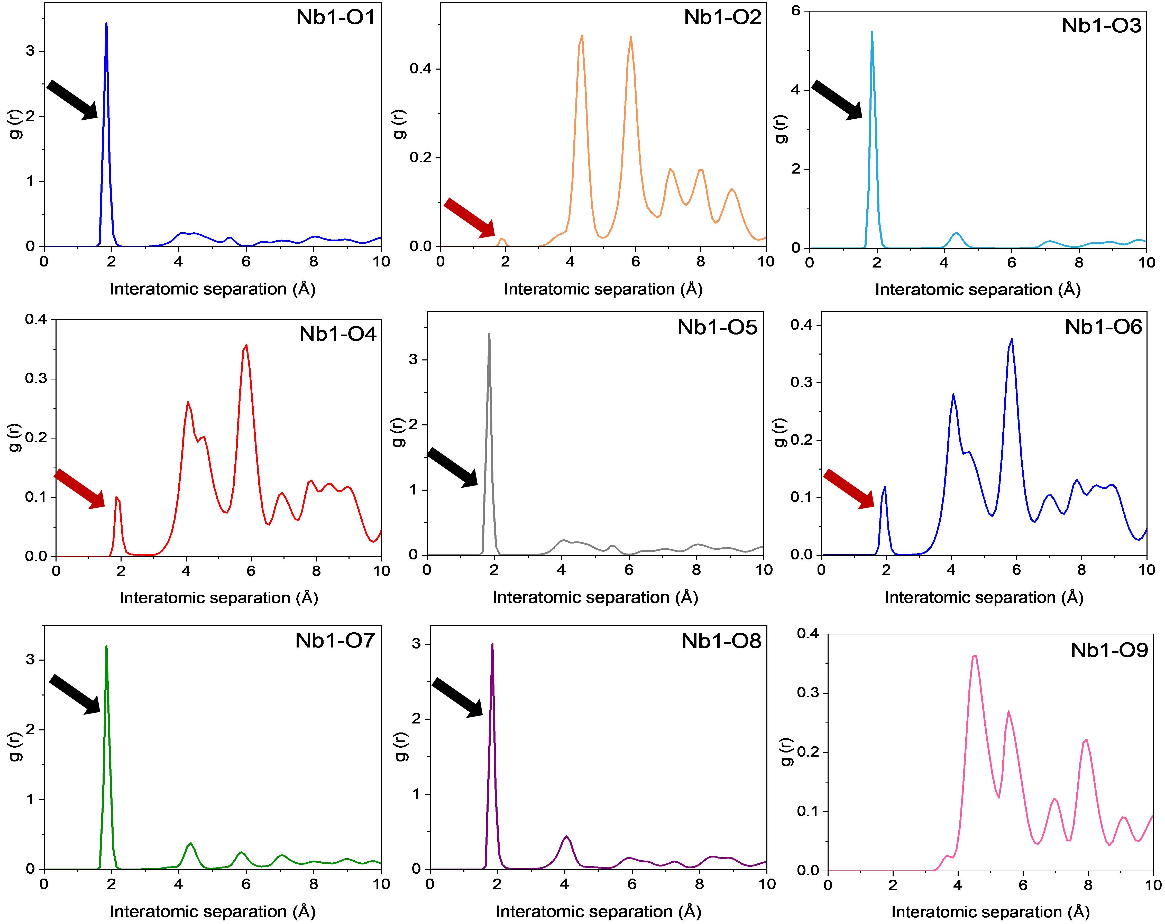
Figure S29. The RDF of Nb1-O interaction over the range of 0-100 ps as a function of simulation time, where the black and red arrows respectively represent the interactions of Nb1 with oxygen atoms at the originally bonded sites O (O1, O3, O5, O7 and O8) and unbonded sites O (O2, O4 and O6).

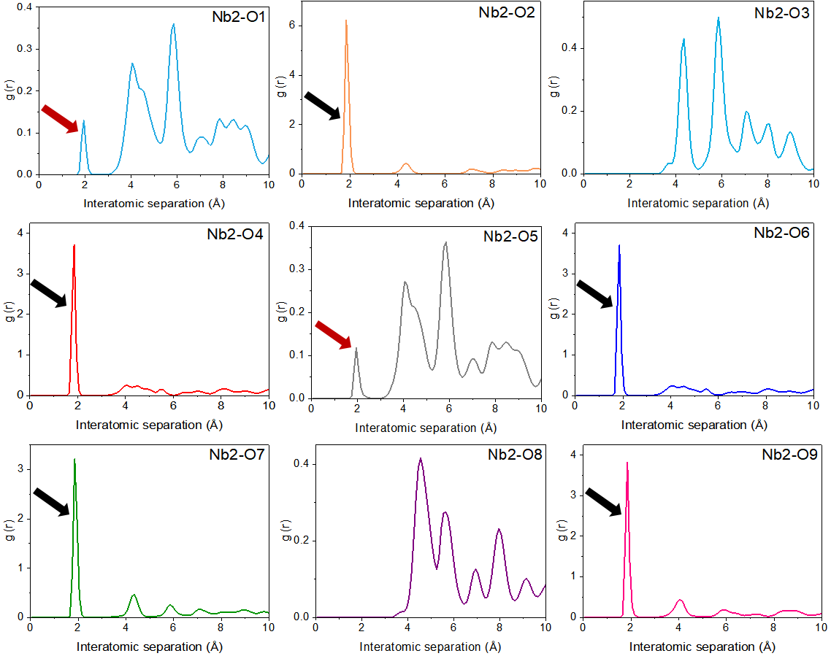
Figure S30. The RDF of Nb2-O interaction over the range of 0-100 ps as a function of simulation time, where the black and red arrows respectively represent the interactions of Nb2 with oxygen atoms at the originally bonded sites (O2, O4, O6, O7 and O9) and unbounded sites O (O1 and O5).

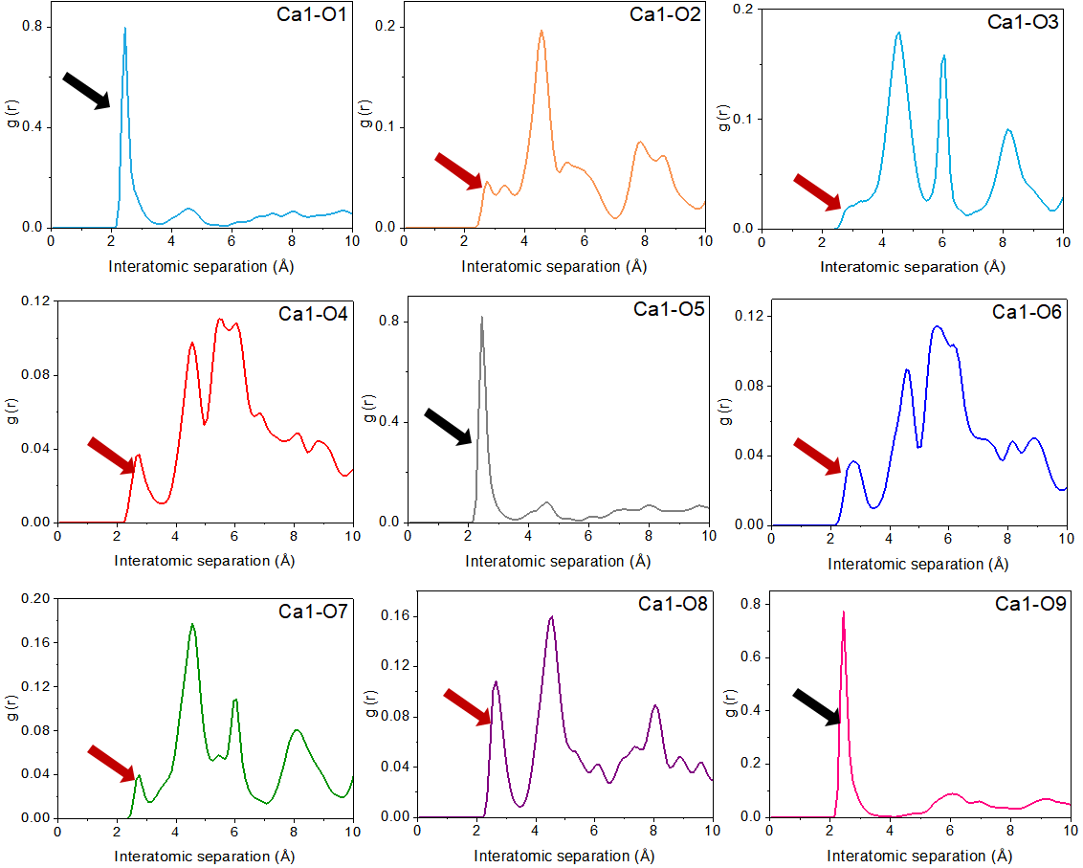
Figure S31. The RDF of Ca1-O interaction over the range of 0-100 ps as a function of simulation time, where the black and red arrows respectively represent the interactions of Ca1 with oxygen atoms at the originally bonded sites (O1, O5, and O9) and unbonded sites (O2, O3, O4, O6, O7 and O8).

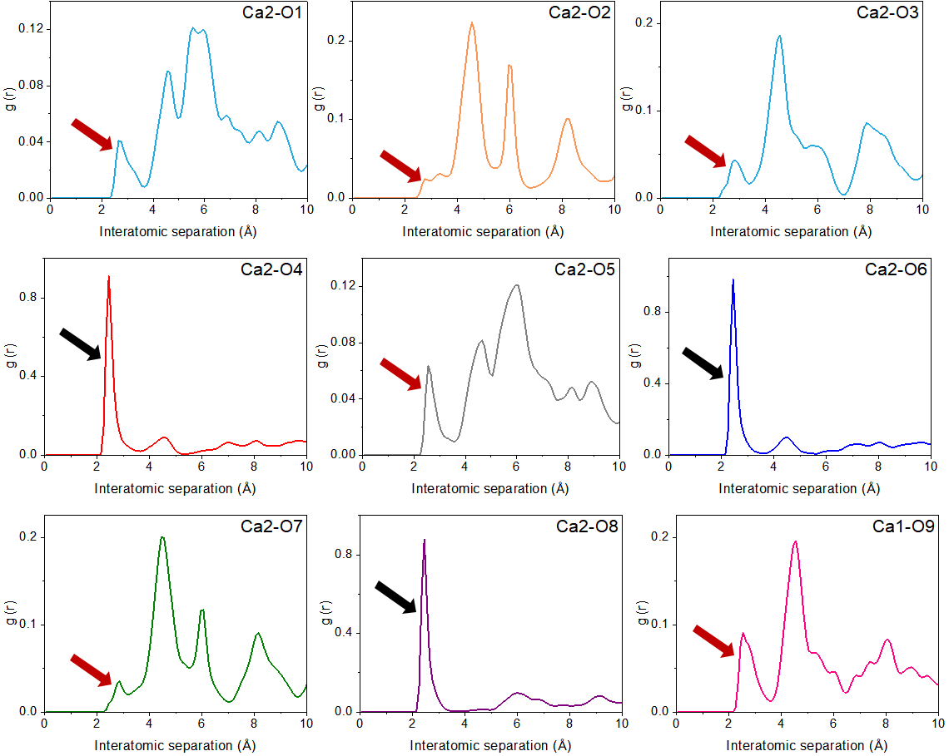
Figure S32. The RDF of Ca2-O interaction over the range of 0-100 ps as a function of simulation time, where the black and red arrows respectively represent the interactions of Ca2 with oxygen atoms at the originally bonded sites (O4, O6, and O8) and unbonded sites (O1，O2，O3，O5，O7 and O9).

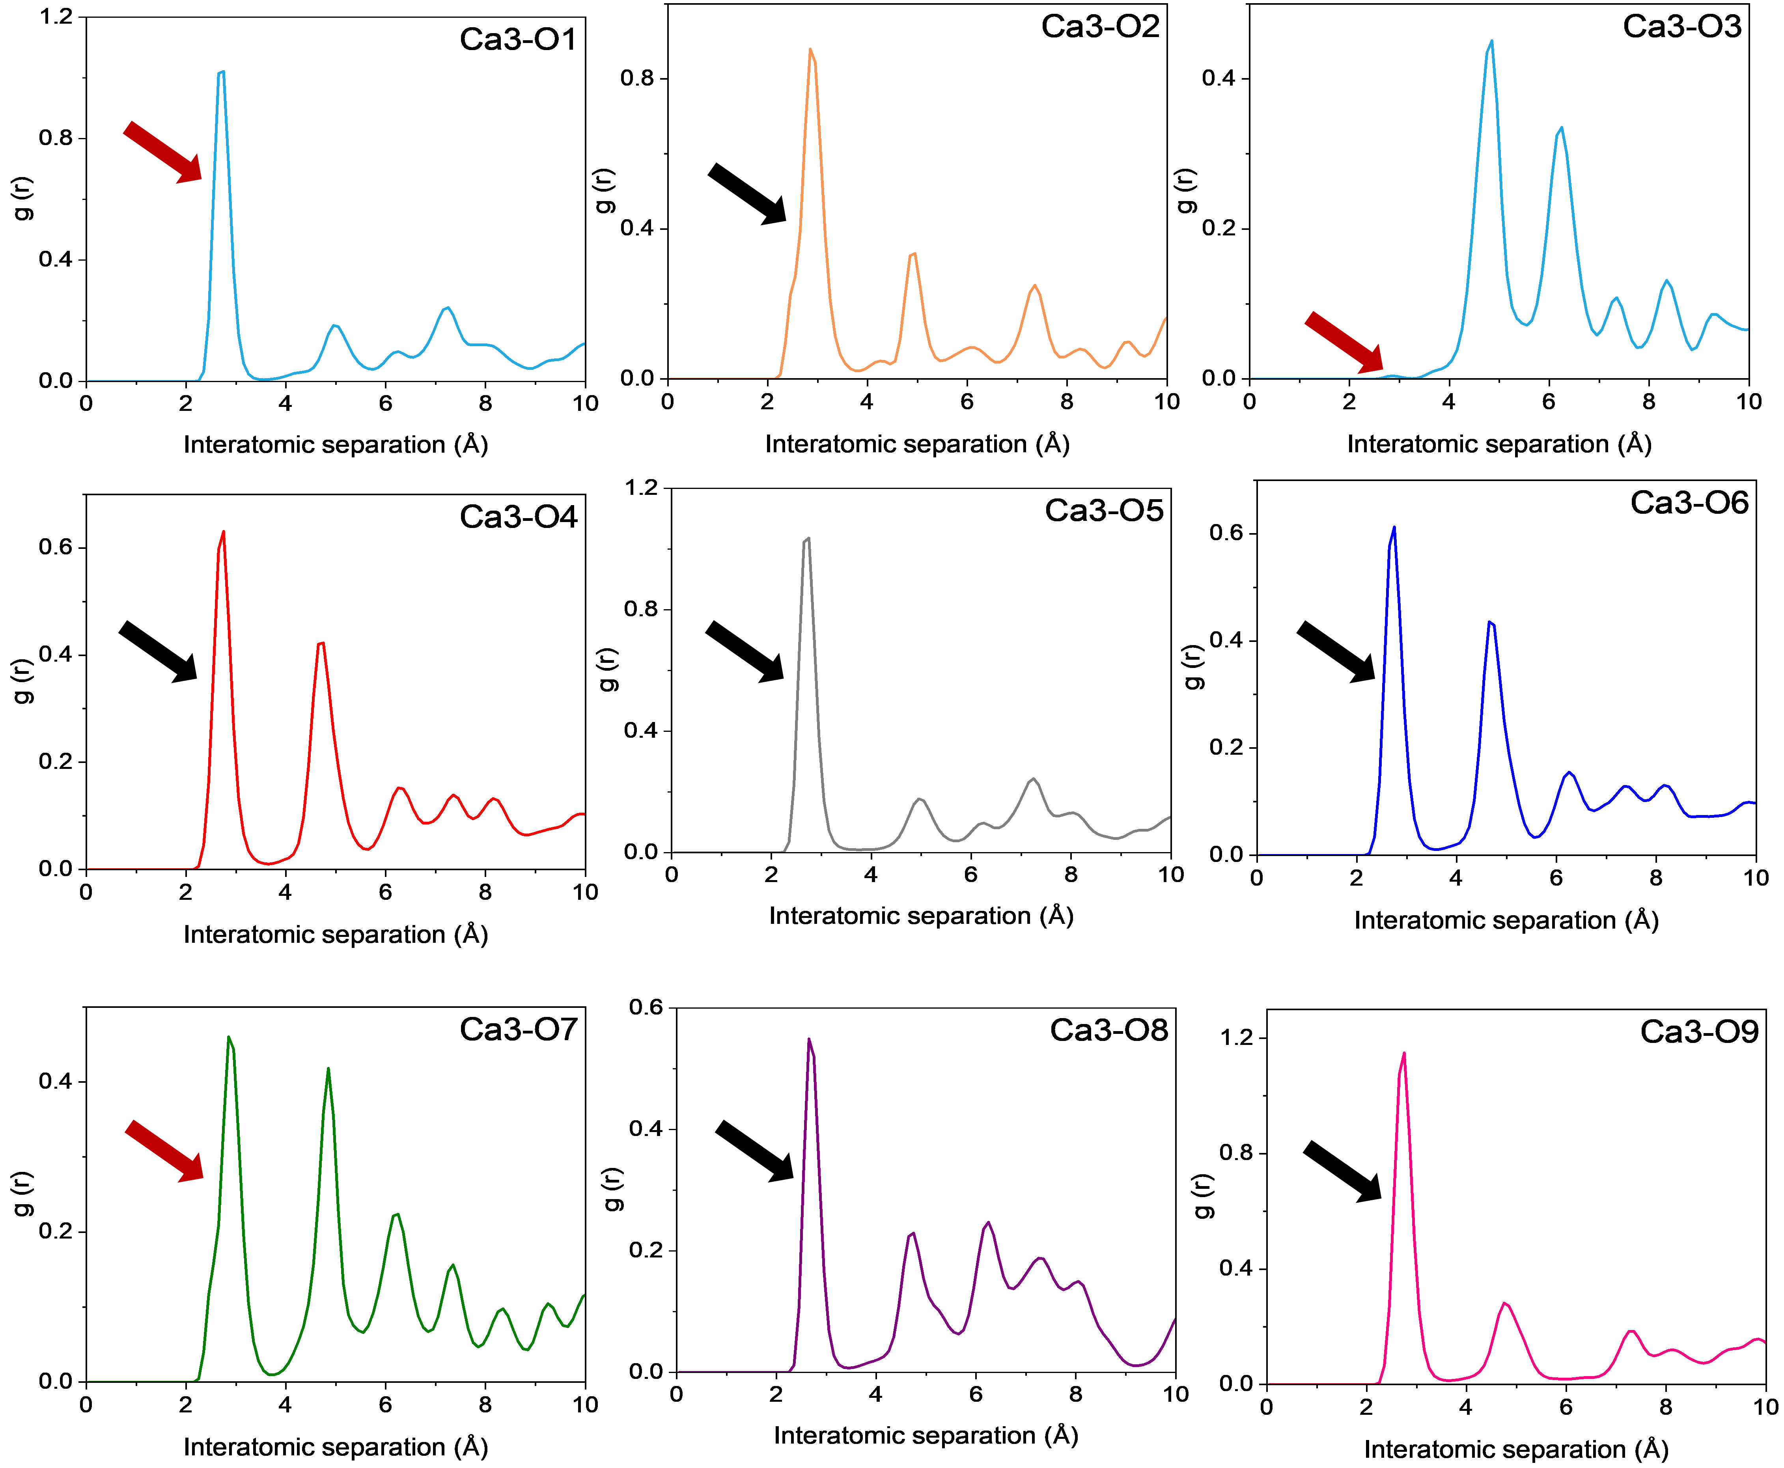
Figure S33. The RDF of Ca3-O interaction over the range of 0-100 ps as a function of simulation time, where the black and red arrows respectively represent the interactions of Ca3 with oxygen atoms at the originally bonded sites (O2，O4，O5，O6，O8 and O9) and unbonded sites (O1, O3, and O7).

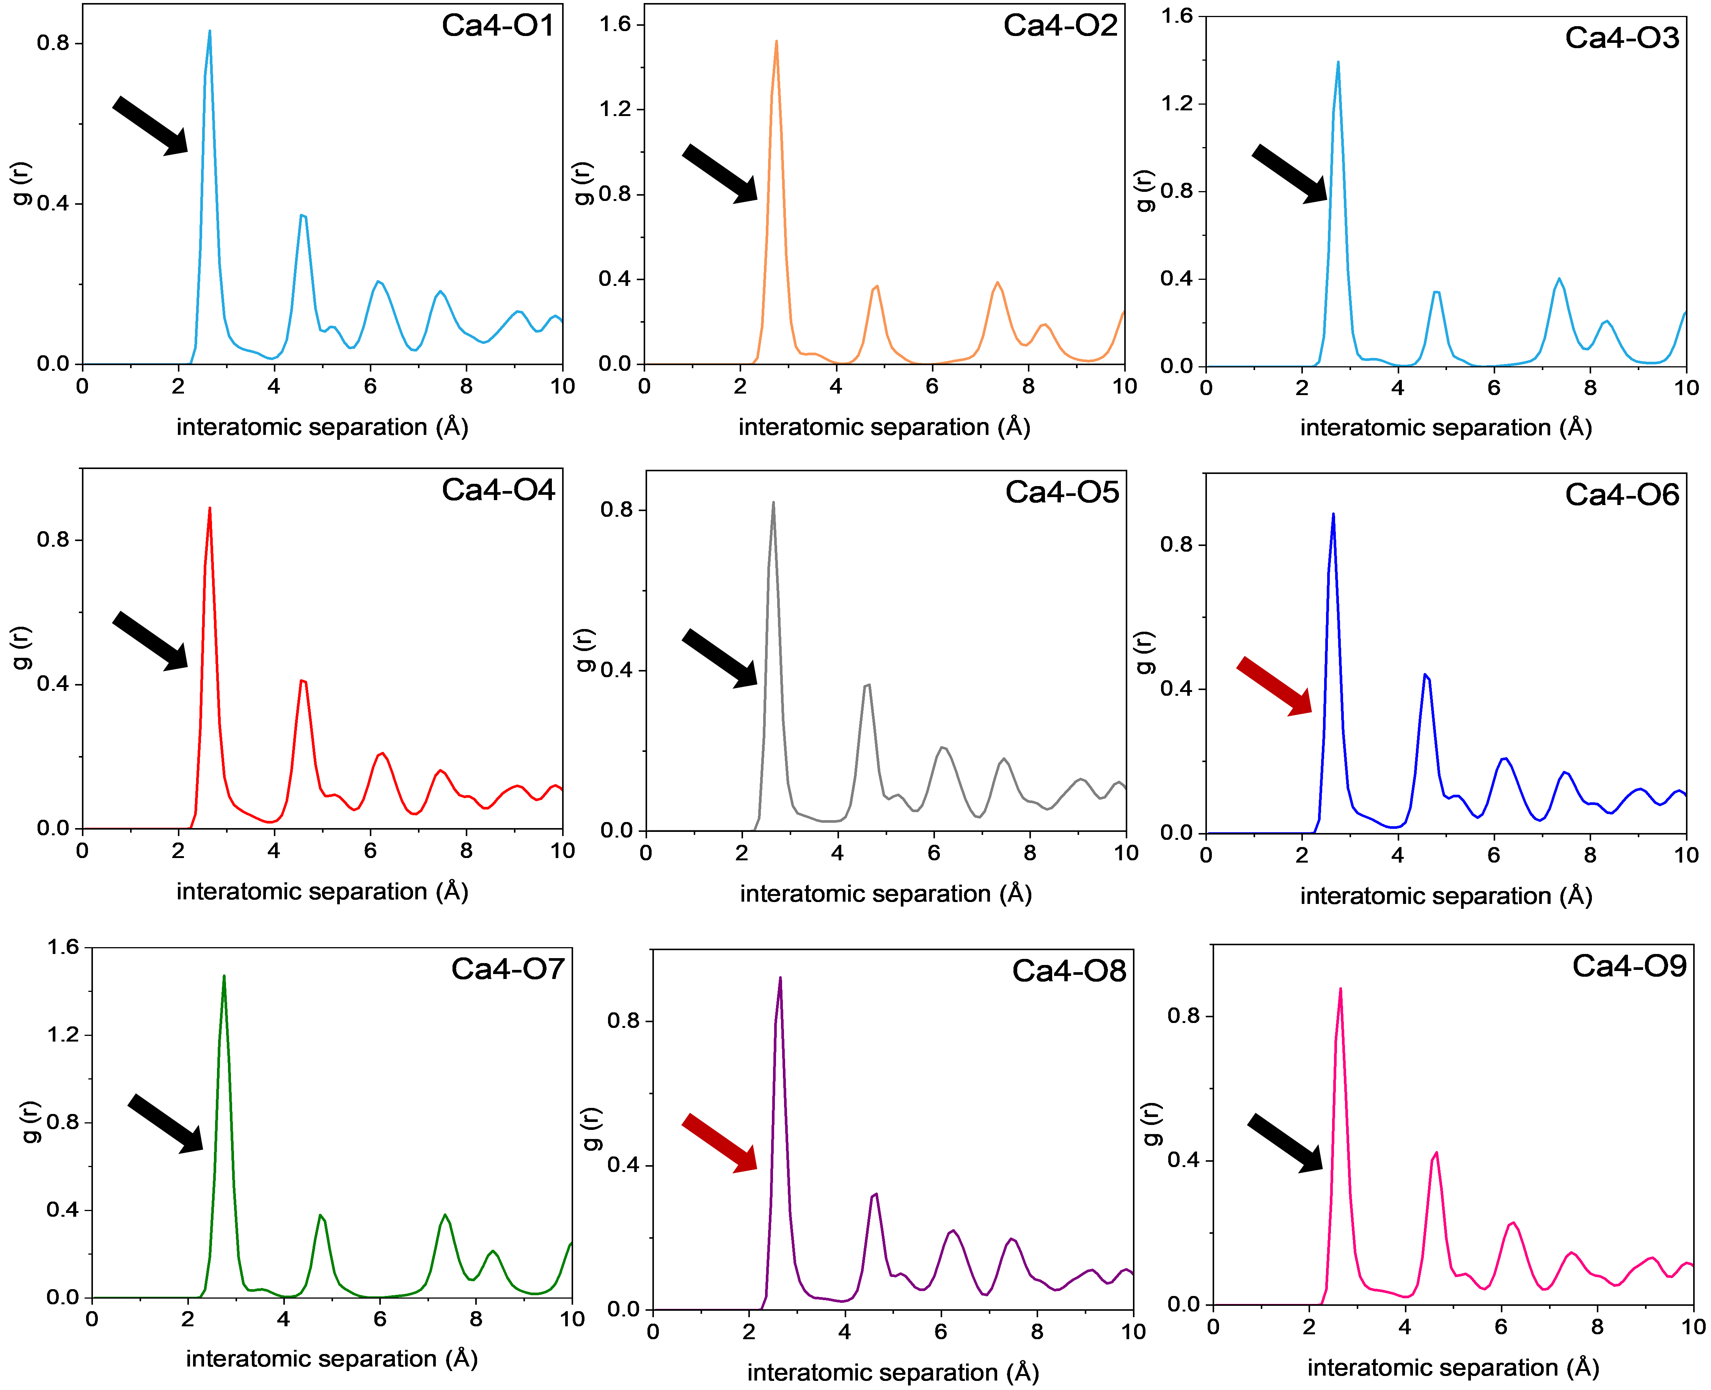
Figure S34. The RDF of Ca4-O interaction over the range of 0-100 ps as a function of simulation time, where the black and red arrows respectively represent the interactions of Ca4 with oxygen atoms at the originally bonded sites (O1，O2，O3，O4，O5，O7 and O9) and unbonded sites (O6, and O8).

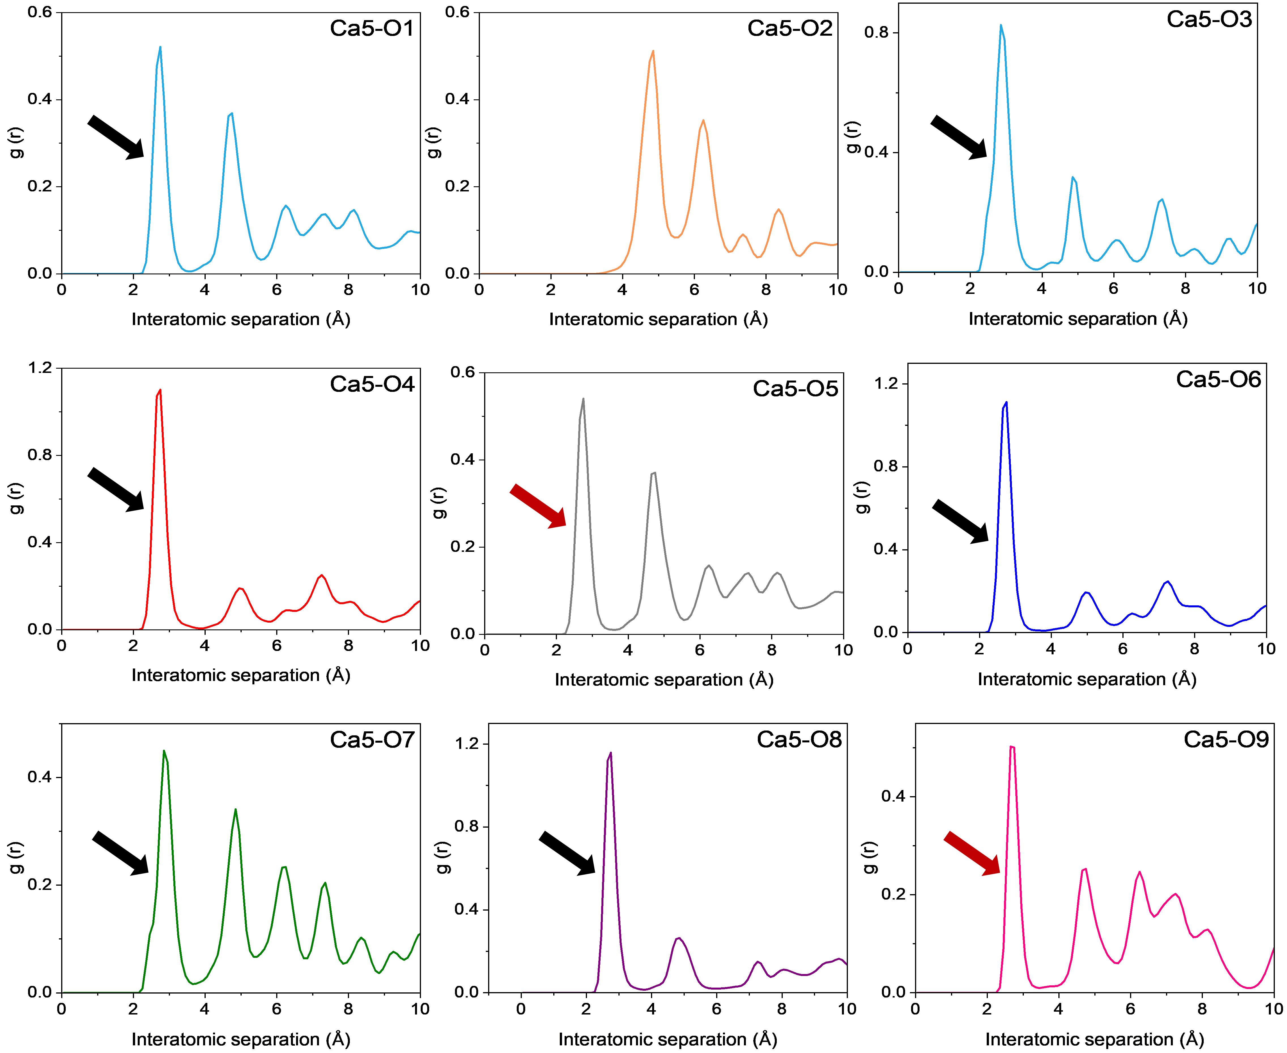
Figure S35. The RDF of Ca5-O interaction over the range of 0-100 ps as a function of simulation time, where the black and red arrows respectively represent the interactions of Ca5 with oxygen atoms at the originally bonded sites O (O1，O3，O5，O6，O7 and O8) and unbonded sites (O5, and O9).

Supplementary Note 6. Ionic-layer-number engineering and propeller-type interstitialcy oxygen migration in double perovskite Ca_{3-x}La_{x}WO_{6+x/2}.
The ionic-layer engineering strategy developed in this work was further expanded by controlling the number and periodic arrangement of ionic layers within a close-packed perovskite framework. We therefore extended the ionic-layer engineering principle from the complex-perovskite framework to the double perovskite Ca₃WO₆, which can also be represented as Ca₂CaWO₆. These two structures contain distinct arrangements of their ion-containing layers. Relative to the complex perovskite, the double-perovskite architecture introduces an additional Ca-containing layer within each structural repeat, increasing the ionic-layer number from one to two and modifying the connectivity between adjacent layers (Figure S36a-b). The resulting double-layer architecture provides additional configurational space for interstitial oxygen-defect accommodation and local structural rearrangement.
Aliovalent substitution of La³⁺ for Ca²⁺ was used to introduce charge-compensating interstitial oxygen according to the composition Ca_{3-x}La_{x}WO_{6+x/2}. Powder X-ray diffraction patterns of Ca_{3-x}La_{x}WO_{6+x/2} (Figure S36c) show that the double-perovskite framework is retained over the range 0 ≤ x ≤ 0.15, whereas additional reflections of CaWO₄ emerge at x = 0.20, indicating the approximate solid-solution limit. Rietveld refinement of the XRD pattern of x = 0.15 composition (Figure S36d) confirms formation of the targeted double-perovskite phase. The Ca-W system therefore represents an architectural extension of ionic-layer engineering rather than a compositional variation within the original Ca-Nb framework.
High-resolution neutron powder diffraction (NPD) was used to determine whether the La-substituted double perovskite accommodates excess oxygen at a non-framework position. Rietveld refinement combined with charge-flipping method was performed for the NPD data of Ca_{3-x}​La_{x​}WO_{6+x/2​} (x = 0.15, Figure S37a and Table S10). A difference nuclear-density map calculated without an additional oxygen site reveals a localized residual maximum at (0.1237(1), 0.28656(2), 0.8279(2)) (Figure S37b). This feature cannot be described by the conventional framework oxygen positions and was therefore assigned to an interstitial oxygen site, O_{i}. Refinement gives an O_{i} occupancy of 0.06(3), consistent within uncertainty with the oxygen excess introduced by La substitution. The refined site lies in the Ca/La-containing region and is coordinated by neighboring Ca, La and W cations (Figure S37c-d). These results establish the incorporation of interstitial oxygen into the double-perovskite framework.
The refined anisotropic displacement parameters provide further insight into the structural flexibility surrounding the oxygen defects (Figure S38 and Table S11). The principal axes of several oxygen displacement ellipsoids are oriented predominantly transverse to the corresponding Ca/La-O and W-O bonds. These displacements therefore contain a substantial tangential component rather than being dominated by radial bond stretching. Their orientations are consistent with local librational, torsional and cage-deformation motions of the Ca/La- and W-centered coordination environments. Such transverse fluctuations provide a means of adapting the local coordination geometry around Oᵢ without destabilizing the close-packed cation framework.
The defect-centered local structure was further examined using high-energy X-ray total scattering and complementary small-box PDF and large-box RMC analyses (Figure S39). The average crystallographic model reproduces the principal short-range pair correlations but does not capture the configurational diversity surrounding the partially occupied interstitial site (Figure S39a). RMC refinement using a 14×14×10 supercell resolves substantial local relaxation around Oᵢ while retaining the average double-perovskite framework (Figure S39b-c). The resulting configurations contain a distribution of three- to five-coordinate Oᵢ environments, including Ca₂La-O_{i}, Ca₂WLa-O_{i} and Ca₃WLa-O_{i} motifs (Figure S39d-h). Interstitial oxygen therefore samples multiple Ca/La/W coordination states rather than occupying a single rigid local geometry. This coordination diversity connects the average interstitial site to neighboring framework oxygen positions and supplies the local rearrangements required for interstitialcy exchange.
The electrical measurements establish the transport consequence of interstitial-oxygen incorporation (Figure S40). Parent Ca₂WO₆ shows no pronounced low-frequency electrode-polarization response at 600 and 700 °C (Figure S40a-b). By contrast, Ca_{2.85}La_{0.15}WO_{6.075} exhibits substantially reduced impedance and a distinct low-frequency response over 550-700 °C, consistent with enhanced ionic transport (Figure S40c-f). Oxygen concentration-cell measurements yield oxygen transport numbers above 0.80 between 500 and 1000 °C (Figure S40g), demonstrating that oxide ions are the dominant charge carriers. The bulk conductivity is only weakly dependent on oxygen partial pressure over most of the investigated range (Figure S40h). A modest increase under reducing conditions at lower temperatures indicates a minor n-type electronic contribution, but oxide-ion conduction remains dominant.
La substitution increases the bulk conductivity throughout the measured temperature range (Figure S40i). The conductivity of Ca_{2.85}La_{0.15}WO_{6.075} reaches 1.77×10⁻³ S/cm at 1000 °C, more than one order of magnitude higher than the corresponding Ca-Nb complex-perovskite composition. The NPD, PDF/RMC and electrical transport measurements thus define a consistent structure-defect-transport relationship in which La substitution introduces interstitial oxygen into the expanded Ca/La-containing layers, while local coordination flexibility enables its redistribution and long-range transport.
BVSE calculations identify interconnected low-energy regions for oxide-ion migration within the Ca/La-containing portion of the double-perovskite framework (Figure S41). The calculated pathways link the interstitial region to adjacent framework oxygen positions and extend along the crystallographic a, b and c directions. The energy landscape is anisotropic, with the most accessible connectivity concentrated within the ionic-layer plane. This pathway geometry is consistent with the interstitial position obtained from NPD and the range of O_{i} coordination environments resolved by RMC modeling.
AIMD simulations further confirm that oxygen is the dynamically active species responsible for long-range transport (Figure S42). MSD values show that oxygen increases substantially with temperature, whereas Ca, La, and W remain comparatively localized (Figure S42a). The oxide-ion diffusion coefficients show Arrhenius behavior, confirming thermally activated transport (Figure S42c). Time- and temperature-dependent trajectory distributions viewed along [010] show progressive broadening and connection of the oxygen trajectories at elevated temperatures, while the cation positions remain comparatively confined (Figure S42d). Long-range transport therefore arises from oxygen rearrangement within a structurally retained cation framework.
Direction-resolved MSD analysis reveals preferential oxygen transport along the crystallographic b direction within the ab plane (Figures S45a). The corresponding transport plane in the Ca-Nb complex perovskite is indexed as the ac plane. Although the crystallographic indices differ, the two planes have the same topological orientation relative to their respective ionic-layer architectures. Increasing the ionic-layer number from one to two therefore preserves the characteristic in-plane transport dimensionality while expanding the structural region available for defect accommodation and migration.
The most mobile oxygen atoms repeatedly sample the La-containing coordination environments, as indicated by their nearest O-La distances (Figures S43b-S44b). Their stepwise displacements are temporally associated with torsional and cage-deformation motions of the surrounding WO₆, CaO₆ and LaO₆ units (Figures S44c,d-S46c,d). These motions are not described by the rigid-body rotation of an isolated WO₆ octahedron. Instead, they involve a spatially coupled response in which WO₆ torsion and Ca/La-O cage deformation continuously reshape the local oxygen coordination environment and the associated migration bottlenecks.
The cooperative character of these motions is quantified by the correlations between the instantaneous torsional amplitudes of neighboring coordination environments. At 1473 K, the Pearson correlation coefficients between WO₆ torsion and the LaO₆ and CaO₆ torsional coordinates are 0.69 and 0.81, respectively (Figure S43e-f). These correlations increase to 0.89 and 0.92 at 1673 K (Figure S44e-f) and reach 0.94 and 0.92 at 1873 K (Figure S45e-f). The positive, temperature-enhanced correlations show that the neighboring polyhedral motions are dynamically coupled rather than arising from independent thermal fluctuations.
Together, the BVSE and AIMD results support propeller-type interstitialcy oxygen migration in the Ca-W double perovskite. Here, “propeller-type” denotes a correlated sequence of WO₆ torsion and Ca/La-O cage deformation rather than the rigid rotation of an isolated polyhedron. These collective angular fluctuations transiently widen or redirect the migration bottlenecks, allowing an interstitial oxygen to displace a neighboring framework oxygen. The displaced framework oxygen subsequently occupies another interstitial or framework position, propagating oxygen transport through a sequence of interstitialcy exchanges. Repetition of these coupled events produces long-range migration within the ionic-layer plane.
The Ca-W double perovskite therefore demonstrates how ionic-layer number and connectivity can be used as structural variables for regulating oxygen-defect accommodation and migration. Increasing the ionic-layer repeat from one to two creates an expanded Ca/La-containing region that accommodates heterogeneous interstitial-oxygen configurations while retaining the cooperative polyhedral dynamics required for propeller-type interstitialcy transport. These results establish a direct connection between ionic-layer architecture, local coordination adaptability and long-range oxide-ion migration in close-packed perovskites.

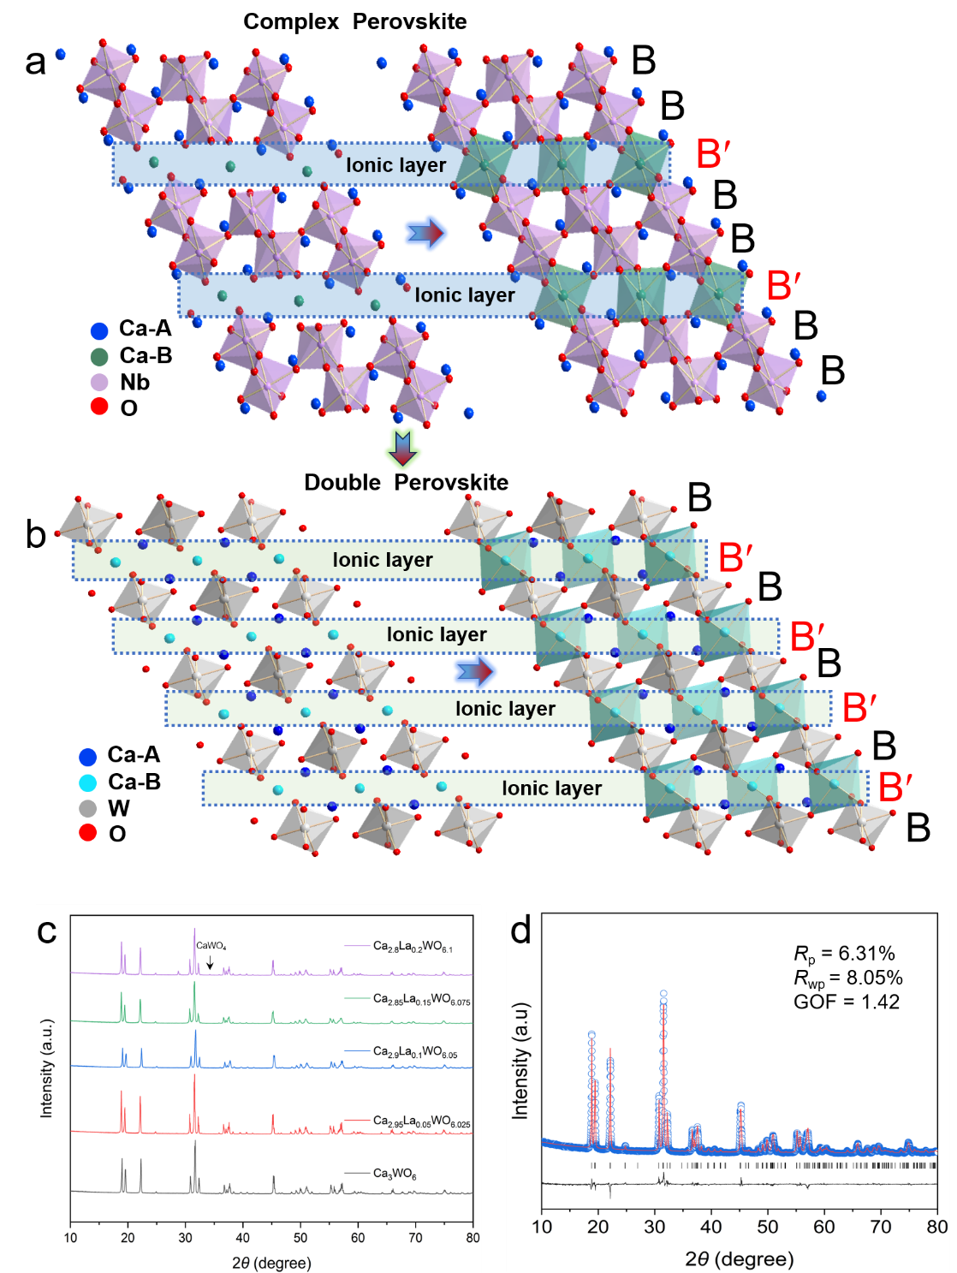
Figure S36. Structural comparison between the complex-perovskite and double-perovskite architectures. (a, b) Crystal structures of the complex perovskite and double perovskite, respectively, highlighting the distinct ion-layer arrangements. Compared with the complex-perovskite structure, the double-perovskite architecture exhibits a doubled ion-layer repeat, providing an expanded structural motif for accommodating and regulating mobile ionic species. (c) XRD patterns of Ca_{3-x}La_{x}WO_{6+x/2} (0.00 ≤ x ≤ 0.15) (c) Rietveld refinement plots of XRD pattern for x = 0.15 composition.
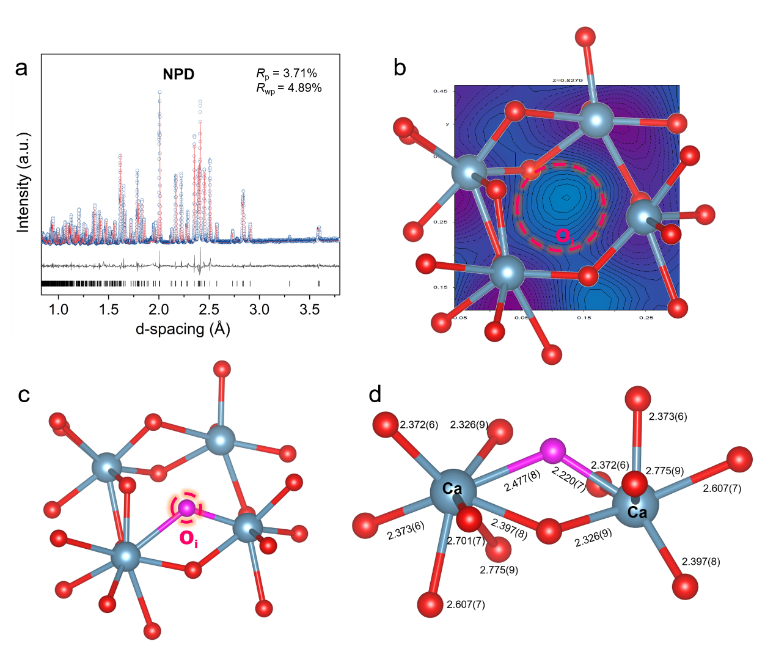
Figure S37. Average structure of Ca_{3-x}La_{x}WO_{6+x/2}. (a) Rietveld refinements of NPD data of Ca_{3-x}La_{x}WO_{6+x/2} (x = 0.15). (b) Difference nuclear-density map derived from NPD data, with the red dashed circle highlighting residual nuclear density assigned to an interstitial oxygen site. (b, c) Average coordination environments of the interstitial oxygen site.

Table S10. Refined structural parameters for Ca_{3-x}La_{x}WO_{6+x/2} (x = 0.15) from NPD data.*
Atom | site | x | y | z | Occ | U_{iso}(Å²)
Ca1 | 4e | 0.4857(3) | 0.5567(2) | 0.2539(2) | 0.097(5) | 0.0144(6)
La1 | 4e | 0.4857(3) | 0.5567(2) | 0.2539(2) | 0.023(5) | 0.0144(6)
Ca2 | 2c | 0 | 0.5 | 0 | 0.89(5) | 0.015(2)
La2 | 2c | 0 | 0.5 | 0 | 0.11(5) | 0.015(2)
W1 | 2d | 0.5 | 0 | 0 | 1 | 0.006(1)
O1 | 4e | 0.3329(3) | 0.2745(2) | 0.06828(18) | 1 | 0.0126(6)
O2 | 4e | 0.2179(3) | 0.8246(2) | 0.04847(19) | 1 | 0.0092(6)
O3 | 4e | 0.6126(3) | -0.0516(2) | 0.22575(18) | 0.93(5) | 0.0110(5)
Oi | 4e | 0.1237(1) | 0.28656(2) | 0.8279(2) | 0.06 (3) | 0.028 (2)
*Space group: P 2₁/n (14), a = 5.56(2) Å, b = 5.82(2) Å, c = 8.02(2) Å, β = 90.2096(7)º, V = 259.0(17) Å³, Z = 2.

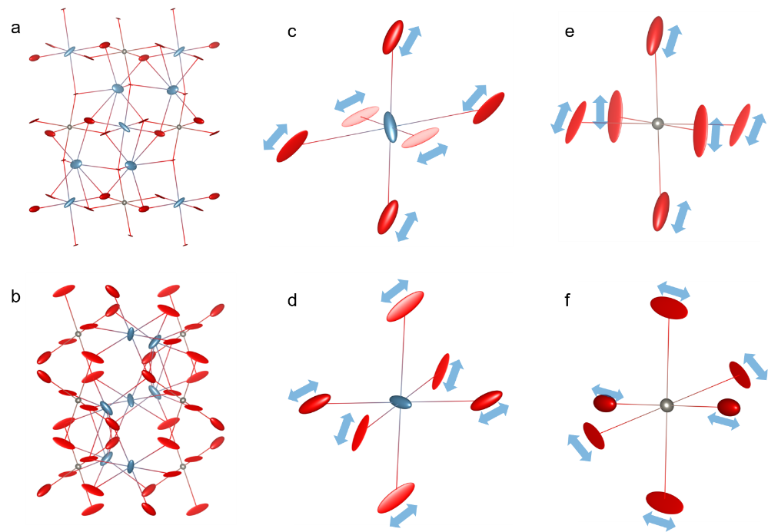
Figure S38. Anisotropic atomic displacement parameters of Ca_{3-x}La_{x}WO_{6+x/2} (x = 0.15). (a, b) Average structure shown with anisotropic displacement ellipsoids viewed along (a) b- and (d) a-axes, respectively. (c, d) Representative Ca/La-centered local coordination environments. (e, f) Representative W-centered local coordination environments. Blue arrows indicate the principal directions of oxygen displacements. The elongated oxygen displacement ellipsoids are predominantly oriented transverse to the local M-O bond directions, revealing a pronounced tangential component of the oxygen displacements. This anisotropic response is consistent with local librational and torsional flexibility of the coordination framework rather than simple radial M-O bond stretching.

Table S11. Refined anisotropic displacement parameters for Ca_{3-x}La_{x}WO_{6+x/2} (x = 0.15).
Atom | U₁₁(Å²) | U₂₂(Å²) | U₃₃(Å²) | U₁₂(Å²) | U₁₃(Å²) | U₂₃(Å²)
Ca1 | 0.033049 | 0.041495 | 0.026643 | 0.025967 | 0.016423 | 0.007290
La1 | 0.033049 | 0.041495 | 0.026643 | 0.025967 | 0.016423 | 0.007290
Ca2 | 0.009865 | 0.0383393 | 0.031800 | 0.005970 | 0.009040 | 0.028025
La2 | 0.009865 | 0.0383393 | 0.031800 | 0.005970 | 0.009040 | 0.028025
W | 0.007701 | 0.007227 | 0.007723 | 0.000641 | 0.004579 | 0.000510
O1 | 0.068904 | 0.0078615 | 0.001152 | 0.009836 | -0.001433 | 0.002398
O2 | 0.010187 | 0.031237 | 0.007202 | 0.040714 | 0.023390 | 0.013562
O3 | 0.041854 | 0.034709 | 0.013089 | 0.024846 | 0.000702 | -0.006843
Oi | 0.016890 | 0.009990 | 0.006390 | 0.002261 | -0.006072 | -0.001261

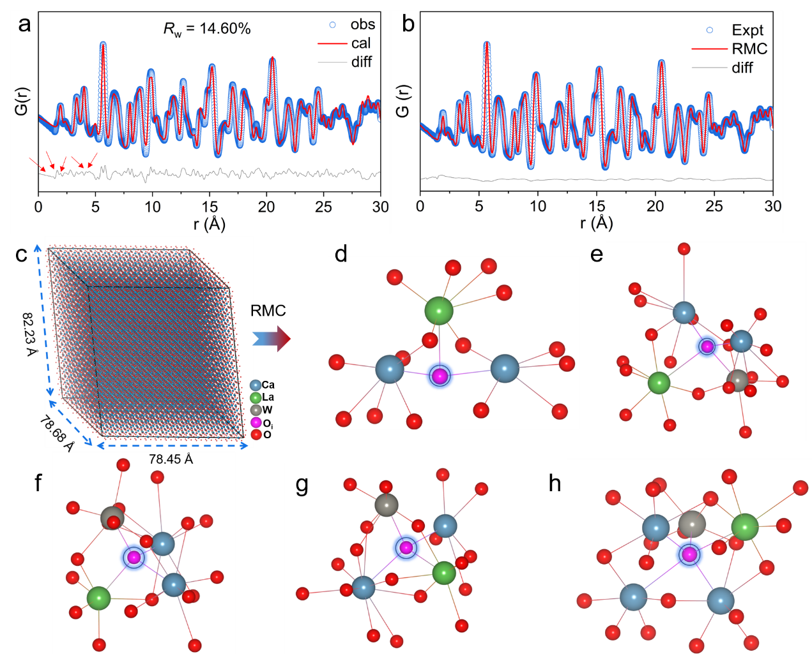
Figure S39. Small-box and big-box PDF analysis of the local coordination environments of interstitial oxygen in Ca_{3-x​}La_{x​}WO_{6+x/2​}. (a) Small-box fitting of the PDF data, with the observed, calculated, and difference profiles shown in blue, red, and grey, respectively. (b) Big-box fitting of the PDF data using reverse Monte Carlo (RMC) modelling. (c) Representative RMC-refined supercell illustrating the local structural disorder developed within the extended lattice. (d-h) Representative local coordination environments centered on interstitial oxygen extracted from the RMC-refined big-box configuration: (d) three-coordinate Ca₂La-O_{i}, (e, f, g) four-coordinate Ca₂WLa-O_{i}, and (h) five-coordinate Ca₃WLa-O_{i} configurations.

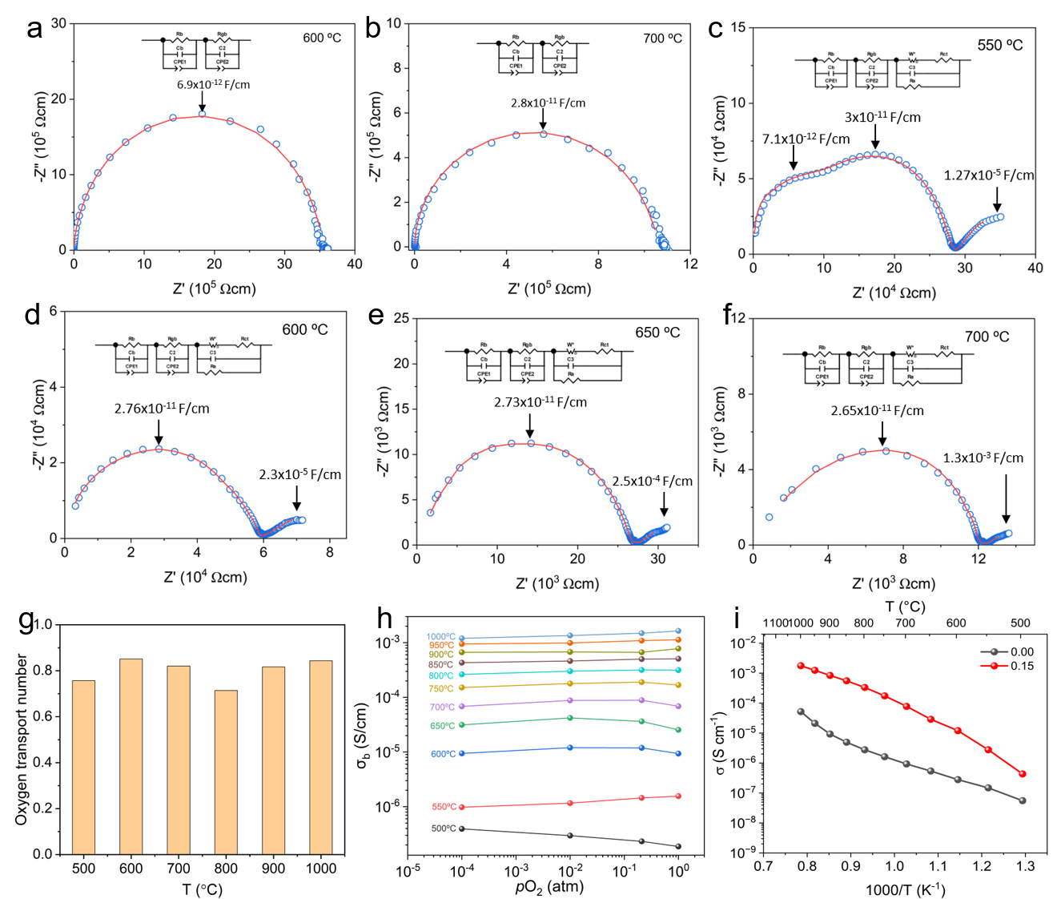
Figure S40. Electrical transport properties of double perovskite Ca_{3-x}La_{x}WO_{6+x/2}. (a, b) Complex impedance spectra of the parent Ca₃WO₆ at (a) 600 ºC and (b) 700 ºC. (c-f) Complex impedance spectra of the parent La- doped composition Ca_{3-x}La_{x}WO_{6+x/2} (x = 0.15) at (c) 550 ºC, (d) 600 ºC, (e) 650 ºC, and (f) 700 ºC. The pronounced low-frequency electrode-polarization response after La substitution is consistent with enhanced ionic transport. (g) Oxygen transport number of Ca_{3-x}La_{x}W₂O_{6+x/2} (x = 0.15). (h) Bulk conductivities of x = 0.15 composition as a function of oxygen partial pressure at different temperatures. (i) Arrhenius plots of the bulk conductivities of Ca_{3-x}La_{x}WO_{6+x/2} (x = 0 and 0.15).

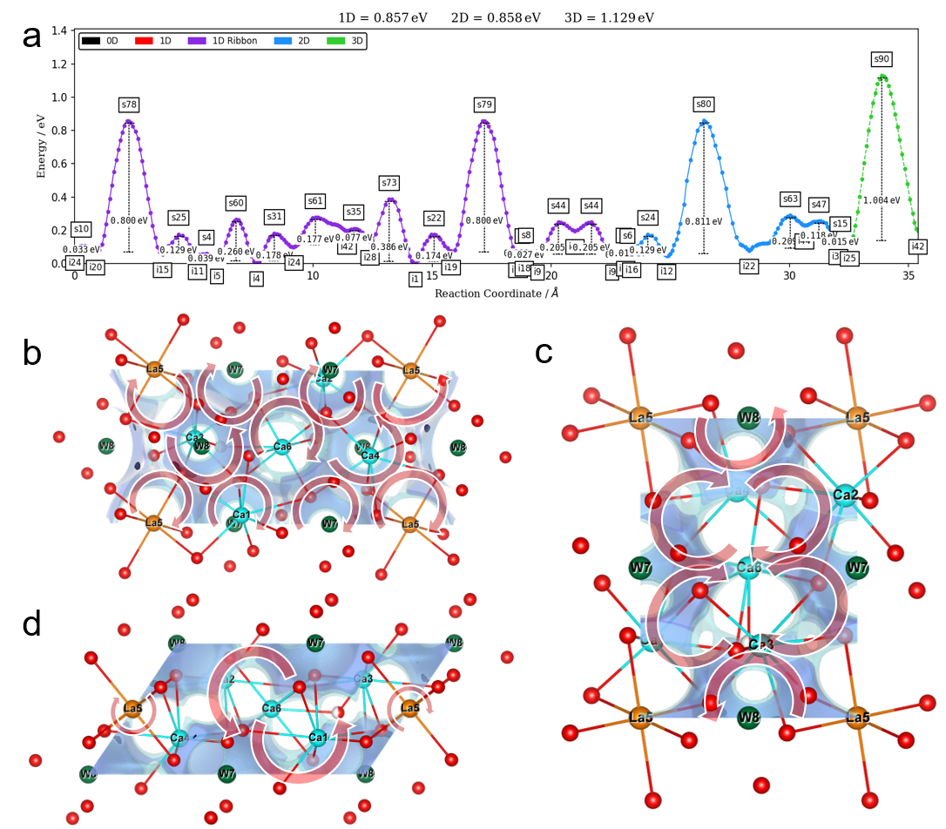
Figure S41. Bond valence site energy (BVSE) calculations for Ca_{3-x}La_{x}WO_{6+x/2} (x = 0.15). (a) BVSE-calculated migration barriers along different dimensional. (b-d) BVSE-calculated maps of oxide-ion migration along the (b) c-axis, (c) a-axis, and (d) b-axis.
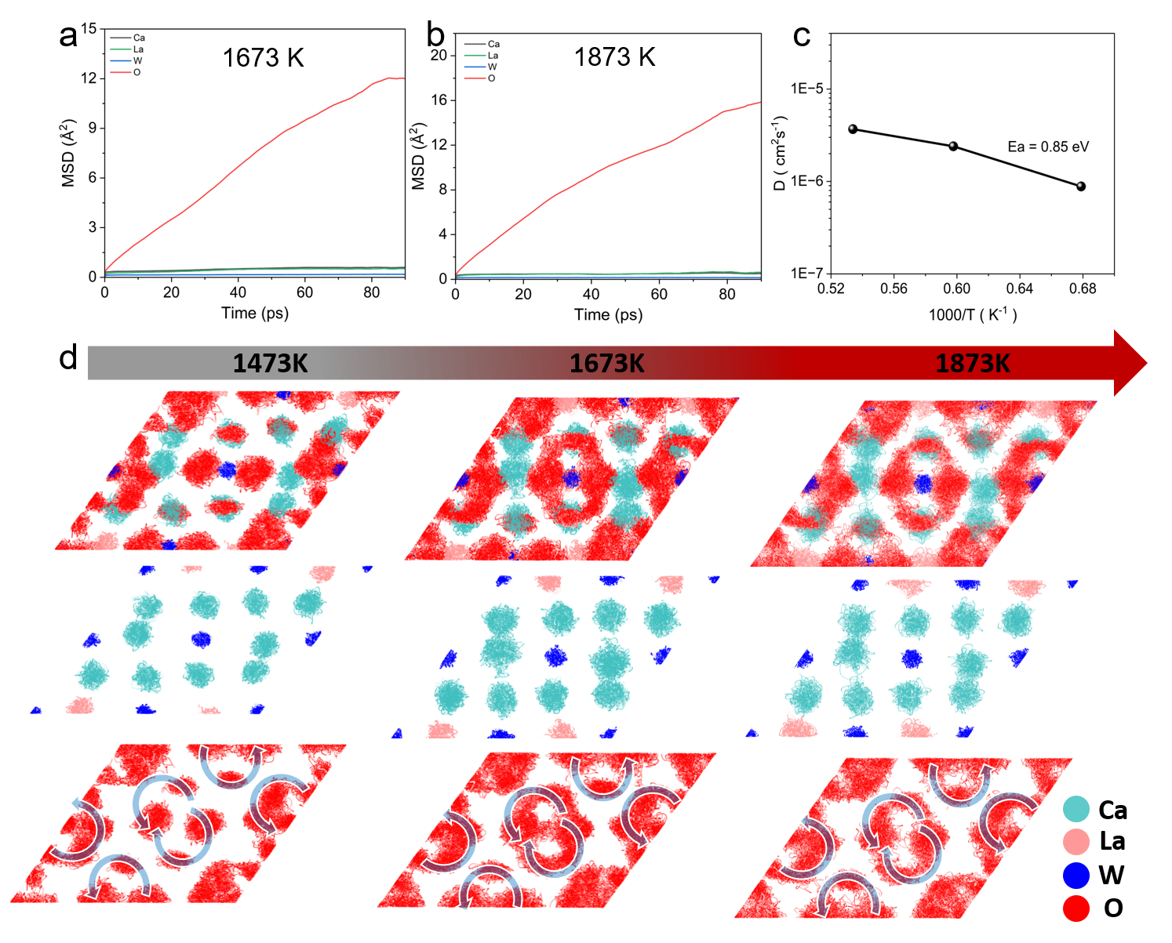
Figure S42. Ab initio molecular dynamics (AIMD) simulations for Ca_{3-x}La_{x}WO_{6+x/2} (x = 0.15). (a, b) Mean square displacement values of Ca, La, W, and O atoms at (a) 1673 K and (b) 1873 K. (c) Arrhenius plot of the oxide-ion diffusion coefficients. (d) Time- and temperature-dependent scatter plots from AIMD trajectories along the [010] direction, showing (top) all atoms, (middle) cations, and (bottom) oxide-ion trajectories.

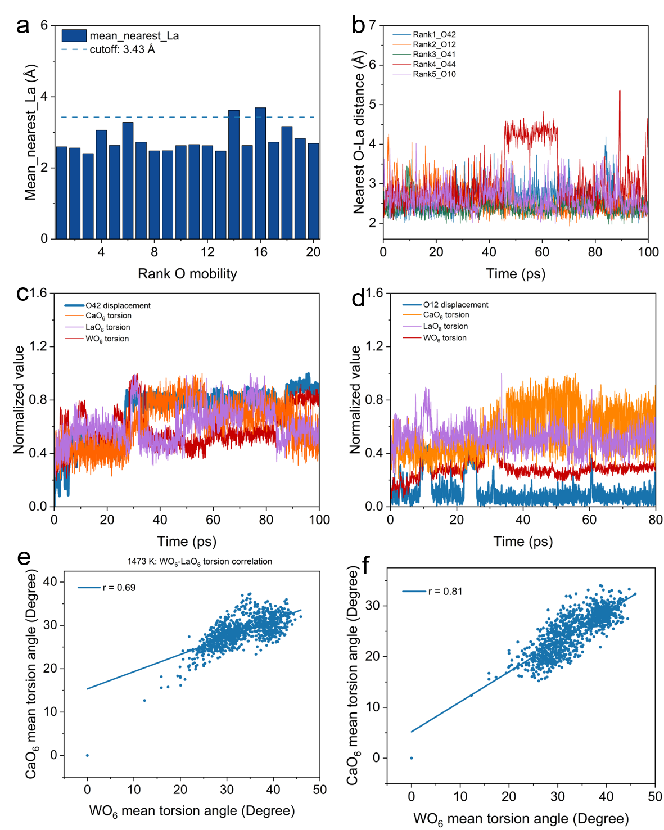
Figure S43. Oxide-ion migration and cooperative polyhedral dynamics in double perovskite framework from AIMD simulations at 1473 K. (a) Mean nearest O-La distances for the top 20 most mobile oxide ions identified from the individual-O mobility analysis. The dashed line denotes the La-O first-shell cutoff of 3.43 Å. (b) Time evolution of the nearest O-La distances for the five most mobile oxide-ions. (c, d) Normalized displacement of representative mobile oxide ions O42 and O12, respectively, compared with the normalized local WO₆​, CaO₆​, and LaO₆​ torsional motions. The correlated temporal evolution indicates that long-range oxide-ion displacement is dynamically associated with collective distortional/rotational motions of the surrounding polyhedral framework. (e, f) Correlations between the mean WO₆​ torsion angle and the mean LaO₆​ and CaO₆​ torsion angles, respectively. Each point represents one AIMD time frame, and the solid lines are linear fits. The high Pearson correlation coefficients, r = 0.69 for WO₆​-LaO₆​ and r = 0.81 for WO₆​-CaO₆​, demonstrate strongly cooperative framework torsion at 1473 K.
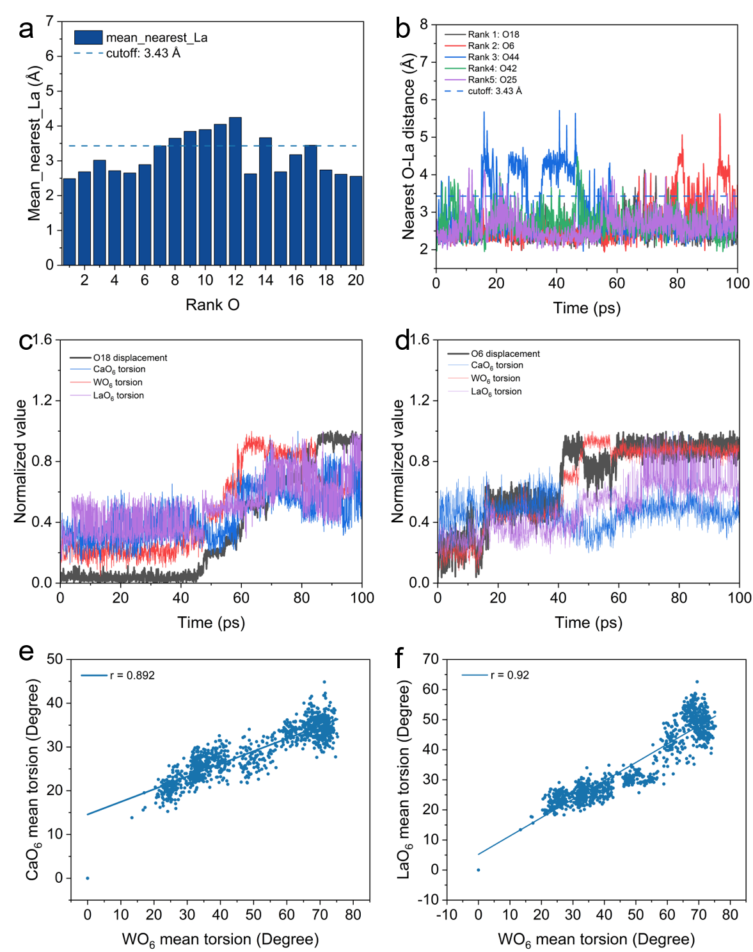
Figure S44. Oxide-ion migration and cooperative polyhedral dynamics in double perovskite framework from AIMD simulations at 1673 K. (a) Mean nearest O-La distances for the top 20 most mobile oxide ions identified from the individual-O mobility analysis. The dashed line denotes the La-O first-shell cutoff of 3.43 Å. (b) Time evolution of the nearest O-La distances for the five most mobile oxide-ions. (c, d) Normalized displacement of representative mobile oxide ions O18 and O6, respectively, compared with the normalized local WO₆​, CaO₆​, and LaO₆​ torsional motions. The correlated temporal evolution indicates that long-range oxide-ion displacement is dynamically associated with collective distortional/rotational motions of the surrounding polyhedral framework. (e, f) Correlations between the mean WO₆​ torsion angle and the mean LaO₆​ and CaO₆​ torsion angles, respectively. Each point represents one AIMD time frame, and the solid lines are linear fits. The high Pearson correlation coefficients, r = 0.89 for WO₆​-LaO₆​ and r = 0.92 for WO₆​-CaO₆​, demonstrate strongly cooperative framework torsion at 1673 K.
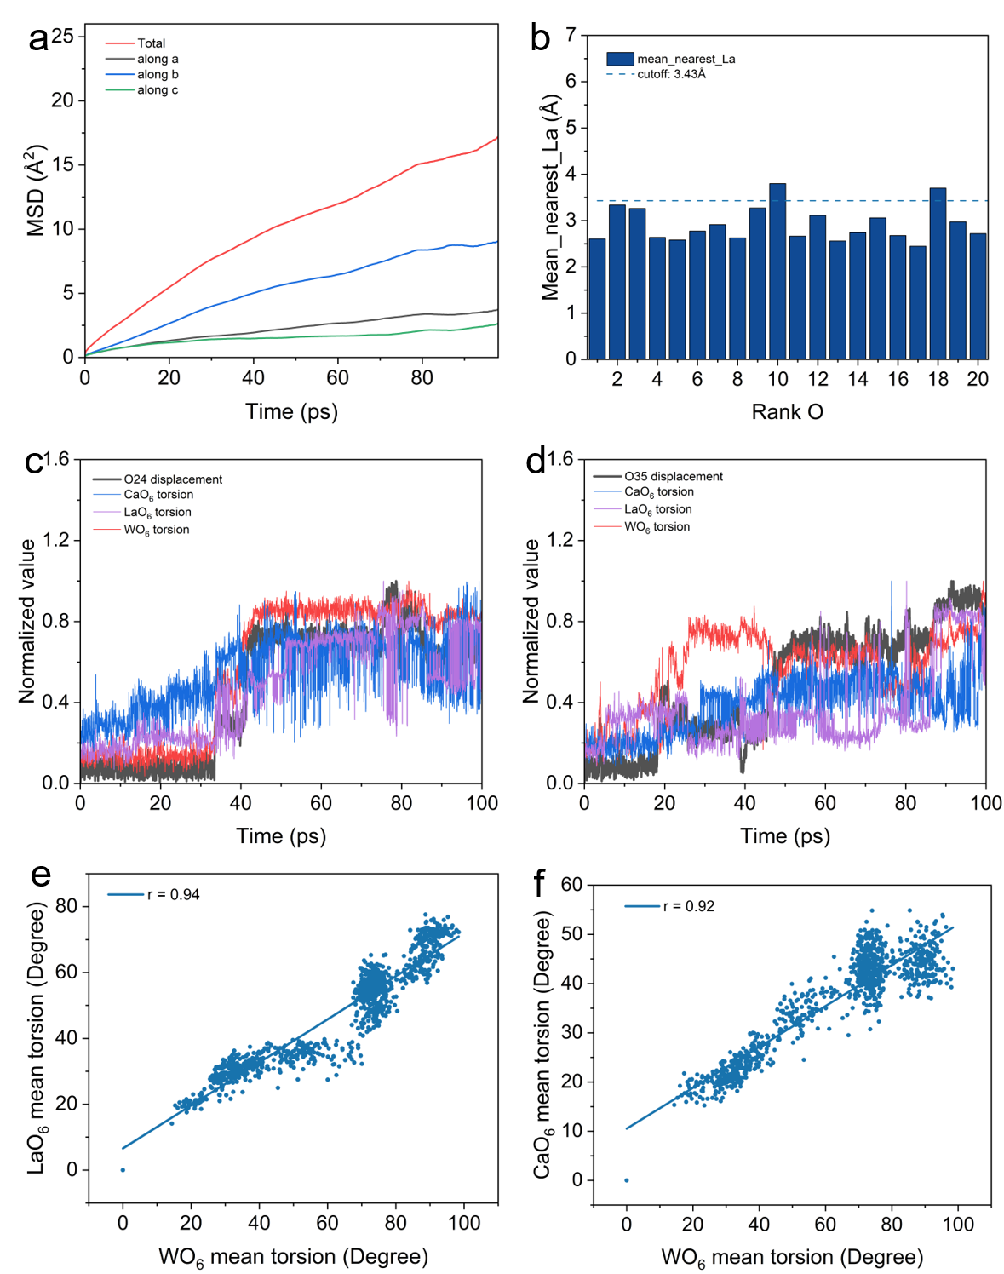
Figure S45. Oxide-ion migration and cooperative polyhedral dynamics in double perovskite framework from AIMD simulations at 1873 K. (a) Time evolution of the total oxide-ion mean-squared displacement (MSD) and its projections along the crystallographic a, b, and c directions over the 0-100 ps trajectory, showing pronounced anisotropic transport with preferential migration along the b direction. (b) Mean nearest O-La distances for the top 20 most mobile oxide ions identified from the individual-O mobility analysis. The dashed line denotes the La-O first-shell cutoff of 3.43 Å. (c, d) Normalized displacement of representative mobile oxide ions O24 and O35, respectively, compared with the normalized local WO₆​, CaO₆​, and LaO₆​ torsional motions. The correlated temporal evolution indicates that long-range oxide-ion displacement is dynamically associated with collective distortional/rotational motions of the surrounding polyhedral framework. (e, f) Correlations between the mean WO₆​ torsion angle and the mean LaO₆​ and CaO₆​ torsion angles, respectively. Each point represents one AIMD time frame, and the solid lines are linear fits. The high Pearson correlation coefficients, r = 0.94 for WO₆​-LaO₆​ and r = 0.92 for WO₆​-CaO₆​, demonstrate strongly cooperative framework torsion at 1873 K.

Reference
1. Macdonald, J. S. Note on the parameterization of the constant-phase admittance element. Solid State Ion. 13, 147-149, (1984).
2. Irvine, J. T. S., Sinclair, D. C. & West, A. R. Electroceramics : Characterization by Impedance Spectroscopy. Adv. Mater. 2, 132-138, (1990).
3. Masó, N. & West, A. R. Electronic Conductivity in Yttria-Stabilized Zirconia under a Small dc Bias. Chem. Mater. 27, 1552-1558, (2015).
4. Masó, N., Yue, X. Y., Goto, T. & West, A. R. Frequency-dependent electrical properties of ferroelectric BaTi₂O₅ single crystal. J. Appl. Phys. 109, 024107 (2011).
5. Abram, E. J., Sinclair, D. C. & West, A. R. A Strategy for Analysis and Modelling of Impedance Spectroscopy Data of Electroceramics: Doped Lanthanum Gallate. J. Electroceram. 10, 165-177, (2003).

