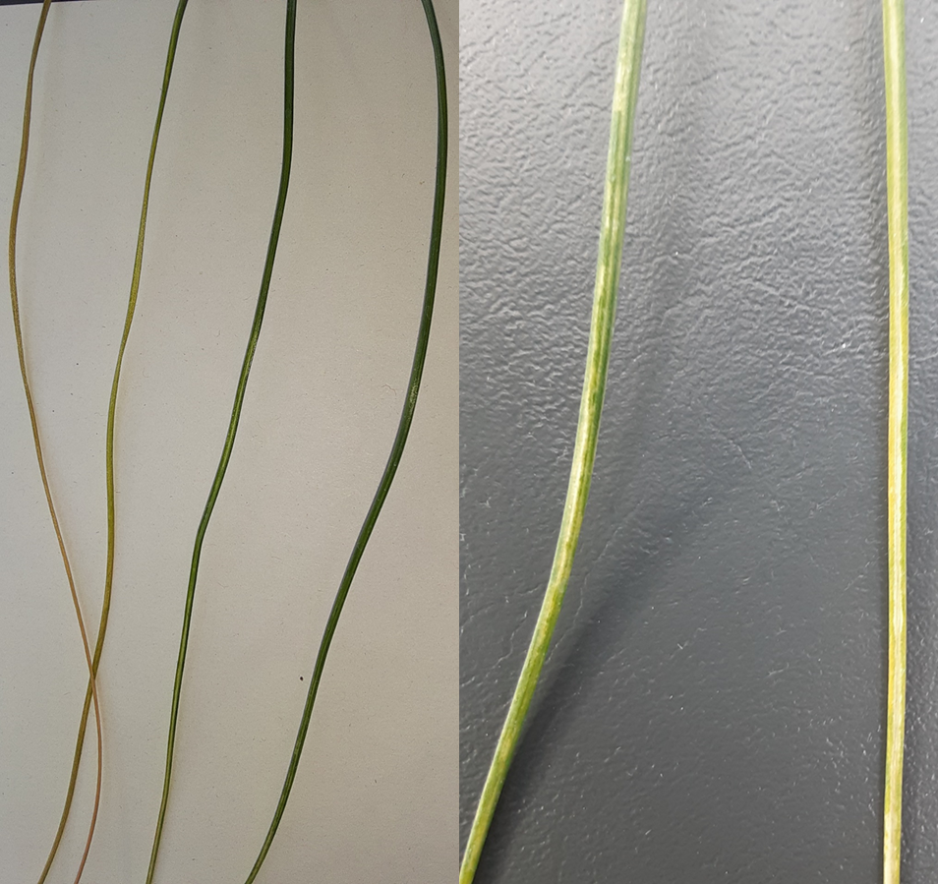

Supplementary Figure 1 Symptoms of leaf chlorosis in the studied Narcissus albidus plant

Supplementary Table 1 List of PCR primers used in this study
Name | Sequence (5′ to 3′) |  | Position
ValMV-F1 | ACAGGAACACTCAACAAAAC |  | 1–20
ValMV-R1 | CTTGCCAACAATTTCAATAGTC |  | 611–632
ValMV-F2 | CGCAGATAGTGGAGACAATC |  | 424–443
ValMV-R2 | CGACTCGCTGATGTTTCAC |  | 1,020–1,038
ValMV-F3 | GATGCGACAATTCAGATGG |  | 927–945
ValMV-R3 | GCTGATTATCACACATAAGCG |  | 1,552–1,572
ValMV-F4 | GTGCGCTACTCGAAGTGAC |  | 1,441–1,459
ValMV-R4 | CGCTCACGTTAACTAGCATAG |  | 2,023–2,043
ValMV-F5 | CTGGAGATGCCAAGTATGTG |  | 1,930–1,949
ValMV-R5 | GCAACCATTCGTACGATTG |  | 2,551–2,569
ValMV-F6 | GACGAGCCTTGTATACTCGC |  | 2,439–2,458
ValMV-R6 | GTAAACTTGCGCGAACAATG |  | 3,086–3,105
ValMV-F7 | GATGTGCGAAGGAGAAGTC |  | 2,983–3,001
ValMV-R7 | CAGTCGTTGAAGGTCACATC |  | 3,639–3,658
ValMV-F8 | CGAGAATGACGTGTACCATC |  | 3,527–3,546
ValMV-R8 | GTTCATTGCTTCGAATTCG |  | 4,178–4,196
ValMV-F9 | GTCATGTCTTGGACAGCTC |  | 4,072–4,090
ValMV-R9 | CTTGTTGTAACATTGTGCGTC |  | 4,736–4,756
ValMV-F10 | CGTATTGGTCACACAGAGAAG |  | 4,641–4,661
ValMV-R10 | CTTGCTTCACCTGCTCTTG |  | 5,205–5,223
ValMV-F11 | GCAGTGAAGATTGCATACAC |  | 5,124–5,143
ValMV-R11 | GTATTCGGATGGATCGAATC |  | 5,806–5,825
Supplementary Table 1 List of PCR primers used in this study (continued)
Name |  | Sequence (5' to 3') |  | Position
ValMV-F12 |  | GTCGCGAAGTATATGCAGAC |  | 5,671–5,690
ValMV-R12 |  | CGATTCGTAATAATGCAACC |  | 6,306–6,325
ValMV-F13 |  | GGACTGCGCGATTATAACC |  | 6,210–6,228
ValMV-R13 |  | GTCTTGCTGAAGCTTGAGAC |  | 6,832–6,851
ValMV-F14 |  | CAACGGTTAGCAATTCGAAG |  | 6,700–6,719
ValMV-R14 |  | GTGATAGTTCCATGCCAGC |  | 7,341–7,359
ValMV-F15 |  | GTGTGAGTATATCACTGACCCTG |  | 7,244–7,266
ValMV-R15 |  | GGTTAGGATAACCATCAGCG |  | 7,879–7,898
ValMV-F16 |  | GAGATGCTCAGGAACCTGTAC |  | 7,758–7,778
ValMV-R16 |  | GATGGTAGACCATCTCATCC |  | 8,453–8,472
ValMV-F17 |  | GCATACATGTTGGATCAGG |  | 8,289–8,307
ValMV-R17 |  | GTTAGATTACGTTGGCTGCC |  | 8,988–9,007
ValMV-F18 |  | GCAGCCGAAGCTTACATC |  | 8,931–8,948
ValMV-R18 |  | GTCTCTCGCTGCAATGTGT |  | 9,433–9,451
ValMV-R0(5′ RACE) |  | GGGTCATGAATCCCATTC |  | 203–220
ValMV-F19(3′ RACE) |  | CAGACTACAGCTTAGCACGC |  | 9,007–9,026

Supplementary Table 2 Comparison of nucleotide and amino acid sequence identities between various genomic regions from ValMV-Nar and related potyviruses
 |  |  | Whole genome | polyprotein | 5'UTR | P1 | HC-Pro | P3 | 6K1 | CI | 6K2 | NIa-VPg | NIa-Pro | NIb | CP | 3'UTR
ValMV-Nar | vs | AV1 | 59.1ª / -^{b} | 59.4 / 48.3 | 51.9 / - | 49.6 / 20.1 | 60.0 / 52.3 | 52.4 / 27.7 | 57.7 / 46.2 | 62.7 / 55.7 | 55.4 / 47.2 | 60.9 / 54.3 | 59.8 / 48.6 | 62.3 / 57.8 | 65.6 / 64.9 | 49.3 / -
ValMV-Nar | vs | DMV | 58.1 / - | 58.1 / 45.3 | 49.3 / - | 49.5 / 18.3 | 59.0 / 48.0 | 51.9 / 23.2 | 57.1 / 45.3 | 60.2 / 52.9 | 55.0 / 34.0 | 57.9 / 48.5 | 58.0 / 46.9 | 62.7 / 59.1 | 63.0 / 57.5 | 50.0 / -
ValMV-Nar | vs | LMoV | 58.5 / - | 58.6 / 47.4 | 56.2 / - | 51.0 / 21.6 | 60.2 / 46.6 | 53.8 /30.8 | 55.9 / 43.4 | 60.5 / 56.4 | 55.3 / 35.0 | 59.5 / 51.0 | 58.0 / 50.2 | 61.2 / 58.1 | 61.5 / 59.5 | 51.7 / -
ValMV-Nar | vs | OrMV | 65.4 / - | 65.9 / 66.3 | 56.6 / - | 53.4 / 30.9 | 66.5 / 68.7 | 60.7 / 52.9 | 68.0 / 78.9 | 68.9 / 74.5 | 65.0 / 66.0 | 67.5 / 72.2 | 67.1 / 70.4 | 67.8 / 71.6 | 71.9 / 76.8 | 55.3 / -
ValMV-Nar | vs | ValMV^{C}  (Nerine sarniensis, the United Kingdom) | nd | nd | nd | nd | nd | nd | nd | nd | nd | nd | nd | nd | 99.1 / 98.8 | 93.1 / -
ValMV-Nar | vs | ValMV^{C}  (Nerine sp.,  New Zealand) | nd | nd | nd | nd | nd | nd | nd | nd | nd | nd | nd | nd | 99.2 / 98.8 | 98.6 / -
ValMV-Nar | vs | ValMV^{C}  (Cyrtanthus elatus, the United States) | nd | nd | nd | nd | nd | nd | nd | nd | nd | nd | nd | nd | 99.1 / 98.8 | 98.6 / -
a, nucleotide sequence identity; b, amino acid sequence identity; c, ValMV isolates are partial sequence registered in NCBI databses. nd, no data.
The abbreviations (accession number) used are as follows: AV1; asparagus virus 1 (KJ830760.1), DMV; dioscorea mosaic virus (MH206616.1), LMoV; lily mottle virus (AJ564636.1), OrMV; ornithogalum mosaic virus (JQ807997.1), and ValMV; vallota mosaic virus (the United Kingdom; EF507688.1, New Zealand; FJ618540.1, the United States; EF441726.1).

