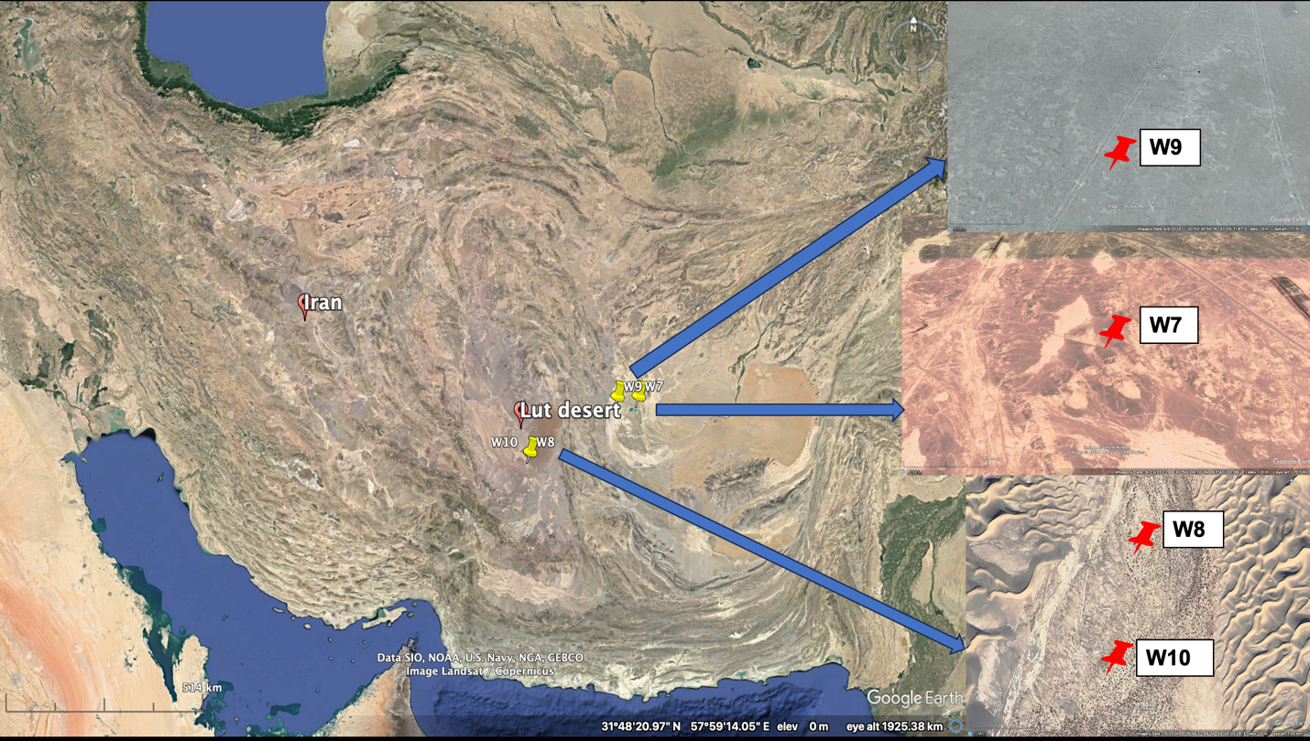
Supplementary Fig. 1 Sampling sites, Lut Desert, Iran. The location points were W7 (30$°$, 50$´$, 00.10$´´$N 61$°$, 40$´$, 00.06$´´$E), W8 (29$°$, 48$´$, 59$´´$N 59$°$, 04$´$, 04$´´$E), W9 (30$°$, 50$´$, 30.62$´´$N 61$°$, 09$´$, 32.83$´´$E), and W10 (29$°$, 48$´$, 46.2$´´$N, 59$°$, 04$´$, 07$´´$E). The map was constructed using Google Earth Pro software.

