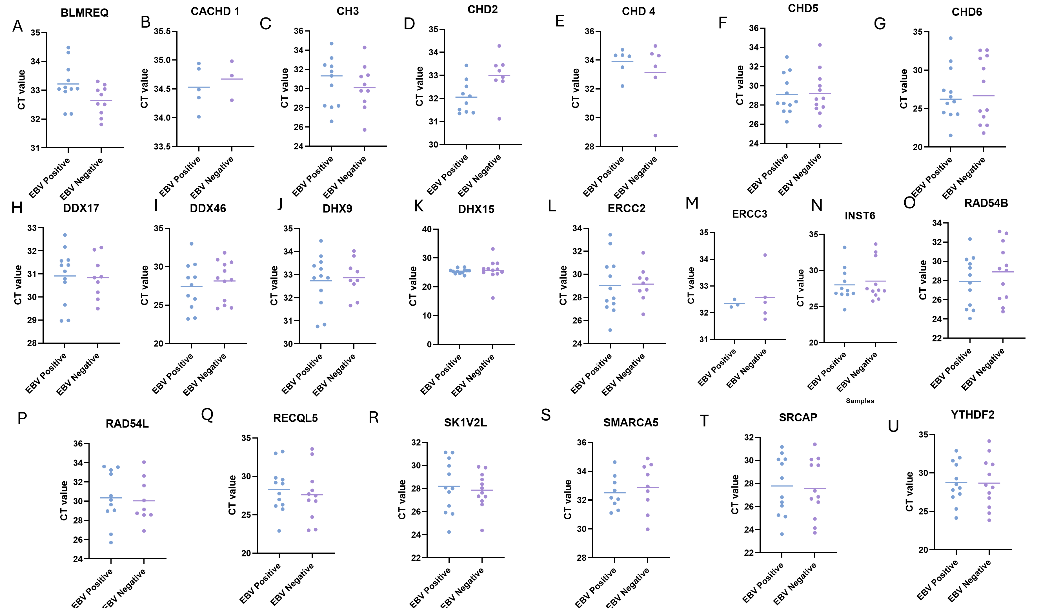

Supplementary Figure 1: Expression of Helicase genes in EBV-positive and EBV-negative prostate cancer tissues. Dot plots show the expression levels of the indicated genes in EBV-positive (blue) and EBV-negative (purple) prostate cancer samples. Each dot represents an individual sample, with horizontal bars indicating group means. Each graph represents one gene: BLMREQ, CACHD-1, CH3, CHD2, CHD4, CHD5, CHD6, DDX17, DDX46, DHX9, DHX15, ERCC2, ERCC3, INST6, RAD54B, RAD54L, RECQL5, SK1V2L, SMARCA5, SRCAP and YTHDF2. Each dot represents a CT value for individual sample prostate cancer sample

