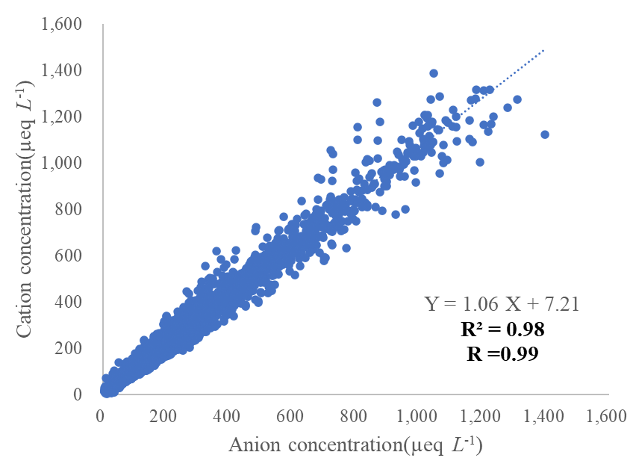
Fig. S1. Distribution of Anion and Cation Concentrations
(a)
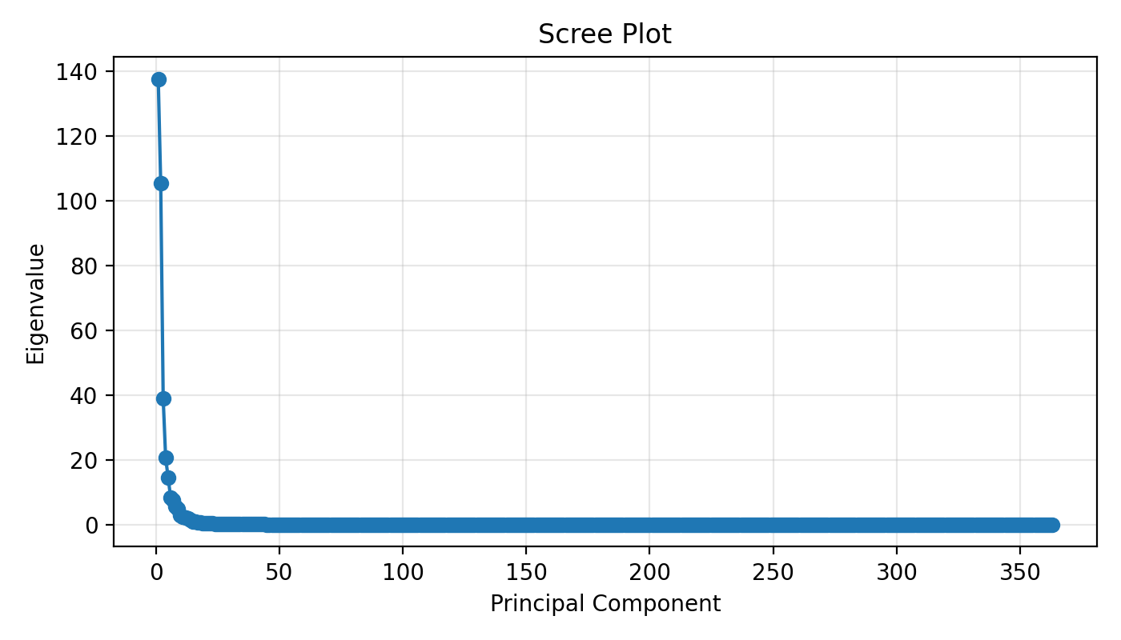
(b)
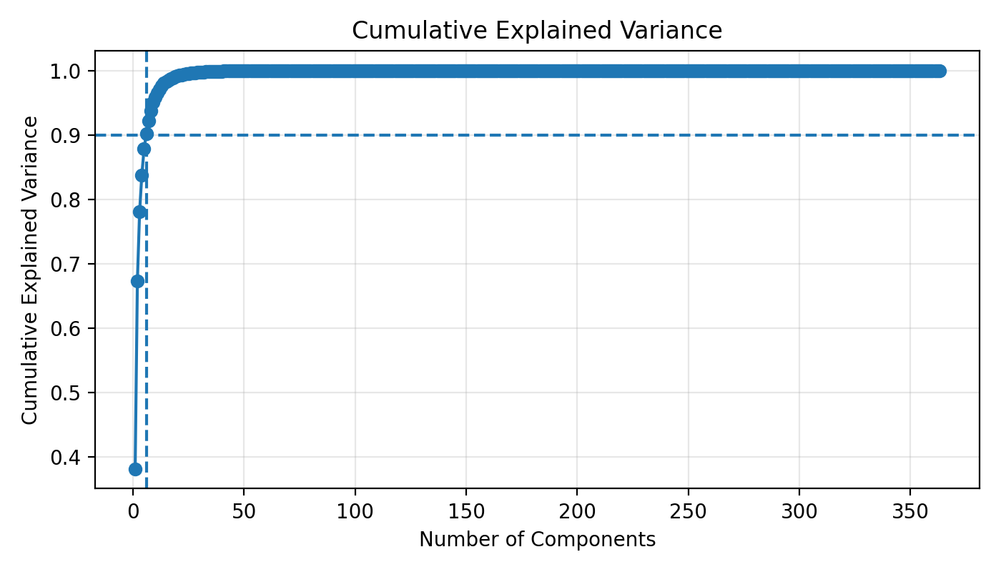
Fig. S2. Diagnostic plots for determining trajectory cluster dimensions: (a) Scree plot of eigenvalues across principal components, indicating an elbow at the fourth component; (b) Cumulative explained variance ratio as a function of retained components, with the dashed lines marking the leading retained modes and the 90% variance threshold.

(a) | (b)
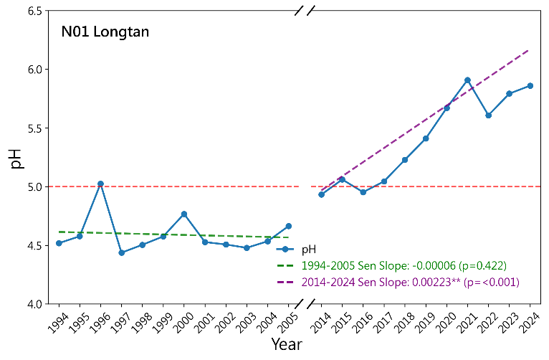 | 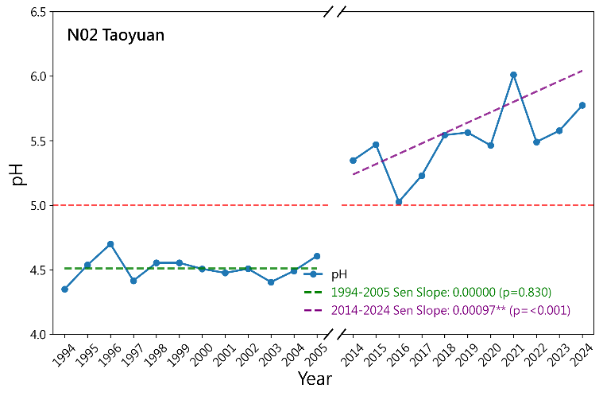
(c) | (d)
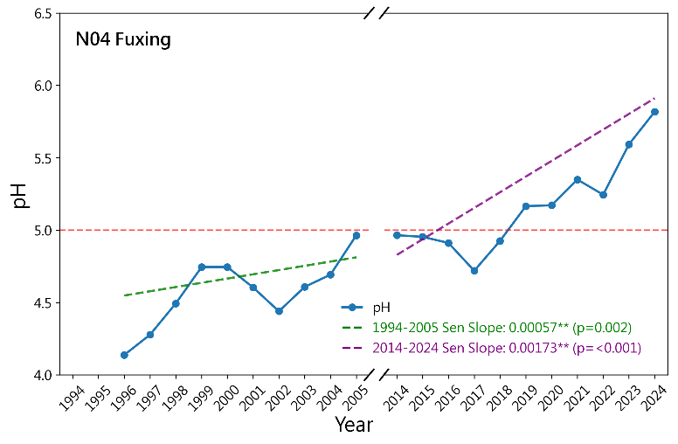 | 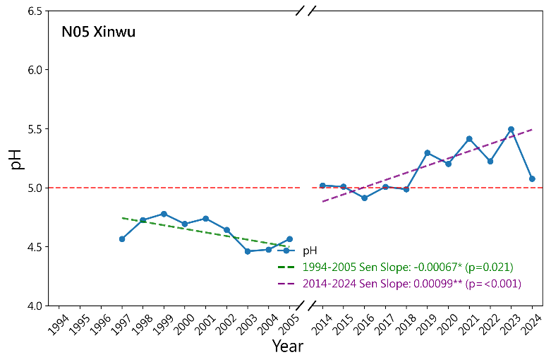
Fig. S3. VWM variation of pH at (a) Longtan ; (b) Taoyuan ; (c) Fuxing ; (d) Xinwu stations from Phase I (1994-2005) and Phase II (2014-2024).
Note: Trend lines represent Sen’s slopes calculated from individual daily precipitation events across the multi-year observation sequence, displayed alongside annual VWM values for visual orientation.
(a) | (b)
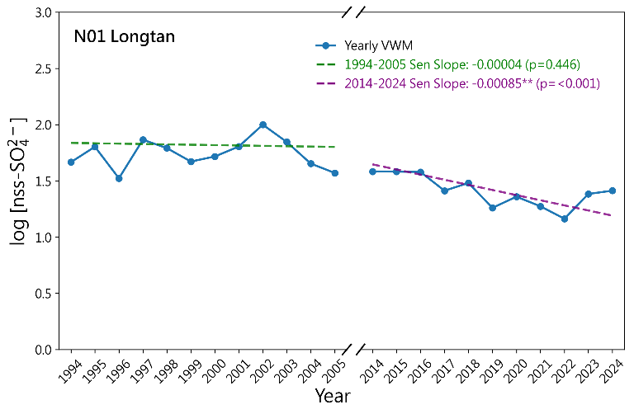 | 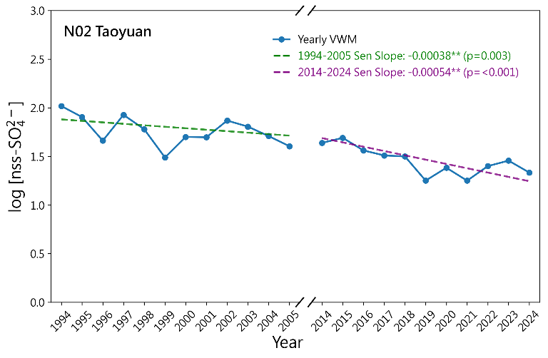
(c) | (d)
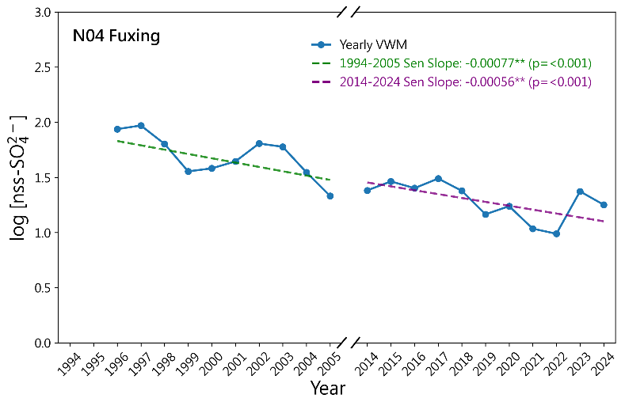 | 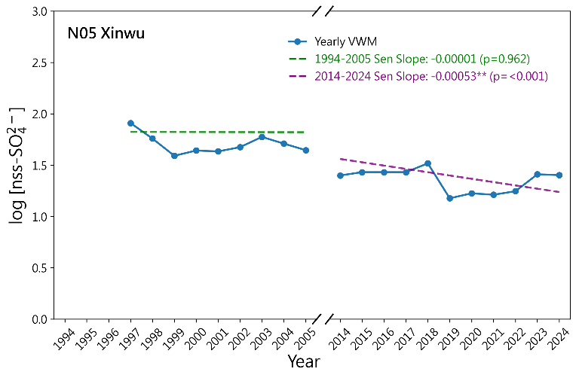
Fig. S4. VWM log concentration of nss-SO₄²⁻ at (a) Longtan ; (b) Taoyuan ; (c) Fuxing ; (d) Xinwu stations from Phase I (1994-2005) and Phase II (2014-2024).
Note: Trend lines represent Sen’s slopes calculated from individual daily precipitation events across the multi-year observation sequence, displayed alongside annual VWM values for visual orientation.
(a) | (b)
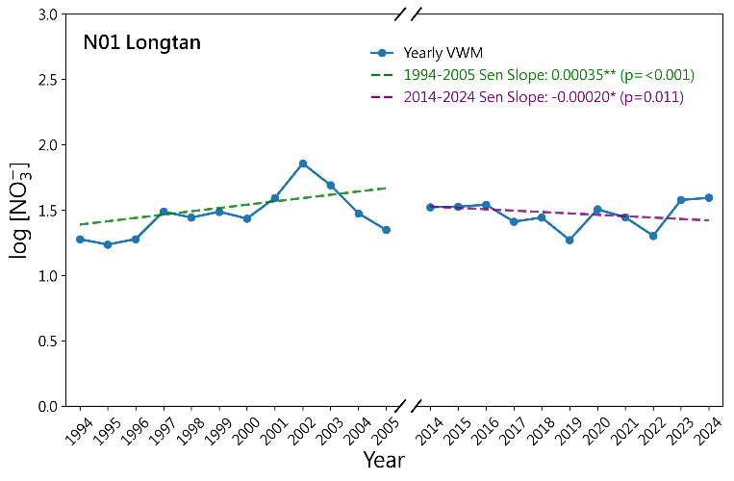 | 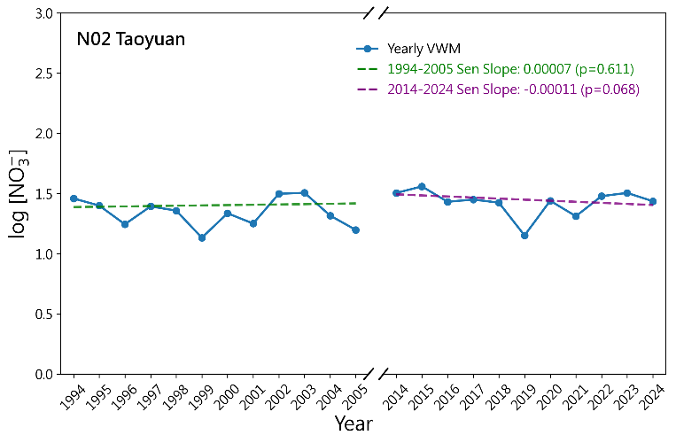
(c) | (d)
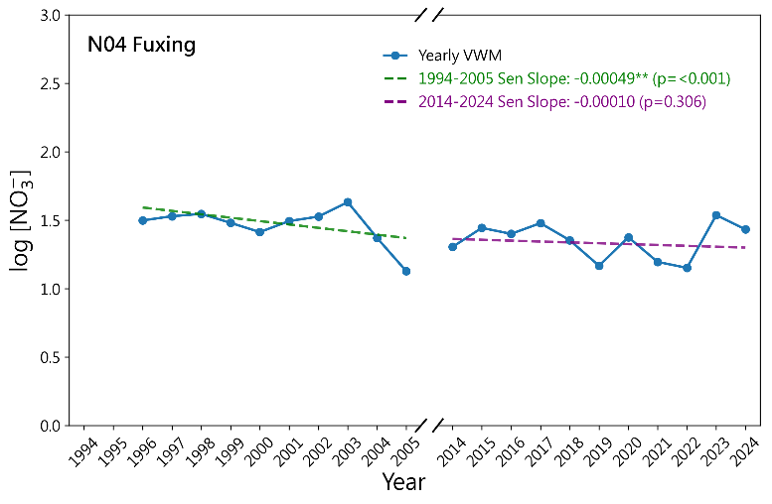 | 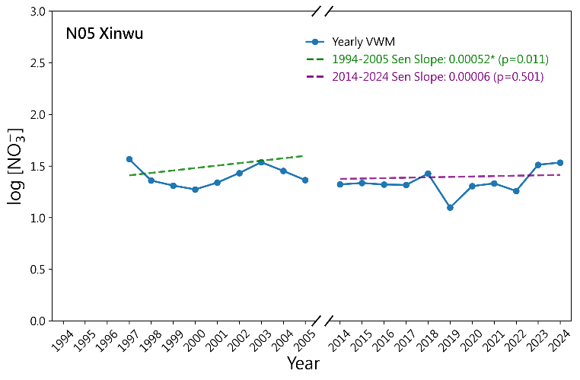
Fig. S5. VWM log concentration of NO₃⁻ at (a) Longtan ; (b) Taoyuan ; (c) Fuxing ; (d) Xinwu stations from Phase I (1994-2005) and Phase II (2014-2024).
Note: Trend lines represent Sen’s slopes calculated from individual daily precipitation events across the multi-year observation sequence, displayed alongside annual VWM values for visual orientation.

(a) | (b)
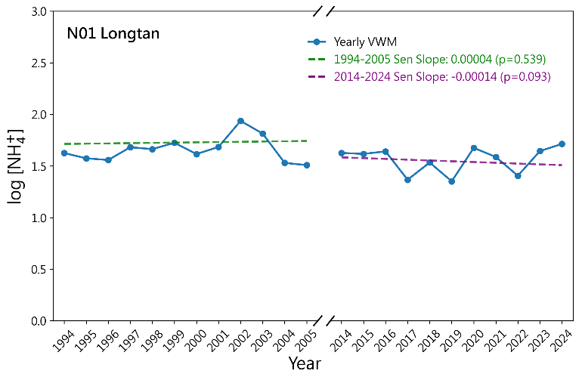 | 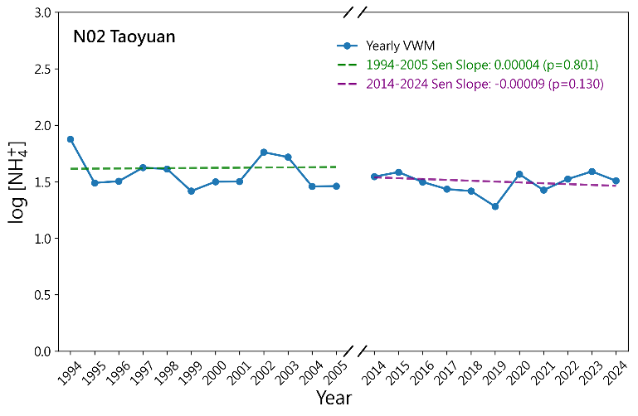
(c) | (d)
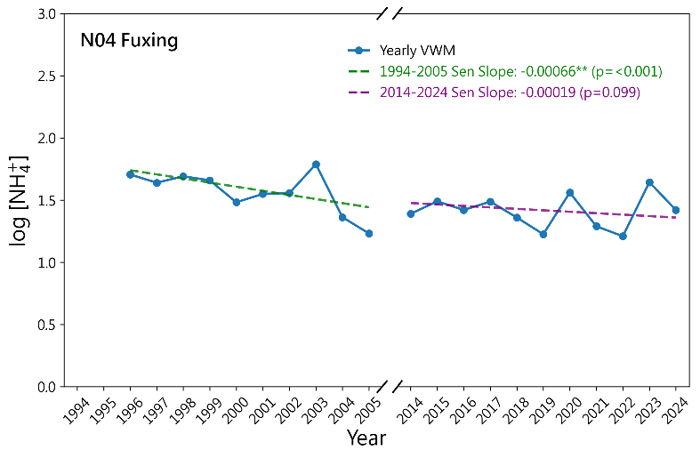 | 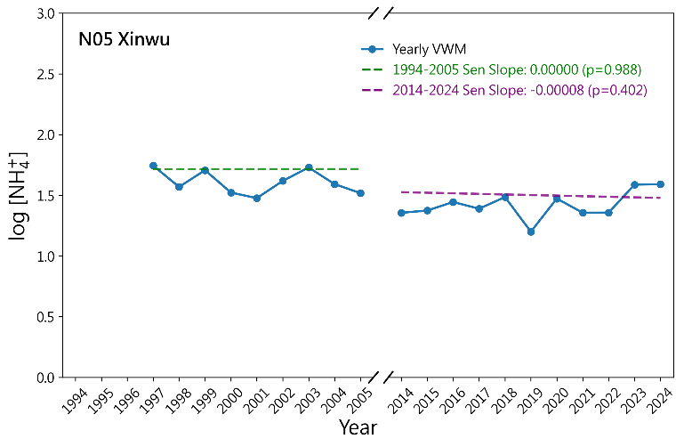
Fig. S6. VWM log concentration of NH₄⁺ at (a) Longtan ; (b) Taoyuan ; (c) Fuxing ; (d) Xinwu stations from Phase I (1994-2005) and Phase II (2014-2024).
Note: Trend lines represent Sen’s slopes calculated from individual daily precipitation events across the multi-year observation sequence, displayed alongside annual VWM values for visual orientation.
(a) | (b)
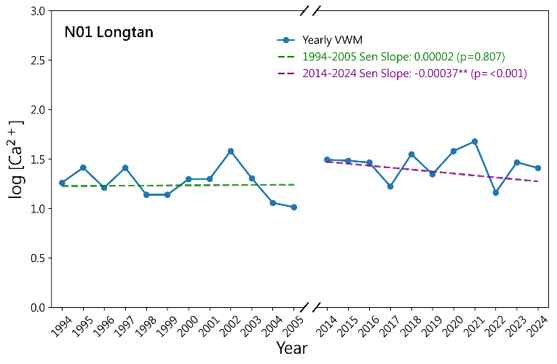 | 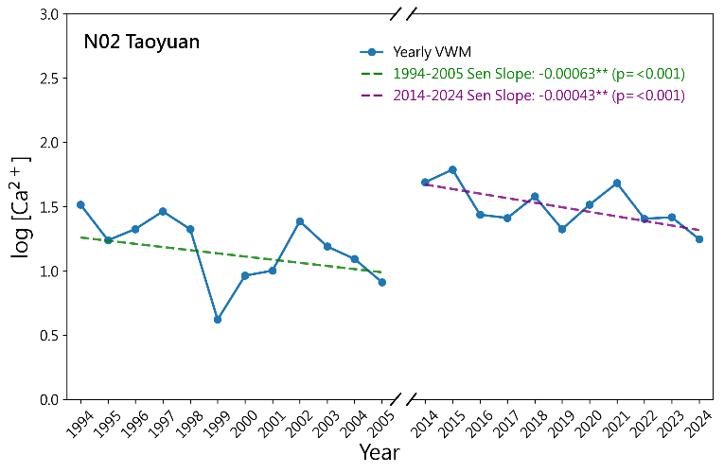
(c) | (d)
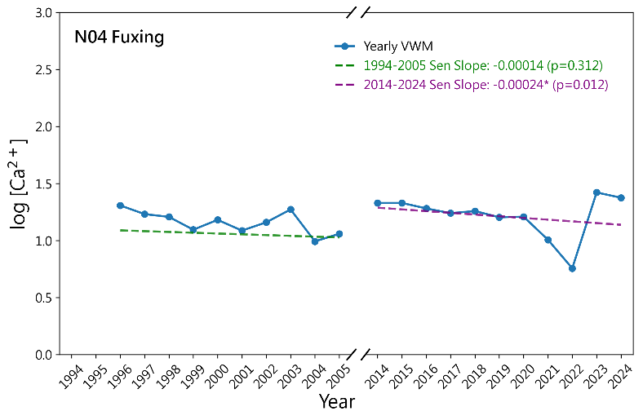 | 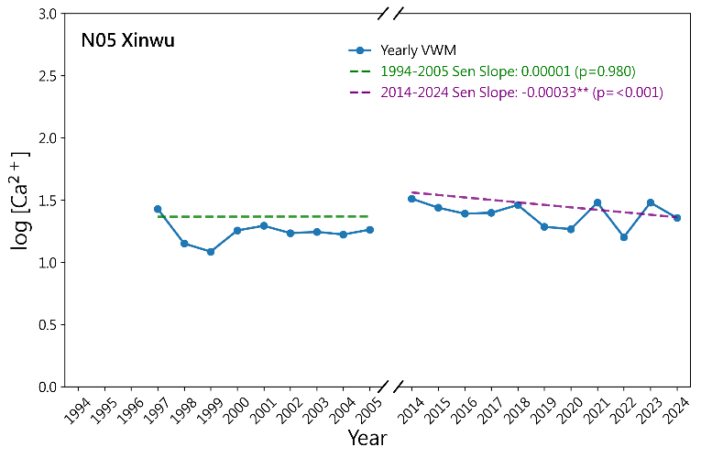
Fig. S7. VWM log concentration of Ca²⁺ at (a) Longtan ; (b) Taoyuan ; (c) Fuxing ; (d) Xinwu stations from Phase I (1994-2005) and Phase II (2014-2024).
Note: Trend lines represent Sen’s slopes calculated from individual daily precipitation events across the multi-year observation sequence, displayed alongside annual VWM values for visual orientation.

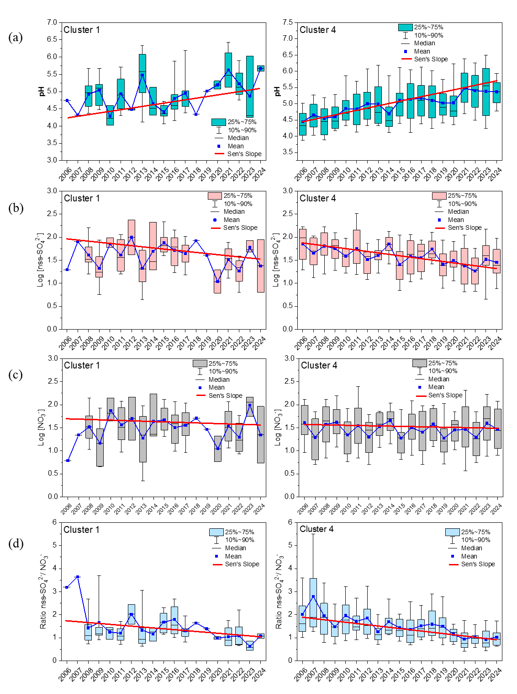
Fig. S8. Box plots (10th–90th percentile whiskers, 25th–75th percentiles, and median) of Chungli station daily concentrations under C1 (left panel) and C4 (right panel) trajectory clusters for (a) VWM pH, (b) Log[nss-SO₄²⁻], (c) Log[NO₃⁻], (d) ratio of nss-SO₄²⁻ /NO₃⁻ during 2006–2024. The red line indicates Sen’s slope trend.

