Supplementary material

- Codebook with coding structure for the Qualitative Content Analysis
Figure 4 presents the coding structure used in qualitative content analysis, including the main code categories, pre-established deductive codes, and inductive sub-codes.

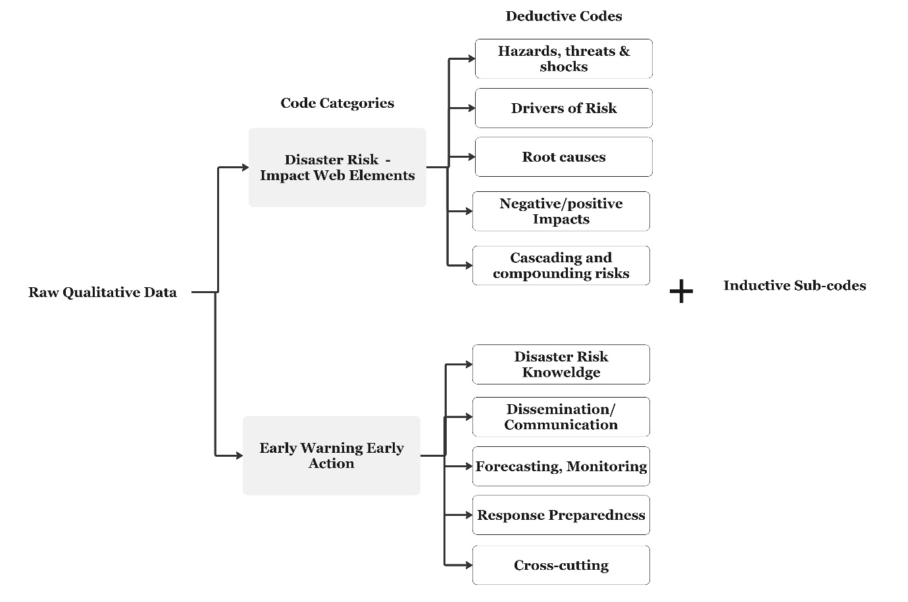
Figure 1 Codebook for qualitative content analysis

- Table 2 Barriers and enablers of EWEA in Dadaab Refugee Complex
Table 2 summarizes the identified barriers and enablers (section 4.2), with illustrative qualitative data from stakeholder engagement, alongside the four components of EWEA: Disaster Risk Knowledge; monitoring, forecasting, analysis, warning dissemination and communication; and response preparedness.
Table 2 Barriers and enablers of EWEA in Dadaab Refugee Complex
Barrier/ enabler | Early Warning Early Action component | Illustrative insights from stakeholder engagement | Source
Disaster Risk Knowledge
Barrier | Fragmented risk knowledge across humanitarian sector clusters | “Also, data collection is usually done for sector-specific purposes, such as health, WASH, protection, and not for identifying vulnerability data for flood impacts” | KII
Barrier | Link from disaster risk knowledge to action | "The camps have also been mapped - we know the highlands and the flood-prone zones, we know where people are vulnerable. That's why I said, it's not about knowing, it's about doing something with that knowledge. Moving from knowledge to action is the missing link. That's the real gap: knowing is not the problem; the problem is acting on it." (KII, Dadaab) | KII
Barrier | Lack of a dedicated interagency working group | “Coordination between the different sectors in terms of DRM is too little, especially for using risk knowledge for rapid preparedness; there are gaps we need to fill” | FGD
Enabler | Field staff and established structures of refugee representatives can utilize community-based disaster risk assessments to build disaster risk knowledge. | Youth Refugee representatives identified the main flood impacts and anticipatory actions for the camp block maps, including the most affected blocks, evacuation routes, and the most vulnerable households in IFO II. | Workshop
Enabler | Conducting post-disaster risk assessments, mapping areas, and collecting data specifically for the purpose of disaster risks, facilitating storytelling and participatory sessions for documenting lived experiences | Solid documentation of data from past events and maps of the most affected areas exist; REACH did extensive mapping of the area, which helps with planning. Also, the stories of how disasters have historically impacted people can be documented to improve coordination. | KII
Forecast, Monitoring and Analysis
Barrier | Data gaps | “Data mainly comes from the sectors specifically (e.g. health impacts) but is not streamlined in one place for the purpose of EWEA. Also, we usually do that more for sector purposes and not for identifying vulnerability data for flood impacts.” | KIIs
Barrier | Cross-border observation and monitoring | Regional outlooks and advisories exist; however, gaps in linking them to humanitarian implications, such as food insecurity and the influx of new refugees due to transboundary issues, remain. | KIIs
Enabler | Impact-based forecasts | Complementing hazard forecasts with exposure and vulnerability data at a camp-relevant spatial resolution to advance usability for camp coordination of EWEA. | KIIs
Warning Communication and Dissemination
Enabler | Local communication channels | Connection of youth networks and self-organizing groups report a tight communication network and information flow across blocks and with humanitarian field staff | FDGS
Enabler | Established structures from ongoing humanitarian operations | Sectoral cluster groups have channels through WhatsApp, SMS messenger, phone calls, and direct focal points in the different blocks, which are utilized for warning communication | KIIs, Workshop
Barriers | Inter-agency communication | Despite working groups across sectors, the protocols for warning communication and dissemination, from camp coordination to field staff, are highly dynamic and constrained by the timeliness of information and available resources. | Workshop
Barriers | Multilingual, multi-literacy camp population makes single-channel or single-language information underreach | New arrivals and women-headed households do not always have access to phones, and alert messages sometimes do not reach them. | FGDs
Barriers | Dependency on humanitarian actors | “Official authorities, there is a strong dependency on humanitarian field staff for spreading official information.” | KIIs
Response capacities and preparedness
Barrier | Fragmented response capacities | Across humanitarian clusters (WASH, health, shelter) there is a need for a more streamlined end-to-end responsibility for implementation of SOPs and EAPs | Workshop
Barrier | Lack of funding for preparedness | Anticipatory action financing is typically short-term and project-bound, undermining the sustained institutional commitment for building response mechanisms. | KIIs
Barrier | Compounding threats | Preparedness capacity is constrained by the structural limits of camp life itself, such as restricted mobility, security issues, compounding threats, and dependency on humanitarian assistance, which limit the response options. | Transect walk
Barrier | Translating risk knowledge into concrete response actions | “After every drought or heavy rain, we carry out assessments with recommendations; carry out post-disaster needs assessment, give report to stakeholders; most actions are not followed up; only emerge in the next season; too late …once these assessments are done they should be prioritized; immediately follow up on these action points” | KII
Barrier | Informal coping | Households in protracted displacement may rely on accumulated informal coping strategies (asset protection, mobility planning, mistrust) that can challenge formal anticipatory action plans. | Workshop
Enabler | Build capacities for response preparedness | “We should integrate it into the school curricula; how to behave is part of the curriculum (e.g., hygiene, safe tracks for kids, no swimming during floods).”  “Training of Trainers for multi-actors including field staff, cluster leads, camp coordination, refugee representatives on response preparedness for different hazards” | KII, FGD
Enabler | Anticipatory action financing mechanism | Establishing forecast-based finance triggers linked to humanitarian needs (food, relief items) to pre-position resources can be informed not by a single hazard and rapidly before an acute emergency, but by complex risks across sectors. | Workshop
Enabler | Inter-agency, cross-sectoral, multi-actor response capacities | Establish an inter-agency working group for disaster preparedness, set up a refugee-led DRM committee, regular assessment cycles across sectors for complex risks | Workshop

