Fig. S1. Complete set of pairwise mycelial interactions among eleven I. lacteus isolates on PDA.
The 55 unique inter-isolate pairings among isolates n1-n11 are shown. Mycelial plugs (7 mm in diameter) excised from the margins of actively growing colonies were placed on opposite sides of potato dextrose agar plates and incubated at 25 °C until the colonies came into contact and interaction boundaries developed. Each pairing was tested using three independent replicate plates, and one representative plate is shown. Visible demarcation or barrage lines formed at the colony interfaces in all pairings.
Fig. S2. Time-course colony morphology of eleven I. lacteus isolates on shredded C. korshinskii residue medium.
Representative colony images of isolates n1-n11 were recorded during 7 d of cultivation at 25 °C. Columns correspond to isolates n1-n11, and rows correspond to cultivation days 1-7, arranged from top to bottom. The images illustrate isolate-dependent differences in the rate and extent of substrate colonization. Quantitative colony-diameter data are presented in Fig. 2A and B.

Fig. S1
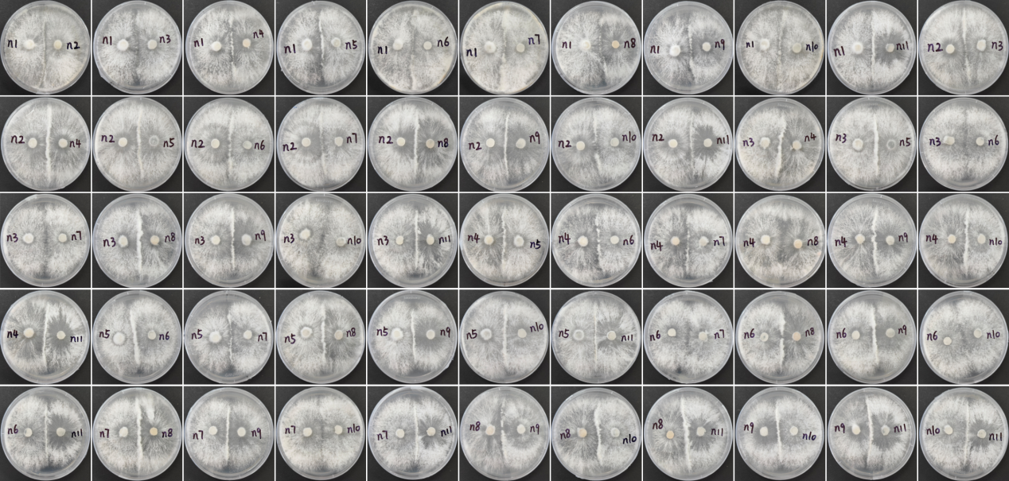

Fig. S2
