Spectrally Extended Line Field Optical Coherence Tomography Angiography

Si Chen, Kan Lin, and Linbo Liu*
School of Electrical & Electronic Engineering, Nanyang Technological University, Singapore
*Correspondence: L. L. (liulinbo@ntu.edu.sg)

Supplementary Information
- Skin angiographic imaging with 1300 nm OCT system
  - System construction and characterization
We combine two superluminescent diode modules (IPSDS1313 and IPSDS1201C, Inphenix, CA, USA) with a 50:50 fibre coupler (TW1300R5A2, Thorlabs Inc, USA) (Fig. 1). The combined light source provides a radiation from 1230 nm to 1360 nm (-6 dB). The outputs of the fibre coupler are connected to two optical circulators (PIBCIR-1214-12-L-10-FA, FOPTO, Shenzhen, China), which guide the light beams to the sample arm and reference arm, respectively. The light back reflected from the reference arm and back-scattered from the sample arm are combined using a 95:5 fibre coupler (WP3105202A120511, AC Photonics, CA, USA). In the sample arm of the point scanning scheme, the sample beam is firstly collimated by an achromatic lens L1 (AC050-010-C, Thorlabs Inc., USA) before reflected by a mirror (RM) and a pair of galvanometer scanners and focused by an objective lens L2 (AC254-050-C, Thorlabs Inc, USA).
In the SELF-OCTA scheme, the mirror (RM) is replaced by a set of three identical prisms (N-SF11, PS872-C, Thorlabs Inc.) with apex angle of 30° and angular spacing of ~56.9°. Switching between the point scanning scheme and SELF-OCTA scheme is realized with a manual translation stage (Fig. 1A). The prism is with anti-reflection coating so that one-way transmission efficiency of three prisms was measured to be 94%. The polychromatic sample beam is dispersed by the prisms into a line along the slow (Y) axis in the focal plane of the objective lens L2 (Fig. 1B). The spectrometer is comprised of a collimating lens L5 (AC254-035-C, Thorlabs Inc., USA), a transmission grating (PING-sample-106, Ibsen Photonics, Denmark), a home-made multi-element camera lens and a line scan camera (LDH2, Sensors Unlimited, USA). The camera pixel size is 25 µm by 500 µm (width by height) and we used all 1024 pixels. The total spectrometer efficiency was measured to be 0.61, including the quantum efficiency of the camera. The spectral resolution is 0.148 nm, resulting in a total ranging depth of 2.89 mm in air. The axial resolution was measured to be 9.82 µm in air. The 6-dB ranging depth was measured to be 1.6 mm in air and the sensitivity roll-off over depth is ~3.75 dB/mm. With the optical power incident on the sample being 4.74 mW, the sensitivity measured at ~150 µm from DC is 108.52 dB, 102.56 dB, and 98.58 dB at the A-line rate of 22k Hz, 50k Hz, and 80k Hz, respectively, which agree with the theoretical predictions (Fig. 4C).
We used 16 Hamming windows with size of 263 pixels and spacing of 52 pixels to generate 16 spectral bands (Supplementary Fig. 2A), respectively. The axial resolution (FWHM) of each band was measured to be ~28.5 µm in tissue (refractive index = 1.38) (Fig. 2C). The transverse resolution of each band was measured to be 39.6 µm (10-90% width of an edge scan) because of the convolution between the Hamming window and monochromatic point-spread function (PSF) (Supplementary Fig. 2B), which is 1.51 times larger than the monochromatic transverse resolution and agree well with theoretical prediction (Supplementary Fig. 2C). The trade-off between axial and transverse resolution along Y-axis is characterized in Supplementary Fig. 2D.
The theoretical transverse spot size at 1310 nm is ~27 µm (full-width at half maximum, FWHM) since the nominal mode field diameter of SMF-28e fibre is 9.2 µm at 1310 nm. The monochromatic transverse resolution at 1310 nm was approximated to be 26.2 µm by measuring 10-90% width of an edge scan using the part of signal at the centre of the spectrum with a narrow line width (~1.5 nm FWHM) (Fig. 2D). For a Gaussian spot, the lateral resolution, defined at its e⁻² radius, can be shown to be 0.78 times the 10–90% edge width [1], so that the monochromatic spot size (FWHM) is estimated to be 24.1 µm.
For deconvolution along Y direction, we used Lucy-Richardson method (deconvlucy in MATLAB®). We used the Hamming window mentioned above as the point-spread function (PSF in deconvlucy) and damping threshold of 2.
  - Maximum permissible exposure of line field
Following the literature [2], the relevant ‘most restrictive’ evaluation angular subtense is the one with the maximum ratio of partial power/ evaluation angular subtense. The partial power is the total optical power contained in the evaluation angular subtense. The intensity profile of the line field was measured by scanning a fiber tip (SMF-28e) along Y-axis in the focal plane of the objective lens and record the optical power coupled into the fiber (Supplementary fig. 1A). Since it is a line illumination, the angular subtense along X-axis takes 1.5 mrad [3]. Therefore, the ratio of partial power/ evaluation angular subtense
$\frac{P}{δ}=2P/(α_{Y}+1.5 mrad)$ (1)
According to the equation (1), the angular subtense in Y-axis ($α_{Y}$) obtained using ‘Most restrictive ratio’ analysis is 3.176 mrad (Supplementary fig. 1B). The extended source correction factor C_{E} is (3.176 +1.5 mrad) /2/1.5 mrad = 1.5587. Note that power limit calculated using C_{E} applies only to the partial power within the angular subtense δ, instead of the total power. There are 20.11% of total power that is outside the angular subtense δ. For the experiments conducted with the point-scanning scheme and total image acquisition time of 4.096 s (Fig. 3 and Supplementary Fig. 8), the optical power incident on the sample is 4.74 mW. The corresponding power for the SELF scheme is calculated as (4.74 mW × C_{E}) / (1 - 0.2011) = 9.25 mW. Therefore, we used ~9.10 mW for all the experiments assuming the SELF scheme. For the experiments conducted with the point-scanning scheme and total image acquisition time of 3.26 s, the optical power incident on the sample is 9.1 mW (Figs. 4A1-3).
  - Image acquisition
The sample beam focused by the objective lens L2 propagates along the horizontal direction to the sample (Fig. 1B). We used a compact lab jack (L200, Thorlabs Inc.) as the vertical hand rest and a cage plate (CP33T/M, Thorlabs Inc.) as the horizontal hand rest to minimize motion. Ultrasound transmission gel (Aqua Sonic 100) was applied to avoid high reflection signal from the skin surface.
Most of the skin images are acquired at 50k Hz A-line rate, except for Fig. 4 in which 22k Hz and 80 k Hz are used. There are 512 A-lines per B-scan, except for Fig. 5 where 384 A-lines per B-scan was used. For images generated with the point-scanning scheme, there are 400 cross-sectional angiograms so that the field of view (FOV) is 6.55 mm by 5.12 mm (width by height). For images generated with SELF-OCTA and L = 2, there are 800 cross-sectional angiograms so that the FOV is 6.55 mm by 10.24 mm (width by height). For all the OCTA images in this study, the number of repeated B-scans N is 2.
  - OCT structural image processing
Owning to the ‘frequency flow’ scanning mechanism, there are M/L partial-spectrum decorrelation frames at each Y image position, acquired during M/L consecutive Y-scan cycles. Note that N = 2 repeated B-scans at a Y-scan position are considered as one complete Y-scan cycle. We corrected bulk motion among all the partial-spectrum interference data before coherently added them into a spectrum interference data with the full spectral bandwidth. The phase differences between B-scans of consecutive Y-scan positions are calculated following the method described by An et al [4]. The axial resolution of SELF-OCT cross-sectional images are comparable to that of the point-scanning OCT (Supplementary Fig. 4). However, due to residual bulk motion and local tissue motion such as blood flow, SELF-OCT cross-sectional images are not as crispy as that of the point-scanning OCT.
  - Speckle contrast analysis
We additionally analyzed speckle contrast of en face SELF-OCTA images with 1, 2, 4, and 8 partial-spectrum decorrelation frames at each Y image position, which corresponds to the cases of L = 16, 8, 4 and 2, respectively.
$Speckle contrast=\frac{σ_{S}}{\overline{I_{S}}}$ (2)
Where $\overline{I_{S}}$ is the averaged intensity over the area of signal, and $σ_{S}$ is the standard deviation of signal intensity. We selected 24 regions of interest (ROIs) in a blood vessel with most of the pixels saturated (maximum decorrelation) as shown in Supplementary Figs. 10A-D.
  - Multiple inter-scan time and high dynamic range
The model of dynamic range extension is based on the autocorrelation equation of the laser speckle signal [5, 6]
$\overline{D }=1-exp\left[-\frac{τ∙\left(v_{flow}+v_{brownian}+v_{bulk}\right)}{k}\right]$ (3)
Where $\overline{D }$ is the amplitude decorrelation, τ is the exposure time, which can be correlated to inter-scan time ΔT in OCTA. $v_{flow}$ is the velocity of the blood flow, $v_{brownian}$ and $v_{bulk}$ are velocity related with Brownian and bulk motion of the tissue. k is a constant.
According to this simplified equation (3), the decorrelation functions corresponding to the inter-scan time of ΔT and ΔT/2 are plotted in Fig. 5B. Obviously, there is a range of flow velocity over which the decorrelation is approximately linearly dependent on flow velocity. Following the method described in the literature [6], we define the decorrelation range of [σ, $\overline{D_{max} }$-σ] to be the linear region, where σ is the standard deviation of decorrelation signals. That is to say, σ is the sensitivity limit and $\overline{D_{max} }$-σ is the saturation limit. The dynamic ranges of signals acquired with ΔT and ΔT/2 are then defined as the flow velocity ranges corresponding to the linear region, respectively.
Since in the linear region, decorrelation signals acquired with ΔT and ΔT/2 are assumed to be linear, the ratio between their slopes α can be obtained. If we multiply the decorrelation profile of ΔT/2 with α, the new signal, referred as α*D_{ΔT/2}, overlap with decorrelation signal acquired with ΔT in the linear region. Since this simplified model is based on a number of assumptions and approximations, readers are referred to previous phantom studies for an accurate model [7-9].
According to the model proposed above, the procedures to construct high dynamic range angiograms are listed below:
1. Measure the mean maximum decorrelation signal ($\overline{D_{max} }$=0.2079) and the standard deviation σ (σ =0.0151) of decorrelation signal from blood vessels in the amplitude decorrelation image of inter-scan time ΔT;
2. Perform 3x3 median filtering on the en face SELF-OCTA images acquired with ΔT and ΔT/2. We term the new images ΔT_median and ΔT/2_median, respectively;
3. Remove all pixels in the en face SELF-OCTA images acquired with ΔT, whose decorrelation value in ΔT_median is outside the linear region [σ, $\overline{D_{max} }$-σ]. The new image is named ΔT_linear. Remove all pixels in the en face SELF-OCTA images acquired with ΔT/2, whose decorrelation value in ΔT/2_median is outside the linear region [σ, $\overline{D_{max} }$-σ]. The new image is named ΔT/2_linear.
4. Find α using histogram of ΔT_linear – α*ΔT/2_linear. The histogram is centred at 0 when α = 1.35.
5. The high dynamic range image is synthesized as follows (green curve in Fig. 5B). For pixels in the linear region, the decorrelation values take the mean of ΔT_linear and α*ΔT/2_linear; for pixels with value larger than $\overline{D_{max} }$–σ, the decorrelation will take the corresponding values in α*D_{ΔT/2}; for pixels with value smaller than σ, the decorrelation will take the corresponding values in ΔT.
  - Motion tracking and correction
Transverse motion is calculated by use of 2D registration algorithm available via:
http://mtshasta.phys.washington.edu/website/superSegger/SuperSegger/Internal/dftregistration.html
This registration algorithm calculate cross-correlation to determine relative motion in sub-pixels along the two transverse directions between 2D en face projects of adjacent Y-scan positions, which is also termed as local motion. The accumulative motion is then used for correcting motion between partial spectrum decorrelation frames at each Y imaging position. To suppress noise, we set a threshold for the cross-correlation difference before and after motion correction. If the improvement in cross-correlation coefficient is lower than the threshold, the tracking data will be rejected. This threshold is empirically determined according to the ground truth.

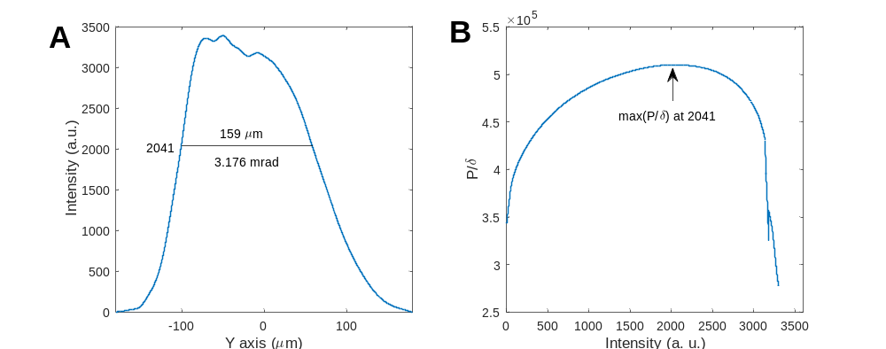
Supplementary Fig. 1. (A) Intensity profile of focus along Y-axis. (B) Ration between partial power (P) within window width (δ) for “Most Restrictive Ratio’ method. The window width is 159 µm (3.176 mrad) when the ratio reaches the maximum.
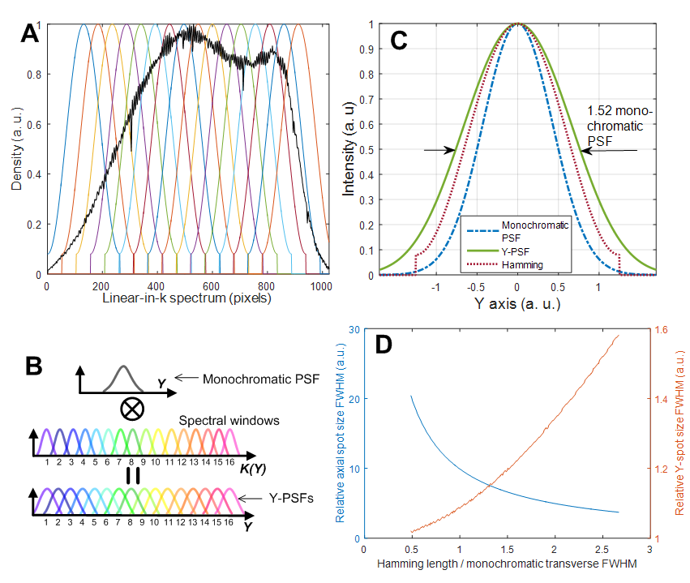
Supplementary Fig. 2. (A) Spectrum detected by the OCT spectrometer in k-space and Hamming filters. (B) Spectral convolution process. (C) Transverse point-spread function (PSF) along Y-axis (Y-PSF) as the result of convolution between the Hamming window and monochromatic PSF. (D) Spatial resolution as a function of hamming window length. Relative axial spot size = axial resolution of each spectral band / axial resolution of full spectrum. Relative Y-spot size = transverse resolution along Y-axis / monochromatic transverse resolution.

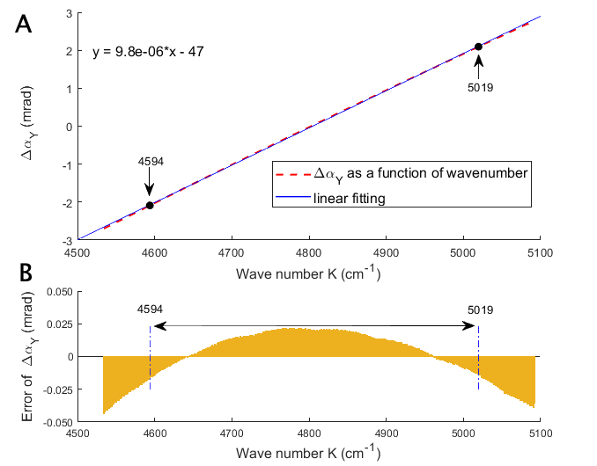
Supplementary Fig. 3. (A) Angular substance along Y-axis (∆α_{Y}) as a function of wave number (K) (red dash line). Blue solid line is the linear fitting. The center wave number of the 1st and 16th spectral band are 4594 cm⁻¹ and 5019 cm⁻¹, respectively. (B) Linear error of ∆α_{Y} is <0.0217 mrad within the range from 4594 cm⁻¹ to 5019 cm⁻¹, corresponding to <1.0855 µm in the focal plane of the objective lens.

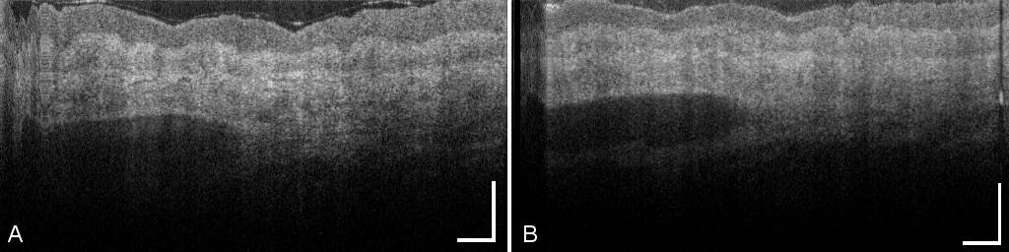
Supplementary Fig. 4. Cross-sectional structural images (amplitude frames) of human skin obtained using the point-scanning OCT (A) and SELF-OCT (B). Scale bars: 0.5 mm.

Supplementary Fig. 5. ROIs for comparison of decorrelation between point-scanning (A) and SELF OCTA (B). Scale bars: 1 mm.

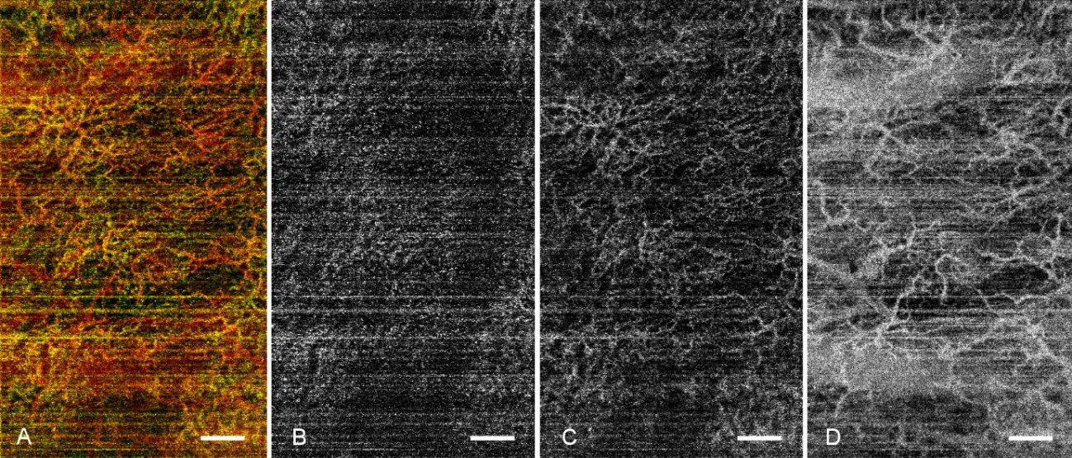
Supplementary Fig. 6. Representative en face SELF-OCTA projections reconstructed from the dataset with one partial-spectrum decorrelation images per Y-image position. (A) color coded projection of three slabs, (B) slab of capillary loop, (C) slab of subpapillary plexus and (D) slab of deep vascular plexus. Scale bars: 1 mm.

Supplementary Fig. 7. (A) En face angiograms generated with the point-scanning scheme. Motion was minimized using both horizontal and vertical hand rests during image acquisition. (B) En face angiograms produced by the point-scanning scheme. Motion was due to lack of the vertical hand rest during image acquisition. (C) En face angiograms generated with the SELF-OCTA scheme, Motion was due to lack of the vertical hand rest during image acquisition. Arrows indicate the same blood vessel. Blue stars indicate large blood vessels at the deep layer of the skin. Scale bars: 1 mm.

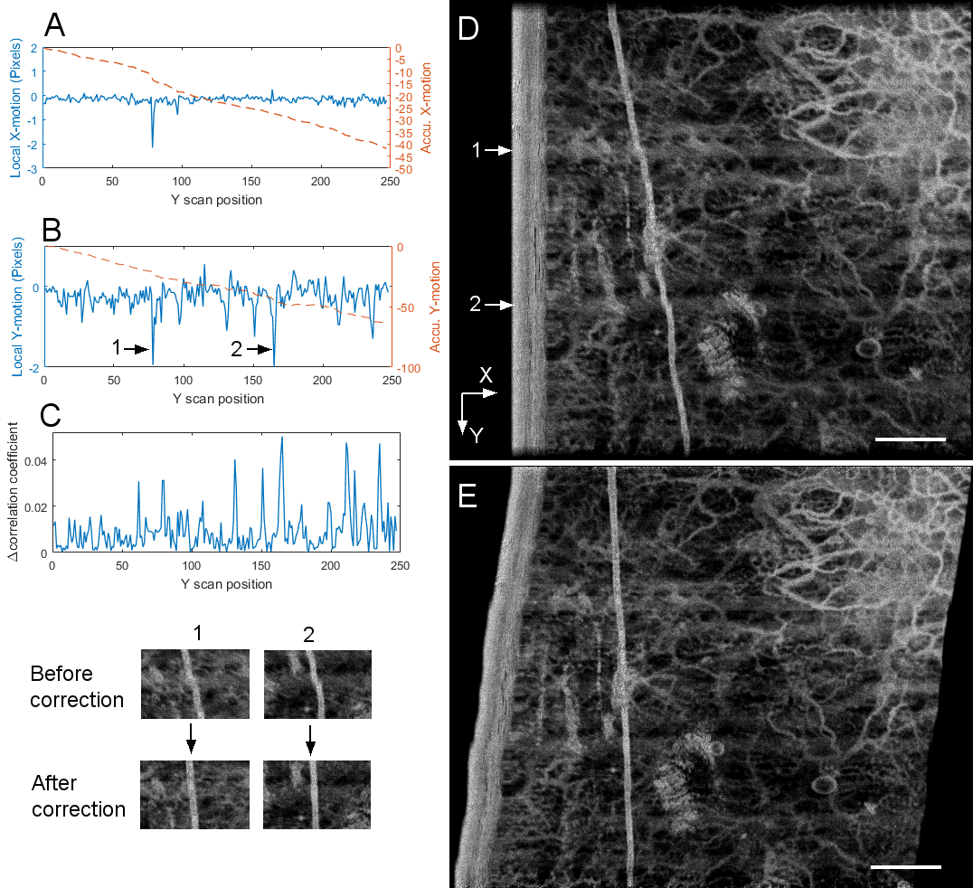
Supplementary Fig. 8. SELF-OCTA based motion tracking and correction. (A)&(B) Registered motion along X and Y-axis, respectively. Local motion stands for relative motion between 2D en face projections acquired in a complete Y-scan cycle. Accu. X/Y-motion refers to the total motion accumulated at a Y imaging position relative to the first B-scan. (C) Δ correlation coefficient is the difference in correlation coefficient between adjacent 2D en face projections before and after correction. (D)&(E) En face angiograms before and after motion correction, respectively. (Lower left) Regions (1,2) with local motion = 2 pixels before and after correction.

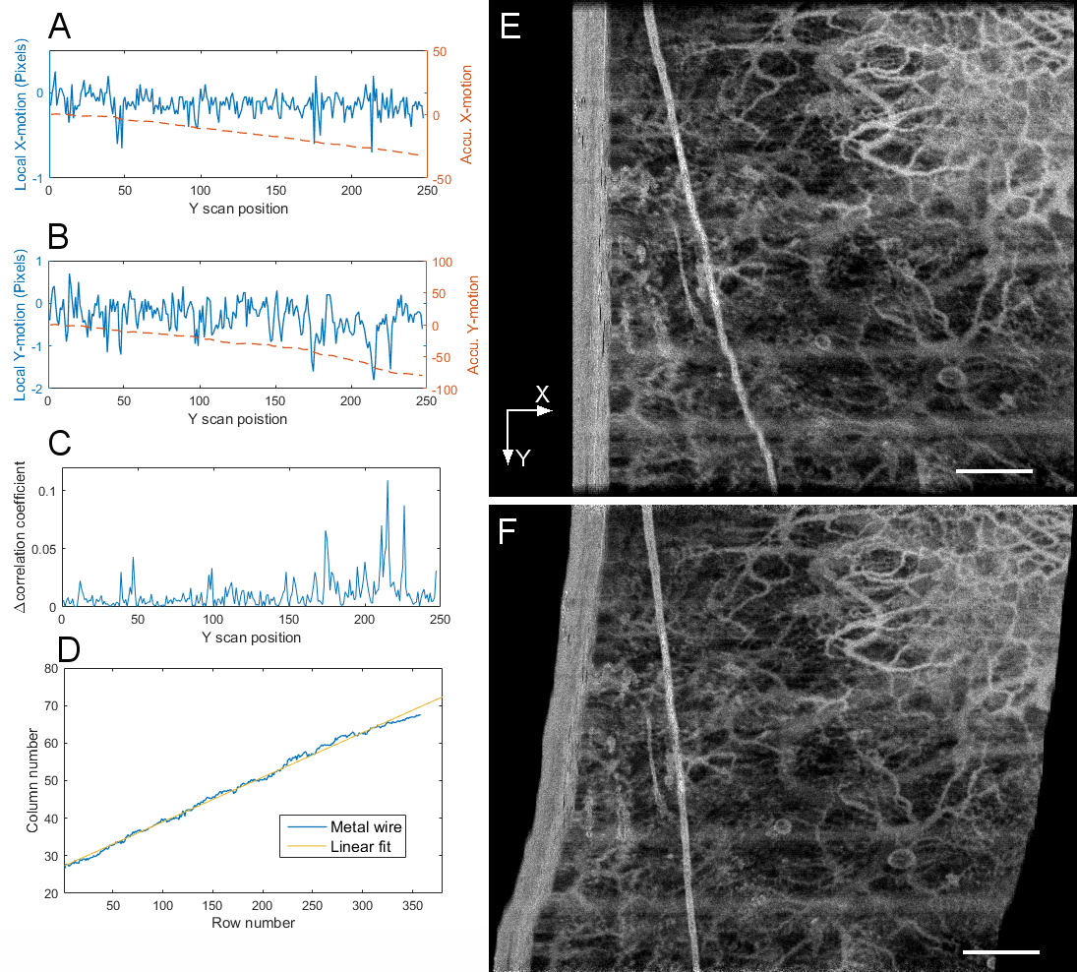
Supplementary Fig. 9. SELF-OCTA based motion tracking and correction. (A)&(B), Registered motion along X and Y-axis, respectively. Local motion stands for relative motion between 2D en face projections acquired in a complete Y scan cycle. Accu. X/Y-motion refers to the total motion accumulated at a Y imaging position relative to the first B-scan. (C) Δ correlation coefficient is the difference in correlation coefficient between adjacent 2D en face projections before and after correction. (B) Metal wire position and its linear fit. With its linear fit as the mean, the standard deviation of the wire transverse position is 0.8537 pixels, which is equivalent to 10.9 µm. (E)&(F) En face angiograms before and after motion correction, respectively.
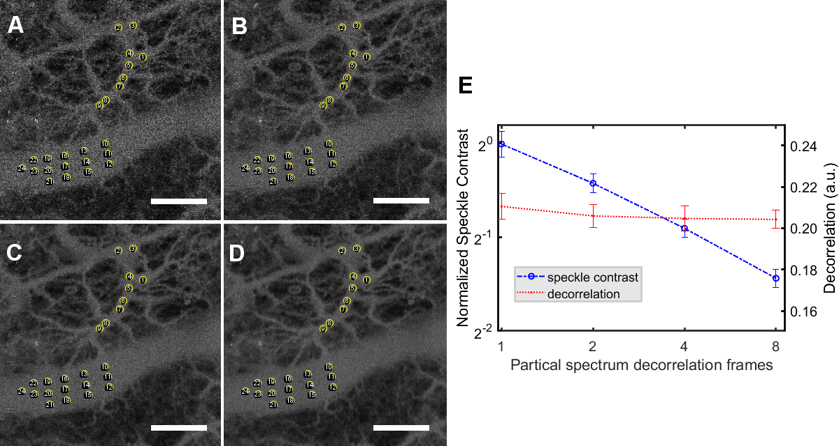
Supplementary Fig. 10. Speckle contrast in en face SELF-OCTA images dependent on the number of partial-spectrum decorrelation frames at each Y image position. (A-D) ROIs for speckle contrast with averaging 1 partial-spectrum decorrelation frame (3rd frame, A); averaging 2 partial-spectrum decorrelation frames (3rd and 7th frames, B); averaging 4 partial-spectrum decorrelation frames (1st, 3rd, 5th, and 7th frames, C); averaging 8 partial-spectrum decorrelation frames (all 1st to 8th frames, D). (E) Speckle contrast of SELF-OCTA signals is inversely proportional to the number of partial-spectrum decorrelation frames in frequency-temporal compounding. Scale bar: 1mm.

Supplementary Movie 1. Sequential display of en face SELF-OCTA projections with each reconstructed from a 3D dataset of one partial-spectrum decorrelation frame. The number at the bottom indicate the sequence number of the partial-spectrum decorrelation frame.

- Retina angiographic imaging with 1060 nm OCT system
  - System construction and calibration
A superluminescent diode module with a central wavelength of 1067 nm and spectral bandwidth of 62.91 nm (-3 dB) was used for retinal imaging (860650449, Inphenix, CA, USA) (Supplementary Fig. 11). The light source is connected to a 50:50 fibre coupler (T0056765, Thorlabs Inc, USA) and the outputs of the fibre coupler are connected to two optical circulators (PIBCIR1050H6-10-SS, FOPTO, Shenzhen, China), which guide the light beams to the sample arm and reference arm, respectively. The light back reflected from the two arms are combined using a 90:10 fibre coupler (T073999, Thorlabs Inc, USA) and is directed to the spectrometer. The sample beam of the point scanning scheme is collimated by an achromatic lens L1 (AC050-010-C, Thorlabs Inc., USA) and reflected to X-Y galvanometer scanners through a reflective mirror (RM) before directed to a telescope system. The telescope system contains two sets of 200-mm doublets (L2) and two sets of 80-mm doublets (L3). In the SELF-OCTA scheme, the mirror (RM) in the sample arm is replaced by a customized prism (BK7) with apex angle of 62.2° and transmission efficiency of 93%. A manual translation stage is used to switch between the point scanning scheme and the SELF-OCTA scheme (Supplementary Fig. 11).
The spectrometer is comprised of a customized collimating lens L8, a transmission grating (PING-1379-422, Ibsen Photonics, Denmark), a home-made multi-element camera lens and a line scan camera with pixel size of 10 µm x 210 µm (width x height) (G2048R, Sensors Unlimited, USA). The overall spectrometer efficiency was measured to be 0.70. The spectral resolution is 0.049 nm and the total ranging depth is 5.84 mm in air. The 6-dB intensity ranging depth was measured to be 2.34 mm in air.
The axial resolution of OCT structural image was measured to be 7.17 µm in retina (refractive index = 1.38) and the monochromatic transverse resolution was calculated to be 16.3 µm using Zemax simulation with an eye model given the focal length of eye being 17.2 mm. The methods for splitting the spectrum and spectral deconvolution are the same as those mentioned above in 1300 nm data processing. Specifically, we used 8 Hamming windows with size of 780 pixels and spacing of 210 pixels to generate 8 spectral bands. The measured axial resolution (FWHM) of each band was ~20.46 µm in retina. The Hamming window extends the transverse PSF along Y-axis through spectral convolution by approximately 1.19, so that the Y-axis transverse resolution of SELF-OCT before deconvolution is estimated to be 19.4 µm.
  - Maximum permissible exposure of line field
The intensity profile of the line field was estimated using the light source spectrum captured by the spectrometer (Supplementary fig. 12A). The transverse positions of spectral bands were calibrated using a USAF 1951 resolution chart.
According to the equation (1), the angular subtense in Y-axis ($α_{Y}$) obtained using ‘Most restrictive ratio’ analysis shown in Supplementary fig. 12. The extended source correction factor C_{E} is (2.763+1.5 mrad) /2/1.5 mrad = 1.421. Note that power limit calculated using C_{E} applies only to the partial power within the angular subtense δ, instead of the total power. There are 27.02% of total power that is outside the angular subtense δ. For the experiments conducted with the point-scanning scheme and total image acquisition time of 4.7 s (Fig. 7), the optical power incident on the cornea is 1.754 mW. The corresponding power for the SELF scheme is calculated as (1.754 mW × C_{E}) / (1 - 0.2702) = 3.415 mW. We used ~3.20 mW for all the experiments assuming the SELF scheme.
  - Image acquisition
The subject was asked to focus on the internal fixation target of the OCT system during image acquisition. For every Y-scan position, there are 2 repeated B-scans, each of which is subdivided into 8 bands as mentioned above. For each of the 8 bands, we subtracted one of the two repeated complex B-frame from the other. The resultant partial spectrum differential frames that dwell at the same location from 4 Y-scan cycles are incoherently added to generate a cross-sectional OCTA images, the same way as described in 1300 nm data processing (Result section, paragraphs 3-4). We enhanced the contrast of cross-sectional OCTA images using the method provided in [10].
  - OCT structural image processing
The OCT structural images were generated with the same method used in skin imaging (section 1.4). However, because the movement of eye is much faster than that of hand, the phase errors between spectral data at the same location acquired from different Y-scan cycles significantly decrease axial resolution and image quality. To tackle this issue, we performed an additional structural cube scan right after the OCTA scan: 800 A-lines per B frame and 100 B-frames covering the same FOV as that in OCTA scan. In this additional scan which takes 1.18 s with A-line rates of 67,590, the fast axis is along the line field direction so that the time interval between spectral data at the same position is minimized to one A-line period and the phase error can be readily compensated.
Owning to the ‘frequency flow’ scanning mechanism, since L = 1 and M = 8 there are M/L=8 partial-spectrum OCTA frames at each Y image position. Similar to the method described in section 1.4, we corrected bulk motion between adjacent A-scan before splitting the spectrum of each A-line into M = 8 spectral bands, and coherently added 8 spectral bands of the same lateral position into a spectral interference data with the full spectral bandwidth. With this approach, the axial resolution of SELF-OCT cross-sectional images (Fig. 7D) are comparable to that of the point-scanning OCT (Fig. 7A).

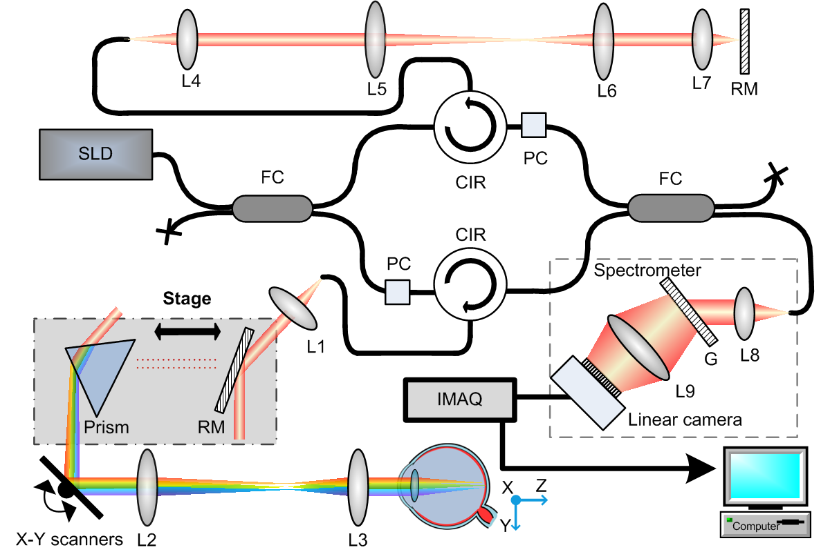
Supplementary Fig. 11. 1060-nm System schematic for retinal imaging. SLD: superluminescent diode source; FC: fiber coupler; PC: polarization controller; CIR: circulator; L1-8: achromatic lenses; L9: camera lens; RM: reflective mirror; G: transmission grating; IMAQ: image acquisition card.

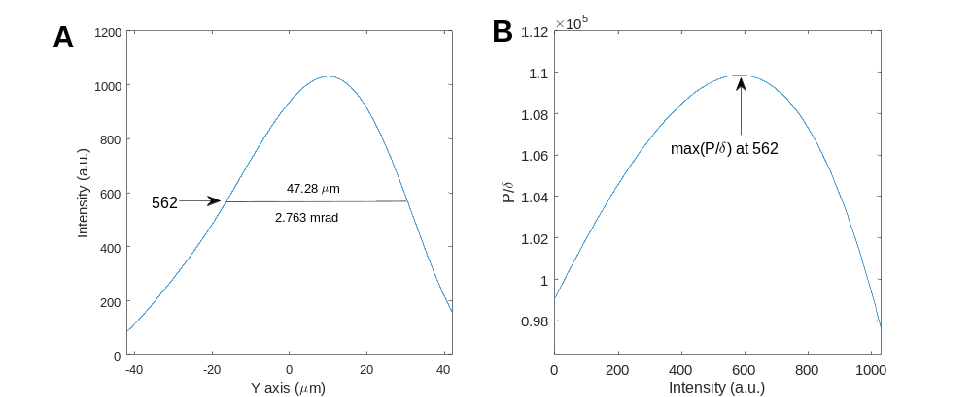
Supplementary Fig. 12. (A) Intensity profile of focus along Y-axis of ophthalmic SELF-OCT system. (B) Ration between partial power (P) within window width (δ) for “Most Restrictive Ratio’ method. The window width is 47.28 µm (2.763 mrad) when the ratio reaches the maximum.

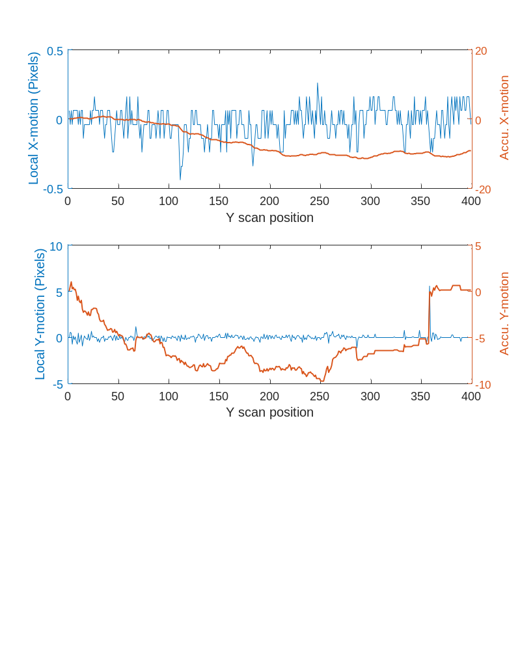
Supplementary Fig. 13. Registered motion along X and Y-axis, respectively corresponding to Figs. 7B&C. Local motion stands for relative motion between 2D en face projections acquired in a complete Y scan cycle. Accu. X/Y-motion refers to the total motion accumulated at a Y imaging position relative to the first B-scan.

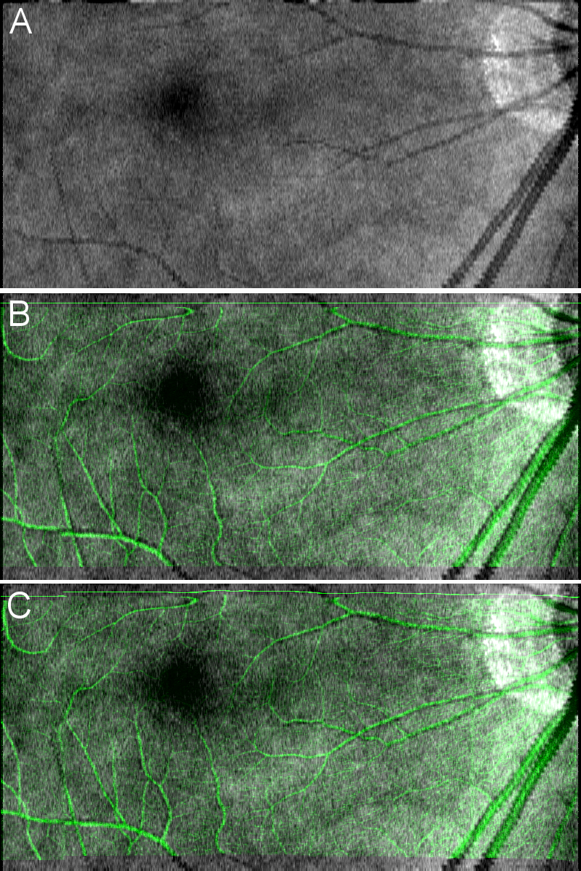

Supplementary Fig. 14. (A). En face projection of OCT structural images acquired within 1.18 s. (B). En face OCTA image before motion correction merged with OCT structural image. (C). En face OCTA image after motion correction merged with OCT structural image.

References
1. Rajadhyaksha M, Anderson RR, Webb RH. Video-rate confocal scanning laser microscope for imaging human tissues in vivo. Appl Opt. 1999;38(10):2105-15. doi: 10.1364/AO.38.002105.
2. Schulmeister K, Gilber R, Seiser B, Edthofer F, Husinsky J, Fekete B, et al. Retinal thermal laser damage thresholds for different beam profiles and scanned exposure: SPIE; 2008.
3. International Electrotechnical Commission, Safety of laser products - Part 1: Equipment classification and requirements. IEC 60825-1. Edition 2.2.
4. An L, Wang RK. In vivo volumetric imaging of vascular perfusion within human retina and choroids with optical micro-angiography. Opt Express. 2008;16(15):11438-52. doi: 10.1364/OE.16.011438.
5. Fercher AF, Briers JD. Flow visualization by means of single-exposure speckle photography. Optics Communications. 1981;37(5):326-30. doi: https://doi.org/10.1016/0030-4018(81)90428-4.
6. Xiang Wei TTH, Shaohua Pi, Yukun Guo, Yifan Jian, and Yali Jia. High dynamic range optical coherence tomography angiography (HDR-OCTA). Biomed Opt Express. 2019;10(7):3560-71. doi: 10.1364/BOE.10.003560.
7. Tokayer J, Jia Y, Dhalla A-H, Huang D. Blood flow velocity quantification using split-spectrum amplitude-decorrelation angiography with optical coherence tomography. Biomed Opt Express. 2013;4(10):1909-24. doi: 10.1364/BOE.4.001909.
8. Choi WJ, Qin W, Chen C-L, Wang J, Zhang Q, Yang X, et al. Characterizing relationship between optical microangiography signals and capillary flow using microfluidic channels. Biomed Opt Express. 2016;7(7):2709-28. doi: 10.1364/BOE.7.002709.
9. Su J, Chandwani R, Gao S, Pechauer A, Zhang M, Wang J, et al. Calibration of optical coherence tomography angiography with a microfluidic chip. Journal of Biomedical Optics. 2016;21(8):086015.
10. Schmoll T, Bagherinia H, Ren H. OCTA flow signal enhancement by reducing residual structural signal. Investigative Ophthalmology & Visual Science. 2019;60(11):PB048-PB.

