Supporting Information

Enhanced Orbital Hall Effect via sp,d-Coupling-Engineered Orbital Texture

Junda Qu^{1,3,†}, Chenyue Wen^{1,3,†}, Kun Zhang^{1,3,†,*}, Xiaobai Ning^{1,3}, Qingtao Xia^{1,3}, Tianren Luo^{1,3}, Yaru Zhao^{1,3}, Dapeng Zhu^{1,2,3,*}, and Weisheng Zhao^{1,2,3,*}

¹Fert Beijing Research Institute, MIIT Key Laboratory of Spintronics, School of Integrated Circuit Science and Engineering, Beihang University, Beijing 100191, P. R. China.
²State Key Laboratory of Spintronics, Hangzhou International Innovation Institute, Beihang University, Hangzhou 311115, P. R. China.
³Shandong Laboratory of ASIC and Intelligent Instruments in Qingdao, Beihang University, Qingdao 266400, P. R. China.
†These authors equally contribute to this paper.
*Corresponding author email:
zhang_kun@buaa.edu.cn; zhudp@buaa.edu.cn; weisheng.zhao@buaa.edu.cn

Table of Contents
Section 1: Structure and magnetic property characterization
Section 2: Determination of effective magnetization and damping coefficient
Section 3: Quantification of SOT effective fields via second harmonic measurement
Section 4: Experimental setup and protocol for AMR-based state detection
Section 5: Orbital-resolved electronic band structures
Section 6: Orbital Hamiltonian matrix elements
Section 7: Energy-dependent OHC and projected contributions
Section 8: First-principles calculation details

Section 1: Magnetic and structure property characterization
Figure S1 presents the structural and magnetic characterization of the prepared heterostructures. Figure S1(a) shows the in-plane magnetization (M) versus external magnetic field (H_{x}) hysteresis loops for the Ni (8 nm) and CoFeB (CFB) (5 nm) films deposited on 8 nm Cu₇Ta₁ alloy. Both films exhibit clear in-plane magnetic anisotropy with saturation magnetization (M_{S}) values of approximately 346 emu/cm³ for Ni and 751 emu/cm³ for CFB, consistent with typical values reported in the literature¹. Figure S1(b) presents the cross-sectional characterization of the Cu₇Ta₁/Ni heterostructure. The left panel shows a scanning transmission electron microscopy (STEM) image, revealing distinct layer structures with thicknesses of approximately 8 nm for both the Cu₇Ta₁ layer and the Ni capping layer. The right panel displays the energy-dispersive X-ray spectroscopy (EDX) line scan across the interface, confirming the elemental composition. Quantitative analysis of the EDX data reveals a Cu:Ta atomic ratio of approximately 7:1 in the doped Cu layer.
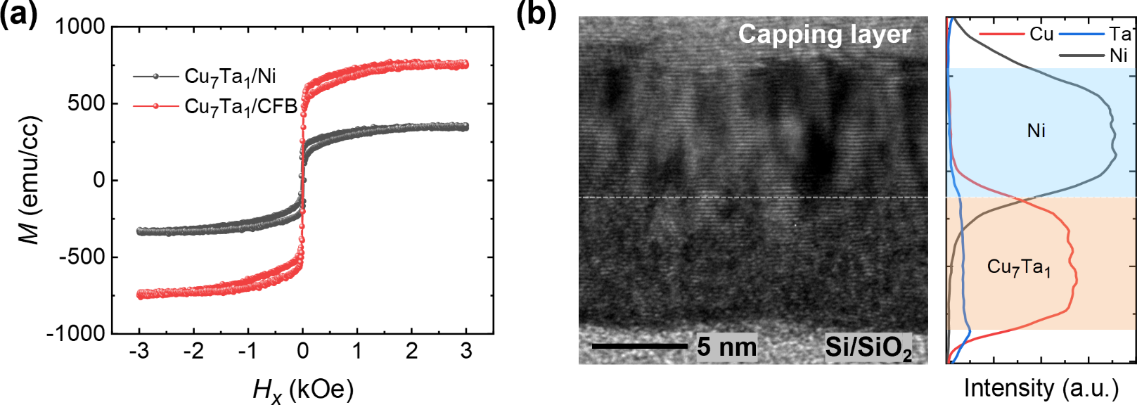
Figure S1. Magnetic and structure property for Cu₇Ta₁-based heterostructure. (a) Magnetization versus in-plane magnetic field hysteresis loops for Cu₇Ta₁/Ni and Cu₇Ta₁/CFB heterostructure; (b) Cross-sectional STEM image and EDX elemental line of the Cu₇Ta₁/Ni heterostructure.

Section 2: Determination of effective magnetization and damping coefficient
Figure S2 presents the broadband spin-torque ferromagnetic resonance (ST-FMR) spectra (9~13 GHz) for two series of samples with Ni and CFB ferromagnetic (FM) layer deposited on nonmagnetic (NM) layer of Cu₇X₁ alloy (X=Ta, W, Tb and Mn) and pure Cu. At each frequency, the signal is fitted to symmetric and antisymmetric Lorentzian components to extract the resonance field H_{r} and linewidth ΔH, which are then used for the Kittel and damping analyses described below.
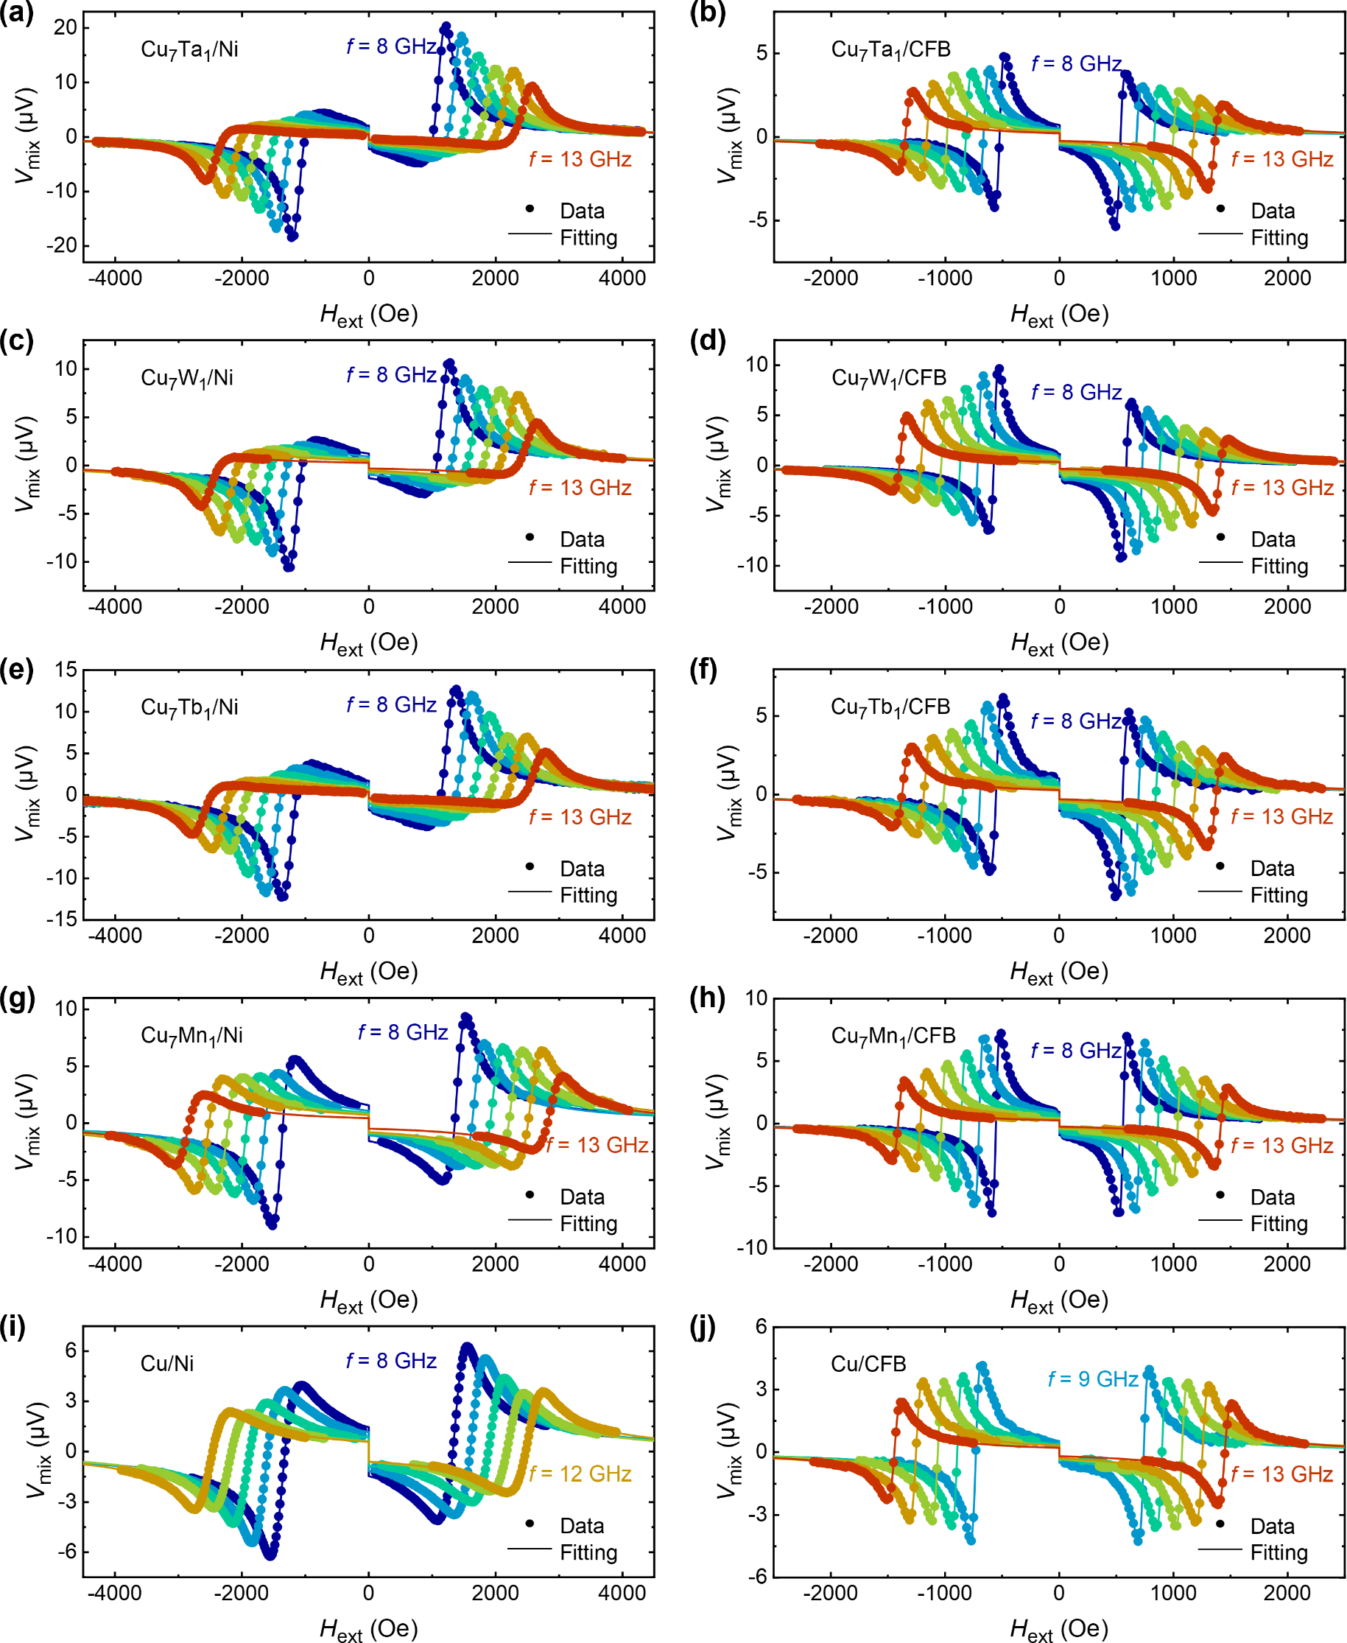
Figure S2. Broadband ST-FMR spectra for (a) Cu₇Ta₁/Ni, (b) Cu₇Ta₁/CFB, (c) Cu₇W₁/Ni, (d) Cu₇W₁/CFB, (e) Cu₇Tb₁/Ni, (d) Cu₇Tb₁/CFB, (g) Cu₇Mn₁/Ni, (h) Cu₇Mn₁/CFB, (i) Cu/Ni, (j) Cu/CFB.
Figures S3(a) and S3(b) display the resonance frequency (f) as a function of the external resonance magnetic field (H_{r}) for two series of samples with Ni and CFB depositing on Cu₇X₁ and pure Cu. This relationship was fitted using the Kittel formula²:
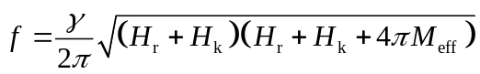 (1)
where γ is the gyromagnetic ratio, H_{k} is the in-plane anisotropy field and 4πM_{eff} is the effective magnetization.
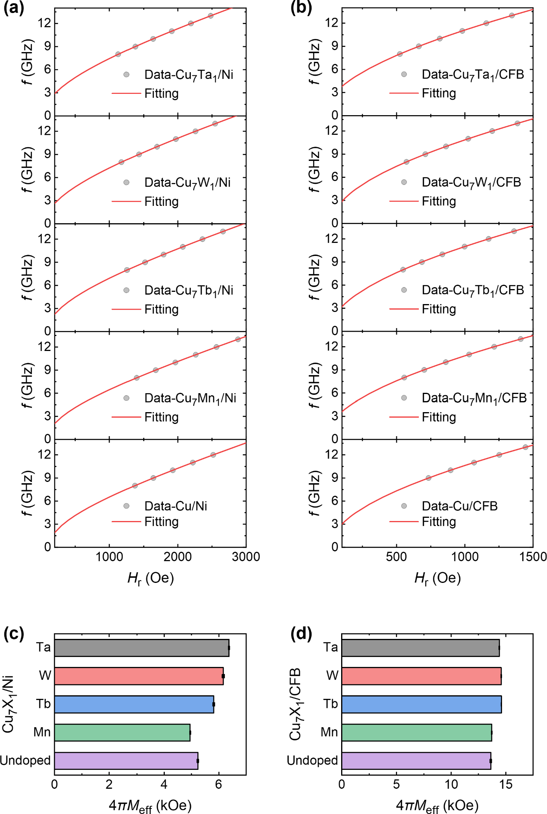
Figure S3. Effective magnetization analysis of NM/FM heterostructures. (a) and (b) Kittel fittings for resonance frequency versus resonance field for NM/Ni and NM/CFB; (c) and (d) Summary of effective magnetization 4πM_{eff} for NM/Ni and NM/CFB samples.
The damping coefficients (α) of the NM/FM heterostructures are extracted from the frequency-dependent ST-FMR linewidth (ΔH). The linewidth as a function of resonance frequency f follows the linear relation³:
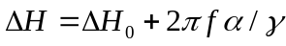 (2)
Figures S4(a) and S4(b) present ΔH versus f for the NM/Ni and NM/CFB series, respectively. The deduced damping coefficients for the NM/Ni and NM/CFB series are summarized in Figures S4(c) and S4(d).
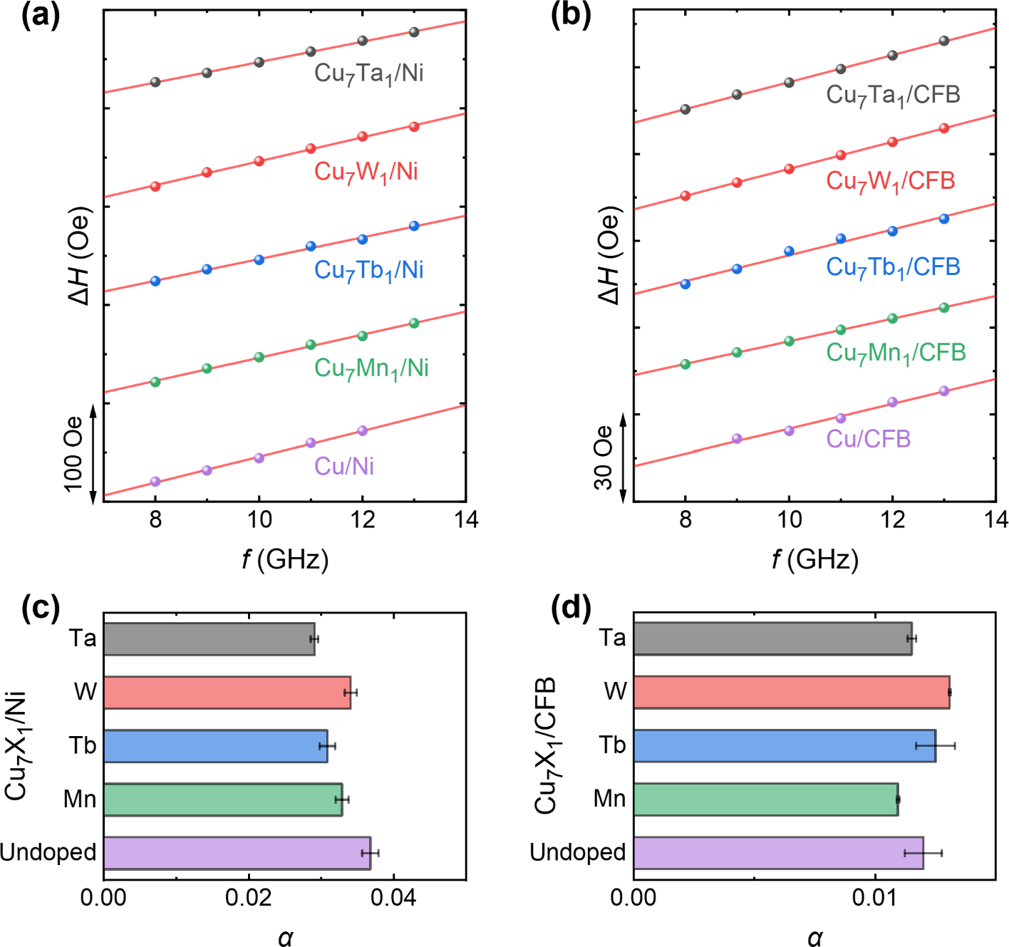
Figure S4. Damping coefficient analysis of NM/FM heterostructures. (a) and (b) Linewidth as a function of resonance frequency for NM/Ni and NM/CFB samples; (c) and (d) Summary of damping coefficients for NM/Ni and NM/CFB samples.

Section 3: Quantification of SOT effective fields via second harmonic measurements
The results of the harmonic Hall effect measurements are presented in Figure S5. The experimental setup is schematically illustrated in Figure S5(a). An alternating current (AC) with a frequency of 133.33 Hz and an amplitude of 12 mA is applied along the x-direction of the sample. A lock-in amplifier is used to detect both the first harmonic (R_{ω}) and second harmonic (R_{2ω}) responses of the transverse Hall voltage. The first harmonic Hall resistance, R_{ω} (Figure S5(b)), and the second harmonic Hall resistance, R_{2ω} (Figure S5(c)), are measured as a function of the in-plane angle φ under an external magnetic field, H_{ext}, of 300 mT for the Cu₇Ta₁/Ni system. Due to the in-plane easy-magnetization axis of the Ni layer, the first harmonic signal, R_{ω}, is predominantly governed by the planar Hall effect (PHE). Its angular dependence is expressed as⁴:
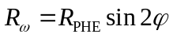 (3)
where R_{PHE} is the PHE resistance. The value of R_{PHE} is determined by fitting the experimental R_{ω} data with Equation (3). The second harmonic signal, R_{2ω}, originates from the modulation of the FM magnetization direction by the spin orbit torque (SOT). The R_{2ω} response is described by the following equation⁴:
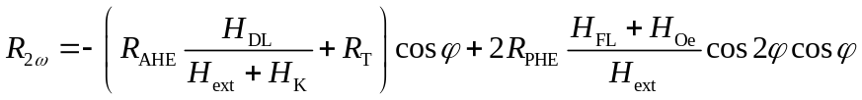 (4)
where H_{DL} and H_{FL} are the damping-like and field-like SOT effective fields, respectively. R_{T} is the harmonic resistance component resulting from thermal effects. H_{ext} is the external magnetic field magnitude. H_{Oe} is the Oersted field induced by the applied current, which can be calculated using Ampère's law.
The experimental R_{2ω} data are fitted using Equation (4). The resulting decomposition into the damping-like term (∝ cos φ) and the field-like term (∝cos 2φ cos φ) is shown by the blue and green curves, respectively, in Figure S5(c). To extract the damping-like effective field H_{DL} by isolating the SOT contribution from the cos φ term, the dependence of the cos φ coefficient, $R_{2ω}^{\cos{φ}}$, on H_{ext} is further investigated. As shown in Figure S5(d), the coefficient $R_{2ω}^{\cos{φ}}$ ($R_{2ω}^{\cos{2φ cos φ}}$) exhibits a linear relationship with 1/(H_{ext} + H_{K}), from which we can deduce the value of H_{DL} (H_{FL}). Figure S5(e) compares the H_{FL} extracted from the cos φ contribution with the Oersted field H_{Oe} calculated from Ampère's law. The H_{FL} accounts for less than 15% of the H_{Oe}, indicating that the current-induced torque is dominated by the DL component. In addition, the small H_{FL} is also consistent with the basic premise of ST-FMR measurement for accurate quantification of SOT efficiency. Figure S5(f) presents a comparison of the SOT efficiency θ_{eff} obtained from the ST-FMR and second harmonic measurements across all Cu₇X₁/Ni samples. The two independent methods yield consistent values, confirming the reliability of the reported SOT efficiencies.
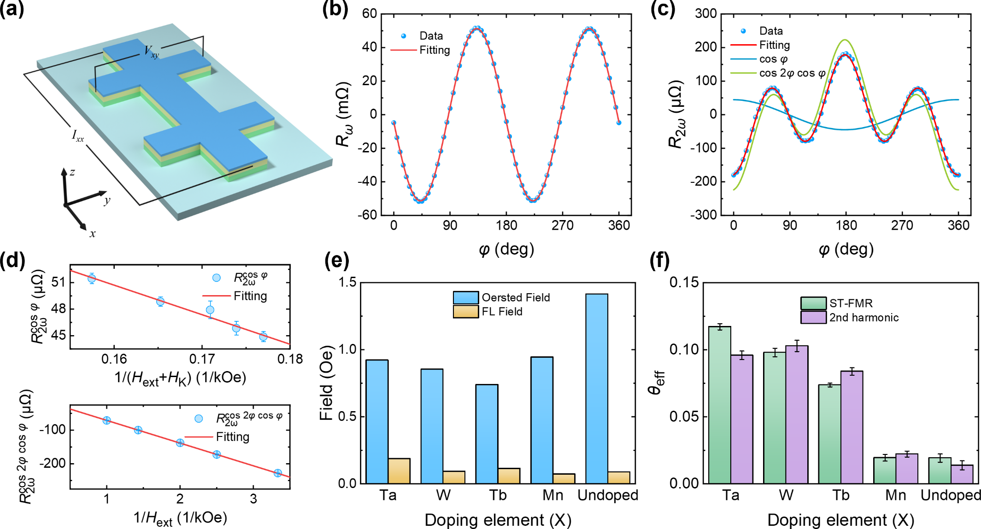
Figure S5. Second harmonic analysis of SOT in NM/FM heterostructures. (a) Schematic illustration of the second harmonic measurement setup, showing the current injection, magnetic field configuration, and harmonic signal detection pathways; (b) First harmonic component R_{ω} versus the in-plane magnetic field angle (φ) curve; (c) Experimental data (scatter points) for the second harmonic component R_{2ω} and its component fits: the blue curve represents the signal corresponding to the H_{DL}, and the green curve represents the mixed contribution of the H_{FL} and the Oersted field; (d) Dependence of the amplitude of the FL and DL components in R_{2ω} on the external magnetic field, where the slopes yield the field efficiency and damping efficiency, respectively; (e) Comparison of the H_{Oe} and the H_{FL}; (f) Comparison of the SOT efficiency obtained from the second harmonic measurement with the results from the ST-FMR measurement.

Section 4: Experimental setup and protocol for AMR-based state detection
Figure S6(a) shows the schematic illustration of the anisotropic magnetoresistance (AMR) measurement and AMR-based state detection for the NM/FM thin film using the four-point probe method⁵. We inject a current (including the readout current I_{read} and the pulse current I_{pulse}) and apply a sweeping external magnetic field H_{ext} along the y-direction, while recording the voltage along the x-direction to calculate the resistance. Figure S6(b) demonstrates the specific current sweeping and signal measurement procedure. First, the pulse current I_{pulse} is swept from its negative maximum to its positive maximum, and then back to its negative maximum, completing one full pulsing cycle. Following the application of each pulse current, a fixed readout current, I_{read} = 2 mA, is injected, and the corresponding resistance values, R(+H_{assist}) and R(-H_{assist}), are measured under positive and negative auxiliary magnetic fields, H_{assist}. To avoid altering the magnetization state, H_{assist} is kept sufficiently small. The change in resistance, ΔR, is defined as the difference between these two values: ΔR = R(+H_{assist}) - R(-H_{assist}). The magnetic state, or the direction of the magnetic moment, is determined by the sign of ΔR: when the magnetic moment is parallel to the positive direction of the auxiliary field, ΔR < 0; conversely, when the magnetic moment is anti-parallel to the positive direction of the auxiliary field, ΔR > 0. In this manner, we can directly measure the current-induced switching of in-plane magnetization.
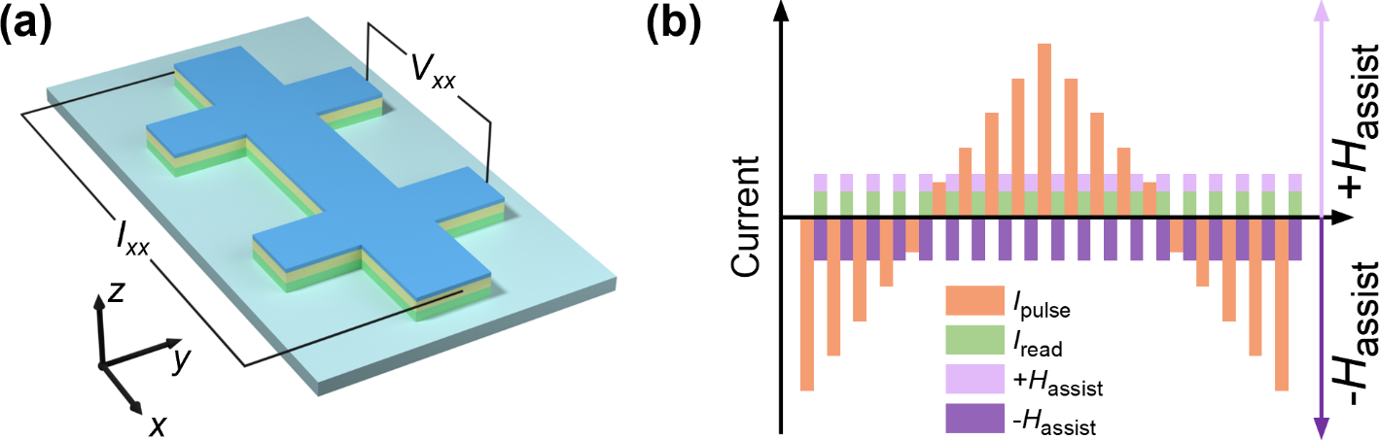
Figure S6. Experimental setup and protocol for AMR-based state detection. (a) Four-point probe setup for AMR measurement; (b) I_{pulse} sweeps followed by I_{read} measurement under assist fields to determine magnetic state.

Section 5: Orbital-resolved electronic band structures
Figures S7-S11 present the orbital-projected band structures for Cu₇Ta₁, Cu₇W₁, Cu₇Tb₁, Cu₇Mn₁, and pure Cu, respectively (the Fermi level is set to zero). The color scale denotes the orbital projection weight of each Bloch state |ψ_{nk}> onto the indicated atomic-orbital subspace:
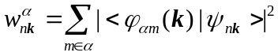 (5)
where α could be set of orbitals such as Cu 4p, Tb 5d, Tb 4f, etc. First of all, Cu 4s and 4p orbital electron present sizable orbital projection weigh at Fermi level because of the Cu-base structure. Moreover, the dopant element also provides the other orbital electrons at the Fermi level except for the Cu 4s and 4p orbital electron. In the Cu₇Ta₁ and Cu₇W₁ systems, the electronic states near the Fermi level are primarily characterized by the 5d orbital characters of the heavy metal dopants. Particularly, in the Cu₇Mn₁ system, the Mn 3d orbital characters with large orbital angular momentum (OAM) are located 0.5 eV above the Fermi level, and thus cannot contribute to conduction. For the Cu₇Tb₁ system, the Tb 4f orbital projection weight in the vicinity of the Fermi level is predominantly concentrated in a series of weakly dispersive and narrow bands. The combination of weak band dispersion and narrow spectral features is consistent with the predominantly localized and atomic-like character generally associated with the 4f electrons of elemental Tb and heavy rare-earth metals^{6,7}. Combined with the small orbital Hamiltonian matrix elements between Tb 4f and other conduction orbitals (Figure S12(b) in the Section 6), this indicates that the 4f electrons exhibit very weak coupling with other orbital electrons. These results suggest that the dopant 5d orbital electron, possessing significant OAM and spatially extended character, is quite possible to couples with the Cu 4s and 4p orbital electron to construct orbital texture and induce a remarkable orbital Hall conductivity (OHC).
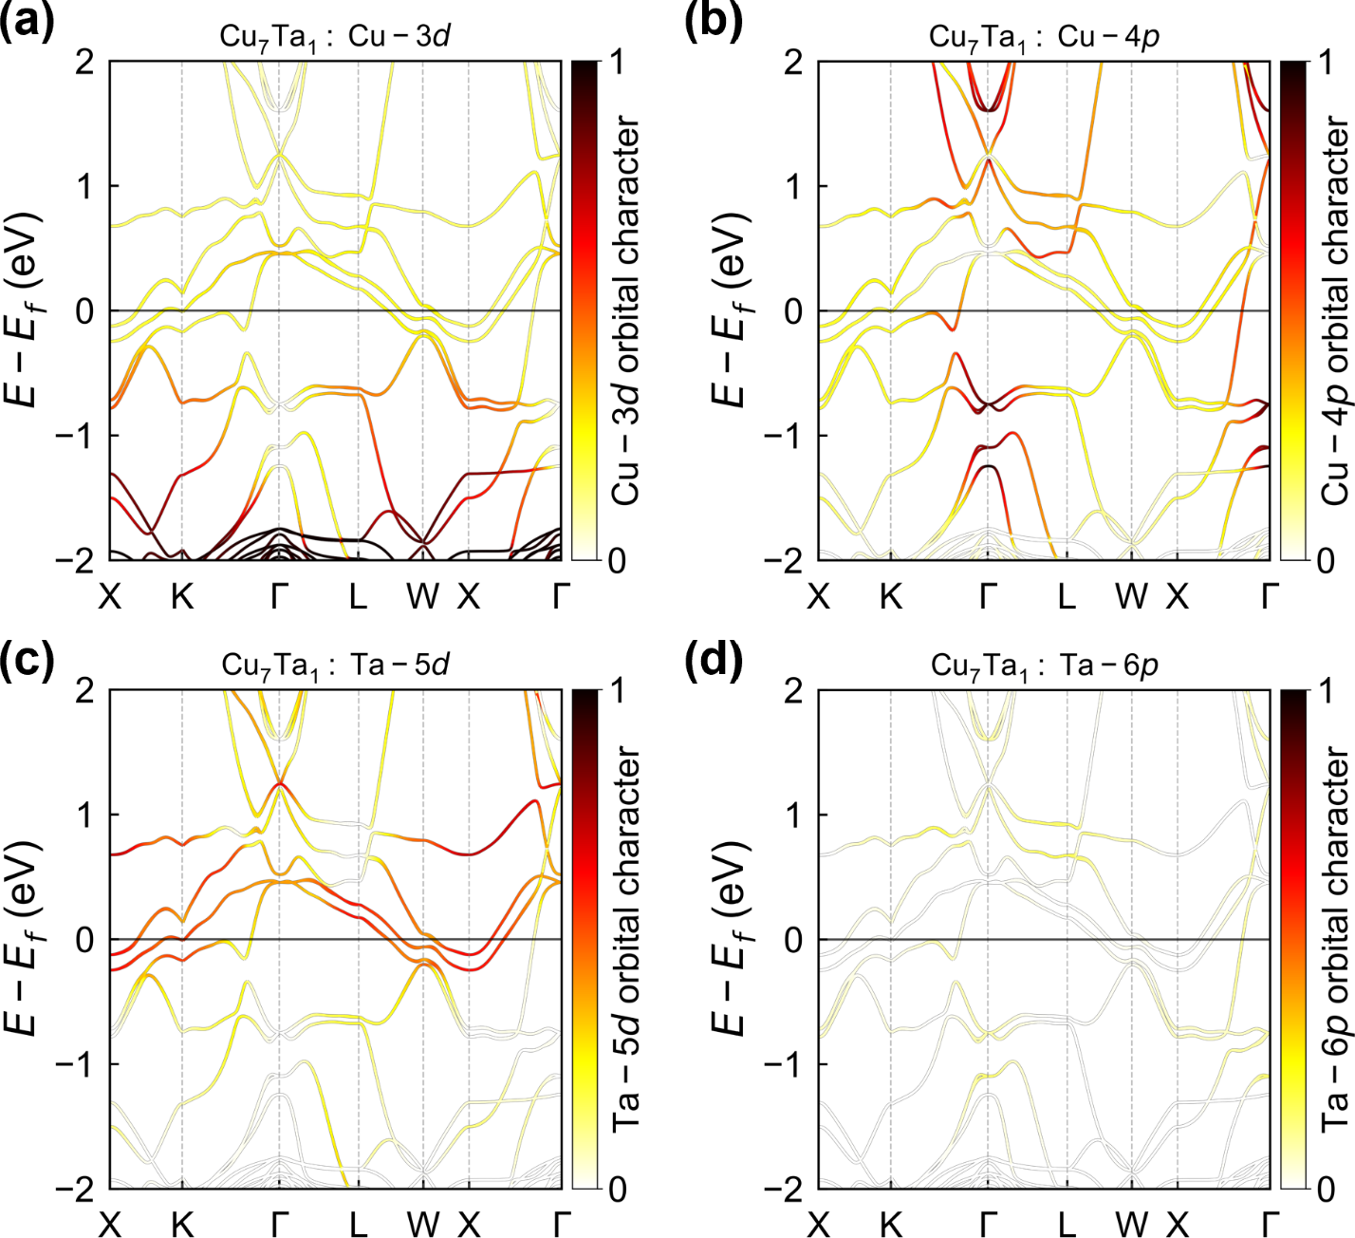
Figure S7. Orbital-projected band structure analysis showing the energy distribution of (a) Cu-3d, (b) Cu-4p, (c) Ta-5d, and (d) Ta-6p electron characteristics in Cu₇Ta₁.
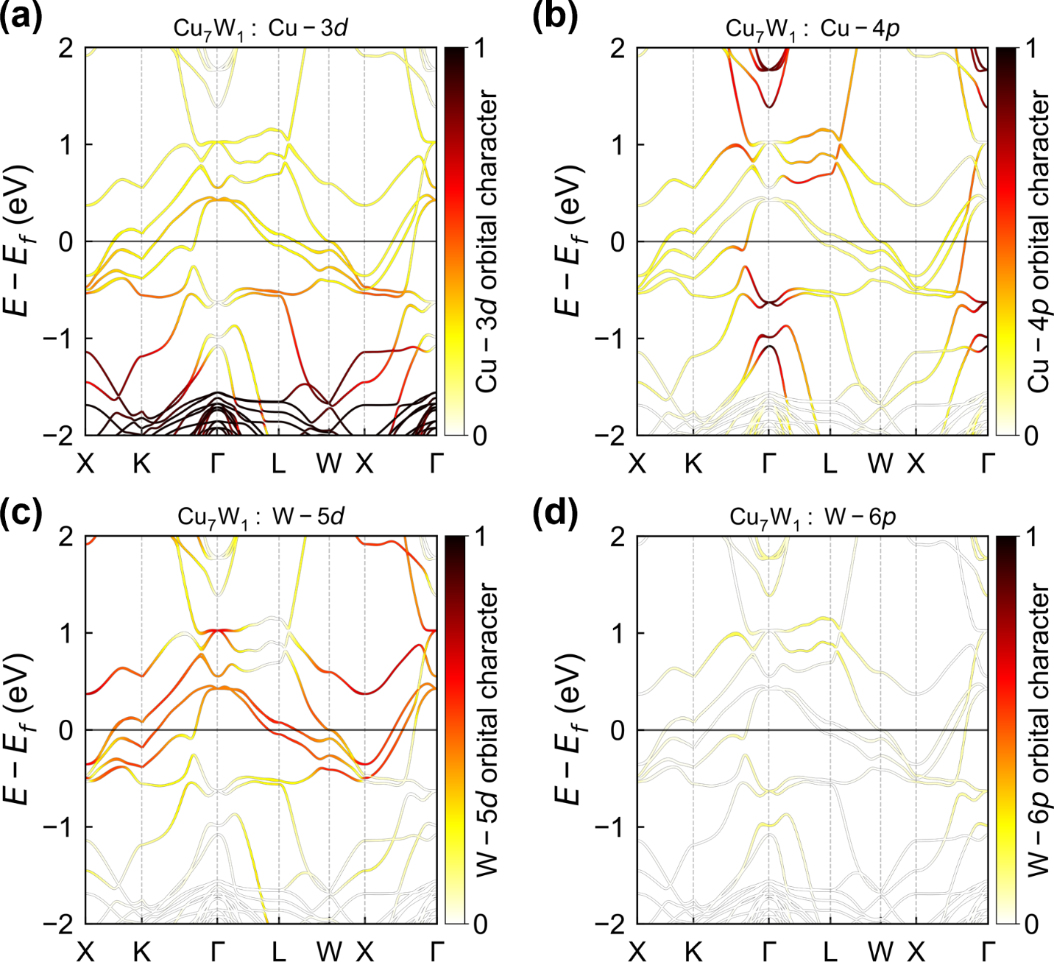
Figure S8. Orbital-projected band structure analysis showing the energy distribution of (a) Cu-3d, (b) Cu-4p, (c) W-5d, and (d) W-6p electron characteristics in Cu₇W₁.
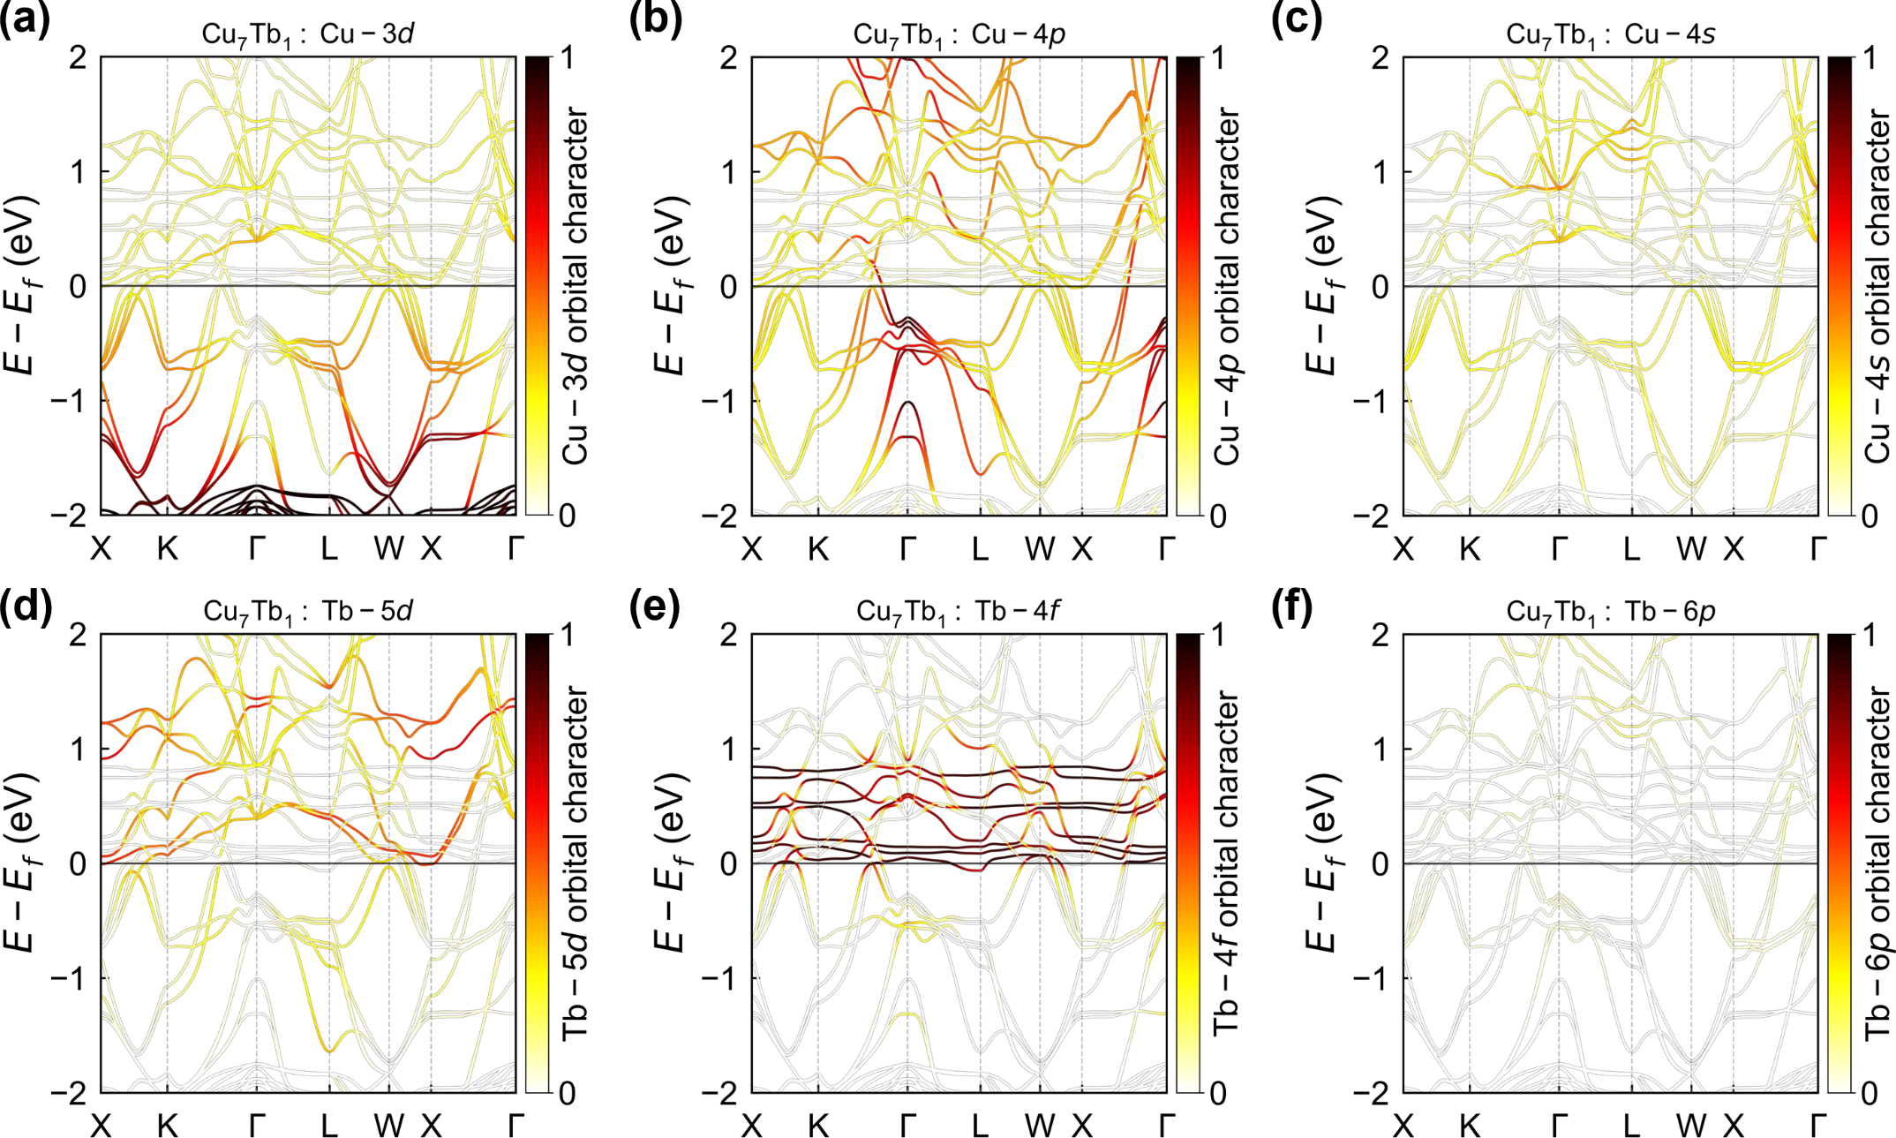
Figure S9. Orbital-projected band structure analysis showing the energy distribution of (a) Cu-3d, (b) Cu-4p, (c) Cu-4s, (d) Tb-5d, (e) Tb-4f, and (f) Tb-6p electron characteristics in Cu₇Tb₁.
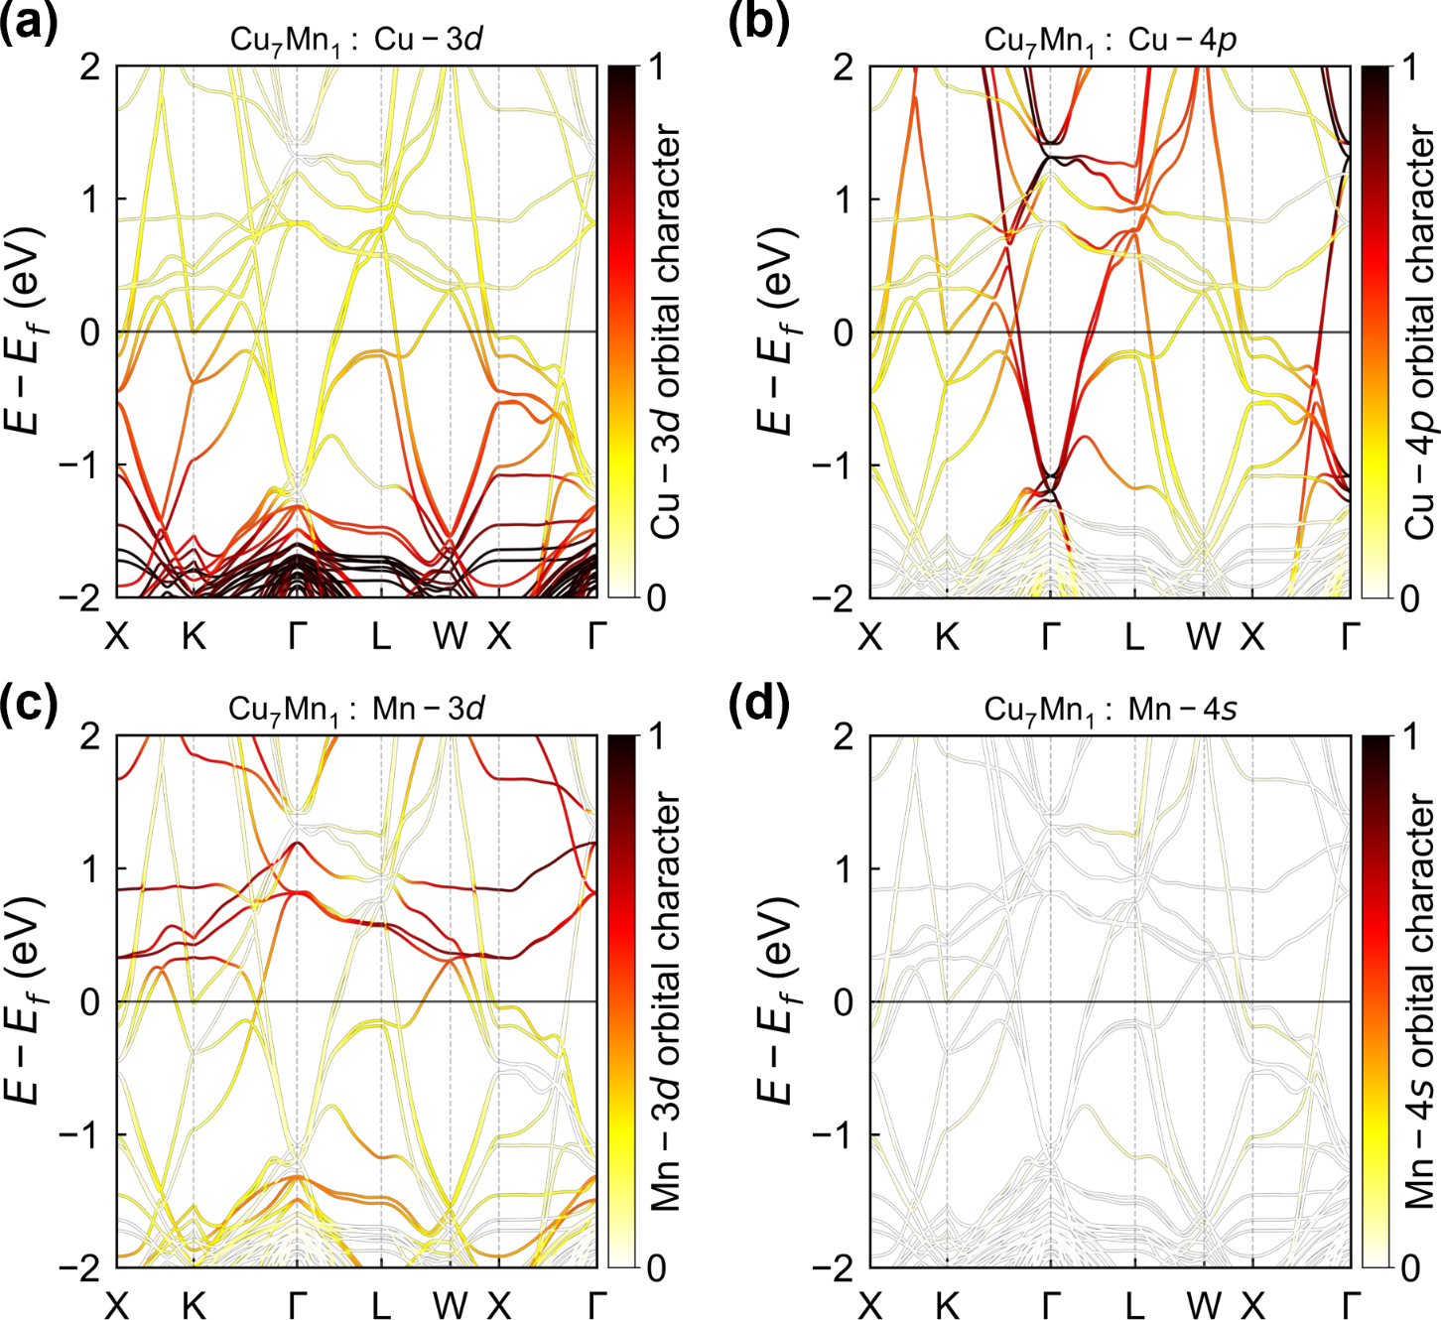
Figure S10. Orbital-projected band structure analysis showing the energy distribution of (a) Cu-3d, (b) Cu-4p, (c) Mn-3d, and (d) Mn-4s electron characteristics in Cu₇Mn₁.
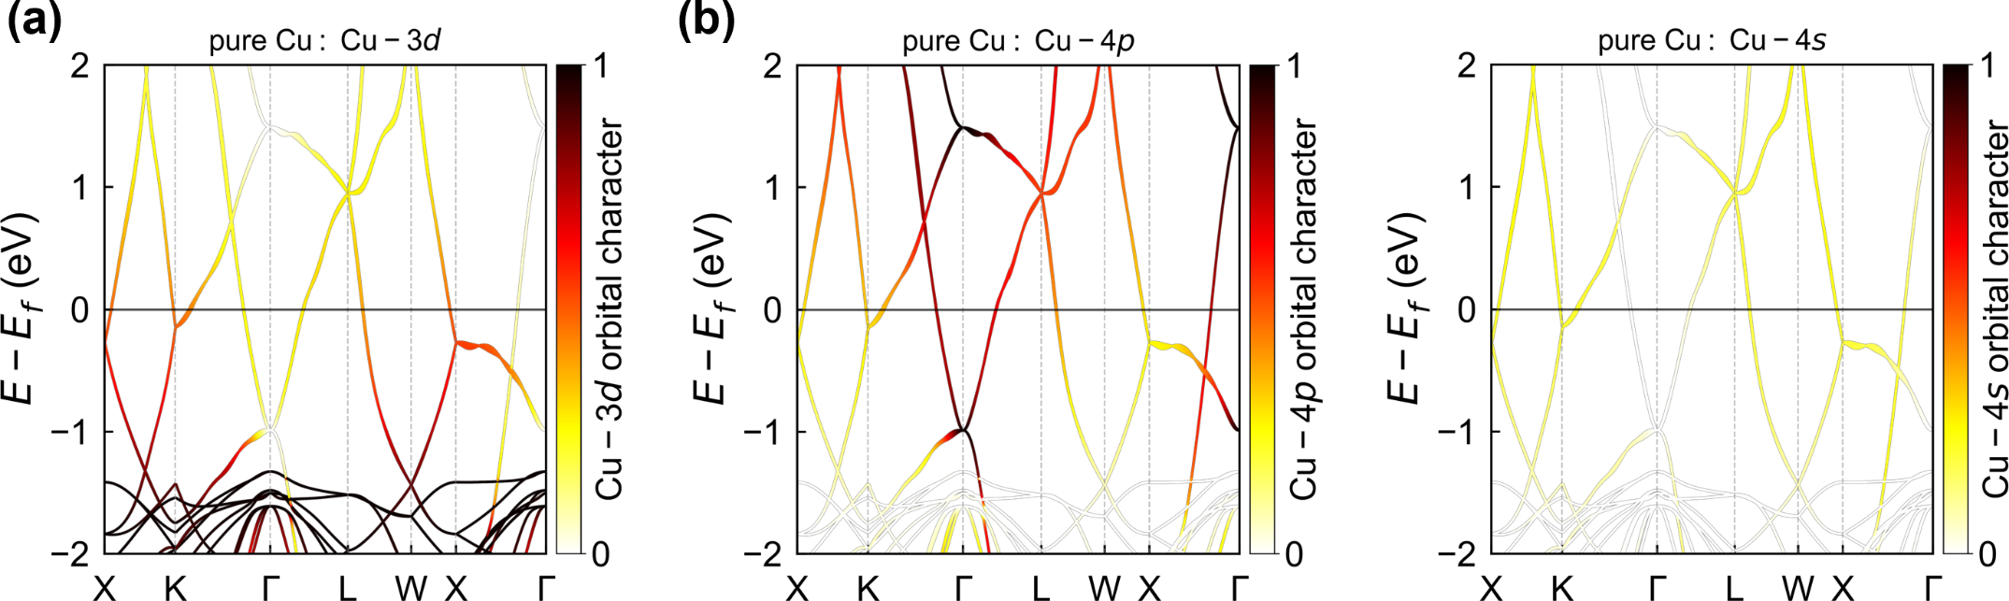
Figure S11. Orbital-projected band structure analysis showing the energy distribution of (a) Cu-3d, (b) Cu-4p, and (c) Cu-4s electron characteristics in pure Cu.

Section 6: Orbital Hamiltonian matrix elements in Cu-based alloys
To elucidate the microscopic origin of the enhanced OHE, we calculated the orbital-resolved Hamiltonian matrix elements <i|H|j> for pure Cu and Cu₇X₁ alloys. These matrix elements quantify the coupling strength between atomic orbitals and provide direct evidence for the s-p-d orbital coupling mechanism. Figure S12 presents the Hamiltonian matrix elements as two-dimensional heatmaps, where the x- and y-axes represent electron orbitals of the host Cu and dopant atoms, respectively. The color scale indicates the matrix element magnitude in eV. These analyses demonstrate that strong coupling between 4s, 4p orbital of Cu and 5d orbital from W and Tb dopants is the key factor driving the enhancement of OHC. In contrast, the coupling strength between Cu 4s, 4p orbital and Mn 3d, Tb 4f orbital is relative weak, contributing little to the enhancement of OHC.
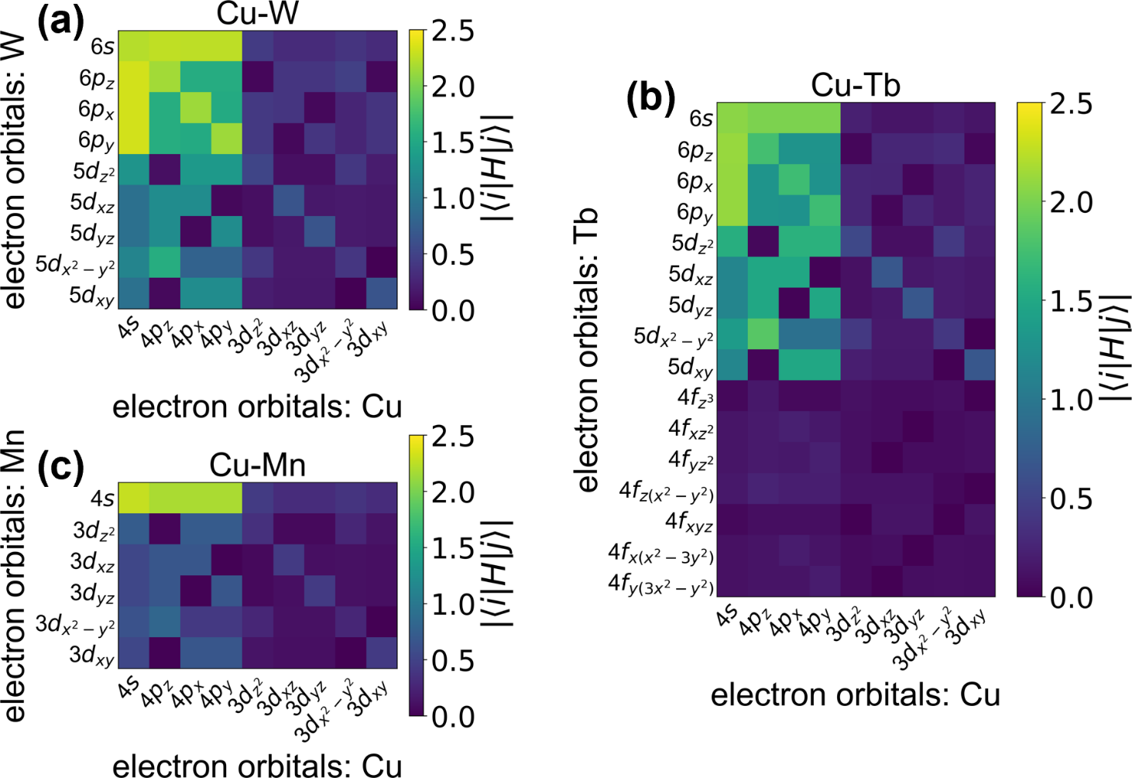
Figure S12. The orbital Hamiltonian matrix elements for (a) Cu₇W₁, (b) Cu₇Tb₁, and (c) Cu₇Mn₁ systems.
Section 7: Energy-dependent OHC and projected contributions
Figure S13 illustrate the energy dependence of the total OHC (black line) and the projected OHC (POHC) of each orbital for pure Cu, Cu₇W₁, Cu₇Tb₁, Cu₇Mn₁, from which we can deduce the total OHC value. Moreover, we can conclude that the 5d orbital plays a dominant role for the enhanced OHC in Cu₇W₁, Cu₇Tb₁, Cu₇Ta₁ (shown in the main text).
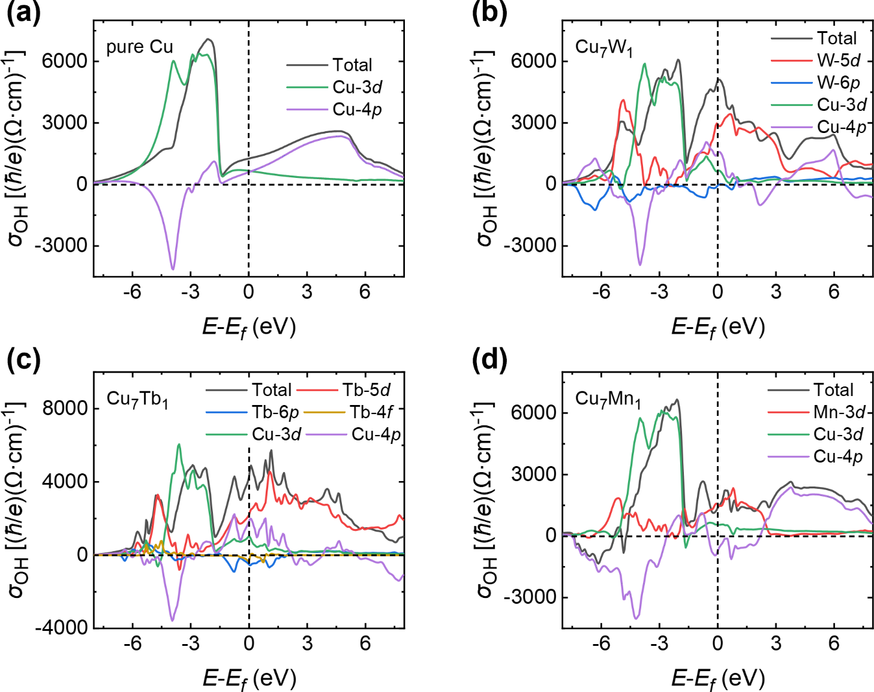
Figure S13. Energy dependence of the total OHC (black line) and POHC in: (a) pure Cu, (b) Cu₇W₁, (c) Cu₇Tb₁, (d) Cu₇Mn₁.

Section 8: First-principles calculation details
The OHC is computed from this Hamiltonian using the Kubo formula:
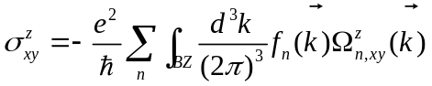 (6)
where the orbital Berry curvature is defined as
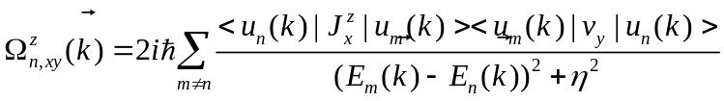 (7)
Here, 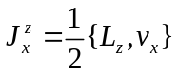 is the orbital current operator, 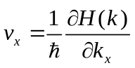 is the velocity operator. The basis used to construct the tight-binding Hamiltonian is the initial Wannier90 guess basis, i.e., the real atomic basis. 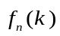 is the Fermi-Dirac distribution, and the temperature was set to 30 K. The Lorentzian broadening term η is set to 0.025 eV as usual in the literature^{8,9}. The Brillouin zone (BZ) is sampled by k grids of 200 × 200 × 200. Note that the unit of OHC is (ћ/e)(Ω·cm)⁻¹.
The analytical expressions for the matrix elements of the OAM operators L_{x}, L_{y}, and L_{z} (excluding electron spin) within the real atomic basis corresponding to p (L = 1), d (L = 2), and f (L = 3) orbitals are provided below. For the p orbitals, the real atomic basis is 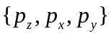. In this basis, the matrix representations of the orbital angular momentum operators are:
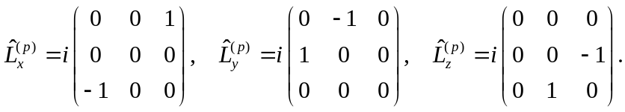 (8)
For the d orbitals, the real atomic basis is 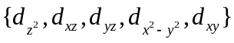. In this basis:
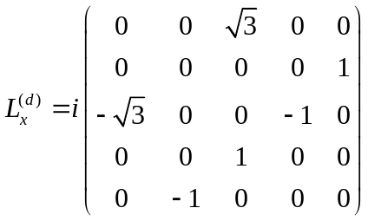 (9)
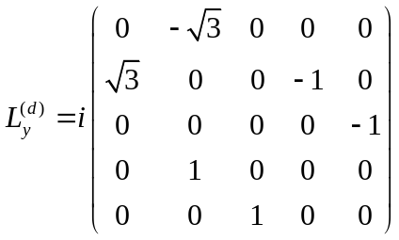 (10)
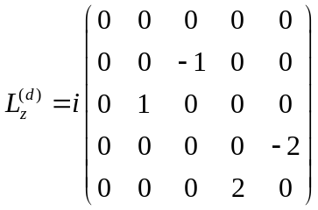 (11)
For the f orbitals, the real atomic basis is . In this basis:
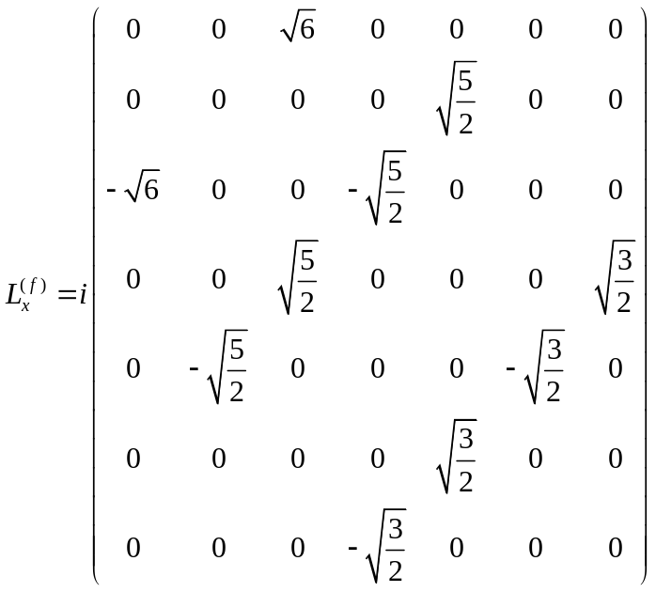 (12)
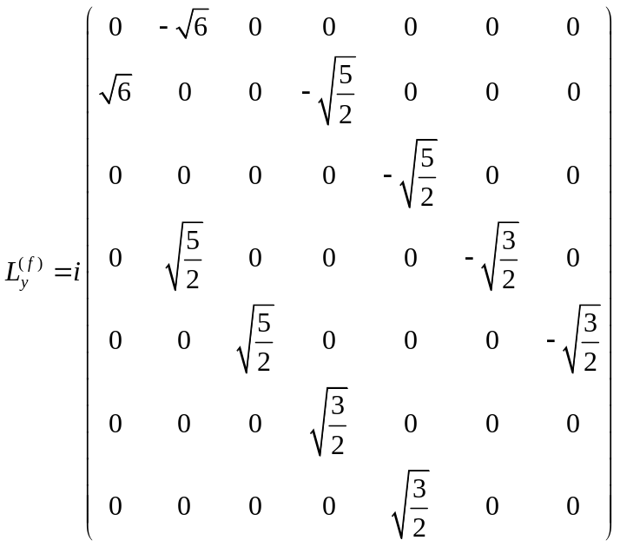 (13)
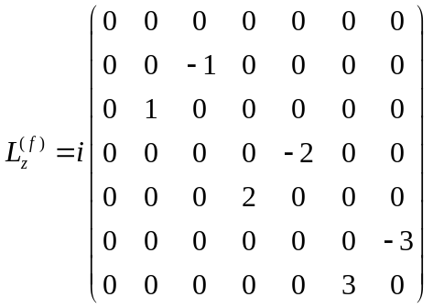 (14)

References
1. Luo, T. et al. Weak temperature dependence of orbital Hall angle in Ta/Ni bilayers. Nanotechnol. 36, 445201 (2025).
2. Xu, X. et al. Observation of giant effective orbital Hall angle in Ti/Pt metallic heterostructure. Small 21, 2408721 (2025).
3. Demasius, K. U. et al. Enhanced spin-orbit torques by oxygen incorporation in tungsten films. Nature Communications 7, 7 (2016).
4. Zhu, D. et al. Sign change of spin-orbit torque in Pt / NiO / CoFeB structures. Phys. Rev. Lett. 128, 217702 (2022).
5. Hao, R. et al. Probing the magnetization switching with in-plane magnetic anisotropy through field-modified magnetoresistance measurement. Chin. Phys. B 31, 017502 (2022).
6. Thielemann-Kühn, N. et al. Optical control of 4f orbital state in rare-earth metals. Sci. Adv. 10, eadk9522 (2024).
7. Frietsch, B. et al. The role of ultrafast magnon generation in the magnetization dynamics of rare-earth metals. Sci. Adv. 6, eabb1601 (2020).
8. Go, D. & Lee, H.-W. Orbital torque: Torque generation by orbital current injection. Phys. Rev. Res. 2, 013177 (2020).
9. Go, D., Lee, H.-W., Oppeneer, P. M., Blügel, S. & Mokrousov, Y. First-principles calculation of orbital Hall effect by Wannier interpolation: Role of orbital dependence of the anomalous position. Phys. Rev. B 109, 174435 (2024).

