Supplementary Material for
When conspiracies are true: exposure to documented pharmaceutical misconduct undermines institutional trust

Table of Contents
S1 Text. Socioeconomic status derived from diploma and occupation 2
S1 Table. Demographic characteristics of participants 2
S2 Table. Descriptive statistics of outcome measures 2
S1 Appendix. Study design diagram 3
S2 Appendix. Question items (original and translated) 3
S3 Table. Correlation matrix of pre-test trust measures 5
S4 Table. Fixed effects of all models including baseline conspiracy belief score 5
Material used in the study 7

S1 Text. Socioeconomic status derived from diploma and occupation

A principal component analysis conducted on diploma and occupation scores (N=433) supported a one-component SES structure. The correlation matrix showed no evidence of multicollinearity or singularity (determinant = 0.85), and tests of factorability indicated that the data were suitable for dimension reduction (Bartlett: χ²(1) = 74.78, p < 0.001; overall and item-level KMO = 0.50). Converging criteria supported the retention of a single component, including the eigenvalue-greater-than-one rule (Kaiser, 1960), the scree plot (Cattell, 1966), and parallel analysis (Horn, 1965). This first principal component (PC1) had an eigenvalue of 1.40 and explained 70% of the variance. Both indicators loaded strongly on PC1 (diploma = .84, occupation = .84), with communalities of .70 for each variable.

S1 Table. Demographic characteristics of participants

Variable | Control M  N = 219¹ | Experimental M  N = 214¹ | Group comparison
Age | 28 ± 7 | 29 ± 7 | t(426) = −1.10, p = .27
Unknown | 0 | 5
Gender |  |  | χ²(2, N= ..) = 0.50, p = .78
Female | 93 (42%) | 85 (40%) | χ²(2, N= ..) = 0.50, p = .78
Male | 86 (39%) | 85 (40%) | χ²(2, N= ..) = 0.50, p = .78
Other | 40 (18%) | 44 (21%) | χ²(2, N= ..) = 0.50, p = .78
Diploma |  |  | χ²(2, N= ..) = 0.50, p = .78
No Diploma | 2 (0.9%) | 4 (1.9%) | χ²(2, N= ..) = 6.10, p = .53
Lower Secondary Education | 4 (1.8%) | 6 (2.8%) | χ²(2, N= ..) = 6.10, p = .53
High School Diploma | 74 (34%) | 71 (33%) | χ²(2, N= ..) = 6.10, p = .53
Some University | 28 (13%) | 30 (14%) | χ²(2, N= ..) = 6.10, p = .53
Bachelor's Degree or more | 66 (30%) | 55 (26%) | χ²(2, N= ..) = 6.10, p = .53
Master's Degree or more | 45 (21%) | 48 (22%) | χ²(2, N= ..) = 6.10, p = .53
Socioeconomic status index* | -0.003 (0.97) | 0.003 (1.03) | t(428) = −0.05, p = .96
Note : ¹Mean ± SD; n (%)

S2 Table. Descriptive statistics of outcome measures

 | Control |  | Experimental
Dependent variable | Pre-test  N = 219¹ | Post-test  N = 219¹ | Pre-test  N = 214¹ | Post-test  N = 214¹
Pharmaceutical industry | 4.17 (1.32) | 4.08 (1.41) | 4.25 (1.31) | 3.44 (1.41)
Research institutions | 5.02 (1.20) | 4.77 (1.46) | 5.09 (1.21) | 4.53 (1.47)
Public health institutions | 4.03 (1.53) | 4.00 (1.57) | 4.11 (1.60) | 3.80 (1.62)
Ministry of Health | 4.21 (1.59) | 4.26 (1.61) | 4.28 (1.63) | 4.01 (1.63)
Scientific research | 4.81 (1.39) | 4.66 (1.51) | 4.93 (1.32) | 4.39 (1.53)
Mandatory vaccines | 4.63 (1.58) | 4.62 (1.63) | 4.59 (1.62) | 4.28 (1.72)
Conspiracy theories | 4.04 (1.25) | 4.05 (1.37) | 3.88 (1.43) | 4.02 (1.50)
¹Mean (SD)

S1 Appendix. Study design diagram

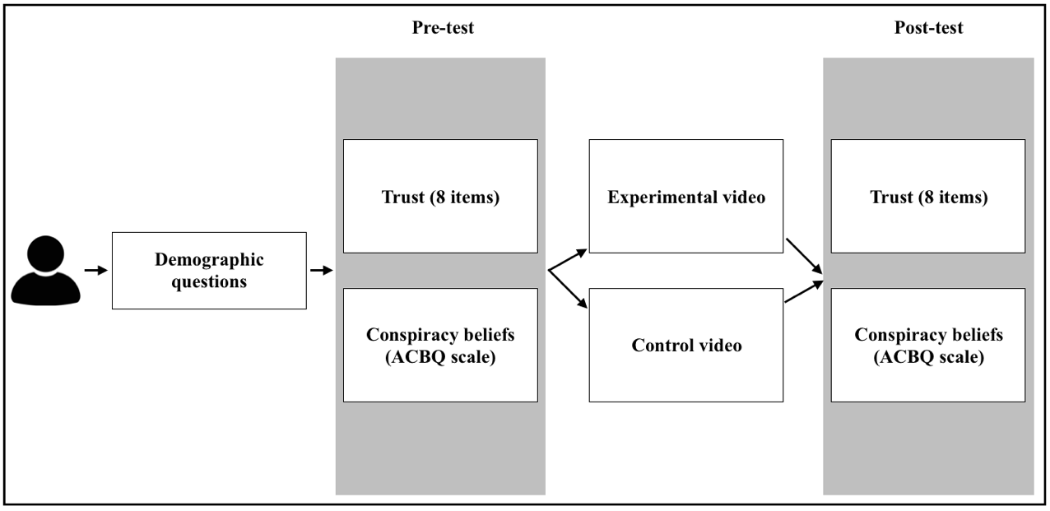

S2 Appendix. Question items (original and translated)

Trust in the pharmaceutical industry (3 items)
- (Original) J’ai confiance dans l’industrie pharmaceutique.
(Translated) I trust the pharmaceutical industry.

- (Original) J’ai confiance dans l’industrie pharmaceutique pour privilégier la santé publique par rapport aux profits.
(Translated) I trust the pharmaceutical industry to prioritize public health over profits.

- (Original) Je pense que les entreprises pharmaceutiques communiquent l’ensemble des risques et les effets secondaires de leurs médicaments.
(Translated) I believe pharmaceutical companies discloses all known side effects of their medications.

Trust in research institutions (1 item)
(Original) J’ai confiance dans les travaux de recherche menés par l’Institut National de la Santé et de la Recherche Médicale (INSERM), par l’Institut Pasteur et par le Centre National de la Recherche Scientifique (CNRS).
(Translated) I trust the research conducted by the National Institute of Health and Medical Research (INSERM), the Pasteur Institute, and the National Centre for Scientific Research (CNRS).

Trust in public health institutions (1 item)
(Original) Je pense que les agences nationales de la santé privilégient la santé publique par rapport aux considérations politiques et économiques.
(Translated) I believe national health agencies to prioritize public health over political and economic considerations.

Trust in the ministry of health (1 item)
(Original) J’ai confiance dans le ministère de la santé en France pour assurer la sécurité et l’efficacité des produits de santé (traitements, médicaments, vaccins).
(Translated) I trust the French ministry of health to ensure the safety and effectiveness of health products (treatments, medications, vaccines).

Trust in scientific research (1 item)
(Original) Je fais confiance à la recherche scientifique pour fournir des informations précises et fiables.
(Translated) I trust scientific research to provide accurate and reliable information.

Trust in mandatory vaccines (1 item)
(Original) J’ai confiance dans les vaccins obligatoires.
(Translated) I trust mandatory vaccines.

S3 Table. Correlation matrix of pre-test trust measures

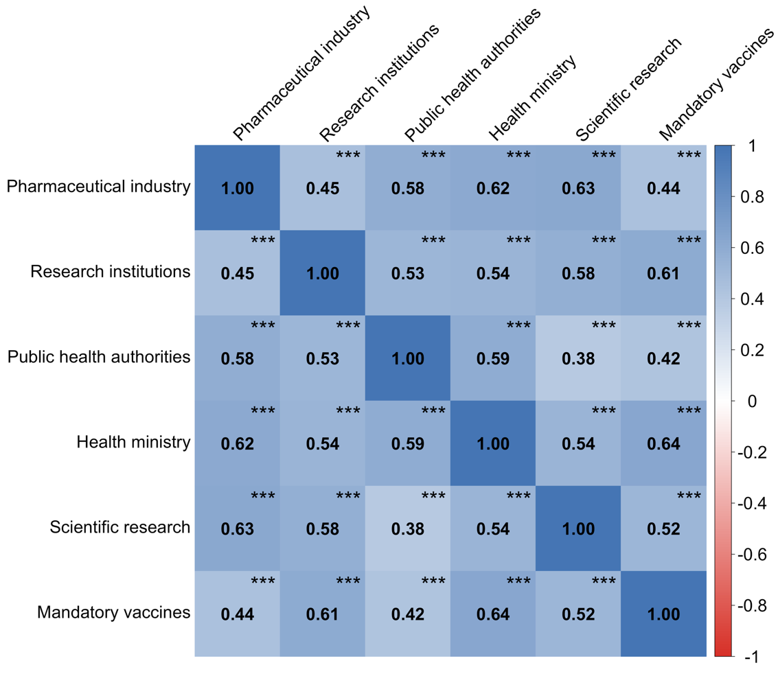

S4 Table. Fixed effects of all models including baseline conspiracy belief score

Model | Fixed effects | beta | SE | t | p | 95% CI
Pharmaceutical Industry | Intercept | -0.178 | 0.046 | -3.87 | < .001 | [-0.268, -0.088]
Pharmaceutical Industry | Session (Pre = -0.5, Post = 0.5) | -0.348 | 0.033 | -10.46 | < .001 | [-0.413, -0.283]
Pharmaceutical Industry | Condition (Ctrl = -0.5, Exp = 0.5 | -0.231 | 0.092 | -2.51 | 0.012 | [-0.412, -0.05]
Pharmaceutical Industry | Conspiracy_pre | -0.181 | 0.046 | -3.90 | < .001 | [-0.272, -0.09]
Pharmaceutical Industry | Familiarity | 0.091 | 0.046 | 1.99 | 0.047 | [0.001, 0.182]
Pharmaceutical Industry | Session x Condition | -0.550 | 0.067 | -8.26 | < .001 | [-0.68, -0.419]
Pharmaceutical Industry | Session x Conspiracy_pre | -0.022 | 0.034 | -0.66 | 0.512 | [-0.088, 0.044]
Pharmaceutical Industry | Condition x Conspiracy_pre | -0.149 | 0.093 | -1.61 | 0.109 | [-0.332, 0.033]
Pharmaceutical Industry | Session x Condition x Conspiracy_pre | -0.013 | 0.067 | -0.20 | 0.842 | [-0.145, 0.119]
Research Institutions | Intercept | -0.170 | 0.046 | -3.74 | < .001 | [-0.26, -0.081]
Research Institutions | Session (Pre = -0.5, Post = 0.5) | -0.336 | 0.048 | -7.02 | < .001 | [-0.43, -0.242]
Research Institutions | Condition (Ctrl = -0.5, Exp = 0.5 | -0.107 | 0.091 | -1.17 | 0.241 | [-0.286, 0.072]
Research Institutions | Conspiracy_pre | -0.301 | 0.046 | -6.56 | < .001 | [-0.392, -0.211]
Research Institutions | Familiarity | -0.100 | 0.046 | -2.20 | 0.029 | [-0.189, -0.011]
Research Institutions | Session x Condition | -0.263 | 0.096 | -2.75 | 0.006 | [-0.451, -0.075]
Research Institutions | Session x Conspiracy_pre | -0.085 | 0.048 | -1.76 | 0.079 | [-0.18, 0.01]
Research Institutions | Condition x Conspiracy_pre | -0.098 | 0.092 | -1.06 | 0.289 | [-0.278, 0.083]
Research Institutions | Session x Condition x Conspiracy_pre | -0.026 | 0.097 | -0.27 | 0.788 | [-0.216, 0.164]
Public Health Authorities | Intercept | -0.055 | 0.042 | -1.31 | 0.190 | [-0.138, 0.027]
Public Health Authorities | Session (Pre = -0.5, Post = 0.5) | -0.108 | 0.044 | -2.47 | 0.014 | [-0.194, -0.022]
Public Health Authorities | Condition (Ctrl = -0.5, Exp = 0.5 | -0.064 | 0.084 | -0.77 | 0.444 | [-0.23, 0.101]
Public Health Authorities | Conspiracy_pre | -0.233 | 0.042 | -5.48 | < .001 | [-0.316, -0.149]
Public Health Authorities | Familiarity | 0.015 | 0.042 | 0.36 | 0.721 | [-0.068, 0.098]
Public Health Authorities | Session x Condition | -0.182 | 0.088 | -2.08 | 0.038 | [-0.354, -0.01]
Public Health Authorities | Session x Conspiracy_pre | -0.040 | 0.044 | -0.91 | 0.361 | [-0.127, 0.046]
Public Health Authorities | Condition x Conspiracy_pre | -0.080 | 0.085 | -0.94 | 0.346 | [-0.247, 0.087]
Public Health Authorities | Session x Condition x Conspiracy_pre | -0.063 | 0.088 | -0.72 | 0.474 | [-0.237, 0.11]
Health Ministry | Intercept | -0.037 | 0.042 | -0.89 | 0.376 | [-0.12, 0.045]
Health Ministry | Session (Pre = -0.5, Post = 0.5) | -0.068 | 0.037 | -1.87 | 0.062 | [-0.14, 0.003]
Health Ministry | Condition (Ctrl = -0.5, Exp = 0.5 | -0.090 | 0.084 | -1.07 | 0.283 | [-0.255, 0.075]
Health Ministry | Conspiracy_pre | -0.320 | 0.042 | -7.54 | < .001 | [-0.403, -0.236]
Health Ministry | Familiarity | 0.038 | 0.042 | 0.91 | 0.363 | [-0.044, 0.121]
Health Ministry | Session x Condition | -0.200 | 0.073 | -2.74 | 0.006 | [-0.344, -0.056]
Health Ministry | Session x Conspiracy_pre | -0.005 | 0.037 | -0.12 | 0.902 | [-0.077, 0.068]
Health Ministry | Condition x Conspiracy_pre | -0.098 | 0.085 | -1.15 | 0.249 | [-0.264, 0.069]
Health Ministry | Session x Condition x Conspiracy_pre | 0.007 | 0.074 | 0.09 | 0.928 | [-0.138, 0.152]
Scientific Research | Intercept | -0.135 | 0.044 | -3.08 | 0.002 | [-0.221, -0.049]
Scientific Research | Session (Pre = -0.5, Post = 0.5) | -0.257 | 0.044 | -5.81 | < .001 | [-0.344, -0.17]
Scientific Research | Condition (Ctrl = -0.5, Exp = 0.5 | -0.088 | 0.087 | -1.01 | 0.313 | [-0.26, 0.084]
Scientific Research | Conspiracy_pre | -0.272 | 0.044 | -6.17 | < .001 | [-0.359, -0.185]
Scientific Research | Familiarity | -0.041 | 0.044 | -0.93 | 0.354 | [-0.126, 0.045]
Scientific Research | Session x Condition | -0.291 | 0.089 | -3.28 | 0.001 | [-0.465, -0.117]
Scientific Research | Session x Conspiracy_pre | -0.016 | 0.045 | -0.36 | 0.719 | [-0.104, 0.072]
Scientific Research | Condition x Conspiracy_pre | -0.243 | 0.088 | -2.75 | 0.006 | [-0.416, -0.069]
Scientific Research | Session x Condition x Conspiracy_pre | -0.053 | 0.089 | -0.59 | 0.553 | [-0.229, 0.123]
Mandatory Vaccines | Intercept | -0.055 | 0.043 | -1.28 | 0.202 | [-0.14, 0.03]
Mandatory Vaccines | Session (Pre = -0.5, Post = 0.5) | -0.104 | 0.027 | -3.88 | < .001 | [-0.156, -0.051]
Mandatory Vaccines | Condition (Ctrl = -0.5, Exp = 0.5) | -0.169 | 0.086 | -1.96 | 0.051 | [-0.338, 0.001]
Mandatory Vaccines | Conspiracy_pre | -0.403 | 0.043 | -9.27 | < .001 | [-0.488, -0.317]
Mandatory Vaccines | Familiarity | -0.072 | 0.043 | -1.67 | 0.095 | [-0.157, 0.013]
Mandatory Vaccines | Session x Condition | -0.188 | 0.053 | -3.53 | < .001 | [-0.293, -0.083]
Mandatory Vaccines | Session x Conspiracy_pre | -0.028 | 0.027 | -1.05 | 0.294 | [-0.081, 0.025]
Mandatory Vaccines | Condition x Conspiracy_pre | -0.139 | 0.087 | -1.60 | 0.111 | [-0.31, 0.032]
Mandatory Vaccines | Session x Condition x Conspiracy_pre | -0.088 | 0.054 | -1.63 | 0.103 | [-0.194, 0.018]

Material used in the study

Refer to OSF page.

