Crosslinking of Shellac with Citric and Phosphoric Acids for Improved Wood Adhesive Performance
Maks Brus¹, Klemen Kotnik¹, Luka Kramarič¹, Milan Šernek^{1*}
¹University of Ljubljana, Biotechnical Faculty, Department of Wood Science and Technology, Jamnikarjeva 101, Ljubljana, 1000, Slovenia
* Corresponding author email: milan.sernek@bf.uni-lj.si

1 DOE model parameters
S 1: Overview plot of model fit and coefficients. Variability of replicants is low, model fit and predictive ability is high, residuals are normally distributed, with no significant outliers. Scaled and centred coefficients of MLR model for DOE. Temperature is the main variable affecting shear strength, followed by CA and P content, time shows least influence.
S Table 1: Full worksheet for DOE modelling.
Exp No | Exp Name | Run Order | Incl/Excl | Time | Temp | CA | P | Strength
1 | N1 | 26 | Incl | 300 | 125 | 2.5 | 0 | 2.08
2 | N2 | 35 | Incl | 600 | 125 | 2.5 | 0 | 2.08
3 | N3 | 33 | Incl | 300 | 150 | 2.5 | 0 | 3.5
4 | N4 | 24 | Incl | 600 | 150 | 2.5 | 0 | 4
5 | N5 | 20 | Incl | 300 | 175 | 2.5 | 0 | 4.23
6 | N6 | 12 | Incl | 600 | 175 | 2.5 | 0 | 5.66
7 | N7 | 22 | Incl | 300 | 125 | 10 | 0 | 3.4
8 | N8 | 25 | Incl | 600 | 125 | 10 | 0 | 3.6
9 | N9 | 39 | Incl | 300 | 150 | 10 | 0 | 4.28
10 | N10 | 18 | Incl | 600 | 150 | 10 | 0 | 5.42
11 | N11 | 38 | Incl | 300 | 175 | 10 | 0 | 6.12
12 | N12 | 1 | Incl | 600 | 175 | 10 | 0 | 7.05
13 | N13 | 21 | Incl | 300 | 125 | 20 | 0 | 4.26
14 | N14 | 6 | Incl | 600 | 125 | 20 | 0 | 4.93
15 | N15 | 11 | Incl | 300 | 150 | 20 | 0 | 5.4
16 | N16 | 5 | Incl | 600 | 150 | 20 | 0 | 6.33
17 | N17 | 14 | Incl | 300 | 175 | 20 | 0 | 6.7
18 | N18 | 36 | Incl | 600 | 175 | 20 | 0 | 7.33
19 | N19 | 17 | Incl | 300 | 125 | 2.5 | 62 | 3.12
20 | N20 | 37 | Incl | 600 | 125 | 2.5 | 62 | 3.6
21 | N21 | 28 | Incl | 300 | 150 | 2.5 | 62 | 4.95
22 | N22 | 3 | Incl | 600 | 150 | 2.5 | 62 | 6.27
23 | N23 | 4 | Incl | 300 | 175 | 2.5 | 62 | 5.98
24 | N24 | 32 | Incl | 600 | 175 | 2.5 | 62 | 6.7
25 | N25 | 9 | Incl | 300 | 125 | 10 | 62 | 4.55
26 | N26 | 27 | Incl | 600 | 125 | 10 | 62 | 5.67
27 | N27 | 34 | Incl | 300 | 150 | 10 | 62 | 6.21
28 | N28 | 7 | Incl | 600 | 150 | 10 | 62 | 6.45
29 | N29 | 23 | Incl | 300 | 175 | 10 | 62 | 6.76
30 | N30 | 13 | Incl | 600 | 175 | 10 | 62 | 6.64
31 | N31 | 16 | Incl | 300 | 125 | 20 | 62 | 5.52
32 | N32 | 2 | Incl | 600 | 125 | 20 | 62 | 6.34
33 | N33 | 10 | Incl | 300 | 150 | 20 | 62 | 6.59
34 | N34 | 31 | Incl | 600 | 150 | 20 | 62 | 6.49
35 | N35 | 8 | Incl | 300 | 175 | 20 | 62 | 6.77
36 | N36 | 19 | Incl | 600 | 175 | 20 | 62 | 6.5
37 | N37 | 30 | Incl | 420 | 175 | 20 | 0 | 6.76
38 | N38 | 15 | Incl | 420 | 175 | 20 | 0 | 6.54
39 | N39 | 29 | Incl | 420 | 175 | 20 | 0 | 6.64
40 | N40 | 40 | Incl | 600 | 175 | 0 | 0 | 4.85
41 | N41 | 41 | Incl | 300 | 125 | 10 | 15.5 | 3.35
42 | N42 | 42 | Incl | 600 | 125 | 10 | 15.5 | 3.692
43 | N43 | 43 | Incl | 300 | 150 | 10 | 15.5 | 5.112
44 | N44 | 44 | Incl | 600 | 150 | 10 | 15.5 | 6.34
45 | N45 | 45 | Incl | 300 | 175 | 10 | 15.5 | 6.49
46 | N46 | 46 | Incl | 600 | 175 | 10 | 15.5 | 6.73
47 | N47 | 47 | Incl | 300 | 125 | 20 | 7.75 | 3.84
48 | N48 | 48 | Incl | 600 | 125 | 20 | 7.75 | 5.09
49 | N49 | 49 | Incl | 300 | 150 | 20 | 7.75 | 6.35
50 | N50 | 50 | Incl | 600 | 150 | 20 | 7.75 | 6.87
51 | N51 | 51 | Incl | 300 | 175 | 20 | 7.75 | 6.86
52 | N52 | 52 | Incl | 600 | 175 | 20 | 7.75 | 7.22

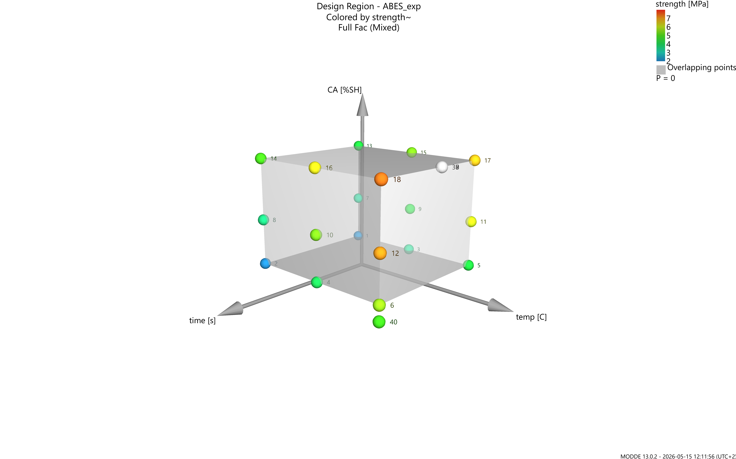
 | 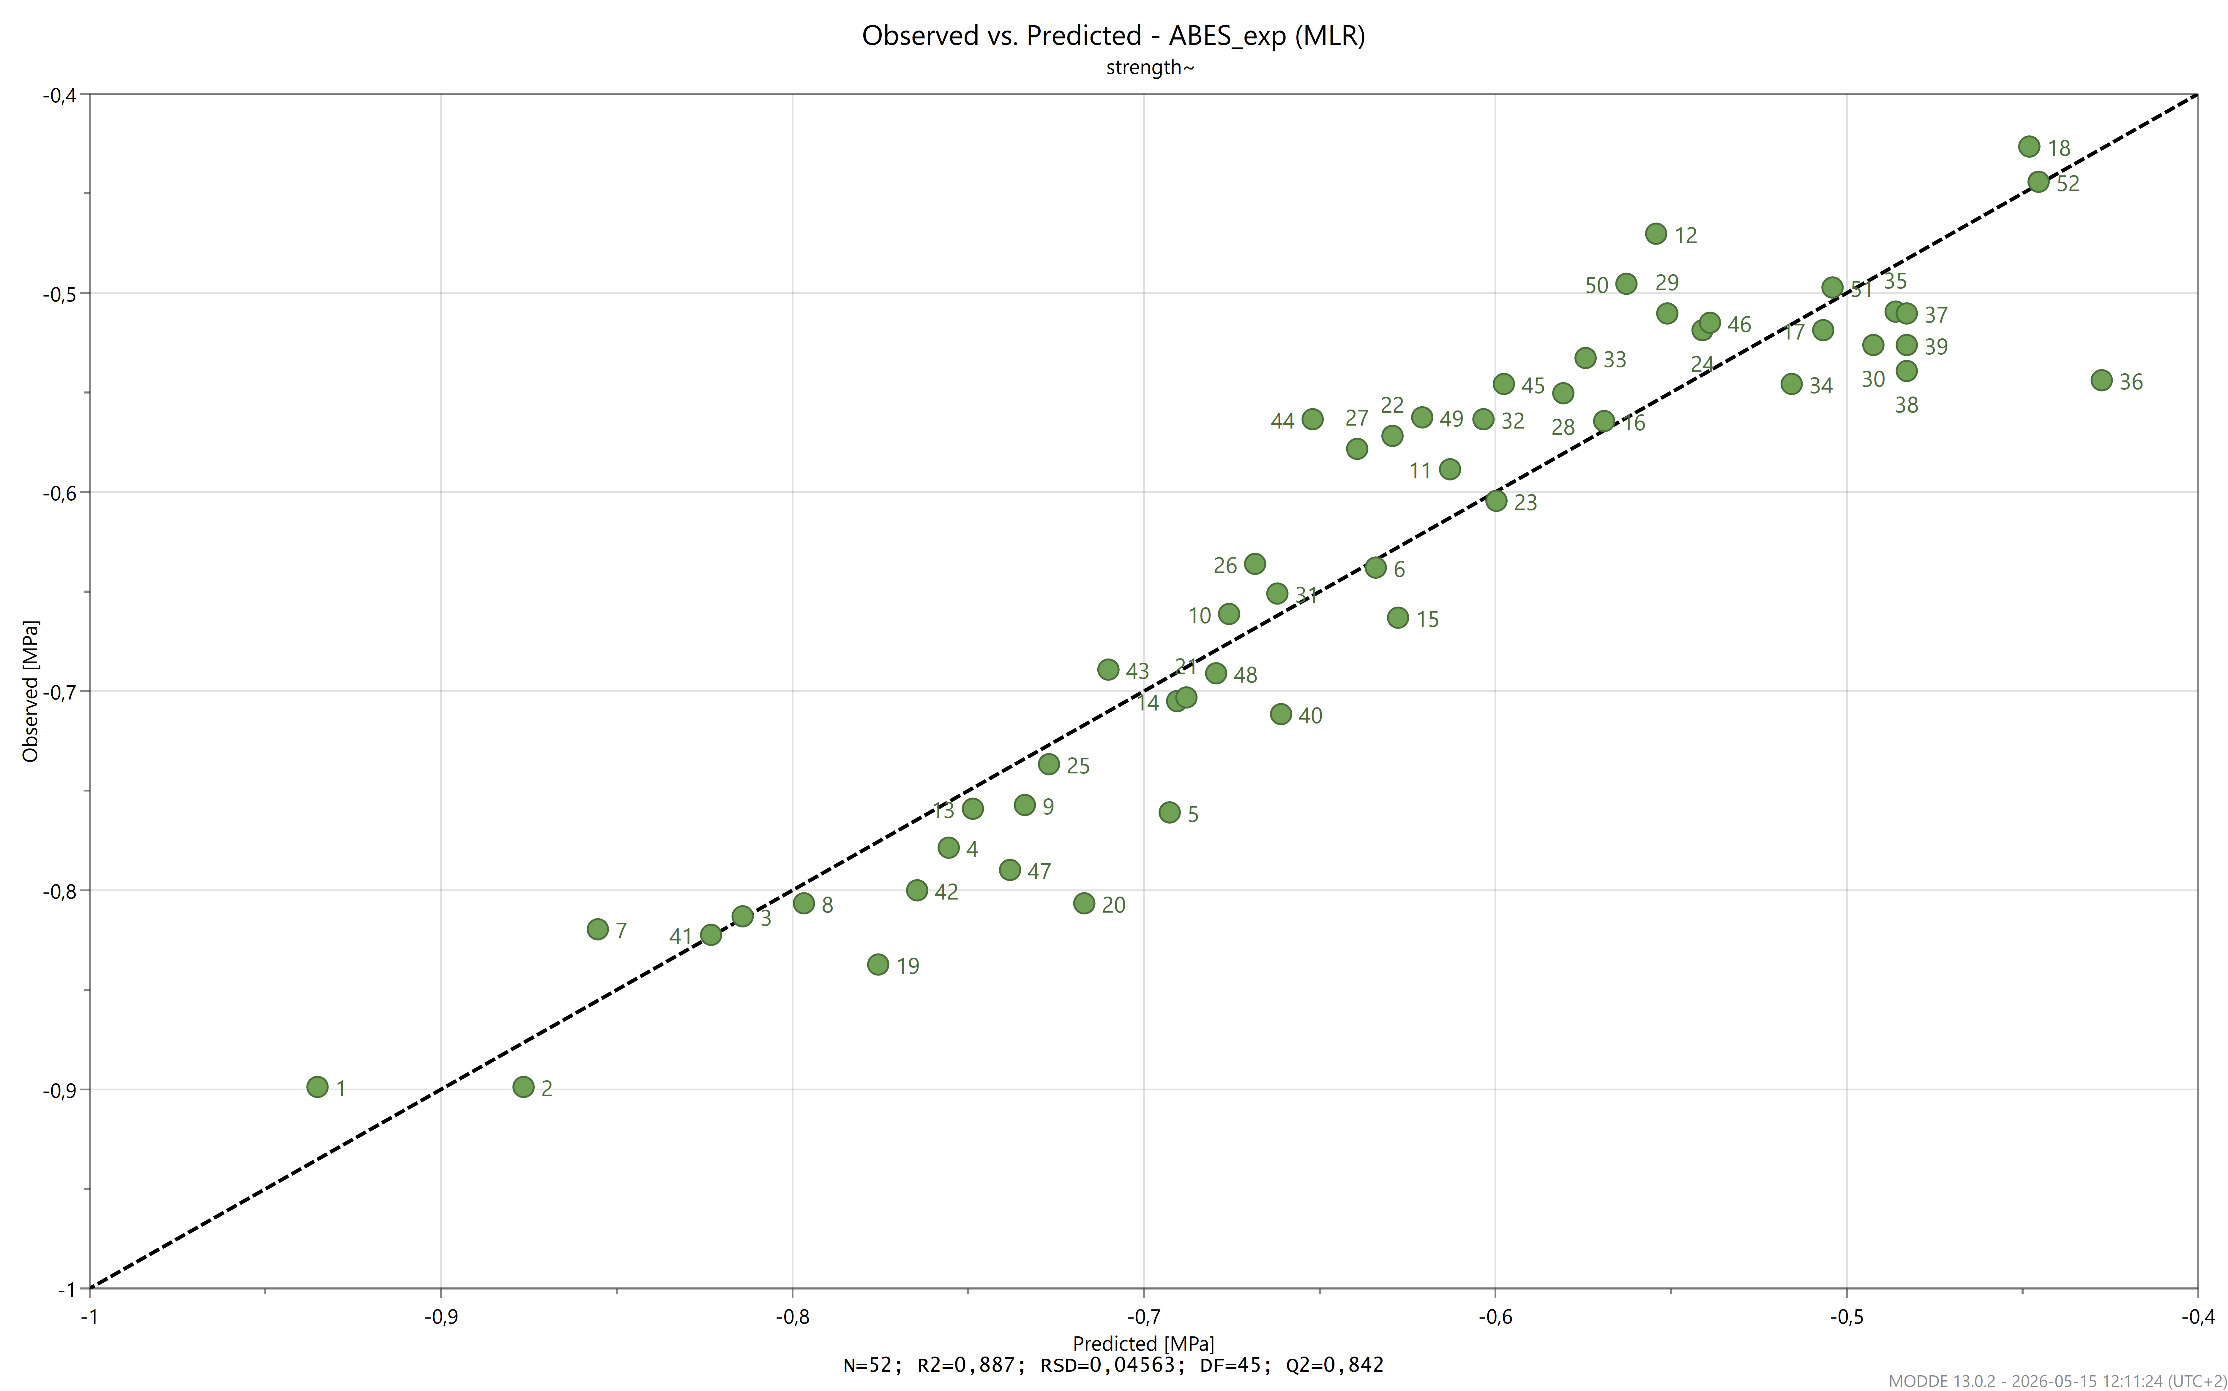
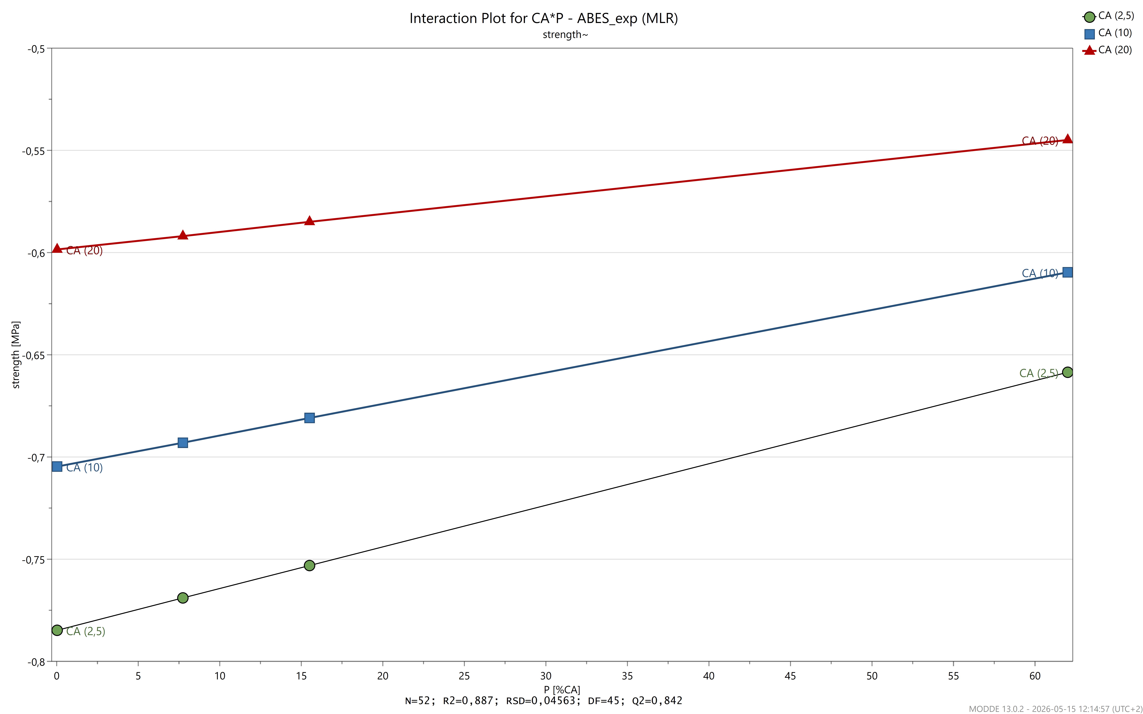 | 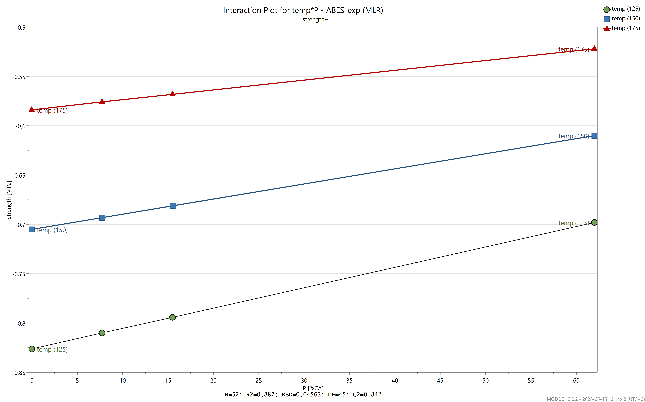
S 2: Model parameters for DOE of ABES data. Design space, correlation plot, effects plot, observed vs. predicted plot, interaction plots of CA – P and Temperature – P.
S Table 2: Unscaled and uncentered MLR model coefficients and model summary data.
Strength~ | Coeff. | Std. Err. | P | Conf. int(±)
Constant | -162.594 | -- | -- | --
Time | 0.000195 | -- | -- | --
Temp | 0.004846 | -- | -- | --
CA | 0.010643 | -- | -- | --
P | 0.005415 | -- | -- | --
Temp*P | -2.14E+00 | -- | -- | --
CA*P | -6.70E+00 | -- | -- | --
N = 52 | Q2 = | 0.842 | Cond. no. = | 1.68
DF = 45 | R2 = | 0.887 | RSD = | 0.04563
 | R2 adj. = | 0.872
 |  |  | Confidence = | 0.95

2 FTIR
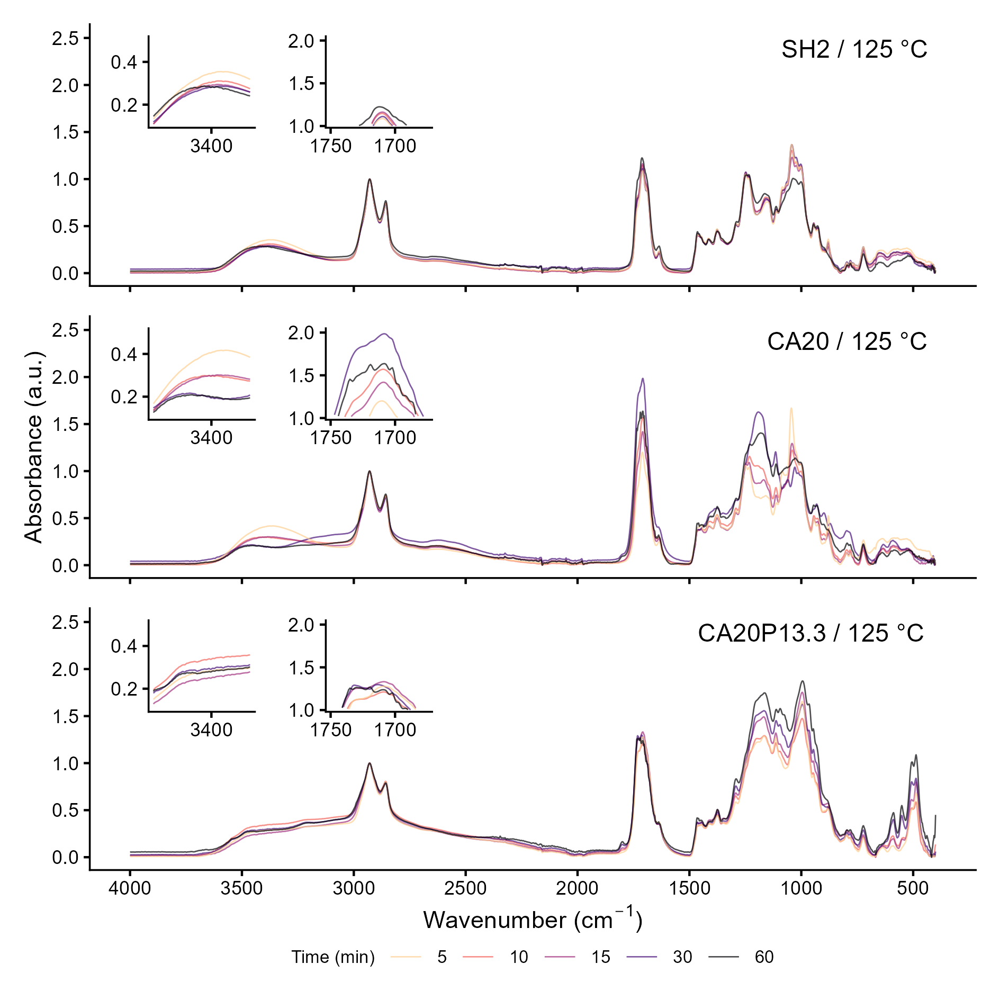 | 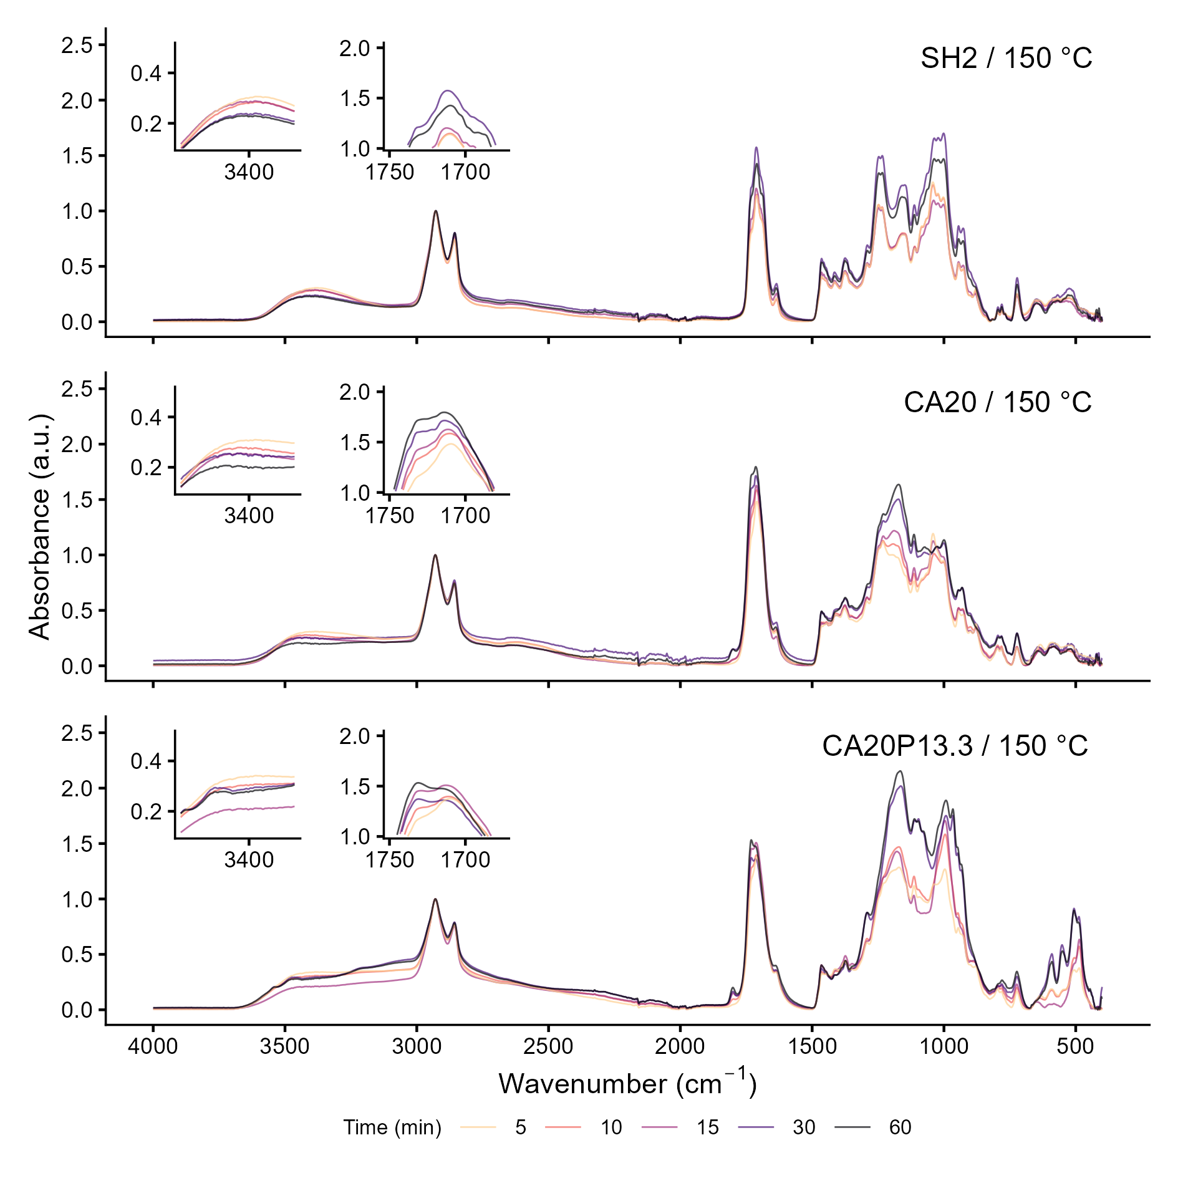
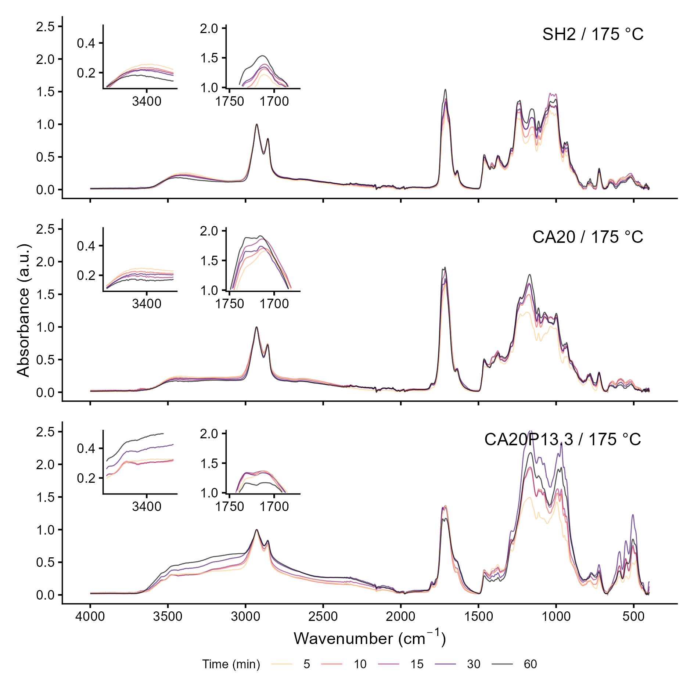
S 3: FTIR spectra of samples cured at different temperatures for different times.

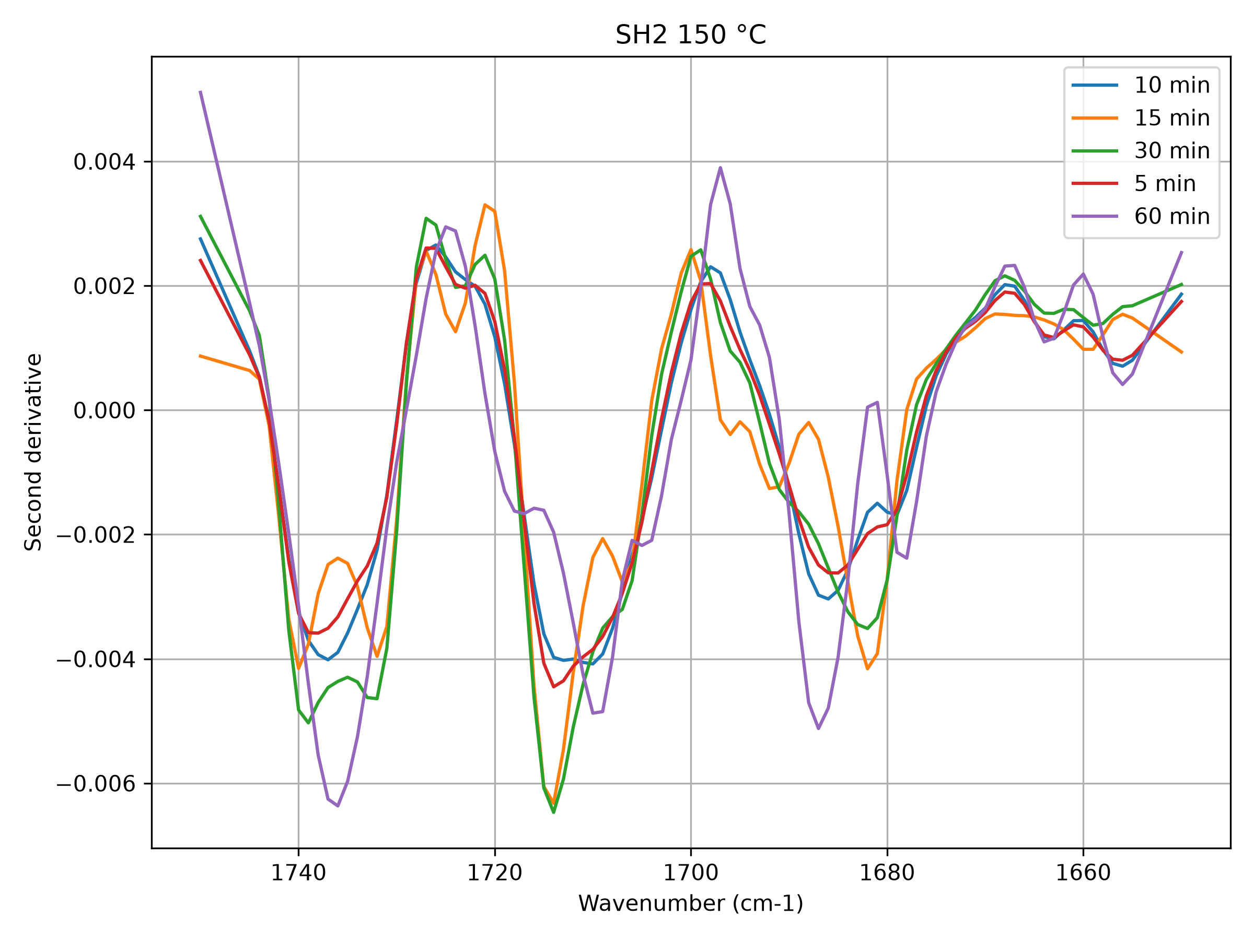 | 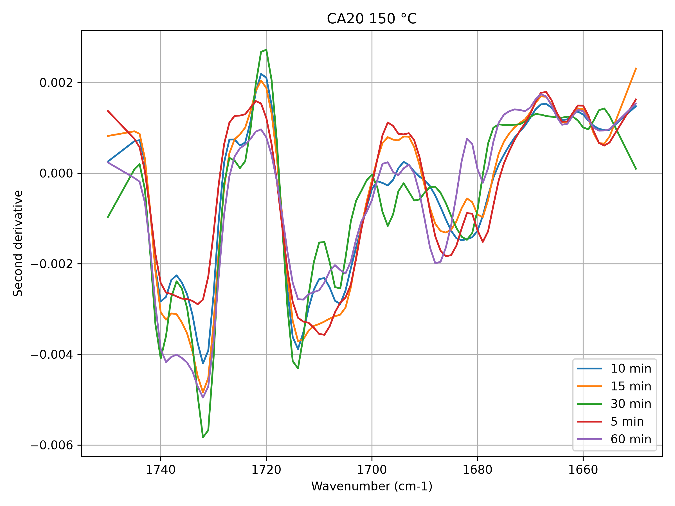
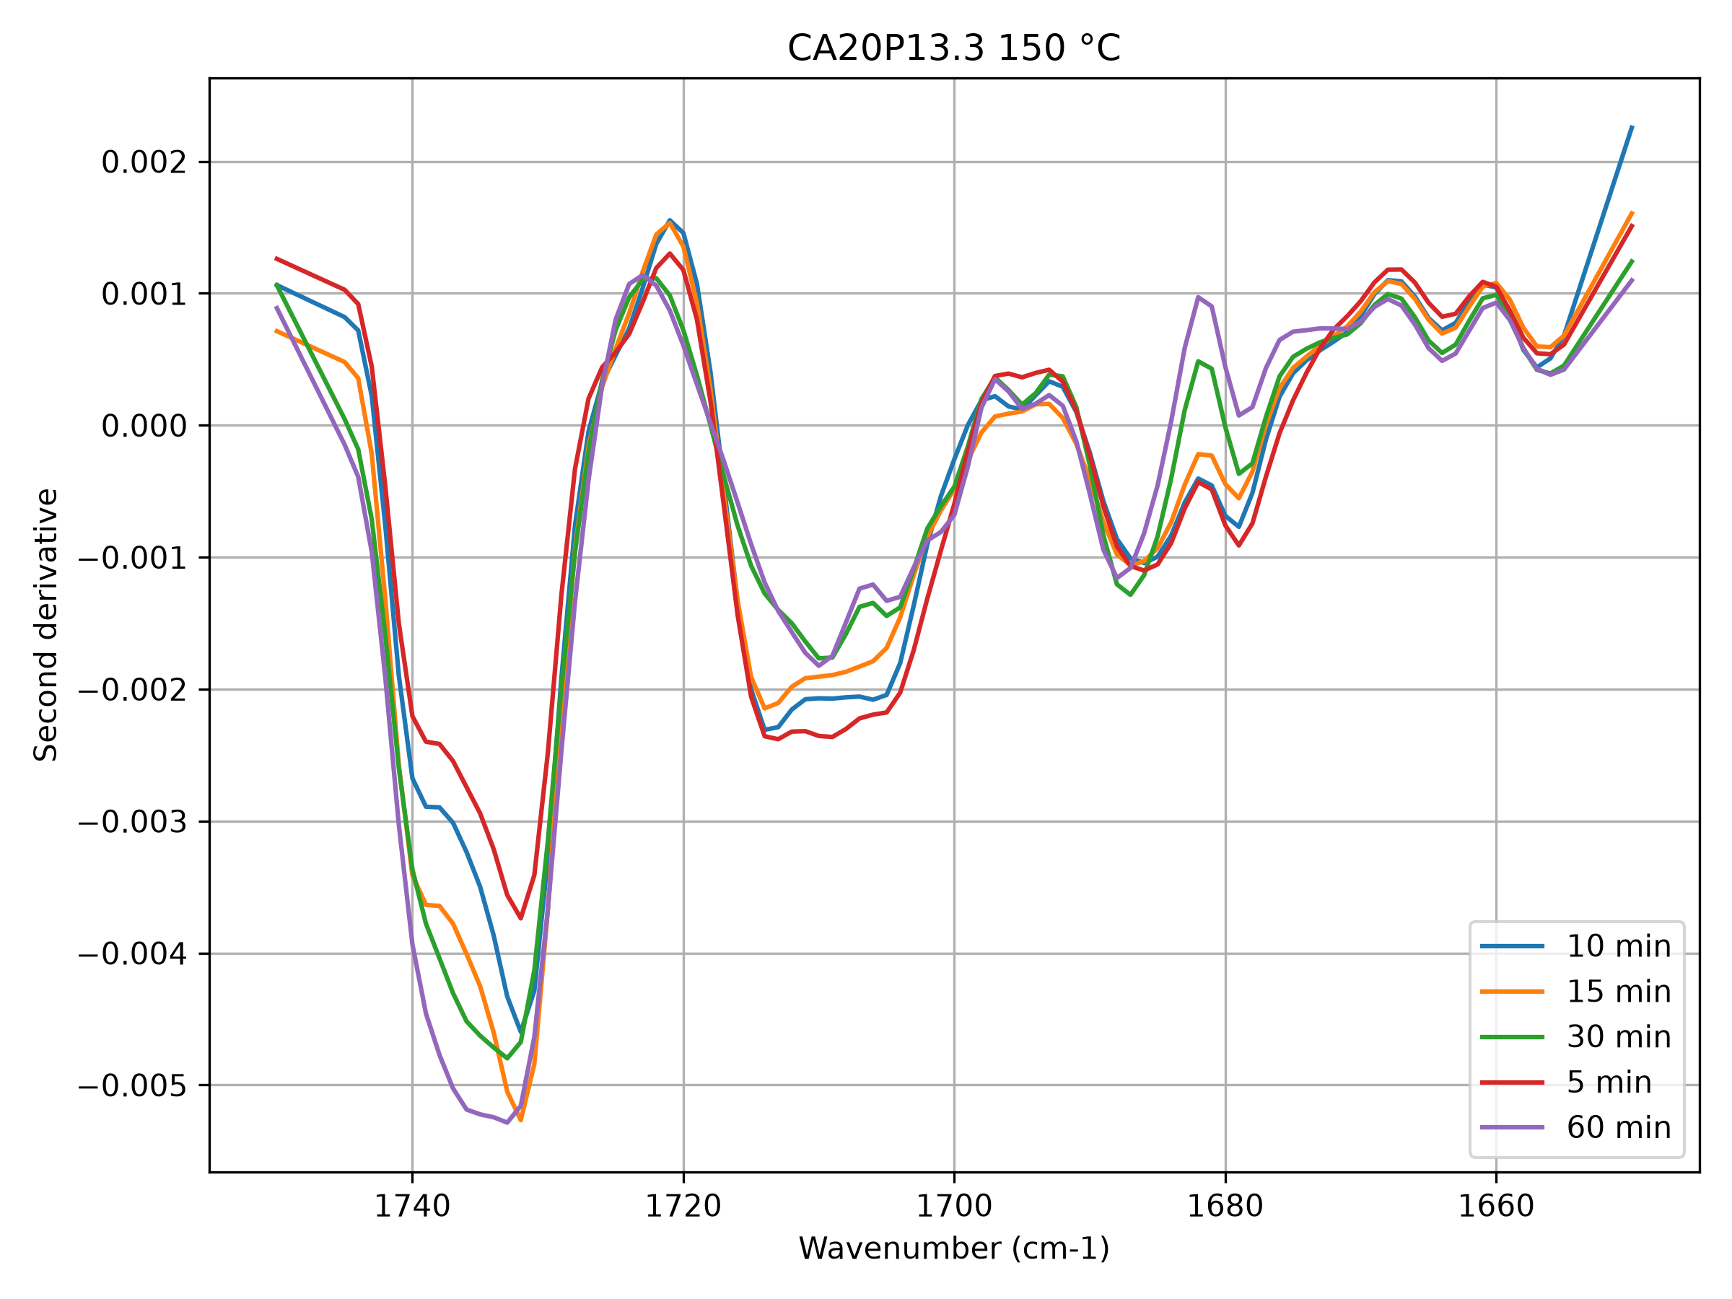
S 4: Second derivative of FTIR spectra around the carbonyl region (1750 - 1650 cm-1) for curing at 150 °C.
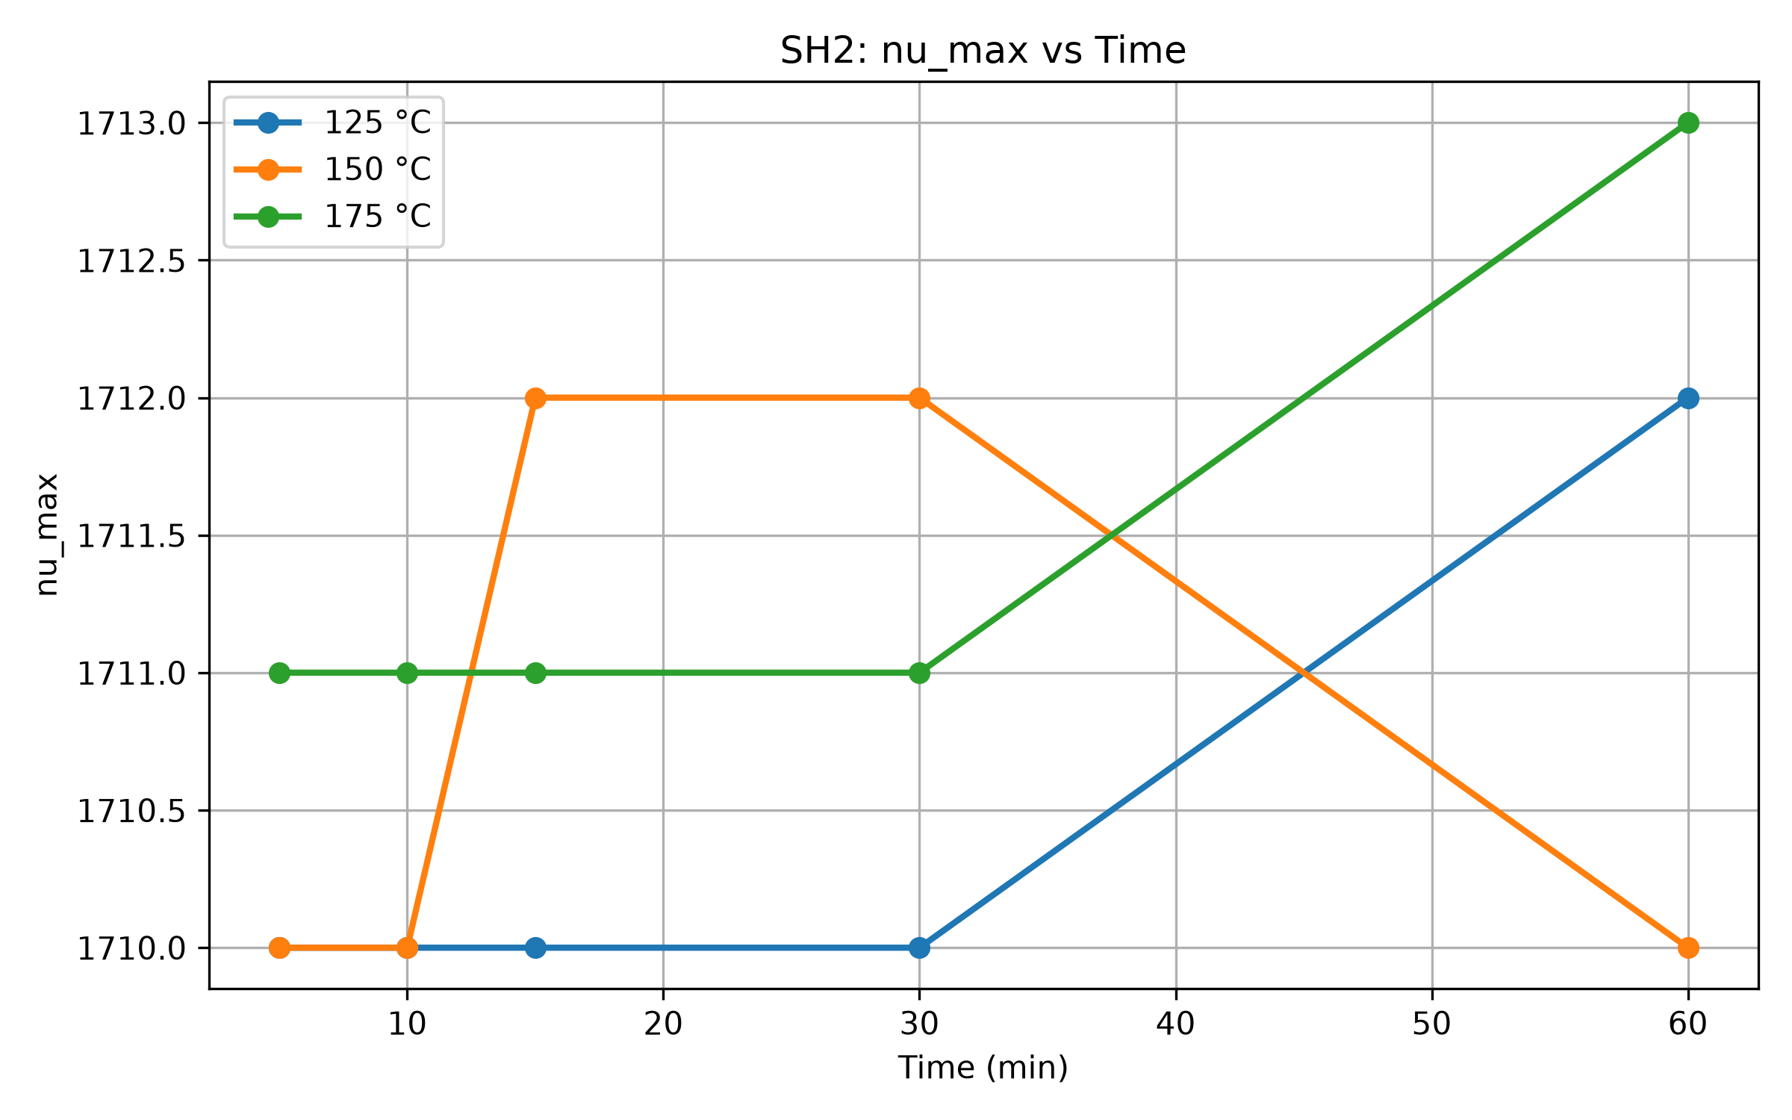 | 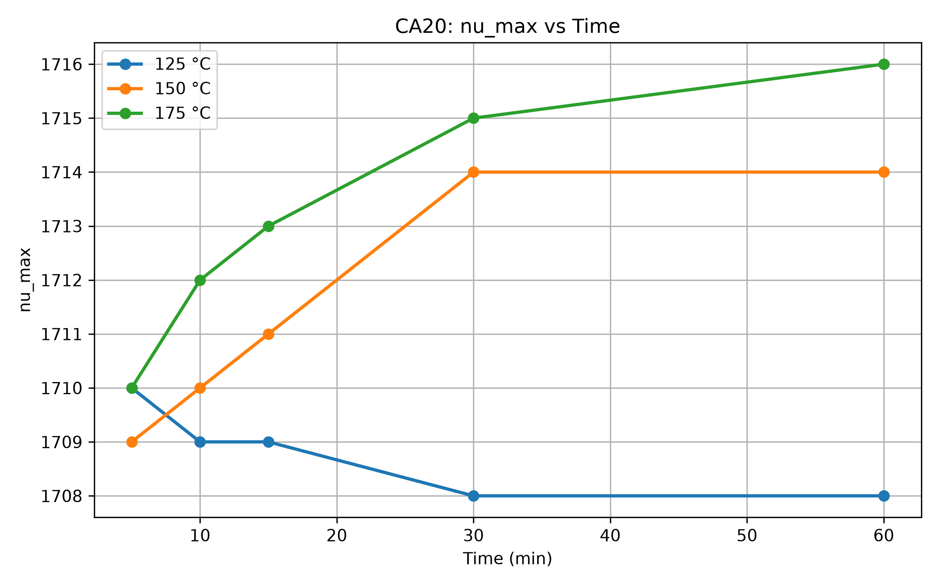
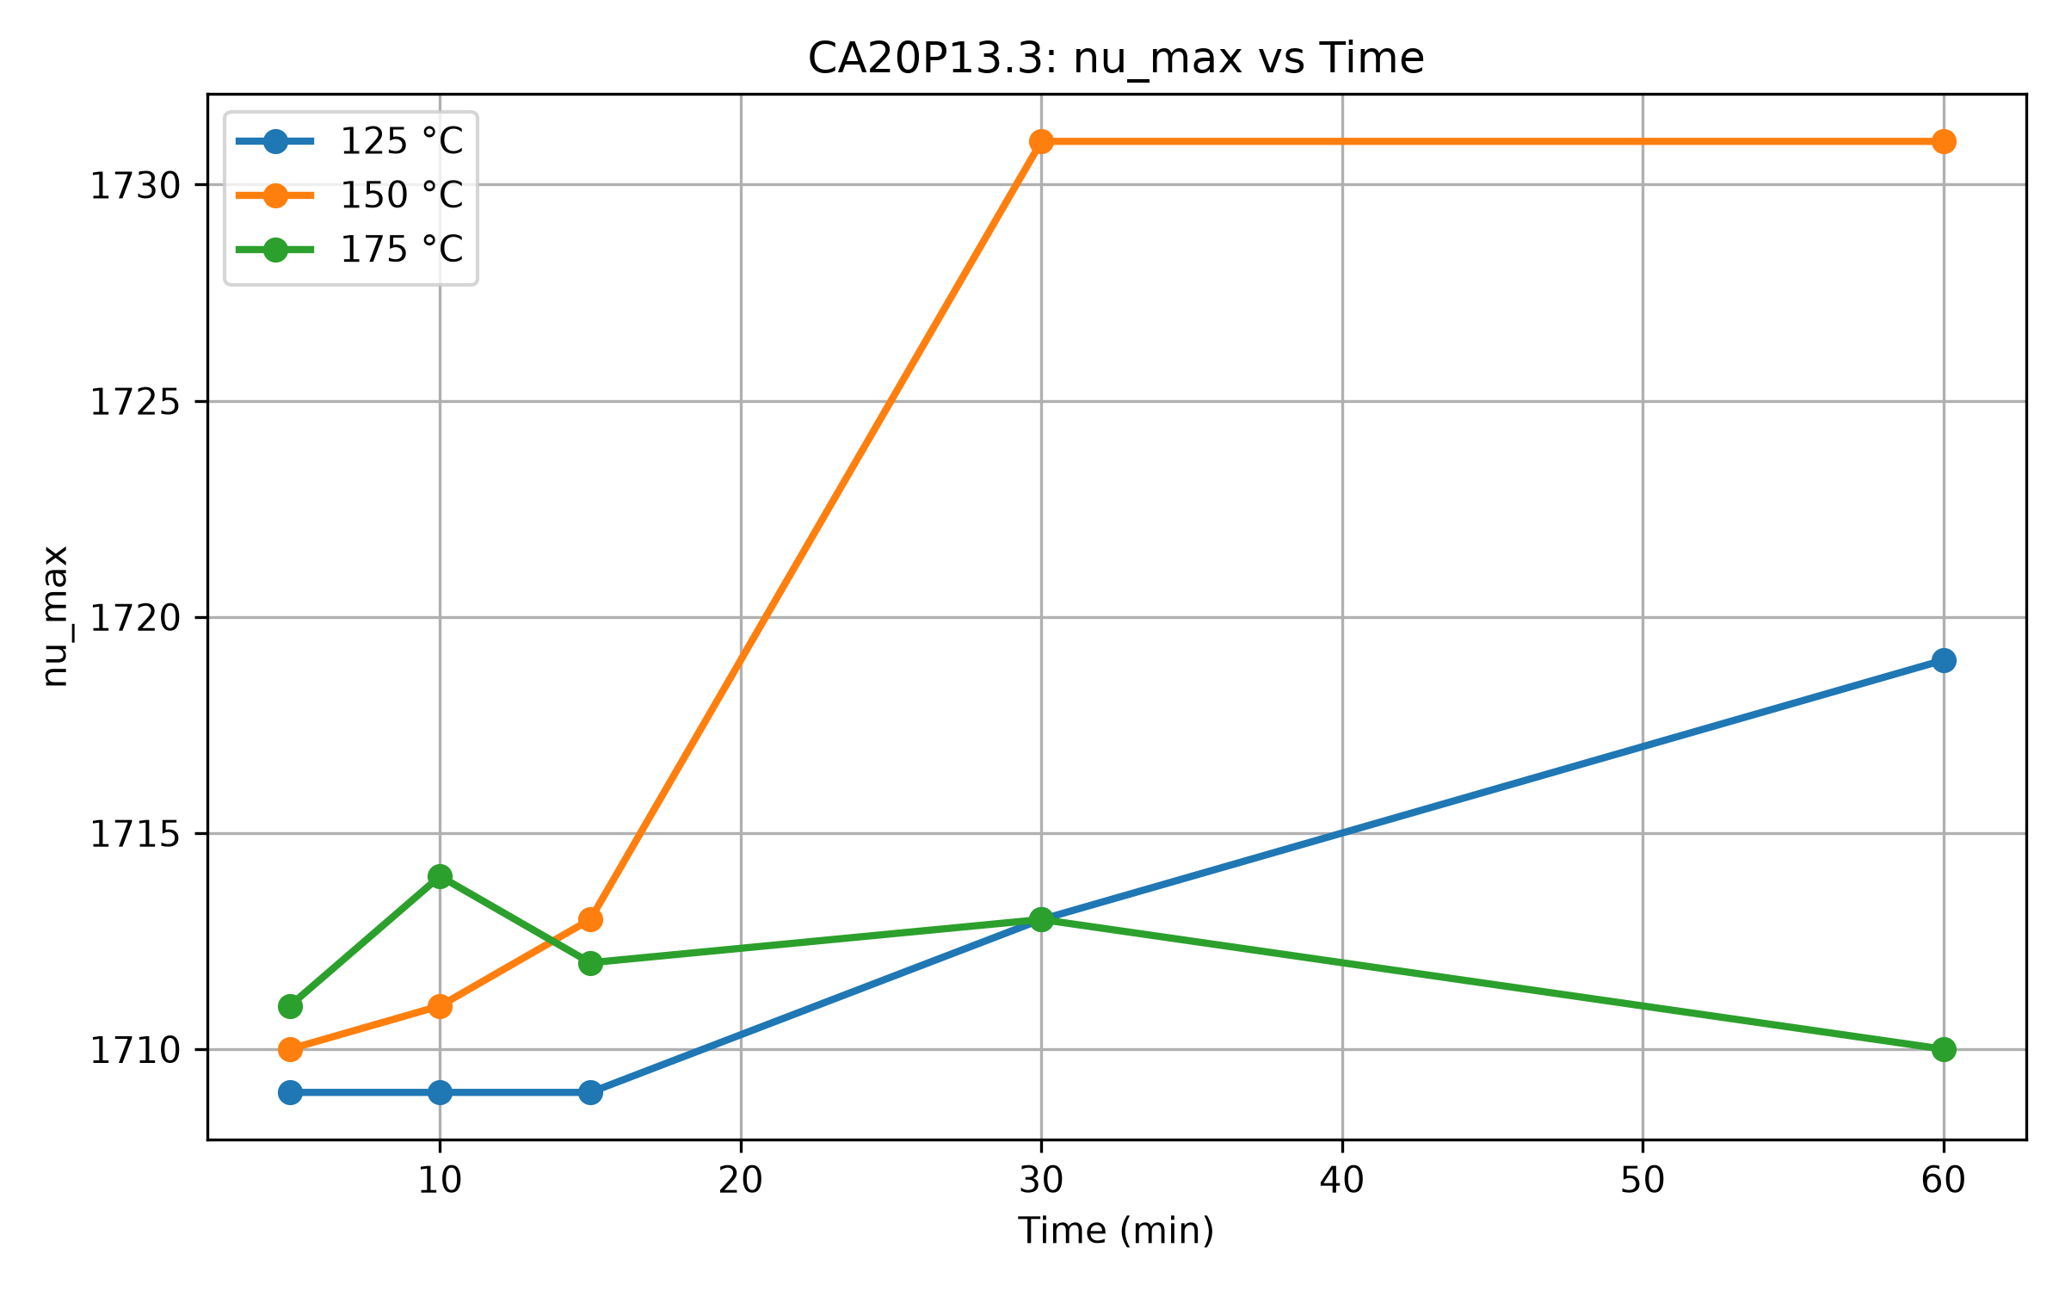
S 5: Shift of peak at 1712 cm-1 due to curing time and temperature.

3 DSC
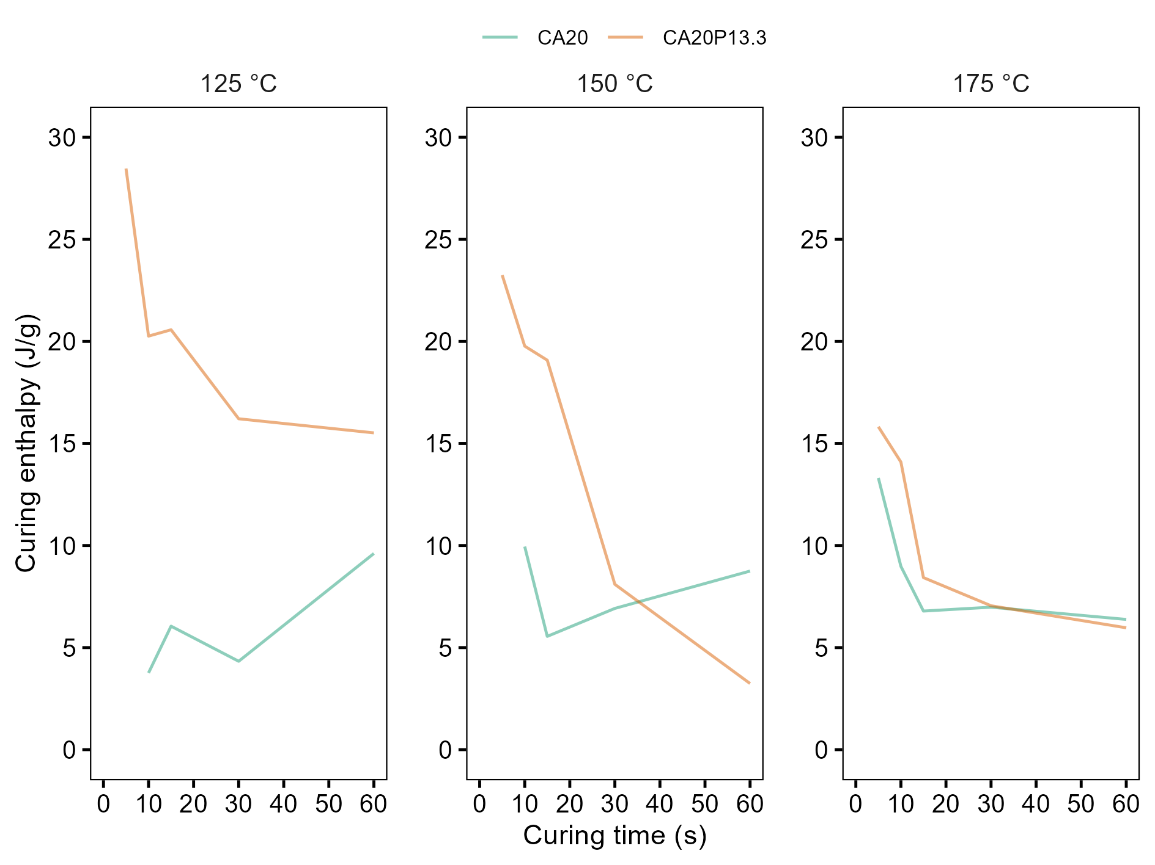  a) | 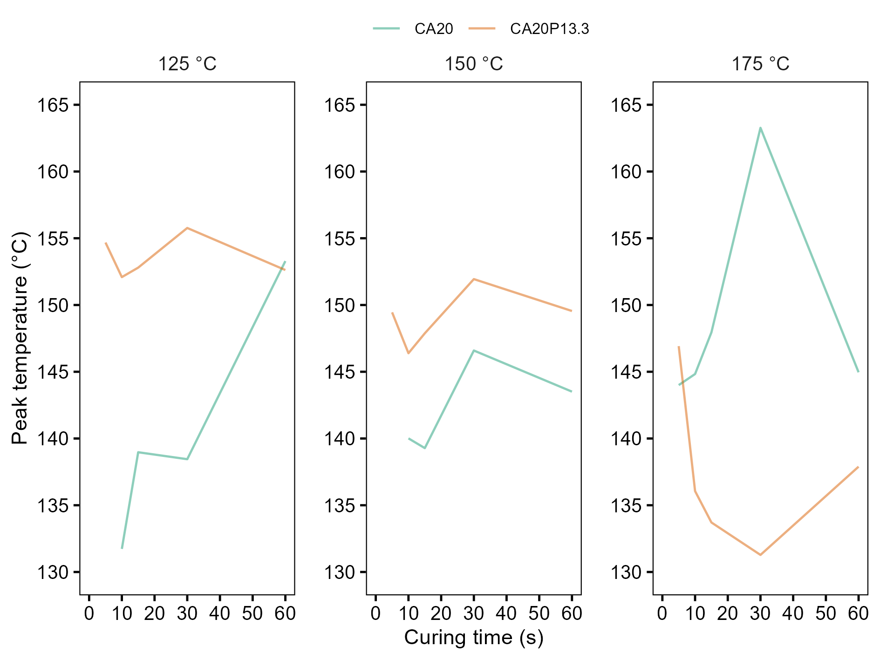  b)
c)

S 6:Changes in curing enthalpy (a), peak temperature (b), and glass transition temperature (c) as a function of time and curing temperature.

4 ABES MODEL FIT
S Table 3: Comparison of model fit for bond strength development data from ABES.
Adhesive | Model | AIC | RMSE | R2
SH2 | Exponential | 142.00 | 0.738 | 0.850
CA20 | Exponential | 135.82 | 0.714 | 0.752
CA20P13.3 | Exponential | 92.95 | 0.499 | 0.925
SH2 | Gompertz | 143.58 | 0.735 | 0.851
CA20 | Gompertz | 86.37 | 0.465 | 0.895
CA20P13.3 | Gompertz | 114.26 | 0.587 | 0.897
SH2 | Avrami | 127.51 | 0.644 | 0.886
CA20 | Avrami | 79.68 | 0.440 | 0.906
CA20P13.3 | Avrami | 92.66 | 0.490 | 0.928
SH2 | Logistic | 150.28 | 0.777 | 0.834
CA20 | Logistic | 89.54 | 0.477 | 0.889
CA20P13.3 | Logistic | 125.74 | 0.645 | 0.875

