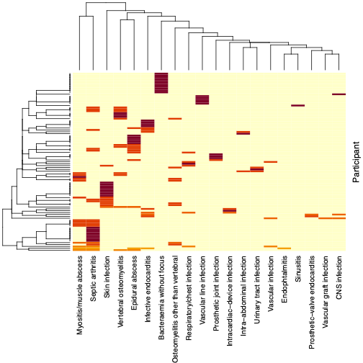

Figure S1. Heatmap representing the combination of infection foci among 89 BARISTA participants with S. aureus bacteraemia. Hierarchical clustering in R was used to generate the dendrograms.

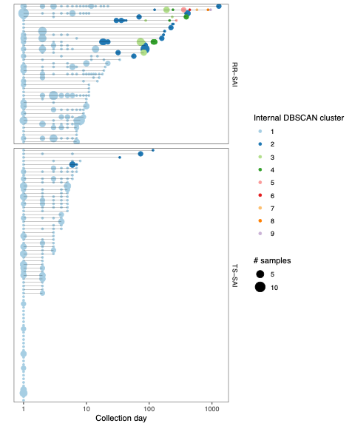

Figure S2. Microbiological samples timelines for refractory / recurrent S. aureus infections (RR-SAI) and treatment-sensitive S. aureus infections (TS-SAI). Dot size is proportional to the number of sample collected per day, while the colour depicts the internal cluster based on DBSCAN. Each row represent a study participant, the x axis is in logarithmic scale. All recorded microbiological samples are represented, including samples not included in the study.
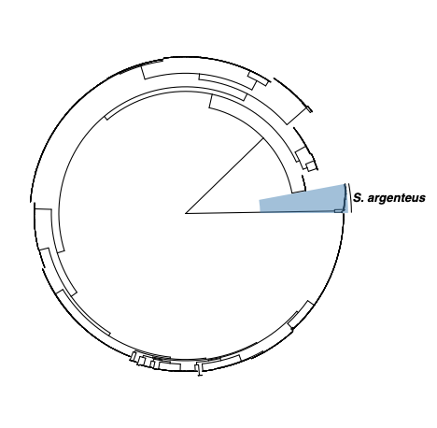
Figure S3. Global phylogeny of all 1,971 genomes included in BARISTA (57 Staphylococcus argenteus genomes are highlighted in blue).
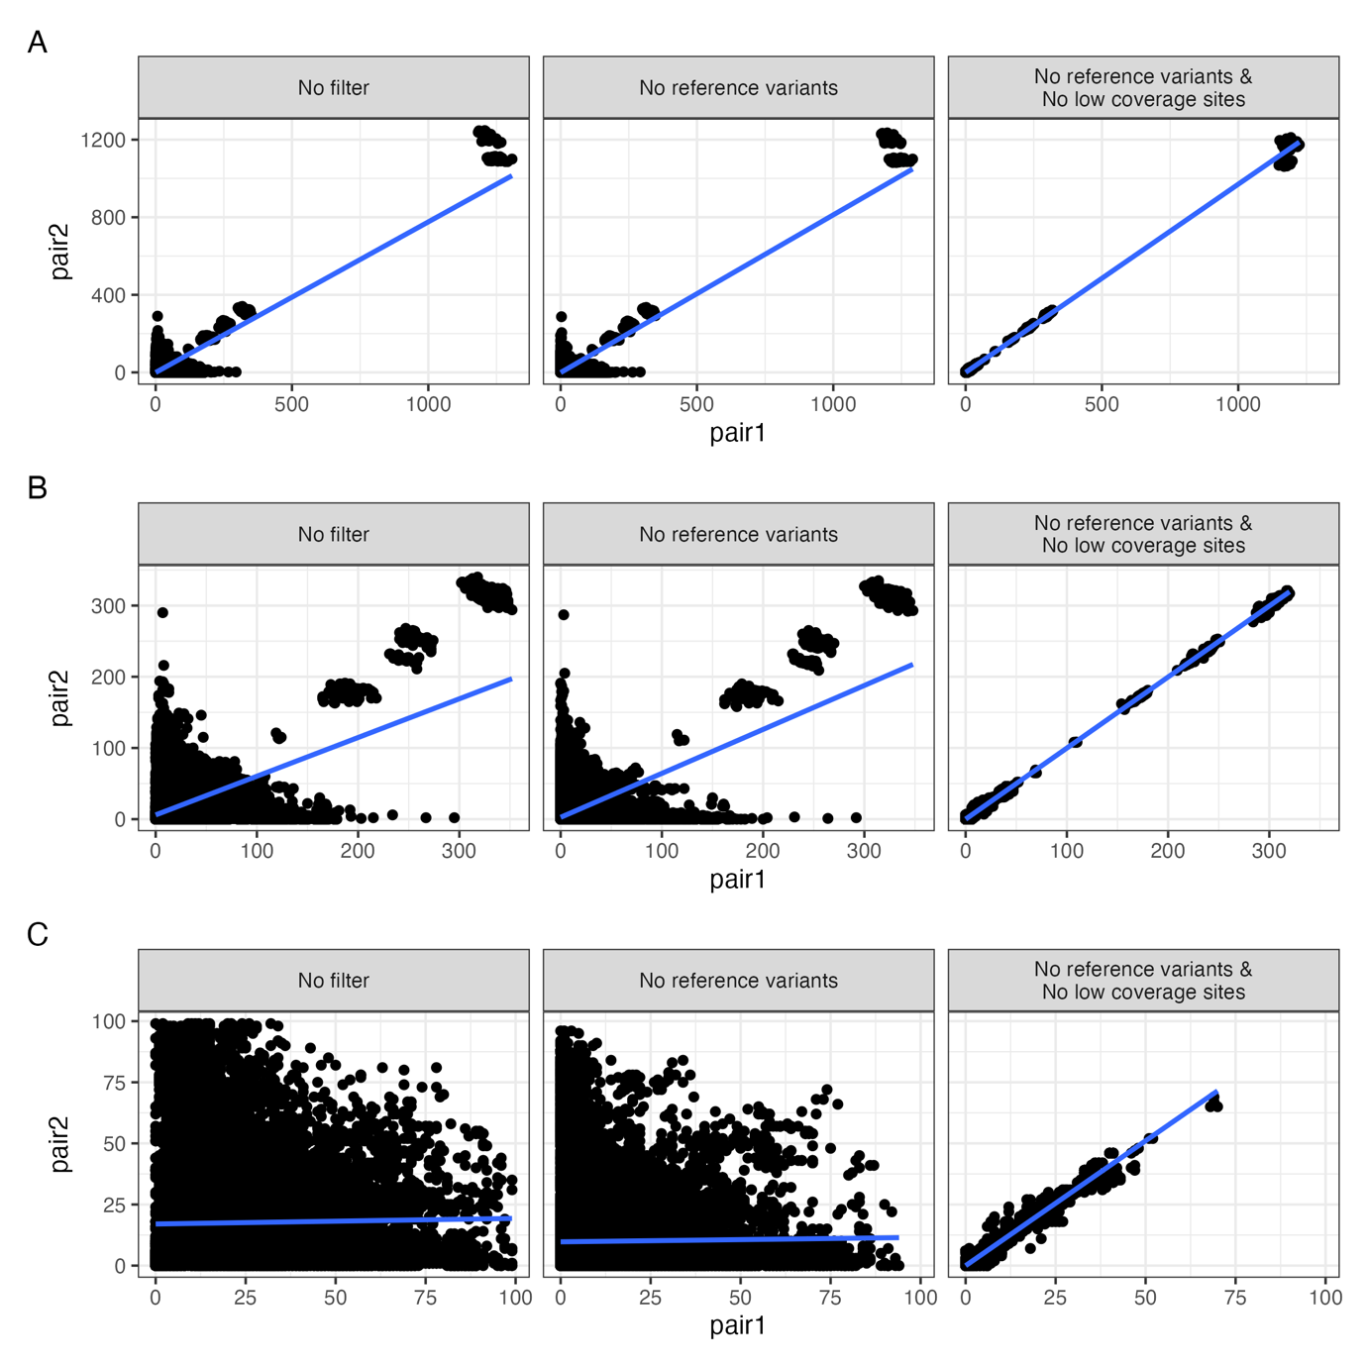

Figure S4. Mutation counts correlation between symmetric pairs (i.e. pair1: iso2 reads on iso1 vs pair2: iso1 reads on iso2), according to the filtering method: raw Snippy output (No filter); after masking of variants from reference reads (No reference variants); after masking of variants from reference reads and sites with low coverage (< 10x) (No reference variants & No low coverage sites). A: All comparisons. B: Less than 1,000 variants per comparison. C: Less than 100 variants per comparison.

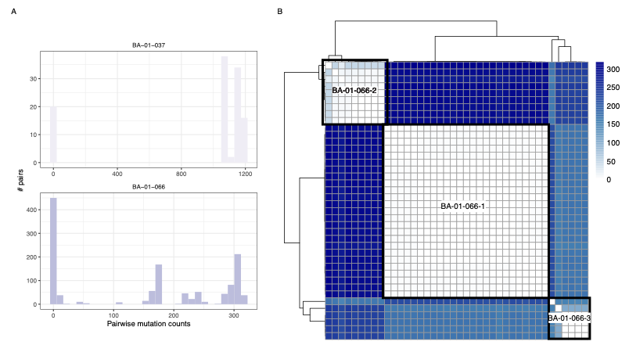

Figure S5. Mutations visualisations of BARISTA participants with maximum pairwise mutation counts between 100 and 1000. A: Distribution of pairwise mutation counts. B: Heatmap depicting the genetic distance based on BA-01-066 pairwise mutations counts. The three MRPs identified based on hierarchical clustering are shown.

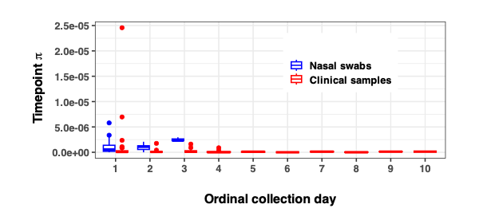

Figure S6. Within-timepoint diversity π at each collection timepoint.

