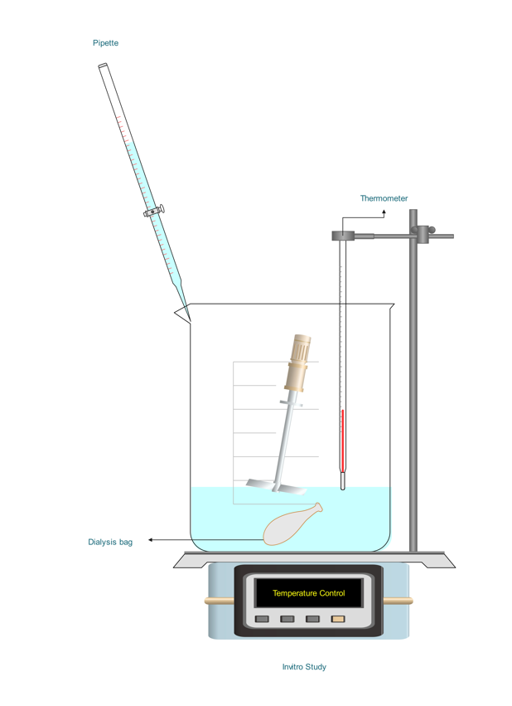
Fig S. 1 Schematic representation of the in vitro study setup.

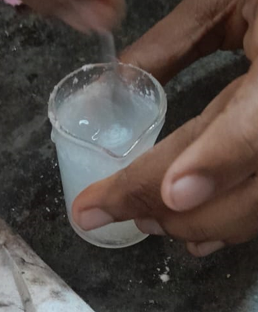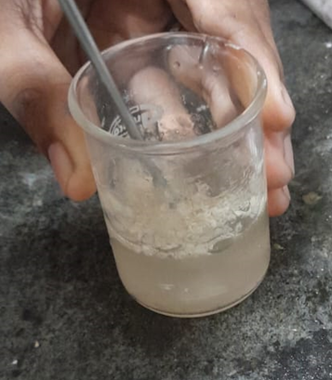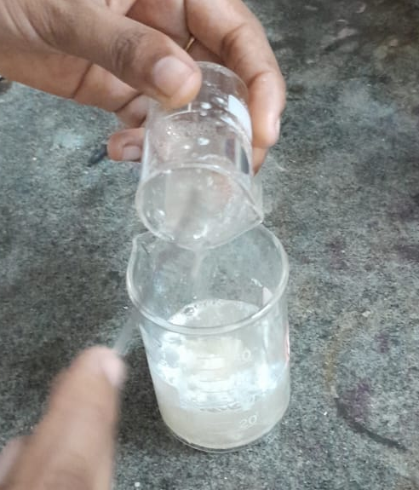
Fig S. 2. a) Caseinate in citric acid solution. b) Sodium Alginate in distilled water. c) Mixing of both the solutions.

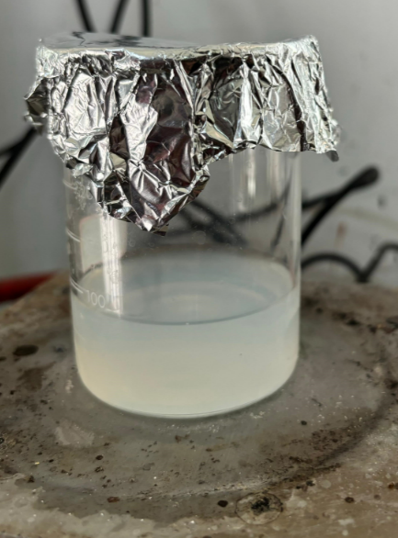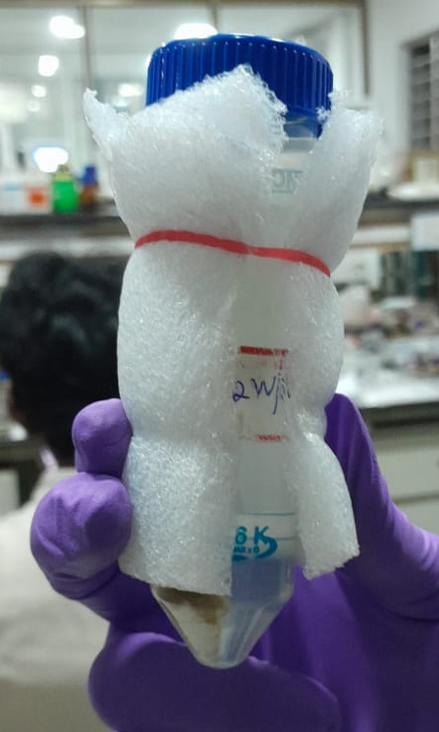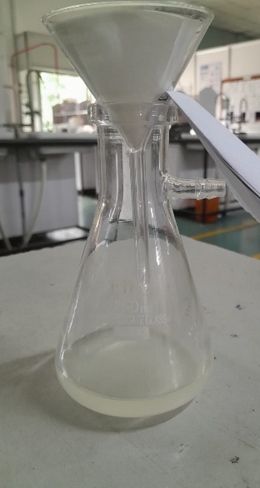
Fig S. 3. a) Magnetic stirring. b) Centrifuged sample. c) Filtering the centrifuged sample.

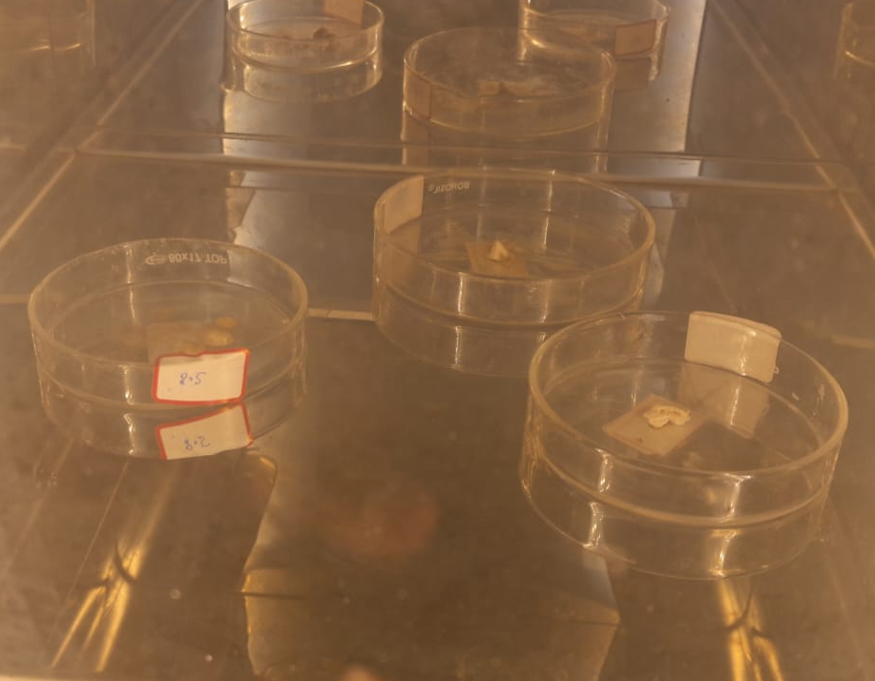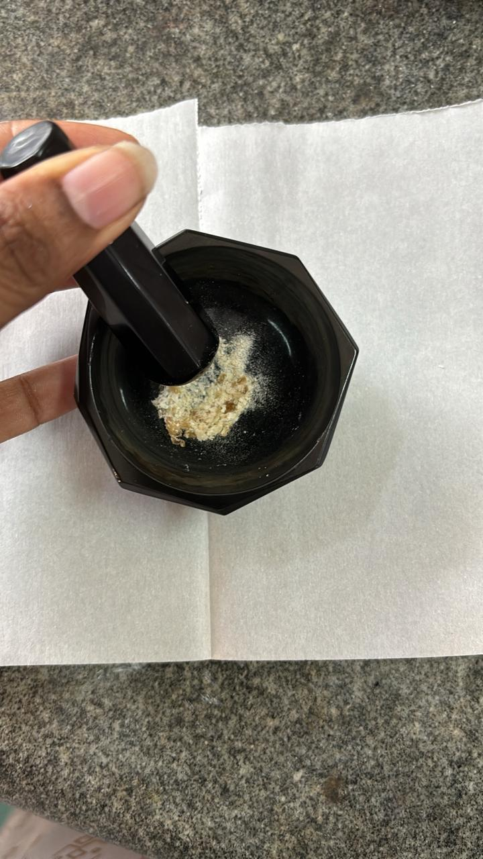
Fig S. 4. a) Vacuum drying the settled particles after filtering. b) Grinding and powdering of sample.

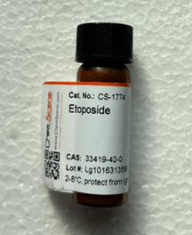
Fig S. 5. Etoposide medication.

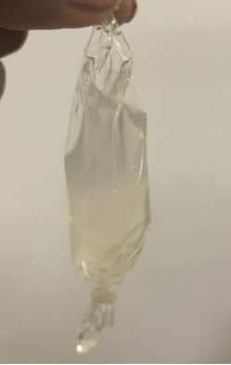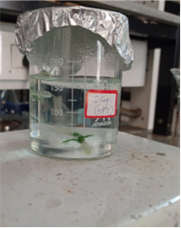

Fig S. 6. a) Dialysis bag. b) Dialysis bag submerged in phosphate buffer solution.

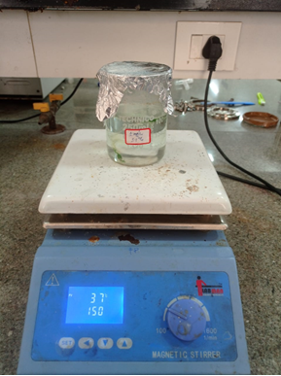
Fig S. 7. In vitro study setup.

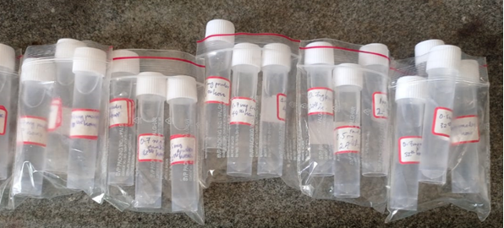
Fig S. 8. Samples collected for testing and analysis.

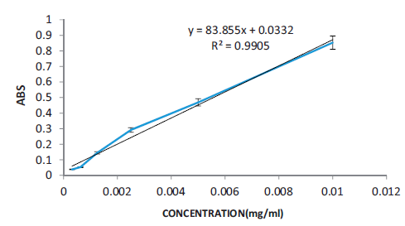
Fig S. 9. Calibration curve

Table S.1 PLIP-validated hydrogen-bond interactions between etoposide and casein residues (D···A ≤ 4.1 Å; D–H···A angle ≥ 90°; PLIP v3.0.0).
Complex | Residue | Donor Atom | Acceptor Atom | D···A (Å) | D-H···A (°)
α-CN | Glu45 | Oε (sidechain) | O3-etoposide (hydroxyl) | 4.03 | 112.6°
α-CN | Val46 | N (backbone NH) | O3-etoposide (hydroxyl) | 3.19 | 133.9°
α-CN | Phe47 (i) | O3-etoposide (hydroxyl) | O2-Phe47 (backbone C=O) | 2.80 | 110.3°
α-CN | Phe47 (ii) | N (backbone NH) | O3-etoposide (hydroxyl) | 3.75 | 148.6°
β-CN | Gln55 | O3-etoposide (hydroxyl) | Oε-Gln55 (sidechain C=O) | 2.76 | 157.5°

