An MF59-Based Nanoemulsion Adjuvant： Couples Immunogenic Cell Death with Trained Immunity for Potent RSV Vaccine Responses

Authors: Baoshuo Ruan^{1#}, Mingzhi Zheng^{1#}, Jinrong He^{1,2#}, Qiong Long¹, Hongmei Bai¹, Ying Yang¹, Xu Yang¹, Yiting Ding¹, Xiaoning Li¹, Wenjia Sun¹, Peng Zheng¹, Tong Yu¹, Xin Yin¹, Hui Li^{1,3}, Yanbing Ma^{1,}*
¹Laboratory of Molecular Immunology, Institute of Medical Biology, Chinese Academy of Medical Sciences & Peking Union Medical College, Kunming 650118, China
²Yunnan Provincial Center for Disease Control and Prevention (Yunnan Provincial Academy of Preventive Medicine), Xianghe Road #1177, Kunming, Yunnan, 650500, China.
³School of Life Sciences, Yunnan University, Kunming 650091, China.
# Baoshuo Ruan and Mingzhi Zheng and Jinrong He contributed equally to this work.
* Correspondence: MolecularImmunology@imbcams.com.cn
Supplement Figure1~3

Material and methods
3.1 Experimental animals and models
The animals used in this study were SPF female BALB/c mice (6-8 weeks old). They were purchased from Sberford (Beijing) Biotechnology Co., Ltd., and the mice were raised in the Experimental Animal Center of the Institute of Medical Biology, Chinese Academy of Medical Sciences. All animal experiments were in accordance with the ethical and moral standards of experimental animals. The experiment was approved by the Animal Use and Management Committee of the Institute of Medical Biology, Chinese Academy of Medical Sciences ( ethical number : DWSP202110005 ).
3.2 Preparation of MF59 and MF59@MDP nanoemulsion adjuvant
Referring to the formula of MF59 nanoemulsion adjuvant reported by Novartis Pharmaceutical Co., Ltd^{[51]}, we prepared a nanoemulsion adjuvant formula with a mass volume ratio (w/v) of 4.3% squalene, 0.5% Span85, 0.5% Tween80 and dissolved in citric acid buffer (pH6.5~7.0). MF59 is composed of 4.3 % (w/v) squalene and 0.5% (w/v) Span85 in a beaker, and the mixed oil phase is uniformly mixed at 1000 rpm. MM59@MDP was composed of 4.3% (w/v) squalene, 0.5% (w/v) Span85 and 3 mg MDP dissolved in 1mL DMSO in a beaker. The mixed oil phase was uniformly mixed at 1000 rpm. 0.5 % (w/v) Tween80 and citric acid buffer (pH 6.5 ~ 7.0 ) were mixed in a conical flask, and the mixed aqueous phase was uniformly mixed at 1000 rpm. The mixed solution was uniformly mixed at 1000 rpm for 30 min to prepare the colostrum. The nanoemulsion adjuvant was prepared at 700 bar at high pressure homogenizer. After the preparation was completed, the 0.22 μm filter membrane was filtered to obtain sterile MF59 nanoemulsion adjuvant under different conditions.
3.3 The MF59 nanoemulsion adjuvant prepared under different conditions was detected by Malvern particle size analyzer.
After 10 μL of MF59 nanoemulsion particles prepared by different engineering methods were diluted to 1 mL with PBS, the cuvette was placed in a Malvern particle size analyzer for dynamic light scattering (DLS) measurement to determine the particle size distribution (size) and polydispersity index (PDI) of different nanopreparations.
3.4 Transmission electron microscopy (TEM) was used to detect the adjuvant prepared under different conditions.
10 μL of nanoemulsion particles prepared under different conditions were added to the carbon-coated copper mesh, and then stood at room temperature for 5min. The excess liquid on the copper mesh was removed by absorbent paper, and the 2% phosphotungstic acid solution (pH=6.5) was prepared. The staining solution was dried for 30 min, and the prepared electron microscope samples were placed in a transmission electron microscope (model HITACHI H-7650) for observation at a voltage of 80 kV.
3.5 Nanoemulsion adjuvant physically stimulates cell death to release immunogenic substances
293T cells were seeded proportionally in 6-well plates. When confluence reached 80%, a total volume of 100 µL was prepared, to which different volumes of MF59@MDP were added, with the remaining volume made up using complete medium. After 24 h of incubation, the culture supernatants were collected for immunogenicity detection. ATP, LDH, and dsDNA were measured using (Beyotime cat: S0027), (Beyotime cat: C0019S), and (Yeasen cat: 12640ES60), respectively.
3.6 Isolation and preparation of mouse BMDCs
The femur and tibia of mice were taken : C57BL/6J mice aged 6-8 weeks were anesthetized and sacrificed, and the mice were immersed in 75% alcohol for disinfection. An incision of about 1cm in diameter was cut in the abdomen of the mice with scissors. The femur and tibia of the mice were taken out, and the muscles around the bone were shaved as much as possible and immersed in 75% alcohol for 5min. The isolation of bone marrow cells : The isolated femur and tibia of mice were transferred to a sterile PBS. After washing 2-3 times, the ends of the femur and tibia were cut with scissors. The bone marrow cells in the femur and tibia were repeatedly washed with 1mL sterile RPMI-1640 medium, and the collected cell suspension was placed in a 15mL centrifuge tube using a 70mm cell network filter. The collected cell suspension was centrifuged at 500 xg for 5min, 5mL of red blood cell lysate was added to lyse red blood cells, and then 5mL of sterile PBS was added to terminate, 800 xg was centrifuged for 5min, and the cells were collected. Induced differentiation of BMDCs: The cells were resuspended in RPMI-1640 complete medium containing 10% fetal bovine serum and 1% double antibody, and then added to the culture dish, 10mL/dish. Recombinant mouse granulocyte-macrophage colony stimulating factor (GM-CSF) was added to the culture medium to a final concentration of 10 ng/mL. The culture dish was placed in a 37°C, 5% CO2 incubator for static culture. Half of the medium was changed 3 days after culture. 5mL medium was slowly sucked out, and RPMI-1640 complete medium containing 10ng/mL GM-CSF was added to continue culture (the medium was changed every two days). BMDCs were collected after 8days of culture for subsequent experiments.
3.7 Western Blot Analysis
BMDCs were isolated as reported previously. A total of 1×10⁶ BMDCs were transfected with 400μL MF59、12µg of MDP、400μL MF59@MDP. To analyze trained immunity pathway activation, cells were lysed at 2 hours post-incubation using RIPA buffer containing PMSF.
Proteins were separated by 10% SDS-PAGE, transferred to PVDF membranes (Millipore), and probed with the following primary antibodies: anti-AKT (CST, 4691T, 1:1000), anti-Phospho-AKT (Ser473) (CST, 4060T, 1:1000), anti-mTOR (CST, 2983T, 1:1000), anti-Phospho- mTOR (Ser2448) (CST, 5536T, 1:1000), anti-HIF-1α (CST, 14179T, 1:1000), and anti-β-Actin (Proteintech, 66009-1-Ig, 1:20000). HRP-conjugated goat anti-rabbit or anti-mouse secondary antibodies (Proteintech, 1:5000) were used, and signals were detected using an Omni-ECL™ ultrasensitive chemiluminescence kit (Epizyme Biotech).
3.8 Supervise the stimulating effect of immunogenic substances on DC cells.
The collected cell death supernatant was mixed with the complete medium at a ratio of 1:4, and the stimulated differentiated BMDC was laid into a 96 U-shaped hole. The mixed medium was incubated with BMDC overnight. After 24 hours of stimulation, the medium was removed for flow cytometry staining. The phenotypic and functional changes of DC cells after stimulation were identified by flow cytometry.
3.9 immune animal
The purified pre-F protein was diluted to 200μg/mL or 400μg/mL, and 25μL diluted protein solution was mixed with 25μL nanoemulsion adjuvant to prepare pre-F protein subunit vaccine. The vaccine was intramuscularly injected into BALB/c mice according to the immune flow chart, and blood was collected after immunization. The antibody level was detected by ELISA.
3.10 The titer of IgG binding antibody against per-F protein was analyzed by ELISA.
The 50ng pre-F subunit protein was diluted with ELISA coating solution and placed in an ELISA plate, 50 μL per well, coated overnight at 4°C, and washed three times with PBST buffer. The prepared 2% BSA was added, 200μL per well, incubated at 37°C for 1-2 h, and washed with PBST buffer for 3 times. Diluted serum was added, 50μL per well, incubated at 37°C for 1h, and washed with PBST buffer for 3 times. The prepared HRP-Anti Mouse IgG secondary antibody was added, 50μL per well, incubated at 37°C for 1h, and washed 5 times with PBST buffer. Add the chromogenic solution TMB, and stop reading the OD value at an appropriate time. When the OD value is greater than the OD value of the blank group*2.1, it is considered to be a positive hole.
3.11 Tissue Section Immunofluorescence
Mice were intramuscularly injected with the following Adjuvant: PBS, MF59(25μL), MDP(750ng), MF59@MDP(25μL), Muscle tissue was collected 72 hours after injection.Tissue sections were incubated overnight at 4°C with primary antibodies: anti-CD11c (Servicebio, GB11059, 1:2000). Sections were then incubated with Alexa Fluor 488 conjugated secondary antibodies for 1 hour at room temperature, counterstained with DAPI (Servicebio, G1012), and imaged using a Nikon Eclipse C1 fluorescence microscope.
3.12 Isolation of mouse spleen lymphocytes in vitro
After the mice were sacrificed, the spleen was quickly removed from the body and collected into a centrifuge tube. The spleen was ground in a 70μm filter in a biological safety cabinet, and the lymphocyte separation solution was added several times to grind until the final volume was 5 mL. Then, 500 μL RPMI-1640 medium was slowly added along the tube wall to ensure the separation of the two interfaces. After centrifugation at 800 xg for 30min, the white middle layer, namely the lymphocyte layer, was slowly taken out and sucked out into another centrifuge tube. If the middle layer was red, it indicated the presence of red blood cells. The red blood cell lysate was used to lyse the red blood cells, and then centrifuged at 500 xg for 5min to collect the precipitated lymphocytes. After the supernatant was discarded, an appropriate amount of 1640 complete medium was used to re-suspend the cells, and then the cells were counted.
3.13 Isolation of mouse lymph node lymphocytes in vitro
After sacrifice, the lymph nodes were removed and placed in a 1.5mL centrifuge tube on ice. In the centrifuge tube, the lymph nodes were chopped with scissors, and 500μL of collagenase A solution (1mg/mL) was added in RPMI-1640 medium. The centrifuge tube was placed on a shaker at 37°C, 120rpm, and the lymph node tissue was digested for 1h ; the subsequent operation was basically consistent with the operation of isolating mouse spleen lymphocytes in vitro.
3.14 Detection of cellular immune level by flow cytometry
Surface staining: 96-well U-shaped plates were centrifuged at 500 xg at room temperature for 5 min, and cells were washed twice with cell staining buffer, 2min each time. Cells were resuspended with 100μL cell staining buffer, and the corresponding surface antibody mixture was added to each well and mixed. After incubation for 30min at room temperature, 200μL cell staining buffer was added to each well and washed once. If intracellular staining was not required, 200μL cell staining buffer was used for resuspension and detection. Cells were plated and stained : 1×10⁷ lymphocytes were plated on 96-well U-shaped plates. Stimulation (such as cytotoxic T lymphocytes): pre-F antigen protein was added to the plate for stimulation (final concentration of 50μg/mL). After 12h of stimulation in the incubator, 1μL of 100 x Brefeldin A was added to each well, and BFA was terminated, and then cultured for 2h. Cell fixation : 200μL of 1x Fixation buffer was added to each well to re-suspend the cells, and incubated at room temperature in dark for 20min. Subsequently, the fixative was removed by centrifugation at 500 ×g for 5min, and 200μL cell staining buffer was washed once, and the supernatant was discarded. Cell membrane rupture : Dilute 10x Permeabilization Wash Buffer with high-pressure distilled water, add 200μL 1x Permeabilization Wash Buffer to re-suspend fixed cells, 500 xg, centrifuge for 5min, discard the supernatant. The cells were resuspended with 200μL cell Staining buffer for detection.
3.15 The level of secreted cytokines was detected by enzyme-linked immunospot assay (ELISPOT).
Pretreatment : Mouse IFN-γ / IL-4 pre-coated capture antibody plates were washed four times with 200μL/well PBS, followed by incubation with 200μL/well 1640 complete medium at room temperature for 30min. Cell inoculation: After the mouse lymphocytes were isolated and counted, the 96-well cell plate was activated with RPMI-1640 medium, and then the cells were inoculated. Each well was inoculated with 100 μL cell suspension (3×10⁵ cells) ; stimulator stimulation: The concentration of pre-F protein was added to the experimental well at a final concentration of (10μg/mL). Incubation at 37°C, 5% CO2 incubator for 24h ; subsequently, the cells were washed with 200μL/well PBS for 5 times. Incubation detection antibody: FBS was diluted with PBS to 0.5%, and 0.5% FBS-PBS diluent was prepared. The diluent was diluted to a concentration of 1μg/mL, 100μL/well, and incubated at room temperature for 2h. Then washed with 200μL/well PBS for 5 times. Incubation of ALP: The antibody was diluted with 0.5% FBS-PBS to 1μg/mL, 100μL/well, and incubated at room temperature for 1h. Then washed with 200μL/well PBS for 5times. Color development and termination: The developer was filtered with a 0.45μm filter, and 100μL of color development was added to each hole for 20~45 min. The base could be removed when spots appeared in the positive hole, and the color development was terminated by washing with tap water. Place the board in a cool place at room temperature and let it dry naturally. ELISPOT reader system was used to count spots, and various parameters of spots were recorded for statistical analysis.
3.16 Mice challenge protection experiment
The mice were intranasally inoculated with 5×10⁵ PFU A2 strain virus at 56days after two doses of immunization. The body weight and body temperature of the mice were monitored daily after challenge, and the mice were sacrificed at 4days after challenge to evaluate the pathological changes of the lungs.
3.17 Bronchoalveolar lavage fluid and left lung of mice were taken.
The indwelling needle containing 1mL PBS solution was used for lung lavage, and the alveolar lavage fluid was obtained after repeated blowing and sucking for three times, and the volume of the lavage fluid was recorded. The supernatant and cells containing the lavage fluid were obtained by centrifugation at 500 xg for 5min. The cells were blown with the same volume of PBS. One part was counted using a red blood cell counting plate, and the other part was taken 10μL for flicking and Giemsa staining. After the left lung was separated, 4% paraformaldehyde was placed for fixation and HE sections were performed.
3.18 Hematoxylin and eosin staining of mouse lung tissue
Paraffin sections were dewaxed to water: The sections were placed in an environmentally friendly dewaxing solution for 20min-environmentally friendly dewaxing solution for 20min-anhydrous ethanol for 5min-anhydrous ethanol for 5min-75% alcohol for 5min, and washed with tap water. Rewarming fixation of frozen sections : The frozen sections were taken out from the refrigerator at -20°C and restored to room temperature, fixed with tissue fixative for 15min, and rinsed with running water. Pretreatment: Slices were treated with high-definition constant staining pretreatment solution for 1 min. Hematoxylin staining: Slices were stained with hematoxylin staining solution for 3-5 min, washed with tap water, differentiated with differentiation solution, washed with tap water, returned blue solution returned blue, and washed with running water. Eosin staining: The sections were dehydrated in 95% alcohol for 1min and stained in eosin staining solution for 15s. Dehydration sealing: slices were placed in anhydrous ethanol 2min-anhydrous ethanol 2min-anhydrous ethanol 2min-n-butanol 2min-n-butanol 2min-xylene 2min-xylene 2min transparent, neutral gum sealing. Microscopic examination, image acquisition and analysis.
3.19 statistical analysis
Statistical analysis was performed using prism 9.0 (GraphPad software). The values were shown as mean ± SD. One-way or T-test analysis was used for comparison between two or more groups. P < 0.05 was considered to be significantly different (* p < 0.5, * * p < 0.01, * * * p < 0.001, * * * * p < 0.0001), and ' ns ' indicated no significant difference.

Supplement Figure1 MF59@MDP dose-dependently caused cell death to release immunogenic substances.
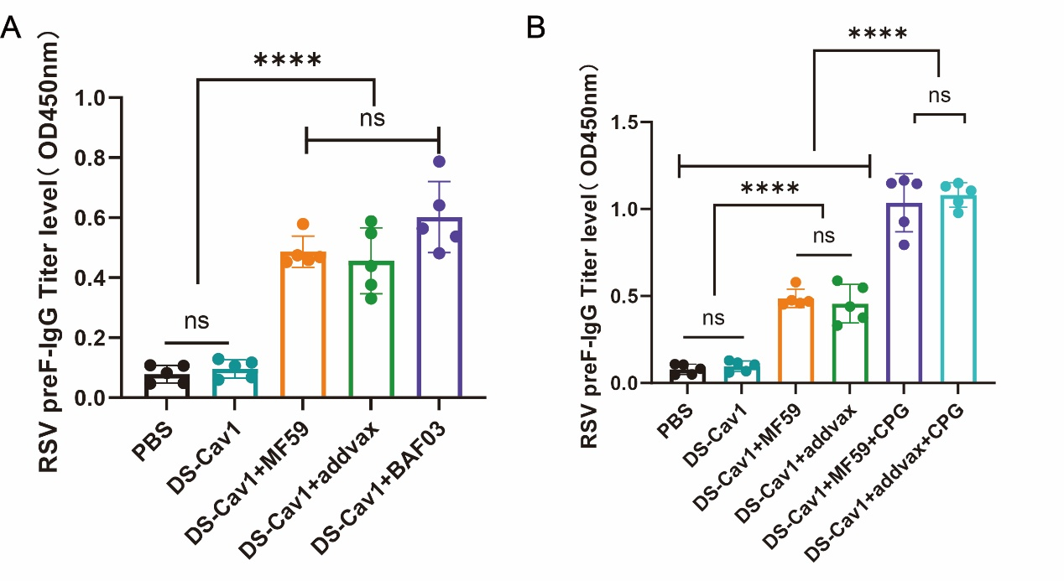
(A) The specificity of pre-F under the action of MF59 adjuvant from different sources IgG antibody response.
(B) Pre-F specific IgG antibody response after MF59 and AddaVaxTM combined with CpG.

Supplement Figure2 MF59@MDP dose-dependently caused cell death to release immunogenic substances.
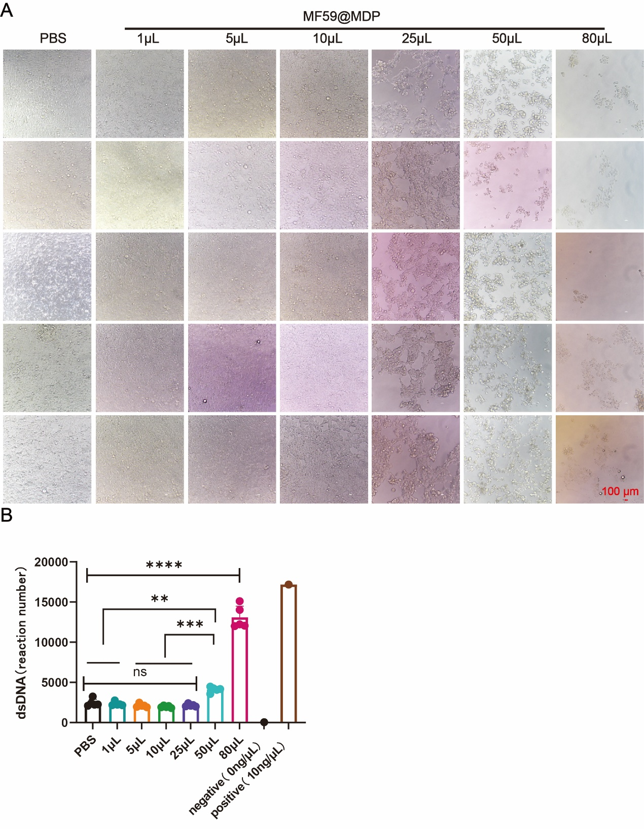
(A)The death of 293 T cells caused by different proportions of MF59@MDP was observed under electron microscope.
(B)The dose of dsDNA released from the supernatant of dead cells at different doses

Supplement Figure 3 Compared with MF59, MF59@MDP has a better effect on improving immune bias.
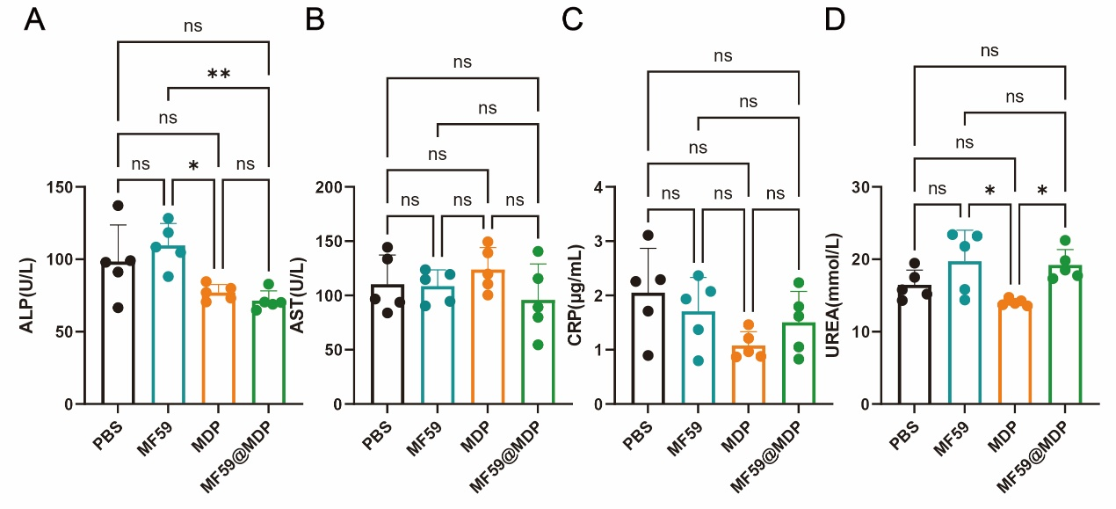
(A) Three days after the second immunization, the blood of the mice was collected to detect the ALP level.
(B) AST level.
(C) CRP level.
(D) UREA level.

